**Invitation to Tender (ITT)**

**Lake District National Park Design Guide (including design code)**

Created by: Rob Allison

Created on: 6 April 2022

**Summary**

Lake District National Park Authority (LDNPA) are seeking consultancy support for the preparation of a Design Guide (including Design Coding) to cover the area of the National Park. This may be a single multidisciplinary consultancy or a collaboration of consultants working under a lead consultant.

**Return of written submissions:** 3 May 2022

**Appointment of Consultant:**  w/c 16 May 2022

**Completion of Commission**: 31 March 2023

**Budget:** Up to £80,000

**Please read the document carefully and fully understand the timescales etc.**

CONTENTS:

1. BACKGROUND
2. SCOPE OF THE PROJECT
3. PROCUREMENT PROCESS
4. SUBMISSION OF TENDER DOCUMENTS
5. TENDER INFORMATION
6. APPENDICES

A Company Information

B Company CVs

C Declaration of non-collusion

D References

E Form of Tender

F Map of project area

G Draft programme and milestones

7.0 SUPPORTING DOCUMENTS:

Draft Project Plan submitted to DLUHC

**1.0 Background**

The LDNPA has been successful in securing a place on the Department for Levelling Up, Housing and Communities (DLUHC) Design Code Pathfinder Programme which aims to support communities across the country to lead the way in shaping the design of their neighbourhoods. It is the only National Park to be selected on the programme and therefore presents a unique opportunity to develop an exemplar Design Guide/Code that supports a national landscape designation, a World Heritage Site, and helps other rural authorities understand how Design Guides/Codes can be applied. LDNPA is seeking to appoint a consultant to work with the LDNPA prepare the design guide for the Lake District.

The National Planning Policy Framework identifies that *“…all local planning authorities should prepare design guides or codes consistent with the principles set out in the National Design Guide and National Model Design Code…”*. The LDNPA adopted its new [Local Plan](https://www.lakedistrict.gov.uk/planning/planningpolicies/local-plan/policies/policy-06-design-and-development) in May 2021 and will use this guide to build on the policies of the Local Plan. The Design Guide will be prepared to be a Supplementary Planning Document. We have taken the conscious decision to produce a Design Guide incorporating design coding given the limited amount of new housing development in the Lake District. Retrofitting of distinctive and traditional Lakeland properties to address climate change, and conversion of traditional agricultural buildings to address climate change and biodiversity net gain. The opportunities to manage and support changes to existing buildings through this guide is as important for the Lake District as it is for new buildings. New Forest National Park has recently adopted a Design Guide Supplementary Planning Document which incorporates design coding.

The design guide for the Lake District will provide clear, concise, and where possible, measurable guidance to help achieve high standards of design in development proposals. It will reinforce distinctiveness of place including respecting and enhancing the special qualities of the National Park, including local character and attributes of Outstanding Universal Value of the World Heritage Site. It will also provide the opportunity to address climate change and ensure that all new homes and neighbourhoods are adaptable, resilient and flexible to guarantee homes are fit for purpose in the future.

The appointed consultant team responsible for producing a guide will need to be an inter-disciplinary team of built environment and heritage professionals and may include architects, landscape architects, urban designers, communications and stakeholder management professionals, and content creators. The Authority has a multi-disciplinary internal team and will provide the local planning authority officer specialist support.

The Design Code Pathfinder Programme launched in March and the LDNPA is required to have a final draft of the guide/code ready for 31st March 2023. Further information about the National Design Guide and National Model Design Code can be found at:

National Design Guide <https://www.gov.uk/government/publications/national-design-guide>

National Model Design Code (Parts 1 and 2) <https://www.gov.uk/government/publications/national-model-design-code>

A budget of up to £80,000 is available, inclusive of disbursements.

We will score the tenders according to the evaluation in Section 4.2 but may invite some companies for interview on 11th May.

The inception meeting is expected to take place on the afternoon of the 18th May.

**2.0 Scope of the project**

The appointed consultant will lead and prepare a Design Guide that incorporates design coding as outlined in the National Model Design Code for the National Park boundary, as extended in 2016 (Appendix F). This may include appointing appropriate and managing sub-contractors to provide specialist input on matters of consultation and engagement, heritage and built environment matters, graphic design and content creation, for example.

The design guide will need to meet the following aims, outputs and outcomes.

The aims for this design guide are:

* To provide clear, concise and easy to understand guidance;
* To set out the LDNPA’s and communities’ expectations on what constitutes ‘good design’ in the Lake District;
* To celebrate and reinforce the unique character, identity, heritage and culture of the Lake District;
* To addresses the specific issues relating to the built environment and climate change, encourage greater biodiversity, and enable people to engage with nature;
* To inspire applicants, architects, parish councils and planners to create beautiful places and well designed buildings, including through imagery and digital content;
* To create award winning design guidance that will provide a framework for award winning schemes; and
* To provide learning from the project that can be captured and shared with other Authorities and DLUHC.

The LDNPA has identified that the guide will focus on the following characteristics of the National Design Model Design Code:

* Distinctiveness of place, local character and heritage (Context and Identity)
* Beauty, design principles, materials, and well-designed homes (Built Form, and Homes and Buildings)
* Biodiversity net gain including the role of SuDs (Nature)
* Climate change (Resources)

The following workstreams should help inform your approach to the preparation of the Guide, but we are still learning about design codes and guides. The LDNPA expect this to be an iterative process with support from DLUHC (who are currently reviewing the draft Project Plans (see section 7) before providing feedback), and guided by the appointed consultant who can bring ideas and expertise to help provide clarity and support for the LDNPA to prepare this design guide. The pathfinder programme is an opportunity to learn and pass this on to other authorities.

**Workstream 1: Evidence gathering and analysis**

To develop guidance on the characteristics we wish to focus the guide on, it is anticipated that the consultant will need to develop an understanding of the:

* **Place**, for example local characteristics and context, the historic environment, heritage and culture, and natural environment;
* **History and character**, for example local vernacular and architecture;
* **Sensitivities**, for examples use of materials, landscape character, attributes of Outstanding Universal Value;
* **Challenges**, for example climate change, nature recovery, local materials, and skills;
* **Expectations and obligations of the pathfinder programme**; for example engagement and consultation.

**Workstream 2: Drafting the design guidance and coding**

Through community and stakeholder engagement the guide will be created building upon the key characteristics we have identified above. It will include:

* The development of a design vision. This will reflect community aspirations about how they envisage the Lake District
* Coding plan., Likely to be map based on broad area types for example – rural, small settlements, larger villages, towns and strategic allocations identified in the Local Plan
* Preparation of coding and code wide design guidance that delivers the design vision and reflects focused key characteristics of the National Model Design Code:
  + Distinctiveness of place, local character and heritage (Context and Identity)
  + Beauty, design principles, materials, and well-designed homes (Built Form, and Homes and Buildings)
  + Biodiversity net gain including the role of SuDs (Nature)
  + Climate change (Resources);
* Options development and consultation – guidance, codes and testing;

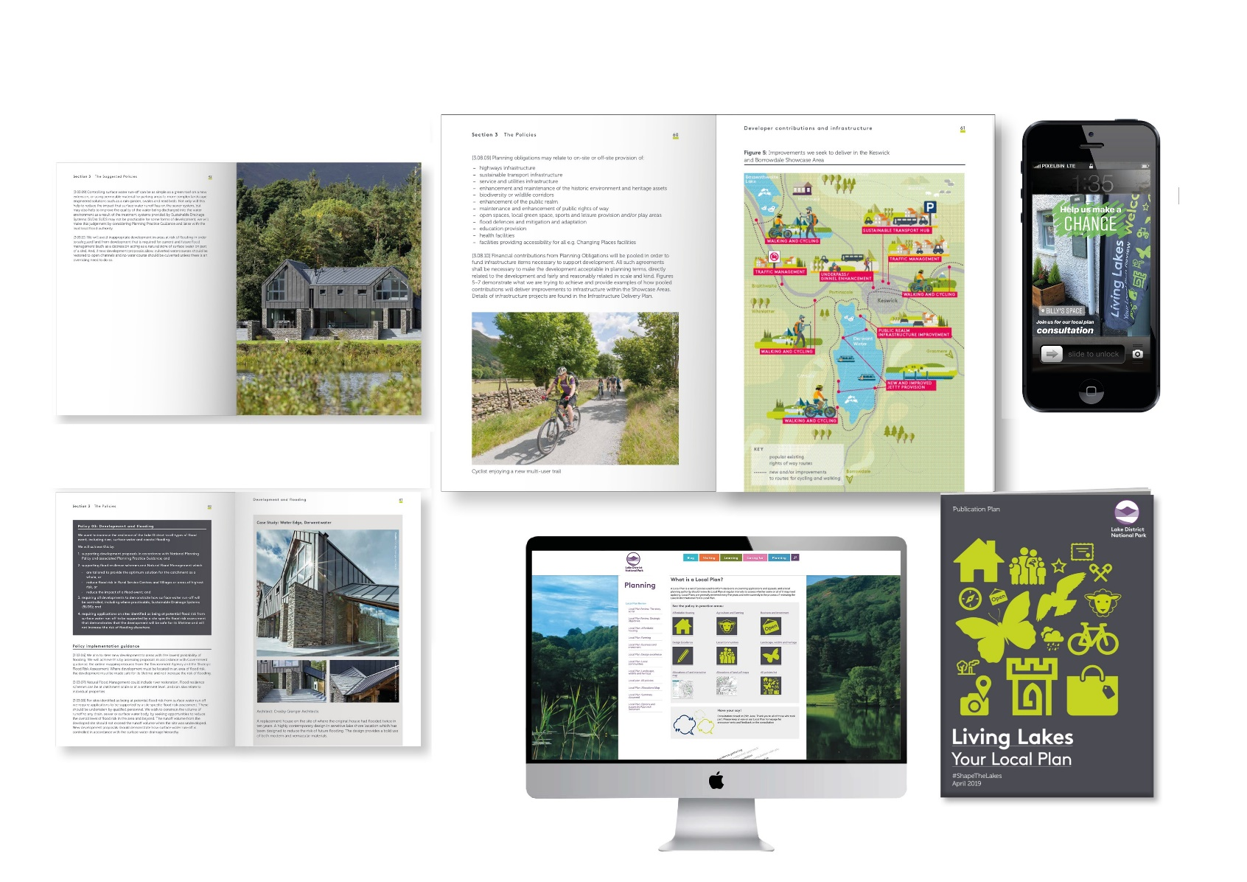

The LDNPA expect the guide to include imagery and digital content to inspire users of the guide. Through the presentation of the guide there are some questions we would like you to consider:

* How do we bring the design guide to life to inspire good design, how can website content and social media support this?
* What role can Architects portfolios play in showcasing the design guide? E.g. <https://bencunliffe.co.uk/our-work/>



* What is the role of technology as a tool to inspire and explain the design guide?
* How could the LDNPA and communities present and use the ‘product’?
  + accessible, user friendly, visual content etc;
  + Production of mapping, illustrations, case studies.

**Workstream 3: Stakeholder engagement, consultation and communications**

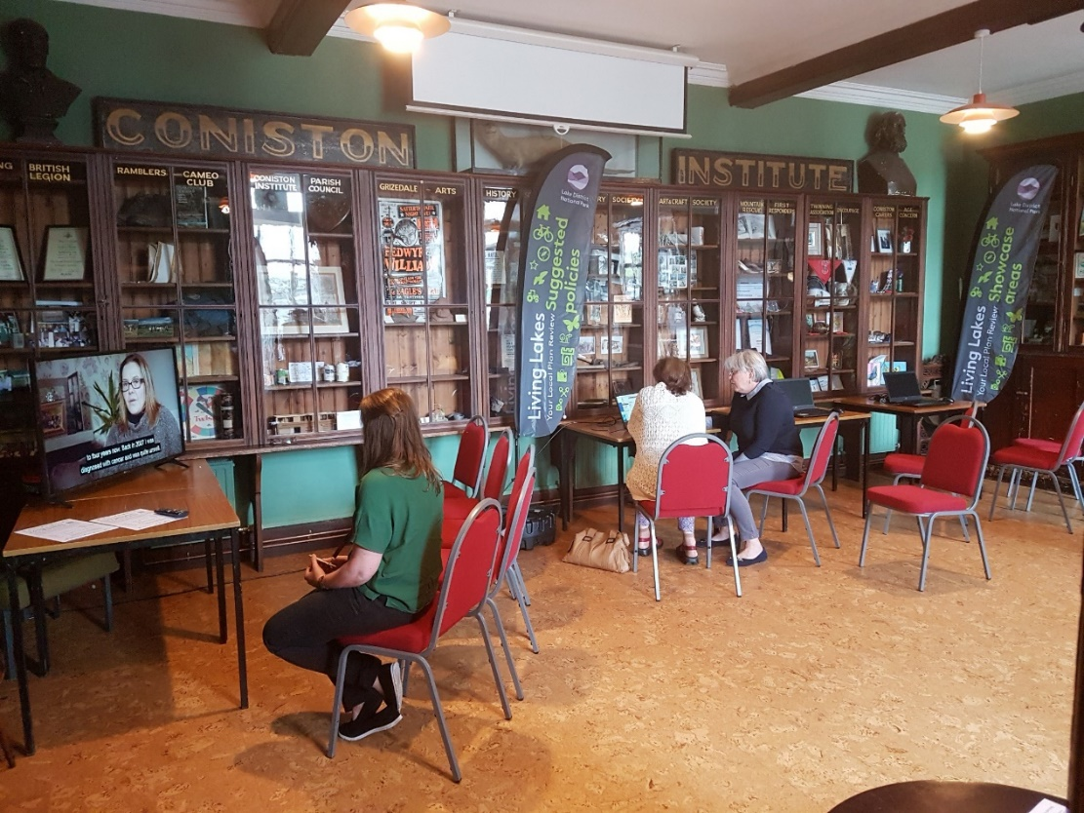

When preparing design guides/codes, communities need to be involved at each stage of the process. You will lead the preparation of and delivery of a consultation strategy that includes feedback from the initial consultation exercise to ensure communications are effectively managed over the project timeframe.

Local planning authorities are expected to apply a balance of face to face and digital engagement techniques appropriate to their circumstances and the type and scale of development. A series of engagement tools are identified in the coding guidance to support engagement and consultation:

* Visual preference surveys;
* Place assessment tools;
* Structured workshops and charrettes;
* Community panels or forums;
* Drop in events and exhibitions;
* Design review panels;
* Digital engagement tools –
  + social media, apps, email campaigns and websites;
  + Digital models of design codes and their context, area or sites;
  + Other visualisation techniques for 3D models;
  + Community level data gathering;

The appointed consultant will work with the Authority to finalise the stakeholders involved and develop the engagement and consultation plan. We have identified the following community and stakeholder groups so far:

* Authority Members and Committees
* Town and Parish Councils (82);
* Cumbria Association of Local Councils;
* Local climate change action groups that are active in some settlements (e.g. Keswick, Staveley, and Ambleside);
* Civic Groups/Societies;
* Lancaster and Westmorland Society of Architects;
* Zero Carbon Cumbria;
* Cumbria Action for Sustainability;
* The Lake District National Park Partnership.

**Measuring community support**

Those leading engagement will need to consider how they can demonstrate measurable community representation and support to ensure guides/codes are based on what is popular locally, on the basis of evidence. The appointed consultant will work with the LDNPA to establish appropriate and realistic measurable targets to demonstrate engagement and consultation with communities in the production of the guide.

Your methodology for preparing the design guide will need to demonstrate a clear understanding of the task, what is expected and your approach to delivering the design guide in the timeframe for the project.

The outputs of this project will be:

* Collation and presentation of evidence and analysis that demonstrates a thorough understanding of the issues and opportunities. This is anticipated to include reports, maps and GIS data layers;
* Delivery of an effective engagement and consultation plan which meets agreed targets and a communications plan;
* Draft design guide for public consultation in both HTML format content for the LDNPA website and a Word/PDF document. This will include two rounds of review with the LDNPA;
* A final draft Design Guide SPD that can be adopted by the Authority. The final version will need to be in HTML format for our website and Word / PDF document. This will include digital content and imagery that can be used across digital channels including social media. This will include two rounds of review with the LDNPA;
* Delivery of three training events to LDNPA Development Management team, architects and agents, and Parish Councils to help them understand and use the guide;
* A checklist for developers when submitting a planning application (This will also be used within Development Management’s GIS constraints checklist);
* Your feedback into a lessons learned report;
* Weekly highlight reports to outline progress on the project.

The outcomes the LDNPA desire from the Design Guide, and which it will be measured and evaluated against is:

* Development protects or enhances the authenticity, integrity and significance of the Lake District;
* Development of codes within the design guide that are measurable and achievable (e.g. development must do’s, quantitative requirements etc) so the LDNPA can monitor positive changes over time;
* New development is inspired by and contributes to local distinctiveness;
* The built environment is resilient to climate change and addresses energy efficiency in a sustainable way, taking into account embodied carbon ;
* The historic environment is conserved and enhanced and makes a positive contribution to landscape character; and
* New development creates award winning beautiful places, beautiful and well-designed homes, and contributes to improving the landscape.

**Reporting**

Day to day project management is undertaken by LDNPA officers.

You will update the LDNPA Project Board via:

* Monthly project board progress reports (MS Teams). However, there may be occasions when it is most appropriate and convenient to meet in person, and this will be arranged with you.
* Weekly Highlight Reports (email)

A monthly written progress report is provided by the consultant to the Authority for the project board, complemented with weekly highlight reports with the Authority’s project manager. The monthly progress update reports are detailed, covering technical progress, risks, issues and finances. The weekly highlight reports summarise tasks completed in the previous week and any issues arising along with a discussion on actions.

Progress meetings are held every month. These progress meetings cover the monthly progress report prepared by the Consultant, and provide more technical detail about the results of the project and address any issues for escalation. The progress meetings are attended by the Authority’s Project Manager and Project Board members.

The Consultants appoints a suitable qualified Lead consultant who attends all meetings and acts as the main point of contact for the Authority’s Project Manager.

The Consultants prepare and maintain a project Risk Register, Issues Log and an Action Log.

The Consultant provides quality assurance procedures for the check and review of all deliverables prior to submission to the Authority.

**3.0 Procurement Process**

The Lake District National Park Authority (LDNPA) are using a two stage process for this tender. We are using The Chest to be as inclusive as possible as it is free for suppliers to join and express an interest.

The pre-qualifying questionnaire (PQQ) stage is complete. This stage is designed in order for companies to demonstrate they have the basic and underlying ability to deliver the service that we require, without committing a significant amount of time and resource to complete a detailed tender. Following submission of your PQQ, your company, if selected, will be asked to complete the second stage, which is to complete the full tender process. Each tender will be evaluated and competitively marked by a team of LDNPA staff. This may result in interviews taking place before the contract can be awarded on 11th May.

If you have any questions that you wish to ask the Authority, you must submit them via The Chest. Where responses give information that could be advantageous to all tendering then the answer will be made available to all parties.

**3.1 What we need back from you (the supplier) at this stage**

A thorough quote that will stand up to bid scrutiny based upon the specification detailed and uploaded by 1pm on 3rd May 2022. As part of the cost breakdown, please provide details of day rates and the number of days each team member will be providing.

The full bid price must be completed in the last section of this document. Please ensure that any costs such as travel and accommodation are included within the total cost.

Please include any policies related to Equality, Diversity and Inclusion or supporting information to support how you will approach stakeholder engagement in an inclusive manner.

Confirmation of your company’s ability to deliver the project within the scope required, and demonstrated through the project timeline.

**Timing**

The Consultants undertake the work between May 2022 and March 2023. The project commences with an inception meeting to establish the working team and key contacts; finalise the proposed programme and timescales; key project risks and issues; and review the proposed project methodology

Confirmation should be made of the proposed project completion date, which should be no later than 31st March 2023.

**Programme**

A detailed programme is provided by the *Consultant* as part of the tender submission showing tasks, milestones and meeting dates. An initial draft timeline is appended (Appendix G) which formed part of the draft project plan submitted to DLUHC. Please review and develop a project plan with clear tasks, milestones, and gate reviews. The programme includes adequate time to allow the Authority to review, comment and feedback on draft documents before they are finalised. In addition it takes account of LDNP Park Strategy and Vision Committee sign off and approvals.

The programme clearly shows the key stages and tasks to be completed for the study.

The Authority assumes that draft Design Guide is completed by 31st March 2022. Consultants consider this target timescales are achievable and present a realistic deliverable programme as part of the tender return. If this is not the case an alternative programme is submitted with the tender including supporting text to explain the timescales included in the programme.

The Programme includes:

* Governance
* Communication and engagement programme
* Reporting

A Project management methodology is to be completed that assures us that you can deliver the project at the quality levels expected within the timescales.

The tender submitted must be a Word document and saved as: your company, tender and the month (for example the file name for acme consultancy would be: - ACME ITT MAY). Please do not submit any other brochures or supporting documentation at this stage unless specifically asked for. If we receive additional documentation, if your tender is not saved correctly, or if it is saved in the wrong format we may not be able to review and evaluate your tender.

We will not consider any documentation that is late. We often receive documents uploaded onto The Chest that are on the borderline. We would encourage you to submit your tender well in advance of the deadline. It is important to remember it takes time to upload documents onto The Chest, if you encounter technical difficulties, please contact Due North (The Chest software provider) who will be able to offer assistance.

These measures ensure there is consistency in the way that questions are presented, making the process fair for all applicants.

**4.0 Submission of Tenders**

**4.1 Tenders to be received by**

The tender is to be uploaded to The Chest by **1 pm on the 3 May 2022.** Tender documents uploaded late will not be considered.

You must provide:

Company Information (Appendix A)

Company CV’s (Appendix B)

Declaration of non-collusion (Appendix C)

References (Appendix D)

Form of Tender (Appendix E)

Information that demonstrates you will be able to deliver on time

**4.2 Evaluation**

All tenders received will be evaluated based on the information they have submitted in their tender. Evaluation will be based upon the following criteria:

| **Criteria** | **Potential Score** | **Weighting** | **Max Score** |
| --- | --- | --- | --- |
| Ability to deliver on Time (inc. project timeline) | 1-5 | 4 | 20 |
| Cost | 1-5 | 4 | 20 |
| References | 1-5 | 2 | 10 |
| Relevant experience and knowledge | 1-5 | 5 | 25 |
| Understanding of the brief and outline of methodology | 1-5 | 5 | 25 |
| **Maximum Possible Score** | | | **100** |

**4.3 Award of tender**

The Authority will decide to whom the contract shall be awarded based on the evaluation criteria outline above. The Authority does not bind itself to accept the lowest or any tender/quotation and reserves the right to accept the whole or parts of tenders/quotations. The Authority will notify acceptance of the tender to the successful tenderer as soon as is reasonably practicable.

If you have any difficulties submitting your invitation to tender or if you have any technical difficulties please contact Due North ([support@due-north.com](mailto:support@due-north.com) 01670 597120. If you need help in completing a tender we recommend you contact the local Business Link office ([www.businesslink.gov.uk](http://www.businesslink.gov.uk))

**5.0 Tender Information**

**5.1 Confidentiality**

The details of these documents and all associated documents are to be treated as private and confidential for use only in connection with the tender process and funding application.

**5.2 Freedom of Information**

The Authority is committed to meeting its legal responsibilities under the Freedom of Information Act 2000. Accordingly all information submitted to the Authority may need to be disclosed in response to a request under the Act. If you consider that any of the information included in your tender is commercially sensitive, please identify it and explain (in broad terms) what harm may result from disclosure if a request is received, and the time period applicable to that sensitivity. You should be aware that, even where you have indicated that information is commercially sensitive, we may be required to disclose it under the Act if a request is received. Please also note that the receipt of any material marked ‘confidential’ or equivalent by the public authority should not be taken to mean that the public authority accepts any duty of confidence by virtue of that marking. If a request is received, we may also be required to disclose details of unsuccessful tenders.

**5.3 Anti Fraud and Corruption Policy**

The Authority has an Anti Fraud and Corruption Strategy which sets out the responsibilities of officers and action to be taken in cases of theft, corruption, irregularity, or when damage is suspected. The Confidential Reporting Code, (Whistle Blowing Policy), forms part of this Strategy which provides a mechanism for staff to report suspected wrong doings confidentially.  In the event of such an issue, an investigation would be carried out and action taken as necessary.

**5.4 Costs and expenses**

The Authority will not be responsible for, or pay for, expenses or losses which may be incurred by a tenderer in the preparation of their tender. The Authority does not bind itself to accept any of the tenders as a result of the tendering process.

**5.5 Preparation of Tenders**

For the preparation of their tender and entering into a contract with the Authority, tenderers must ensure that they have all the information required and must satisfy themselves of the correct interpretation of terminology used in these documents.

**5.6** **Queries on the tenders**

If any points in these tender documents are considered by the tenderer as unclear, the tenderer should address their queries via the Chest. Their query will be responded to via The Chest and the answer sent to all tenderes, but it shall not be construed in a way that adds to, modifies or takes away from the meaning and intent of the contract and/or the obligations and liabilities of the contract.

**5.7 Alterations**

None of these documents may be altered by the tenderer. If the tenderer wishes to propose modifications to any of the documents (which they may consider would provide a better way to achieve the contracts objectives) they must provide details in a separate letter accompanying the tender response on The Chest.

**5.8 Prices**

All prices must be net and, where applicable, carriage paid with all cash and trade discounts allowed for.

**5.9 VAT**

All prices and/or rates shall be exclusive of Value Added Tax.

**5.10 Validity of tenders**

Tenders shall be valid for a minimum of three calendar months from the closing date for receipt of tenders.

**5.11 Sub-contractors**

The names and addresses of any sub-contractors the tenderer proposes to employ must be provided with the tender.

**5.12 Quality of goods / services**

Tenderers must ensure that the persons responsible for completing work tendered for have the necessary experience and skills as outlined in this tender brief.

**5.13 Conflict of Interest**

The Authority requires all tenderers to confirm whether any actual or potential conflicts of interest that exist which may prevent them undertaking this work, and a description of measures they would adopt if a potential conflict of interest arose during or following completion of this work.

**5.14 Treatment of tender**

The acknowledgement of receipt of any submitted tender shall not constitute any actual or implied agreement between the Authority and the tenderer.

**5.15 Debriefing**

All unsuccessful bidders will be offered the opportunity to be given a debriefing. Requests for debriefing are to be made in writing.

**Contact:**

Rob Allison, Team Leader – Strategy, Partnerships and Policy

Hanna Latty, Head of Strategy and Ranger Services

**6.0 APPENDICES**

**APPENDIX A**

**COMPANY INFORMATION**

Please provide the following information.

1. Name, address and Registered Number of the company.
2. Names and addresses of any sub-contractors to be engaged on the project.
3. Details of the company’s Professional Indemnity Insurance cover. For this project we require this to be of at least £1,000,000
4. A summary of the company’s approach to Health and Safety or copy of relevant Health and Safety Policies / Risk assessments as the appointed consultant will be undertaking engagement events and/or surveying and assessing sites.

### APPENDIX B

**COMPANY C.V.s.**

Please provide the following information:

1. Examples of relevant projects undertaken to include:
   1. Costs
   2. References (please complete and return Appendix D)
   3. Evidential material
   4. Successful completed project documents
2. CVs of the Project Team who will undertake the work

### APPENDIX C

### DECLARATION OF NON-COLLUSION

To: Lake District National Park Authority

The essence of selective tendering is that the Authority shall receive bona fide competitive tenders from all firms tendering. In recognition of this principle, I/We certify that this is a bona fide tender, intended to be competitive and that I/We have not and will not (either personally or by anyone on my/our behalf):-

1. Fix or adjust the amount of the tender (or the rate and prices quoted) by agreement with any other person.
2. Communicate to anyone, other than the person calling for this tenders, the amount or approximate amount or terms of the proposed tender (except other than in confidence, where essential to obtain professional advice or insurance premium quotations required for the preparation of the tender).
3. Enter into any agreement or arrangement with any other person that he shall refrain from tendering or as to the amount or terms of any tenders to be submitted.
4. Canvass or solicit any member, officer or other employee of the Authority in connection with the award of this or any other Authority contract or tender.
5. Offer, give or agree to give any inducement or reward in respect of this or any other Authority contract or tender.

|  |  |
| --- | --- |
| Signed (as in Tenders) duly authorised to sign | ………………………………………………………………………… |
| For and behalf of | ………………………………………….…………………………….. |
| Date | ………………………………………….…………………………….. |

**APPENDIX D – REFERENCES**

Potential suppliers are required to submit details of three organisations **where you have carried out similar works before**

This is so that references may be obtained. If you are currently supplying to other Local Authorities, please include these.

**Reference 1 Comments**

|  |  |
| --- | --- |
| Organisation Name |  |
| Contact Name |  |
| Address |  |
| Telephone Number |  |
| Fax Number |  |
| Estimated contract sum | £ |
| Project description |  |

**Reference 2**

|  |  |
| --- | --- |
| Organisation Name |  |
| Contact Name |  |
| Address |  |
| Telephone Number |  |
| Fax Number |  |
| Estimated contract sum | £ |
| Project description |  |

Please note that all information will be treated in the strictest confidence and will be used purely as a means of obtaining references.

## APPENDIX E

## FORM OF TENDER

### Project Title:

**Project Reference:**

Name of Tenderer: ……………………………………………………………….

Address of Tenderer: …………………………………………………………

……………………………………………………………….

……………………………………………………………….

……………………………………………………………….

…………………………………………………(Tenderer to insert name) hereby

submit our lump sum tender price of

£…………………………………..(Tenderer to insert price) all in accordance with the submitted tender and corresponding documentation and terms and conditions contained therein.

Tenderer signature: ………………………………………………………………

Print Name: ………………………………………………………………

Position held: …………………………………………………………

**APPENDIX F**

Map of project area

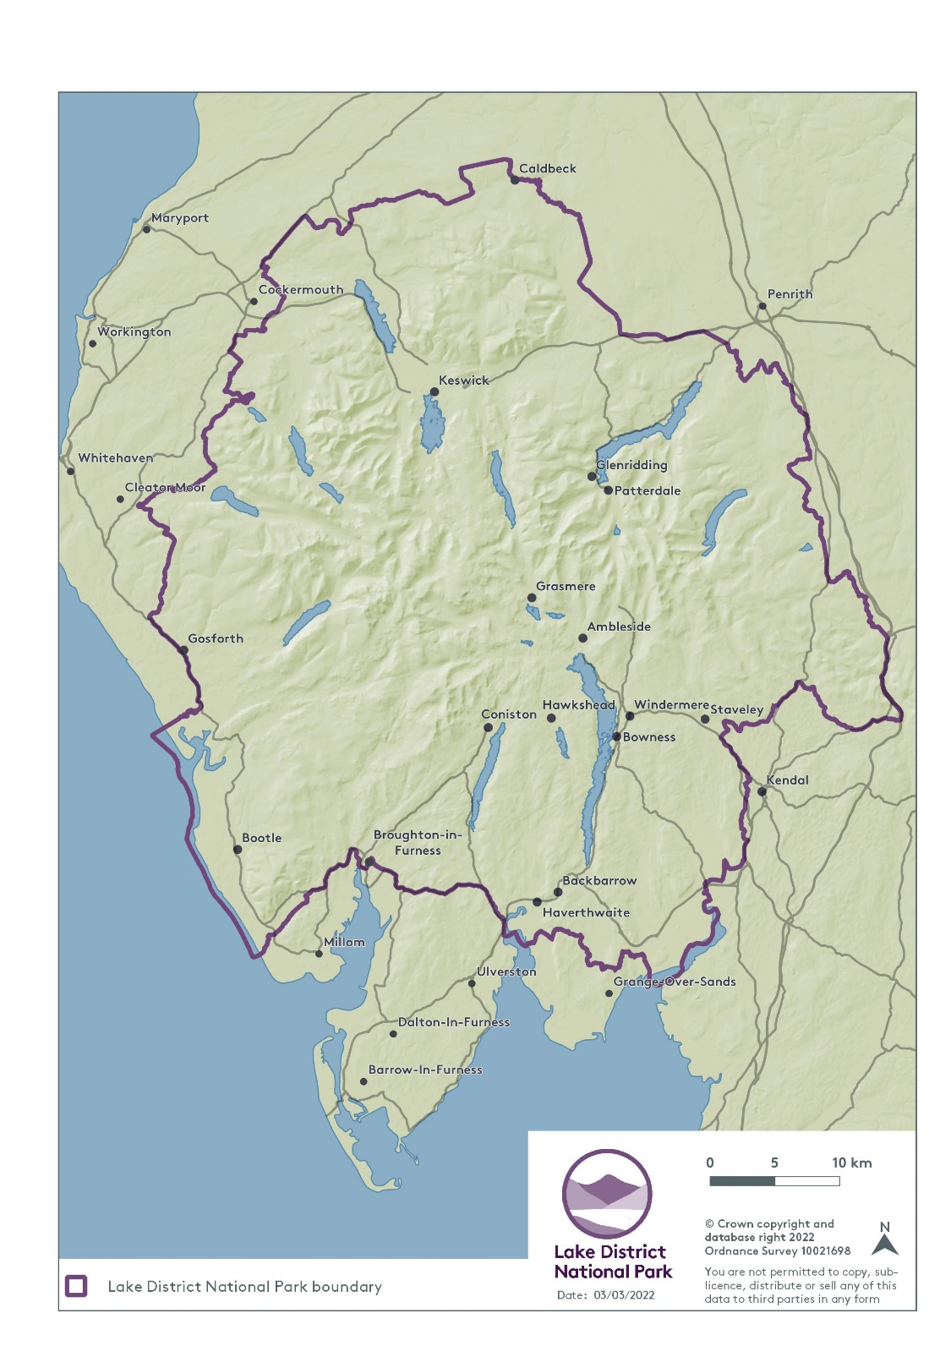

**APPENDIX G**

Draft programme and milestones

|  |  |  |  |  |  |  |  |  |  |  |  |  |  |  |  |  |  |  |  |  |  |  |  |  |  |  |  |  |  |  |  |  |  |  |  |  |  |  |  |
| --- | --- | --- | --- | --- | --- | --- | --- | --- | --- | --- | --- | --- | --- | --- | --- | --- | --- | --- | --- | --- | --- | --- | --- | --- | --- | --- | --- | --- | --- | --- | --- | --- | --- | --- | --- | --- | --- | --- | --- |
| **Task** | April | | | | May | | | | | June | | | | July | | | | August | | | | | September | | | | October | | | | | November | | | | December | | | |
| 4 | 11 | 18 | 25 | 2 | 9 | 16 | 23 | 30 | 6 | 13 | 20 | 27 | 4 | 11 | 18 | 25 | 1 | 8 | 15 | 22 | 29 | 5 | 12 | 19 | 26 | 3 | 10 | 17 | 24 | 31 | 7 | 14 | 21 | 28 | 5 | 12 | 19 | 26 |
| **1 Analysis, 1A) Scoping**   * Complete |  |  |  |  |  |  |  |  |  |  |  |  |  |  |  |  |  |  |  |  |  |  |  |  |  |  |  |  |  |  |  |  |  |  |  |  |  |  |  |
| **Appointment of consultants**  * Inception meeting |  |  |  |  |  |  |  |  | **\*** |  |  |  |  |  |  |  |  |  |  |  |  |  |  |  |  |  |  |  |  |  |  |  |  |  |  |  |  |  |  |
| **Initial stakeholder engagement**   * Awareness raising and understand local aspirations |  |  |  |  |  |  |  |  |  |  |  |  |  |  |  |  |  |  |  |  |  |  |  |  |  |  |  |  |  |  |  |  |  |  |  |  |  |  |  |
| **1 Analysis, 1B) Baseline**   * Character and context |  |  |  |  |  |  |  |  |  |  |  |  |  |  |  |  |  |  |  |  |  |  |  |  |  |  |  |  |  |  |  |  |  |  |  |  |  |  |  |
| **Stakeholder engagement** |  |  |  |  |  |  |  |  |  |  |  |  |  |  |  |  |  |  |  |  |  |  |  |  |  |  |  |  |  |  |  |  |  |  |  |  |  |  |  |
| **2 Vision, 2A) Design Vision** |  |  |  |  |  |  |  |  |  |  |  |  |  |  |  |  |  |  |  |  |  |  |  |  |  |  |  |  |  |  |  |  |  |  |  |  |  |  |  |
| **Design Guide themes**   * **Design principles** |  |  |  |  |  |  |  |  |  |  |  |  |  |  |  |  |  |  |  |  |  |  |  |  |  |  |  |  |  |  |  |  |  |  |  |  |  |  |  |
| **Design code elements**   * **3A – Guidance for Area Types:** * **3B – Code Wide Guidance** |  |  |  |  |  |  |  |  |  |  |  |  |  |  |  |  |  |  |  |  |  |  |  |  |  |  |  |  |  |  |  |  |  |  |  |  |  |  |  |
| **Design / preparation of web content** |  |  |  |  |  |  |  |  |  |  |  |  |  |  |  |  |  |  |  |  |  |  |  |  |  |  |  |  |  |  |  |  |  |  |  |  |  |  |  |
| Flex in project plan |  |  |  |  |  |  |  |  |  |  |  |  |  |  |  |  |  |  |  |  |  |  |  |  |  |  |  |  |  |  |  |  |  |  |  |  |  |  |  |
| **PSV committee approve consultation draft** |  |  |  |  |  |  |  |  |  |  |  |  |  |  |  |  |  |  |  |  |  |  |  |  |  |  |  |  |  | 26 TBC |  |  |  |  | 29  TBC |  |  |  |  |
| **Public Consultation** |  |  |  |  |  |  |  |  |  |  |  |  |  |  |  |  |  |  |  |  |  |  |  |  |  |  |  |  |  |  |  |  |  |  |  |  |  |  |  |

**Key milestones**

|  |  |  |  |  |  |  |  |  |  |  |  |  |  |  |  |  |  |  |  |  |  |  |  |  |  |  |
| --- | --- | --- | --- | --- | --- | --- | --- | --- | --- | --- | --- | --- | --- | --- | --- | --- | --- | --- | --- | --- | --- | --- | --- | --- | --- | --- |
| **Task** | **December** | | | | **January** | | | | | **February** | | | | **March** | | | | **April** | | | | **May** | | | | |
|  | 5 | 12 | 19 | 26 | 2 | 9 | 16 | 23 | 30 | 6 | 13 | 20 | 27 | 6 | 13 | 20 | 27 | 3 | 10 | 17 | 24 | 1 | 8 | 15 | 23 | 29 |
| Public Consultation (continued) |  |  |  |  |  |  |  |  |  |  |  |  |  |  |  |  |  |  |  |  |  |  |  |  |  |  |
| Review and update |  |  |  |  |  |  |  |  |  |  |  |  |  |  |  |  |  |  |  |  |  |  |  |  |  |  |
| Project Board and Programme Board sign off |  |  |  |  |  |  |  |  |  |  |  |  |  |  | TBC | TBC |  |  |  |  |  |  |  |  |  |  |
| Park Strategy and Vision Committee - Approval to Authority |  |  |  |  |  |  |  |  |  |  |  |  |  |  |  |  |  |  |  |  | 26 |  |  |  |  |  |
| Authority - Adoption |  |  |  |  |  |  |  |  |  |  |  |  |  |  |  |  |  |  |  |  |  |  |  |  | 24 |  |

**7.0 SUPPORTING INFORMATION**

**Draft Project Plan**

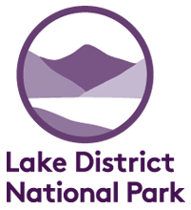Lake District Design Guide (incorporating the Design Code)

**Lake District National Park Authority**

# Context

## Overview

Designated in 1951, the Lake District is a mountainous region in North West England of some 2,362 sq. kilometres. As well as being the largest National Park in England, it has a resident population of approximately 40,297 (2017) making it the second most populated National Park in England. Its boundary extends across parts of Eden, Allerdale, Copeland and South Lakeland districts and it encompasses 82 parishes. It has some of the country’s finest upland scenery which attracts approximately 19 million visitors each year, making tourism a major industry. It was awarded World Heritage Site inscription in 2017.

Being a National Park and World Heritage site (WHS) the scale of change is small and incremental; we aim to deliver 80 new dwellings a year, but receive approximately 2,000 planning related applications a year ranging from agricultural development, householder applications, conservation and listed building applications to large scale tourism proposals. We therefore need a design guide to provide advice to help achieve high standards of design in all development proposals, and incorporate the relevant design code elements for the National Park area that reflect the scale and amount of development to achieve beautiful places and buildings that conserve and enhance the Lake District, and deliver sustainable development.

## Definition of area selected

The Lake District National Park boundary as extended in 2016 (See Map section 1) is the area selected for the design code.

## Predominant area types

The Lake District is characterised by rural settlements characterised by sparse rural areas containing traditional hamlets and villages which showcase the local vernacular and reflecting the local geology (limestone, sandstone, and predominantly slate). The towns of Ambleside, Keswick, Bowness and Windermere act as key local service and visitor destinations.

## What the design code will achieve

A design guide for the Lake District will provide clear and, where possible, measurable guidance to help achieve high standards of design in development proposals, reinforce distinctiveness of place including respecting and enhancing the special qualities of the National Park, including local character and attributes of Outstanding Universal Value of WHS. It will also provide the opportunity to address climate change and ensure that all new homes and neighbourhoods are adaptable, resilient and flexible to guarantee homes are fit for purpose in the future. This is of particular relevance given the age of some of our existing housing stock.

# Key themes and support

## Key themes and objectives

Through the design guide we build on our adopted Local Plan and embed the following key themes:

* Distinctiveness of place, local character and heritage (Context and Identity)
* Biodiversity net gain including the role of SuDs (Nature)
* Climate change (Resources)
* Beauty, design principles, materials, and well-designed homes (Built Form, and Homes and Buildings)

Our objectives are to ensure new development conserves and enhances the Lake District’s heritage and beauty. One of the most significant factors influencing the future of the Lake District is the climate and nature emergency. This design guide will include design codes that will secure principles of good design that enable buildings to adapt to climate change, and secure biodiversity gains, for example, retrofitting of distinctive and traditional Lakeland properties to address climate change, and conversion of traditional agricultural buildings to address climate change and biodiversity net gain. The opportunities to manage and support changes to existing buildings through this guide is as important for the Lake District as it is for new buildings.

## Design code support

Having further reflected on the design coding process we would benefit with support in understanding how to ensure the coding is proportional and reflective of the small scale of development in sparse rural areas where the guide/code is not site specific. We would welcome ongoing review sessions so we can share the learning on this as the guide is progressed. We are keen to work through what aspects of coding are relevant for rural areas through peer-to peer support including liaising with other National Park Authorities (some of whom have recently adopted or consulted on draft Design Guides/Codes), and themed workshops (e.g. nature, resources) would also support this.

# Community and stakeholder engagement

## Community groups

We maintain effective communication with our 82 Parish and Town Councils. We also regularly use Cumbria Association of Local Councils (CALC) to communicate effectively with all town and parish councils. There are also a number of local climate change action groups that are active in some settlements (e.g. Keswick, Staveley, and Ambleside) and civic groups.

## Stakeholder groups

Recognising the importance of collaboration the National Park Authority established the [Lake District National Park Partnership](https://www.lakedistrict.gov.uk/caringfor/lake-district-national-park-partnership) in 2006. This partnership comprises of 25 organisations that represent a diverse range of stakeholders and many in turn represent wider communities.

Additionally, the following stakeholders groups will also be engaged in the project:

* Lancaster and Westmorland Society of Architects
* Zero Carbon Cumbria
* Cumbria Action for Sustainability

We will continue to identify others who are relevant through the initial engagement.

## Planned community and stakeholder engagement

We expect to replicate and build on previous effective models of engagement used when preparing the new Local Plan and National Park Management Plan, which prioritised digital content and put the user at the core of engagement design.

We have completed engagement and consultation on the Design and Development Policy, and Distinctive Area Policy that form part of the adopted Local Plan. Distinctive Area groups have been established and offer further engagement opportunities.

Lancaster and Westmorland Society of Architects host design awards in the area, in partnership with LDNPA. With support from the LDNPA, they also ran a “Design Excellence Programme”. This provides excellent opportunities for training and engagement that will support the production and subsequent use of the design guide.

## Planned approaches to community and stakeholder engagement

A range of approaches are likely to be utilised including:

* Prize draw for respondents to encourage responses to consultations and visual preference surveys;
* Social media campaign (targeting specific audiences) to gather information (such as surveys, consultations, snap polls,) and promote events;
* Online information (webpages) to share information;
* Community drop in events and design tours of different character areas and recently completed developments which will help to showcase and encourage debate on different topics relevant to the guide;
* Inspiration through imagery (part of social media campaign) such as photos, and video content, and through showcasing materials we would like builders, architects and others to use; and
* Developing connections with design schools to engage young people in design (for example Lancaster University), potentially through design panels with Lancaster and Westmorland Society of Architects.

## Community and stakeholder engagement strategy

We will use our Statement of Community Involvement and Local Plan Review stakeholder engagement plan and our learning from this as the basis for developing our community and stakeholder engagement strategy.

## Users of the design code

Prospective developers, architects and agents, parish councils and community groups, and our Development Management team, will be the primary users of the design code. We intend to adopt it as a Supplementary Planning Document.

## Who will lead community engagement?

An external consultant will be appointed to lead the community and stakeholder engagement, supported by officers from the LDNPA. The design code production will be undertaken by consultants and overseen by the LDNPA. A tender brief will outline the project requirements, including establishment of clear outputs and outcomes.

We will also set appropriate targets for engagement to ensure effective community engagement.

# Design code process

## Stages of the National Model Design Code

Some elements of the Analysis has already taken place, the geographical area to be covered by the guide has been established as have key focus areas (distinctiveness and heritage, beauty, climate change, biodiversity). Baseline information is already available through various data sources. We need to bring this together and establish further evidence and data to underpin the guide and coding through the consultant appointment.

As required in the scoping stage we are yet to carry out an initial consultation exercise to explain and develop a consultation strategy for the guide.

The internal project team will begin the Design Vision (2A) work whilst the tendering process is taking place.

We plan to cover all the stages in the 12 month pathfinder programme which are proportionate to the scale of change and development in the Lake District (for example we do not intend to undertake Masterplanning (2C) as part of the guide).

We anticipate “Code Wide Guidance (3B)” will form the core part of our Design Guide, providing greater clarity on our Local Plan policies.

# Design resources

## The team

The code will be led by the LDNPA’s Strategy and Ranger Team and supported by consultants and other services including GIS and Communications.

**Steve Ratcliffe – Director of Sustainable Development.** Directs Development Management, and Strategy and Ranger Service and lead officer of Lake District National Park Partnership. Chairman of WHS Steering Group Advises on strategy and policies, facilitating the delivery of the Vision for the National Park. Led the Lake District Design Programme with Lancaster and Westmorland Society of Architects.

**Hanna Latty – Head of Strategy and Ranger Services.** Specialises in policy and strategy development, project management and securing investment. A background in economic development and regeneration, and over 5 years’ experience at the Lake District leading the production of the Local Plan and the Partnership’s Management Plan.

**Andrew Smith – Head of Development Management**. Responsible for the effective management of the Lake District’s Development Management Team. Extensive experience of the practical application of planning policies in a protected landscape.

**Rob Allison – Team Leader Strategy, Partnerships and Policy.** Over 12 years’ experience of Planning Policy at the Lake District, working across all areas of policy development including Local Plan’s, National Park Management Plans, World Heritage Site Nomination dossier, Supplementary Planning Documents

**Paula Allen – Strategy Planner.** 30 years working in Planning. Particular areas of expertise are policy development through the production of Local Plans and associated development plan documents, including Neighbourhood Development Plans, community engagement, and policy application through the development management process.

**Chloe Swift – Strategy Planner.** Knowledge and previous experience of housing strategy and effective place making. Responsible for the monitoring and delivery of the Local Plan policies, actions in the Partnership Management Plan and the development of Supplementary Planning Documents.

**Rose Lord – Built Environment Adviser.** Specialising in advice, guidance and determining planning applications on works to listed buildings, vernacular architecture of the Lake District and Conservation Areas. Knowledge of local materials, techniques and sustainable retrofitting of traditional buildings. Involved with a number of built environment and heritage networks.

**Mairi Lock – World Heritage Coordinator for the English Lake District WHS.** Has worked for the Lake District National Park for the last 19 years as a Planner and since 2018 as the World Heritage Site Coordinator. Her role is to provide advice on matters relating to world heritage.

**Ben Long – Area Planner.** An experienced planning officer having worked in Development Management for many years, and has also contributed regularly on policy development and compliance issues. Good design is a particular strength of his, having been involved with key developments in the Lake District National Park that have either won a design award or been nominated for an award, including the Sterling Prize.

**Charlie Westney – Online Manager, Communications and Customer Engagement.** Championing inclusivity and accessibility on the Lake District National Park website and associated commercial centres Brockhole and Coniston Boating Centre.

**Sarah Calderbank – Assistant Head of Communications, Communications and Customer Engagement.** Responsible for effective internal and external communications. Over seven years’ experience of communications at the Lake District, including social media and supporting the delivery of local planning policies.

## Role of consultants

In order to provide the necessary resources to deliver the Design Guide against the pathfinder timescales we are in the process of appointing consultants to lead the production of the Guide. They will be supported by the internal Project Team and Project Board to deliver the following workstreams:

* Analysis – Baseline evidence
* Drafting the design guidance and coding:
  + Distinctiveness of place, local character and heritage (Context and Identity)
  + Biodiversity net gain including the role of SuDs (Nature)
  + Climate change (Resources)
  + Beauty, design principles, materials, and well-designed homes (Built Form, and Homes and Buildings)
* Production of mapping, illustrations, case studies, and visual content
* Stakeholder engagement and consultation

## Team structure

# Programme, adoption and use

## Draft programme and milestones

See Annex 1

## Adoption route

Our Local Plan was adopted in May 2021 and includes a policy covering “[Design and Development](https://www.lakedistrict.gov.uk/planning/planningpolicies/local-plan/policies/policy-06-design-and-development)” which will provide the policy hooks. The Local Development Scheme also identifies the productions of a “Local Design Guide” Supplementary Planning Document (SPD).

The planned adoption route for the Supplementary Planning Document will be:

* Park Strategy and Vision Committee approve Design Code SPD consultation document (26th October or 29th November 2022)
* Park Strategy and Vision Committee recommend the Design Code SPD for adoption (26th April 2023)
* Authority Committee adopt the Supplementary Planning Document. (24th May 2023)

## Responsibility for the design code after the path finder programme

The LDNPA Strategy and Ranger Service will be responsible for the design code once the programme finishes. This will include adoption of the Supplementary Planning Document if this has not been achieved within the programme timeframe. This, along with any subsequent reviews, will be reflected in the Authority’s Local Development Scheme.

## Sharing learning from the design code

The design code will be published in ‘html’ format (i.e. as webpages) on our website to ensure it is accessible to all users. We will capture our learning from this project and share it online, as well as utilising relevant stakeholders groups to share the information, such as the Cumbria Development Plans Officers Group. Information will include an outline of the high level project plan and milestones of the production of the design code and explanations of how we created it, along with any issues we encountered, and solutions applied.

We will also make available a number of documents on request such as:

* Communications and engagement plans
* Lessons learned review
* Consultant briefs