

www.gov.uk/naturalengland
Request for Quotation

Request for Quotation
Geological Monitoring Programme: Cowbit Wash SSSI and Horbling Fen SSSI, Lincolnshire

You are invited, to submit a quotation for the requirement described in the specification below.

Please confirm, by email, receipt of these documents and whether you intend to submit a quote.

Your response should be returned to the following email address by:

Email: dan.burgess@naturalengland.org.uk and hannah.townley@naturalengland.org.uk
Date: 15th September 2023
Time: 12:00

Ensure you state ‘Geological Monitoring Programme: Cowbit Wash SSSI and Horbling Fen SSSI in the subject field to make it clear that it is your response.

Contact Details and Timeline

Dan Burgess and Hannah Townley will be your contacts for any questions linked to the content of the quote pack or the process. Please submit any questions by email and note that, unless commercially sensitive, both the question and the response will be circulated to all tenderers.

Action | Date
Date of issue of RFQ | 21-Aug-2023 at 13:45 GMT
Deadline for clarifications questions | 01-Sept-2023 at 17:00 GMT
Deadline for receipt of Quotation | 15-Sept-2023 at 12:00 GMT
Intended date of Contract Award | 18-Sept-2023
Intended Contract Start Date | 25-Sept-2023
Intended Delivery Date / Contract Duration | 02-Jan-2024

Glossary

Unless the context otherwise requires the following words and expressions used within this Request for Quotation shall have the following meanings (to be interpreted in the singular or plural as the context requires):

“Authority” | Means the Department for Environment, Food and Rural Affairs acting as part of Natural England
“RFQ” | Means this Request for Quotation and all related documents published by the Authority and made available to suppliers
“Contract” | Means the contract to be entered into by the Authority and the successful supplier.

Conditions applying to the RFQ

You should examine your response to the RFQ and related documents ensuring it is complete prior to submitting your completed quotation.

Your quotation must contain sufficient information to enable the Authority to evaluate it fairly and effectively. You should ensure that you have prepared your quotation fully and accurately and that prices quoted are arithmetically correct for the units stated.

The supplier by submitting a quotation is deemed to accept the terms and conditions in the RFQ. Failure to comply with the instructions set out in the RTQ may result in the supplier’s exclusion from this procurement.

Acceptance of Quotations

By issuing this RFQ the Authority does not bind itself to accept any quotation and reserves the right not to award a contract to any supplier who submits a quotation.

Costs

The Authority will not reimburse you for any costs and expenses which you incur preparing and submitting your quotation, even if the Authority amends or terminates the procurement process.

Mandatory Requirements

The RFQ includes mandatory requirements and, if you do not comply with them, your quotation will not be evaluated. All mandatory requirements are set out in Bravo.

Clarifications

The Authority reserves the right to discuss, confidentially, any aspect of your quotation with you prior to any award of Contract to clarify matters.

Amendments

The Authority may amend the RFQ at any time prior to the deadline for receipt. If it amends the RFQ the Authority will notify you in writing and may extend the deadline for receipt in order to give you a reasonable time in which to take the amendment into account.

Conditions of Contract

The terms and conditions - Condensed Terms and Conditions will be included in any contract awarded as a result of this RFQ process. The Authority will not accept any material changes to these terms and conditions proposed by a supplier.

Specification

The Authority is Natural England. The Authority’s priorities are to secure a healthy natural environment; a sustainable, low-carbon economy; a thriving farming sector and a sustainable, healthy and secure food supply. Further information about the Authority can be found at: Natural England

- Introduction
Natural England is the government’s advisor for the natural environment in England, helping to protect England’s nature and landscapes for people to enjoy and for the services they provide.

Natural England assesses the condition of Sites of Special Scientific Interest (SSSIs) for its notified features as part of its Common Standards Monitoring (CSM) programme. In order to do this effectively, sufficient baseline information for each feature must be available (documented).

This contract is required to aid understanding of the geological features at Cowbit Wash SSSI and Horbling Fen SSSI.
Results from this project will aid future monitoring and management of the site.

- Requirement

Access permissions and risk assessments
As part of the RFQ bid APPLICATION the contractor must provide Natural England with:
- A generic risk assessment, covering detailed requirements about how you will take various risks into account as well as the current risk of avian influenza– you must send this as part of the bid application. Site-specific risk assessments will be required on award of the contract. Further guidance on avian influenza can be found at: https://www.gov.uk/government/news/bird-flu-avian-influenza-latest-situation-in-england#guidance
- Covid-19 is no longer required to be considered as a specific Health & Safety risk but should be assessed as one of the many infectious respiratory diseases that may be encountered, along with appropriate measures to control its risk. Further guidance can be found at: https://www.gov.uk/coronavirus

The site owner may require you to attend a safety briefing and to provide insurance and risk assessments in advance of your visit. Please budget for this in your quote.

The project will be co-ordinated by Natural England’s geology specialists.

The Sites
- Horbling Fen SSSI
  - Horbling Fen SSSI (TF154353) is located about 20km southwest of Boston, Lincolnshire, on the western side of the village of Horbling off the A52. The site comprises 3 fields that are under agricultural management, and the geological interest lies beneath the topsoil.
  - The site citation can be found in Appendix B, with a description of the reason for notification.
  - A geological documentation called Site Management Brief (SMB) was compiled by Dr Stuart Graham, English Nature (1993) prior to the site SSSI notification; Appendix C covers the scientific description included in the SMB and a full copy of this and the draft Geological Conservation Review (GCR) entry for the site can be obtained on request.
- Cowbit Wash SSSI
  - Cowbit Wash SSSI (TF240191) is located 3km south of Spalding off Soke Dyke, Lincolnshire off the A16 and A1073 roundabout. The site comprises of one large field that is managed under agricultural use, where the geological interest lies under the topsoil.
  - A SMB was also provided by Dr Stuart Graham (1993) and covers important information about the Holocene Sea Level changes in the Lincolnshire fenland. A series of boreholes were investigated (no date), and radiocarbon dates extracted, and the locations are recorded on the SMB.
  - Appendix C provides further information on scientific importance of the site and the radiocarbon dating results. A full copy of the SMB and the draft GCR entry for the site can be obtained on request.
Survey Overview
Natural England requires a geological investigation of the buried sediments at both SSSIs to assess their condition. There are concerns that fluctuating water levels at both sites may have affected the sediments and the quality of the fossil material they contain. If water tables are too low, the uppermost organic sediments can degrade. The fossils, such as pollen, plant macrofossils and diatoms, enable palaeoenvironmental reconstructions to be carried out that provide evidence of past environmental and sea level change. They also enable the sequence to be radiocarbon dated to provide age estimates for these changes.
Aims
The aims of these investigations are to:
- Establish the stratigraphic profile at each site and provide a description of the Holocene deposits, together with an interpretation of the sequence. It is particularly important to confirm the depth of organic units at both sites to inform management regimes (water levels)
- Undertake an assessment of the presence and quality of pollen and other relevant palaeoecological proxies (e.g., plant macrofossils, diatoms), and the suitability of the sediments preserved for future palaeoenvironmental reconstruction and dating
- Undertake an assessment of the position of the current local water table at the time of fieldwork, and identify any properties of the sediments that indicate a zone of fluctuation in the water table and/or oxidation

Survey requirements
The field work requirement is to carry out 2 boreholes at Cowbit Wash and 2 boreholes at Horbling Fen at agreed locations at each site and at a suitable time when the fields are not in an important cultivation period. If any sections through the sediments are available and safely accessible, e.g., in cleared drains, these can also be logged and sampled.
Once samples have been logged and a stratigraphy produced, these should be shared with Natural England so that a suitable laboratory sampling and assessment strategy can be agreed in advance. The laboratory requirement is to carry out appropriate analyses to confirm the presence and quality of the pollen, diatoms and other palaeoenvironmental proxies held in the sediment at both sites.
The investigations and reporting must be carried out by a named individual or team which must include a suitably qualified independent Quaternary Scientist with specific expertise in palaeoenvironmental analysis and sedimentology, and the Pleistocene Fenland stratigraphy of the East of England.
Suggested Methodology
Boreholes must be taken at agreed locations and geo-referenced to inform future research. Disturbance of cultivated areas must be avoided unless previously agreed with the landowners. The excavations must be backfilled, and the topsoil reinstated to the satisfaction of Natural England and the landowners. Sections in the sedimentary profile e.g., in cleared drains, should be logged if available and safely accessible. The borehole locations and restoration methodology must be detailed in the final report.

An example sampling strategy (to determine the presence/absence and quality of pollen, diatoms and other palaeoenvironmental proxies) could be samples at 20cm intervals in the upper peat(s) most likely to be impacted by water level fluctuations, and one sample per horizon in buried peats below the water table. This must be agreed with Natural England before work commences.

Previously published stratigraphies from these sites suggest that a suitable number and location of assessment samples might be:
- Cowbit Wash SSSI
  - Approximately 4 organic units have been identified from which 10 pollen samples will be taken for assessment. The focus should be on the uppermost peat so that the impact of fluctuating water levels can be investigated
  - 10 samples will be taken for a diatom assessment throughout the sequence
  - Total samples = 10 x pollen and 10 x diatom
- Horbling Fen SSSI
  - 1 main organic unit from which 3 pollen samples will be taken
  - 1 pollen sample from a basal palaeosol and 1 pollen sample from overlying silts
  - 6 diatom samples taken throughout the sequence
  - Total samples = 6 x pollen and 6 x diatom
Please note that Natural England do not require a full palaeoenvironmental reconstruction from all cores taken. The purpose of this work is to determine present site condition and whether the current site management regime (water levels) is suitable for conserving the buried organic deposits. We therefore only require analyses to determine presence/absence of pollen, diatoms and other relevant palaeoenvironmental proxies, along with their quality for future scientific research.
If the successful contractor wishes to carry out additional scientific work on cores beyond Natural England’s requirement, this is possible as long as Natural England are provided with a copy of the results for our site files and are acknowledged in any future publications arising from the work.

Outputs
- A copy of any correspondence with the landowner
- Confirmation (maps, logs, photographs, results of laboratory analyses etc.) of the depth and nature of the notified features within the SSSI
- The presence and quality of pollen, diatoms and other palaeoenvironmental proxies that will provide an understanding of Holocene environmental changes in the SSSI
- The current level of the water table and a discussion of any evidence of fluctuations of the water-table determined from sedimentary properties
- Any further brief comments on site condition and future management

Reports to be provided as an MS Word file (including embedded photographs and maps). Tenderers should be aware that Natural England and Defra may subsequently publish reports

Post contract award activities:

- Provision of/access to resources including:
  - Location maps, SSSI citation and site management brief will be provided along with the draft Geological Conservation Review entry for the sites

- Access permissions – Natural England will obtain permission for your work and provide landowner contact details, along with access routes for machinery agreed where necessary

- The site survey will involve liaison with land managers (as above). Agreed risk assessments and H&S procedures should always be followed, including appropriate bio-security measures.

- Post survey a report will be produced (see outputs) to the Natural England Project Officer for the site.

All site surveys and working practice to be undertaken with an agreed risk assessment that is Covid compliant and meeting relevant government guidelines.

Other considerations
The successful contractor must agree the final methodology and location of boreholes in writing with Natural England, consent for access and the work must be agreed with the owner and Natural England prior to work commencing on site.
Restoration of excavations must be completed to a satisfactory timetable and standard as may be set out by Natural England and the landowner.
Natural England will use the results of the investigation to inform its response to future applications for consent and to inform the ongoing management of the notified features.
Tender evaluation
Evaluation criteria
The contract will be awarded to the tender which best fits the profile of requirements. This will be assessed by the project officer in consultation with relevant colleagues using the evaluation criteria below.
We will award this contract in line with the most economically advantageous tender as set out in the following award criteria:
Price – 40%
Quality – 60%

Quality Criteria | Weighting | To include
Technical knowledge - geology | 30% | Demonstration of sufficient geological knowledge to be able to carry out type of work (you may want to include brief CVs of relevant personnel)
Technical experience – site survey | 25% | Demonstration of field experience in this type of work (you may want to include brief CVs of relevant personnel and examples of other similar projects)
Methodology | 5% | An outline of the methodology that will be adopted and applied

Score | Justification
For a score of hundred (100): | Excellent - Response is completely relevant and excellent overall. The response is comprehensive, unambiguous and demonstrates a thorough understanding of the requirement and provides details of how the requirement will be met in full.
For a score of seventy (70): | Good - Response is relevant and good. The response demonstrates a good understanding and provides details on how the requirements will be fulfilled.
For a score of fifty (50): | Acceptable - Response is relevant and acceptable. The response provides sufficient evidence to fulfil basic requirements.
For a score of twenty (20): | Poor - Response is partially relevant and/or poor. The response addresses some elements of the requirements but contains insufficient / limited detail or explanation to demonstrate how the requirement will be fulfilled.
For a score of zero (0): | Unacceptable - Nil or inadequate response. Fails to demonstrate an ability to meet the requirement.

Quotation Submission

The submission will be assessed against the methodology (5%), knowledge and experience of geology and surveys (55%) under quality and cost (40%). Using the bidder template provided please include a detail explanation of the methodology you intend to use for the surveys.

In addition, include information relating to your quality assurance and project management procedures.

You will also be required to submit a brief curriculum vitae for each person that will be carrying out survey work in relation to this contract. This must include their qualifications and experience relating to geology surveys.

As outlined above, we require a detailed risk assessment covering;
- A generic risk assessment. Site-specific risk assessments will be required as part of your submission. Please see examples attached to the email
- Assurance that contractors will work within government guidance on working outdoors: https://www.gov.uk/guidance/working-safely-during-coronavirus-covid-19/construction-and-other-outdoor-work

Timescales

W/C 25th September 2023 – Inception meeting between project officers and supplier by teleconference if required (alternately happy to correspond by email)
w/c 1st January 2024 – Final reports, in digital format via e-mail, due to project officer

Prices will remain fixed for the duration of the contract award period. We may at our sole discretion extend this contract to include related or further work or if there are extenuating circumstances meaning you cannot access the sites. Any extension shall be agreed in advance of any work commencing and may be subject to further competition.

We will raise purchase orders to cover the cost of the services and will issue to the awarded supplier following contract award.

Suppliers will be required to invoice after the final reports have been received and signed off by Natural England.

Prices

Prices must be submitted in £ sterling, inclusive of VAT (where applicable).

Please provide a breakdown of the costs in the copy of this table in the bidder template document.

 | Item of work | Day £ rate of staff | Number of days | Total Price £  (ex. VAT)
1 | Fieldwork
2 | Laboratory Analyses
3 | Hire of Equipment (If applicable)
4 | Reporting
5 | Travel and subsistence costs
6 | Other costs (please specify)
7 | Sub-total
8 | VAT at 20% if applicable
8 | Total

Contract Management

This contract shall be managed on behalf of the Authority by:

Dan Burgess
Dan.burgess@naturalengland.org.uk
07503 180206

Hannah Townley
hannah.townley@naturalengland.org.uk
07780 688 242

Disclosure

All Central Government Departments, their Executive Agencies and Non Departmental Public Bodies are subject to control and reporting within Government. In particular, they report to the Cabinet Office and HM Treasury for all expenditure. Further the Cabinet Office has a cross-Government role delivering overall Government policy on public procurement, including ensuring value for money and related aspects of good procurement practice.

For these purposes, the Authority may disclose within Government any details contained in your quotation. The information will not be disclosed outside Government during the procurement.

In addition, the Authority is subject to the Freedom of Information Act 2000 and the Environmental Information Regulations 2004, which provide a public right of access to information held by public bodies. In accordance with these two statutes, the Authority may be required to disclose information contained in your quotation to any person who submits a request for information pursuant to those statutes.

By submitting a quotation you consent to these terms as part of the procurement.

Disclaimers

Whilst the information in this RFQ and any supporting information referred to herein or provided to you by the Authority have been prepared in good faith the Authority does not warrant that this information is comprehensive or that it has been independently verified.

The Authority does not:

- make any representation or warranty (express or implied) as to the accuracy, reasonableness or completeness of the RFQ;

- accept any liability for the information contained in the RFQ or for the fairness, accuracy or completeness of that information; or

- accept any liability for any loss or damage (other than in respect of fraudulent misrepresentation or any other liability which cannot lawfully be excluded) arising as a result of reliance on such information or any subsequent communication.

Any supplier considering entering into contractual relationships with the Authority following receipt of the RFQ should make its own investigations and independent assessment of the Authority and its requirements for the goods and/or services and should seek its own professional financial and legal advice.

Protection of Personal Data

In order to comply with the General Data Protection Regulations 2018 the contractor must agree to the following:

- You must only process any personal data in strict accordance with instructions from the Authority
- You must ensure that all the personal data that we disclose to you or you collect on our behalf under this agreement are kept confidential.
- You must take reasonable steps to ensure the reliability of employees who have access to personal data.
- Only employees who may be required to assist in meeting the obligations under this agreement may have access to the personal data.
- Any disclosure of personal data must be made in confidence and extend only so far as that which is specifically necessary for the purposes of this agreement.
- You must ensure that there are appropriate security measures in place to safeguard against any unauthorised access or unlawful processing or accidental loss, destruction or damage or disclosure of the personal data.
- On termination of this agreement, for whatever reason, the personal data must be returned to us promptly and safely, together with all copies in your possession or control.

General Data Protection Regulations 2018
For the purposes of the Regulations the Authority is the data processor.

The personal information that we have asked you provide on individuals (data subjects) that will be working for you on this contract will be used in compiling the tender list and in assessing your offer. If you are unsuccessful the information will be held and destroyed within two years of the award of contracts. If you are awarded a contract it will be retained for the duration of the contract and destroyed within seven years of the contract’s expiry.

We may monitor the performance of the individuals during the execution of the contract, and the results of our monitoring, together with the information that you have provided, will be used in determining what work is allocated under the contract, and in any renewal of the contract or in the award of future contracts of a similar nature. The information will not be disclosed to anyone outside the Authority without the consent of the data subject, unless the Authority is required by law to make such disclosures
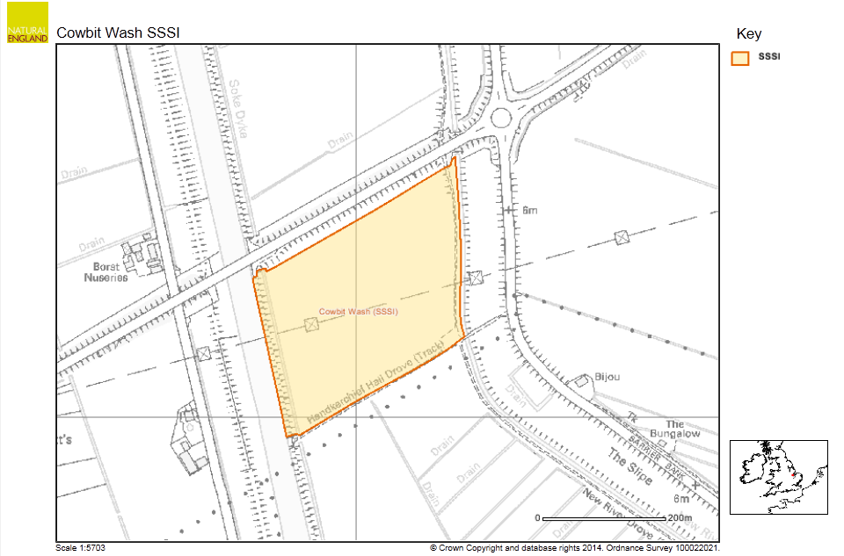
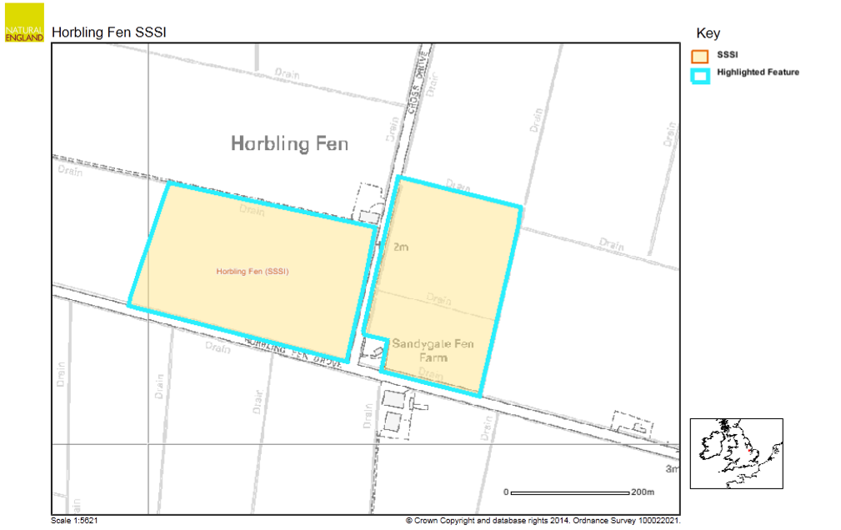
Appendix A: - Site Maps

Appendix B: - Scientific Interest and Citation

Appendix C: - Site Management Brief extract, Horbling Fen SSSI 1993

Site Management Brief extract, Cowbit Wash SSSI 1993

