Getting Our Voices Heard

A new project about disabled people.

What your organisation must do if you want to do this project.

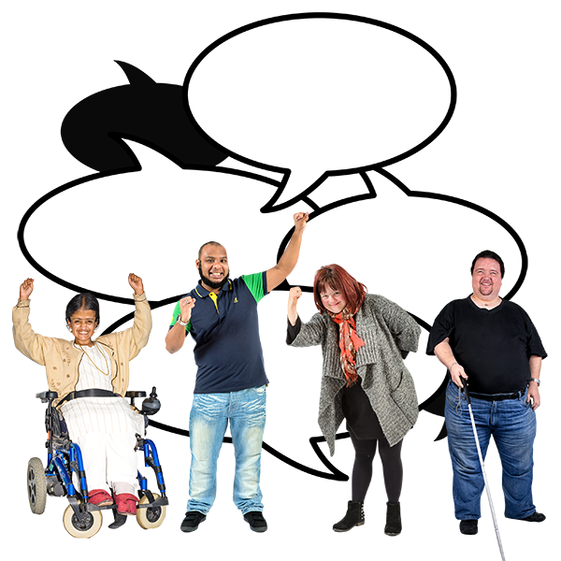

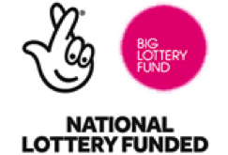
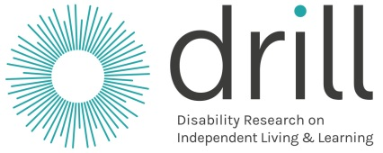

What is in this booklet

 | Page
About this booklet | 3
About DRILL | 4
About Getting Our Voices Heard | 6  27  27  27  27
The work you would need to do | 7
What DRILL wants to happen | 120
Other things to know | 14
How you will work with DRILL | 150
What will happen when | 16
How to say you want to do the project | 17

About this booklet

We are DRILL.

DRILL is short for Disability Research on Independent Living and Learning.

We have a new project called
Getting Our Voices Heard.

A project is a piece of work.

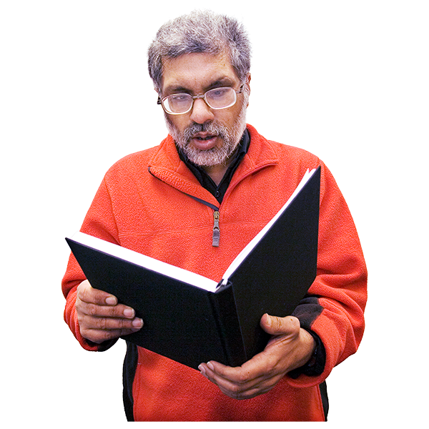
This booklet tells you about:

- The project

- What your organisation must do if you want to do the project

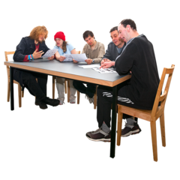
We will look at all organisations that want to do the project.

We will choose one organisation to do the project.

About DRILL

DRILL gives money for important projects to make life better for disabled people in the UK.

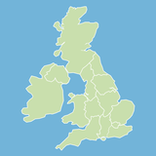

The UK is Northern Ireland, Scotland, Wales and England.

The projects will help disabled people to:

- Live how they want to

- Make their own choices

- Have the best life they can

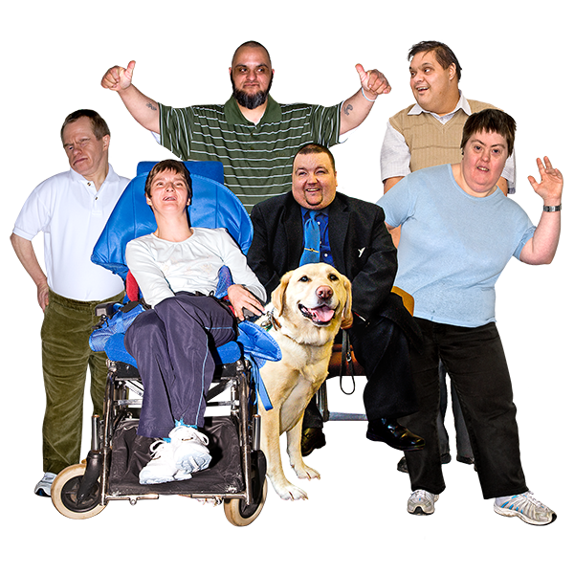
This is called independent living.

DRILL wants all disabled people to have a good life like this.

DRILL wants better information about how to make sure all disabled people have a good life.

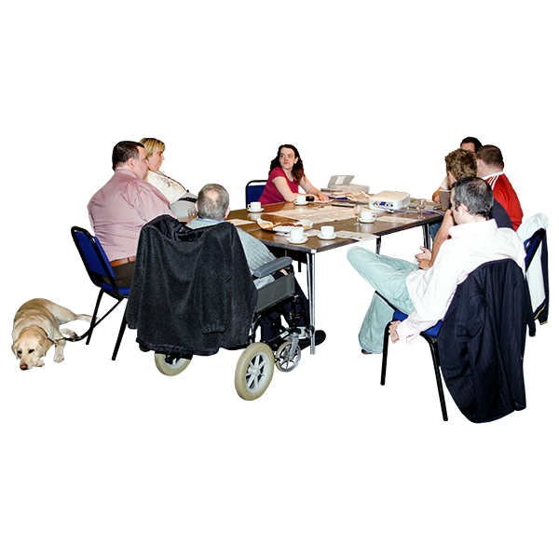

The information DRILL finds out will help:

- Disabled people and other people work together to make good plans
and services

- Disabled people to have a big say
in what happens to them

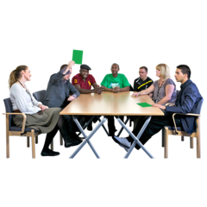

DRILL is different because disabled people have a big say
in everything that DRILL does.

About Getting Our Voices Heard

Getting Our Voices Heard is a new project.

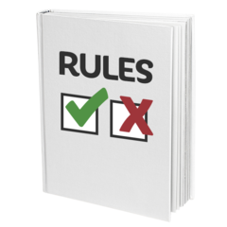
The project is about how to make sure that:

- Disabled people can help change laws, rules, plans and services that stop them having a good life

- The government, councils and other people listen to disabled people and change things when they need to

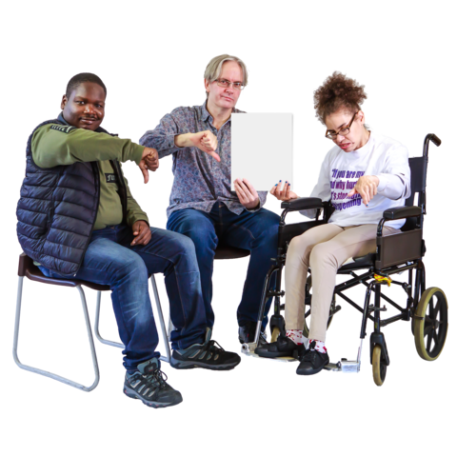

At the moment, this does not always happen.

For example, disabled people can find it hard to change some things in their countries and across the UK.

The work you would need to do

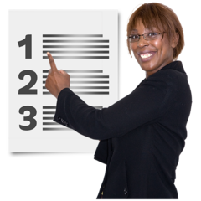

There are 3 main parts of the project.

Your organisation must work with disabled people on all parts of the project.

1
Stage 1

Your organisation should do the following things:

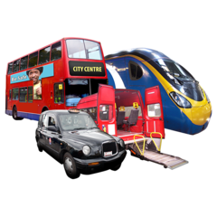
- Look at one problem that needs to change so disabled people can have a good life
(This is called independent living).

We want to know more about:

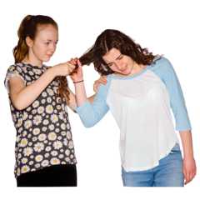
- Services that support disabled people. This is called social care

- Transport

- Hate Crime

But we will look at other ideas if they are very good.

- Look at how disabled people
can change the problem in their countries and across the UK

For example, there may be laws, rules, plans or services that needs to change.

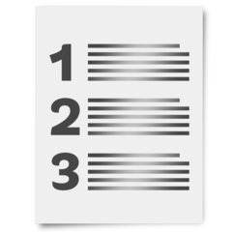

There may be one way to change them or different ways.

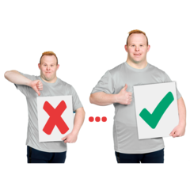

You can look at work that disabled people and their organisations have already done on this.

We want to know what works
and what does not work.

3. Look at how the ideas you have might work in each country in the UK.

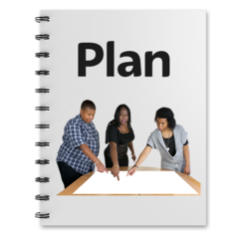
- Look at how to make a plan about how disabled people can change the problem.

Look at how to make the plan work.

5. Look at how the ideas you have can help all disabled people have a good life.

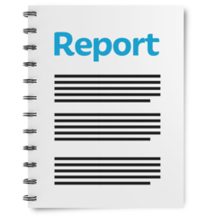
Your organisation must write a report about:

- What you find out

- How you think disabled people can help change the problem in their countries and the UK

Stage 2
2

Your organisation must:

- Look at what you have learned in the project

- Use this to write a plan about how disabled people and others can change the problem in their countries and the UK.

This plan is called an Impact Strategy and Action Plan.

You may need different Action Plans
for each country in the UK.

You must start work on the
Action Plans.

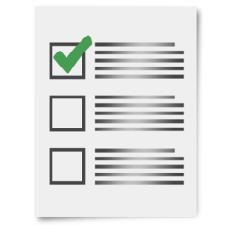

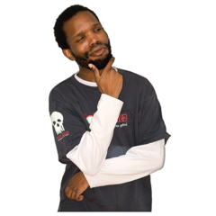
You need to think about:

- How to check how well the plans are working

- How people will carry on the work after DRILL has finished

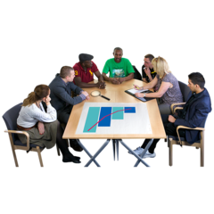
Stage 3
3

Your organisation will need to:

- Help check how your work with DRILL has gone

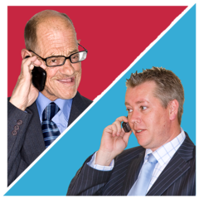

- Get in touch with another DRILL project called Including Missing Voices.

See what you have both learned that can help DRILL

Your organisation must write:

- A plan about how to share what you have learned with other people in the UK

- A final report about what you have done, what you found out and how the project is going

What DRILL wants to happen

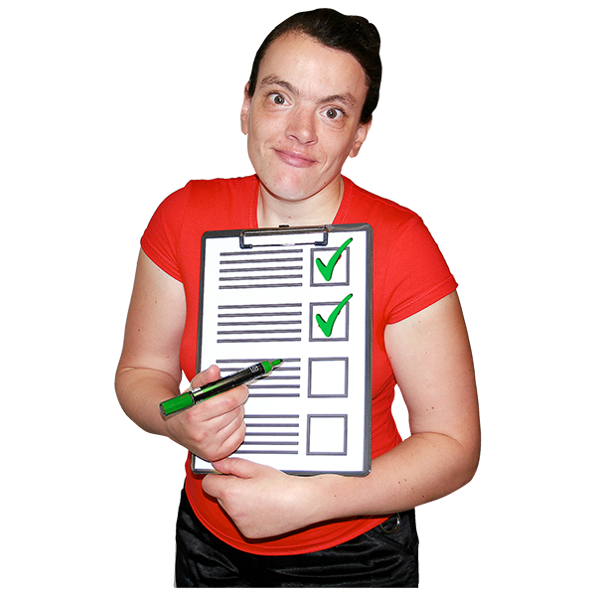
There are 4 things that DRILL wants to happen.

They are called outcomes.

The Getting Our Voices Heard project
will help with all 4 things.

But it will help with numbers 3 and 4 the most.

Here are the DRILL outcomes:
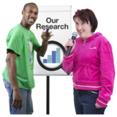

- Your project will help people learn about what is important to disabled people.

You will find out new information about how to make life better for disabled people.

- Your project will help disabled people have a better life by taking part in your project.

- Your project will help people in charge make good decisions about things like plans and services for disabled people.

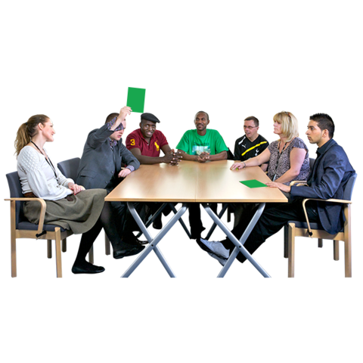
- Your project will help disabled people have a big say in laws, plans, services and other decisions.

Your organisation must say how your project will help with all the outcomes and how you will check this.

Other things to know

Working with other organisations

Your organisation will work with other organisations on the project.

Please tell us how you will do this.

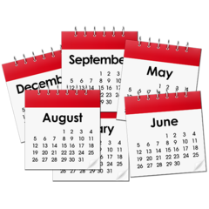
How much money and how long

DRILL and your organisation would agree to work together for 1 year.

This is called a contract.

The most money you can ask for is £100,000.

You must tell DRILL how much all the work will cost.

This includes support for disabled people to take part.

How you will work with DRILL

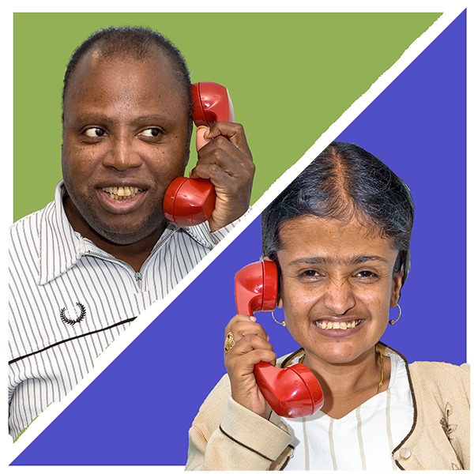

There will be one main person from your organisation that DRILL will speak to about the project.

Your organisation would need to:

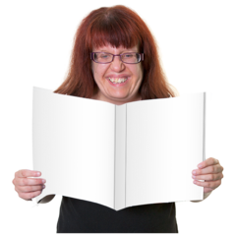

- Make sure the project runs well

- Make sure DRILL gets all the information it needs
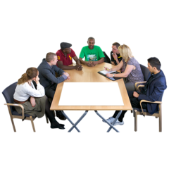

- Go to meetings with DRILL about the project

- Write reports about how the project is going

What will happen when

This may change once the project starts.

What | When
Your organisation would come to a meeting with DRILL.  This is to talk about how we will work together. | In 10 working days or less after the contract starts.  The contract is the agreement we make together.
Your organisation would send us the information we need about how we will work together.  DRILL will write up notes from the meeting. | In 10 working days or less after the meeting.
Your organisation would do the work for Stage 1 (see page 7 for more information) | In 20 weeks or less after the contract starts.
Your organisation would do the work for Stage 2 (see page 10 for more information) | In 45 weeks or less after the contact starts.
Your organisation would do the work for Stage 3 (see page 11 for more information) | By the date that the contract ends.
Your organisation would write a final report and come to a meeting about the project. | Report in 1 month or less after the contract ends.  Meeting in 1 month or less after you send us the final report.

How to say you want to do the project

You need to give us all the information we ask for.

Email your information to:
sylviagordon@disabilityaction.org

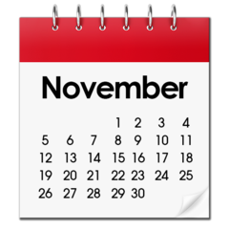
You must send us the information by
27 November 2018 at 12pm.

Our website is www.drilluk.org/tenders
Pictures by Photosymbols

