

**Hilton Parish Council**

Hilton Village Hall, Peacroft Lane, Hilton.DE65 5GH

Tel Office: 01283 730969 Email: [clerk@hiltonparishcouncil.org.uk](mailto:clerk@hiltonparishcouncil.org.uk)

Invitation to Tender Reference: HPC003 issued 12 July 2021

Hilton Parish Council has committed to creating an Adventure Playground. Whilst the vision is for an extensive play area, the Parish Council have decided to take a phased approach. In this first phase, the Parish Council are seeking bids for the supply and installation of a double zip wire. Bids are invited in conformance with the enclosed tender documentation. If you would like to be considered for this contract, please read through the document carefully and submit your tender in accordance with the specified procedures. Should you have any queries or require clarification on any point, please contact the undersigned on the above email address.

**General Requirement**

Bids are invited for the supply of two 30 metre zip wires to stand and be operated side by side in the location shown in the picture below. There will be grass mat safety surface underneath and to each side of the zip wires as shown in blue. (The Project)

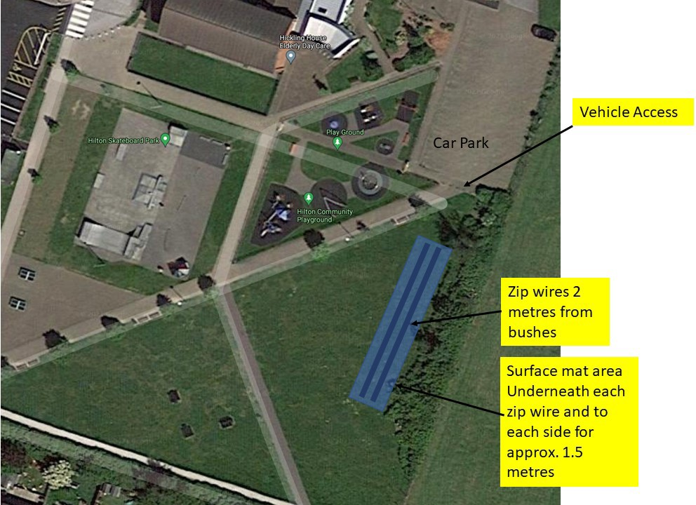

1. This is a turn key Project. The successful bidder will be required to provide all the necessary labour and equipment to bring the Project to a completed fully functional condition on acceptance by the Parish Council.
   1. Full access to the site will be provided via the dropped bollards shown on the picture above.
   2. Bidders are expected to visit the site prior to submission of the tender and advise if any ground work is required before installation.
   3. Any ground work other than installation will be agreed with the Parish Council before any work commences.
   4. The successful bidder will supply, install and commission the zip wires and safety surfaces as above.
   5. On acceptance by the Parish Council, the successful bidder will remove all their equipment, excess material and waste and make good the wider area if necessary.

[note: The Parish Council can provide a local supply of electricity and water, if required. There is a car park adjacent to the access with ample space for a skip or other equipment. See picture above]

1. The bid will comprise a fixed price, timescales and guarantees/warranty

The fixed price for the Project will be broken down into the following elements:

* 1. Price for any pre-installation ground work as identified in 1.3 above
  2. Price of 2 x 30metre zip wires with starting ramps in either galvanised metal or non-chip turquoise paint.
  3. Price for installing the zip wires and starting ramps.
  4. Price for the safety surface over the area agreed.
  5. Price for installing the safety surface
  6. The successful bidder will provide a timescale plan, preferably in GANTT chart form, showing the duration of the Project. Any dependencies on weather or other requirements beyond the control of the bidder will be highlighted. The Parish Council is looking for a start date as soon as possible after bidder selection.
  7. The successful bidder will guarantee that the zip wire, starting ramps and safety surface will not require any repair for a minimum of seven years when maintained in accordance with the manufacturer’s requirements. If any repair or replacement becomes necessary within the guarantee period, then the successful bidder will carry out the necessary remedial work to return the zip wire, starting ramps and/or the safety surface to a fully useable and safe condition at no charge to the Parish Council.
  8. The successful bidder will provide the maintenance requirements for the zip wires, starting ramps and the safety surface that may or may not be required as part of the guarantee above.

**Tender Documentation**

**All bidders are required to complete all the following sections fully and honestly. If questions are left unanswered, this will be deemed a fail in the bidding process. If the Parish Council subsequently discovers any discrepancy in the bidder’s response, the bidder will be eliminated from the bidding process. If any such discrepancy is discovered after the contract is awarded, then depending on the nature of the discrepancy, the successful bidder may have the contract terminated with immediate effect and at no cost to the Parish Council.**

**Information of the Bidder**

1. Please confirm that your company has the financial capability to take on this Project Yes/No
2. Please confirm that your company has Employer’s Liability insurance, Public Liability Insurance and Professional Indemnity Cover and provide the level of such cover Yes/No
   1. Employer’s Liability £XXm
   2. Public Liability £XXm
   3. Professional Indemnity £Xm
3. Please confirm that your company or its directors has/have not been the subject of any proceedings which would automatically eliminate your company from the bidding process including bankruptcy, administration, court proceedings of a criminal nature etc. This list is not exhaustive. Yes/No
4. Please confirm that your company has not been involved in any dispute with other customers for a similar contract in the last three years Yes/No
5. Please confirm that your company complies with all current employment and business legislation Yes/No
6. Please provide details below of your company’s experience in delivering this type

of Project

1. Please provide details of two contracts that your company has secured that are relevant to this Project. Please include contact details for the customers so we may contact them for a reference.

**Pricing**

**All prices submitted are to be in Pounds Sterling and exclusive of VAT**

1. Fixed price excluding VAT for any work identified under 1.3 above £xxx
2. Fixed price excluding VAT for supplying 30 metre zip wires and starting ramps as in 2.2 above £xxx
3. Fixed price excluding VAT for installing two 30 metre zip wires and starting ramps £xxx
4. Fixed price excluding VAT for supplying the safety surface as agreed £xxx
5. Fixed price excluding VAT for installing the safety surface over the agreed area £xxx
6. Please confirm that all labour and equipment necessary for the completion of the Project will be supplied by your company Yes/No
7. Please confirm that an inspection of the area will be carried out before the submission of the bid to identify and agree with the Parish Council any pre- installation ground work. Yes/No

**Timescales**

**The duration of the Project and the time of year when the Project is undertaken is important to the Parish Council. A detailed plan is required, preferably in the form of a GANTT chart, that shows the days expected for each phase of the Project.**

1. Please confirm that a plan as specified above will be provided from Commencement date to Project completion/hand over Yes/No
2. Are there weather considerations that could disrupt the plan? Yes/No If Yes, please state below what those considerations are
3. Please confirm that any necessary changes to the agreed plan will be discussed and agreed with the Parish Council before a revised plan is issued

Yes/No

**Business Requirements**

**The Parish Council and the successful bidder will each appoint a Project co-ordinator who will be the point of contact between the Parish Council and the successful bidder. The Project co-ordinators will have the authority to make binding decisions on both parties under the terms of the signed contract.**

**The Parish Council requires that the zip wires, starting ramps, the safety surface and the installation is underwritten by meaningful guarantees/warranties**

1. Please confirm that the zip wires and starting ramps, subject to normal1 usage and maintained to the manufacturer’s requirements, is guaranteed not to require any repair or replacement for 7 years from date of installation. This includes corrosion of the metal work, any significant re- painting, if relevant, and the installation becoming unstable.

Yes/No

If No, please indicate below the length of guarantee

In the event that it is independently assessed that the zip wires, starting ramps and/or the safety surface needs repairing or replacing within this 7 year period of normal usage and correct maintenance, please confirm that repair or replacement of the zip wire, starting ramps and/or the safety surface will be carried out at no cost to the Parish Council.

1 Normal usage is defined as daily use throughout the year by children and adults

1. Please confirm that any training required for the regular maintenance will be provided free of charge Yes/No
2. Please state if access to an electricity supply is required Yes/No
3. Please state if access to a water supply is required Yes/No

**Contract**

**The successful bidder will be required to enter into a contract incorporating the above commitments.**

**Submission of Quotation**

**Quotations should be submitted by post by no later than 9 August 2021.**

**Two copies of the completed tender documentation are required plus an electronic version by email to the address above.**

**The envelope should be sealed and addressed to the Clerk at the address above. The tender reference number must be put on the envelope.**

**Quotations received after the closing date will not be considered.**

**If you wish to query or have clarified any aspect of this tender documentation, then please allow sufficient time for the Parish Council to respond before the deadline for submission and in all cases no later than five working days before the deadline.**

**After the receipt of the quotations, they will be opened by a sub-committee of the Parish Council on 10 August 2021. The sub-committee of the Parish Council will ensure compliance of all bids with the tender documentation requirements. The sub-committee will then evaluate the bids against its award criteria. Please note that the Parish Council does not have to select the lowest quotation.**

**During this evaluation, the Parish Council may seek clarification of certain inputs. The Parish Council also reserves the right to seek another round of bidding from a short list of bidders.**

**The Parish Council will notify the successful bidder in writing.**

**All pages of this tender document must be returned and will form part of the final contract for the successful bidder.**

[The Parish Council give this tender documentation to bidders, on the basis that it remains the Parish Council’s property and bidders must treat the contents as confidential. If bidders are unable or unwilling to keep to this rule, they:

* must destroy this RFQ and all associated documents at once; and
* must not keep any electronic or paper copies.]

Bidders must not take part in any publicity activities with any part of the media about this tender process without getting the Parish Council’s written agreement first. This includes the Parish Council’s agreement on the format and content of any publicity.

This tender documentation is made available in good faith. The Parish Council give no warranty as to the accuracy or completeness of the information contained in it. The Parish Council also disclaim any liability for any inaccuracy or incompleteness. The Parish Council reserve the right to cancel this tender process at any point.

The Parish Council are not liable for any costs resulting from any cancellation of this tender process or for any other costs that bidders may incur by tendering for this contract. Bidders must obtain at their own expense all the information that they need for the preparation of their tender.

Bidders will be deemed to fully understand the processes that the Parish Council must follow under relevant European and UK legislation, particularly The Public Contracts Regulations 2015 and Public Contracts (Amendment) Regulations 2009.

|  |  |
| --- | --- |
| I DECLARE THAT TO THE BEST OF MY KNOWLEDGE THE ANSWERS SUBMITTED IN THE TENDER DOCUMENTATION ARE CORRECT. I UNDERSTAND THAT THE INFORMATION WILL BE USED IN THE EVALUATION PROCESS TO ASSESS MY ORGANISATION’S SUITABILITY TO TENDER FOR THE PARISH COUNCIL’S REQUIREMENT. SHOULD THE COUNCIL DISCOVER ANY DISCREPANCIES OR THAT I HAVE BEEN DISHONEST WITH THE ANSWERS THIS WILL RESULT IN THE ORGANISATION TO WHICH I HAVE COMPLETED THIS QUOTATION FOR, BEING REJECTED FROM THE TENDER PROCESS OR IF AWARDED A CONTRACT WILL HAVE THE CONTRACT TERMINATED WITH IMMEDIATE EFFECT AND NO COST INCURRED TO THE COUNCIL. **SIGNATURE IS MANDATORY, FAILURE TO DO SO WILL RESULT IN YOUR BID BEING DEEMED NON COMPLIANT WHICH WILL RESULT IN YOUR BID BEING DISQUALIFIED FROM THIS TENDERING PROCESS.** | |
| 1. | Name: |
| 2. | Position (Job Title): |
| 3. | Date: |
| 4. | Telephone number: |
| 5. | Signature: |

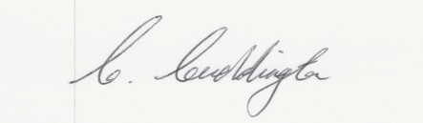**Signed for and on behalf of Hilton Parish Council**

**Name Charles Cuddington**

**Position Chairman**

**Date 12th July 2021**