**GREAT CORNARD PARISH COUNCIL**

**Invitation to Tender**

**Tender Specifications:** **Great Cornard – The Stevenson Centre Recreation Ground Play Equipment Replacement & Enhancement**

**Introduction**

The Parish Council is looking to replace various items of play equipment in its enclosed play area, upgrade some existing impact absorbing tiles with new black wetpour, provide 4 new pieces of adult exercise equipment outside of the play area on the recreation ground and install a new large piece of play equipment on the recreation ground suitable for the teens age group.

The Recreation Ground provides an open space central to the village of Great Cornard for children to play and is popular with dog walkers. It is located next to The Stevenson Centre and Parish Council offices and is surrounded by residential properties, the Great Cornard Bowls Club and various species of tree. The open recreation ground contains a teen shelter, some benches and an enclosed play area with equipment suitable for children up to the ages of approximately 11 years old.

**The Site and Access**



The Stevenson Centre is located at the purple dot with the enclosed play area just below it (circled in red). The site can be accessed via Stevenson Approach which leads up to The Stevenson Centre from Broom Street. There is a large car park to the rear of the building which should be used for contractors’ vehicles.

Location address: The Stevenson Centre, Stevenson Approach, Great Cornard, Suffolk, CO10 0WD

**Project Area 1**

**REMOVE IMPACT ABSORBING TILES AND REPLACE WITH BLACK WETPOUR ONLY (equipment to remain)**

**Swing Set**

**Photo No: 1**

**Baby Swings**

**Photo No: 2**

**Multi-use gym**

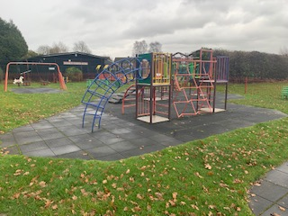

**Photo No: 3**

**Project Area 2**

**EXISTING ROUNDABOUT AND IMPACT ABSORBING TILES TO BE REMOVED AND REPLACED WITH NEW INCLUSIVE ROUNDABOUT AND BLACK WETPOUR**

**Roundabout**

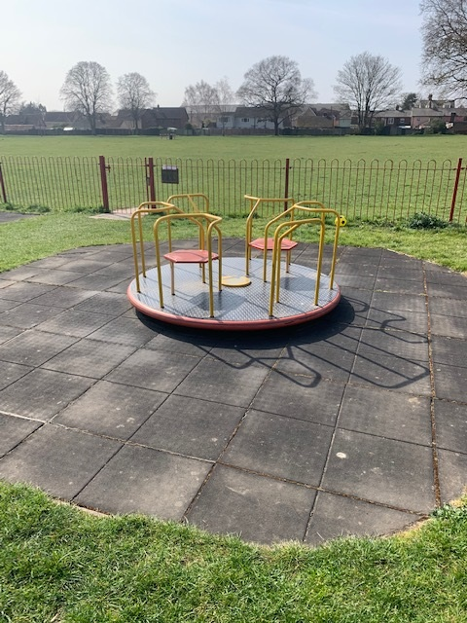

**Photo No: 4**

**Project Area 3**

**‘TODDLER ZONE’ - FOUR PIECES OF EQUIPMENT TOGETHER WITH IMPACT ABSORBING TILES TO BE REMOVED AND REPLACED WITH SUITABLE EQUIPMENT FOR AGE RANGE 1-5 (to include a tunnel and spinning bowl) WITH EITHER BLACK WET POUR OR APPROPRIATE IMPACT ABSORBING SURFACE, WHICHEVER IS RELEVANT TO THE DESIGN OF THE NEW ‘TODDLER ZONE’**

**All four pieces**

**Photo No: 5**

**INDIVIDUAL PHOTOS OF TODDLER ZONE (Project Area 3)**

**Photo No: 6 Photo No: 7**

**Photo No: 8 Photo No: 9**

**Project Area 4**

**INSTALL 3 x MULTI-USER PIECES OF ADULT EXERCISE EQUIPMENT ONTO THE RECREATION GROUND, OUTSIDE OF THE ENCLOSED PLAY AREA (indicated by red dots). EQUIPMENT TO BE INSTALLED INTO GROUND WITH APPROPRIATE IMPACT ABSORBING SURFACE**

The Parish Council would like 3 pieces of adult exercise equipment, with at least two pieces being multi-user, which target different areas of the body; thereby creating a small adult exercise area outside of the enclosed play area. Examples of suitable pieces are shown on the following page.

**EXAMPLES OF PREFERRED PIECES (INCLUDING MULTI-USER)**

* Double chest pull down
* Surfer
* Double leg press
* Rower

|  |  |
| --- | --- |
|  |  |
|  |  |

**Project Area 5**

**TEEN PIECE**

**INSTALL ONE LARGE PIECE OF EQUIPMENT ON THE RECREATION GROUND (indicated by red circle) SUITABLE FOR THE TEENS AGE RANGE TOGETHER WITH APPROPRIATE IMPACT ABSORBING SURFACE AND TO INCLUDE A CLIMBING ELEMENT**

To create an area for children of the teen age group, outside of the enclosed play area. Equipment to be installed freestanding into the grass together with the appropriate impact absorbing surface. The piece should look interesting, encourage activity and play and be constructed of metal rather than wood. It should include a climbing element and ideally contain a limited amount of rope as part of the design.

**EXAMPLES OF TEEN PIECE WHICH COULD BE CONSIDERED**

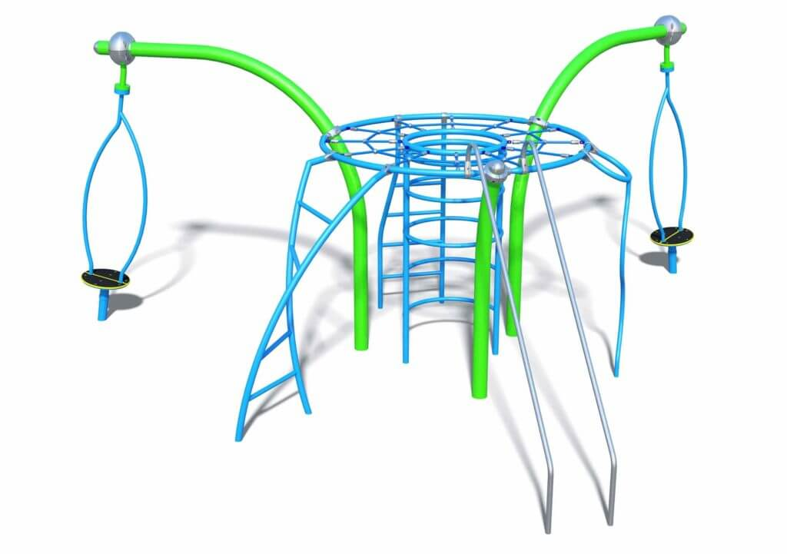

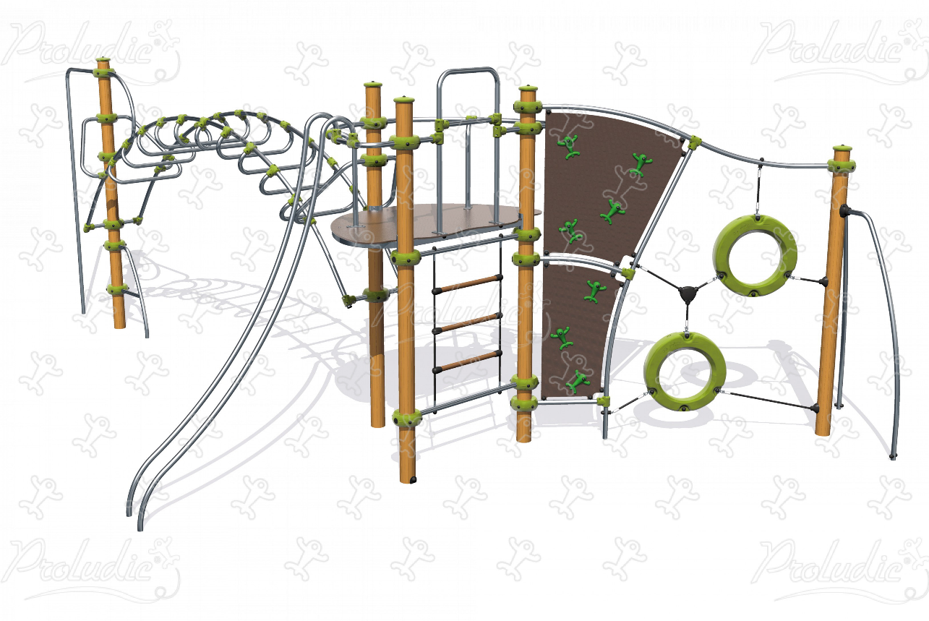

**Requirements**

**Project Area 1 – Replacing wetpour**

* Remove impact absorbing tiles from 3 areas ***(Photo Nos: 1, 2 and 3)***
* Replace with black wet pour
* Clear old tiles and any other waste off site and dispose of appropriately
* All existing equipment to remain

**Project Area 2 - Roundabout**

* Remove existing roundabout and impact absorbing tiles ***(Photo No: 4)***
* Install inclusive roundabout and black wetpour
* Clear old tiles and roundabout off site and dispose of appropriately

**Project Area 3 – Toddler Zone**

* Remove small multi-use unit, spinner, horse springer and turtle springer and all impact absorbing tiles ***(Photo Nos: 5, 6, 7, 8 and 9)***
* Create new and exciting ‘Toddler Zone’ by replacing the four pieces with new equipment for age range 1-5 (to include a tunnel and spinning bowl) and either new black wetpour or appropriate impact absorbing surface, whichever is relevant to the new equipment
* Clear old tiles and equipment off site and dispose of appropriately

**Equipment that is largely made up of wood and/or rope materials will not be considered**

**Project Area 4 – Adult Gym Equipment**

* Install three pieces of adult exercise equipment with at least two for ‘multi-user’, on the recreation ground together with appropriate impact absorbing surface

**Project Area 5 – Teen Piece**

* Install one large piece of play equipment (to include a climbing element) for teen age range on the recreation ground with appropriate impact absorbing surface.

**A ‘zip-wire’ or equipment that is largely made up of wood and/or rope materials will not be considered. A limited amount of rope will be considered.**

Tenderers are invited to submit ideas and options for the above, including photographs of suggested equipment.

All equipment and surfaces supplied and works carried out, must comply with current UK standards and regulations for supply and installation and all equipment will be fit for purpose and come with a guarantee or warranty.

A site visit will be necessary in order to fully appreciate the site specific conditions and works required. Tenderers are welcome to visit the site at any time but, to discuss the project in full, a meeting with a Council representative on site will be required.