**Key Workers Service in Bedfordshire, Luton and Milton Keynes (BLMK)**

Bedfordshire, Luton and Milton Keynes (BLMK) Integrated Care Board (ICB) require a dedicated keyworkers service to work across BLMK with the aim of reducing the mental health inpatient admission rates of children and young people (CYP) with learning disability (LD) and/or an autism spectrum condition (ASC).

Keyworkers are required to support CYP up to the age of 25 years with learning difficulties and/or autism (LDA) who are currently inpatients or at risk of being admitted to hospital, and who are rated Red and Amber on our Dynamic Support Register (DSR) and whose needs can escalate quickly.

A key function of this role will be to offer flexibility in its broadest term, from delivering flexible, cross-system personalised child centred support, including face to face interventions, to involvement and access for the family, ensuring continuity of care and support as well as a strategic role supporting the BLMK Integrated Care System to ensure resources are in place to meet the needs of these children.

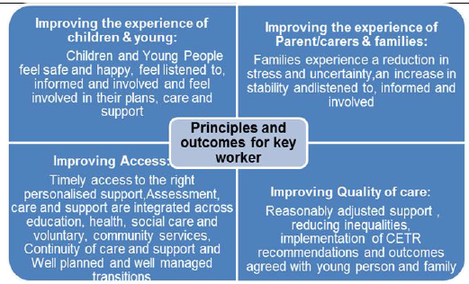

The prospective provider will need to be:

* Able to fully mobilise and provide services by 1st October 2023, and provide detailed and resourced mobilisation plan, including timescales.
* Able to demonstrate experience of delivering the keyworker function in an ICB footprint
* Able to have in place a dedicated workplace base within BLMK to accommodate key workers and key worker manager
* Able to deliver Keyworker service across BLMK and able to provide face to face interventions in BLMK.
* Able to demonstrate they can provide the required workforce Whole Time Equivalent (WTE) to meet the requirements the service, and in line with TUPE requirements
* Able to demonstrate that workforce has sufficient training to support a young person who has a LD and/or ASC
* Able to demonstrate management and delivery of personal health budgets
* Able to demonstrate a good understanding of BLMK education, care and health system

It is expected that the contracts will be for an initial period of 3 years with the opportunity to extend for a further period of up to 2 years (at the discretion of the Contracting Authority: maximum term of 5 years). The indicative annual contract value for this service is £800,000 per annum (excluding VAT).

If you would like to express an interest in this opportunity, please complete the attached Expression of Interest (EOI) form and return to [agem.procurementblmk@nhs.net](mailto:agem.procurementblmk@nhs.net) by no later than 4pm on 14th July 2023.  
  
At the Commissioner's discretion, providers who evidence that they meet the above requirements may be taken through to the next round of the procurement process. Due to the time constraints for this process, you will be notified of your organisation's inclusion in the next stage in a timely manner.