Specification for research project

In service pilot of the T1135 operational decision-making tool: Assessing performance and customer impact

IMP-T1135 WP-04
The draft research specification that follows, outlines RSSB’s proposed research to assess the performance and customer impact from implementing an operational decision support tool.
A pre-tender suppliers meeting has been arranged for 18 March 2019 at 13:00 – 14:00, at the RSSB offices in Moorgate, London. The purpose of this meeting is to:
- Provide an outline of the project proposal
- Provide interested suppliers an opportunity to discuss, understand and inform the research specification
Suppliers should be prepared to discuss the following:
- What data and information would be required to provide best possible estimates of the performance, service disruption and customer benefits and impact, from taking a different approach to operational decision making?
- A list of proposed measures is provided in Appendix A – what measures do suppliers see as essential, missing, or unnecessary to this work?
- What are the challenges and barriers to delivering this work? What enablers would support successful delivery of the project?
- What is the suppliers estimate of effort required to deliver the project?

Suppliers wishing to attend in person or by dialling into the meeting should contact Shareditt@rssb.co.uk to confirm arrangements.

- Background
Operational decision making can be described as ‘the art of making things happen’, moving people and goods around the railway network in the safest way possible. There is a concern at senior levels of the rail industry that operational decision making has become undervalued in recent years, which may adversely affect train performance and impact on whole system safety risk.
RSSB research T1135 Development of an operational decision-making model for abnormal working, aimed to investigate the current state of decision-making training for front-line staff and managers in the GB railway industry, and determine what additional support could help staff to make more effective operational decisions. T1135 examined whether a decision-making tool, as used in other safety-critical sectors such as aviation and the emergency services, might be a viable aid for rail staff. The research developed a decision-making tool and training package to support and improve front-line operational decision making. For an overview of the tool, see Appendix B.
The T1135 tool is expected to equip front-line staff and managers with the knowledge and skills to use a structured decision-making process to use when faced with abnormal situations that may be unfamiliar or unusual. Where staff are empowered to make sound and rational safe decisions, this is expected reduce the need for unnecessary escalation and keep people and trains moving; resulting in less accumulative delay, and wider knock-on system risks associated with disruption. Moreover, the decision-making tool and training will enable staff to adopt a consistent approach when making decisions and potentially counteract decision-making ‘paralysis’. Such benefits are believed to reduce delay minutes and breaching service disruption thresholds and customer service level 2 (CSL2) commitments.
IMP-T1135 In service pilot of the T1135 operational decision making tool, has been set up to assess the benefits and impact of the operational decision making tool. This project is intended to also support the wider industry implementation of the tool. The trial will be undertaken on the Midland main line, with support from East Midlands Trains (EMT) and Network Rail London North East (LNE) Route. This will trial will be conducted over a 1-year period to embed and deploying the tool within the company organisation and culture, and a 6-month monitoring and assessment period.
IMP-T1135 will assess the benefits and impact on:
- Staff experience and confidence
- System safety
- Service disruption threshold
- Operational performance
- Customer experience
RSSB are leading the trial and will monitor and assess the impact on staff experience and system safety. This tender is for a supplier to define, measure and quantify any impact and benefits on operational performance, service disruption and customer experience. The supplier will be supported by RSSB, EMT and LNE to access appropriate datasets required for the analysis.
The overarching hypothesis for IMP-T1135 is: The tool will empower staff to make more effective decisions during abnormal situations to keep people and trains moving safety.
The work identified in this tender should support the testing of this hypothesis, identify applicable benefits and impact of the tool, and test the following sub-hypotheses:
- H1: The tool will support staff to manage abnormal situations effectively by keeping people and trains moving safely, resulting in:
  - Fewer delay minutes
  - Fewer incidents
  - Fewer incidents breaching disruption thresholds
  - Improved capacity utilisation during contingent operations
  - Improved recovery time following service disruption
  - Less overall attributed delays
  - Changes to the delay attribution profile, where some categories may increase and others decrease (e.g. less attributed delay for one incident type may increase sub-threshold reactionary delay)
- H2: The tool will improve staff confidence to make more operational decisions during abnormal situations, resulting in less escalated decisions (e.g. to control, on-call structure), reducing other operational workflows, effort and time when managing and recovering from incidents
- H3: Staff using the tool are more likely maintain or improve operational performance
- H4: The impact from improving performance, managing abnormal situations and disruption, will indirectly improve the customer experience

- Project Structure
IMP-T1135 has 4 work packages, all of which are outlined below. The purpose of this tender is to procure a supplier to deliver work package 4. RSSB will deliver the remaining three work packages.
- Work Package 1 (WP1): Project scoping and development. This has been undertaken and delivered by RSSB.
- Work Package 2 (WP2): Embedding the decisional making tool within company culture. This will be undertaken by RSSB and will include supporting the training and deployment of the decision-making tool with EMT and LNE operations on the Midland main line.
- Work Package 3 (WP3): Assessing staff impact and use. This will be undertaken by RSSB, and will include a range of interviews, workshops and survey methods to evaluate staff experience, empowerment and confidence to operational decision making.
- Work Package 4 (WP4): Assessing performance and customer impact. This will be undertaken by the winning supplier from this ITT. The information in this document will focus on the delivery of work package 4.

WP4 will apply an experimental design to analyse data before and after the trial and compare findings to a control group. Analysis undertaken should test the hypotheses stated above.
 | Treatment group (Midland main line) | Control group (another line - TBD)
Before training and tool use | Measure staff experience and confidence (survey, interviews and workshops. Undertaken by RSSB)  Measure performance, service disruption and customer impact (number and type of datasets to be defined. Undertaken by supplier) | Measure performance, service disruption and customer impact (number and type of datasets to be defined. Undertaken by supplier)
After training and tool use | Measure staff experience and confidence (survey, interviews and workshops. Undertaken by RSSB)  Measure performance, service disruption and customer impact (number and type of datasets to be defined. Undertaken by supplier)
It is expected that the datasets required to measure the performance and customer impact will be defined during the research, in collaboration with RSSB, EMT and LNE. An initial list measures are suggested in Appendix A.
The collection of datasets is envisaged to occur at set points during the trial, which may include, for example, to capture baseline/historical data, before training and tool use, and during the trial.
Expected timescales and an overview of the trial are illustrated on the following page.

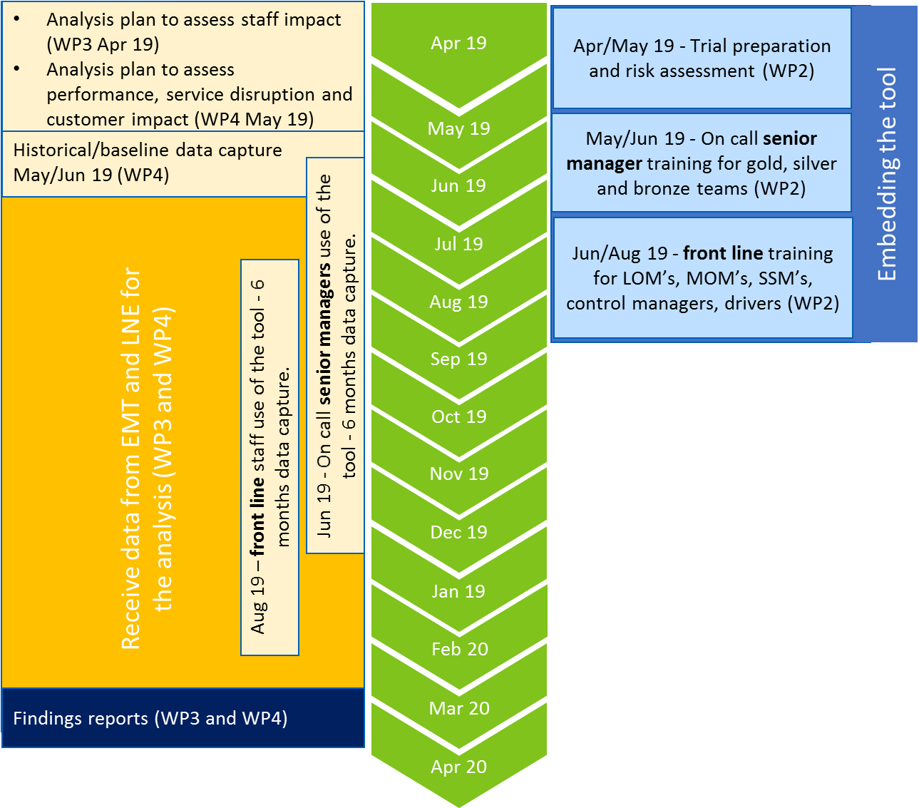
- Work Package 4 - Objectives
The overarching aim of IMP-T1135 is to undertake an in-service pilot to assess the direct benefits and impact of the decision-making tool deployed across front line staff and senior staff on the Midland main line. Work package 4 is expected to complement the trial by collecting and analysing data to assess the performance, service disruption and customer benefits and impact of the trial.
The objectives for work package 4 are presented below:
- Define the measures required to analyse the performance, service disruption and customer benefits and impact of the trial
- Develop a robust method to undertake the data collection and analysis to test the project hypotheses
- Collect, monitor and analyse data to assess the impact and benefits of the trial of the tool
- Identify factors that may have led to any impacts identified
- Provide recommendations on the implications and transferability of the findings to the wider industry
The supplier is expected to work collaboratively with RSSB, EMT and LNE teams throughout the trial, which may include periodic correspondence and quarterly steering group meetings.
As the trial is being deployed in a live operating environment, data collection methods must not impede the operations of train services. Proposed approaches must be discussed and agreed in advance with RSSB, EMT and LNE.

- Scope
In scope | Out of scope
- Work collaboratively with RSSB, EMT and LNE throughout the trial  - Process map the operational workflows to identify scenarios where the tool may be used and benefits and impact measured  - Identify the data sources required to measure the benefits and impact of the tool on performance, service disruption and customer impact  - Define a robust method to undertake the analysis  - Receive data from EMT and LNE to analyse:  - Historical / baseline data prior staff training of the decision-making tool  - Data from the Midland main line (treatment group) and comparative line (control group)  - Where required clean raw data to undertake the analysis  - Identify significant patterns, trends, relationships, key themes that indicate the benefits and impact of the decision-making tool  - Test the hypotheses of WP4  - Identify any differences where the tool has / has not been used  - Identify any underlining factors that led influenced the changes in benefits or impact of the tool use  - Identify any implications the findings may have on the IMP-T1135 trial  - Provide recommendations on the transferability of the findings to the wider industry should another operator/NR Route adopt the tool | - Schedule 4 and 8 industry payments  - Measuring staff experience, confidence and impact of the tool

- Methodology
Suppliers are expected to explain the methodology that they are intending to use to successfully meet the work package requirements of this work package. The work package requirements are detailed within the following sections:
- Objectives
- Scope
- Deliverables
The work package requirements are set in context by:
- Background
- Project structure

- Deliverables
Analysis plan | Interim report
This report will detail the study design and approach to the data analysis, and should detail:
- The process maps that illustrate when the tool will be used and what measures can be taken to assess the impact and benefits of the tool
- The datasets and measures
- Data management, including approach to cleaning raw data
- Analysis method
All documentation to be produced in the standard RSSB format and to be made widely available.

Baseline data report | Interim report
This report should detail the baseline level of performance, service disruption, and customer experience, before training and tool use on the Midland main line. Baseline findings should include applicable historical data and compare measures between control and treatment groups. This report should also indicate what datasets and measures are suitable for the follow up analysis, after training and tool use.
All documentation to be produced in the standard RSSB format and to be made widely available.

In service pilot of the T1135 operational decision-making tool: WP-04 Performance and customer impact | Project report
This report will consolidate and build on the analysis plan and baseline report to present a full technical report of the trial findings. The report should detail the research methodology, findings and implications for current practice on the deployment of the decision-making tool. This should include:
- The data captured and analysed during trial
- The key benefits and impact, including tangible and intangible benefits
- Assessing the findings against the project hypothesis and sub-hypotheses
- Implications of the findings for the IMP-T1135 trial, and wider industry use of the tool
All documentation to be produced in the standard RSSB format and to be made widely available.

- Stakeholders roles and responsibilities
 | General role in project | Specific role in acceptance of deliverables
Project manager | The RSSB project manager is the first point of contact during project delivery. The RSSB project manager responsible for the coordination of RSSB activities to support the supplier delivery and reviews project schedules, cost reporting and other relevant project management tasks.  The RSSB project manager leads the project in organising meetings, etc and supports timely and effective delivery towards project objectives. | Facilitates technical review and acceptance processes, identifies and monitors corrective actions where needed, including facilitating decision making.
Technical expert | Throughout the project, the RSSB technical expert ensures that technical aspects are reflected accurately.  Technical aspects can refer to specific issues around railway signalling, track engineering, safety relevant operations or any other specialist field. | Reviews emerging outputs from technical perspective.
Industry and RSSB sponsor | The Industry and RSSB sponsors act as figureheads for the research, championing its importance and its outputs.  Their key role is to provide steer to the research as it progresses and exert pressure on the industry to make use of its findings. | Formally accepts deliverables
Project supporters | The project supporters represent parts of industry complementary to the sponsor’s organisation. They offer expertise for effective project delivery and support the implementation of findings led by the champion through networking, advice and other support. | Formally accepts deliverables
Project steering group | The project steering group ensures the project delivers to industry needs.  As such, it helps formulate specifications, assesses tenders, reviews draft and final outputs and other relevant tasks. | Formally accepts deliverables

- Timescales and dependencies
The work is expected to start in April 2019 and be completed by April 2020. Data is envisaged to be collected in waves, at key phases during the trial, such as:
- Before tool use, to collect baseline/historical data (estimated May/June 2019)
- The collection of data and monitoring data during the trial (estimated from June 2019 – February 2020
- Analysis and findings report (estimated March 2020)

- Critical success factors and risk management
The following critical success criteria have been identified to help ensure successful delivery and to increase likelihood of industry acceptance/implementation:
- Collaborative working with RSSB, EMT and LNE, and ensuring this work package aligns to and complements the wider project. The supplier is expected to produce and maintain a communication, correspond with RSSB on a periodic basis and attend quarterly steering group meetings.
- Access to data and information to undertake the data analysis. RSSB, EMT and LNE will support the supplier by providing access to data, information, and where applicable, staff to consult to facilitate the data analysis requirements.
- Identification of tangible and intangible benefits and impact of the tool. This should be support by the supplier’s expertise in data analysis and rail performance.

The following risks have been identified to highlight where the work package may encounter issues during delivery:
- Limited quality / quantity of data that make it difficult to infer or isolate evidence to demonstrate direct benefits and impacts from implementing the tool. Mitigation measures include robust analysis plan, early identification of suitable datasets, engaging EMT/LNE to understand possible cofounding factors.

A detailed risk and mitigations register should be provided as part of the submission illustrating required actions to support the success of the work package.

- Selection and award criteria
Selection criteria
Heading | Specific question(s) | Evaluation Criteria
S1 Experience of the supplier in assessing rail performance  [Max 1 page] | Provide a brief description of two projects you have undertaken on assessing rail performance for clients over the last 5 years. Please provide a brief explanation on why they are relevant to our needs. | Pass: The Tenderer provides RSSB with a strong degree of confidence in its experience shown in two suitable projects.  Fail: The Tenderer either fails to provide evidence of two examples or fails to provide RSSB with sufficient confidence in its experience.
S2 Experience of the supplier in developing analytical approaches [Max 1 page] | Provide a brief description of two projects you have developed analytical approaches, which you have delivered to clients over the last 5 years. Please provide a brief explanation on why they are relevant to our needs. | Pass: The Tenderer provides RSSB with a strong degree of confidence in its experience shown in two suitable projects.  Fail: The Tenderer either fails to provide evidence of two examples or fails to provide RSSB with sufficient confidence in its experience.
S3 Strengths and key points of the proposal  [Max 1 page] | The Tenderer must provide a summary of the strengths and key points of the proposal. | Pass: The Tenderer has provided a concise summary highlighting the key aspects of their proposal.  Fail: The Tenderer has not provided a concise summary or has not provided a summary highlighting the key aspects of their proposal.

Award criteria
Heading | Specific question(s) | Evaluation Criteria | Weight
A1 Method statement: Evidence of the Tenderer’s ability to meet the specified objectives and deliverables through a robust methodology  [Max 4 pages] | The Tenderer should provide evidence of their expertise to deliver this project in the form of a method statement. This should set out how it will fully meet the objectives and scope of the project, adding value where possible.  - How will the supplier identify appropriate measures to assess performance and customer impact from an organisational change in decision making?  - How will the supplier collect, monitor and analyse performance and customer data to assess the benefits and impact of the decision tool?  - How will the supplier identify tangible benefits and impact of the decision-making tool?  - How will the supplier ensure a robust analysis and transferability of the findings to the wider industry? | The Tenderer’s response:  - Demonstrates their understanding of the objectives and provide a coherent and systematic approach to meet these objectives.  - Proposes a feasible and appropriate way to approach to measure the benefits and impact of the tool  - Proposes a sound, impartial and robust methodology to developing to collecting and analysing data  - Proposes how tangible benefits and impact will be identified and assessed during the trial  - Identifies a robust approach to undertaking the analysis and how the findings will be made transferable to the wider industry | 25%
A2 Evidence of the Tenderer’s technical ability  [Max 3 pages] | The Tenderer should provide evidence of relevant previous projects, experience and knowledge of the project team.  - How will the tenderer apply their knowledge, expertise and skills to meet the objectives of this work?  - What expertise does the supplier have on measuring and analysing rail performance?  - What expertise does the supplier have on data science, modelling or analysis? | The Tenderer’s response includes:  - Evidence of their knowledge and expertise in the subject area  - Describes how they will apply their knowledge, expertise, and technical competence to deliver the objectives of this research  - Evidence of their technical competence in collecting and analysing performance data  - Evidence of their technical competence in data analytics and data modelling | 20%
A3 Project Delivery and Resources [Max 2 pages] | The tenderer identifies the key roles and responsibilities that are essential to deliver the requirements of this work.  - How will adequate allocation of appropriate resources be made against each deliverable?  - How will the team ensure the quality and the content of the deliverables are fit for purpose?  - What is the schedule that each task will be delivered against?  - How will effective communication be achieved with key stakeholders, including RSSB, EMT and LNE? | The Tenderer’s response shows that it:  - Has provided a credible plan for delivering successful outcomes to time, quality and cost  - Has identified relevant individuals to deliver the work and that the overall mix of skills covered is adequate  - Has identified appropriate ways to engage with RSSB, EMT, and LNE | 15%
A4 Risk Management  [Max 1 pages] | Tenderers should detail what risks and opportunities are foreseen in the delivery of the project. The tenderer should detail the impact and likelihood of risks, the mitigating actions in relation to these risks, and how opportunities can be maximised.  What are the potential risks to this project? How will these risks be managed?  What are the potential opportunities that could be maximised during the delivery of this work? | The tenderer’s response:  - Identifies appropriate risks and opportunities through the use of a risk register.  - Identifies what mitigation actions will be taken with specific regard to each risk or challenge identified.  - Identifies approaches to maximising any opportunities through effective management. | 10%
A5 Cost of project | The Tenderer should provide a fixed cost for the project and the associated cost break down. | - The tender with the lowest total cost will receive 100% of the available weighted score (30%).  Other Tenderer’s tenders will receive a pro-rated relative to the lowest cost according to the following formula:  Score of other tender = lowest tender total cost / other tender total cost x 100%. | 30%

Info for procurement

PROCUREMENT TIMELINE
 | Start Date
Supplier meeting | 18 March 2019
Invitation to Tender issued | 22 March 2019
Supplier clarification questions deadline | 29 March 2019
Deadline for Submitting Tenders | 12 April 2019
Post Tender Clarification | w/c 15 April 2019
Estimated notification of award decision | w/c 22 April 2019
Target contract commencement date | w/c 29 April 2019

Appendix A – possible measures to test the hypotheses
RSSB consider the below list possible measures that may support testing the hypotheses. The supplier may include these, or appropriate other approaches, as part of their analysis plan. All datasets to be used within the trial will need to be agreed by EMT and LNE.
- Operational performance
  - Average minutes lateness
  - Total delay minutes, primary and reactionary delay minutes
  - PPM / PPM failures, ‘right time’ and ‘on time’ metrics
  - Changes in PPM attrition
  - CaSL metric, including full and part cancellations
  - Delay per incident
  - Excludable and void days (PPM and delay minutes)
  - Changes across the TRUST delay attribution profile (categorised delays)
- Service disruption threshold
  - Number of Customer Service Level 2 escalations
  - Number of incident notifications, company holding and core messages
  - Number of contingency / recovery plans implemented
  - Number of operational changes, such as employees mobilised, uplift in capacity delivered (how close to planned capacity did contingent operations run)
  - Travel warnings and other external passenger communications
  - Number of incidents of serious disruption (>1,000 delay minutes)
  - Number of calls, including GSM-R, phone calls to control and senior managers.
- Customer experience
  - Average passenger lateness
  - Average passengers affected
  - Existing passenger satisfaction surveys gathered by EMT / LNE, and Transport Focus National Rail Passenger Survey
  - Frequency and type of passenger complaints, compensation claims
  - Data mining passenger impact from social media feeds

Appendix B – T1135 Operational decision-making tool
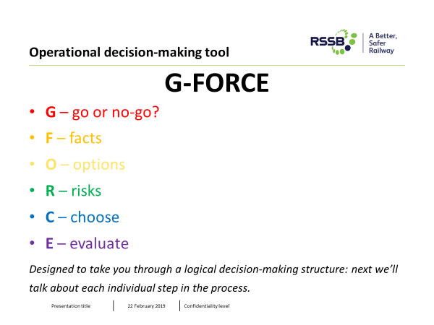
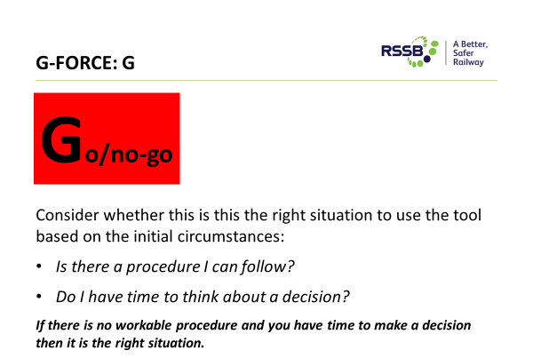
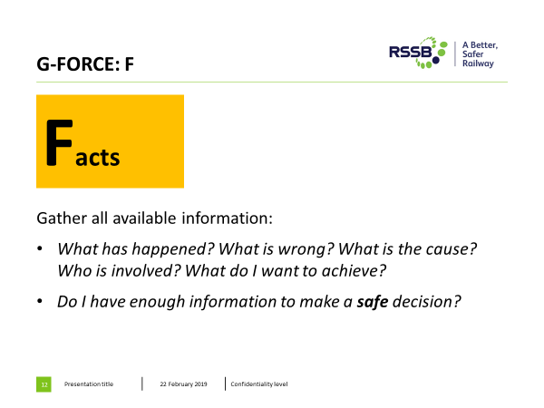
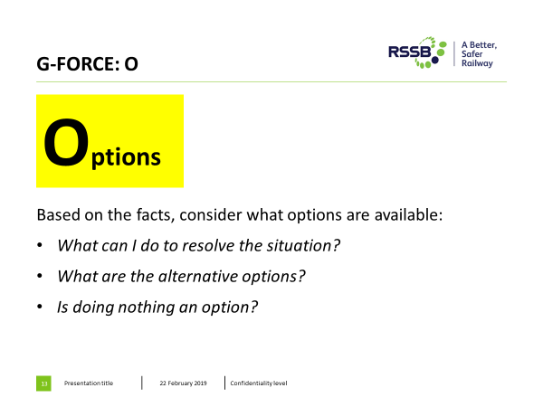
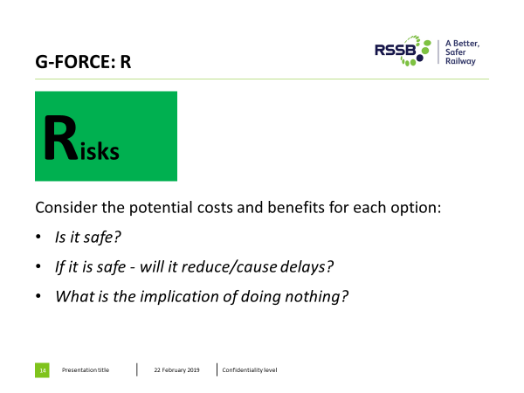
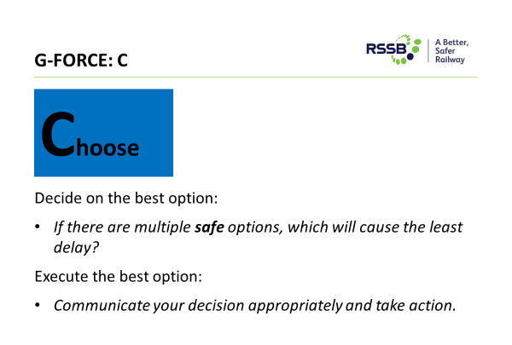

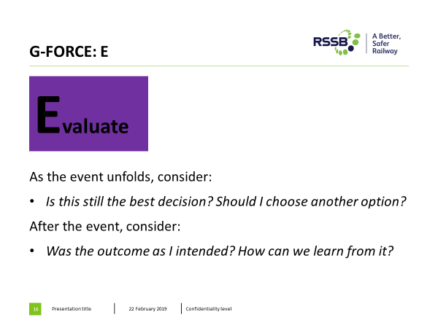

Each operator will have a service disruption threshold and CSL2 commitment, which denotes the mobilisation of workflows, resources and communication feeds required to recover from major delays/disruption.
Staff confidence will be assessed by RSSB. The supplier should be assessing the impact this has on operational performance, service disruption and customer experience.

