Didcot Civic Hall
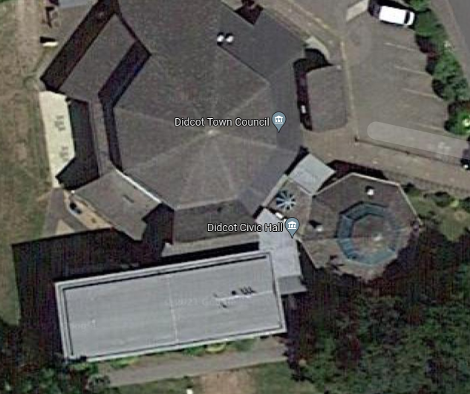
Location of Meter, Basement
Location of Panels

Willowbrook Leisure Centre.
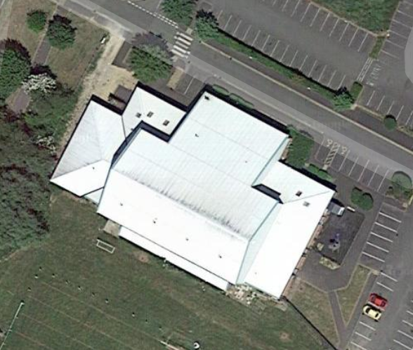
Location of Meter,
Location of Panels

Outdoor Services Building
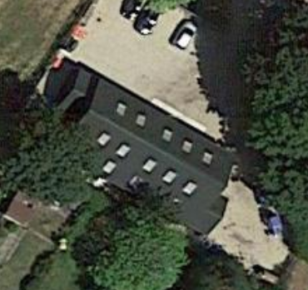
Location of Panels
Over hanging Trees Removed / Reduced., Completed
Location of Meter,

