QUALITY QUESTIONS

FOR

National Highways Dynamic Display System (DDS) Service Support: Engineering Remote Access Solution

Further Competition QUALITY QUESTIONS

introduction

This document sets out the questions that will be evaluated as part of this Further Competition.

The following information has been provided in relation to each question (where applicable):

Weighting – highlights the relative importance of the question;

Guidance – sets out information for the Potential Provider to consider when preparing a response; and

Marking Scheme – details the marks available to evaluators during evaluation.

DOCUMENT COMPLETION

Potential Providers must provide a response to every question in the blue shaded boxes. All responses must be in Arial font, no less than size 11.

Potential Providers must not alter / amend the document in any way.

Potential Providers must not submit any additional information with your Tender other than that specifically requested in this document or the Instructions for tendering

RESPONSE TEMPLATE
 | COMPANY INFORMATION
1 | Please state your full company name. This must be the same as the contracted entity named on the CCS DPS Agreement.
2 | Please provide the name, telephone number and email address of your proposed Supplier’s Representative  Please provide the name, telephone number and email address of your proposed contact for service of any Termination Notice(s)
3 | For each proposed Key Sub Contractor, please provide  - The name, registered address and Company Number of any Key Sub Contractors  - Detail of the deliverables each Key Sub Contractor will deliver  - The % of the Call-Off value estimated to be spent with each Key Sub Contractor  - The key role of each Key Sub Contractor in the Deliverables  - Credit Rating of each Key Sub Contractor  - Credit Threshold of each Key Sub Contractor

 | CONTRACT MANAGER CONTACT
1 | Please state your Contract Managers name
2 | Please state the Contract Managers telephone number
3 | Please state the Contract Managers e-mail address

 | PASS/FAIL QUESTIONS |  | Pass/Fail
Please Note: The following question is a Pass / Fail question, therefore if a Potential Provider cannot or is unwilling to answer ‘Yes’, their Tender may be deemed non-compliant and they will be unable to be considered for this requirement. The Potential Provider should confirm by deleting the inappropriate answer.
3.1 | Please provide confirmation that  You will ensure the Services you may provide remains compliant with all specifications and standards referenced in the documentation comprising this Further Competition during the lifetime of any Contract, including any applicable warranty period | Yes |  | No
3.2 | Please provide confirmation that  You will ensure there is handover of all relevant documents and information at the end of this contract to an incoming supplier and/or National Highways. This will include but not limited to providing the incoming supplier with information that has been collated and held for the purposes of the services delivered under the Contract. | Yes |  | No

 | Question 1 of 6 – Proposed Solution | Weighting (25%)
Question:
With reference to the high-level design document, please provide a proposal and full architecture design, together with evidence of how you have previously designed, delivered & operated a similar DDS Remote Engineering Access Service over multiple geographical dispersed DDS sites for another customer.

Response should cover:
- Project management
- Technical management
- Cyber security adherence
- Customer communications
- Incident management
- Escalation / jeopardy management of incidents
- Conflicting demands on engineering resources between customers

A4 PAGE LIMIT – 4

 | Question 2 of 6 – Proposed Solution | Weighting (20%)
Question:
National Highways DDS system interfaces to other operational technology interconnected by the Fibre optic core network. Please provide evidence of how you have worked collaboratively with other suppliers to address design, delivery, and service support of a DDS Remote Engineering Access Service as part of an IT Operational Ecosystems.
A4 PAGE LIMIT – 3

 | Question 3 of 6 – Supplier Experience | Weighting (20%)
Question:
Please provide a walkthrough of the methodology you propose and have previously applied in starting up a new contract/project. Please explain how you manage the technical design/delivery/testing/transition planning, resource planning and knowledge transfer. Provide examples where you have delivered this type of transition of Services to other customers.
A4 PAGE LIMIT – 3

 | Question 4 of 6 – Staff / Key People | Weighting (15%)
Question:
Please explain and demonstrate how your proposed solution will be resourced and demonstrate the capabilities of your resources including:

- Prior experience and performance of this type of work
- Proposed Key Personnel (include their experience, competence and relevant qualifications, and supporting CVs) and the roles they will fulfil including percentage of time allocated to deliver the contract; accompany this with an organogram which also clearly identifies the ‘points of contact’, where to raise issues and an escalation process.

A4 PAGE LIMIT – 2 Pages + Max 2 Pages Per CV

 | Question 5 of 6 – Service Support/Warranty | Weighting (10%)
Question:
Please provide evidence of your ability to comply fully with the contract SLAs, as well as the response and resolution times.
A4 PAGE LIMIT – 2

 | Question 6 of 6 – Social Value & Environmental | Weighting (10%)
Question:
Please explain and demonstrate how your proposed solution will:

- Cater for inclusivity of the engineers who use it daily
- Minimise power consumption, and what innovative solutions are being proposed
- Minimise the need/frequency of maintenance
- Make use of local business, labour, suppliers, apprenticeships, work shadowing etc
- Manage waste materials and irreparable hardware from the project ethically

A4 PAGE LIMIT - 2

 |  | Quality Criteria Marking Scheme

This tender is based on a total Quality/Price weighting of 70/30 Quality/Price. For the purposes of this table, “Requirements” refers to the content of the relevant question (as relevant to the Deliverables) and corresponding reference documentation for the question being scored.
Quality Marking Scheme:
The following marking scheme will be used to assess the response provided to this question:
0 | An Unacceptable score will be applied if the response:  fails to demonstrate an approach that meets the Requirements or demonstrates an approach which is unacceptable and does not meet the Requirements
3 | A Poor or Limited quality score will be applied if the response:  is of poor or limited quality and/or it demonstrates an approach which meets some but not all the Requirements and/or there are one or more material weaknesses or material omissions in the quality of the response and/or the approach to delivering the Requirements
5 | A Satisfactory score will be applied if the response:  is of satisfactory quality and demonstrates an approach which meets the Requirements in all respects and/or there is one or more minor reservations or minor omissions in the quality of the response and/or the approach to delivering the Requirements
7 | A Good score will be applied if the response:  is of good quality and demonstrates an approach which meets the Requirements in all respects
10 | An Excellent score will be applied if:  is of excellent quality and demonstrates an approach which meets the Requirements in all respects. The response also demonstrates an approach which exceeds some or all of the Requirements which will offer demonstrable benefits to the provision of the Deliverables (as relevant to the Quality Question)
A consensus meeting will be held between members of a Quality Assessment Panels to agree a quality score and rationale for each question assessed. The session will be independently facilitated by National Highways Procurement team to reach an agreed consensus score and rationale for each quality question assessed. These consensus scores will override all individual assessor’s scores. In scoring the Quality Submission the Tenderers quality question marks will be converted into Quality Scores using the equation below.

$$Quality Score=Qw×\left(\frac{Qi}{Qmax}\right) \\ Qw=Quality Weighting (as defined at Further Competition) \\ Qi=Framework Supplier^{'}s total quality mark (out of 100\%) \\ Qmax=100\%$$

Formula A – for conversion of total marks into Quality Score for Further Competition

Quality Score for further competition will rounded up to the nearest whole number.
 |  | MINIMUM OVERALL MEAN MARK | 50

 | PRICE | Weighting PRICE
Guidance and Marking Scheme:
Commercial Workbook details the full requirements that may be required during the contract. Guidance is included within the documentation in the Notes pages at the front of the workbook.

The maximum mark available for Price will be. This mark will be awarded to the most economically advantageous bid based on two sub-weighted elements of price assessment.

Total Score:

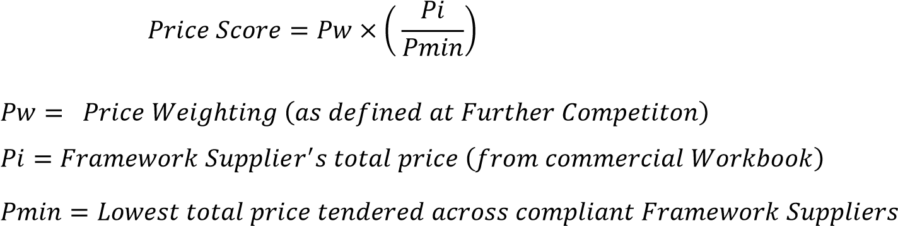

The Total Charges will be scored by calculating the Total Assessment Value as indicated on the Assessment Tab using the Equation above

TOTAL SCORE MARKING SCHEME
Guidance
The total Quality Score and the Price Score will be combined to give an overall score for each Supplier that submitted a compliant tender in the Further Competition. The tender submission that achieves the highest overall score will be the MEAT.

The Supplier that is identified as submitting the MEAT will be subject to the Verification Process as set out in the Further Competition Tender Documentation.

