

Part 2: Specification

Contract Reference: RBGKEW1083

Pricing Strategy - Wakehurst

This document is for information

**Wakehurst Pricing Strategy**

**Executive Summary  
_________________________________________________________________________________________________________________________________________________________________________________________________________________________________**

Wakehurst is at a key transition point, moving from a tactical phase of incremental change towards focused strategic investment over a 10-year period. Visitor numbers and self-generated income have risen rapidly since the introduction of the new business model in 2014. This growth has been generated by low-cost but effective investments in the gardens, programming (including the flagship Glow Wild), membership, and marcomms activity to drive new visitors and secondary spend. Having reached visitation levels similar to key peers, Wakehurst is looking to consolidate gains and achieve a new phase of growth to deliver on commitments outlined in RBG Kew’s 10-year strategy - [Our manifesto for change (kew.org)](https://www.kew.org/sites/default/files/2021-12/13320%20Corporate%20Strategy%202020-2030_accessible011221_0.pdf).

Central to new growth is the development of a robust pricing strategy that maximises income from admission and membership, with a secondary objective of managing demand to improve visitor experience and secondary spend. The strategy must: ensure that visitors continue to feel they have paid a fair price (i.e. pricing is value-based), deliver a pricing structure that is accessible to as wide a range of audiences as possible, increase the proportion of web-based sales and, encourage a more even distribution of visitors across the year (day, week, month).

**Business Model & Pricing  
_________________________________________________________________________________________________________________________________________________________________________________________________________________________________**

The new business model of 2014 introduced car parking charges for National Trust members (NT) - who do not otherwise pay to enter - along with a new Wakehurst membership scheme. The NT charges led to a significant decline in visitor numbers, negative PR, and ill-feeling among NT visitors. Crucially, the new model increased overall visitor income, providing an incentive for RBG Kew to invest further in Wakehurst. This investment has since led to a recovery in total visitor volume which provides a secure platform from which to grow the business.

Despite this, the complex set of inter-relationships and cross incentives between day paying visitors, NT members and Wakehurst/Kew members imposes significant constraints on pricing strategy. It is important to keep day-paying and membership charges below levels that would incentivise NT members to continue (or revert to) using the low-cost entry option of entering free as NT members and just paying a car-parking charge (which can cover 2-4 people in a car). Equally however, NT members – a natural core audience - who use their low-cost entry option can still generate substantial levered income from retail and catering sales. They also form a large, dedicated, ‘captive’ target group for future membership growth.

Admission and membership generate good per-visitor income, and our focus is growing our membership base. However, maintaining strong NT entry also generates substantial levered income from secondary spends, e.g. retail, catering.

Changes to the existing pricing structure needs to comprehensively model the potential impact on visitor behaviour and revenue losses/gains between all of these groups.

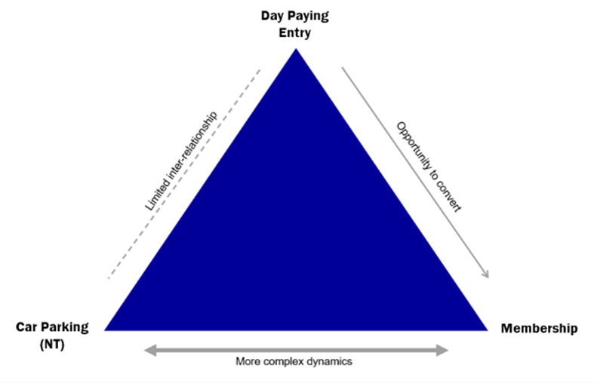

**Strategic Context  
_________________________________________________________________________________________________________________________________________________________________________________________________________________________________**

The development principles of consolidate, grow, and transform frame the positioning of Wakehurst’s pricing strategy within a wider strategic context.

The period since the introduction of the new business model has been a time of ***consolidation***. We’ve spent time fixing the basics; recruiting the right skills and expertise, establishing more agile ways of working, encouraging greater collaboration between teams across RBG Kew, developing operational standards and investing in the business to stabilise and drive revenue.

The next 3 years (FY 22/23 – 24/25) will be defined by a period of visitor and commercial ***growth*** and an enhanced contribution to the bottom line, driven by our new Business Plan. We will drive a greater level of penetration of the market, and both expand our current income potential while unlocking and exploiting new commercial opportunities within our existing assets.

***Transformation***, through the Wakehurst Masterplan, shifts Wakehurst beyond its current market position, perception, and status to a national destination: for visitor, professional peer, researcher, and influencer alike. At this point, the site and the story have achieved a step-change from Wakehurst’s existing position: Wakehurst’s narrative as a champion of natural capital, conservation ecology and ecological horticulture is unparalleled - a nationally competitive visitor experience assured.

The pricing strategy will need to take account of the Wakehurst Masterplan which sets out the future vision for Wakehurst. The Masterplan includes recommendations for physical interventions including both infrastructure changes and new visitor offers. Future changes must align with the Masterplan such that our pricing reflects the proposed investments in the visitor offer.

**Scope of Work**

**_________________________________________________________________________________________________________________________________________________________________________________________________________________________________**

In developing a pricing strategy for Wakehurst, the following will need to be addressed:

* **Ticketing Structure**: Wakehurst currently has a fairly basic ticketing structure and is one of few venues that do not charge for children (16 years and under). A key area to review is the introduction of a broader range of ticket types (including child and family tickets) with consideration to timing and price sensitivity and the overall impact on admissions revenue. Greater alignment with Kew Gardens pricing structure is considered preferable but not essential.
* **Car Park Charges**: Charging for car parking (and the broader issue of how to monetise National Trust members) is a sensitive issue for Wakehurst but a possible area of opportunity. The review should look at the impact on revenue and visitor behaviour from different pricing models such as introducing a single fixed parking charge**. Future changes will need to balance the risks for Wakehurst: visitor downturn, market comparisons and perceptions of value for car parking, together with the resultant income generation opportunities.

** The current car parking system consists of an end-of-life product which does not live up to the demands of a large-scale visitor attraction. The system is in constant state of repair causing operational friction and delivering a poor customer experience. Due to this, the current car parking system has been decommissioned, pending implementation of a new solution which is expected to be delivered and operational by Autumn 2022. A fixed-rate fee – set at the minimum charging tier - has been in operation since April.

* **Membership**: The price to be a Wakehurst member has been deliberately set at a low multiple of the full day car parking charge, to encourage NT members to purchase a Wakehurst membership as a way of avoiding the need to pay for parking. Since April 2014 membership has subsequently grown from c.3k to 18k.Consideration is needed in determining whether the membership fee can be increased further based on a value proposition and benchmarking other membership schemes, e.g. English Heritage, RHS or the National Trust, all of which allow access to multiple sites, nationwide. This includes alignment to the separate but inherently linked Kew Gardens membership scheme.

Is there potential to adjust the cost of membership and still deliver value for money; what pricing structure should be adopted for Wakehurst membership; and can additional tiers of membership be introduced, e.g. family, joint or senior membership?

* **Gift Aid**: Wakehurst does not currently claim gift aid on visitor admission or membership because the car parking element of admission charging exceeds the allowable benefit in kind. The review should challenge historic assumptions (based on interpretation of HMRC gift aid rules) and seek to answer if there is a model which would allow Wakehurst to claim gift aid and whether this option would be financially viable.
* **Online & Advanced Booking**: Advanced booking for day visitors was introduced for the first time in June 2020 in response to the Covid-19 pandemic to manage capacity through pre-booked timeslots. More recently, Wakehurst has moved to a hybrid system with online booking encouraged but not essential. The percentage of visitors booking online has dropped as a result, though it remains a crucial tool to gather insights and tailor communications to our visitors. Incentivising online sales remains constrained by the low volume of day paying visitors (c.8%).
* **Dynamic Pricing**: As a predominantly outside attraction, Wakehurst experiences significant peaks and troughs in trading based on audience and seasonality. At present, pricing is fixed across the year and does not flex based on demand. Consideration should be given to dynamic pricing models and whether this would be appropriate for the business.
* **Visitor Programming**: Throughout the year Wakehurst offers a variety of events varying in scale, subject matter, and audience. Some of these events are available with general admission such as our very successful Easter brand partnerships, whilst others, which are usually out of standard daytime opening hours, come at a separate cost such as the large-scale Glow Wild and diverse Wellbeing events. Our goal is to drive visitor volume and commercial performance by continuing to offer diverse and ambitious visitor programming.

Other considerations:

* **EVE Project**: RBG Kew is currently embarking on a large-scale transformation project - EVE (enhancing the visitor experience) - which places visitors (and enhanced visitor interactions) at its core. Successful delivery of the EVE Project is critical to optimising commercial activity through improved technology solutions and more efficient and effective processes.

The EVE Project is a significant undertaking for RBG Kew and represents one of the primary strategic initiatives for the organisation in FY22/23. The project is being delivered in two phases with Phase 1 (retail management system) delivered in May 2022 and Phase 2 analysis and delivery (including, but not limited to, ticketing, membership, Wakehurst car parking, event management) commencing from May 2022.

To support the changes, additional visitor-related data, and associated analysis, will be introduced – much of it happening in ‘real-time’. Solutions which add to this data, and data-driven approach are therefore being assessed within various teams and departments across RBG Kew with car parking being a key element of this.

**Methodology**

**_________________________________________________________________________________________________________________________________________________________________________________________________________________________________**

We do not require this work to be carried out in line with any specific pricing methodology though it would be beneficial to understand the rationale behind your recommended approach for Wakehurst.

The delivery of a new car parking system in Autumn 2022, following a period of reduced car park charges, places an immediate need to address car parking charges upon implementation and will need to be factored into the methodology and delivery timeline.

**Deliverables**

**_________________________________________________________________________________________________________________________________________________________________________________________________________________________________**

Key deliverables and outputs include, but are not limited to:

* A review or audit of Wakehurst’s pricing landscape inc. previous research, reports, and benchmark analysis.
* A collaborative, consultative approach, involving key stakeholders from across the business.
* A process that speaks to other projects, insights, and strategies, building on existing thinking.
* Co-development of a pricing strategy incorporating analysis, findings, recommendations, and implementation plan - format and elements to be discussed.
* Clear guidance or training on how to use any proposed financial models in the future.
* On-going advice and support through implementation – to be costed separately and at a future date based on requirement.

**Timescale**

**_________________________________________________________________________________________________________________________________________________________________________________________________________________________________**

It is envisaged that we will appoint a successful supplier by early September with a view to starting as soon as possible following contract signing.

Timescales are indicative and may need to change depending on resources and availability.

**Budget**

**_________________________________________________________________________________________________________________________________________________________________________________________________________________________________**

The budget for this project will be £30,000 - £35,000 (ex. VAT).

**\* * \***

**About Wakehurst**

Founded in 1759, Royal Botanic Gardens Kew operates across two sites: Kew Gardens in London, and Wakehurst in Sussex: home to RBG Kew’s Millennium Seed Bank (MSB). In 1965, RBG Kew chose Wakehurst as a home for a temperate plant collection, due to its climate, soils, and topography. This led to a 99-year lease with its owner, the National Trust. Wakehurst is now a large-scale botanic garden and estate, owned by the National Trust, but managed by RBG Kew, delivering powerful contributions to the UK visitor economy and global plant conservation. Since 2014, Wakehurst has undergone momentous changes through focused investment, with development on key destination drivers including the Winter Garden and American Prairie, as well as popular events, including Glow Wild.

Through these milestones and visitor experience improvements, footfall and self-generated income have risen rapidly, reaching just under 400,000 in 2021/22, and ranking in the top 50 (42nd) of ALVA’s latest figures, surpassing many other regional ALVA destinations.

Wakehurst attracts a variety of audiences from across the country, from day trippers to garden enthusiasts, with free entry for under 16s. Offering an ever-changing and inspiring environment, Wakehurst inspires people and connects audiences with nature, building support through membership and repeat visits. Through a strong participation programme focusing on science and wellbeing, Wakehurst reaches underserved regional audiences, working across society to broaden the communities who benefit from our amazing site.

Wakehurst is now entering a new growth phase, delivering on commitments outlined in RBG Kew’s Corporate Strategy, the Manifesto for Change.