# Introduction

The use of a wooden corebox has been the norm for many years within the Drilling Industry, but with the price of wood becoming ever higher while the costs of producing plastic alternatives are reducing the continued use of the wooden corebox is becoming less attractive. While the use of more recycled plastics is becoming more widespread. Traditional core boxes are hard to carry, too heavy, even when empty, not durable, not sustainable, have limited lifespan and are difficult to label.

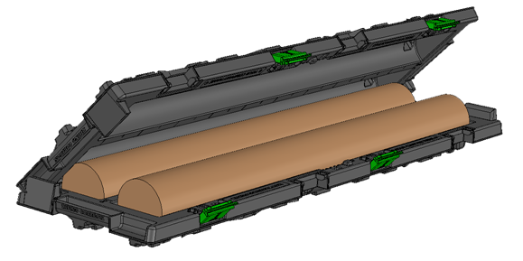

Equipe Geosolutions has already developed a dual channel/trough plastic core box but has recognised an opportunity to develop an alternative version. The development of an alternative plastic corebox must address all of the problems identified with wooden coreboxes, as well as being cost effective and environmentally friendly.

We are now looking for a Design Partner to produce CAD drawings which can be passed on to tooling and injection mould specialists.

# Outline Objective

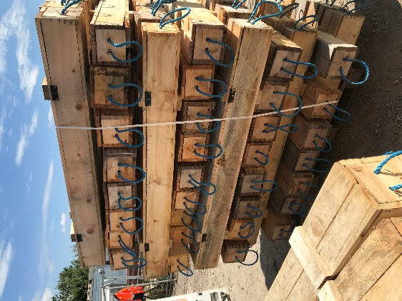The drilling market in the UK has recognised the significant manual handling risks surrounding core boxes and in recent years has moved to a box which can transport and store a length of 1.50m cylindrical core up to 110mm in diameter. This long thin box is traditionally made of wood and this option whilst reducing manual handling risks does not eliminate them. The wooden boxes are also difficult to stack safely and use up the same space when stored or transported empty or full.

The outline objective is to create a plastic corebox which provides cost, environmental, storage, handling, transportation and safety benefits to the purchaser and users.

# Designer’s Brief

The design concept is a single tray which can used for both the top and bottom of the box thus allowing these to be stackable inside each other when not in use to make transportation and storage easy and less space hungry.

**Example of a double trough design**

The tray will require the following features or attributes:

* Consist of a single trough capable of holding core up to 110mm diameter cylindrical core.
* Each box should hold 1.5m of core in length
* The core should be a snug fit in the box with its associated liner.
* Each tray should have drainage holes to allow excess water to drain from the box.
* When filled they should fit together (via a simple integral hinge) clipping or snapping into place.
* They should be stackable in a stable manner interlocking on top of each other.
* They should be strong enough to allow stacking a minimum of 6 boxes high when full.
* They must have comfortable ergonomic hand grips at both ends.
* Should have a flat area of at least 50mm x 75mm both inside and out to allow for sticky identification labels to be attached.
* The design should consider ease of manufacture utilizing injection moulding techniques using recyclable materials, wherever possible.
* Overall weight should be kept to a minimum whilst remaining robust and twist free.
* They should be useable in a temperature range of -20 to + 60 degrees without changes in the materials properties (brittleness)