Service Specification

Service Specification No. | 1
Service | Integrated language and communication service
Commissioner Lead | Sandwell and West Birmingham CCG
Provider Lead | TBC
Period | April 2020 – March 2025
Date of Review | April 2021

1. Population Needs
National/local context and evidence base
The NHS Constitution
The aim of the Constitution is to safeguard the enduring principles and values of the NHS. The Constitution also sets out clear expectations about the behaviours of both staff and patients. It is intended to empower the public, patients and staff by setting out existing legal rights and pledges in one place and in clear and simple language. By knowing and exercising their rights, the public, patients (their carers and families) and staff can help the NHS improve the care it provides.

Specific Requirements for Clinical Commissioning Groups
As an authorised public sector organisation, NHS Sandwell and West Birmingham Clinical Commissioning Group (SWB CCG) is required by the Equality Act 2010 and Human Rights Act 1998 to work in ways that ensure equality and inclusion is embedded into all of its functions.
It is the intention of SWB CCG to eliminate unfair and unlawful discriminatory practices in line with current equality and Human Rights legislation.

Public Sector Equality Duty (PSED)
In the exercise of its functions SWB CCG must have due regard to the need to:

“Eliminate discrimination, harassment and victimisation and any other conduct that is prohibited by or under the Equality Act 2010 b. Advance equality of opportunity between persons who share a relevant protected characteristic and persons who do not share it c. Foster good relations between persons who share a relevant protected characteristic and persons who do not share it”
The National Patient Contract
The NHS standard contract states: (13.2)
The Provider must provide appropriate assistance and make reasonable adjustments for service users, carers and legal guardians who do not, speak, read or who have communication difficulties (including hearing, oral or learning impairments)
http://www.england.nhs.uk/wp-content/uploads/2013/03/contract-service.pdf

Current use of Service
Based on activity data from 2017/18 it is expected the top 10 languages interpreted are;

In Sandwell

Language | Interpretations
Polish | 2494
Punjabi | 686
Romanian | 480
Bengali | 442
Kurdish | 342
Russian | 321
BSL | 290
Slovakian | 284
FARSI | 244

In West Birmingham;

Language | Interpretations
ROMANIAN | 2368
POLISH | 2304
BENGALI | 1895
PUNJABI | 1868
ARABIC | 1759
FARSI | 1612
KURDISH (SORANI) - CENTRAL | 1205
SLOVAKIAN | 1179
CZECH | 770
TIGRANIAN | 762

2. Outcomes
2.1 NHS Outcomes Framework Domains & Indicators

Domain 1 | Preventing people from dying prematurely
Domain 2 | Enhancing quality of life for people with long-term conditions
Domain 3 | Helping people to recover from episodes of ill-health or following injury
Domain 4 | Ensuring people have a positive experience of care
Domain 5 | Treating and caring for people in safe environment and protecting them from avoidable harm

3.1 Aims of service

The aim of this service is to provide an integrated language and communication service for all patients accessing primary care.
The service aims are to;

- Meet current demand of interpreting services
- Manage future growing demand of interpreting services
- Enable patients and staff to overcome communication barriers and build capacity for patient activation, to improve knowledge, skills and confidence
- a place based language and communication system that encourages, more collaborative working and puts the outcomes of our population at the heart

3.2 Objectives of service

Domain 1 – Access

- A holistic approach to language and communications needs which focuses on patients strengths and assets
- Convenient and accessible booking system for interpreting services
- Patients are assessed on their interpreting needs
- Digital modes developed throughout the lifetime of the contract
- Support GP Practices to understand how best to use the interpreting service to provide the best service for their patients
- An evidence base is developed to demonstrate equitable access to services and gather evidence of outcomes to be monitored regularly
- Work with all partners to ensure there is relevant understanding and enough suitable staff available to meet the cultural needs of all people to ensure equity of opportunity and reduce health inequalities
- Ensure services are in line with the requirements of the Equality Act 2010. Provide evidence of the awareness of and demonstrate accessibility of the service to the relevant protected characteristics. This information should be collected and available to Commissioners on request.
- Ensure no patient is disadvantaged due to where they live or access services
- Access to services is fair, consistent and proportionate to need.
- Continuity and consistency are embedded. Patients are able to navigate services across pathways with ease
- The service promotes and facilitates access to digital interpreting services
- Support is in place to support deaf or blind people, referring to the Accessible Information Standard as necessary.
- There is appropriate understanding of supportive services and how a patient can access them so that no patient is disadvantaged due to language/communication barriers
- Any information (verbal or written) given to patients is confirmed to be understood and any need for further information is highlighted to the GP Practice as appropriate
- Patients that frequently do not attend their appointments are highlighted and working with the relevant GP Practice a process is agreed of how to work with the patient on their attendance
Domain 2 – Developing independence
- To proactively seek opportunities to develop patient resilience and improve language and communication
- To ensure interpreters are trained on health care navigation and local community assets
- If it is felt that the patient could be accessing services that would better support their needs then the interpreter will work with the GP Practice on education about alternatives (including self-care and pharmacy)
- To develop sustainable partnerships with community organisations that also help to enhance literacy as well as facilitate access to community services (e.g. voluntary and community sector services, local authority)
- To harness community organisations and faith groups as assets in promoting messages and behaviour change.
- To facilitate access to self-care opportunities (coaching, social prescribing, digital self-care, ESOL and if these services are not available, to deliver ESOL classes.
- To ensure patients are aware of NHS requirements pertaining to patient choice.
- Develop health education material and resources in language and culturally appropriate formats.
- Work with all partners to co-design self-care IT solutions that fulfil the needs of the local population
- Support Primary Care Networks and communities to deliver group education sessions around general health awareness and other more specific condition specific education projects as required by the needs of the community
- Support in the delivery of planned patient and service user engagement at the requirements of the CCG. This would include assisting in delivering presentations, supporting workshop discussions and interpreting patient stories
- Be flexible to deal with changes in the service requirements in the future, this could be due to changes within communities and therefore interpreting needs and also looking at developments or advances in technology to support more responsive interpreting services.
- To provide basic signposting to Health, Social or Voluntary Sector Services to ensure that no patient is without the support they need (this information will be made accessible to the Interpreting service)
- To assess the interpreting needs of each patient and support the maximum number of patients within each session/visit
- To work with the GP Practices to minimise the number of patients who do not attend their GP appointments
- To review with commissioners service demand trends and put forward, for discussion with commissioners, plans/proposals for managing enhancing patient activation and if required ways of reducing demand.
- To provide a cost-effective service.
Domain 3 – Quality and safety
- Provide a qualified and competent interpreter at the correct time and date arranged by GP Practice
- Be responsible for providing training, support services such as advices or counselling services for their interpreters.
- There are processes in place which underpin patient safety and quality
- Ensure that all staff have the appropriate DBS clearance before starting
- Ensure that all staff undertake both adult and child safeguarding training
- Ensure that any information divulged to the interpreter outside of direct translation is passed on to the clinician
- Ensure that all staff understand how to refer safeguarding concerns and are supported by their management to make referrals as appropriate and without delay
- Patients and staff understand how to and have an opportunity to provide feedback on the service in confidence, as well as an opportunity to feedback on the impact on health care and treatment
- Data and information on key performance areas is made available in real time.
- Services meet commissioners’ governance, quality and procurement guidelines
- There are sufficient staff to deal with the interpreting needs of GP Practices and Clinical Commissioning Groups
- to ensure a responsive and timely service is provided at all times.
- Interpreting services are available throughout opening times of GP Practices
- Appropriate training programme are delivered to maintain staff skills and meet necessary
- The service shall be delivered by appropriately qualified, skilled and competent staff
- To ensure health professionals understand the level of trauma/crises a patient may be in and how this information is relayed. It is requirement of the interpreter to have mental health first aid training.
- Staff are able to demonstrate compassion and empathy with the patient
- There is a robust information technology infrastructure in place to allow for quick and easy booking processes
- Information Governance (IG) Data sharing and reporting measures are in place
- IT systems are in place to enable the collation of specific, accurate and easily accessible information as requested by the Commissioner.
- Provide a qualified and competent interpreter at the correct time and date arranged by GP Practice
- be responsible for providing training, support services such as advices or counselling services for their interpreters.

Pathway description

The figure below describes key elements required in the service.

Key element service | Function
Complies with best practice principles | The service adheres to all principles identified by NHS England.  https://www.england.nhs.uk/commissioning/wp-content/uploads/sites/12/2015/03/it_principles.pdf
Choice and scale | The service offers a full complement of interpreting and translation requirements for our population demography (100+ languages)
Accessible | Interpreting requests are fulfilled within 24 hours or less and are open the same hours as primary care.  There is a single route of entry and the booking process is simple  10 practices in the CCG footprint account for 64% of total interpreting activity. The new service needs to ensure services are accessible and also needs to ensure it is targeted to those who need it most.
Give service users a voice | Patients and staff have a clear means to comment on the quality and their experience of the interpreting service in confidence.
Harnessing the workforce | Where language demand is highest at certain practices, there needs to be more sustainable solutions, such as recruiting full time interpreters or harnessing bi-lingual staff.  Existing or new staff should be recruited to undertake interpreting and translation. (This would be for the languages most interpreted in each locality).  Staff should perform a dual role of healthcare support/coaching to build up levels of patient activation for patients who cannot speak English.
Harnessing digital technology | Over 95% of interpretations are currently conducted face to face. The service needs to increase choice through the use of digital technology. This could be through telephone or video communication services. Patients should also be encouraged to adopt self-care options.
A ‘whole-person’ approach | For more complex cases, a language specific health coaching/social prescribing function should be offered. Patients should be referred for social needs in the same way they do for physical and mental needs. Staff should carry personalised ‘what matters to you?’ assessments for patients which take account of holistic needs. This should be interpreted in their own language.  The service helps people to identify peers that have shared interests, to help them overcome isolation and connect with existing groups  The service connects people into a wide range of social, leisure and faith based activities that are available in communities.  The service should have access to community experts, connected with the voluntary and community sector to understand which services/activities are accessible, who delivers them, when and where.
Empowering people to take control of their own health and care | The service should facilitate access to support for improving English language (through formal qualifications or informal means)  Future models of community-based care should support people to take control of their own health and well-being as far as possible. This might involve encouraging people to lead healthier lifestyles, improving their understanding of their health or supporting them to manage long-term conditions.  The service should facilitate access to a health coaching function which helps patients to become more active in managing their condition and that can support people from certain high-risk groups to set goals and promote behaviour change.
Outcomes focused | A movement to an outcomes based model which helps to kick start innovation, social value, community ownership, patient activation

The services will be provided directly in response to formal requests from GP Practices. The service will be ordered via a single contact centre which shall be provided by the supplier which may be reached by phone and email. The use of an online portal to book and review appointments is required.

The service will provide Face to Face, Telephone, and British Sign Language (BSL) interpreting and translation. The provider will also be expected to provide new methods of interpreting such as Video/Web based solutions, to targeted cohorts of patients.
If no interpreter is available in the first instance in a specified language, then the service provider will source and provide an interpreter at no additional cost. Interpreters can be provided either face to face interpreting or Telephone interpreting.
Traditionally GPs prefer face to face appointments and there is an expectation that this will continue within the new contract, however we expect the successful provider to work with practices to agree the most appropriate ongoing service solution noting that the final decision will rest with the GP.

The service being commissioned includes interpreting services in primary care as well as;
  - Language specific targeted health coaching and social prescribing
  - Language specific shared decision making support (In primary care)
  - Improving health awareness and literacy of targeted populations to enable them to make informed choices about their health and well-being.
  - Ensuring people access ESOL or equivalent

The service does not include actual provision of ESOL, (or equivalent). The service is required to work in partnership with ESOL providers (or equivalent) to ensure service users access these services to help improve English language.

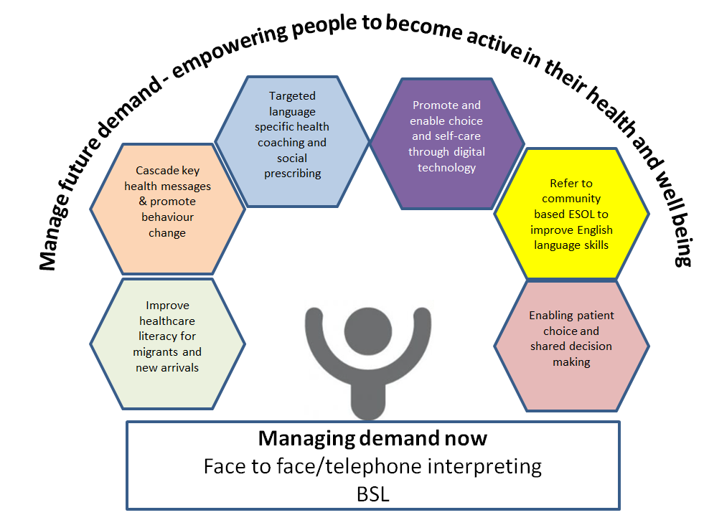

Day/hours of operation

The service will need to run for the operating hours of GP Practices which is normally 8:00 to 6.30pm excluding bank holidays. However, based on the needs of specific Practices this may change and include work before 8am, after 6.30pm and on bank holidays and weekends. The specific needs of each GP Practice will need to be negotiated with them.
The Supplier/s shall be responsible for their Interpreters being aware of and adhering to the Working Time Directive and any other relevant Directives that may come into force during the life of the Contract
Where a specific gender request is made the provider is expected to meet this requirement.

Activity Reporting and Performance Management

There will be quarterly meetings with the commissioner to discuss the monitoring and management of the service. These meetings will be responsible for monitoring and managing the overall performance and deciding how the interpreting and translation services will develop over time.

The activity reporting and performance requirements will measure against a series of operational and quality indicators to be reported by the Provider.

The Provider shall have overall responsibility for ensuring that the key service outcomes are achieved and reported on in accordance with NHS contracting General Conditions (including GC 8, 15). The CCG reserves the right to audit at any time and requires a monthly/quarterly quality report.

The Provider agrees to allow the CCG to have reasonable rights of audit and access to any of the Provider’s premises, personnel, systems and if appropriate the sub-Providers facilities, premises, any relevant records (including the right to copy) and other reasonable support as the Commissioner may require whilst the service is being provided and for twenty four (24) months following the end of the contract in order to verify any aspect of the service or Providers performance.

Providers to have a continuous service improvement plan, in order to ensure that all improvements to the service are actioned effectively to maintain the quality of the service. This should include necessary actions for managing/reducing demand.

Cancellation of Bookings
The GP practices can cancel a booking at any time.

3.3 Population covered

Patients registered to a General Practitioner within Sandwell and West Birmingham CCG. The estimated annual usage of the service is below.

Place | Interpretations
West Birmingham | 16202
Sandwell | 6913
Total | 23115

3.4 Any acceptance and exclusion criteria and thresholds

Security Clearances

Interpreters provided under this contract/s will need to be security cleared to the DBS (Disclosure & Barring Service), and in the last year (and on a yearly basis) undergone relevant training. The supplier will maintain details of the clearance levels of interpreters and dates for validity.

Because of the level of diversity the CCG cannot accurately predict with any precision which languages will be required, or how prevalently each will figure in the totality of service requests. As a multi-cultural society, the variety of languages and dialects will vary across factors such as locality.

Monitoring

The Provider will monitor the contract based on the following criteria, but not exclusively limited to:
 | Measure
Quality | GPs reporting improved patient experience during consultation time
Quality | Improved patient/citizen activation - levels of knowledge, skills and confidence increased
Innovation | Digital offering helps to improve patient choice and activation
Productivity | Number of fulfilled interpretations per month (fulfilled interpretations >95%
Prevention | Referrals to ESOL (80% of patient cohort referred)
Prevention | ESOL course completion rate of at least 75%

Other reporting requirements include
Language interpreted, ethnicity, language, age group, time resident in UK.

3.5 Interdependence with other services/providers

Not Applicable

3.6 Payment

Payment will be made in the form of a fixed amount on a monthly basis that will cover the provision of the service. The service is delivered through a block and outcomes contract.

The table below shows the proposed financial envelope for each ‘place’.

The provider would receive a monthly mandate payment for 1/12th of the contract value @ 80%. The remaining 20% would be paid on invoice upon confirmation that agreed outcomes have been achieved.

3.7 Training and Development

The Provider must satisfy Sandwell & West Birmingham CCG that all Interpreters are appropriately accredited and trained to provide the services detailed in this Service Specification.

The Provider will maintain details of the training received by all interpreters and dates for validity.

The Provider shall provide appropriate, on-going training for users on how to use the service including specialist services such as when working within mental health. There shall be no additional cost to the CCG for training.

Professional Qualifications
The range of interpreter qualifications and experience required to be supplied under the contract are:

Face to Face

- NRPSI Full Status registrant
- NRPSI Rare Language Registrant
- Institute of Translation and Interpreting member
- DPSI qualified
- NRPSI Limited Assessment category
- Member of the Institute of Linguists
- AIT Assessment (formerly IAA assessment)
- IND Assessment
- DPSI Oral only
- NVQ Level 3
- OCN
- LOCN
Safeguarding Children & Adults
All staff who come into contact with children, young people and adults have a responsibility to safeguard and promote their welfare. To fulfil these responsibilities, it is the duty of healthcare organisations to ensure that all health staff have access to appropriate safeguarding training, learning opportunities and support to facilitate their understanding of the clinical aspects of child and adult wellbeing and information sharing.

Identification of abuse and neglect is defined in Working Together to Safeguard Children (DoH, 2018).
All provider staff who identify a child who is suffering or likely to suffer harm should make a referral to the local Multi Agency Safeguarding Hub (MASH) and/or Police. If a risk is identified the Multi-Agency Referral Form (MARF) must be completed. Identification of abuse and neglect of adults is defined in The Care Act (2014). All provider staff who identify an adult who has additional care and support needs should make a referral to Adult Social Care.

In addition the provider will be compliant with national and local policies as required in the NHS Contract.

Safeguarding Training Matrix

Level of training | Target group | Frequency | Access
Level 1 - Children | All staff working in health care settings | Over a three year period refresher training equivalent to a minimum of 2 hours | SWB CCG Statutory and Mandatory training - leaflet
Level 2 - Children | All non- clinical and clinical staff who have contact with children, young people , and/or parents/carers | In addition to level 1 training, over a three-year period, refresher training equivalent to a minimum of 3 – 4 hours | E-module online training or Sandwell/Birmingham Children’s Safeguarding Partnership multi-agency face to face training
Level 1 - Adult | All staff working in health care settings | Induction – 30 mins within 6 months of commencing post. Duration over a 3 year period 2 hours | Sandwell & Birmingham Adult Safeguarding Board training
Level 2 - Adult | All staff who have regular contact with patients, their families or carers, or the public. | Induction – 30 mins within 6 months of commencing post. Duration over a 3 year period 4 hours | Sandwell & Birmingham Safeguarding Adult Board training

4. Applicable Service Standards
4.1 Applicable national standards (e.g. NICE)

Association of Translation Companies

4.2 Applicable standards set out in Guidance and/or issued by a competent body (e.g. Royal Colleges)

4.3 Applicable local standards

Interpreters provided under this contract/s will need to be security cleared to the enhanced level of DBS (Disclosure & Barring Service), and in the last year (and on a yearly basis) undergone relevant training. The supplier will maintain details of the clearance levels of interpreters and dates for validity.

5. Applicable quality requirements and CQUIN goals
  - Applicable quality requirements (See Schedule 4 Parts A-D)
  - Applicable CQUIN goals (See Schedule 4 Part E)

Not applicable
6. Location of Provider Premises
7. Individual Service User Placement

