Invitation to Tender
Downs to the Sea – Ferry Fields Wetland Enhancement
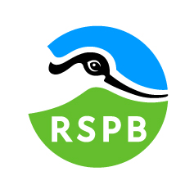


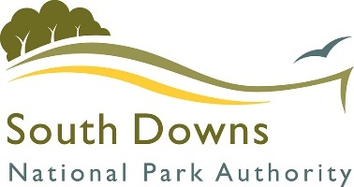
Contents
Document A: Instructions and Information 3
Document B: A Brief Introduction 5
The RSPB 5
The Downs to the Sea Project 5
Pagham: Ferry Fields Wetland Enhancement 6
Document C: Specification 7
1. Predator Exclusion Fence 7
2. Standard Required Paperwork 9
Document D: Company Information 10
Document E: Form of Offer 14
Cost 14
Approach to the Project 14
References 14
Document F: RSPB Terms and Conditions 16
Document G: Certificate of Bona Fide Offer 17
Annex 1: Site Maps 18
Annex 2: Works Maps 20
Map 1a: Predator Exclusion Fence 20
Map 1b: Predator Exclusion Fence – Water Vole Mitigation 21

Dear Sir or Madam,
TENDER FOR THE SUPPLY OF:
Downs to the Sea – Ferry Fields Project Works – Predator Exclusion Fence Installation
Period 01/08/2026 to 31/10/2026
You are invited to tender in competition with others to provide the goods and/or services specified above to the RSPB.

The following documents are enclosed and must be, where applicable, completed and signed on behalf of the supplier. Subcontractors must be disclosed at the tendering stage and should also sign off on the tender documents that are applicable to their area of the works.

Your tender response should be sent to ruth.gillies@rspb.org.uk by 09:00 on 13th April 2026.

Only tenders submitted in accordance with the RSPB’s Terms and Conditions will be considered. Any tenders that are incomplete, or received after the time indicated, may be disregarded.

If you wish to discuss any aspect of this tender prior to tendering, please email ruth.gillies@rspb.org.uk

Site visits are mandatory. Any submissions that have not completed a site visit will be disregarded.

Yours faithfully,
Ruth Gillies
Project Manager – Downs to the Sea
RSPB

Document A: Instructions and Information

- This document is designed to be completed electronically. You are required to mark boxes, insert information or submit additional documentation in response to the questions herein. Whilst the text boxes should expand as you add text, if there is insufficient space for your response please attach a separate document clearly marked with the name of your Company, the reference number and the number(s) of the question(s) to which it relates. Please ‘sign’ this document by adding your name to the end of Document G.
- If you are unable to comply with a request for information or provide documentation requested then a written account explaining the absence of the information must accompany the return of this tender. Please be aware that the failure to respond to any of the questions, without a written reason, may result in a negative evaluation of that element within the overall evaluation of this questionnaire.
- The RSPB may require supplementary information or clarification or further evidence of the information given. The RSPB may wish to visit reference sites given as evidence of relevant experience.
- The RSPB may request interviews with all or a selection of applicants or none. Applicants will be notified in due course. The ability of suppliers may also be determined by, amongst other factors, references, certification, site visits and ‘mystery shopping’.
- Please answer the questions specifically for your company, NOT for the group if you are part of a group of companies. Please note the term “Company” refers to: Sole proprietor, partnership, incorporated company, co-operative, or voluntary organisation as appropriate.
- During the term of this agreement and for 1 year thereafter, neither party shall solicit to work for it any person who is or was employed by the other party and who has been involved in the provision of the Services at any time during the preceding 12 months. For the avoidance of doubt, if a person who is or was employed by the other party at the relevant time responds to a publicly advertised recruitment campaign, the recruiting party shall not be deemed to have solicited that person from the other party. If either party is in breach of this it shall pay to the other party an amount equivalent to the gross salary paid by that other party to the relevant employee for the final 12 months of employment.
- No charge will be made to the RSPB by applicants for any preparation costs accrued during the tender process, whether the applicant was successful or not.
- You are invited to submit your best offer for the work as detailed below. The RSPB reserves the right to undertake post-tender negotiations.
- It should be noted that in any contractual relationship that is subsequently entered into, reference will be made to the detailed information provided in the formal response to this tender document provided by the successful organisation. Thus answers and information given in your reply will become a binding part of the contractual obligations between yourselves and the RSPB.
- Timetable
Invitation to Tender document advertised | 09/03/2026
Tender documents to be returned | 13/04/2026 09:00
Tender Review by Pannel | Week Commencing 13/04/2026
Award of contract | 21/04/2026
Commencement of services / orders for goods | 01/08/2026
End of contract* | 31/10/2026

* Three-year contracts may be extended for a further year.
- The RSPB does not bind itself to accept the lowest or any Tender, and reserves the right to accept part only of a Tender. RSPB reserves the right to procure individual elements of the required solution from one or more supplier as appropriate.
Whilst the RSPB aims to provide feedback on failed submissions this may not always be possible, and the RSPB is under no obligation to do so.
- Tender Evaluation Process
Tenders that fail to meet essential requirements may be excluded from consideration.
Tenders that fulfil essential requirements will be evaluated on the basis of the most economically advantageous tender, weightings as detailed below.
Criterion | Weighting
Price | 30%
Relevant experience | 40%
Environmental considerations | 30%

Document B: A Brief Introduction

The RSPB
For details on the RSPB’s challenges and achievements in the previous financial year please go to
How the RSPB is Run | About Us - The RSPB

For an overview of the RSPB please go to:
About the RSPB - The RSPB

The RSPB is the largest wildlife conservation charity in Europe with over one million members.
Our purpose is to advance the conservation of birds, other wildlife, and the natural world, by protecting and restoring habitats and landscapes, saving species and connecting people to nature. We carry out conservation work that you can see from space, built from the ground up. We believe that the planet is facing a nature and climate emergency and that we have a moral duty to pass on the natural world in a better state to future generations.
Our vision is a shared world where wildlife, wild places, and all people thrive. We believe we’re all connected by the wonder of nature. The health of the natural world is fundamental to the survival of all species and has the right to flourish. We know that birds, other wildlife and the habitats on which these depend are interconnected. We recognise that the health and resilience of individuals, our society and the economy is dependent on the health and sustainability of the planet’s ecosystems. We believe that we have the greatest impact when our strategy is informed both by our understanding of the state of species and ecosystems and our core beliefs.
To support our mission and vision we manage 226 nature reserves, supporting over 18,700 species covering more than 159,000 hectares. Our nature reserves encompass many of the UK’s important habitats including lowland wet grassland, reedbeds and estuaries. More about our mission can be found here.

The Downs to the Sea Project
The Arun Valley, running through the South Downs National Park (SDNP), is one of the most biodiverse floodplain wetlands in England. It contains a string of RSPB reserves which are some of the most highly designated sites in the South Downs National Park, and southern England. This critical natural heritage faces a multitude of threats, such as climate change, development, fragmentation and pollution. Here, and across the SDNP, one of the biggest issues is water – quantity and quality for people and wildlife and flood storage. These are issues which are only becoming more pressing in the face of climate change.

Downs to the Sea has been established as a multi-partner project, led by the South Downs National Park Authority, to tackle these issues with the aim of helping to restore and protect crucial ponds and wetlands that are instrumental in nature recovery and resilience to climate change at scale, providing multiple ecosystem services: water for homes and farms, flood storage, wildlife habitat and recreation.

The project will also connect with underserved audiences and those most vulnerable to health and wellbeing problems in the area and leave a legacy that highlights and supports the need for recovery and resilience in our communities, for both people and nature.

The RSPB projects included in Downs to the Sea will see vital restoration works on a string of functionally connected nature reserves down through the Arun Valley, at RSPB Pulborough Brooks and Amberley Wildbrooks, and at Ferry Pool wetlands on the coast, part of RSPB Pagham Harbour and Medmerry. These sites are internationally designated for their wildlife but need urgent investment to meet their ecological potential and build climate resilience.

The RSPB sites that are subject of this invitation to quote are:
i) RSPB Pagham Harbour, Ferry Field/Ferry Pool Complex (FP) (SZ853963)

c/o
RSPB Pagham Harbour Local Nature Reserve
Selsey Road
Chichester
PO20 7NE

Work will focus on improving lowland wet grassland across the RSPB sites to benefit RSPB priority species (breeding waders and wintering wildfowl) through a combination of the following:
- enhancing wetland features by creating scrapes, islands, foot-drains and reprofiling ditches;
- improving water level management and control through installation of sluices, pumps and culverts, and the creation of bunds and berms to reduce water loss and increase our ability to hold and control water, enabling us to balance salinity levels at Ferry Pools and increase the sites’ climate resilience into the future;
- reducing disturbance through access improvements (footpath improvements, installing stock fencing)
- reducing mammalian predation through the installation of predator exclusion fencing.

Pagham: Ferry Fields Wetland Enhancement
Following the improvement of the wet features on site in 2025, we will be installing a predator exclusion fence to reduce predation of ground-nesting birds by foxes and badgers.

Document C: Specification
The successful supplier will supply a service to which the following points will apply:

The information below is a statement of minimum requirements and is not intended to limit creative or original thinking in the preparation of proposals.

Predator Exclusion Fence
- Supply and install a predator exclusion fence as marked on Map 1 in Annex 2.
- 1900m of Tornado wire (or similar) fencing (e.g. R23/240/5 or R18/170/5 C5)
  - Wire should have a minimum strained load of 30kg (average 54kg)
  - Wire to have 50mm vertical spacings.
  - 1.6m finished vertical height plus an overhang.
- Mesh Additional 40cm extended overhang section set at 45 degrees
  - 100mm beyond top of bracket to create ‘floppy-top’, ensuring a minimum overall height of 1.8m.
  - Bracket on every second post.
  - Wire to have 50mm vertical spacings
- Metal posts with 30-year guarantee:
  - 2.9m long metal intermediate posts with stainless steel clips
  - Intermediates every 4m
  - Strutted (box or New Zealand) metal strainers every 100m
  - Strutted (box or New Zealand) metal strainer at every corner
  - Strutted (box or New Zealand) metal strainers either side of the gates
- Mesh “apron” to be buried 60cm deep
  - Wire to have 50mm vertical spacings
  - Backfill must be placed on the inside of the fence, squashing the net onto the outward face of the trench.
  - A mesh skirt extending 1m a ground level and securely pinned to the ground along the section marked in pink on map 1a.
- A 3.6m wide fully-meshed galvanised gate on steel posts
  - 30cm x 30cm x 360cm smoothed concrete plinth beneath.
  - Mesh overhang to same height as fence with no gaps.
  - Wire to have 50mm vertical spacings.
- One strand high tensile barbed wire on inside of posts
  - Extending min. 150mm from mesh.
  - 1200mm from ground.
- Fence to be positioned 3m from boundary features.

- For the section in the lagoon, marked in green on map 1a, please provide two quotes:
  - Quote 1:
    - Chestnut posts (strainers and intermediates) used
    - Same metal tornado wire as used on the rest of the fence.
  - Quote 2:
    - PVC-coated V Mesh fencing panels and posts as shown in Figure 3.
    - Vertical spacings must still be 50mm
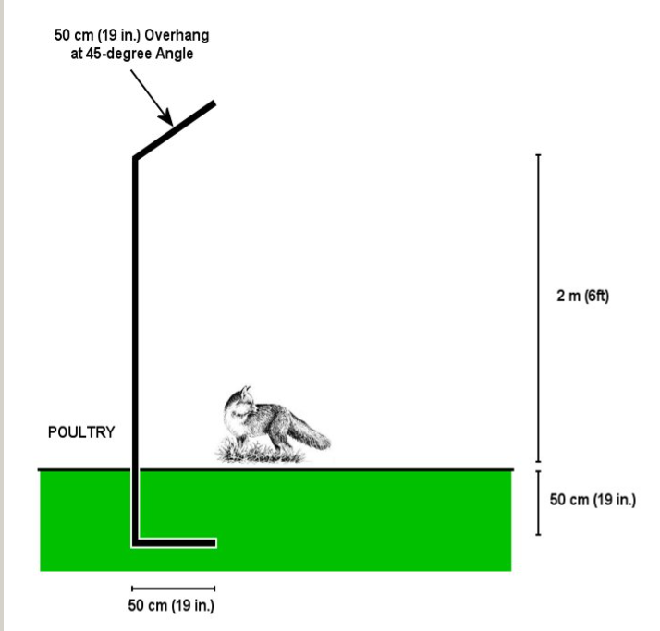
1.6m + angled 40cm overhang
Folded if practicable, otherwise min. 60cm buried apron depth
Breeding birds

Figure 1 Diagram of Predator Exclusion Fence
40cm

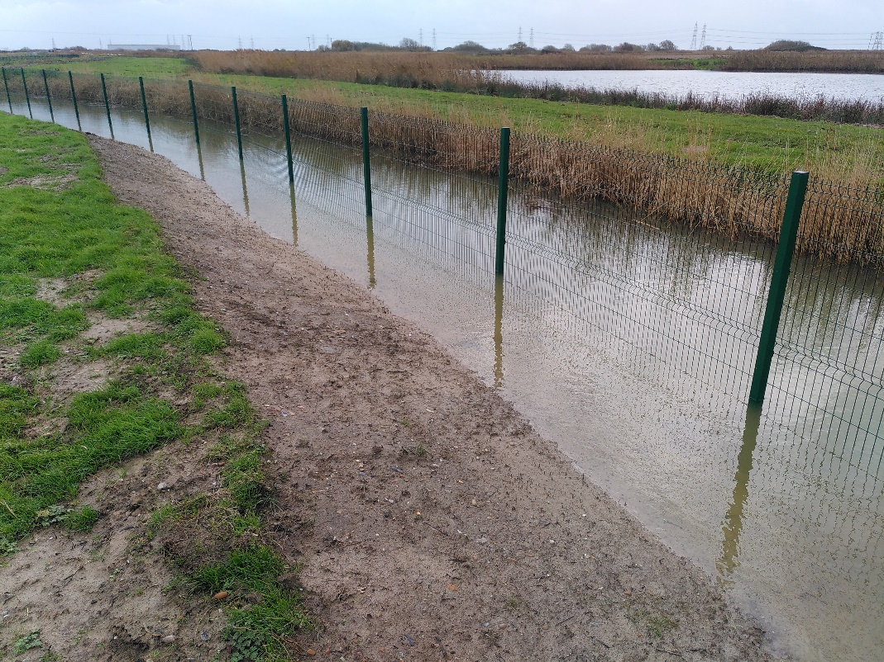
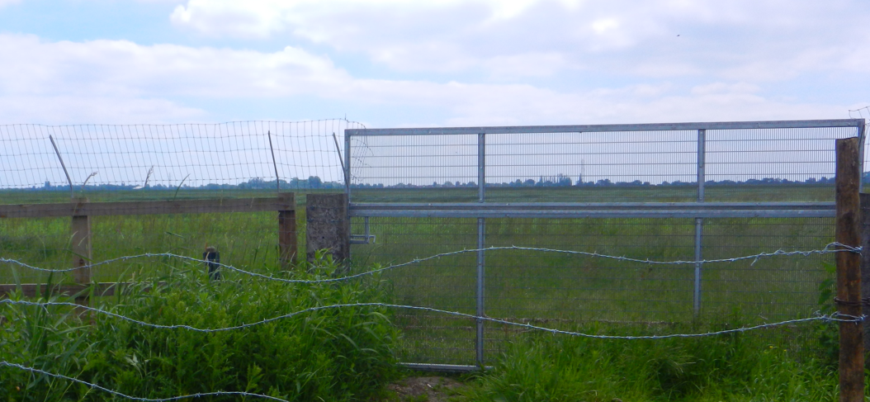
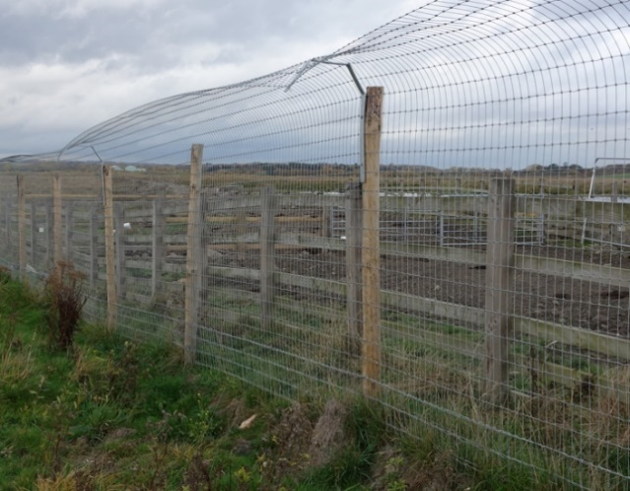
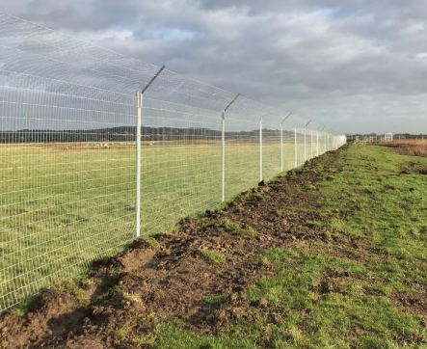
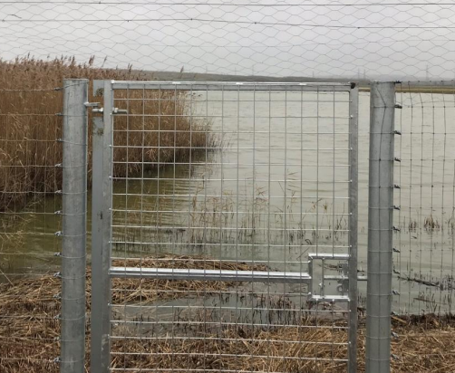
Figure 3 PVC-coated V Mesh fencing
Mesh extending slightly beyond length of extender brackets preferred
Arced overhang preferred
Extender brackets on alternate posts to provide floppy top
Metal Delta Post system preferred
Example of style of pedestrian gate
Figure 2 Images of predator exclusion fences

Are you able to meet this specification in full?
If so, please give details below
If not, please state any differences in service offered
Specification met? Yes /Part met / No (tick as appropriate)
Details

Standard Required Paperwork
To include:
- Risk Assessment
- Method Statement
- Construction Management Plan

Are you able to meet this specification in full?
If so, please give details below
If not, please state any differences in service offered
Specification met? Yes /Part met / No (tick as appropriate)
Details

Document D: Company Information

1.0 | General
1.1 | Registered Name  Trading Name (if different)
1.2 | Correspondence Details  Name of person applying on behalf of the company  Address:  Telephone:  Mobile:  Email:
 | Registered office Address (if different from above)
1.3 | Company Registration No (if applicable)  VAT registration number (if applicable)
1.4 | Date company was founded (if a limited company, date of incorporation)
1.5 | Company structure and nature of company  Please outline the nature of the company, whether it is a partnership, sole trader, plc etc.  Is the company proposed as party to the contract part of a larger organisation? If so please explain the relationship between the various parts of the organisation, up to the ultimate holding company.  Current number of full time equivalent staff currently employed by the company (not larger parent company)
1.6 | Accreditation by / Membership of Trade Association(s)  Is your Company registered with any industry accreditation body? YES NO  If yes, please provide details:  Is your Company on any public sector Framework agreements? YES NO  If yes, please provide details:  Please state membership of any professional bodies/ other associations below:
1.7 | Quality Assurance  Is all / part of your company ISO9001 Quality Assured? YES NO  Is all / part of your company ISO14001 Quality Assured? YES NO  If yes please provide copy of certification  Do you have any other Quality Assurance? If Yes, please summarise details below
1.8 | Environmental Commitments  Is all / part of your company registered under Science Based Targets Is all / part of your company registered or signed up to Science Based Targets (https://sciencebasedtargets.org/net-zero), SME Climate Hub (https://smeclimatehub.org/uk/), ISO 14064, ISO 14067 or a similar scheme to calculate and reduce your impact on the climate?  YES NO  If Yes, please summarise details below

2.0 | Financial & Business Probity
2.1 | Judgements etc.  Are there any judgements, claims or suits pending or outstanding against your company?  Yes No If Yes, please provide full details  Has your company ever failed to complete a contract?  Yes No If Yes, please provide full details
2.2 | Please answer all of the following questions as they apply to your Company’s circumstances. Please confirm that:  1) being a company, no resolution has been passed or Order of the Court made for the company’s winding up otherwise than for the purposes of bona fide reconstruction or amalgamation, nor has a receiver, manager or administrator on behalf of a creditor been appointed in respect of the company’s business or any part thereof, nor is it the subject of any proceedings for any of the above procedures, nor is it the subject of similar procedures under the law of any other state.  Confirmed Not confirmed Non-applicable  2) being a partnership, it has not granted a trust deed or become otherwise apparently insolvent, or it is not the subject of a petition presented for sequestration of its estate.  Confirmed Not confirmed Non-applicable  3) being an individual, you are not bankrupt, or have not had a receiving order or administration order made against you, or have not made a composition or arrangement or trust deed with or for the benefit of your creditors, or have not made any conveyance or assignment for the benefit of your creditors, or have not had a petition presented for sequestration of your estate or do not appear to be able to pay or to have no reasonable prospect of being able to pay a debt within the meaning of the Insolvency Act or any similar procedure under the law of any EC member state.  Confirmed Not confirmed Non-applicable  4) no Directors, Partners, Associates or the Company Secretary have been involved in any Company which has been liquidated or gone into receivership.  Confirmed Not confirmed Non-applicable  5) none of the Directors, Partners, Associates or the Company Secretary have been convicted of a criminal offence relating to the conduct of their business or profession.  Confirmed Not confirmed Non-applicable  6) neither the Company nor any of the Directors, Partners, Associates or Company Secretary has committed an act of grave misconduct in the course of their business or profession.  Confirmed Not confirmed Non-applicable  7) all obligations relating to the payment of taxes under the law of any part of the United Kingdom or the EC member state in which the Company is established has been fulfilled  Confirmed Not confirmed Non-applicable  8) all obligations relating to the payment of social security contributions under the law of any part of the United Kingdom or the EC member state in which the Company is established have been fulfilled.  Confirmed Not confirmed Non-applicable  If you have ticked ‘Not confirmed’ for any questions above please give details here

2.3 | Please list the names of any Director, Partner, Associate or Company Secretary who have been employed by the RSPB, giving department and dates.  Please give details of any Director, Partner, Associate or Company Secretary who have a relative who is employed by the RSPB at a senior level.  Please list the names of any Director, Partner, Associate or Company Secretary who have any involvement in other Companies who provide services to the RSPB  Is any work being undertaken or likely to be undertaken during the next three years by the Company or staff within it which could give rise to a conflict of interest through acting for third parties or otherwise? If yes, please explain the actual or likely circumstances and how such potential conflicts of interest would be handled.

2.4 | Insurances (a scanned copy of each certificate may be requested)
 |  | Insurer | Policy No | Value of Cover | Expiry Date
 | Employers Liability
 | Public Liability
 | Prof. Indemnity
All Risks
(if applicable)

2.5 | Has your company (or any building/project you have undertaken) won any awards, accolades or recognition?  YES NO If yes please provide full details.

3.0 | Health & Safety and Environment
3.1 | Has your company been served with any enforcement or prohibition notices or been prosecuted in the past 5 years for breaches of health & safety legislation?  YES NO If yes please provide full details.
3.2 | Has your company been served with any enforcement or prohibition notices or been prosecuted in the past 5 years for breaches of environmental legislation?  YES NO If yes please provide full details.
3.3 | Has your company been served with any enforcement or prohibition notices or been prosecuted in the past 5 years for breaches of data protection legislation?  YES NO If yes please provide full details.
3.4 | Have any restrictive clauses in relation to your company’s Employer’s Liability, Public Liability or Professional Indemnity Insurance policies been enforced in the last 5 years due to past Health & Safety performance?  YES NO If yes please provide full details.

Document E: Form of Offer

Cost
Please complete the attached Pricing Schedule spreadsheet.

Approach to the Project
What would be your approach to this project (including methods, any management and control procedures, quality assurance, resources etc.)? (Attach separate document if needed)

References
Suppliers are requested to provide details of three references from their existing clientele of hydrological projects on sensitive ecological sites, supplying full name, address, telephone number, email address, contact name, period of Contract and the estimated annual value of the Contract. In supplying this information, Suppliers shall have granted the RSPB permission to seek such information as deemed necessary, in relation to the Suppliers performance with their nominated references. Please attach further documents if you wish to show works in more detail.
Reference 1
Company Name
Address
Telephone No |  | Ext
Email
Contact |  | Dates of work
Nature of work done |  | Value of contract

Reference 2
Company Name
Address
Telephone No |  | Ext
Email
Contact |  | Dates of work
Nature of work done |  | Value of contract

Reference 3
Company Name
Address
Telephone No |  | Ext
Email
Contact |  | Dates of Work
Nature of work done |  | Value of contract

Document F: RSPB Terms and Conditions

The basis of the contractual agreement between RSPB and the applicant is detailed in the ‘RSPB Terms and Conditions of Purchase of Goods and Services’ – please click on this link to download. In applying for this tender you are explicitly agreeing to be bound by these Terms and Conditions for the duration of the contract. If you require any alterations to these Terms and Conditions please state your issues below. (Attach separate document if needed)

The RSPB expects that all suppliers it works with to adhere to certain ethical and environmental standards. Please download the RSPB Ethical and Environmental Procurement Policy and tick this box if you agree to be bound by its terms and conditions

An NEC3 Short contract will be used for this work. Therefore, the Terms and Conditions of this will also apply. Please contact ruth.gillies@rspb.org.uk if you required a copy of these.

Document G: Certificate of Bona Fide Offer

We certify that this offer is made in good faith, and that we have not fixed or adjusted the amount of the offer by or under or in accordance with any agreement of arrangement with any other person. We also certify that we have not, and we undertake that we will not:

1 a) communicate to any person other than the person inviting these offers the amount or approximate amount of the offer or proposed offer, except where the disclosure, in confidence, of the approximate amount of the offer was necessary to obtain insurance quotations required for the preparation of the offer;
b) enter into any agreement with any other person that s/he shall refrain from making an offer or as to the amount of any offer to be submitted;

2 pay, give or offer or agree to pay or to give any sum of money or other valuable consideration directly or indirectly to any person for doing or having done or causing or having caused to be done in relation to any offer or proposed offer for the goods/services any act or thing of the sort described in 1 a) or 1 b) above.

We acknowledge that if we acted or shall act in contravention of this certificate, the RSPB will be entitled to cancel the agreement and to recover from ourselves the amount of any loss and expense resulting from such cancellation.

I state that everything in this tender submission is truthful, that if found to be untruthful the RSPB can terminate any agreement between the RSPB and the company formed on the basis of this tender, and we will pay to the RSPB any loss or expenses the RSPB suffers as a result of such untruthfulness, whether an agreement is entered into or not.

In this certificate, the word “person” includes any persons and any body or association, corporate or unincorporated; “any agreement or arrangement” includes any transaction, formal or informal, and whether legally binding or not.

Signed
On behalf of
Date

Please note: a name added in an electronic document is functionally equivalent to a signature.

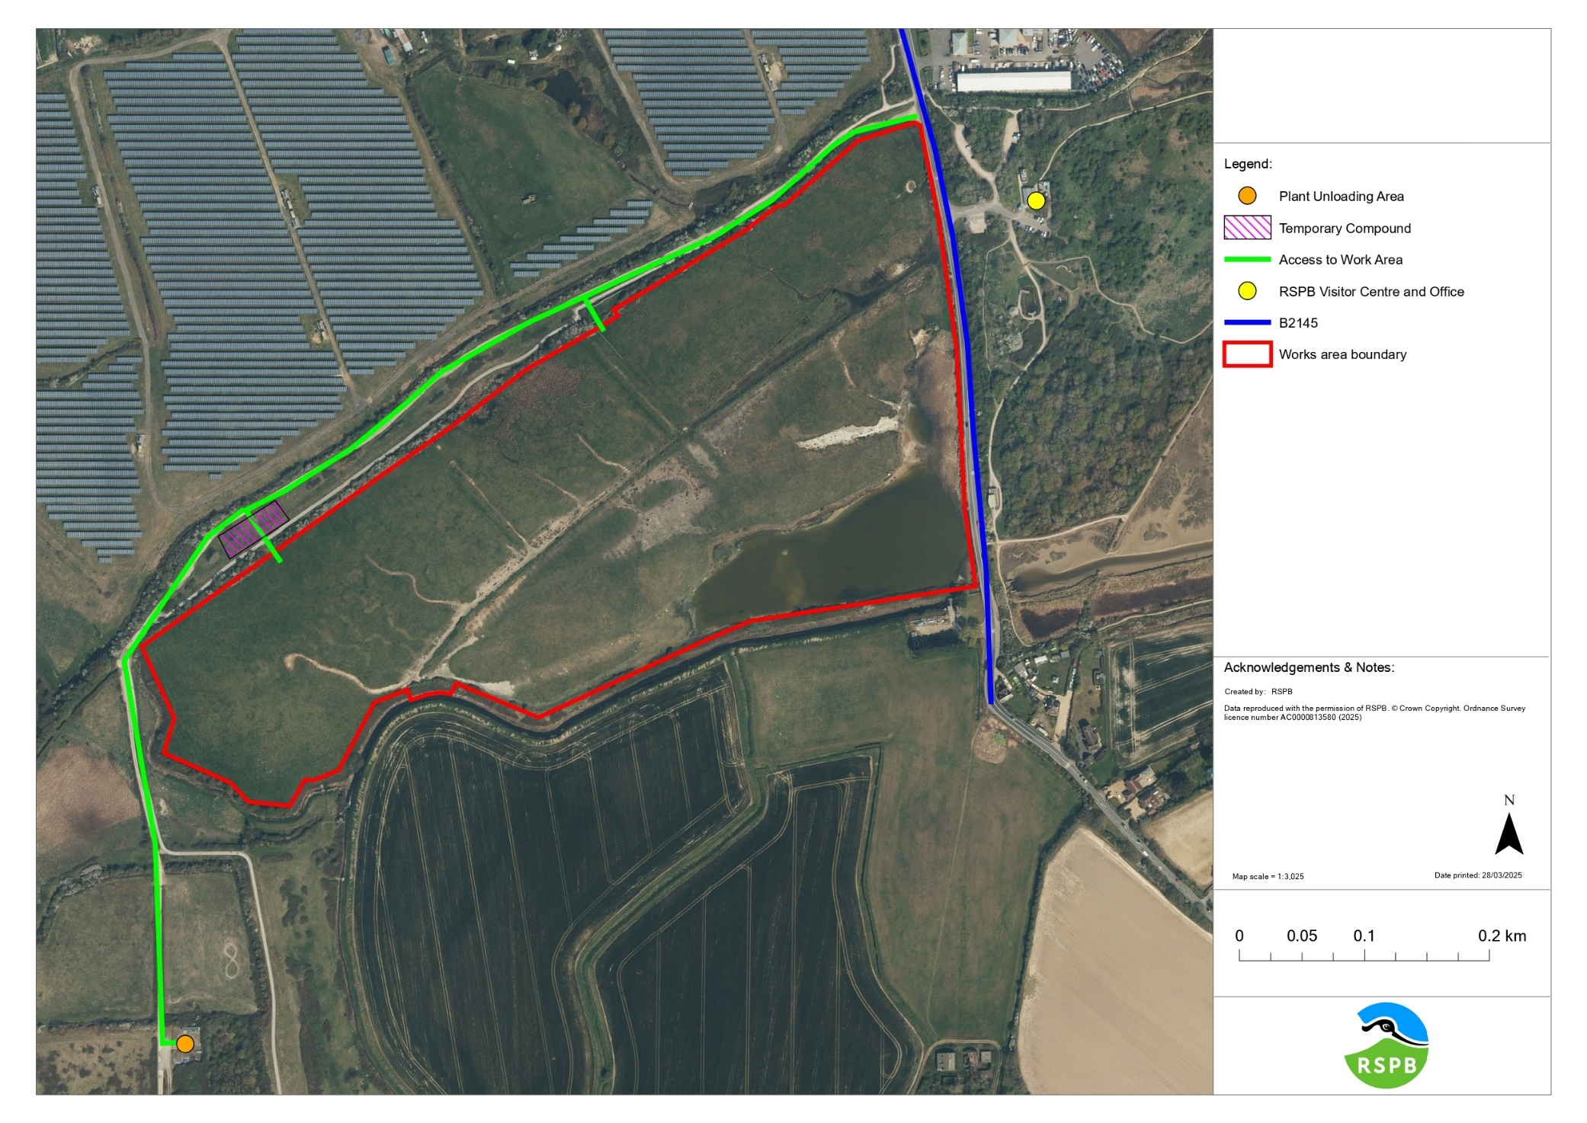
Annex 1: Site Maps
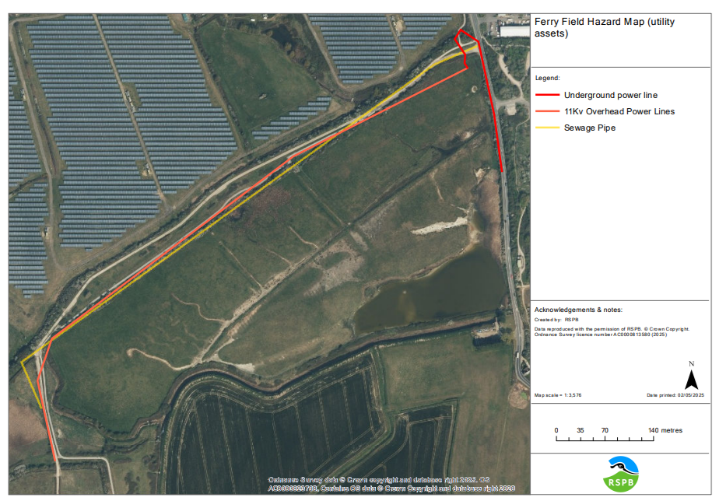

Annex 2: Works Maps

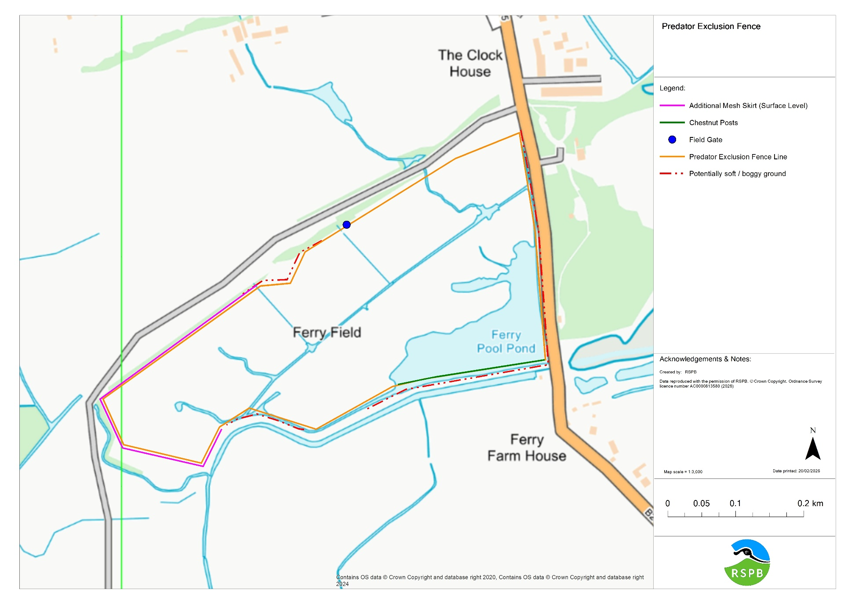
Map 1a: Predator Exclusion Fence

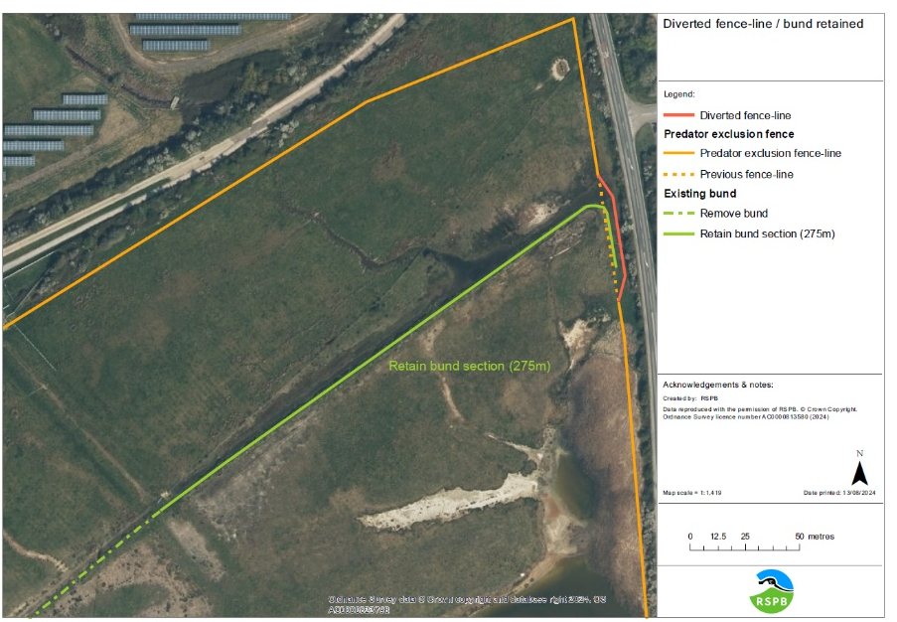
Map 1b: Predator Exclusion Fence – Water Vole Mitigation

