**Schedule 7A**

**Order Form for Standard Goods and Services – Direct Award**

**Cisco Support Renewal**

**Call-Off Contract under the HealthTrust Europe LLP Framework Agreement for the provision of Enterprise Level Information Communication Technology (ICT) Solutions for hardware, software, programs, applications, security, computer science, managed services, consultancy, support and associated services – 2019 (reference number: SF050716) dated 27th September 2019.**

|  |  |
| --- | --- |
| **The Authority** | **Manchester University NHS Foundation Trust,** Cobbett House, Manchester Royal Infirmary, Oxford Rd, Manchester M13 9WL, UK |
| **The Supplier** | **CDW Limited,** 1 New Change, London, EC4M 9AF, UK |
| **HealthTrust**  **Europe Contract Reference** | **HTE-005703** |
| **Commencement Date of the Contract** | **02/12/2022** |
| **Total Value** | **£** **49,216.07 (Exc. VAT)** |
| **Term of the contract** | **02/12/2022 to 31/03/2023** |

The Supplier and the Authority hereby agree as follows:

1. The Authority wishes to enter into a Contract in respect of the Goods and/or Services pursuant to the framework agreement between Health Trust Europe LLP and Supplier dated 27th September 2019 (the “Framework Agreement”).
2. The Contract incorporates, and the Supplier agrees to abide by, the following documents:
   1. The Specification of the Authority’s requirements as appended at Appendix 1 overleaf.
   2. the Contract Price, as appended at Appendix 2 overleaf; and
   3. the Call-Off Terms and Conditions set out at Appendix A to the Framework Agreement (including the front page and all Schedules thereto).
3. Where the Call-Off Terms and Conditions set out at Schedule 1 of Appendix A to the Framework Agreement apply, the Authority acknowledges and agrees to the HealthTrust Europe Key Provisions, in particular, as stated below for the avoidance of doubt:
4. In the event that the Authority terminates its agreement with HealthTrust Europe (made pursuant to the provisions of the UHCW Framework) for convenience or otherwise, and such termination takes effect before the end of the Initial Term (as defined in the UHCW Framework) or in the event that the Authority’s agreement with HealthTrust Europe (made pursuant to the provisions of the UHCW Framework) expires without being renewed on or after such Initial Term, HealthTrust Europe shall notify the Supplier of such termination or expiry in accordance with the provisions of Clause 16 of Schedule 1 of the Framework Agreement (“**Beneficiary Withdrawal Notice**”). Upon receipt of such Beneficiary Withdrawal Notice by the Supplier, the Supplier shall cease to apply for the benefit

of the Authority, the Contract Price or any special discounts in relation to such supply which applied solely by reason of the operation of the UHCW Framework and its associated services and/or framework agreements or any contract made between the Authority made pursuant thereto and further the Authority shall no longer be permitted to place Orders or benefit from the Contract Price, save with the prior written consent of HealthTrust Europe

1. The Authority acknowledges and agrees that the Supplier is subject to an activity-based income (ABI) management charge in relation to any Orders placed by the Authority under the Framework Agreement.
2. The Authority and the Supplier agree that (in addition to the Authority’s right to enforce the Contract) HealthTrust Europe may enforce any term of the Contract as principal in respect of ABI and Management Information and as agent on behalf of the Authority in respect of all other terms.
3. **The Commencement Date of the Contract shall be 02/12/2022**
   1. **Total Value £** **49,216.07 (Exc. VAT)**
   2. **The term of the contract will be 02/12/2022 to 31/03/2023**

The Term of this Contract shall be 4 months from the Commencement Date and may be extended in accordance with Clause 15.2 of Schedule 2 of the Call -Off Terms and Conditions provided that the duration of this Contract shall be no longer than 1 year in total.

1. Supplier shall use reasonable endeavours to deliver the Goods and/or Services under this agreement by the agreed delivery date.
2. The Services shall be provided, and Goods delivered by the Supplier at the Premises and Locations listed below:

MFT

Oxford Rd, Manchester M13 9WL

1. The payment profile for this Contract shall be 30 days from Invoice.
2. Use of Subcontractors

The Authority grants permission for the Supplier to Sub -contract any of its obligations/ specific obligations under this Framework Agreement. This shall not impose any duty on the Authority to enquire as to the competency of any authorised Sub-contractor. The Supplier shall ensure that any authorised Sub -contractor has the appropriate capability and capacity to perform the relevant obligations and that the obligations carried out by such Sub-contractor are fully in accordance with the Framework Agreement.

1. The end user license agreement (EULA) applicable to the relevant Software Product, as stipulated by the Manufacturer of that Product appended at Appendix 3 ( Not Applicable)
2. The Contract Managers at the commencement of this Contract are:

(a) for the Authority:

## Karen Flintoft

## Deputy Director of Informatics Commercial Services

## Trafford General Hospital, Davyhulme,

## Manchester, M41 5SL

1. for the Supplier:

Shamraz Khan, Account Director

1. Notices served under this Contract are to be delivered to:
2. for the Authority:

Manchester University NHS Foundation Trust Headquarters

Cobbett House

Oxford Road

Manchester M13 9WL

(b) for the Supplier:

[Legal@uk.cdw.com](mailto:Legal@uk.cdw.com)

1. In this Contract, unless the context otherwise requires, all capitalised words and expressions shall have the meanings ascribed to them by the Framework Agreement and/or Call-Off Terms and Conditions.
2. The following Appendices are incorporated within this Contract:

|  |  |
| --- | --- |
| Appendix 1 | Authority Specification |
| Appendix 2 | Contract Price |
| Appendix 3 | Change Control Process |
| Appendix 4 | Implementation Plan |
| Appendix 5 | Lease and/or Licence to access Premises and Locations - **Not used** |
| Appendix 6 | Step In Rights - **Not used** |
| Appendix 7 | Termination Sum - **Not used** |
| Appendix 8 | Staff Transfer - **Not used** |
| Appendix 9 | Software and End User License Agreement (EULA)]-**Not Applicable** |
| Appendix 10 | Key Performance Indicators- **Not used** |
| Appendix 11 | Subcontractors – **Not used** |

# Signed by the authorised representative of THE AUTHORITY

|  |  |  |  |
| --- | --- | --- | --- |
| Name: | Jiten Patel | Signature: |  |
| Position: | Director Of Technology (Acting) | Date: | 06/01/2023 |

**Signed by the authorised representative of THE SUPPLIER**

|  |  |  |  |
| --- | --- | --- | --- |
| Name: | Penny Williams | Signature | . |
| Position: | VP of Sales | Date: | 05/01/2023 |

**Appendix 1 Authority Specification**

|  |  |  |  |  |  |  |  |
| --- | --- | --- | --- | --- | --- | --- | --- |
| Product Number | Product Description | PAK/Serial Number | Service Level | Service Level Description | Start Date | End Date | Sum of Quantity |
| C9500-24Y4C-A | Catalyst 9500 24x1/10/25G and 4-port 40/100G, Advantage | CAT2334L03G | **L14HR** | CX LEVEL 1 24X7X4 | **02-Dec-2022** | **31-Mar-2023** | 1 |
| C9500-24Y4C-A | Catalyst 9500 24x1/10/25G and 4-port 40/100G, Advantage | CAT2336L0Y8 | **L14HR** | CX LEVEL 1 24X7X4 | **02-Dec-2022** | **31-Mar-2023** | 1 |
| C9500-24Y4C-A | Catalyst 9500 24x1/10/25G and 4-port 40/100G, Advantage | CAT2336L0YT | **L14HR** | CX LEVEL 1 24X7X4 | **02-Dec-2022** | **31-Mar-2023** | 1 |
| C9500-24Y4C-A | Catalyst 9500 24x1/10/25G and 4-port 40/100G, Advantage | CAT2336L143 | **L14HR** | CX LEVEL 1 24X7X4 | **02-Dec-2022** | **31-Mar-2023** | 1 |
| C9500-32C-A | Catalyst 9500 32-port 100G only, Advantage | FDO25120BL6 | **L14HR** | CX LEVEL 1 24X7X4 | **02-Dec-2022** | **31-Mar-2023** | 1 |
| C9500-32C-A | Catalyst 9500 32-port 100G only, Advantage | FDO25120BNL | **L14HR** | CX LEVEL 1 24X7X4 | **02-Dec-2022** | **31-Mar-2023** | 1 |
| C9500-48Y4C-A | Catalyst 9500 48-port x 1/10/25G + 4-port 40/100G, Advantage | FDO251105AY | **L14HR** | CX LEVEL 1 24X7X4 | **02-Dec-2022** | **31-Mar-2023** | 1 |
| C9500-48Y4C-A | Catalyst 9500 48-port x 1/10/25G + 4-port 40/100G, Advantage | FDO25110TZ9 | **L14HR** | CX LEVEL 1 24X7X4 | **02-Dec-2022** | **31-Mar-2023** | 1 |
| C9500-48Y4C-A | Catalyst 9500 48-port x 1/10/25G + 4-port 40/100G, Advantage | FDO251203PG | **L14HR** | CX LEVEL 1 24X7X4 | **02-Dec-2022** | **31-Mar-2023** | 1 |
| C9500-48Y4C-A | Catalyst 9500 48-port x 1/10/25G + 4-port 40/100G, Advantage | FDO2512041A | **L14HR** | CX LEVEL 1 24X7X4 | **02-Dec-2022** | **31-Mar-2023** | 1 |
| C9500-DNA-32C-A | C9500 DNA Advantage, Term License | (blank) | **L1SWT** | CX LEVEL 1 SW SUB | **02-Dec-2022** | **31-Mar-2023** | 2 |
| C9500-DNA-48Y4C-A | C9500 DNA Advantage, Term License | (blank) | **L1SWT** | CX LEVEL 1 SW SUB | **02-Dec-2022** | **31-Mar-2023** | 4 |
| C9800-40-K9 | Cisco Catalyst 9800-40 Wireless Controller | TTM2511007A | **L14HR** | CX LEVEL 1 24X7X4 | **02-Dec-2022** | **31-Mar-2023** | 1 |
| C9800-40-K9 | Cisco Catalyst 9800-40 Wireless Controller | TTM25110085 | **L14HR** | CX LEVEL 1 24X7X4 | **02-Dec-2022** | **31-Mar-2023** | 1 |
| C9800-40-K9 | Cisco Catalyst 9800-40 Wireless Controller | TTM25240225 | **L14HR** | CX LEVEL 1 24X7X4 | **02-Dec-2022** | **31-Mar-2023** | 1 |
| DN2-HW-APL-XL | DNA Center Appliance (Gen 2) | FCH2503L15J | **L14HR** | CX LEVEL 1 24X7X4 | **02-Dec-2022** | **31-Mar-2023** | 1 |
| DN2-HW-APL-XL-U | DNA Center Appliance (Gen 2)- 112 core for Promos | FCH2510L07J | **L14HR** | CX LEVEL 1 24X7X4 | **02-Dec-2022** | **31-Mar-2023** | 1 |
| SNS-3615-K9 | Small Secure Network Server for ISE Applications | WZP245012JR | **SSSNE** | SOLN SUPP 8X5X4 | **02-Dec-2022** | **31-Mar-2023** | 1 |
| SNS-3615-K9 | Small Secure Network Server for ISE Applications | WZP250107LY | **SSSNE** | SOLN SUPP 8X5X4 | **02-Dec-2022** | **31-Mar-2023** | 1 |
| SNS-3655-K9 | Medium Secure Network Server for ISE Applications | WZP245012L2 | **SSSNE** | SOLN SUPP 8X5X4 | **02-Dec-2022** | **31-Mar-2023** | 1 |
| SNS-3655-K9 | Medium Secure Network Server for ISE Applications | WZP245012LG | **SSSNE** | SOLN SUPP 8X5X4 | **02-Dec-2022** | **31-Mar-2023** | 1 |
| SNS-3655-K9 | Medium Secure Network Server for ISE Applications | WZP245012LM | **SSSNE** | SOLN SUPP 8X5X4 | **02-Dec-2022** | **31-Mar-2023** | 1 |
| SNS-3655-K9 | Medium Secure Network Server for ISE Applications | WZP245308L8 | **SSSNE** | SOLN SUPP 8X5X4 | **02-Dec-2022** | **31-Mar-2023** | 1 |
| SNS-3655-K9 | Medium Secure Network Server for ISE Applications | WZP2501005L | **SSSNE** | SOLN SUPP 8X5X4 | **02-Dec-2022** | **31-Mar-2023** | 1 |
| SNS-3655-K9 | Medium Secure Network Server for ISE Applications | WZP250107KS | **SSSNE** | SOLN SUPP 8X5X4 | **02-Dec-2022** | **31-Mar-2023** | 1 |

**Appendix 2 Contract Price**

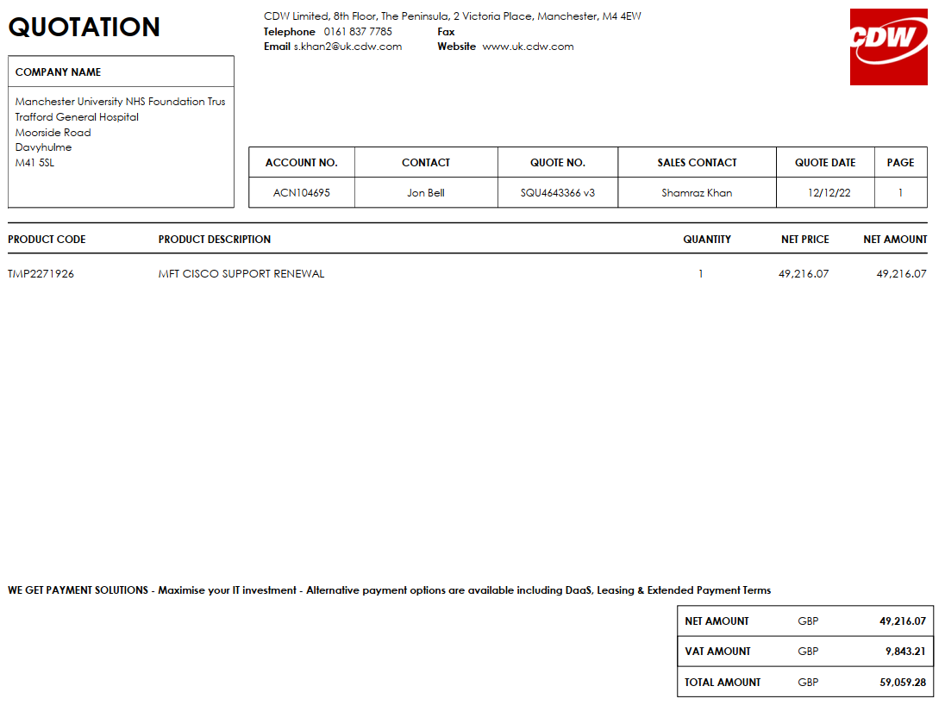

All prices exclude VAT

**Appendix 3**

**Change Control Process**

The Contract can be varied only by a change control note, defined under Section 42 of Appendix A Call-off Terms and Conditions, which explicitly states it is intended to vary this Contract, and which is signed by an authorised representative of each Party. Each Party may from time to time notify the other in writing as to who is the point of receipt of that notification and an authorised representative for that Party.



**Appendix 4**

**Implementation Plan**

To be agreed at Project Initiation

**Appendix 9**

**Software and EULA**

Not applicable