Appendix 1

WITHYHAM PARISH COUNCIL

Request for Quotation (RFQ)
For Groombridge Recreation Ground Play Area Rejuvenation:
(Play area equipment &/or Fencing &/or Surfacing)

Appendix 1: Detailed Specification

Note: This Appendix 1 forms a legal and binding part of the
Request for Quotation
Ref WPCGRG/App1/2020

Withyham Parish Council
The Old Station
Station Road
Groombridge
East Sussex
TN3 9RD

Appendix 1
Groombridge Recreation Ground Play Area Rejuvenation:
(Play area equipment &/or Fencing &/or Surfacing)

1 Play Area Location: Recreation Ground, Station Road, Groombridge TN3 9QY

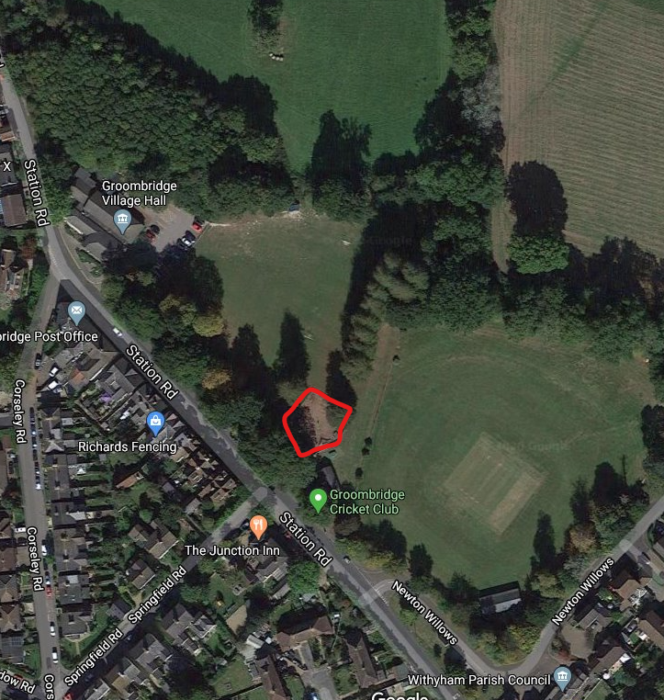
Site of play area
Cricket Ground Ground
Recreation Ground
Figure 1: Map showing the site of the existing play area (and site of proposed play area) on Groombridge Recreation Ground

The requirements for each of the three components (Fencing, Equipment and Surfacing) are tabulated below. Contractors may submit tenders for 1, 2 or all 3 elements but should make each one separately:

- Fencing Specific Requirements
Component | Item | Task | Details | Notes
Fencing | A circular palisade incorporating towers, fort like in its appearance | Purpose built palisade and towers | Design, supply and install fencing.  This is in the form of a circular palisade incorporating towers, which is fort like in its appearance | The Planning application describes:  The top of the timber balustrade around the palisade is 3.6 metres above ground level.  At the four ‘turrets’, the eaves height is 4.6 metres and the apex of the pyramidal roof is 6.06 metres. The proposed ‘turrets’ are 2150mm square. The overall diameter of the proposed enclosure is 28.5 metres  Architects plans (Appendix 2) show intended design  The design received planning permission from Wealden District Council WD/2019/2359/F. During consultation on this application, some members of the public raised concerns about being able to see in or out of the play area so we would be happy to receive tenders containing modifications that have lower elements facing towards the recreation ground (retaining height towards the cricket ground to give protection from balls), and/or more open boarding to the fencing all the way round

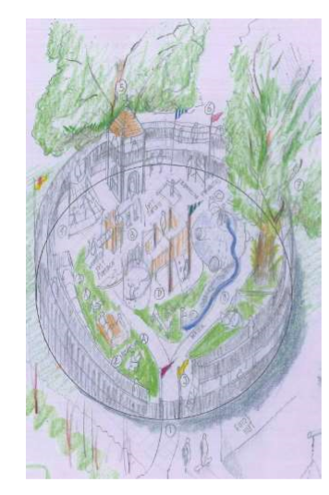 | Figure 2  An early sketch proposal for the new surrounding structure to the playground. As well as forming a promenade, the high level part of the structure will mean that there can be rope walks, slides, and climbing nets from the ground to the upper level.
- Equipment Specific Requirements
Component | Item | Task | Details | Notes
Play equipment | Items of play equipment | New equipment | Remove existing equipment and dispose  Supply and install new play equipment | Figure 2 above is an impression and deliberately includes more ideas than we could actually fit into the given area.  We would therefore welcome suggestions in order to achieve the best possible project  The architect has indicated that some equipment should utilise the fence/palisade structure, for example rope walks, slides, and climbing nets from the ground to the upper level.  Activities for smaller children would likely be towards the middle of the palisade.  Rather than providing a list of equipment the tender proposal should advise on a set of equipment that would:  - Utilise the surrounding palisade/towers where appropriate  - Develop a range of skills  - Allow a range of play such as jumping, swinging, sliding, climbing, balancing  - Be appropriate for a range of ages up to 12  - Be appropriate for a range of abilities/disabilities  - Include some sensory provision  - Allow for an appropriate level of risk taking

- Surfacing Specific Requirements
Component | Item | Task | Details | Notes
Surfacing | Surfacing across the extent of the new play area footprint | New surface | Remove and dispose of existing wood chip  Supply and install wet pour or bonded mulch | Wet pour or bonded mulch to be in a single, natural colour in order to fit with the natural environment  Surfacing to cover the extent of the new play area footprint

