

Request for Quotation

Solent & Isle of Wight Intertidal Seagrass Survey

26th May 2023

Contents

Request for Quotation 2

Glossary 2

Conditions applying to the RFQ 3

Acceptance of Quotations 3

Costs 3

Mandatory Requirements 3

Clarifications 3

Amendments 3

Conditions of Contract 3

Specification 4

Award Stage 18

Appendices 22

# Request for Quotation

This bid is for a survey of the intertidal seagrass beds within Solent and the Isle of Wight.

You are invited by Natural England (the Authority), to submit a quotation for the requirement described in the specification below.

Please submit your quotation via email to [Connor.Reid@naturalengland.org.uk](mailto:Connor.Reid@naturalengland.org.uk) and [Jessica.Taylor@naturalengland.org.uk](mailto:Jessica.Taylor@naturalengland.org.uk) on or before the deadline given below; Submissions will be opened at the same time after the submission deadline to ensure fairness.

|  |  |
| --- | --- |
| **Action** | **Date** |
| **Date of publication of RFQ** | **26 May 2023** |
| **Deadline for submission of clarification questions** | **12 noon on 09 June 2023** |
| **Deadline for receipt of Quotation** | **12 noon on 16 June 2023** |
| **Evaluation of bids** | **Week commencing 19 June 2023** |
| **Intended date of Contract Award** | **21 June 2023** |
| **Intended Contract Start Date** | **23 June 2023** |
| **Intended Delivery Date / Contract Duration** | **23 June 2023 – 15 March 2024** |

# Glossary

Unless the context otherwise requires the following words and expressions used within this Request for Quotation shall have the following meanings (to be interpreted in the singular or plural as the context requires).

|  |  |
| --- | --- |
| **Words/Expression** | **Meaning** |
| **“Authority”** | **Means Natural England acting as part of the Crown.** |
| **“Contract”** | **Means the contract to be entered into by the Authority and the successful supplier** |
| **“RFQ”** | **Means this Request for Quotation and all related documents published by the Authority and made available to suppliers** |

# Conditions applying to the RFQ

You should examine your quotation response to the RFQ and related documents ensuring it is complete prior to submitting your completed quotation.

Your quotation must contain sufficient information to enable the Authority to evaluate it fairly and effectively. You should ensure that you have prepared your quotation fully and accurately and that prices quoted are arithmetically correct for the units stated.

# Acceptance of Quotations

By issuing this RFQ the Authority does not bind itself to accept any quotation and reserves the right not to award a contract to any supplier who submits a quotation.

# Costs

The Authority will not reimburse you for any costs and expenses which you incur preparing and submitting your quotation, even if the Authority amends or terminates the procurement process.

# Mandatory Requirements

The RFQ includes mandatory requirements and, if you do not comply with them, your quotation will not be evaluated.

# Clarifications

The Authority reserves the right to discuss, confidentially, any aspect of your quotation with you prior to any award of Contract to clarify matters.

# Amendments

The Authority may amend the RFQ at any time prior to the deadline for receipt. If it amends the RFQ the Authority will notify you in writing and may extend the deadline for receipt in order to give you a reasonable time in which to take the amendment into account.

# Conditions of Contract

The terms and conditions attached [Condensed Terms and Conditions](https://www.gov.uk/government/organisations/natural-england/about/procurement) will be included in any contract awarded as a result of this RFQ process. The Authority will not accept any material changes to these terms and conditions proposed by a supplier.

# Specification

1. **Background to Natural England**

Natural England (NE) is the government’s advisor on the natural environment. We provide practical advice, grounded in science, on how best to safeguard England’s natural wealth for the benefit of everyone.

NEs remit is to ensure sustainable stewardship of the land and sea so that people and nature can thrive. It is NEs responsibility to see that England’s rich natural environment can adapt and survive intact for future generations to enjoy.

Further information on the Authority can be found at: [Natural England](http://www.naturalengland.org.uk/)

1. **Site Background and Survey Areas**

The Solent waterbody is composed of a myriad of designated sites, all of which have been designated for a wide range of habitats and species. Some of these sites are host to ecologically significant intertidal seagrass *Zostera* sp. either as a designated feature in its own right or as supporting habitat for bird species. These sites are:

Designated feature:

* Solent Maritime Special Area of Conservation

Supporting Habitat

* Chichester and Langstone Harbours Special Protection Area (SPA)
* Solent and Southampton Water SPA
* Portsmouth Harbour SPA

This bid is for a phase one survey of intertidal seagrass across the Solent. Figures 2.1 to 2.8 below show current known locations of mapped seagrass in more detail, as well as the current extent of seagrass at each site. However, your response should indicate how you would design a cost effective sampling strategy to conduct a broader survey of the areas as Natural England are aware of beds that have not been previously mapped (for example The Kench in Langstone Harbour). Natural England recommend also viewing the national seagrass layer on [Magic Map Application](https://magic.defra.gov.uk/MagicMap.aspx) for more detailed maps of current and historical records to inform your survey design.

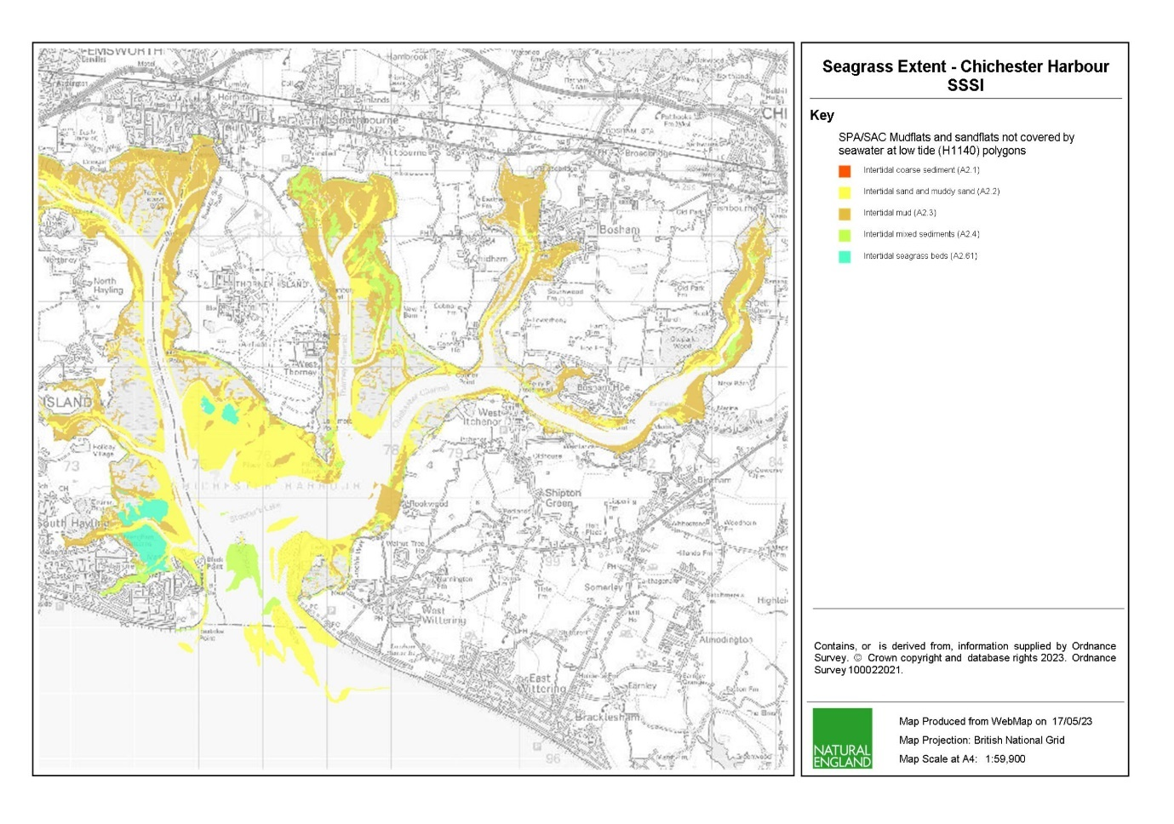

*Figure 2.1 – Current Seagrass extent and Mudflat/Sandflat composition for Chichester Harbour*

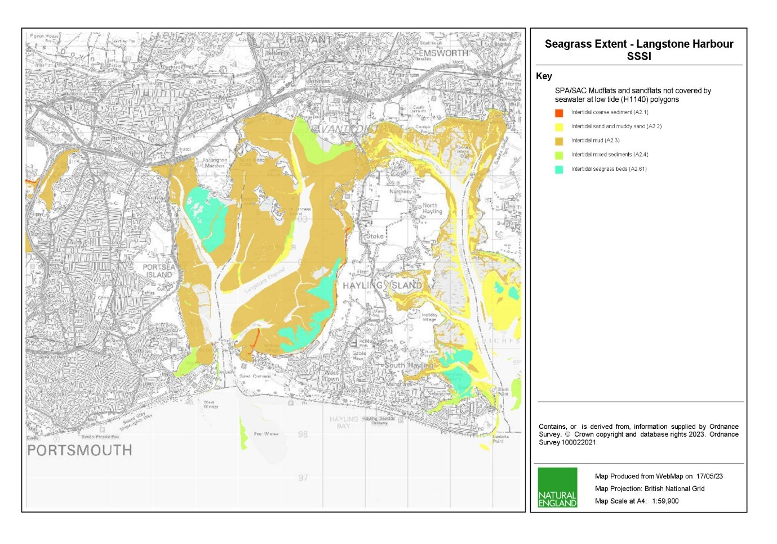

*Figure 2.2 – Current Seagrass extent and Mudflat/Sandflat composition for Langstone Harbour*

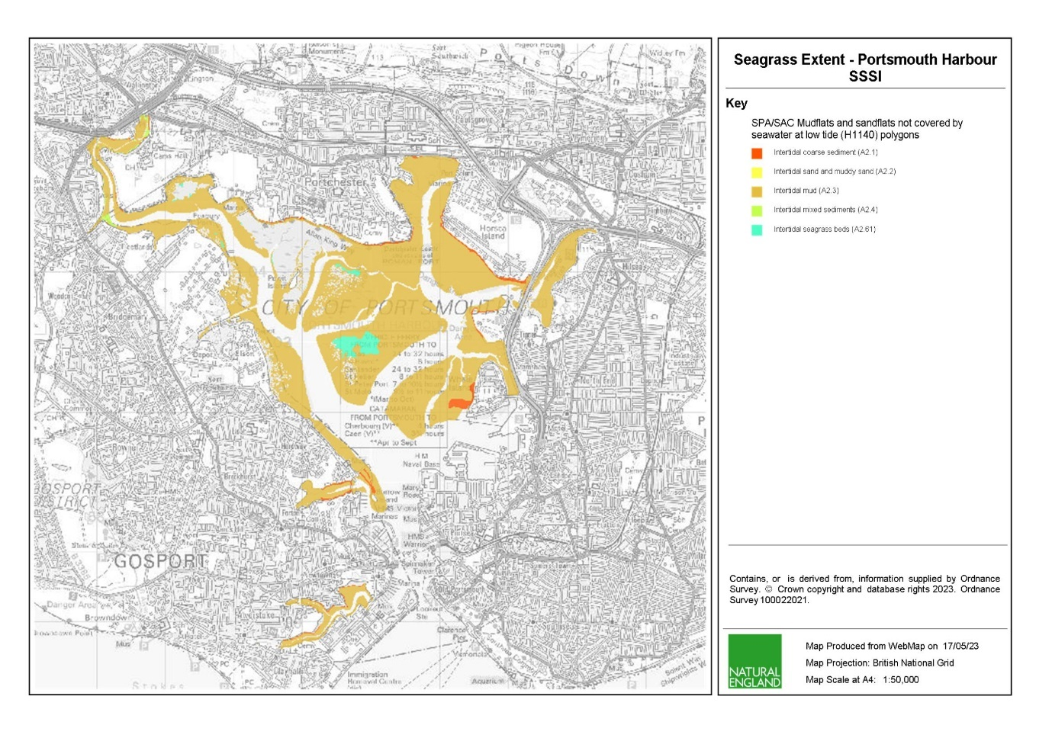

*Figure 2.3 – Current Seagrass extent and Mudflat/Sandflat composition for Portsmouth Harbour*

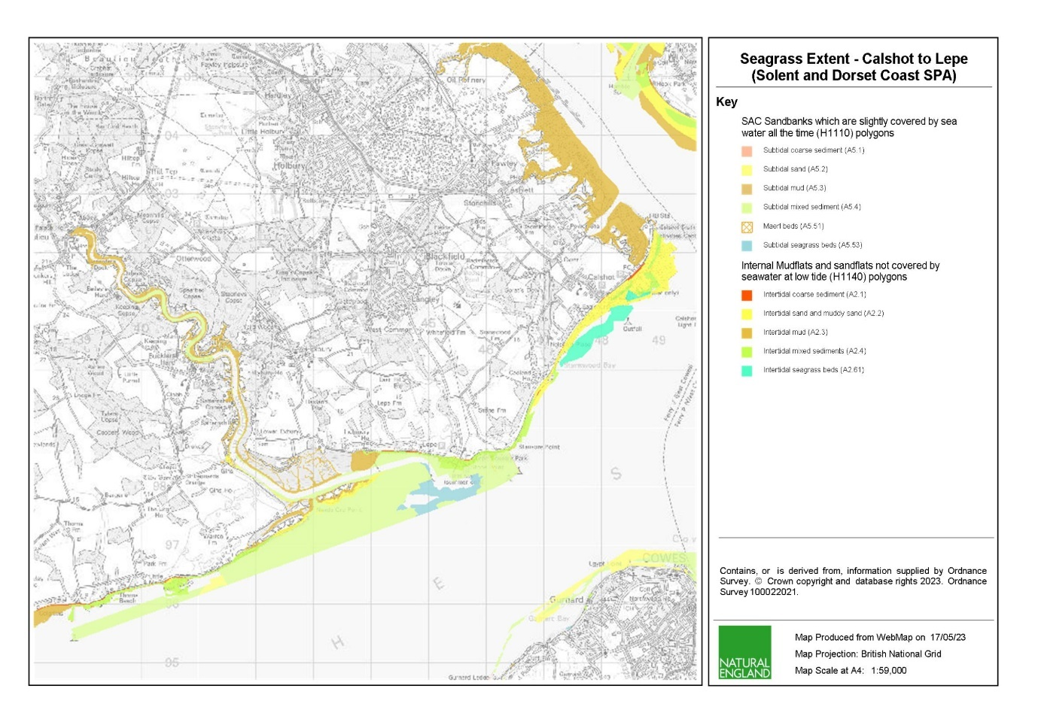

*Figure 2.4 – Current Seagrass extent and Mudflat/Sandflat composition for Calshot to Lepe*

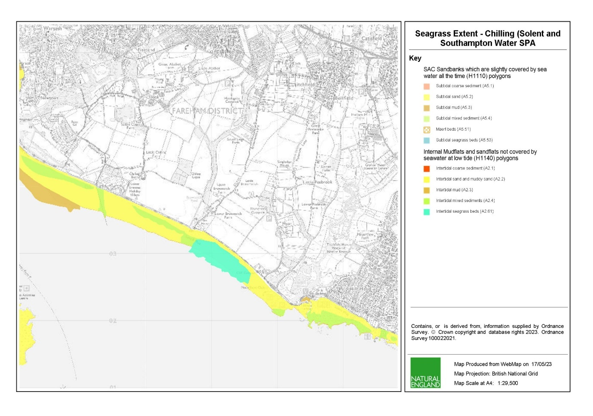

*Figure 2.5 – Current Seagrass extent and Mudflat/Sandflat composition for Chilling*

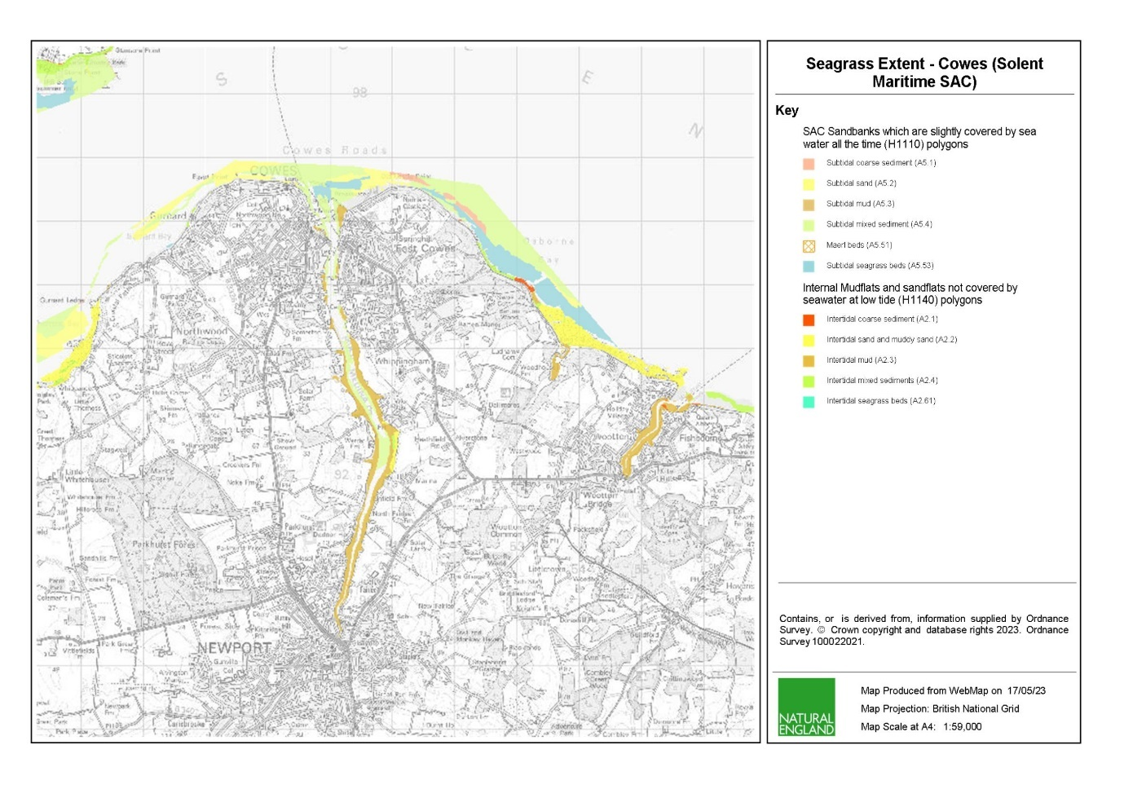

*Figure 2.6 – Current Seagrass extent and Mudflat/Sandflat composition for Cowes*

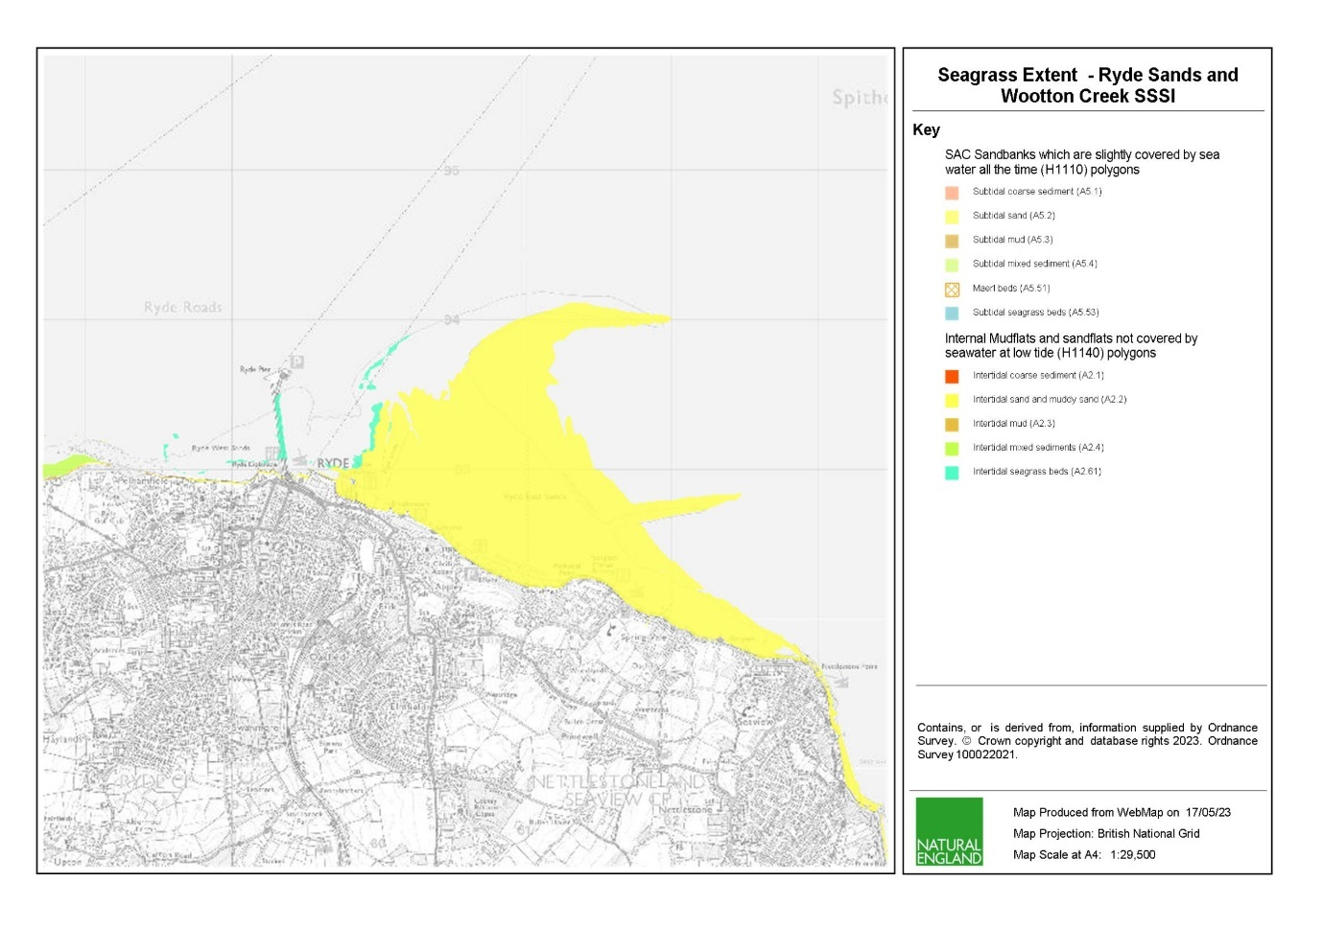

*Figure 2.7 – Current Seagrass extent and Mudflat/Sandflat composition for Ryde Sands and Wootton Creek*

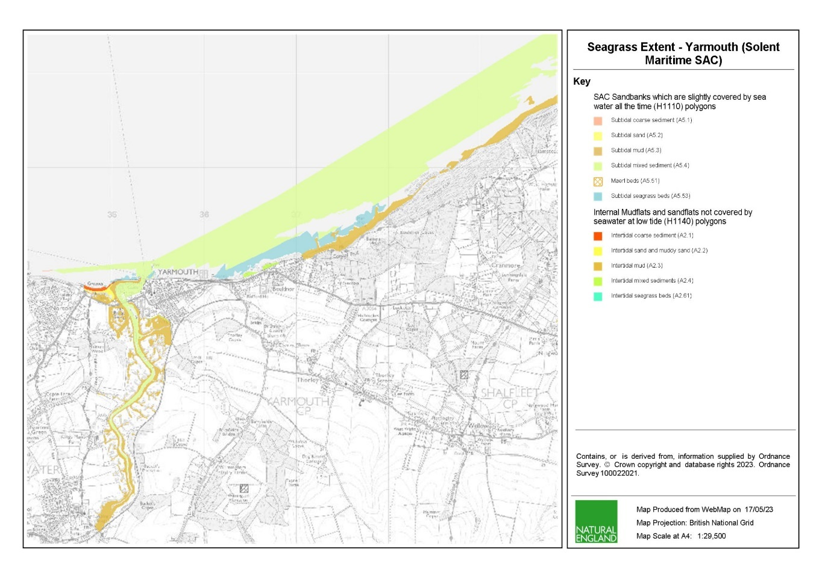

*Figure 2.8 – Current Seagrass extent and Mudflat/Sandflat composition for Yarmouth*

1. **Previous Surveys**

Supporting datasets are available on request from Natural England. Applicants may also find useful the national seagrass layer filter on Defra’s [Magic Map](https://magic.defra.gov.uk/MagicMap.aspx) for current and historical extent of seagrass.

Seagrass beds within the Solent and Isle of Wight have been surveyed by Hampshire and Isle of Wight Wildlife Trust (HIWWT) and others on a near annual occurrence for seagrass (See references and surveys below). There are over 200 hectares of intertidal seagrass beds in the Solent Maritime SAC, with the largest beds being found in Langstone and Chichester Harbours and along the north coast of the Isle of Wight  (Marsden and Chesworth, 2014), ([Marsden and Chesworth, 2015](javascript:refPopup(%22Reference%22,%22%3ca%20href=@http://www.hiwwt.org.uk/sites/default/files/files/Reports/Eelgrass-Section%201_Report_2015_92pp_FINAL.pdf@%20target=@Reference@%3eMarsden,%20A.%20L.%20and%20Chesworth,%20J.%20C.%202015.%20Inventory%20of%20eelgrass%20beds%20in%20Hampshire%20and%20the%20Isle%20of%20Wight%202015,%20Section%20One:%20Report.%20Version%207:%20May%202015.:%20Hampshire%20and%20the%20Isle%20of%20Wight%20Wildlife%20Trust.%20%3c/a%3e%22))), (Hampshire & Isle of Wight Wildlife Trust, 2013), (Isle of Wight County Council, 2004). (Centre for Marine and Coastal Studies Ltd. (CMACS), 2012), (ERT Ltd Marine Environmental Consultants, 2005). Surveys have also recorded three species of seagrass in intertidal areas of Solent Maritime SAC: dwarf eelgrass (*Zostera noltii*), common eelgrass (*Zostera marina*) and beaked tasselweed (*Ruppia maritima*) (Marsden and Chesworth, 2015), (Hampshire & Isle of Wight Wildlife Trust, 2014).

Please note that, where possible, the previous surveys stated in this specification should be incorporated into this funded survey, as the tenderer updates the established baseline. Any deviance from previous methodologies is not necessarily discouraged, but the benefits either for data or cost reduction must be explained. Please find below a list of relevant previous surveys:

* Centre for Marine and Coastal Studies - Solent Maritime SAC intertidal survey report 2012
* HIWWT - Inventory of eelgrass beds in Hampshire and the Isle of Wight 2014
* HIWWT - Inventory of eelgrass beds in Hampshire and the Isle of Wight 2015
* HIWWT – Solent SAC and Isle of Wight Eelgrass Surveys 2018
* Isle of Wight County Council - Distribution of Zostera beds around Ryde Sands and Osborne Bay; northeast Isle of Wight 2004
* LIFE Recreation ReMEDIES – River Medina and Osborne Bay, Isle of Wight Subtidal Seagrass Surveys 2020
* University of Brighton - A biological survey of the Intertidal sediments of Lee-on-the-Solent to Itchen Estuaries, Medina Estuaries, North Solent, Thanet Coast and Thorness Bay Sites of SSSI for the purpose of SSSI condition assessment 2009

1. **Aims**

Natural England wishes to commission ecological survey work at all specified sites in summer 2023 (August – September), to assess the current extent and condition of all seagrass habitats and communities at the peak of their natural cycle. In short, the monitoring required should assess the condition of intertidal seagrass beds. Please find below attributes which Natural England assess:

* Distribution: presence and spatial distribution of biological communities: mapping and biotope assignment should be taken to species level (e.g. *Z. noltii* or *Z. marina*)
* Density (% cover) and shoot length
* Extent and Distribution
* Sediment composition and distribution across the sub feature: Please note it is not anticipated that particle size analysis will be conducted as part of this contract.
* Non-native species and pathogens across the sub feature: This should include signs of wasting disease
* Water quality – nutrients: abundance of macroalgal matts across the subfeature
* Map signs of any anthropogenic pressures: This should include, but not be limited to, anchoring or mooring scars, bait digging, hand gathering of shellfish resource and trampling.

The information must be of sufficient quality to provide a comparison with previous surveys. Surveys of littoral sediment habitats should adhere to methodologies and best practice measures as outlined in [JNCC Common Standards Monitoring Guidance for Marine](https://hub.jncc.gov.uk/assets/9b4bff32-b2b1-4059-aa00-bb57d747db23).

Natural England are seeking tenderers to pay particular attention to survey design so that qualitatively robust data is acquired which will permit rigorous statistical analysis and support robust condition assessment judgements of the designated sites.

Should tenderers identify limitations or positive improvements within the survey design these suggestions should be indicated. In doing so tenderers should consider the costs and benefits offered by an alternative survey design and incorporation of existing sites to allow historical comparison of data. **You should indicate any cost savings in your tender bid.**

The survey should:

* Continue with a statistically rigorous and repeatable programme of monitoring across the site which in future years can be repeated, in order to quantify and assess community changes and inform assessments of feature condition.
* As previous data is available data acquired must seek to enable assessment of change in community and sub-feature extent and thereby inform an assessment of feature condition against those attributes listed above.

1. **Objectives**

**5.1 General Objectives**

1. Characterisation survey of intertidal seagrass extent, distribution, and density across all sites, using the common standards monitoring guidance
2. Surveys could include a combination of on-the-ground techniques (ie. Walkovers, hovercraft, sampling sites or otherwise) across each specific site.
3. Evaluate the effectiveness of data collection methods, techniques, and equipment
4. Provide an assessment of the direction of ecological change at all sites by the integration of previously obtained relevant data
5. During the survey, note any areas of particular abundance of macroalgae on seagrass features across the selected sites
6. Ensure that the survey can be replicated for future comparison by providing fully detailed data collection methods and operating protocols
7. Throughout the survey process, identify and record any anthropogenic influences impacting on identified feature’s ability to achieve favourable condition, quantifying and mapping where possible
8. To report the detailed findings of the project in succinct and clear final reports, with appropriate GIS outputs

Surveys should be designed and conducted to ascertain the direction of ecological change, allowing comparison to previous data gathered where available. Surveys should result in data which allows Natural England an ecological baseline with which to judge favourable status of seagrass species for each specific site.

**5.2 Specific Objectives**

To undertake a cost-effective survey strategy, like that established in 2014 by HIWWT, to obtain ground-truthed data that uses the Common Standards Monitoring Guidance and assessed against relevant attributes. As a good baseline of intertidal seagrass beds exist for the area it is anticipated that this previous data will be utilised to reduce time in the field and reporting. **You should indicate in your tender bid what these cost savings could be.**

* + 1. Seagrass Attributes are:

1. Distribution: presence and spatial distribution of biological communities: mapping and biotope assignment should be taken to species level (e.g. *Z. noltii* or *Z. marina*)
2. Extent and Distribution
3. Density (% cover of seagrass in sample stations) and shoot length
4. Sediment composition and distribution across the sub feature
5. Non-native species and pathogens across the sub feature (% cover of any concerning non-natives at walkover sites, to be discussed with the case officer prior to surveying). Please note *Arcuatula senhousia* or the Asian Date Mussel has been recorded within seagrass beds within the Solent. This species is of particular concern for seagrass restoration in the area and so particular note should be taken if this species is found.
6. Water quality – nutrients: abundance of macroalgal matts across the sub feature (take notes of any highly affected seagrass beds to this pressure in walkovers)

For further details on these attributes please refer to the [Solent Maritime SAC Conservation Objectives.](https://publications.naturalengland.org.uk/publication/5762436174970880)

This survey work and subsequent analysis will contribute to Natural England’s statutory duty to monitor and report on a range of features and attributes for designated sites.

1. **Methods**

**6.1 Pre-survey Deskwork**

Before the survey is carried out the successful Contractor will discuss any pre-survey work with the Natural England project officer, including:

1. Clarification of roles, responsibilities and expectations
2. Acquisition and checking of sources of relevant information and gathering of local advice in preparation of a project plan
3. Review existing information provided by Natural England or any datasets known to the contractor.
4. Ways of working and close collaboration with NE in developing project plan, particularly selection of survey sites, taking account of NE/EA pre-survey scoping work, and finalising survey design and methodologies.

**6.2 Development of a Suitable Sampling Design**

The successful contractor will need to develop an appropriate mapping strategy design in order to meet the aims of the project outlined above. The full detail of this design will be provided to, and subsequently owned by Natural England.

In developing an appropriate habitat mapping strategy contractors should not be bound to simply repeat the previous methodology undertaken; rather they should seek to implement an improved approach which enables a comparison with existing data but at the same time delivers Natural England’s requirements for a more statistically robust approach.

Tenderers should make the best use of available GIS datasets in the design of their project plan and sampling process. Natural England will be able to provide the following GIS datasets under license to the successful contractor for use in this contract:

* Base map data from Ordnance Survey
* Imagery from Next Perspectives
* Environmental data from Environment Agency
* Site specific datasets

**6.3 Site access**

Survey work will not be able to begin until access permissions have been obtained.

The successful contractor may be expected to obtain permission from seabed owners or leaseholders for survey work on the seabed. Information on ownership and tenancy can be supplied by the Natural England Project Officer. Verbal authority for entry onto privately owned land from the relevant owner\occupier may suffice but should be fully documented and made available to the Natural England project officer. Each member of the survey team must carry a letter from Natural England to confirm that they are doing this work on the behalf of Natural England.

The Natural England project officer should be contacted on commencement of any fieldwork.

**6.4 Protected Species Licencing**

The successful Contractor should ensure that all appropriate marine and protected species licences and legal requirements (such as a Habitats Regulations Assessment) for the survey have been attained and are valid before the survey commences. The Natural England Project Officer will support this process.

**6.5 Field Survey – Methodology**

**Natural England envisages that the required survey work under this specification should be completed within ten days before end of September 2023, where seasonal dieback begins to occur in seagrass species. Walkover surveys should be carried out across all sites.**

Information in the Marine Monitoring Handbook (Davies et al., 2001) <http://jncc.defra.gov.uk/page-2430> should provide the basis for sampling procedures in the field.

Proposed dates for survey work under the contract to be scheduled and completed and contingency dates should be included in the quotation response e.g. in case of weather downtime. A maximum of one day weather downtime will be paid for by Natural England.

**6.5.1 Walkover Surveys**

Walkover surveys should be consistent with the Marine Monitoring Handbook.

Walkover surveys should map bed extent using the accepted >5% shoot density for a continuous bed. Georeferenced photographs should be taken at regular intervals and in 50 x 50 cm quadrats where possible for percentage cover estimation. GPS survey tracks must be recorded.

**6.6 Invasive Non-Native Species**

Invasive non-native species (INNS) are considered to be one of the top five pressures directly driving biodiversity loss globally. Prevention is the key focus, particularly in marine environments. The contractor needs to be aware of and work in accordance with standard good practice biosecurity measures to avoid spread of INNS:

* Equipment, clothes and boots should be clean before carrying out any work on site
* When on or near water it is important that equipment is drained after use and as far as possible dried
* Dry all clothes and boots thoroughly
* Boats or other watercraft (e.g. hovercraft) to be used in survey work should have their hulls cleaned on a regular basis. Best practice guidelines should be followed as outlined by The Green Blue

A statement of biosecurity measures that the successful Contractor will undertake is required with the tender.

The successful Contractor shall report any records of INNS observed on site to the Marine Biological Association <http://www.mba.ac.uk/recording> and to the Natural England project officer. More information and guidance including ID guides can be found at [www.nonnativespecies.org](http://www.nonnativespecies.org) and the [Marine Aliens Project](http://www.marlin.ac.uk/marine_aliens/)

**6.7 Risk Assessments**

All risk assessments for mini tenders need to be seen and signed off by the project leads (ideally when presented with their project plan), as part of the contract management process.

**6.8 Data Analysis**

Natural England expect that robust and appropriate statistical analysis is employed as required, and the results presented and briefly discussed with the Natural England project officer. An explanation of why certain methods have been chosen should be appended, and a brief justification of any relevant assumptions supplied. GIS should be used to present any geographical information and data gathered or created during the project. Base mapping including OS tiles and aerial photographs can be provided by Natural England under licence if required.

The results should be compared to those previous surveys and other relevant papers (including appropriate statistical analysis) and any changes set into context using other existing information. Where possible, conclusions should be drawn as to the relative status of the condition of features as well as the status of the sub-features (using Natural England Guidance).

**6.9 Data Outputs and Management**

All project outputs should be delivered to agreed deadlines.

Data must be interpreted, analysed and presented in light of the overarching hypotheses stated above. Tenderers should pay particular consideration to the data and GIS required formats for information compatibility including MEDIN metadata standards and Marine Recorder provision:

* + - 1. All data needs to be entered into Marine Recorder and delivered with the final reports. Natural England will provide licence keys for Marine Recorder to the successful Contractor for use in this contract. A Snapshot file of the data should also be provided. <https://www.esdm.co.uk/marine-recorder>. Guidance ‘Marine Recorder Evidence for Contractors’ will be provided to the successful Contractor.
      2. All GIS datasets need to be provided in ESRI ArcGIS format compatible with ArcGIS 10.2 and have attached metadata compliant with MEDIN metadata standard.
      3. All GIS files containing habitat data for each individual survey need to be produced to the MESH translated habitat data exchange format to the most detailed EUNIS habitat level possible. MNCR (04,05) data should be added to the ORIG_HAB column. The GUI provided by Natural England for each survey will be used, and as much information as possible (survey name, originally assigned feature/habitat name etc.) from the original dataset, as well as any documentation provided (where available) should be included in the resulting datasets to maintain a useful audit trail. Where MESH GUI references are identical, the datasets should be combined and treated as a single survey record. As specified in the MESH data exchange format, data files must be provided as ESRI Shapefiles using geographic coordinates (lat/long) and the WGS84 datum. If the datasets supplied are in other projections, transformation using the appropriate petroleum (EPSG) transformation should be carried out as part of the data formatting procedure.
      4. If not included in the GIS data layers listed above all sampling locations, vessels tracks and links to data obtained should also be included as a single GI layer.
      5. A MESH data confidence assessment for each habitat map should be calculated and provided in a ‘MESH confidence scoresheet’ excel file. The confidence assessment process is described and a template provided in the MESH resources.
      6. Accompanying metadata for the data set must meet the MEDIN metadata discovery standard. Metadata derived as part of this project must be submitted to Natural England in an XML file which Natural England will archive through Data Archive Centres (DACs). Guidance ‘MEDIN Evidence for Contractors’ will be provided to the successful Contractor.
      7. Copies of the original data spreadsheets or databases are to be provided in the appropriate Microsoft Office format.
      8. Stills photographs to be provided in their raw format on CD/DVD or USB compliant external hard drives.
      9. Natural England will be provided with two bound hard copies and one electronic copy (on disc or USB) of the final report. The final report should contain:

1. Executive summary
2. Introduction
3. Methods
4. Results including mapped extent of features and analysis of species composition
5. Comment on biotopes, species identified
6. Condition assessment
7. Description of any impacts to the site resulting from human activity
8. Recommendations for further work
9. Catalogue of data provided
10. References
11. Appendices to include full faunal and particle size data
12. **Outputs – Products and Timescales**

**7.1 Timeline for project delivery:**

|  |  |
| --- | --- |
| Event | Date |
| Contract Award Date | **23 June 2023** |
| Finalise sampling design | **07 July 2023** |
| Produce final project plan | **12 July 2023** |
| Obtain any necessary permissions | **14 July 2023** |
| Survey to be completed by | **30 September 2023** |
| Submission of brief field report by | **31 October 2023** |
| Draft report and associated products to be provided by | **31 January 2024** |
| Final report and full data output to be delivered | **15 March 2024** |

Any delays should be discussed with the Natural England project lead.

1. **Other**

In support of this contract Natural England will provide the successful Contractor with:

* Project support from dedicated project lead
* Opportunity to feedback and discuss progress and the project
* Additional survey staff if appropriate

The intellectual property rights and copyright for all products (including photographs) will lie with Natural England. All data will be made available by Natural England under the Open Government Licence at the end of the project via MESH and the MEDIN Data Archiving Centres.

As part of this contract the successful Contractor will provide a pre-survey planning meeting with NE.

1. **References**

* Centre for Marine and Coastal Studies Ltd. (CMACS). 2012. Solent Maritime SAC intertidal survey report: Centre for Marine and Coastal Studies Ltd. (CMACS), Report for Natural England.
* ERT Ltd Marine Environmental Consultants. 2005. Solent Intertidal survey August to September 2005.
* Ferrero T.J. (2018) Solent Maritime SAC Isle of Wight Eelgrass Surveys 2018 - Fieldwork Report. *Hampshire and Isle of Wight Wildlife Trust, Report No. HIWWT-LS 20190116*. 12 pp.
* JNCC. 2004. Common Standards Monitoring Guidance for Littoral Sediment Habitats
* Joint Nature Conservation Committee (JNCC). 2015. MCZ Features: Seagrass beds.
* Joyce, C., Teasdale, P. and Waller, C. 2009. A biological survey of the Intertidal sediments of Lee-on-the-Solent to Itchen Estuaries, Medina Estuaries, North Solent, Thanet Coast and Thorness Bay Sites of SSSI for the purpose of SSSI condition assessment: The Biogeography and Ecology Research Group at the University of Brighton
* Kenworthy, J. 2020. River Medina and Osborne Bay, Isle of Wight Subtidal Seagrass Surveys. LIFE Recreation ReMEDIES.
* Marsden, A. L. and Chesworth, J. C. 2014. Inventory of eelgrass beds in Hampshire and the Isle of Wight (Version 6) Section One: Hampshire and Isle of Wight Wildlife Trust.
* Marsden, A. L. and Chesworth, J. C. 2015. Inventory of eelgrass beds in Hampshire and the Isle of Wight 2015, Section One: Report. Version 7: May 2015.: Hampshire and the Isle of Wight Wildlife Trust.

# Award Stage

**Evaluation: Award Stage (Stages 3 to 4)**

Evaluation comprises the stages set out in the table below.

|  |  |  |  |
| --- | --- | --- | --- |
| **Stage** | **Section Reference** | **Evaluation Criteria** | **Question Scoring/Weighting (%)** |
| 1 | Complete quotation | Responses have been provided to all of the questions | Pass / Fail |
| 2 | Technical & Professional Ability – Project Specific Requirements (Technical Requirements) | This stage will be evaluated in accordance with the criteria set out in the Technical Questionnaire | Technical Requirements will make up 70% the total marks available.  Overall technical score will be formed from the following breakdown:  E01 – Quality of proposal and sampling Strategy (weighting 55%)  E02 – Experience (20% weighting)  E03 – Ability to mobilise a survey team (weighting 20%)  E04 – GDPR (5% weighting) |
| 3 | Pricing Schedule | Prices will be evaluated in accordance with the criteria set out in the Pricing Schedule | Commercial score will make up 30% of the total marks available |
| 4 | Final score | If you pass stage 1 your Tender will be evaluated in stages 2 and 3  he final score is calculated as follows:  70 % is made up of the total of Stage 1  30 % is made up from Stage 2  The most economically advantageous Tender will be the Tender with the highest final score. | |

Tenders will be evaluated on quality and price using the evaluation criteria to determine which Tender is the most economically advantageous. The Authority will award the Contract to the Tenderer which submits the most economically advantageous tender which will be the highest scoring Tender after the weightings below are applied.

Each question will be scored separately, and no reference will be made between the questions.

To ensure that the relative importance of both sets of criteria is correctly reflected in the Overall score, a weighting system will be applied to the evaluation:

The total quality scores awarded will form 70% of the final score;

The score awarded for price will form 30% of the final score.

Each scoring question in the quality evaluation is given a weighting to indicate the relative importance of that question in the overall quality score. Weightings for quality scores are provided with the evaluation criteria and are detailed in the response form. The evaluation criteria for price are set out in the Pricing Schedule.

Evaluation of Tenders will be undertaken by the two selected case officers. Each officer will first undertake an independent evaluation of the Tenders applying the Relevant evaluation criteria for each question. Then the two case officer will agree on the winning Tenderer.

**Questions E01 – E04 will be assessed using the following scoring criteria**:

|  |  |
| --- | --- |
| **Score** | **Justification** |
| For a score of hundred  (100): | Excellent - Response is completely relevant and excellent overall. The response is comprehensive, unambiguous and demonstrates a thorough understanding of the requirement and provides details of how the requirement will be met in full. |
| For a score of seventy  (70): | Good - Response is relevant and good. The response demonstrates a good understanding and provides details on how the requirements will be fulfilled. |
| For a score of fifty (50): | Acceptable - Response is relevant and acceptable. The response provides sufficient evidence to fulfil basic requirements. |
| For a score of twenty  (20): | Poor - Response is partially relevant and/or poor. The response addresses some elements of the requirements but contains insufficient / limited detail or explanation to demonstrate how the requirement will be fulfilled. |
| For a score of zero (0): | Unacceptable - Nil or inadequate response. Fails to demonstrate an ability to meet the requirement. |

If a bidder scores 20 (twenty) or below for any of the technical evaluation questions (E01 – E03), they will be eliminated from the procurement.

For avoidance of doubt please note: no half marks or a score other than those whole

numbers above will be awarded to responses.

Tenders are required to complete Appendix D: Pricing Schedule and submit this within their

Tender response. This is for information purposes only and will be used by the

Authority to understand how the submitted price is calculated. The information provided

may be used to inform the Pricing Schedule of the final Contract.

The appendices will include worksheets which the Tenderer is requested to complete

for information purposes in order for the Authority to understand how the Tenderer’s costs

are calculated. This information may be used to inform the Pricing Schedule of the

Contract. The weighting and maximum marks available for the price will be 30% and will

be awarded to the Tenderer with the lowest Tender Price. The remaining Tenderers will

receive marks on a pro rata basis from the lowest to the highest price. The calculation

used is the following:

Score = Lowest Tender Price x 30% (Maximum available marks)

Tender Price

For example, if three Tender Responses are received and Tenderer A has quoted £30,000 as their total price, Tenderer B has quoted £50,000 and Tenderer C has quoted £60,000 then the calculation will be as follows:

Tenderer A Score = £30,000/£30,000 x 30% (Maximum available marks) = 30%

Tenderer B Score = £30,000/£50,000 x 30% = 18%

Tenderer C Score = £30,000/£60,000 x 30% = 15%

# Appendices

**APPENDIX A**

**FORM OF TENDER**

To be returned by 12pm (BST) on 16th June 2023

TENDER FOR: **Solent and Isle of Wight Intertidal Seagrass Survey**

Tender Ref:

1. We have examined the invitation to tender and its schedules set out below (the **ITT**) and do hereby offer to provide the services specified in the ITT and in accordance with the attached documents to the Authority commencing 23 June 2023 for the period specified in the ITT.

* Specification of Requirements
* Evaluation
* Form of Tender (Appendix A)
* Authority’s Conditions of Contract (Appendix B)
* Technical Questions (Appendix C)
* Pricing Schedule (Appendix D)
* Conflict of interest declaration form (Appendix E)

1. If this tender is accepted, we will execute the Contract and any other documents required by the Authority within 10 days of being asked to do so.
2. We agree that:
3. before executing the Contract substantially in the form set out in the ITT, the formal acceptance of this tender in writing by this Authority or such parts as may be specified, together with the documents attached shall comprise a binding contract between the Authority and us;
4. pursuant to EU Directive 1999/93/EC (Community Framework for Electronic Signatures) and the Electronic Communications Act 2000, the Contract may be executed electronically using the Authority’s electronic tendering and contract management system, Bravo;
5. we are legally bound to comply with the confidentiality provisions set out in the ITT;
6. any other terms or conditions or any general reservation which may be provided in any correspondence sent by the Authority in connection with this procurement shall not form part of this tender without the prior written consent of the Authority;

1. this tender shall remain valid for 120 days from the closing date for tenders specified in the ITT; and
2. the Authority may disclose our information and documents (submitted to the Authority during the procurement) more widely within Government for the purpose of ensuring effective cross-Government procurement processes, including value for money and related purposes.

4. We confirm that:

* 1. there are no circumstances affecting our organisation which could give rise to an actual or potential conflict of interest that would affect the integrity of the Authority’s decision making in relation to the award of the Contract; or
  2. if there are, or may be such circumstances giving rise to an actual or potential conflict of interest we have disclosed this in full to the Authority.

5. We undertake and it shall be a condition of the Contract that:

1. the amount of our tender has not been calculated by agreement or arrangement with any person other than the Authority and that the amount of our tender has not been communicated to any person until after the closing date for the submission of tenders and in any event not without the consent of the Authority;
2. we have not canvassed and will not, before the evaluation process, canvass or solicit any member or officer, employee or agent of the Authority or other contracting authority in connection with the award of the Contract and that no person employed by us has done or will do any such act; and
3. made arrangements with any other party about whether or not they may submit a tender except for the purposes of forming a joint venture.

6. I warrant that I am authorised to sign this tender and confirm that we have complied with all the requirements of the ITT.

**Signed _____________________________________________________________**

**Date _____________________________________________________________**

**In the capacity of _____________________________________________________________**

**Authorised to sign**

**Tender for and on**

**behalf of _____________________________________________________________**

**Postal Address _____________________________________________________________**

**Post Code _____________________________________________________________**

**Telephone No. _____________________________________________________________**

**Email Address _____________________________________________________________**

**APPENDIX B**

*Authority’s Conditions of Contract*

Please visit the following link and download ‘Standard Condensed Terms and Conditions’ -[Procurement at Natural England - Natural England - GOV.UK (www.gov.uk)](https://www.gov.uk/government/organisations/natural-england/about/procurement). These terms and conditions are non-negotiable.

**APPENDIX C**

*Technical Questions*

The questions below are those which you will be scored against

If a bidder scores twenty (20) or below for any of the evaluation questions (E01 – E04), they will be eliminated from the procurement.

Technical Evaluation Questions

**E01 – Quality of proposal and sampling strategy (weighting 55%)**

Your response will be marked against the quality of the proposal based on the survey design meeting the requirements of the proposal, number of samples, statistical rigour and power of the design.

Your response should include a summary of how you would use the previous survey design methodology to ensure comparability with historic datasets and ensure cost savings both in the field and during reporting.

Please submit a document with the filename: “E01_Your Organisation Name”.

Your response must not exceed a maximum of three sides of A4, font size 11

**E02 – Experience (20% weighting)**

Please provide details of your experience surveying within Marine Protected Areas and identification of marine species and habitats

Your response should include any accreditations, e.g. NMBAQC Scheme accreditation, that the processing laboratory holds.

Please submit a document with the filename: “E02_Your Organisation Name”.

Your response must not exceed a maximum of two sides of A4, font size 11

**E03 – Ability to mobilise a survey team (weighting 20%)**

Please provide details to demonstrate that you can mobilise a survey team and complete the survey specified according to the timetable in this ITT, whilst ensuring compliance with current guidelines regarding Covid-19.

Please submit a document with the filename: “E03_Your Organisation Name”.

Your response must not exceed a maximum of two sides of A4, font size 11

**E04 – GDPR (weighting 5%)**

Please provide details of the technical facilities and measures (including systems and processes) you have in place, or will have in place by contract award, to ensure compliance with the General Data Protection Regulation and to ensure the protection of the rights of data subjects.

Your response should include, but should not be limited to facilities and measures:

• to ensure ongoing confidentiality, integrity, availability and resilience of processing systems and services;

• to comply with the rights of data subjects in respect of receiving privacy information, and access, rectification, deletion and portability of personal data;

• to ensure that any consent based processing meets standards of active, informed consent, and that such consents are recorded and auditable;

• to ensure legal safeguards are in place to legitimise transfers of personal data outside the EU (if such transfers will take place);

• to maintain records of personal data processing activities; and

• to regularly test, assess and evaluate the effectiveness of the above measures.

Responses should not exceed three sides of A4, font size 11.

Please upload your response to this question with the filename: E04_Your Organisation Name

APPENDIX D

*Pricing Schedule*

|  |  |  |  |  |  |
| --- | --- | --- | --- | --- | --- |
| **Costs** | | | | | |
| **ITEM** | **SPECIFICATION TITLE** | **Staff to deliver work** | **No. of days** | **UNIT PRICE (ex. VAT) £** | **TOTAL PRICE**  **(ex.VAT) £** |
| **1** | Project set up/design and review |  |  |  |  |
| **2** | Pre survey planning and design |  |  |  |  |
| **3** | Initial project meeting (to be held by phone) |  |  |  |  |
| **4** | Equipment requirements and duration |  |  |  |  |
| **6** | Field work |  |  |  |  |
| **7** | Data analysis and mapping |  |  |  |  |
| **8** | Marine recorder data entry |  |  |  |  |
| **9** | Reporting |  |  |  |  |
| **11** | GIS data to electronic format |  |  |  |  |
| **12** | Travel and subsistence |  |  |  |  |
| **13** | Customer support / contract management |  |  |  |  |
| **14** | Please detail any assumptions made during pricing |  |  |  |  |
| **15** | Other – please detail, including contingency planning for weather downtime/equipment failure etc. a separate costing for any additional elements/effort that may be required). |  |  |  |  |

**Prices**

Prices must be submitted in £ sterling, exclusive of VAT.

**Quotation Submission**

Details of the Qualification, Technical and Commercial requirements can be located through the Governments Procurement with Natural England Portal: [Procurement at Natural England - Natural England - GOV.UK (www.gov.uk)](https://www.gov.uk/government/organisations/natural-england/about/procurement)

**Disclosure**

All Central Government Departments, their Executive Agencies and Non Departmental Public Bodies are subject to control and reporting within Government. They report to the Cabinet Office and HM Treasury for all expenditure. Further the Cabinet Office has a cross-Government role delivering overall Government policy on public procurement, including ensuring value for money and related aspects of good procurement practice.

For these purposes, the Authority may disclose within Government any details contained in your quotation. The information will not be disclosed outside Government during the procurement.

In addition, the Authority is subject to the Freedom of Information Act 2000 and the Environmental Information Regulations 2004, which provide a public right of access to information held by public bodies. In accordance with these two statutes, the Authority may be required to disclose information contained in your quotation to any person who submits a request for information pursuant to those statutes.

You should also note that the Authority will publish the RFQ and the Contract on the Contracts Finder Website.

By submitting a quotation, you consent to these terms as part of the procurement.

**Disclaimers**

Whilst the information in this RFQ and any supporting information referred to herein or provided to you by the Authority have been prepared in good faith the Authority does not warrant that this information is comprehensive or that it has been independently verified.

The Authority does not:

* make any representation or warranty (express or implied) as to the accuracy, reasonableness or completeness of the RFQ;
* accept any liability for the information contained in the RFQ or for the fairness, accuracy or completeness of that information; or
* accept any liability for any loss or damage (other than in respect of fraudulent misrepresentation or any other liability which cannot lawfully be excluded) arising as a result of reliance on such information or any subsequent communication.

Any supplier considering entering into contractual relationships with the Authority following receipt of the RFQ should make its own investigations and independent assessment of the Authority and its requirements for the goods and/or services and should seek its own professional financial and legal advice.

**Protection of Personal Data**

In order to comply with the General Data Protection Regulations 2018 the contractor must agree to the following:

* You must only process any personal data in strict accordance with instructions from the Authority
* You must ensure that all the personal data that we disclose to you or you collect on our behalf under this agreement are kept confidential.
* You must take reasonable steps to ensure the reliability of employees who have access to personal data.
* Only employees who may be required to assist in meeting the obligations under this agreement may have access to the personal data.
* Any disclosure of personal data must be made in confidence and extend only so far as that which is specifically necessary for the purposes of this agreement.
* You must ensure that there are appropriate security measures in place to safeguard against any unauthorised access or unlawful processing or accidental loss, destruction or damage or disclosure of the personal data.
* On termination of this agreement, for whatever reason, the personal data must be returned to us promptly and safely, together with all copies in your possession or control.

**General Data Protection Regulations 2018**

For the purposes of the Regulations the Authority is the data processor.

The personal information that we have asked you provide on individuals (data subjects) that will be working for you on this contract will be used in compiling the tender list and in assessing your offer. If you are unsuccessful the information will be **held and destroyed within two years** of the award of contracts. If you are awarded a contract it will be retained for the duration of the contract and destroyed within **seven years** of the contract’s expiry.

We may monitor the performance of the individuals during the execution of the contract, and the results of our monitoring, together with the information that you have provided, will be used in determining what work is allocated under the contract, and in any renewal of the contract or in the award of future contracts of a similar nature. The information will not be disclosed to anyone outside the Authority without the consent of the data subject unless the Authority is required by law to make such disclosures.

**Appendix E**

*Conflict of Interest Form*

[Guidance Note:

This Conflict of Interest declaration template aligns with the published template included within Procurement Policy Note Guidance 04/21: Applying Exclusions in Public Procurement, Managing Conflicts of Interest and Whistleblowing published by the Cabinet Office. By using this form DgC is consistent with the standard required by the procurement policy across government.

This form places greater expectation on individuals to highlight their own potential, perceived, or actual conflicts of interest during the lifecycle of any procurement activity. An individual is best placed to make this assessment for themselves, rather than a central procurement or contract manager. But DgC personnel, along with guidance published, can provide support to individuals when considering their situation.

Please read this document before using and follow the instructions below, prior to use.

* select “Open in Desktop App”
* Save a copy of this form in your procurement or project folders.
* The requester needs to ensure that this form is completed, to aid the easy completion by individuals who are required to undertake this due to their involvement with a commercial activity.
* For procurement or contract management activities led by DgC, please ensure that the highlighted text within the square brackets is completed prior to being sent to the customer or stakeholder.
* Also prior to sending, it is recommended to delete these guidance notes.
* If the use of wet or electronic signatures is difficult for users to apply, then the complete form can be emailed back from the individual’s email account and this may be accepted as ‘signed off’. In that case, the associated email should be retained with the completed form.]

**Conflicts of Interest Declaration**

Please complete the declaration for the [ *insert title of procurement, commercial, or relevant activity that the potential for conflicts must be checked for. select appropriate route for procurement, e.g. Single Tender Action/competed opportunity*] [*insert project reference and name*].

(For a Grant Competition, where the term ‘procurement’ appears in this document, you can extend the meaning to include grants).

**Introduction**

This Declaration Form is intended to capture conflicts of interest relating to individuals involved in the aforementioned procurement in order to avoid any distortion of competition and to ensure equal treatment of all companies seeking to do business with the Contracting Authority.

For a procurement, involvement, in the context of conflicts of interest, may relate to any stage in the Commercial Lifecycle including preparation and planning, publication, selection and award and contract implementation.

For a grant, involvement in the context of conflicts of interest, may relate to any stage in the Grant Lifecycle including design and development – market engagement, application assessment, award, performance monitoring and final evaluation.

Individuals must avoid placing themselves in a position where there is a conflict between their personal and/or outside interest and their official duties in a procurement and must comply with internal policy relating to gifts, hospitality and conflicts of interest at all times.

Examples of conflicts of interest may include, but are not restricted to:

* if you are a current or previous employee of an organisation, or have a member of your family, your partner (married, civil partnership or not), your siblings, your children, or any close personal or professional relationships that are an employee of an organisation, that is seeking to do business with the Contracting Authority.
* if you, or a member of your family/friends (as set out above), has a financial interest in an organisation that is seeking to do business with the Contracting Authority.
* if you, or a member of your family/friends (as set out above), has a financial relationship of any kind with an organisation seeking to do business with a Contracting Authority.

This is a non-exhaustive list of examples and it is your responsibility to ensure that any and all actual, potential or perceived conflicts are disclosed prior to you being involved in the procurement.

If you are unsure whether your current or previous relationship or involvement with an organisation that is seeking to do business with the Contracting Authority constitutes a conflict of interest, you should seek advice from an Authorised Individual / DgC commercial contact.

stated below.

This Form also includes a requirement for individuals involved in the procurement to treat information (including but not restricted to bid documents, bidder / organisation evaluations etc.) with the appropriate level of confidentiality, and not make any unauthorised disclosures of this information.

All individuals with access to procurement information must sign this Form.

This COI declaration does not change the Conflicts of Interest Declaration process you must follow within your organisations.

**Authorised Individuals**

Authorised Individuals are responsible for managing the disclosure of procurement information and conflicts of interest. The Authorised Individuals for the procurement are:

[insert name and title of accountable officer and any person(s) to whom management has been delegated]

If conflicts of interest arise at any time during the commercial lifecycle, an Authorised Individual must be notified. Any disclosure of procurement information must also be approved by an Authorised Individual prior to disclosure.

Statements

1. I acknowledge that my official duties cause me to have access to documents or data pertaining to the above procurement. I am aware that unauthorised disclosure of information could damage the integrity of the procurement and that transmission or revelation of such information to unauthorised persons will subject me to disciplinary action.
2. I will not divulge, publish or reveal by word, conduct, or any other means such information or knowledge, except as necessary to do so in the performance of my official duties related to this procurement and in accordance with the laws of the United Kingdom, unless specially authorised in writing in each and every case by an Authorised Individual of the Contracting Authority.
3. I acknowledge that the information I receive will be given only to persons specifically granted access to the procurement, and it may not be further divulged without specific prior written approval from an Authorised Individual.
4. If at any time during the procurement my participation might result in an actual, potential or perceived conflict of interest, I will immediately report the circumstances to the appropriate Authorised Individual.

**Declaration Guidance**

**Declaration A** should be signed if there are no actual, potential or perceived conflicts of interest.

**Declaration B** should be signed if there are actual, potential or perceived conflicts of interest. The conflicts of interest and mitigation must be stated in Appendix 1 below, as must the role that the individual will be carrying out (where appropriate) within the procurement. An Authorised Individual must also sign Declaration B to confirm that they accept that appropriate mitigations have been put in place.

**Declaration A (if no conflicts of interest)**

By signing this Form, I declare that I have read and accept the Statements above, and that there are no conflicts of interest of any nature which would prevent me from participating in the aforementioned procurement.

If any actual, potential or perceived conflicts of interest arise in the future, I will inform an Authorised Individual immediately.

Name:

Job Title: Organisation / Department:

Signature: Date:

**Declaration B (if actual, potential of perceived conflicts of interest)**

By signing this Form, I confirm that the conflicts of interest in Appendix 1 have been mitigated appropriately to allow me to participate in a suitable role within the procurement.

If any other actual, potential or perceived conflicts of interest arise in the future, I will inform an Authorised Individual immediately.

Name:

Job Title: Organisation / Department:

Signature: Date:

**Appendix 1**

My conflict(s) of interest, including mitigations, is/are:

Conflict of interest [insert text]

Mitigation [insert text]

[Delete as appropriate]

Therefore, my role in the procurement will be [briefly describe role]

OR

Therefore, I will not have a role in the procurement.

**Authorised Individual**

By signing this Form, I confirm that the conflicts of interest in Appendix 1 have been mitigated appropriately, and therefore the individual’s role in the procurement, also stated in Appendix 1, is appropriate.

Name:

Job Title: Organisation / Department:

Signature: Date: