Prior to any works commencing the Principal contractor will provide a Construction Phase Plan (CPP) in writing, to be checked and approved by the Principal Designer at least 10 days prior to proposed construction works starting.  
  
Site specific Risk Assessments and Method Statements (RAMS), which take into account task risks and site related risks, including those identified by the DEFRA Client and the Principal Designer.  
  
All work carried out by the contractor should comply with the DEFRA approved code of practice with regards to health, safety and wellbeing.  
  
Site Manager to have SMSTS accreditation (or equivalent) and site supervisors to have SSSTS accreditation.



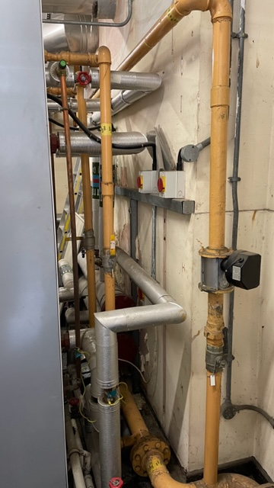

<file:///C:\Users\M993938\Downloads\SHEWCoP%202020.pdf>