
Main Tender Document

Tender Enquiry for design and construction of the children’s playground at South Ascot Recreation Ground, Victoria Road, South Ascot, Berkshire, SL5 9DR

To be submitted no later than 1pm on 14 March 2025
Late submissions will be disregarded.

Employer’s Representative and Named Contact for the Project:

Mrs Helen Goodwin

Clerk to the Parish Council

Tel: 01344 623480 ext. 1001
Mob: 07341 133591

Email: enquiries@s-a-pc.com

Introduction

Sunninghill & Ascot Parish Council is responsible for the upkeep and maintenance of the equipment and facilities that comprise the children’s playground known as the Playground, located at South Ascot Recreation Ground, Victoria Road, South Ascot, Berkshire, SL5 9DR.

South Ascot Recreation Ground is situated in the village of South Ascot, just over half a mile south of Ascot high street and the world-famous racecourse.
The Playground, which is suitable for children from toddlers to school year 6, forms a popular choice for children and families in the local area, being part of a generously sized recreation ground with a football pitch, outdoor gym and other activity equipment.

The village of South Ascot developed once the railway line from London to Wokingham was constructed during the 1850s, and particularly when the branch line to Bagshot was laid down in the 1870s. The mainly Victorian houses, which sprung up around the wooded area below the new railway station, provided homes for people working on the railway, in service to the large houses dotted around, or in local trades.

The Victorian scholar Henry Liddell spent his last years in Ascot, where he died in 1898. His daughter, Alice Liddell, was said to be the inspiration for the author Lewis Carroll’s most famous work, Alice’s Adventures in Wonderland. Two roads in South Ascot, Liddell Way and Carroll Crescent, honour the relationship between Henry Liddell and Lewis Carroll.

The original play equipment at the Playground in South Ascot was installed over 20 years ago and is now mainly at the end of its working life.

Sunninghill & Ascot Parish Council (the Employer) wishes to procure the services of a suitable contractor to undertake the design, manufacture and construction necessary to replace the play equipment listed and described later in this document (the Works).

As detailed above and in a nod to local heritage, we wish to include a reference to Alice’s Adventures in Wonderland in the design of the new Playground, preferably in the form of a motif or small panels on the existing fencing.

This document describes the Works and forms an invitation to tender.

The Tenderer should visit the site and carry out such inspections and surveys as he considers necessary to fully understand the content of the Works, the site and its constraints, in order to facilitate comprehensive and accurate pricing. In particular, the Tenderer is advised that the site of the Works sits within a public recreation area.

Access to the site of the Works is by way of a car park situated on Victoria Road, South Ascot, SL5 9DR.

The project will be solely funded by Sunninghill & Ascot Parish Council.
The appointed contractor will be required to cooperate with the Employer in regard to the provision of reasonable information relating to the Works and access thereto.

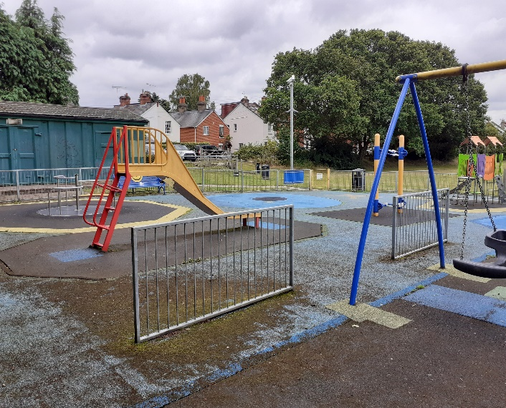
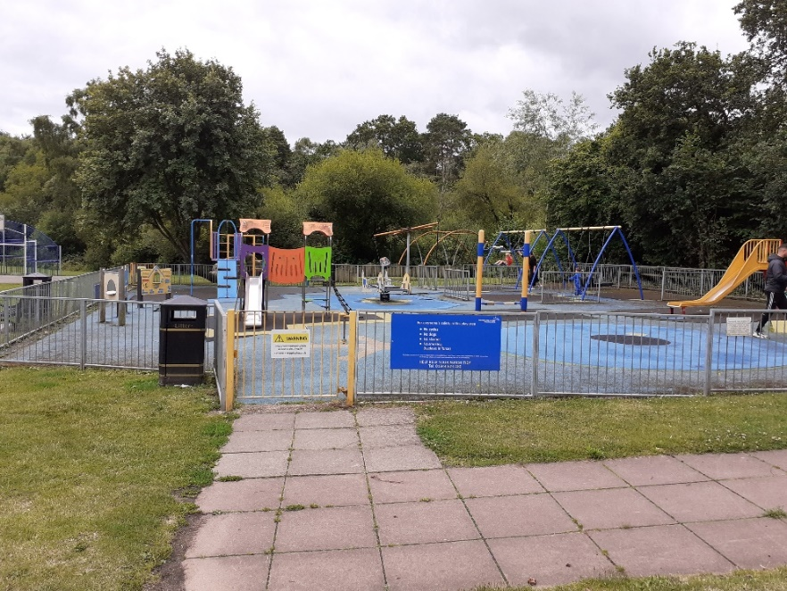
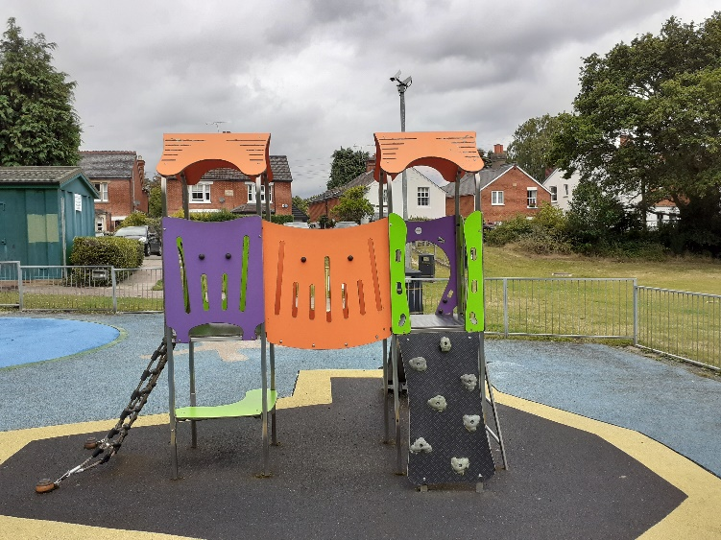

Tender
- Parties
The Employer is Sunninghill & Ascot Parish Council.
- Contract
Any agreement to undertake the Works shall incorporate the duties and responsibilities of the Employer and Contractor as set out below.
The Employer shall:
- Comment on the Contractor’s design proposals in relation to the Employer’s Requirements in a timely manner to facilitate manufacture and installation. Reasonable periods shall be allowed for such commentary and approval.
• Allow access onto the site for the Contractor to carry out the Works.
• Provide water for the works at a single external tap free of charge, such provision not to be abused and to be within the supply limits.
• Pay the agreed sums at completion, provided the Works are to the reasonable satisfaction of the Employer.

The Contractor shall:

• Design the Works to comply with the Employer’s Requirements, relevant British Standards and Codes of Practice together with all applicable legislation.
• Provide detailed design proposals containing drawings and specifications for comment by the Employer.
• Provide all labour, plant, materials and services to complete the Works including fencing to secure and control access onto the site.
• Ensure that construction is controlled so that it proceeds in a safe manner at all times and in accordance with Health and Safety legislation.
• Provide appropriate welfare facilities if required by legislation.
• Proceed regularly and diligently with the Works to secure completion by the dates agreed with the Employer.
• Execute the works to a good standard of workmanship, in accordance with good practice and in compliance with the Specification.
• At completion, clear the site of all plant, temporary facilities and surplus materials, reinstate any damaged areas to their previous condition.
• Maintain all appropriate insurances including Contractors’ All Risks, Public and Product Liability of no less than £5 Million and Employers Liability Insurance of no less than £5 Million. Provide evidence of same on request.
• Provide one set of detailed working drawings and a maintenance manual setting out recommendations for routine maintenance in PDF format and one paper copy of same.
• Make application for payment at the completion of the Works.
• In the event that the project is notifiable under the Construction (Design and Management) Regulations 2015, undertake the duties and responsibilities of Designer and Contractor as required by these Regulations.
• Cooperate with the Employer in regard to compliance with the reasonable requirements of other funders.

3. Employer’s Requirements:

• The Tenderer shall use his expertise and experience as a designer and installer of playground equipment to propose cost effective solutions to replacing or restoring the functionality of the equipment/ apparatus listed and shown below.

The proposals should include the provision of an appropriate construction and surface to the ground area (landing/ launching) beneath and surrounding the item concerned to the extent recommended by the relevant British Standard, and with a view to environmental sustainability in both the manufacture and the disposal at the end of its life. The proposals should provide a robust solution with a minimum period of 10 years from completion to first maintenance. If timber is proposed as a structure, the proposals should demonstrate how longevity in duty can be achieved and support at ground level shall be via steel shoes or similar.

3.1. Works: ITEMS TO BE REMOVED

Our Ref. | Item | Scope
SAP201 | Barriers | To be removed.
SAP202 | Fencing | To be retained if possible; repainting required. Inclusion of motif relating to Alice in Wonderland as detailed above.
SAP203 | Play area Gate 1 | To be retained if possible; repainting required.
SAP204 | Play area Gate 2 | To be retained if possible; repainting required.
SAP205 | Wet pour surfacing | Complete removal and disposal; preparation of ground to level and laying of new surfacing.
SAP206 | Seating x 3 (benches) | To be removed and replaced.
SAP208 | Sign | To be removed and replaced.
SAP215 | Multiplay – Toddler | To be removed.
SAP216 | Play panel 1 – Yellow | To be removed.
SAP217 | Play panel 2 - Blue | To be removed.
SAP218 | Play panel 3 – Shop | To be removed.
SAP219 | Rocker – Horse & Carriage | To be removed.
SAP220 | Slide | To be removed.
SAP221 | Swing – Junior – 1 bay 2 seat | To be removed.
SAP224 | Swing – Toddler – 1 bay 2 seat | To be removed.
 | Inclusive roundabout | To be removed.
 | Multiplay – Junior | To be removed.
 | Pedal Play | To be removed.

3.2. General:

Post-installation inspection: Please allow for a RoSPA post-installation inspection following the completion of the project.

Completion and defects: The whole of the Work shall be completed to the entire satisfaction of the Employer and the defects correction period shall be 12 Months from the Completion date (as signed off by the Employer’s Representative).

Reinstatement: On completion of the project, any area that has been damaged during the installation such as the turf, fencing and existing play equipment must be returned to the original condition at the contractor’s expense. Reinstatement of any damaged turf can be seed including the access to the site.

4. Programme:

The Employer envisages the following schedule:

Action | Date
Issue Tender document | 30 January 2025
Site meetings | Request with parish office
Tender submissions due | 14 March 2025
Appointment of Contractor | 07 May 2025
Target date commence on site | 08 September 2025
Target date completion | 30 September 2025

5. Constraints

The Tenderer should allow for the following constraints in his pricing:
• The site is in a children’s playground. It shall be left secure at the end of each working period.
• All work shall be undertaken Monday to Friday.
• Deliveries shall be made off Victoria Road or Brockenhurst Road. There is a small car park adjoining the recreation ground, off Victoria Road, SL5 9DR.

6. Specification

• The Works shall be designed and constructed in accordance with relevant British Standards and Codes of Practice, in particular the current editions of BS EN1177:2018+A1:2023 (including any new revisions).
• Equipment is to include at least one item that is accessible for a wheelchair; a swing which is accessible for a child with a physical disability; at least one item that is suitable for a child with neurodivergence.

• Play surfaces shall be permeable and drain to below and with a view to environmental sustainability in both the manufacture and the disposal at the end of its life.
• Specific manufacturers’ instructions/ recommendations for the use, application or installation of their manufactures shall be followed.
• The Works shall be designed and constructed to provide a minimum of ten years to first maintenance.

7. Pricing

All pricing should be exclusive of VAT and remain valid for 90 days from the latest tender return due date.

Prices shall be fixed and firm for the duration of the contract.

Following the receipt of tenders and a preferred contractor being awarded the project any changes made to the final pricing as variations or revisions, will fall within the permissible range. (Reg 72 Public Procurement Regulations 2015). Page 9 of 12.

7. Tender Evaluation

In evaluating the tenders, the Employer is seeking the Best Value Tender.
The Employer reserves the right to accept the whole or any part of any Tender submitted, and is not bound to accept this or any Tender.

8. Contract Conditions

The successful contractor will enter into a contract by way of a Letter of Instruction from Sunninghill & Ascot Parish Council.

The successful contractor must provide evidence of Public and Product Liability Insurance of no less than £5 Million and Employers Liability Insurance of no less than £5 Million to the council within the tender response.

Confirmation of work hours, storage of materials, access, location of skips and a final Programme of Works and RAMS will need to be finalised and provided to the council before work begins, most likely at the “Pre-Start” meeting.

9. Payment

Payment for each phase shall be made within 30 days of receipt of an appropriate application subject to the Works having been completed to the reasonable satisfaction of the Employer.

10. Tender Deliverables

The Tenderer shall provide a comprehensive description of his proposals for the Works including sketch details and illustrative photos of the equipment proposed, together with a priced and signed copy of this document.
Visuals are to include:
➢ 1 x 3D visual (to scale)
➢ 1 x CAD of the design

Note: Visuals must not include children or adults or show duplicate equipment.
The Tenderer shall provide contact details of organisations for which contracts of similar size and specification have been provided in the last five years.

These should be e-mailed to the Parish Clerk, Sunninghill & Ascot Parish Council at: enquiries@s-a-pc.com no later than:

Close of business 1pm on Friday, 14 March 2025.

Items sent should be clearly marked “Tender response: South Ascot Playground”.

Please contact the Clerk for the postal address.

11. Offer

11.1 We hereby offer to undertake the Phase 1 Works described above for the

Total Sum excluding VAT of: £………………………………….

made up as follows:

£………………………………….

RoSPA post-installation inspection £………………………………….

11.2 We confirm that:

☐ This offer remains open for acceptance for a minimum period of 90 days after the latest date for the submission of tenders.

☐ We understand that the Employer has the right to refuse any or all submissions without tenderers being able to claim any compensation. All costs associated with the tender process and response is the responsibility of the suppliers that have been invited to participate.

☐ We understand that Sunninghill & Ascot Parish Council is not bound to accept this or any other tender.

Signed: ………………………………………………………………………

Name: ………………………………………………………………………

Position: ………………………………………………………………………

For and on behalf of,

Company: ………………………………………………………………………

Address: ………………………………………………………………………

Contact email: ………………………………………………………………………

Contact phone: ………………………………………………………………………

Date: …………………………………….

VAT registered? YES / NO

