**Tendring District Council *in partnership with* Essex County Council**

**SECTION B**

**Specification and Technical Response**

**Tender:**

**Economic Appraisals of Identified Projects in Advance of Bids to the Levelling Up Fund and Shared Prosperity Fund**

**19th April 2022**

**Version 0.5**

**Our Vision**

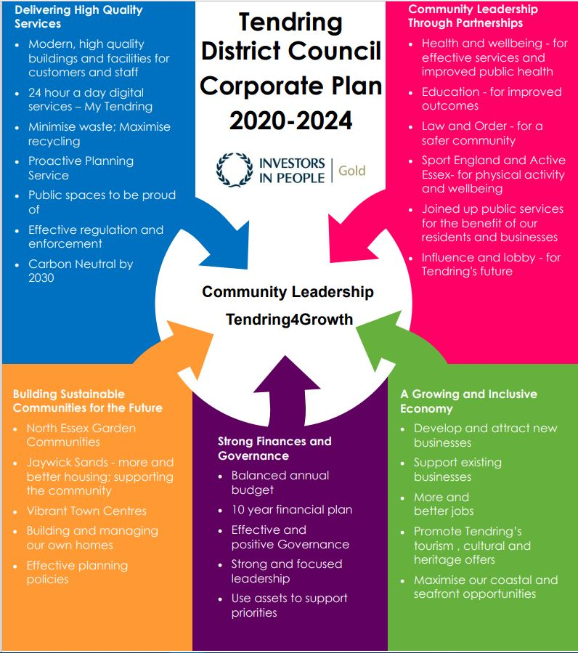***To put community leadership at the heart of everything we do through delivery of high quality, affordable services and working positively with others.***

**Our Values**

♦ Councillors and staff uphold **personal integrity, honesty,** and **respect** for others

♦ **Innovative, flexible, professional** staff **committed** to delivering excellence

♦ Recognising the diversity and equality of individuals

♦ Working **Collaboratively**

1. **Specification**

**Context**

The opportunities offered by national funding schemes including the Levelling Up Fund (LUF) and the Shared Prosperity Fund (SPF) represent a mechanism through which local authorities can work to address areas of deprivation and town centres impacted hard by COVID 19 and, previously, financial downturns.

Tendring District Council (TDC) is working in partnership with Essex County Council (ECC) to deliver transformative regeneration of Clacton, and Harwich & Dovercourt. Although private sector involvement and input will be integral, these funds have been specifically identified for local authorities to submit applications (LUF) or investment plans (SPF) to and therefore the public sector needs to take the lead.

Tendring has been identified as a Priority 1 local authority under the LUF and as such will be submitting two bids for the second round of applications, before the 6th July 2022 deadline. The SPF, which allocates £1,188,232 to Tendring to apply for,, is also a key opportunity for the area. This commission therefore primarily focusses on required information to populate TDC’s LUF bid, but could also form part of the SPF investment plan when required.

We are therefore seeking to appoint a suitably experienced organisation to support the preparation of the economic and financial elements of the wider business cases for each area, aimed at the LUF second round bid but also in support of the SPF investment plan, one each for Clacton and Harwich & Dovercourt.

We will require a business case for each area, formatted using the Five Case Model as per HM Treasury guidance[1] as follows:

1. The Strategic Case – is supported by a robust Case for Change
2. The Economic Case – optimises value for money
3. The Commercial Case – is commercially viable
4. The Financial Case – is financially viable
5. The Management Case – can be delivered successfully

For this commission we are seeking to appoint a suitably qualified organisation with specific expertise in carrying out economic and financial appraisals to feed into our wider bid, as well as quoting a day rate for the strategic, commercial and management cases should the Project Teams need to call on this wider expertise.

Tendring District, Clacton, and Harwich & Dovercourt

The Tendring District is 33,740 hectares in size (approximately 130 square miles), with a population of 144,700 (2017). It has 60km of coastline and manages 19km using its permissive coast protection powers.

Whilst the name of Tendring may not be instantly recognisable, the port of Harwich and the resort towns of Clacton, Frinton and Walton-on the Naze will be more familiar and will provide an identity for this attractive part of North-East Essex.

Clacton-on-Sea is the largest town in Tendring, and as such it is a particularly important driver in the economy of the area, with tourism, care, and retail as the key sectors. It has significant natural assets and good transport links to the wider District, the sub-region and to London. However, Clacton town centre is one area that has not kept pace with some of the more affluent parts of the district, or the wider region, and is in need of regeneration to address both physical and socio-economic problems. A bid was submitted to round one of the LUF (see appendix 5), which was unsuccessful but received promising feedback on identified interventions which could be built on for a second application.

Harwich & Dovercourt, to the North of the Tendring District, combines heritage and a thriving cultural scene with forward-looking opportunities for businesses and residents alike offered by the ongoing Freeport discussions. The town centre, whilst benefitting from an ECC library and a variety of independent shops and cafes, and served by a train line, is in need of investment and public realm improvements as identified in the Dovercourt Masterplan Revisited (see appendix 6). The towns are linked, with Harwich the more historic and tourist-focussed, and Dovercourt the retail centre. This will be the first LUF application on behalf of Harwich & Dovercourt.

1. **Requirements**

**Outputs**

We will require the supplier to:

* Review and adjust existing financials and outputs for the identified projects in Clacton, with reference to local Strategies, the previous Future High Streets Fund, the LUF Round 1 submission and the feedback received on each, alongside relevant colleagues in the Project Team for technical input.
* Review and adjust existing financials and outputs for the identified projects in Harwich and Dovercourt, with reference to existing work from local Strategies including the Dovercourt Masterplan Revisited, alongside relevant colleagues in the Project Team for technical input.
* High quality Economic and Financial Appraisals for each of the identified projects. Appraisals should include, but are not limited to, the cost, the risks, the jobs created/safeguarded, new homes, new business units, transport implications, and environmental impacts.
* Lead on producing an Economic Case and Appraisal Summary Table (AST) for identified projects, which is fully compliant with HMT Green Book principles and corresponds to the requirements of the LUF bid, and for possible use in the SPF Investment Plan.
* Consult on how, if both SPF and LUF are pursued, they could complement each other going forward.
* Be available to attend project meetings as defined by the Project Team. The potential supplier should, however, maintain responsibility to propose the timing of meetings, workshops and review points as appropriate around mutually agreed milestones.

**Projects Identified for LUF**

*Clacton*

* The ‘Clacton Hub’ scheme and wider area encompassing Carnarvon Road, Station Road and an identified site towards the High Street, to include:
* new library and adult community learning facilities with flexible office space
* 129 new homes
* new multi-storey car park
* start-up business units
* pedestrian/cycleway improvements to public realm

*Harwich & Dovercourt*

* Public Realm Improvements to encompass Kingsway, Station Plaza, reanimation of the Station Building, and High Street Improvements to include facility for events/street markets and upgraded pedestrian facilities at junctions
* Milton Road Scheme for small increase to housing in the town centre and aligning car parking facility and tree planting
* Library Site Improvements to increase the current mezzanine space to facilitate the re-introduction of Adult Community Learning, providing additional, flexible space for the co-location of services, community use and private consultation space.

All projects identified for both areas are to take into account the impact on the natural environment, both in the finalised outcome but also through the process of any works to be carried out. This must be reflected and considered in the financial and economic cases to be produced.

**Please note that the LUF application form has not been released yet so the format of the cases may change. This will be confirmed upon appointment.**

1. **Timescales**

The proposed timetable for this employment for guidance:

|  |  |
| --- | --- |
| *Invitation to Tender issued* | 19.04.22 |
| *Final Date for Clarifications from Bidders* | 26.04.22 |
| *Tender Return Date* | 03.05.22 12:00 noon |
| *Preferred Bidder Shortlisted* | 04.05.22 – 06.05.22 dependent on interview requirement |
| *Contract Preparation* | 09.05.22 |
| *Contract Signature* | by 11.05.22 |
| *Contract Start Date* | 12.05.22 |

The LUF submission deadline is 6th July 2022, and the SPF submission deadline is 1st August 2022. We will require the successful bidder to mobilise and have resources available immediately upon appointment and deliver within the timescales proposed for the work with no opportunities for extensions to this commission. The successful bidder will have a track record in working flexibly and in an agile manner to meet short deadlines successfully.

Therefore a current working deadline for the work in its entirety, with the successful bidder’s input via the economic and financial cases, as well as any supplementary work to be separately agreed on the strategic, commercial and/or management cases for the LUF bids, is to be completed in time for TDC & ECC’s final submission to Government by 1st July 2022, in advance of the final LUF deadline.

It is the Project Team’s current anticipated plan, to be discussed with the successful bidder, that a first draft of both bids should be ready for proofreading and further honing by the end of May/early June 2022.

Approximate milestones regarding the Project Team’s sharing of data and resultant submission of drafts are anticipated to be as follows in relation to the LUF bids:

|  |  |
| --- | --- |
| Consultant start date | 12/05/2022 |
| First draft of financial case and costings | 30/05/2022 |
| First draft of economic case | 10/06/2022 |
| Second draft of both cases | 22/06/2022 |
| Submission of LUF bids | 01/07/2022 |

Due to the linked nature of the commissioned cases and the rest of the LUF application we will expect the cases produced to feed in to the wider bid production therefore regular and timely communication will be essential.

1. **Budget**

* We are inviting quotations for undertaking and producing the financial and economic cases for both LUF bids, excluding VAT.
* Please also quote a day rate for input to each LUF bid’s strategic, commercial and/or management cases, should the Project Teams require.
* Please also quote a day rate for equivalent assistance with the writing of an investment plan as required by Central Government for submission to the Shared Prosperity Fund, in advance of it’s 1st August 2022 deadline. This is a secondary aspect of this request for quotation.

The potential supplier should provide a fixed cost fee proposal including disbursements, and excluding VAT. The fee proposal should be broken down by team member and task. CV’s should be provided for each team member where appropriate.

As the timescales are short for this project it is anticipated that most if not all of the required meetings and/or milestone sessions will be carried out online via MS Teams.

Submitted quotations will be assessed via a scoring matrix which will take into account total cost as a key metric, but will also include the importance of social value considerations and will recognise that the lowest quote does not necessarily represent the best value for money. The scoring matrix will take into account the cost quote for the financial and economic cases only, with the day rates for strategic, management and/or commercial cases as a supplementary.

TDC reserves the right to not commission any bidder. If successful, the Council intends to enter into a contract with the Supplier, using the Council’s standard terms and considerations, as set out in the draft Services Contract appended to this document.

1. **Key Documents**

We have appended/provided a link to the following documents:

1. Profile of Tendring: [Profile of Tendring | Tendring District Council (tendringdc.gov.uk)](https://www.tendringdc.gov.uk/business/regeneration/profile-tendring)
2. Tendring Economic Development Strategy: [Economic Development Strategy](https://www.tendringdc.gov.uk/business/regeneration/economic-development-strategy#:~:text=In%202013%20Tendring%20District%20Council%20undertook%20significant%20work,in%20the%20district%20in%20the%20period%20to%202023.)
3. LUF Prospectus: [Levelling Up Fund Round 2: prospectus - GOV.UK (www.gov.uk)](https://www.gov.uk/government/publications/levelling-up-fund-round-2-prospectus/levelling-up-fund-round-2-prospectus)
4. Shared Prosperity Fund Guidance: [UK Shared Prosperity Fund: pre-launch guidance - GOV.UK (www.gov.uk)](https://www.gov.uk/government/publications/uk-shared-prosperity-fund-pre-launch-guidance/uk-shared-prosperity-fund-pre-launch-guidance)

Clacton

1. Summary of Round 1 Clacton LUF bid *(a full version of the bid, and feedback received, will be provided upon appointment)*

Harwich & Dovercourt

1. Dovercourt Masterplan Revisited: [Dovercourt | Tendring District Council (tendringdc.gov.uk)](https://www.tendringdc.gov.uk/business/regeneration/dovercourt)
2. **Payment**

Payment will be made on receipt of invoice AFTER the completion of each works and in accordance with the council’s procurement and payment policies.

1. **Evaluation Criteria**

The RFQ will be evaluated on passing the mandatory requirements, and a submission weighting of 50% Quality (Section A) and 50% Price (Section B).

**SECTION A – QUALITY – 50% Weighting**

**Quality Technical Questions**

Please answer the following quality questions:

|  |  |  |  |
| --- | --- | --- | --- |
| **Technical Evaluation** | **Question** | **Evaluation Criteria** | **Weighting and Page Limit** |
| 1. **25%** | Please evidence and demonstrate your previous experience carrying out  economic and financial appraisals.  Please give a minimum of two examples of previous work undertaking a similar brief. | Clear and detailed evidence of previous work whereby you have reviewed and carried out economic and financial appraisals. | 2x pages of A4 |
| 1. **25%** | Please detail how you would approach this work. Giving key details on how you will meet each milestone set on Pg 6. | A clear and detailed approach with evidence of how each project milestone will be met. | 2 x pages of A4 |

**Scores will be weighted as detailed in the Technical Evaluation column above, with scoring awarded on a 0-5 basis in line with the table below.**

**If on any question you score below 3, this will classify as a failed score and a failed bid overall.**

**Scoring Methodology Table A:**

|  |  |
| --- | --- |
| **0** | **Unacceptable Response** The response is not relevant to the question, or the question has simply not been answered. Where the question has been answered, the response raises major concerns about understanding or approach which are potentially highly detrimental to satisfactory service delivery or Contract performance. The submission failed to cover any of all areas that should have been addressed within the response |
| **1** | **Poor Response** The response suggests significant shortcomings of understanding or approach which is likely to impact on service delivery or Contract performance. The submission failed to cover a number of all areas that should have been addressed within the response |
| **2** | **Fair Response** The response suggests minor shortcomings of understanding or approach which may impact to a limited extent on service delivery or Contract performance. The submission partially covered all areas that should have been addressed within the response |
| **3** | **Satisfactory Response** The response raises no concerns about understanding or approach to service delivery or Contract performance.  The submission covered all areas that should have been addressed within the response |
| **4** | **Good Response** The response raises no concerns about understanding or approach to service delivery or Contract performance. The response also demonstrates how relevant added value will be provided.  The submission covered all areas that should have been addressed within the response to a high standard |
| **5** | **Excellent Response**  The response raises no concerns about understanding or approach to service delivery or Contract performance. The response demonstrates how relevant added value will be provided including examples of the application of good practice, demonstration of how the study could be consider other perspectives not considered by the client or explores innovative ways to address climate change and net zero targets  The submission covered all areas that should have been addressed within the response to a high standard and demonstrated a commitment to go above and beyond requirements |

**SECTION B – PRICING – 50% Weighting**

A pricing matrix spreadsheet has been included as part of the RFQ documentation issued as **04 Pricing Schedule**

Please complete the spreadsheet as per the instructions stated within the document and return the completed spreadsheet as part of your RFQ submission.

All prices should be exempt of VAT and include any additional costs.

1. **The** **Authority’s Policies** **& Statements**

The bidder will need to adhere with the below policies and statements.

* Data Protection (please see Appendix A)
* Freedom of Information (please see Appendix B).

**Modern Slavery**

The bidder self-certifies that they are taking steps to ensure that there is no modern slavery or human trafficking (as defined in the Modern Slavery Act 2015) in their organisation or supply chain relating to the requested services/supplies requirements.

Here is a link to the Act: <http://www.legislation.gov.uk/ukpga/2015/30/contents/enacted>

**Health and Safety**

The bidder self-certifies that they adhere to the Health & Safety at work Act. Here is a link to the Act: <http://www.hse.gov.uk/legislation/hswa.htm>

**Environment**

The bidder confirms that they are aware of Tendring District Council’s Environmental Statement, and should they be successful, they are committed to working with the Council fulfil the vision outlined in the Statement.

<https://www.tendringdc.gov.uk/environment>

1. **E-procurement requirements**

Tendring District Council has a fully automated Purchase to Pay (P2P) system.

The successful bidder will be able to:

* View their orders online;
* Update their status;
* Notify delivery; and
* Submit and monitor the status of electronic invoices, once they have been submitted.

Orders will be sent electronically to the successful bidder’s central e-mail address from the contract start date.

The successful bidder will be expected to submit electronic invoices from the contract start date. On approval of the electronic invoice an automatic payment will be made via BACS, direct to the successful bidder’s bank account supported by an e-mailed remittance advice, in line with Tendring District Council’s contracted payment terms.

1. **Submission**

Please refer to the bidders guidance for details on submitting your tender. If further clarification is required bidders must be available during week beginning 4th May 2022 for possible presentations.

1. [Assessing business cases 'a short plain english guide' (publishing.service.gov.uk)](https://assets.publishing.service.gov.uk/government/uploads/system/uploads/attachment_data/file/935528/Green_Book_guidance_short_plain_English_guide_to_assessing_business_cases.pdf#:~:text=Business%20cases%20can%20be%20broken%20down%20into%205,robust%20Case%20for%20Change%20%E2%80%93%20the%20Strategic%20Case%3B) Page 2, accessed 1st April 2022