Perfect Circle JV LTD  FAO Redacted  Aecom Limited  Aldgate Tower  2 Leman Street  London  E1 8FA | Redacted  Procurement Officer  1st Floor  Woodlands  Manton Lane  Bedford MK41 7LW  Direct Line: Redacted  19 February 2019
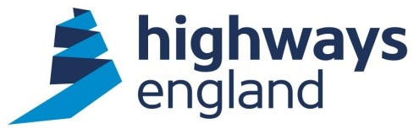
Lower Thames Crossing – Ground Investigation works – Delivery Agreement Phase 2

Dear Redacted,

On behalf of Highways England, I am writing to confirm award of the above-mentioned Delivery Agreement (the “Agreement”) under the Built Environment Consultancy Services (BECS) Scape Framework. This letter confirms the award of the contract pending execution and completion of the Agreement by both parties.

The terms and conditions of the Agreement are attached.

Please note that the starting date of the Agreement is the date of this award letter.

You should note that we will not pay for any work unless it has been specifically authorised in writing within the terms of the Agreement.

The CPF toolkit has now been tailored to suit individual types of task orders/contracts. A CPF will be required in accordance with the CPF guidance and FAQ documents. The CPF may be considered by the Company when allocating future work and other contractual mechanisms.

Invoices should be sent as a PDF file to FS Payments at Highways England via invoices@highwaysengland.co.uk. The invoice should quote the Project Manager’s name and Purchase Order number, which will be obtainable from the Project Manager.

Please note you must not make any public announcements and all media enquiries should be directed to the Highways England Press Office.

Please acknowledge receipt of this letter by return.

Yours sincerely,

Redacted
Procurement Director
Highways England Procurement
Email: Redacted

