 |  | 4 Doolittle Mill  Froghall Road  Ampthill  Bedfordshire  MK45 2ND  Tel: 01525 307060  Email: richard.earl@tgms.co.uk  Web: www.tgms.co.uk

BURGESS HILL TOWN Council

TENDER RETURN DOCUMENT

Conversion of agricultural land into a natural turf playing field on land adjacent to Goosecroft Recreation Ground, Goosecroft Lane, off Beech Road, Purley-On-Thames, near Reading, Berkshire RG8 8DR.

22 JULY 2024

TGMS1228.2

STATUS: FOR ISSUE

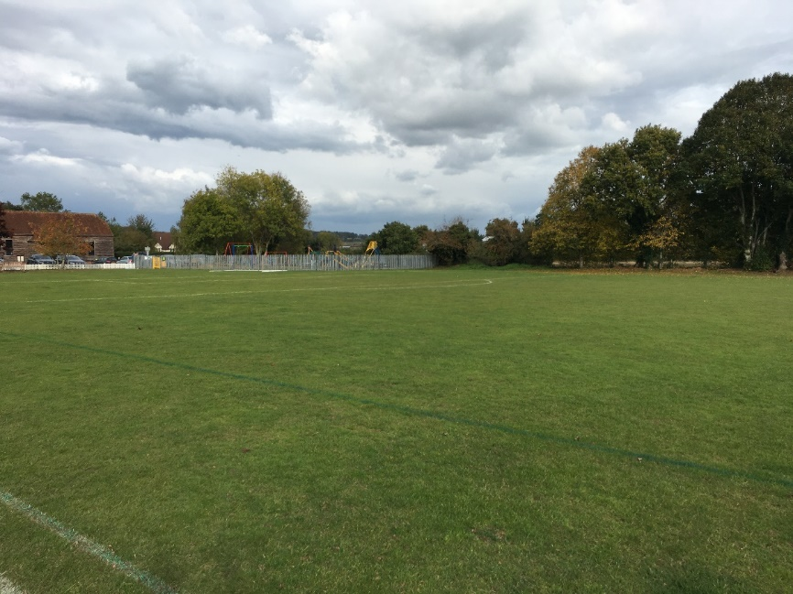

REVISION RECORD
Rev | Date | Description | Prepared | Checked | Approved
0 | 22-07-24 | Document Creation. | RE | MY | MY

TABLE OF CONTENTS
TABLE OF CONTENTS 2
1. FORM OF TENDER 3
2. METHOD STATEMENTS 5
3. SUBCONTRACTORS 6
4. REFERENCES 7

FORM OF TENDER

PROJECT TITLE: Goosecroft Recreation Ground Expansion Project.

We .......................................... (Tenderer’s name to be entered) hereby tender and undertake to perform the whole of the works/services required in and associated with the Project for Purley-on-Thames Parish Council according to the Specification, Work Schedules, Preliminaries and Drawings examined by us for the firm price sum of:

....................................……………………...........(pounds)

..............................…………………….................(pence)

(£ : p) excluding VAT.

Further we are prepared, when called upon to do so, to enter into and sign a contract, the full terms of which we have read, for the due and proper completion of the works/services.

We understand that we are tendering at our own expense and that the Client is not bound to accept the lowest or any tender and that the client reserves the right to award the contract phase by phase.

We declare that we are not party to any scheme or agreement under which:

- we inform any other person the amount of our tender; and/or

- we have fixed the amount of any tender in accordance with a price fixing arrangement.

We accept that the Client is entitled to cancel the contract and to recover from us the amount of any loss resulting from such cancellation if it is discovered that there has been any corrupt or fraudulent act or omission by us which in any way induced the Client to enter into the contract.

We declare that all goods materials and workmanship will meet the appropriate British Standard Specification or British Standard Code of Practice issued by the British Standards Institution or equivalent European standard current at the date of the contract.

We undertake in respect of all persons employed by us or with whom we sub-contract to comply with the Disability Discrimination Act 1995 and the Commission for Racial Equality’s Code of Practice issued under the Race Relations Act 1976 aimed at eliminating discrimination and promoting equality of opportunity.

We undertake not to transfer, assign, or sub-let any portion of the contract nor create any lien or charge on premises, goods or equipment connected with or forming part of the contract, without the written consent of the Client or its duly authorised officer.

We agree that if, before acceptance of this tender, an error in computation of the tender is detected in the priced document submitted by us we will be given details of the error and the opportunity of confirming the total tender sum or withdrawing the tender.

We agree that the insertion by us of any qualifications to this tender or any unauthorised alterations to any of the tender documents will not affect the original text but will cause the tender to be liable to rejection.

We agree that this tender will remain open for acceptance by the Client and will not be withdrawn by us for a period of 90 days from the last date fixed for the receipt of tenders or any notified extension thereof.

We certify that this is a bona fide tender.

Tenderer’s Name ............................……………………………………………………….........

Address ............................……………………………………………………….........

............................……………………………………………………….........

............................……………………………………………………….........

Telephone ............................……………………………………………………….........

Facsimile ............................……………………………………………………….........

Signature* ............................……………………………………………………….........

Name ............................……………………………………………………….........

Date ............................……………………………………………………….........

Witness ............................……………………………………………………….........

Name ............................……………………………………………………….........

Date ............................……………………………………………………….........

* Where the Tenderer is an incorporated association the Company Secretary or a duly authorised Director should sign. In the case of a partnership a Partner should sign. In the case of an individual the Proprietor should sign.

METHOD STATEMENTS
ITEM | Brief method statement (Continue on additional sheets if required) | Type/ name of equipment you intend to use | Is equipment owned by the contractor? | Is equipment rented? | Will work be sub-contracted? | How many staff will be on site?
- Cut and Fill earthworks
- Topsoil return
- Stone separation
- Herbicide application
- Fertiliser application

SUBCONTRACTORS

Please specify the names and contact details for any subcontractors that you intend to use during the project (please continue on a separate sheet if necessary):

Name: | Contact Details: | Role:

REFERENCES

Please provide references from three recent (last 2 years) schemes where you have carried out work of a similar nature and value. Please give name, postal address, email address and telephone number for the referees.

Name: | Contact Details: | Nature of work / project value (£):

