Clarifications to Bidder’s Questions:
Holderness coast habitat map using multibeam and backscatter datasets
Q1) Please could we check regarding the format of the responses to the questions – the instructions seem to suggest that all questions should be within one, four-page limit, yet the ‘information to be returned’ asks for a separate response document for each technical questions?
Please could you confirm whether it is a four-page limit for all questions responses combined (in a single document), or 5 separate responses (for each question) with four-page limit, or 4 separate responses (for each question theme) with a four-page limit?
A1) Please send the answers to all of the technical questions back in a single document, ideally not exceeding 4 pages in total. Then the commercial question should be answered using the commercial response template on contract finder.

Q2) The RFQ states:
The map is to include the nearshore area between Spurn Point and an area South of Flamborough Head, which will encompass:
- Smithic Sands
- Holderness Inshore Marine Conservation Zone (MCZ)
- Flamborough and Filey Coast Special Protection Area (SPA)
- Flamborough Head Special Area of Conservation (SAC) and Site of Special Scientific Interest (SSSI)
- Humber Estuary SAC, SPA and SSSI
Please clarify whether the area to be mapped fully encompasses all of these area features or only partially intersects with them, as depicted in the image below.
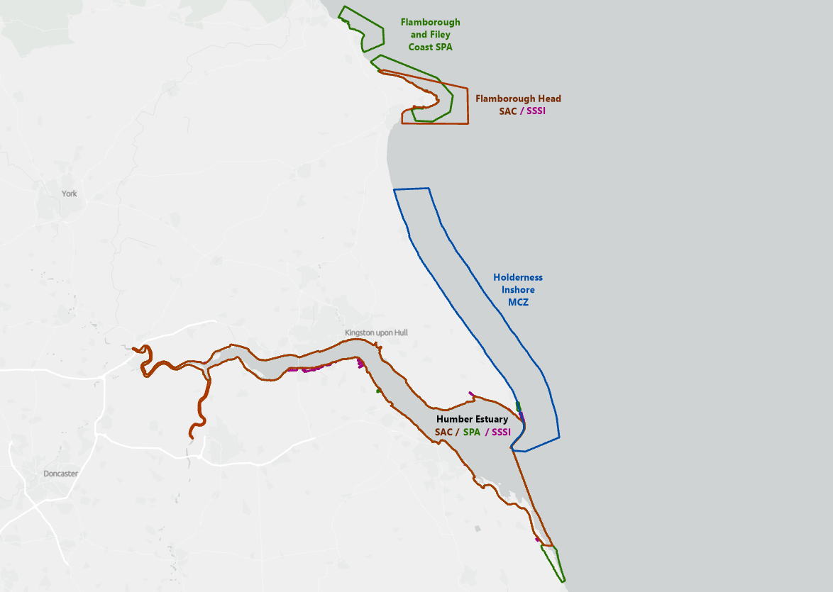
A2) The intention is for the mapped outputs to cover the whole of Holderness inshore MCZ, extending north to incorporate Smithic Sands, which will have a small overlap with the Flamborough Head SAC in southernmost section.

