|  |  |  |
| --- | --- | --- |
| Project Name: | **Southern Windermere Trails** | LDNP2016 |
|  |  |
|  | **Section 6** |

The sections are described from South to North

1. Section 6a

Continues on from section 5e and connects into section 6b. Access / egress for section 6 form the C5026. Alignment follows the boundary wall with the C5026 on the W side of the field.

The trail will require the construction of a new surfaced aggregate path with an average width of 2m. The trail will be fenced on its E side throughout this subsection - this will create a 3m trail corridor with grass verge to each side of the constructed line. An access ramp, with level pull off area, will be constructed to take the trail from road to field level. Warning signage and access furniture – gate / bollards – will be placed at the start of the section. Trail will be dedicated as a public right of way.

CCC Highways were consulted in relation to this section of the route. There are two options for the access egress point which will depend upon landowner consent.

**Section 6a 000 – View S (end of Section 5 start of Section 6)**

**(See Annex 6 - RGP drawing for Highway Design)**

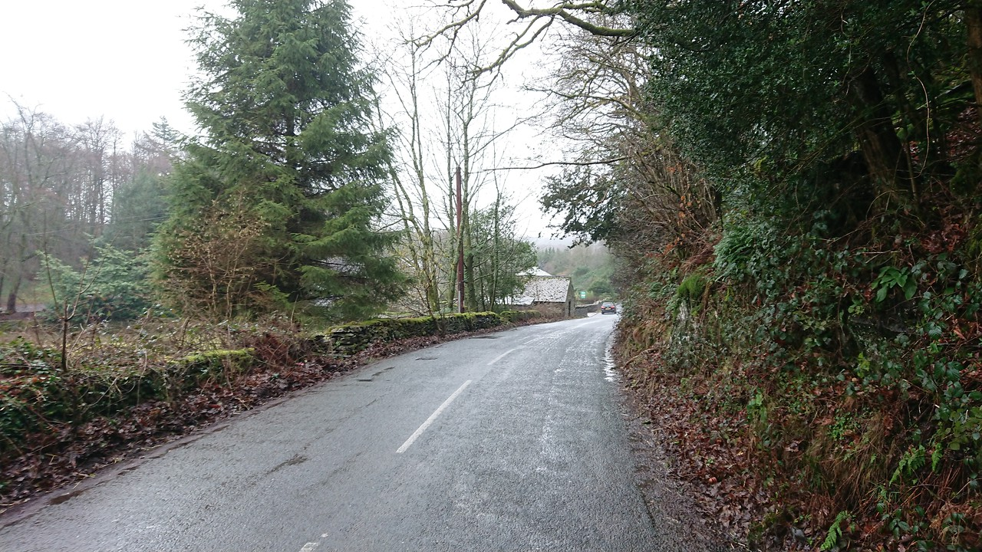

6a

5e

750

000

**Section 6a 010 – View N**

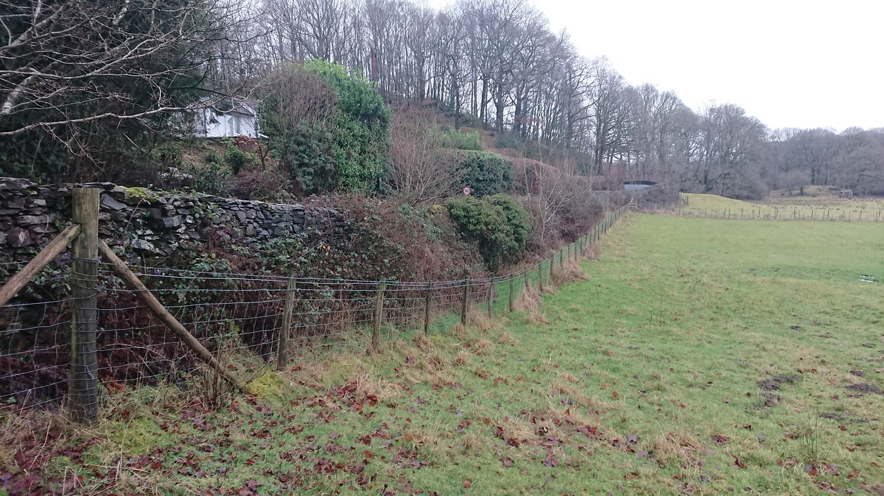

Access option 1 040

Access option 2 080

6a

Access

1. Section 6b

Continues on from section 6a and connects into section 6c. Access / egress points from the C5026 at 265m from start of section. Alignment follows the boundary wall with the C5026 on the W side of the field with small devastations of up to 10m from all to account for ground conditions. The alignment crosses a private access track / road at 265m.

The trail will require the construction of a new surfaced aggregate path with an average width of 2m. The trail will be fenced on its E side throughout this subsection - this will create a 3m trail corridor with grass verge to each side of the constructed line. Access / Egress points and track crossings will be gated. A 4m timber foot/cycle bridge with ford to downstream side will be constructed 337m into the section. End of section will be gated at the point it enters the woodland.

**Section 6b 120 – View N** 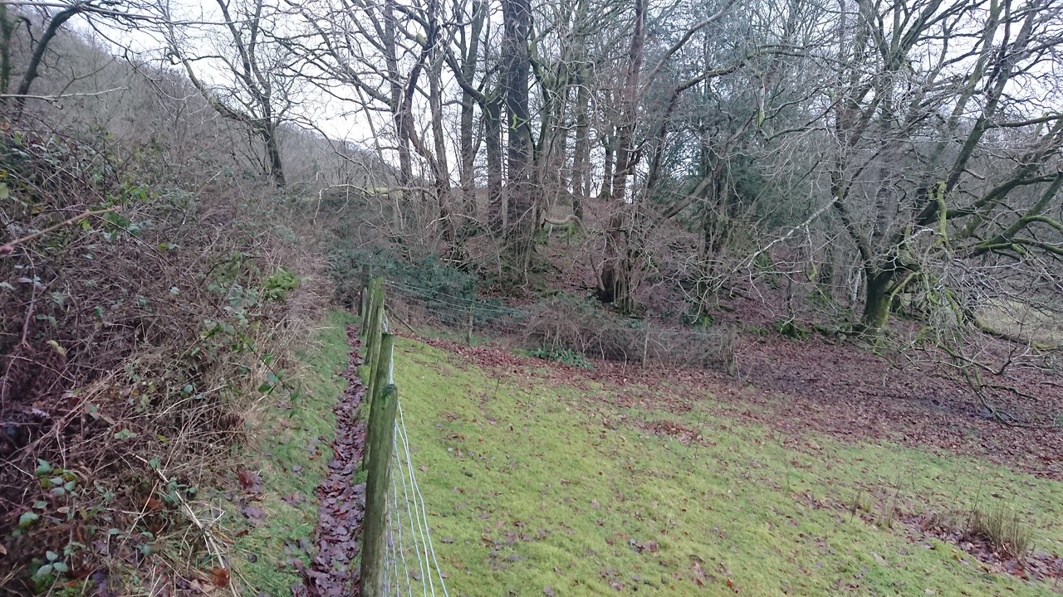

6 b

167

**Section 6b 170 – View N**

[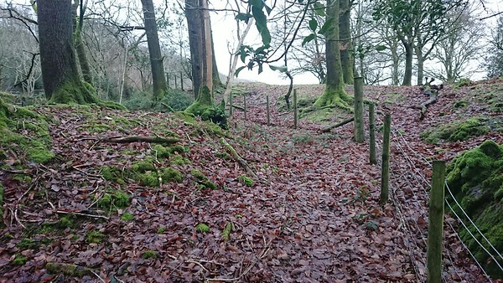](https://bruce-wilkinson.smugmug.com/SWT-Photos-/n-st8nqD/i-jLQ9H8g)

6 b

**Section 6b 235 – View N**

[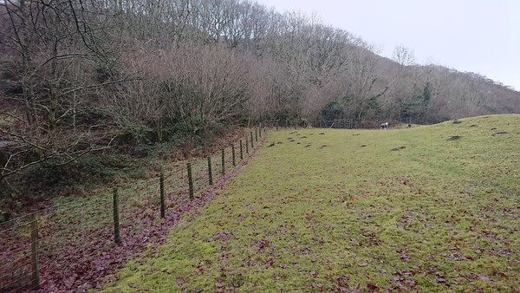](https://bruce-wilkinson.smugmug.com/SWT-Photos-/n-st8nqD/i-22Jc9rL)

6 b

255

**Section 6b 345 – View N**

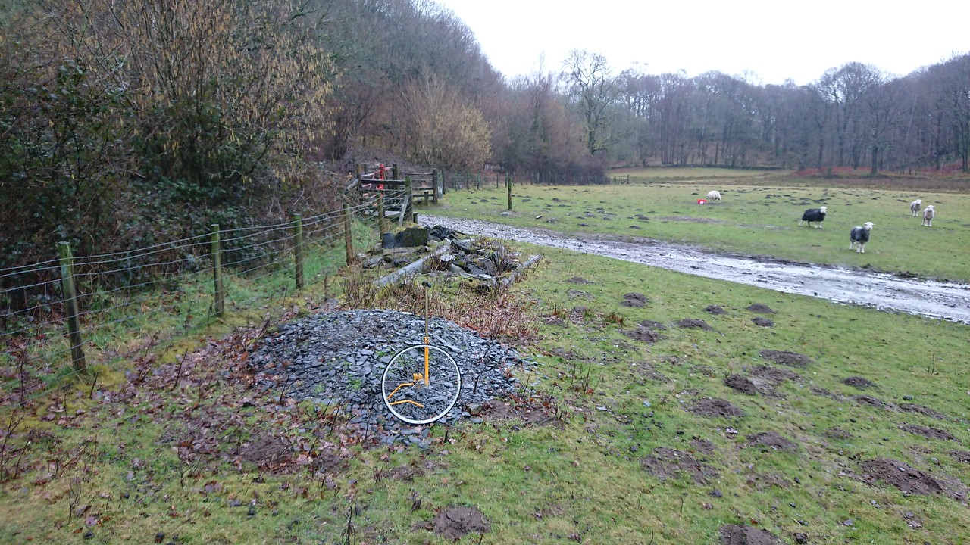

415

342

Gate set back to allow enough space for pick-up + stock trailer to clear the public highway

6 b

530

**Section 6b 429 – View N (Bridleway Bridge with ford to downstream side – water flows towards the bottom left of the photograph)**

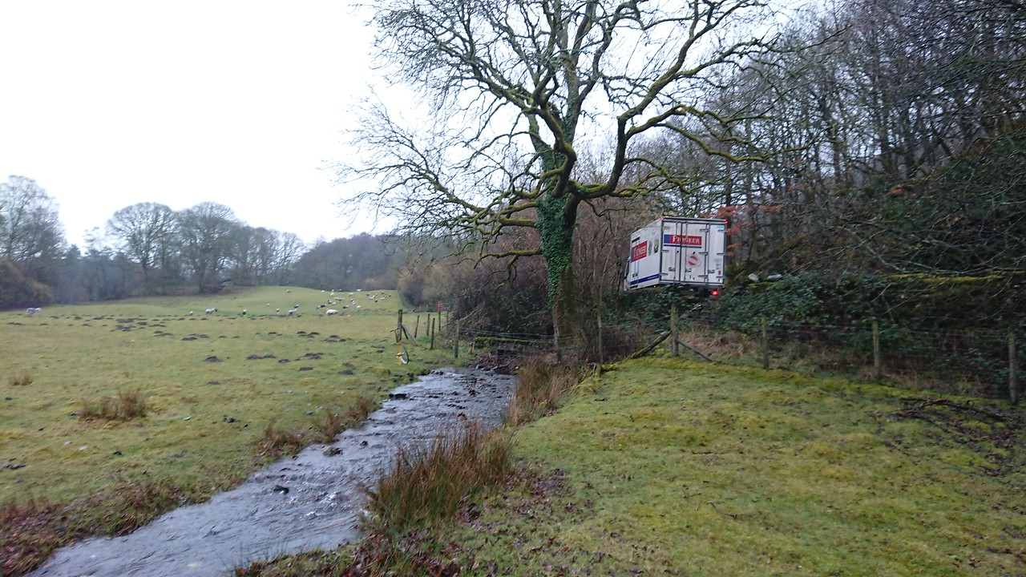

6 b

415

**Section 6b 535 – View N**

[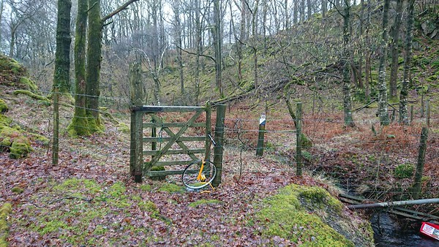](https://bruce-wilkinson.smugmug.com/SWT-Photos-/n-st8nqD/i-jXRD63d)

6 b

535

1. Section 6c

Continues on from 6b and connects into 6d. Follows the E side of the small stream on an existing path from the woodland boundary to the private (tarmac) access road serving South Camp. Path will be constrained by geography and tree cover. Width will be 1.2-2.0m as appropriate for site ground conditions.

The trail will require the re-surfacing of the existing path surface. Cell web will be used as appropriate for tree protection. The end of the section will be chicaned and warn of the track crossing. Stream bank revetment and stone clapper bridge will be restored as part of works.

**Section 6c 580 – View S (path and bank stabilisation)**

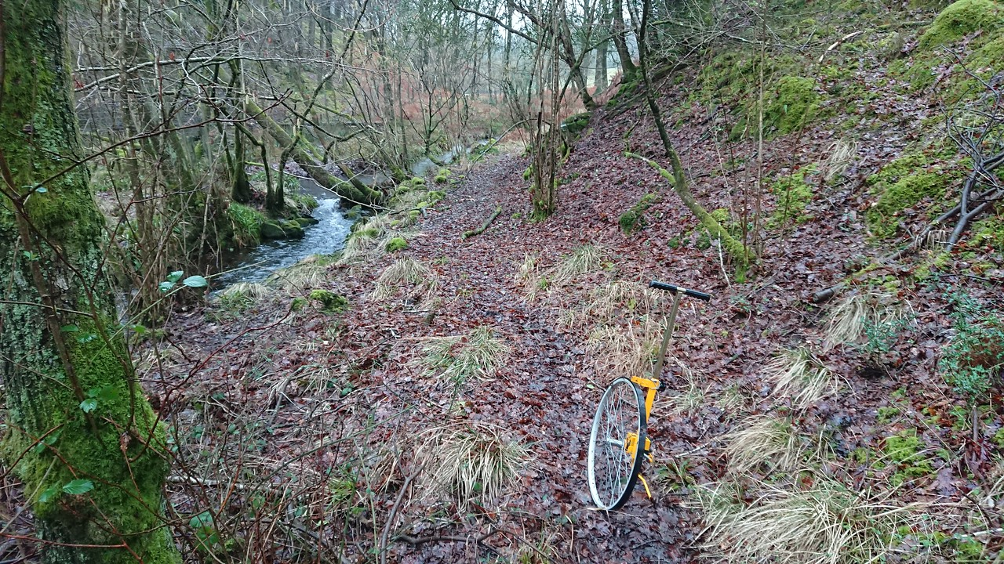

6 c

**Section 6c 580 – View N**[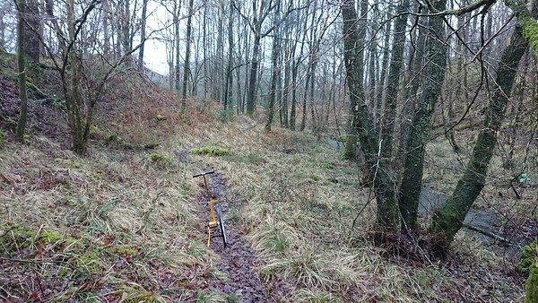](https://bruce-wilkinson.smugmug.com/SWT-Photos-/n-st8nqD/i-GhV3N3g)

6 c

**Section 6c 635 – View S**

[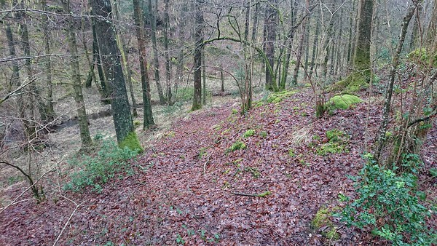](https://bruce-wilkinson.smugmug.com/SWT-Photos-/n-st8nqD/i-fxGcQKR)

6 c

1. Section 6d

Follows the N side of the private access road serving South Camp area of the YMCA site.

**Section 6d 635 – View E**

[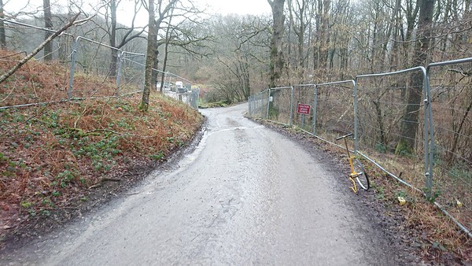](https://bruce-wilkinson.smugmug.com/SWT-Photos-/n-st8nqD/i-7hzNzkP)

670

6 d

1. Section 6e

Creates a new route parallel to the C5026 within 20m of E field boundary. Route as close to boundary as possible. Route will be fenced. Route continues to the northern boundary wall (at the point where the path enters the woodland).

The trail will require the construction of new path and resurfacing / widening of the existing path. It will be fenced to the E side – stock netting – to limit access by the public into the wider YMCA site.

**Section 6e 715 – View E**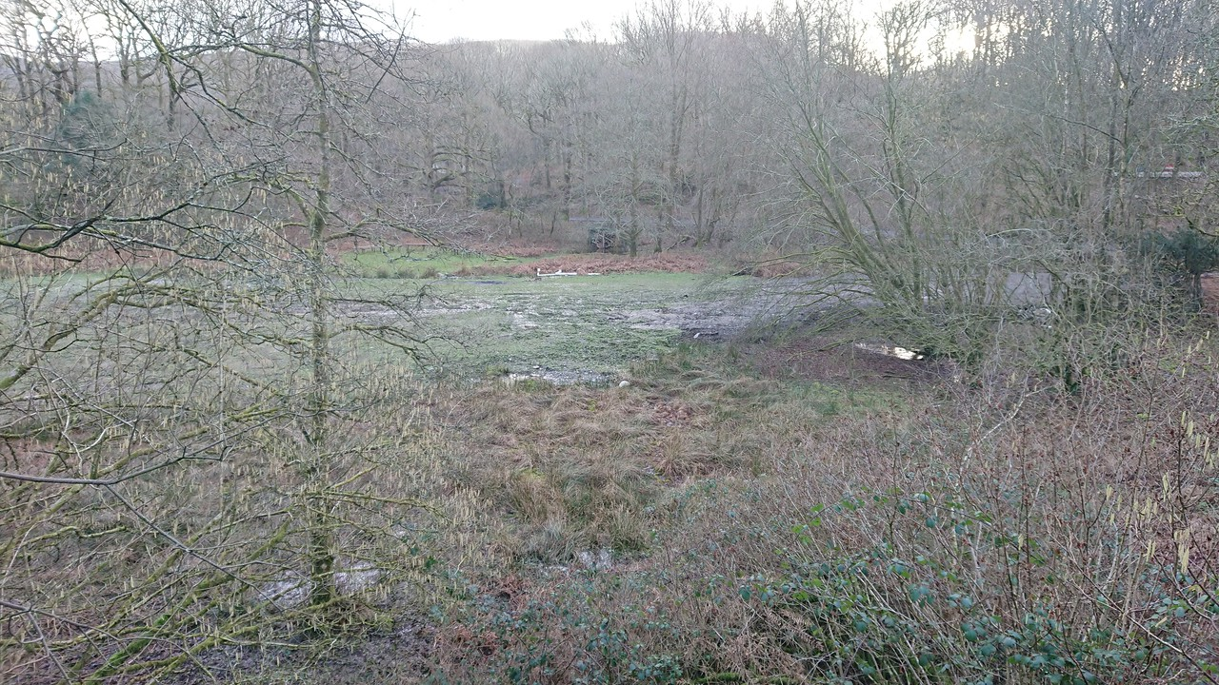

6 e

730

690

**Section 6e 850 – View NE**

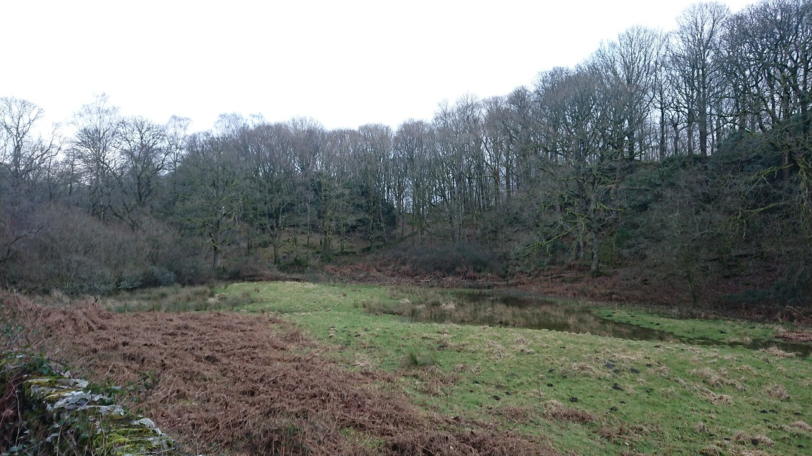

905

6 e

**Section 6e 910 – View NE**

6 e

[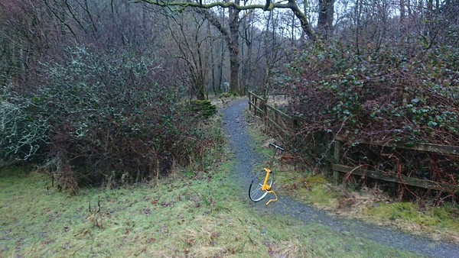](https://bruce-wilkinson.smugmug.com/SWT-Photos-/n-st8nqD/i-WzfqkBh)

930

6 e

1. Section 6f

Continues on from 6e. Follows the line of the existing constructed / surfaced paths in the woodlands of the North Camp area of the YMCA site. The section ends at the private tarmac access road serving the North Camp area and YMCA jetty.

The trail will require the re-surfacing of the track throughout its length. Width will be an average of 2m. Cell web will be used as appropriate for tree protection. The route will be fenced on its E side to limit access by the public into the North Camp site. Private access gates will be provided on tracks joining the route from within North Camp area. Access / egress from the C5026 approximately 25m from the start of the section this link path will be resurfaced. There will be warning signage and bollards marking the road.

**Section 6f 922 – View NE**[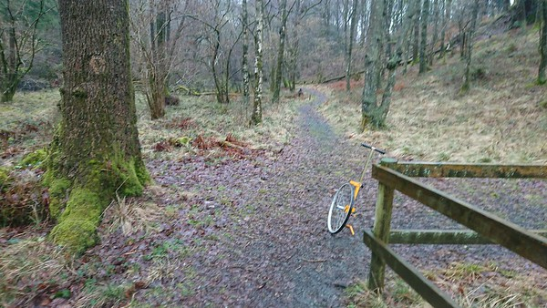](https://bruce-wilkinson.smugmug.com/SWT-Photos-/n-st8nqD/i-PBNWZ22)

6 f

**Section 6f 1130 – View N**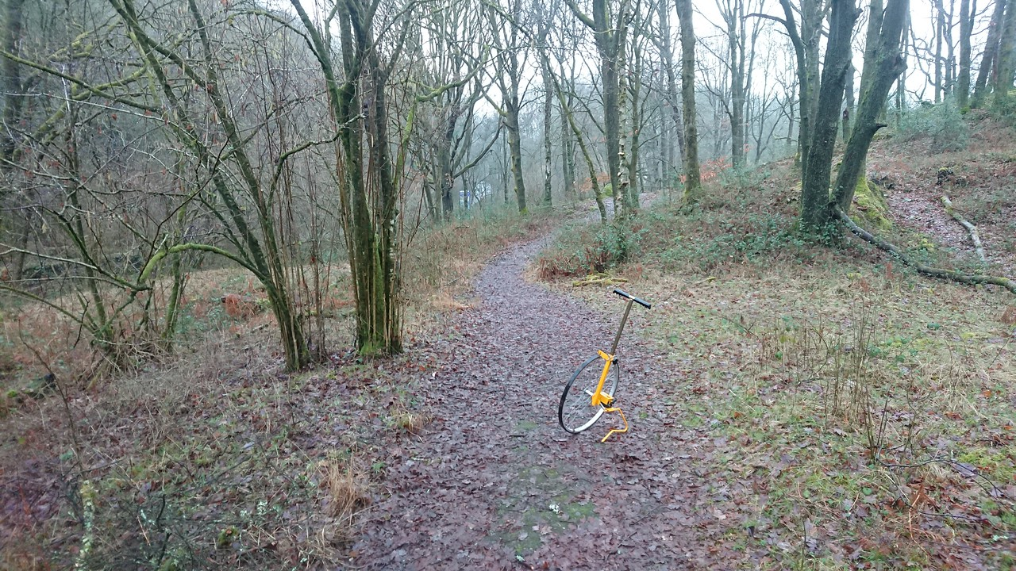

6 f

Section 6g

Continues on from 6f on the N side of the private access track. Descends into the carpark by a newly constructed access ramp. Crosses car park and joins the existing – surfaced – public right of way to the N site boundary.

**Section 6f / 6g 1200 – View E (along private access road to YMCA lakeside)**[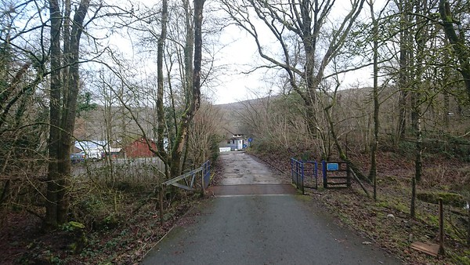](https://bruce-wilkinson.smugmug.com/SWT-Photos-/n-st8nqD/i-4STWV2B)

6 g 1207 **– View N**

6 f 1207 **– View N**

1200

**Section 6g 1200 – View W (route passes through W end of car park)**

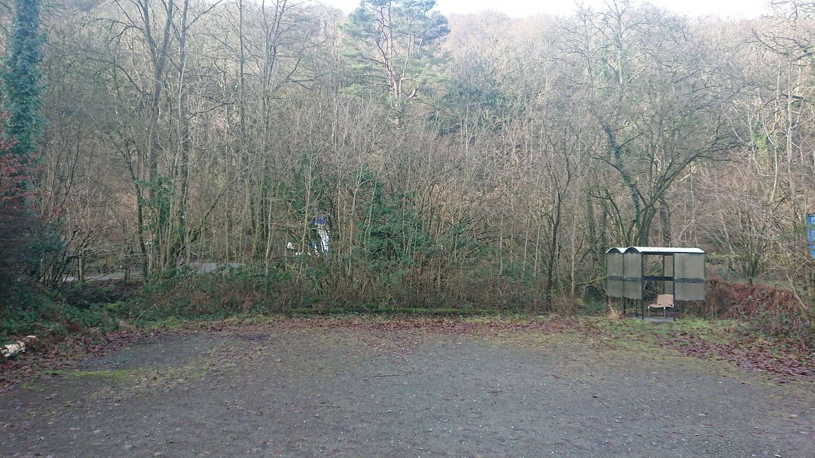

6 g 1207 **– View N**

1200

1225

**Section 6g 1225 – View SE (route passes through W end of car park)**

[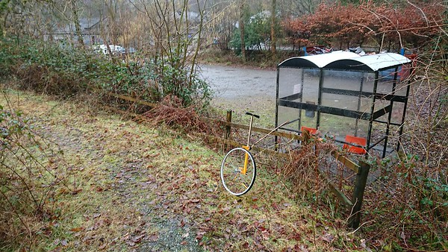](https://bruce-wilkinson.smugmug.com/SWT-Photos-/n-st8nqD/i-tVDz4fN)

6 g 1207 **– View N**

1225

**Section 6g 1225 – View SE (route passes through W end of car park)**

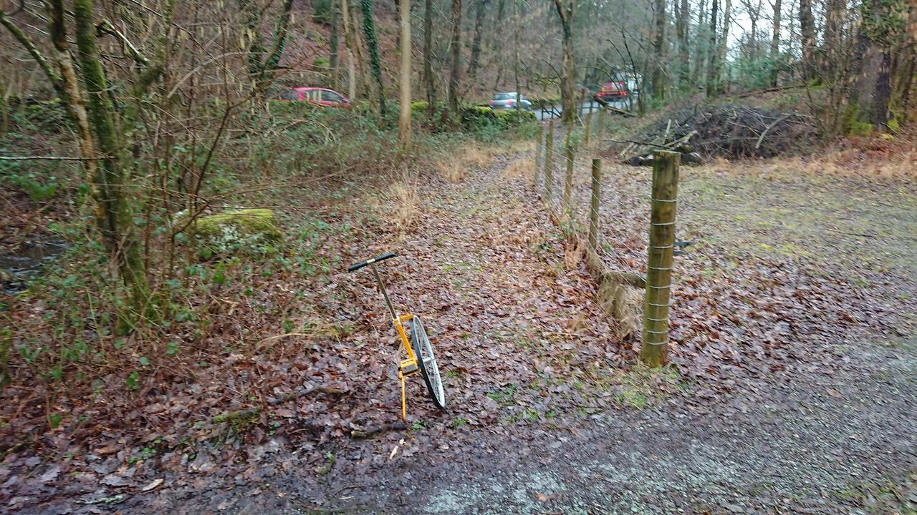

6 g 1207 **– View N**

**Section 6g 1300 – View SE (roadside section)**

[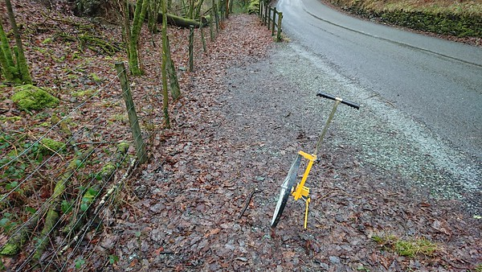](https://bruce-wilkinson.smugmug.com/SWT-Photos-/n-st8nqD/i-Hh4jZzQ)

6 g 1207 **– View N**

**Section ends 1382 - bridle gate**