SCHEDULE 2 – THE SERVICES

- Service Specifications

Service Specification No. | DRAFT ONLY
Service | Community Navigator Service
Commissioner Lead | Southampton City CCG
Provider Lead
Period | 2019/20
Date of Review | September 2019

1. Population Needs
  - Context
Community navigation has been developed in Southampton as a result of public engagement. As part of the Better Care engagement feedback was received that people needed support to access services and opportunities which could improve their health and wellbeing and delay and reduce the need to access health and social care support. The CCG has worked with a number of voluntary organisations to develop the concept and piloted a service in parts of the City. The service model has been coproduced with a number of local voluntary organisations providing navigation functions as part of their charitable service offer and with input from statutory and non-statutory stakeholders.

Based on the evaluation of the pilot community navigation service the following issues are prevalent in the communities of Southampton:
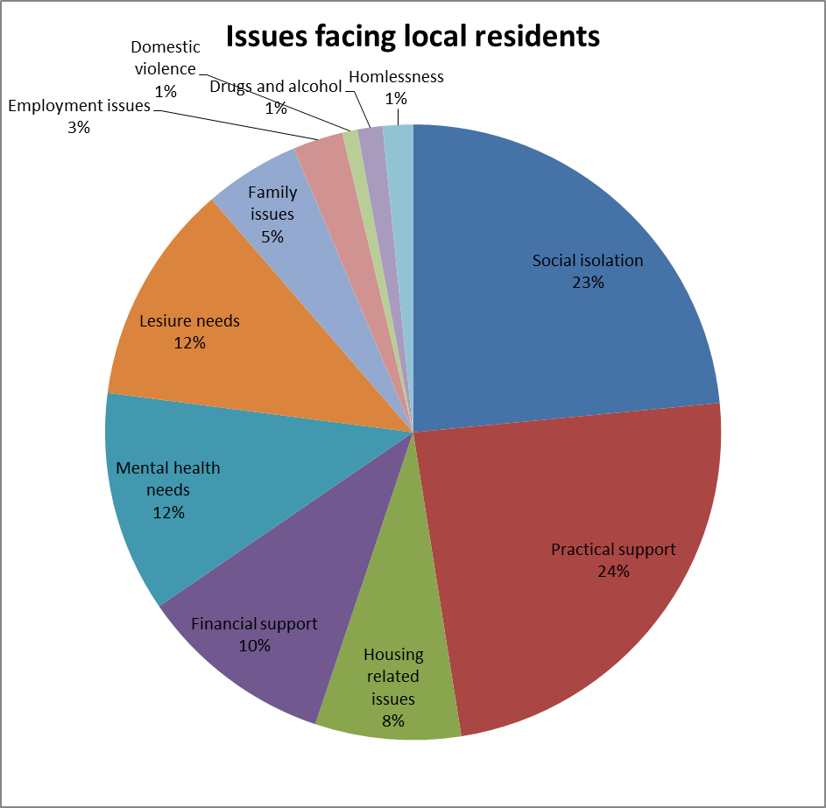
  - National context
The Community Navigation service is aimed at achieving more efficient use of health and social care services, by enabling people to take better control of identifying and planning to meet their own needs and helping them to access the right support at the right time and is supported in the current policy context.

Community Navigators (CNs) enable and encourage people to improve their own wellbeing and independence through identifying and achieving their goals. They also support the person to re-connect with their community through accessing groups and activities in their local area.

Community Navigation is person-centered, utilizing a whole person approach that considers the individual circumstances of a person's life and their broader health and wellbeing needs, not only the services they want to access or the condition(s) they have.

Current Government policy on health and care rests on two main principles:
- Everything should be done to prevent, postpone and minimise people’s need for formal care and support. The system should be built around promoting people’s independence and wellbeing.
- People should be in control of their own care. Growing emphasis on choice, personal budgets and direct payments, backed by clear, comparable information, will empower individuals. Local authorities will have a duty to shape the local market and work to integrate services.

In response to the NHS Five Year Forward View which calls for a new relationship between services and people in their communities, it is argued that place based approaches, drawing on the assets and resources of an area, are a key part of developing local solutions to improve health and wellbeing and reduce health inequalities.

“Just What the Doctor Ordered”: Social prescribing a guide for local authorities, developed by the Local Government Association, provides strong support for this approach and details a number of case studies of national best practice.

In a jointly commissioned report, NHS England and Public Health England respond to this by outlining proven community approaches that can improve health and wellbeing. In drawing together a large body of research, the report concludes:

“There is a compelling case for a shift to more person and community centred ways of working in public health and healthcare.”

The report outlines a ‘family of approaches’ to achieve this shift:
- Strengthening communities “where approaches involve building on community capacities to take action together on health”
- Volunteer and peer roles “where approaches focus on enhancing individual’s capabilities to provide advice, information and support”
- Collaborations and partnerships “where approaches involve communities and local services working together at any stage of the planning cycle”
- Access to community resources “where approaches connect people to community resources, practical help, group activities and volunteering opportunities”

The Community Navigation service incorporates all four of these approaches via its model of social prescribing. Community navigation and social prescribing have a significant role to play in addressing loneliness and health and social wellbeing:
Loneliness

Prevalence:
- Studies since the 1940s have shown that approximately 6 – 13% of people aged 65 and over feel lonely all or most of the time.
- The number of people who feel chronically lonely will increase as our population ages.
- There are a number of things that increase our vulnerability to loneliness. Loneliness can happen at any age but the risk factors are more likely to increase and converge, and our resilience to them reduces, as we age.
- National organisations such as the NSPCC, Ageing Without Children, Movember and CALM (Campaign Against Living Miserably) are all actively seeking to address loneliness in younger people.

Impact:
- Evidence presented identified the link between loneliness and physical and mental health. Evidence is also emerging of the cost to society caused by loneliness and the UK Parliament launched a Commission on Loneliness in January 2017.
- The cost of being chronically lonely to the public sector on average is around £12,000 per person, over 5 years, based on costs associated with GP and A&E visits (LSE study).
- The health service is a place where lonely people are frequently presenting. It has a significant impact on health and care systems.

Mental wellbeing
Research by the Mental Health Foundation found that 78% of GPs had prescribed an antidepressant in the previous three years, despite believing that an alternative treatment might have been more appropriate. Of the GPs surveyed, 60% said they would prescribe antidepressants less frequently if other options were available to them. While both medication and psychological therapies have a role, social prescribing (Community Navigation) provides a further opportunity to respond effectively, and at an early stage, to symptoms of mental distress, as well as to initiate a more proactive approach to common mental health promotion.

Social inclusion of people with common mental health problems is essential to achieving improved quality of life, which supports recovery and improved clinical outcomes. Community navigation supports improved access to psychological treatments, access to services and interventions addressing the wider determinants of mental health, and well as improving mental health and wellbeing. Community navigation should be available as part of prevention and early intervention within primary care.

Community navigation can also improve access to mainstream services and opportunities for people with enduring long-term mental health problems. Community navigation will provide a gateway to community-based resources that will support improved levels of recovery from mental illness and increased social inclusion.

1.3 Local Context
Southampton initially piloted Community Navigation during 2015-16 in two neighbourhoods within the City. This pilot has been extended to run until March 2019. Further pilots have been commissioned focusing around the needs of people with mental health issues (Solent Mind) and patients who are high intensity users of urgent care services (Spectrum).

A number of voluntary sector organisations are providing navigation either as part of their core offer or as new initiatives, funded through charitable sources; these include Age UK and the British Red Cross.

Navigation functions are also being provided by Southampton City Council Over 60’s Housing service.

Locally, Community Navigation supports Southampton’s Better Care programme by enabling individuals to take greater control of their health and wellbeing and access resources in the communities in which they live.

Results from Mental Health Matters public consultation (Feb – May 2016) supported the proposal to develop Community Navigation to help individuals with a mental health problem to improve access to local community resources in order to help maintain their own health and wellbeing.

Community Navigation is also seen as being a key enabler in reducing loneliness in the City, and the City Council have made specific recommendations which include the roll out of Community Navigation in the report findings from the Scrutiny Inquiry into Loneliness in Southampton City published in April 2017 (see appendix 1).

The CCG and City Council, with partner organisations and stakeholders have worked collaboratively to determine the scope and requirements to be delivered including: outcomes for clients, health and social care professionals and commissioners, target population, outline service descriptor to meet the needs of individuals and supporting professionals in promoting self-management.

1.4 Southampton City CCG demographics

Southampton is the largest city in Hampshire. It is a diverse city with a resident population of 249,500 comprising 98,300 households, 53,000 residents who are not white British (22.3%) and approximately 43,000 students. The population of Southampton is predicted to rise by nearly 5% by 2022 to 259,600, with the over 65s and under 15s populations projected to increase by approximately 19% and 10% respectively. The GP registered population of Southampton is larger; 276,250.

Loneliness in Southampton

It has been estimated using national prevalence rates that:

- Within the population aged 16+ there are 29,552 people experiencing loneliness (14.6% of the population).
- Within the population aged 65+ there are 5,482 people experiencing loneliness (15.9% of the population). The map below produced by Age UK identifies neighbourhoods in the City where there are loneliness high risk factors, compared with the national average.
Groups at particular risk of isolation and loneliness include:
- Older People
- Mothers of young children
- Children and young people who do not conform to local norms of appearance, language or behaviour
- Young people and adults who care for others
- Teenage mothers
- Lesbian, gay, bisexual and transgender people
- People in ethnic minority groups
- People with mild to moderate depression and anxiety disorders
- People with long-term conditions and disability (including people with long-term and enduring mental health problems)
- Young people Not in Employment, Education or Training (NEET)
- People who are unemployed
- Working-age men
- People who suffer from addiction
- Homeless people

2. Overview
2.1 Targeted Client Groups
We aim to commission an integrated offer for community navigation comprising generic support to adults as well as more specialist support specifically targeted at adults with enduring long-term mental health problems and individuals with organic mental illness (dementia). This offer will be supported by a “leadership function” (commissioned separately) which will link up the different types of community navigation provision in the city to provide an integrated navigation offer, drawing on the expertise of various voluntary organisations to meet the needs of the population. This leadership function will also link in community navigation services provided by the City Council housing related support services.
Close working with health and social care professionals at a cluster level will be key to successful delivery of the offer, particularly embedding operations within primary care.
The commissioned community navigation services will prioritise support to the following people:
- People who are frequent attenders to primary care, social care and/or emergency and urgent care services (i.e. NHS 111, 999/Ambulance services, ED, Minor Injuries Unit, Out of Hours).
- People, who are not receiving intensive case management from a health or social care professional, but have an identified significant underlying unmet need.
- People assessed by the cluster multi-disciplinary team (involving primary care, community health services, social care, housing, voluntary sector) as being likely in the coming years to be needing high levels of health or social care support.

In terms of the 3 different target groups, it is expected that activity will be delivered in the following proportions:
- Generic offer for all adults (40%)
- Specific support for adults with enduring long-term mental health problems (30%)
- Specific support for adults with organic mental illness (i.e. people with a diagnosis of or with suspected dementia, which includes younger adults with early onset dementia type illness) (30%)

3. Scope – Aims and Objectives
3.1 Aims of the service
- To provide access to self-assessment resources, coaching and one to one assessment, in order to identify opportunities for people to explore their social support and wellbeing needs.
- To empower people to take control/action for their own health and wellbeing.
- To increase the numbers of referrals made by health and social care professionals to local community provision, increasing the numbers of people signposted and connecting people to local community provision.
- To provide support to individuals to improve their general welfare, with a specific focus on reducing loneliness and improve community connectiveness.
- To provide a simple, clear pathway for clients, GPs and other health and social care professionals to make referrals into the service

- With specific reference to targeted community navigation for people with dementia, Southampton is working towards becoming a dementia friendly city where people with dementia will be treated with respect and feel included in our local communities. We want everyone to be able to find information and advice regarding memory problems and dementia quickly and easily, and to receive a diagnosis of dementia as early as possible. The aim for this element of the service is therefore to deliver interventions for people with mild-moderate dementia who do not yet require specialist care.

Provision of this service will be free at the point of access for all clients. Opportunities accessed by individuals may incur a charge by the organiser.

Population covered

- The Community Navigation Service will provide services for any person 18 years or over registered with a GP in Southampton City CCG or resident of Southampton City Council boundary.
- The Service will be organised in a way that supports the 6 cluster areas, (see the map below), linking with primary care services.
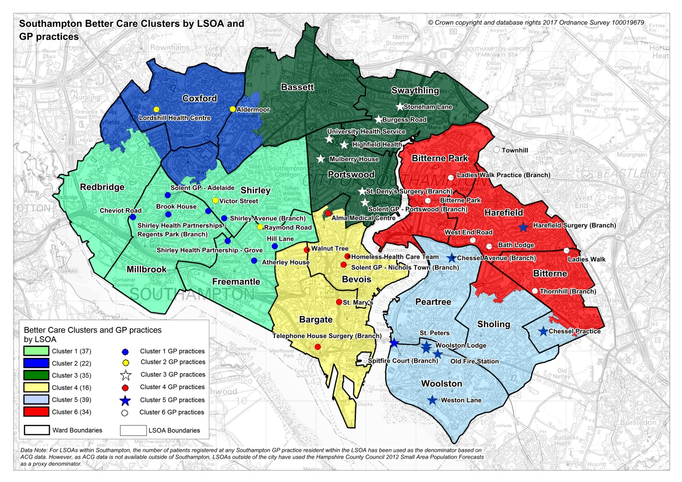

Demographic information per Cluster area

Demographic information per Cluster area | Cluster 1 | Cluster 2 | Cluster 3 | Cluster 4 | Cluster 5 | Cluster 6 | Total
Raw GP List Sizes 01/01/2017 | 54,305 | 35,352 | 51,016 | 44,649 | 49,524 | 47,489 | 282,335
Weighted Population figures 01/01/2017 (1) | 53,927 | 37,020 | 45,097 | 45,762 | 51,829 | 48,700 | 282,335
QoF 2015-16 Dementia (2) | 238 | 246 | 182 | 238 | 439 | 284 | 1,627
QoF 2015-16 Depression (2) | 4,025 | 2,749 | 3,062 | 1,951 | 4,176 | 2,529 | 18,492
QoF 2015-16 Serious Mental Illness (2) | 638 | 329 | 404 | 706 | 507 | 456 | 3,040
(1) Weighting calculation is based on a number of demographic indicators, for example age, deprivation etc.
(2) Quality and Outcomes Framework (QOF) register data provides an indication of the level of Mental Health need, it will not include those individuals who may have an undiagnosed mental health need

3.2 Service Objectives
Service description
3.2.1 Service Functions
- To ensure that appropriate referrals are received and made from/to primary care and cluster teams.
- To ensure that appropriate contact with clients and or referrers is made, to identify initial needs, signpost and/or identify the best voluntary sector agency to deliver further specific support.
- To provide information about how to access community resources and directly link people to these activities/community resources e.g.
- Leisure (sport, interests)
- Employment
- Education
- Welfare rights
- Housing
- Friendship schemes
- Time banking schemes
- Volunteering to support others/co support
- To provide a point of contact to access other universal services.
- To use and promote the use of the GENIE tool (https://www.clahrc-wessex.nihr.ac.uk/news/10/the-genie-is-out-of-the-bottle-but-who-controls-it-dr-anne-kennedy-principal-research-fellow-faculty-of-health-sciences-university-of-southampton) in assisting people to engage in community resources and maximising opportunities of support from their social networks.
- To ensure that people referred are actively followed up to confirm individuals are taking action, discover if the identified solutions are working, identify if the person needs additional support to take action or other solutions.
- To inform the referring organisation of client referrals made into the service from their organisation and provide feedback in relation to interventions made.
- To offer the service in accessible locations (including GP practices and Wellbeing Centres) and venues that are suitable to clients, taking into consideration the geographic, demographic, cultural and transport links of the population.
- To collect and maintain accurate records and data systems, ensuring high quality performance management information is available; this will include providing output and outcome data on a regular basis as specified by the commissioners.
- To ensure that individuals with low confidence levels are supported by offering to accompany or organise initial access to community groups.
- To work with Southampton Living Well Service affiliate programme to support access to local community resources.
- To apply the principles in Every Contact Counts in service delivery (http://www.makingeverycontactcount.co.uk/).
- The Service will work with other community initiatives to support people who are struggling to access technology and support them to use their own and community IT resources.

The service will seek to establish and maintain relationships with community groups and services, building relationships, linking people and networking.

The commissioner acknowledges that there will be circumstances in which the individual needs of clients cannot be met due to a lack of capacity within the identified community and/or where there is a total gap in provision for a particular need. In such cases, capacity issues in the community will be identified by the provider using their knowledge and working relationships with community organisations, particularly those operating in the voluntary community and faith sector.

The provider will be required to submit a quarterly report to commissioners and share with cluster teams and local solutions groups, providing a commentary on community capacity and emerging needs.

Support Provided

The service/s will assess and support individuals based around 3 different levels of intervention as set out below (basic, intermediate and advanced). Over time, as the city develops an approach of signposting being “everyone’s business”, the expectation is that the focus of the Community navigation service will shift to more activity being at the intermediate and advanced levels. The provider will need to be able to identify where the initial request masks a much wider range of complex issues.

The service will be delivered by a skilled and experienced workforce provided across the city with the skills to deliver a service to all three target groups (generic, adults with enduring long-term mental health problems and adults with organic mental illness, i.e. dementia). This workforce can be made up of paid staff and or volunteers. If volunteers are recruited the service will need to ensure that they are appropriately trained and supported.

Basic level
This level will support people who are able to plan their needs but unsure of how to find and access services and activities. They require basic level support and assistance including:
- Effective gathering of client details needed to assess their needs
- Basic identification and provision of information about the next steps needed to address the individual’s problem(s)/needs
- Filtering inappropriate queries and signposting
- Provision of options available to the client
- Assisting the client where the initial assessment has already been carried out

With specific reference to people with dementia, support at this level will be focussed on providing information, support and guidance based on individual need, including a ‘This is me’ book, and signposting to local community activities that the client may not be aware of. Typically limited to an initial contact, with a follow up appointment offered in all cases to ensure that there is no further information required, and that things are moving. Take up of the follow up will depend on the client/carer needs.
With specific reference to people with enduring long-term mental health problems, support at this level will focus on sharing information about options and services available. Typically limited to one or two contacts. Follow up appointment can be offered to ensure things are moving. In addition improved access to meaningful activity in their local community is recognised to help reduce loneliness and improve their physical and mental health.

Support at this level will be short-term i.e. no more than 6 contacts but usually 2 appointments with the person.

Intermediary level
The service must be able to provide a small number of appointments to assess and support the individual’s needs, develop a plan with the individual and assist the person to take the first steps, providing advice directly or make appropriate referrals to other advisors or agencies, where more specialist advice or an alternative service is needed, as specified below:
- Provision of brief initial assistance (e.g. filling in forms, helping the clients draft letters, liaising with third parties to seek information on the client behalf)
- Helping the individual develop a plan which identifies their needs and solutions
- Sign posting people to Advice and Information services
- Making referrals where generalist advice is not able to meet the advice requirements or where another service is needed
- Providing support and assistance to find and access service

With specific reference to people with dementia, support at this level will require more than two contacts or meetings to ensure that actions are being progressed. This could be due to the lengthy process, the complexity of the task or the stage of disease/presentation of the service user. Related to the stage of the disease, an individual may or may not require support to follow up on their actions. The support encourages individuals to gain and/or regain skills and activities that will help maintain independence across the “Well Pathway for Dementia”.

With specific reference to people with enduring long-term mental health problems, support at this level will require more than two contacts or meetings to ensure that all actions have been completed. This could be due to the lengthy process or the complexity of the task. An individual may or may not have the motivation to follow up on their actions independently. The support is of preventative nature. It will have a positive impact on a number of wellbeing factors, including housing, finances and social inclusion.

Support at this level will be over a longer period of time, usually between 6 weeks and 6 months, although it should remain as short as possible to maintain an individual’s level of independence.

Advanced level
- The service must be able to provide more detailed direct support and guidance, typically over a period of months including: Helping people who struggle to identify and plan how to meet their needs
- Helping people who need support and motivation to improve their health and wellbeing
- Situations where multiple needs have been identified which require monitoring and support over a period of time or specialist service / intensive support is required to complete the support package
- Helping to reduce risks to individuals (including to self and others, to tenancy and safeguarding) identified as significant if client’s current situation continues
- Writing letters on the clients behalf, contacting third parties and providing support to deal with the clients issue
- Taking action on behalf of clients in order to address a problem, with the adviser taking some responsibility for action. This could involve consultation and guidance with specialists
- Form completion, which involves more than one form
- Dealing with several issues for the same client
- Undertaking searches (from a range of information resources) due to the nature of the issue/ need and communicating with the client
- Helping people understand individual options where ability is an issue and increases the length of time due to the level of support needed
- Enhanced motivational support
- Detailed negotiation to resolve the issue or avoid an escalation of the issue.
- Preparatory work for specialists

With specific reference to people with dementia, support at this level would typically include an open caseload providing more intensive support for a period of time. This could be due to the lengthy process, the complexity of the task or the stage of disease/presentation of the client. Related to the stage of the disease, an individual will require support over a period of time to follow up on their actions. The support encourages individuals to gain and/or regain skills and activities that will help maintain independence across the “Well Pathway for Dementia”.

With specific reference to people with enduring long-term mental health problems, support at this level would typically include an intensive caseload providing longer term support to ensure sustainment of the current situation, or intensive support required. There are multiple needs identified which require support over a period of time.

Support plan
The provider will need to engage with those clients referred (for people with intermediary or advanced support needs only) to develop a person centred plan detailing the services to be accessed by the individual and the agreed outcomes. The person centred plan is to be developed by the client with support from the community navigator and a copy of the plan will be held by both parties. The support planning intervention may be based on an Outcomes Star approach.

3.2.2 Training, induction and ongoing workforce development
The service will use safe recruitment processes and ensure all staff and volunteers have appropriate levels of personal checks prior to employment or placement. Community Navigators should adopt a de-professionalised approach and deliver the service in a competent manner. Community Navigators should have suitable knowledge and experience in the following areas:
- Motivational interviewing
- Skilled in the use of the GENIE tool (see https://www.southampton.gov.uk/moderngov/documents/s31318/Using%20GENIE%20Presentation.pdf)
- Supporting people with mental health problems, ranging from mild-moderate depression and anxiety related disorders through to severe and enduring mental health problems.
- Learning Disability matters
- Supporting people with Dementia
- Housing related matters
- Managing caseloads
- Problem solving
- Basic counselling skills/techniques/health coaching/mental health first aid
- Knowledge of primary care and the voluntary and community sector
- Making every contact count (MECC) principles
- Delivering general basic welfare advice and referring people with specific issues to the Advice and Information Services

Individuals must feel that the sensitivity and nature of their condition is understood and an empathic approach should be taken to promoting dignity and respect, with a focus on empowering and encouraging people on all aspects of self-care as part of a value base.

Community Navigators will need a broad breadth of knowledge around individuals’ conditions and issues and seek expert advice from cluster team professionals as appropriate.

All staff must have a basic awareness and understanding of the social model of disability. The service/s will ensure staff have the skills and abilities to work with clients with these conditions and be sufficiently skilled in risk assessment to refer to specialist providers as required.

The Community Navigator Job Description must include reference to safeguarding competency levels and a “Think Family” approach; any concern regarding a child’s welfare will take paramount consideration during the visit. Safeguarding children and adult’s training must be provided at the appropriate level to all provider staff and volunteers.

Community Navigators must be familiar with the provider’s Lone Worker Policy.

3.2.3 Referrals
Referrals can be self-referral or originate from either a GP or Health & Social Care professional or other worker providing support in a cluster.
For people with enduring long-term mental health problems potential referrers may include care programme approach care co-ordinators, community mental health team members (psychiatrists, nurses, social workers and community support workers) and inpatient unit staff.
It is expected that most referrals will be generated at a client’s routine visit to a GP practice or by cluster team members service visits, including social care. The consulting GP or Health & Social Care professional will undertake the normal medical appointment/assessment, but would also consider if the client might benefit from addressing their social support needs. The client consent to refer would be required.

The provider will need to develop robust referral and onward referral processes and systems. However, the process must include the ability for referrers, during their initial contact with the client, to make direct bookings with a Community Navigator, potentially via an on-line, web based booking system offering real-time appointment slots as required.

All referrals for intermediate and advance support must be supported by a referral form, developed by the provider and in consultation with practice managers and commissioners. Ideally, the referral form will be completed and uploaded electronically (secure NHS Mail/Pathway Information Portal (PIP)) although paper referrals will also be accepted. Faxed referrals are not permissible.

Following receipt of the referral form, Community Navigators will undertake an initial assessment of the client’s needs.

3.2.4 Assessment
All referrals to the community navigation services will be assessed in order to identify the individual needs of the service user. The assessment scope and process will be agreed with the commissioner but should be holistic covering health and social factors such as: long term conditions, emotional and physical wellbeing, housing, finance etc. (please note this is not an exhaustive list). An Outcomes Star approach may be used.

The assessment process must support people to:
- Identify their need for intervention
- Agree person centred goals
- Agree individual initiated follow-ups back to the service, if required
- Support the individual to access community resources they require

Following assessment, the client will be contacted, by telephone wherever possible. During this first contact, the client will either be provided with the requested information or offered a further appointment with a Community Navigator if not already made.

If the assessment process uncovers a more serious underlying mental health, physical health or social need the service will need to refer the client to their GP or SCC Contact Centre. Any matter relating to a significant risk or safeguarding issue must be dealt with appropriately and under the overarching Local Safeguarding Policy and the Care Act 2014.

The service will develop an outcomes tool to be agreed with commissioners.

3.2.5 Days/hours of operation
Community Navigator Service will work in a flexible way to meet demand. It is expected the service would be fully operational between Monday to Friday and Saturday mornings. There should be the flexibility in place to enable assessments and ‘handholding’ (supporting people to initiate activities/attend appointments by accompanying them) in the early evenings, as appropriate, to promote accessibility.

The service will offer support to people via:
- Face to face
- Telephone/email/text
and be accessible via a single route for statutory services (ideally at cluster level)

3.2.6 Population covered
The service is for adults aged 18 years and above, registered with an NHS Southampton City Clinical Commissioning Group GP or resident within the Southampton City Council boundary area (regardless of GP status).

The Service will ensure a presence within the integrated Cluster Teams and seek intelligence from community groups about vulnerable people living in communities (finding people proactively before services are aware), so that individuals in need are identified for early interventions and prevention services.

It will be important to focus efforts on vulnerable and traditionally marginalised and excluded groups and so the service will need to effectively meet the needs of particular groups including:
- Frequent users of primary care and emergency services e.g. NHS 111, ED, Ambulance Service
- People with an illness or disability (including mental health) and their carers
- Families on a low income
- Older people (over 65 years)
- Black and minority ethnic people
- Victims of violence, including domestic violence
- People living in priority areas (wards with the highest levels of deprivation)
- Service personnel and ex service personnel
- People adversely affected by changes to the benefit system

Any exclusion criteria and thresholds
The following exclusion criteria apply:
- Clients under the age of 18 years
- Clients who have not consented to the care and support offered
- Clients who display unreasonable behaviour unacceptable to the provider and its staff
- Clients who are acutely ill at the point of referral

The Service will not seek to fill gaps in formal health and social care services.

3.2.7 Marketing and Promotion

The Provider will market the community navigation offer to GPs and other referrers, for example social care, housing, community nursing teams, psychological therapies (Southampton Steps to Wellbeing) and other stakeholders in the Southampton City boundary.

Service information should be available in the main languages spoken across Southampton. The provider is responsible for organising interpretation and translation services where required.

Through consultation with potential clients and stakeholders, the provider should propose a name for the service that resonates with clients and a community navigation service information leaflet. The leaflet should include as a minimum: the name of the provider; the name of the service; a description of the service; information about the service including location and opening times; access and referral information; and contact information. An electronic version of the leaflet will also be required, and be available on Southampton Information Directory and NHS Southampton Directory of Service. The service information leaflet will require the approval of the commissioner before issuing.

Branding of the community navigation service and service leaflets will be agreed with partners and the commissioner.

3.2.8 Interdependence with other services/providers
- Cluster Integrated Teams including primary care, community and mental health services, Adult Social care, housing, police, fire services
- Southampton City Contact Centre and Single Point of Access.
- Integrated Community Independence and Discharge Teams
- Cluster and City wide voluntary groups
- Faith groups
- Southampton Healthy Living Service
- Southampton Living Well Service
- Southampton Information Directory (SID)
- Steps to Wellbeing
- Advice Southampton
- General housing services and providers

With specific reference to people with dementia, the service provider will work in close collaboration with all providers in the dementia pathway, in particular with GPs, Southern Health NHS Foundation Trust (the specialist NHS dementia service provider), Solent NHS Trust (the specialist NHS admiral nursing service provider), Adult Social Care, University Hospital NHS Foundation Trust (the General Hospital), Carers in Southampton, Day Services and other third sector providers who are providing services to this population, Southampton Dementia Action Alliance (DAA), and emerging Dementia Friendly Communities in the city.
With specific reference to people with enduring long-term mental health problems, the service provider will work in close collaboration with all providers in the mental health pathways, in particular with GPs, Southern Health NHS Foundation Trust (the specialist NHS mental health service provider), Dorset Healthcare University Foundation Trust (the specialist NHS Improving Access to Psychological Therapies provider), Adult Social Care, University Hospital NHS Foundation Trust (the General Hospital), Carers in Southampton, Mental Health Anti-Stigma Steering Group, Mental Health Partnership Group, Day Services and other third sector providers who are providing services to this population.

The provider will need to establish links with Local Solutions Groups, local voluntary and community sector organisations, faith and neighbourhood groups.

3.3 Leadership Function (commissioned separately)

The Community Navigation Provider will be expected to work in an integrated way as part of a network of community provision, supported by a separately commissioned “Leadership function”. It is expected that the Community Navigation Provider cooperates with the provider of the leadership function. The Leadership function will be commissioned separately to deliver the following:

- To bring together agencies that provide community navigation type activities to deliver a single community offer in the city.
- To provide support and coordination to community navigation providers (encompassing the provider of this Specification but also other non commissioned providers) to develop and raise standards of service and quality.
- To provide leadership for the development of community navigation in the city, linking service delivery to other related services such as Southampton Healthy Living Service, Southampton Living Well, Advice Southampton and the Over 60’s Service provided by SCC Housing.
- To explore the potential for coordinating access through a single point of referral to ensure the most appropriate service can respond in a timely manner.
- To promote community navigation (social prescribing) across the city, facilitating community navigation services to embed service access and delivery within practices and local pharmacies.
- To train and support community navigation services and other voluntary sector groups in the city in using the GENIE tool.
- To work with community navigation providers to develop the workforce, aiming to increase the skills and knowledge of workers/volunteers of technical approaches and increase the awareness of the needs of target groups.
- To consult and gain views from local people and clients in relation to the development, implementation and running of community navigation services in the city.
- To work with other community navigation services to collate, analyse and report to Local Solutions Groups (cluster groups bringing together neighbourhood and voluntary organisations, faith groups and local businesses to support people in their community), and Commissioners on issues raised in relation to service provision, e.g. challenges and trends, identifying gaps in required service provision across geographical and health and social needs categories.
- To work with local solutions groups to map community resources and encourage local organisations and people to record information on the agreed information directory (currently Southampton Information Directory SID), maximising the mapping already undertaken by organisations across the City. (SID is hosted by the City Council and provides a platform for organisations to share their offer and assist people to identify resources in their community).
- To support Community Development services to identify through a process of coproduction gaps in community resources/assets required by the community and clinical teams (linking into the JSNA and Community asset map) to improve health and wellbeing.

4. Applicable Service Standards
  - The service must:

- Take into account cultural, religious and gender sensitivities and provide male or female support when requested
- Make the service available in locations that are geographically convenient with good transport links based within local communities. Where people are unable to travel to appointments visits must be arranged
- The provider must ensure systems and processes are in place to ensure continuity of support and advice and information
- Ensure that services are delivered to meet the specific needs of people with disabilities or mental health problems so they receive equitable access to services
- Be led by client views and opinions in developing integrated services that best suit client needs
- Ensure staff are trained to appropriate level in terms of safeguarding adults and young people
- Provide access to interpretation services to facilitate communication with ethnic minority groups as necessary
- The service will need to develop a proportionate & risk based quality assurance framework
- Develop and operate an effective lone worker procedure
- The provider must ensure that a senior officer is in place with managerial responsibility who takes the lead for the day to day running of the service

The provider must ensure that the following levels of supervision are provided to the community navigator team (paid staff and volunteers):
- Management supervision
- Personal supervision
- Safeguarding supervision (safeguarding issues to be referred to named officers with safeguarding corporate responsibilities)

5. Key Service Outcomes
5.1 The service will contribute to the following outcomes:

- To contribute to the health and social care system delivery of the Better Care “I Statements”
- I feel part of my community
- I have the information I need
- I am supported to understand and make choices
- The professionals involved with my care talk to each other
- My family/carers needs are recognised and supported
- My independence is valued
- Achievement of Person Centred Outcomes at an individual level (as measured through a systematic tool such as the outcomes star and Patient Activation Measure – to be agreed with the Commissioner)
- Reduction in loneliness (measure to be agreed with the commissioner)
- Reduction in GP contacts for medically unexplained symptoms (physical symptoms for which a treating GP or other healthcare professionals have found no medical cause)
- Reduction in avoidable ED attendances and use of other emergency and urgent services (particularly for patients who are identified as being high intensity users)
- Reduction in avoidable use of social care services (measure to be agreed with the commissioner).
- High levels of individual and professional satisfaction with the service provided as measured through client, staff and referrer feedback mechanisms
- Reduction in low level anti-social behaviour
- Increase in the actual number of activities/support being accessed (Age UK, Luncheon Clubs, etc)
- Increase in number of times the information directory is accessed
- Increased numbers of people with LTC/disabilities accessing employment
- Increased numbers of people with improved wellbeing

It is the intension of Commissioners to develop a balance score card approach to track outcome delivery to be developed with the provider.

The provider will develop an evaluation model with commissioners to evaluate performance against these outcomes, exploring how other areas and services have evaluated. This might include:
- Working with referrers and commissioners to track the health and social care service use of individuals referred pre and post intervention to ascertain what impact there has been achieved
- Comparisons with control groups not receiving community navigation
- Simple self-assessment tools used with clients
- Seeking broad stakeholder feedback on the impact of the service (e.g. How has the service contributed to building capacity in the community
- Sample of people using the service (level to be agreed with the commissioner) to be contacted and followed up at 6 weeks and 6 months after discharge to evaluate outcomes, using agreed tool

6. Management Information and Reporting Requirements
All data to be reported by Cluster area.
The provider will be required to collect and report monthly with the following client data:

Progress against an outcomes tool
NHS Number - if known
Demographic data – to include ethnicity: mental health/learning disability/age/gender
First Four digits of the clients postcode and registered GP
Health conditions of clients supported
Number of clients in receipt of welfare support
Number of clients who are not in paid employment

Performance indicator | Indicator | Threshold | Method of measurement | Frequency of monitoring
Outcomes | Person Centred Outcomes (to be agreed with commissioners). E.g. Outcomes Star  Patient Activation Measure. Loneliness Score | % referred who score an improvement from baseline (primarily focused on Intermediary and Advanced support levels)  - 6 weeks following discharge  - 6 months following discharge | Data report  Questionnaire | Quarterly  Quarterly
Activity | Total number of:  - referrals, by target client group and source of referral (e.g. self- referral)  - clients on the caseload by targeted group  - average and maximum time on caseload by targeted group  - clients discharged from the service by targeted group | Snap shot (last working day)  100% of all discharges to be reported | Data report | Monthly
Activity | Number of clients and consultations by target client group, broken down into telephone and face to face, at the following support levels:  - Advanced level  - Intermediate level  - Basic level |  | Data report | Monthly
Activity | Number of clients referred or signposted on to other services by targeted group:  - NHS service (primary and secondary)  - Social Care  - Housing  - Employment support agencies  - Information, advice and guidance services  - Voluntary and Community sector broken down by activities, care and support (including name of organisation)  - Children’s / Adult Safeguarding  - Others as appropriate |  | Data report | Monthly
Activity | Number of client support plans developed, broken down into target client group |  | Data report | Monthly
Activity | Number of:  - referrals declined and reason  - exclusions from service and reason for exclusion |  | Data report | Monthly
Activity | % of clients that do not attend (DNA) consultations, broken down into target client group |  | Data report | Monthly

Performance Indicator | Target | Reporting Frequency | Consequence of Breach
Clients to be contacted within 1 week of referral from receipt of referral | 95% | Monthly | <95% withholding of 1% of monthly contract value  <90% withholding of 2.5% of monthly contract value
Where a face to face assessment has been identified clients to be offered an assessment to take place within one month of receipt of referral | 95% | Monthly | <95% withholding of 1% of monthly contract value  <90% withholding of 2.5% of monthly contract value
Written reports submitted to Commissioners on Service provision, challenges and trends, identifying gaps in required service provision across cluster and health need categories | Submitted Quarterly | Quarterly

