Summary Information
Reference number
Notice Title
Quotation request data
Closing date
Anticipated contract start date
Anticipate contract end date | 31st October 2016
Is this a smaller part of a primary contract | No (if Yes, please state the primary contract)
Lowest value (£) | £25,000
Highest value (£)
Is it suitable for SME and/or VCSE | (SME – Small and Medium Enterprise, VCSE – Voluntary Community and Social Enterprise)
CPV Code (if known)

Officer Name | Michael Brinn | Phone | 02079262813
Cluster | Neighbourhoods and Growth | Address
Team or Section | YNTH | E Mail | mbrinn@lambeth.gov.uk
The London Borough of Lambeth Needs to Procure:
Quantity |  | Description
As per the attached schedule |  | As per the attached schedule
Payment Terms:
Any Other Conditions: |  | (delete if not required)
Lambeth’s Standard Terms and Conditions of Contract: |  | (direct the supplier to the Lambeth website for standard terms of purchase, if applicable)
Quotation Evaluation Methodology: | Price + Quality Lowest price  We recommend to consider whole lifetime costing as well as risks and dependencies. If required, please seek advice from your procurement team.

Note to Suppliers
Please use the following page to provide details of your offer to the Council. Prices should be shown exclusive of VAT and inclusive of carriage and delivery and all discounts.

Quotation Submission
For Completion by the Supplier

(Supplier Name)
Quotation Submission Date:
Contact Name: |  | Phone:
Department (if needed): |  | Fax:
Address: |  | E Mail:

Our firm does hereby offer to supply the following supplies / services [please delete as appropriate] as per the delivery schedule above. We include the fixed prices in the table below; prices shown are exclusive of VAT and inclusive of carriage and delivery and all discounts:

Description | Price Per Item, Day or Instance | Total Price

This quotation will remain valid until [insert date], from the Quotation Submission Date above.

Supplier Declaration
After you have completed this form, please read the statements below and agree to the following statements:

- I have read and understood Lambeth’s procurement guidance for suppliers, “Selling to the Council”
- I accept the Terms and Conditions indicated on this form
- If I am selected to provide the above services and/or supplies this form and the information on it will form part of my contract with the London Borough of Lambeth
- If I am selected to provide the above services and/or supplies I will complete the Council’s Supplier Self Certification form. Failure to complete this form will result in my quotation not being accepted
- Lambeth is under no obligation to accept the final results of the quotation competition or the lowest price for any particular item submitted by a supplier
- Non-delivery of services or products will result in non-payment by the Council
- False representation could result in de-selection from any competition or termination of contract
- It is a criminal offence to give or offer any gift or consideration whatsoever as an inducement or reward to any servant of a public body. I understand that any such action will empower the Council to cancel any contract or commission currently in force and may result in my exclusion from future work
- Lambeth has the right to use this information for the prevention and detection of fraud

If you understand and agree to these statements please check the box below. By checking the box you also certify that the information you have supplied is accurate to the best of your knowledge, has been prepared by your firm with the absence of collusion and that you accept the conditions and undertakings in this form. If you do not check the box you will not be able to work with the London Borough of Lambeth:

Yes

BACKGROUND

The London Borough of Lambeth are refurbishing its Town Hall and building a new Civic Centre (which will be adjacent to the Town Hall) in Brixton. Both buildings are due to be complete and fully operational by early 2018. Staff will be working at a person to desk ratio of 10:6. To achieve this, the Council are preparing teams to work different through flexible working and want to trail a variety of different work settings in one of its core buildings and quotations are invited for the supply, delivery and installation of furniture as outlined in this document.

REQUIREMENTS  The Council intends to pilot the proposed future work settings on the 8th Floor, International House in Brixton. The floor is currently occupied by a number of different teams working within Children’s Social Care.  Quotations are invited for the supply and installation of fit for purpose furniture that complies with the requirements as listed in the schedule on page 2-3 and the attached drawing opposite.  Delivery and installation will have to take place out of office hours and will likely be a weekend. All products must be covered by a minimum warranty period of 5 years.  CAD drawing is supplied with the documentation but suppliers will be required to re-draw the layout to scale including the measurements of products selected.  Products must be able to be dismantled and re-configured at an alternative location if required.  Suppliers must confirm that they will be able to supply and install the furniture to be fully operational by 31st October 2016 by working in conjunction with Lambeth’s ICT, FM and building management services. We are willing to compromise on the precise specification and colour of furniture if it means the project timelines can be shortened. | 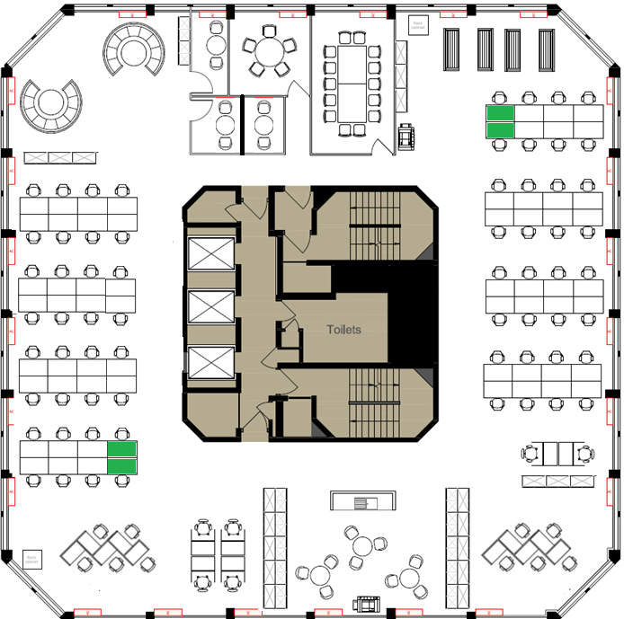

Schedule of required furniture and pricing schedule

Ref. | Symbol | Description |  | No. required | Cost per item £ | Total cost £
 | 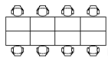 |  | Fabric covered dividing screen up to 450mm high to fit between each pair  White top, leg detail to be supplier standard colour | 6no
  01 - Standard Workstation bench
  Work setting is meant to provide a full desk set up for users, monitor keyboard, mouse, desktop power / data, docking station for laptops and potentially a telephone handset
  Desk benching system made up of 8 x 1200 x 800 desk units. Metal frame with MFC top
 | 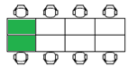 | Work setting is meant to provide a full desk set up for users, monitor keyboard, mouse, desktop power / data, docking station for laptops and potentially a telephone handset |  | 2no
  02 – Standard Workstation bench
  Desk benching system made up of 6 x 1200 x 800 desk units
  Fabric covered dividing screen up to 450mm high to fit between each pair
  Metal frame with MFC top.
  White top, leg detail to be supplier standard colour
03 - Standard Workstation + arm |  | As 01 above | As above but with the addition of a flexible monitor arm - To hold up to 20lb monitor, fixed angle / dynamic link, integrated cable management, arm reach of up to 50cm, height adjustment range of up to 25cm. | 6no
04 - Standard Workstation + arm |  | As 02 above | As above but with the addition of a flexible monitor arm - To hold up to 20lb monitor, fixed angle / dynamic link, integrated cable management, arm reach of up to 50cm, height adjustment range of up to 25cm. | 6no
 |  | Work setting is meant to provide a full desk set up for users, monitor keyboard, mouse, desktop power / data, docking station for laptops and potentially a telephone handset |  | 4no
  05 – Height adjustable (powered)
  Individual 1200 x 800 desk units with motor powered height adjustment
  Metal frame with MFC top – to match desk bench units
 |  | As 05 above |  | 4no
  06 – Height adjustable + arm (powered)
  As above but with the addition of a flexible monitor arm - To hold up to 20lb monitor, fixed angle / dynamic link, integrated cable management, arm reach of up to 50cm, height adjustment range of up to 25cm.
 |  | As 05 above |  | 4no
  07 – Height adjustable (manually adjusted)
  Individual 1200 x 800 desk units with motor powered height adjustment
  Metal frame with MFC top – to match desk bench units
 |  | As 07 above |  | 4no
  08 – Height adjustable + arm (manually adjusted)
  As above but with the addition of a flexible monitor arm - To hold up to 20lb monitor, fixed angle / dynamic link, integrated cable management, arm reach of up to 50cm, height adjustment range of up to 25cm.
 |  |  |  | 2no
  09 - Quiet booth – option 1
  Work setting is to act as a work space for an individual that brings their own ICT kit.
  All booths must provide a comfortable and calming environment with a professional and welcoming feel achieved through the use of soft space not harsh lines.
  Banked units with 1000 x 500 MFC tops (white)
  5 unit cluster
  500 high acoustic screen on 3 sides to create privacy
 |  |  |  | 2no clusters
  10 - Quiet booth – option 2
  Work setting is to act as a work space for an individual that brings their own ICT kit.
  All booths must provide a comfortable and calming environment with a professional and welcoming feel achieved through the use of soft space not harsh lines.
  Banked units with 1000 x 500 MFC tops (white)
  500 high acoustic screen on 3 sides to create privacy
  Configuration is to be designed using standard products as suggested by the supplier – units to deployed in clusters not individually but provide up to 6 small workstations
 |  |  |  | 2
  11 – High back circular booth
  Informal meeting venue for small team meetings
  Fabric and acoustic panelling around sofa benching - ideally to product match with the high backed sofas.
  Round table in the centre (750mm high).
  Unit size to be recommended by supplier
 |  |  |  | 4
  05 – High back sofa
  Informal meeting venue for small, less formal meetings - maximum of 4 persons (on each sofa). No table and power required
  Fabric and acoustic panelling over sofas - ideally to product match with the circular setting
06 - High backed chairs | 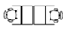 | Informal meeting venue for small, less formal meetings - maximum of 2 persons (in both chairs). No table and power required | Fabric and acoustic panelling over sofas - ideally to product match with the circular setting | 3
07 – Standard Operator Chairs |  |  | Free wheel Castors  Gas lift  Mechanism - Non locking to encourage movement  Integrated seat height and seat depth controls  Seat cushion - Combustion Modified High Resilient (CMHR) moulded foam  Arms - soft touch arm pad with 100mm of height adjustment  Backrest material - mesh  Lumbar - flexible adjustment in lumbar support | 64
  Task chair to provide good ergonomic support and adjustment for users
11- Storage cabinets |  | Storage units should complement the other furniture | 3 drawer / shelf free standing unit  Approx. 1000h x 1000w x 470d | TBC
11- Storage cabinets |  | Please provide a unit cost for the following lockable cabinet types. | 4 drawer / shelf free standing unit  Approx. 1600h x 1000w x 470d | TBC
11- Storage cabinets |  | Please provide a unit cost for the following lockable cabinet types. The Council will decided how many of each type to use before the final order is placed. | 5 shelf free standing unit  Approx. 2000h x 1000w x 470d | TBC
09 – Delivery and installation

Extract from Lambeth’s Customer Environment Design Guide standards

The information below is provided to give an indication of the accent colour scheme to be used as the basis for selecting finishes for soft seating and screening. It is expected that desk tops be white and task chairs to be in a black or grey finish. Exact matches are not required, this has been included as a guideline. The supplier will advise on the best solution to meet the colour scheme extracted from the Lambeth’s Customer Environment Design Guide standards. Suppliers will prove sample swatches, 3D illustrations and drawings to support their proposed solutions.

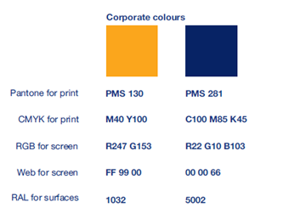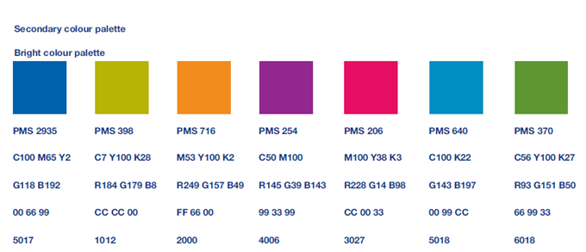

Quotation Evaluation
For internal Lambeth use only

Name of Supplier | Tendered Price | Total score | Name of Supplier | Tendered Price | Total score

Actual Contract Start Date: | Contract End Date:
Recommended supplier: | Rationale:
Type of organisation: SME The 3rd Sector

