SCHEDULE 2 – THE SERVICES

- Service Specifications

This is a non-mandatory model template for local population. Commissioners may retain the structure below, or may determine their own in accordance with the NHS Standard Contract Technical Guidance.

Service Specification No.
Service | Hounslow integrated consultant led community Pulmonary rehabilitation, home oxygen assessment and specialist nurse support service
Commissioner Lead | Hounslow CCG
Provider Lead
Period
Date of Review

1. Population Needs
National/local context and evidence base

National context:

Respiratory diseases are a major cause of morbidity and mortality and place significant demand on NHS resources. Chronic Obstructive Pulmonary Disease (COPD) accounts for a substantial number of deaths in Great Britain: it has consistently given rise to between 25,000 and 30,000 deaths each year over the last 25 years with 15% of those admitted to hospital dying within 3 months of admission, 25% dying within 12 months and 50% dying within 2 years. The number of people suffering from the disease at any given time (prevalence) is difficult to estimate because of different definitions of the disease and under-diagnosis. One recent estimate suggested that there are currently 900,000 diagnosed cases in England and Wales and that, allowing for under-diagnosis, the true prevalence could be 2.8 million.
In England, COPD is the second most common cause of emergency admissions and one of the most costly inpatient conditions to be treated. It is estimated that the direct cost of providing care in the NHS for people with COPD is almost £500 million a year, more than half of which relates to hospital care. The estimated annual cost of treating people with mild COPD is £149 and £1,307 for a person with severe COPD. COPD is a term used to describe a progressive and irreversible decline in lung function which results in reduced airflow in the lungs.
The national aspiration is to reduce the number of people with COPD dying prematurely. It requires proactive care and management at all stages of the disease, with a particular focus on disadvantaged groups and areas with high prevalence. The aim is to improve respiratory health and wellbeing of all communities and to minimise inequalities between communities.
The 2011 Outcomes Strategy for COPD and Asthma recommends a proactive approach to prevention, early identification, diagnosis and intervention. Integration is required across the NHS, Public Health and Social Care services to achieve the goal of a positive, enabling, experience of care and support right through to the end of life.

Local context:

- Chronic obstructive pulmonary disease (COPD) prevalence: Hounslow CCG has a registered prevalence rate of 1.04% (3,225 patients) which is 0.1% lower than the overall London prevalence rates.
- Based on Public Health Outcome Framework (PHOF), in 2011 the estimated prevalence of COPD in Hounslow was 2.72%, which means there are at least 4,900 more patients in Hounslow who have not been diagnosed or are not registered with a GP yet
- Non – elective admission for COPD: 451 ( 2015/2016) and 456 (2016/17)
- Readmission rate for COPD : Number of COPD patients who have more than 2 admissions in one year is 78 resulting in total of 259 admissions (2016/17)
- Rightcare also identifies non- elective admission spent for COPD patients is an area for improvement for Hounslow CCG, when benchmarked with other 10 similar CCGs
2. Outcomes
2.1 NHS Outcomes Framework Domains & Indicators

Domain 1 | Preventing people from dying prematurely | X
Domain 2 | Enhancing quality of life for people with long-term conditions | X
Domain 3 | Helping people to recover from episodes of ill-health or following injury | X
Domain 4 | Ensuring people have a positive experience of care | X
Domain 5 | Treating and caring for people in safe environment and protecting them from avoidable harm | X

2.2 Local defined outcomes:
- Reduction in the number of A&E attendances and Non-Elective admission (NEL) for patients with chronic respiratory conditions e.g. COPD
- Improved health outcomes for patients with chronic respiratory conditions e.g. COPD i.e. fewer exacerbation, less absence through illness and less hospitalisation
- Improved patient awareness and self-management of their own chronic respiratory conditions e.g. COPD condition, i.e. more independent management of their own condition.
- Improved patient satisfaction of the integrated consultant led community Pulmonary rehabilitation, home oxygen assessment and specialist nurse support service
- Improved GP awareness of chronic respiratory conditions, diagnosis and treatment
- Integration with other services i.e. hospitals, social services, voluntary sector, health and social care, other community services and mental health services.
3. Scope
Aim: The overall aim of the Hounslow integrated consultant led community Pulmonary rehabilitation, home oxygen assessment and specialist nurse support service is to provide all eligible patients with a service that meets their needs and achieves the outcomes.
The objectives of the service are to:
- Provide an integrated care service where the Provider will work with other services/stakeholders, to ensure continuity of care is provided to the patients with chronic respiratory conditions, e.g. Chronic Obstructive Pulmonary Disease (COPD)
- Ensure pulmonary rehabilitation is accessible to all individuals with chronic respiratory conditions e.g. COPD
- Provide a systematic and integrated assessment and review of patients on home oxygen (HOS AR)
- Provide recently discharged COPD patients with support so that they can self-manage their condition and avoid re-admission

- Reduce non-elective admission to hospital for those patients with diagnosed COPD, i.e.
  - Through advising primary care (General Practices) on the early identification of deterioration at primary care level
  - Following-up identified discharged patients to promote health and improve self-management, and
  - By facilitating referral into Pulmonary Rehabilitation, oxygen services and other related services as appropriate.
  - By proactively identifying the COPD patients either via SystmOne (S1) search or using WSIC dashboard and offering support to manage any exacerbation
- Empower patients and carers to self-manage their condition and make informed choices through improving their knowledge and education provision as required
- Provide a chest physiotherapy service for patients with chronic respiratory conditions
- Provide a service to patients over 18 years of age and registered with Hounslow GPs
The following service provisions for patients with chronic respiratory conditions are covered in this specification:
- Pulmonary Rehabilitation Service
- Home Oxygen Assessment Service
- Community-based specialist Nursing and Consultant Service
- Chest Rehabilitation

- Pulmonary Rehabilitation Service

Summary of service

The Pulmonary Rehabilitation (PR) service is for patients with Chronic Obstructive Pulmonary Disease (COPD).

Provision of PR and staffing requirements

PR is delivered by a multidisciplinary team of qualified professionals. The staffing ratios that are recommended for the United Kingdom are 1:8 for supervision of exercise classes and 1:16 for education sessions with a minimum of two staff (TBC).

Patient Safety

Patient safety is an important consideration, even though there have not been any reports of adverse events. It is important to ensure that resuscitation facilities are available and that staff have had appropriate training. Ambulatory oxygen should be available for patients who de-saturate on exercise.

Service model: Please refer to appendix 1

Inclusion criteria:
A pulmonary rehabilitation service is designed to meet the needs of specific patient populations with chronic respiratory disorders. PR will be offered to:
- All patients who consider themselves functionally disabled by breathlessness (usually patients whose breathlessness is assessed on the Medical Research Council (MRC) grading scale as MRC3 to MRC5);
- Patients with MRC 1 and MRC 2 who are symptomatic and disabled by their condition, and who require health care professional assessment and supervision of exercise training, rather than simple advice on lifestyle changes;
- Patients with a confirmed diagnosis of COPD and other chronic progressive lung conditions;
- Patients who have either recently had an exacerbation of COPD requiring hospital admission or whose functional baseline has significantly altered and is not following the expected recovery path.
Exclusion criteria
- Patients under 18 years of age and not registered with a Hounslow GP
- Significant unstable cardiac or other disease that would make pulmonary rehabilitation exercise unsafe or prevent programme participation;
- Patients who are unable to walk or whose ability to walk safely and independently is significantly impaired due to non-respiratory related conditions. This should not exclude patients who have general musculo-skeletal problems where exercise is recommended;
- Patients unable to participate in a group environment or for whom group sessions are not suitable (e.g. extreme frailty, sight or balance impairment), or for whom mental health, cognitive, personality or other communication barriers, that make group work inappropriate.

- Home Oxygen Assessment Service

This service provides high quality, evidence based assessment, management, education and support service for patients who require oxygen therapy. The service is delivered within a community setting.
The service will provide assessment to patients who are on two forms of oxygen therapy, and assess patient’s suitability for each:

- Long term oxygen therapy (LTOT) - the provision of oxygen therapy for continuous use at home for patients with chronic hypoxaemia. The oxygen flow rate must be sufficient to raise the walking oxygen tension above 8kPa. Once started, this therapy is likely to be life-long.

- Ambulatory oxygen - the provision of oxygen therapy during exercise and activities of daily living. Ambulatory oxygen therapy can be prescribed for patients on LTOT, who are mobile and need to or can leave home on a regular basis; patients using LTOT, or who are expected to de-saturate on exercise, may need to be assessed for ambulatory oxygen.

A third form of oxygen therapy – Short Burst Oxygen Therapy (SBOT) – is commonly prescribed for breathlessness. However, IMPRESS guidelines recommend that oxygen therapy should not be prescribed for breathlessness. SBOT is therefore out of scope for this service.

Service model: Please refer to appendix 2

Inclusion criteria
The HOS-AR service is designed to meet the needs of patients who might benefit from home oxygen. In most cases, these individuals will show resting hypoxaemia with a SaO2 < 92%
Exclusion criteria
- Patients under 18 years of age and not registered with a Hounslow GP
- Patients who cannot benefit from home oxygen;
- Patients who have not had a clinical assessment or diagnosis (except palliative patients who are not assessed or reviewed through the normal service. Palliative patients should have evidence of hypoxaemia. Some assessment of equipment may be needed and this prescribers for palliative patients may need discussion with the HOS-AR service)

- Community-based Respiratory Nursing and Consultant Service

This service will work very closely with the acute hospitals and other services to offer seamless specialist care to COPD patients:
  - The service will liaise and actively participate with different acute providers (via discharge coordinators and hospital respiratory team) to identify the COPD patients recently discharged from hospitals. These patients will be referred into this service.
  - The service will receive referrals of COPD patients from other sources, e.g. carers, GPs, 111, Specialist Palliative Care, Hounslow and Richmond Community Healthcare Trust (HRCH),
  - The service will proactively identify COPD patients (discharged from hospital) either via SystmOne (S1) search or using WSIC dashboard and offer support to manage any exacerbation
  - All the COPD patients discharged from hospitals will be contacted by the service (either in person or telephone) within 48 hours of discharge from hospital.
  - Depending on the clinical status of the patient the service will determine the number of future contact/visits.
  - Patients with more than 2 non- elective admissions within 1 year will be on the case load of the service
  - Proactively case find by working with Providers in the community whose condition is deteriorating and take necessary measures to avoid emergency admissions.
  - To provide case management or disease management to those patients identified as being at risk of admission or re-admission to hospital using a risk stratification tool
  - To work in partnership with patients through motivational interviewing and goal setting.
  - Provide support and education to patients they need to self-manage their conditions and know the symptoms of exacerbation
  - Regular diagnostic evaluation to ensure that the patient is stable and to take appropriate action if they begin to deteriorate
  - Ensure patient understands how to use medication (e.g. respiratory inhalers, oxygen)
  - Signposting information about local care and support groups (including voluntary organisations e.g. British Lung Foundation

Inclusion criteria
- All the COPD patients who have been discharged recently from acute hospitals following an exacerbation
- COPD patients who are at risk of developing an exacerbation

Exclusion criteria
- Undiagnosed patients.
- General medical condition is not stable at time of referral e.g. other co-morbidities.
- Patients with mental health co-morbidity including alcohol/drug dependency that impairs or prevents engagement and their ability to self-manage their condition.
- Rapidly worsening symptoms that require urgent care intervention.
- Other co morbidities not stable at the time of referral e.g. heart failure, diabetes.
- Patients who have cognitive impairment that would impact on their ability to work with the team, unless living with a carer who can be educated in managing the patient’s condition.

- Chest Physiotherapy

Service requirements
Aim
The aim of chest physiotherapy is to teach the patients with respiratory conditions to be independent in clearing their chest and therefore strengthening respiratory muscles.
Chest physiotherapy patients would require assessment and treatment based on their clinical need, , carried out by a Respiratory Physiotherapist:
Inclusion Criteria:
This service is commissioned for people with chronic respiratory conditions including COPD and Asthma, over 18 years of age and registered with a Hounslow GP.
Exclusion criteria:
- Stroke patients with tracheostomy
- Neuro conditions
- Multiple Sclerosis
- Cystic Fibrosis
- Other tracheostomy patients under the care of a District Nurse

Consultant Leadership
This service will be overseen and led by a consultant specialising in respiratory medicine, who will have overall strategic and clinical leadership for the delivery of the service. The consultant will be accessible in the community and supportive to primary care (GP practice staff)/other community health care clinicians.
The role will include the following for example
- Lead multi-disciplinary case conferences for patients under the care of community team. MDT meetings will be mixture of virtual and face to face (at locality/community setting)
- Support specialist nurse to case manage the COPD patients
- GPs and practice nurses will have access to consultant advice via email, phone or SystmOne (Advice to be provided within 48 hours of receipt of query or 72 hours (Friday);
- Periodic (TBC) triage of all hospital (acute) respiratory referrals at the Hounslow referral facilitation service (RFS)
- Create respiratory pathway and guidelines for Hounslow
- Facilitating education workshop including primary care spirometry training (in conjunction with the specialist nurse where appropriate) : 5 sessions over a year across 5 localities
- Facilitating the discussion about withdrawing home oxygen where review indicates the patient is no longer deriving clinical benefit from the oxygen

Population covered (accessibility)
The service will need to be fully accessible to those registered with Hounslow GP
The HOS-AR service is designed to meet the needs of patients who might benefit from home oxygen. In most cases, these individuals will show resting hypoxaemia with a SaO2 < 92%
The vast majority of patients are likely to suffer from respiratory disease, typically COPD, cystic fibrosis or pulmonary fibrosis. However, in some instances the service is likely to be utilised by patients suffering from cardiac disease, some neurological disorders (e.g. cluster headaches) and patients in receipt of palliative care.
Principles of accessibility for whole service:
- Patients over age of 18 years and registered with a Hounslow GP
- The service must be able to meet the needs of those who do not have English as a first language
- The service must recognise cultural diversity and meet the needs of the population it services
- The service must be located in an accessible area, with good access to transport links
- The service must have access to parking for patients, including disabled patients
- The service must be provided from at least 2 sites positioned to meet the needs of the local population

Interdependencies with other services and notification as appropriate
- GPs
- Community Services
- Community Matrons
- Carers
- Acute Specialist Respiratory Teams
- Other respiratory services
- Cardiac services
- Neurology services
- Care for elderly
- Social care
- Mental Health team
- Home Oxygen Provider
- Specialist Palliative Care Team
- Smoking Cessation Service
- Life Style and Health Promotion Services
- Local fire service
- Ambulance service
- Primary Care Patient Coordinator Service

Communication with GPs/referrers
Patients GPs are often the central point of access for patients with the health care system- therefore regular and clear communication between the provider and General Practice is essential.

Use of electronic communication tools is recommended to support and automate this process.
A dedicated telephone number and email address should be provided to the GPs for communication.
Referral route
All the referrals into the service from GPs will be via Hounslow referral facilitation service (RFS)

All referrals into the service from acute hospitals or other services will be via the Single Point of Access (SPA)

Service Operations
Governance
There must be clear and accountable governance arrangements with senior clinical leadership provided within the Service with appropriate presence at service delivery locations.
Referrals
The service will be provided for adults registered with a Hounslow GP through referral from the GP. It may be necessary for the service provider to check to ensure the patient is eligible to receive the service.
IT and Data Sharing
The service must be able to use SystmOne (or a system interoperable with SystmOne), to transfer all information for patients, appointment booking and referrals management.
Engagement with local data sharing is required, as detailed in the CWHHE memorandum of understanding for data sharing within SystmOne
Premises
The service must be delivered from a clinically appropriate, accessible and centrally located (central to Hounslow) premises, close to transport and with disabled parking available, or the clinical and access needs of the patients must be addressed if a different model is proposed (see below for detail).
Cancellation and Do not attend ( DNA) appointments
If a patient cancels their appointment with more than 24 hours’ notice they will be offered another appointment. If a patient cancels twice on consecutive appointments they are liable to be discharged back to their GP except in exceptional circumstances. A warning will be given after the first cancellation.
If a patient cannot book a further appointment for valid reasons, the appointment may be left open for a maximum of one month. If a patient does not attend their new or follow up appointment, they will be sent a letter asking them to book a new appointment in two weeks. If the new appointment is not taken they will be discharged back to their GP, except in exceptional circumstances. Once discharged, if a patient contacts the service they will be advised to return to their GP for another referral if they still require treatment.
In exceptional circumstances, a patient may be offered another appointment once discharged. DNA rates must be provided at monthly intervals to each CCG as part of the monitoring arrangements.
Discharge
Patients will only be discharged from the service when it is clinically appropriate to do so and a plan is in place for their ongoing care. They will be discharged back to the care of their own GP and the service must ensure that care and support in the community is arranged using an integrated approach.
Days / Hours of operation
Services must be offered to meet the needs of patients where possible and operational as a minimum of 08:30 and 17:30 Monday to Friday and outside of these core working hours to provide a more accessible and convenient service for patients where possible.
4. Applicable Service Standards
4.1 Applicable NICE National Standards:

Please can you check this section with the initial Service Sspecification which contained reference to NICE guidance on the front page

The commissioned service should comply with all national best practice standards and guideline for Pulmonary rehabilitation including;

: IMPRESS Principles, definitions and standards for pulmonary rehabilitation,2008
:NICE pathways, as outlined at: https://pathways.nice.org.uk/pathways/chronic-obstructive-pulmonary-disease

5. Applicable quality requirements and CQUIN goals
  - Applicable Quality Requirements

NICE Quality Standards (updated February 2016): https://www.nice.org.uk/guidance/qs10/chapter/List-of-quality-statements

Quality statement 1: Diagnosis with spirometry
Quality statement 2: Inhaler technique
Quality statement 3: Assessment for long‑term oxygen therapy
Quality statement 4: Pulmonary rehabilitation for stable COPD and exercise limitation
Quality statement 5: Pulmonary rehabilitation after an acute exacerbation
Quality Statement 6: Emergency Oxygen During an Exacerbation
Quality statement 7: Non‑invasive ventilation
Quality statement 8 (placeholder): Hospital discharge care bundle

  - Applicable CQUIN goals TBC

6. Location of Provider Premises
Pulmonary Rehabilitation
- The Pulmonary Rehabilitation Service should be provided from a single central location, the venue for PR will need to be suitable and easily accessible to patients in view of choice of locality, and have disabled parking and good public transport links.
- The programme shall be delivered at a suitable time and in easily accessible buildings (not restricted to medical buildings) for patients including provision for people with disabilities.
- Special consideration should be given to those patients who are most limited by their breathlessness with regards to the provision of transport
- Arrangements need to be made to accommodate race, language and gender issues and for those still working as far as reasonable practicality allows.
- A risk and suitability assessment of the venue must be undertaken.
- The Provider should be flexible and be able to increase availability in periods of high referral rates and/or waiting times, and reduce availability in slower months (for example in mid-summer and mid-winter) as appropriate.
Home oxygen assessment and Chest physiotherapy
- The assessment should take place within premises that are in accordance with appropriate physiology testing facilities especially with respect to infection control, risk assessment and health & safety policy; and are spacious enough to allow for the patients capacity for exercise to be assessed safely when assessment of ambulatory oxygen is performed
- Co-location with other diagnostic facilities (e.g. chest X-ray) would be advantageous
- The assessment can also be carried out in the patient’s own place of residence, provided that infection control, risk assessment and health & safety policy are adhered to.
- The assessment requires measurement of arterial or capillary blood gases as well as oximetry, and such equipment, properly maintained, must be available. In addition a variety of oxygen equipment, both for LTOT and Ambulatory use, must be available in order to assess the patient and ensure they are given the most appropriate equipment for their needs

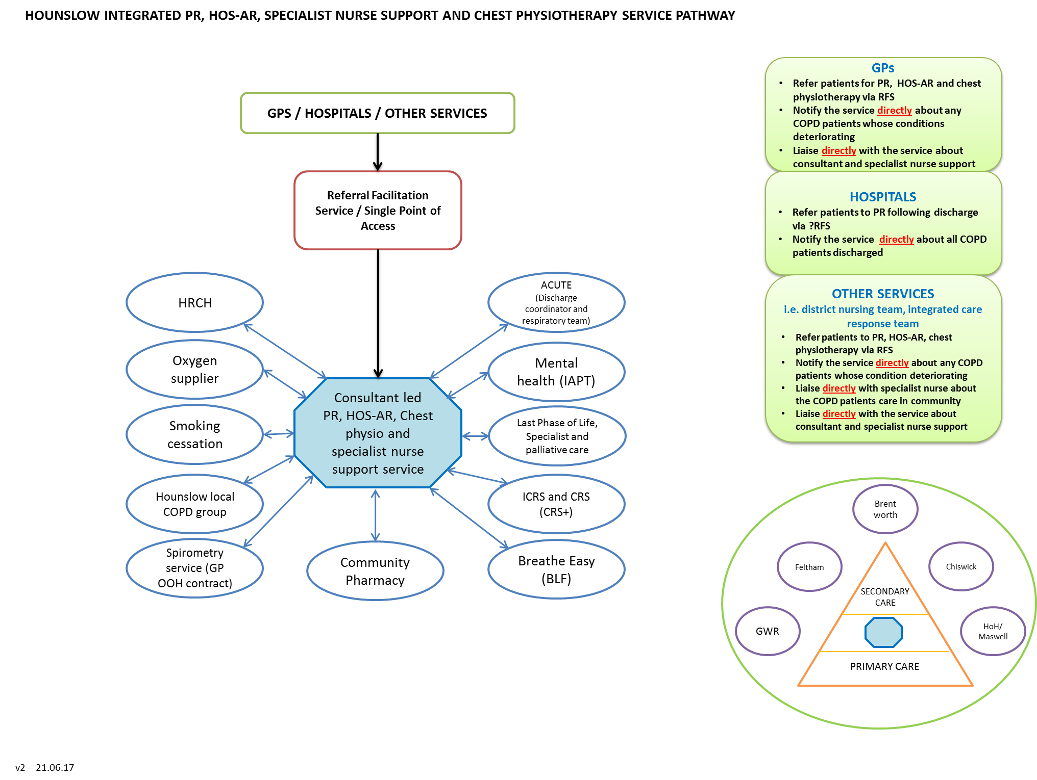
KEY PERFORMANCE INDICATOR: TBC

Appendix 1
Appendix 2

