HARINGEY CCG PRIMARY CARE PREMISES
FEASIBILITY STUDIES Service Specification
Deadline for applications: Tuesday 16th February 2016 at 12 noon
- Background to the specification
The London Borough of Haringey is situated in the north of London, bordered by Barnet and Enfield to the north and west, Camden, Islington and Hackney to the south and Waltham Forest to the east. The Borough spans over 11 square miles, of which over 25% is green space, and is divided into 19 wards, as shown in Figure 1.
Figure 1
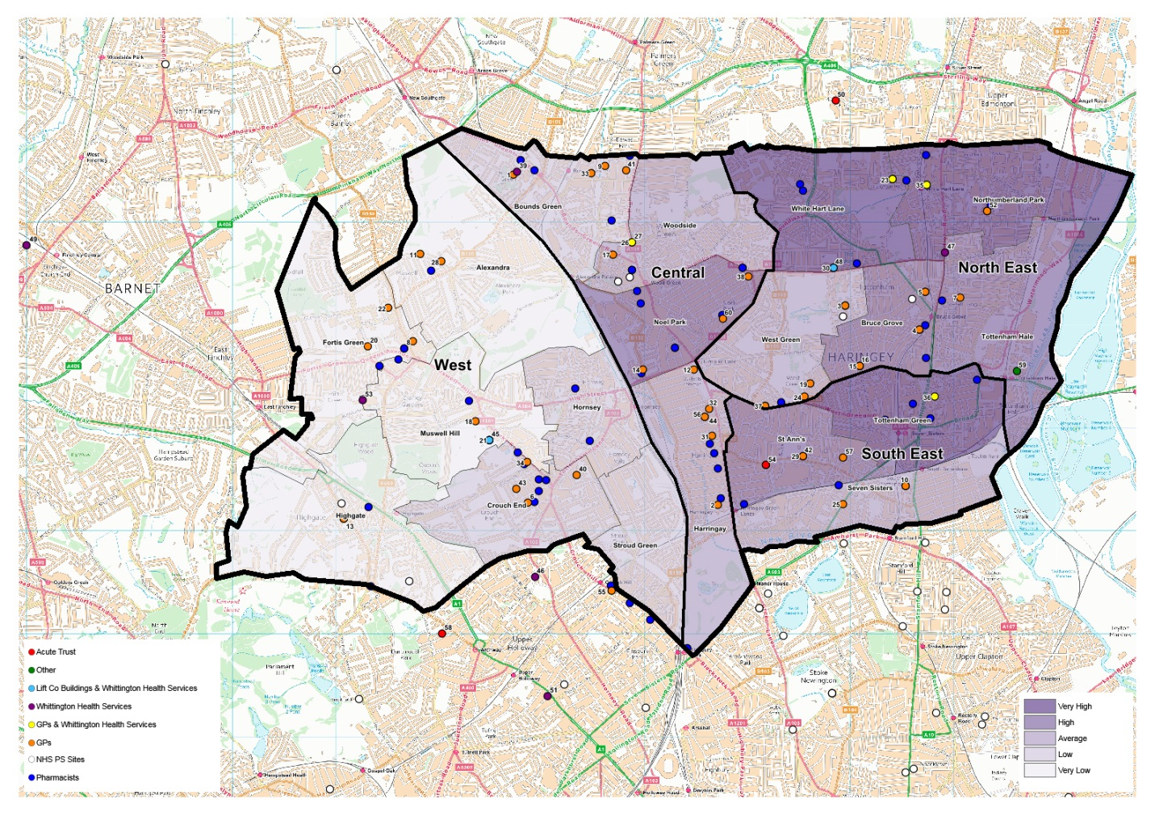

NHS Haringey Clinical Commissioning Group (CCG) is responsible for the healthcare of a population of about 275,000 GP-registered patients.
The borough resident population is 267,540 (according to 2014 Office for National Statistics Mid Year Estimates) and it is predicted that the population will increase to 286,774 by 2021 impacting on the existing primary care infrastructure and services. The borough ranks among the most deprived in the country with pockets of extreme deprivation in the east. Haringey is the 30th most deprived borough in England and the 6th most deprived in London. Almost two-thirds of the population are young people, are from ethnic minority backgrounds, and over 100 languages are spoken in the borough. Haringey’s population is the fifth most ethnically diverse in the country.

Figure 1 above also shows the borough with an Index of Multiple Deprivation Heat Map, from which it is clear that the east of the borough has significant deprivation and the West is an area of relative affluence. GP practices and other healthcare providers are also marked on this map.
As part of its Strategic Premises Development Plan, Haringey CCG invites proposals from suitably qualified providers to undertake a feasibility study for the five priority areas as outlined below.

One of the key purposes of undertaking the feasibility studies is to provide clear evidence for the CCG bids to the Primary Care Transformation Fund. This Fund is available for CCGs to bid in relation to capital projects, which will improve access and capacity in primary care. Whilst further information is awaited from NHS England, it is likely to have a deadline towards the end of April and further guidance will be available by the end of February. These projects must be able to be delivered by 2019.

- Haringey CCG’s Vision
Haringey CCG has summarised its plans from 2015/16 – 2018/19 in a ‘Plan on a Page’, which sets out what the CCG wants to achieve for the people of Haringey to improve their mental and physical health and wellbeing.

The vision for Haringey is to make primary care closer to home really work for all local residents. To achieve this vision, four main Aims and Objectives have been developed;
- Explore and commission alternative models of care.
- More partnership working and integration as well as a greater range of providers.
- Engaging communities in new and more innovative ways to build capacity for populations to enhance their health and wellbeing.
- A re-defined model for primary care providing proactive and holistic services for local communities, supporting “healthier Haringey as a whole”.

- Haringey Council Health and Wellbeing Strategy
Haringey’s Regeneration Strategy summarises its vision “To transform the Borough and the way in which it is perceived by creating economic vitality and prosperity for all through exploitation of Haringey’s strategic location in a global city, major development site opportunities and by developing the Borough’s 21st century business economy.”

Its objectives are categorised as follows:
- People — To unlock the potential of Haringey residents
- Places — Transform Haringey into a place where more people want to live
- Prosperity — Developing a 21st century business economy
There is a high demand for housing across all rented and privately owned tenures. The need for affordable housing outstrips supply with a shortfall in provision of 4,865 units per annum. Responding to this shortfall is a priority for the borough. A housing trajectory projects a further 19,715 housing sites will be made available by 2026, broken down by 3000 being delivered between 2011-2014 and 16000 being delivered between 2015-2026.

Haringey’s Housing Strategy (2009-19) identifies areas of regeneration such as: Mid Tottenham, Seven Sisters, Northumberland Park, White Hart Lane, Bruce Grove / Tottenham Hale, Wood Green Town Centre, Noel Park and parts of Woodside. Residents in these priority areas exhibit some of the highest levels of social deprivation in the Borough.

- Haringey Strategic Service Development Plan
In January 2015, Community Health Partnerships (CHP) commissioned North London Estate Partnerships (NLEP) to produce a Primary Health Care Strategic Service Development Plan (SSDP) in response to the evolving health and social care landscape and the needs of the local population. Its objective was to establish a firm strategic direction for the Haringey locality, drawing on the strategic plans of partner organisations recently established in the ‘new world’ of the NHS reforms. This whole report will be made available to the successful bidder.

The work was precipitated by a Healthwatch report which raised serious concerns about the significant shortfall in available GP patient appointments in the Tottenham Hale area, in the wider context of an overall shortfall in the North East of the borough. There was also a recognition by Haringey CCG (HCCG) that a number of their practices premises will not be viable in the future due to poor estate conditions.

Haringey is supported by NLEP, a Local Improvement Finance Trust (LIFTCo) which was set up by government in 2004 to improve the quality of Health and Social Care estate. To date NLEP has developed two Primary Care facilities in Haringey providing modern, fit-for-purpose accommodation. However, in correlation with England as a whole, the majority of the GP estate in Haringey is privately owned. Condition surveys were carried out in January 2013 by an independent surveyor, and the results of these surveys identifies that 73% do not meet statutory compliance.

Haringey has four GP practice collaboratives, and engagement with each of the four GP Clinical Directors/Leads within the North East, South East, Central and West of Haringey has taken place. This has shown a number of pilot schemes operating across the Borough. The pilots schemes the four collaboratives are currently in operation are;
- IT Interoperability; sharing records so GPs who see patients from other practices can view patient records with consent
- Working together at scale; in the Central and West areas Saturday clinics have been provided. In the South East additional telephone appointments have been extended access and in the North East a call centre has provided better call answering and standardising front of house training and development.
- GP Matchmaking scheme; to support practices identifying salaried GPs who currently work in one Haringey practice who would be interested in also working in another
- Admission avoidance locality teams; development of care plans which support more proactive working with patients with the aim to avoid unplanned admissions
The four CCG collaborative areas being North East, South East, Central and West provide four distinct ‘hubs’ to consider as part of a Borough wide strategy basis, addressing and tailoring the needs from a local level.

The London Borough of Haringey, like many parts of London, is undertaking large regeneration plans increasing and improving the infrastructure, population and demand on public services. These plans have been active since 2011 and go through to 2026. The regeneration schemes are being led by Haringey Council through a number of initiatives as shown in Figure 2 below;
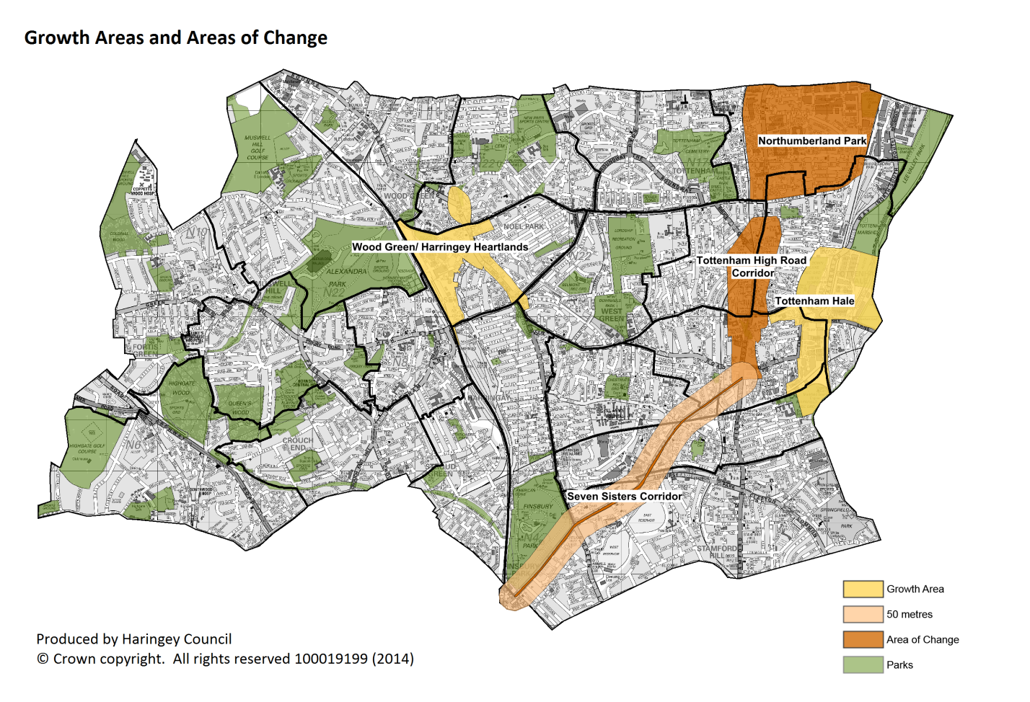
Figure 2: Haringey Growth Areas and Areas of Change
Figure 2 shows two clear Areas of Change within the East of the Borough in Tottenham High Road Corridor and Northumberland Park; both of these areas are where high deprivation is prevalent. Along with Growth Areas marked within the East also, at Tottenham Hale and centrally in the Borough at Wood Green/Haringey Heartlands.

Using the Housing Trajectory by Ward 2015 – 2026 data from Haringey Council, a total of 19,715 net housing units are expected across the Borough. It should be noted though that not all of the development sites are secured and therefore projections in terms of population and housing units should be reviewed as part of any implementation of a strategy as these factors will change dependent upon market requirements at the time.

The Strategic Premises Development plan then involved four “deep dive” areas of focus, of areas predominately in the Central and Eastern areas of the Borough.
- Northumberland Park
- Tottenham Hale
- Noel Park/Wood Green
- Green Lanes
The Deep Dive areas reviewed 20 practices in detail across three, of the four, GP collaborative hubs. Figure 3 below identifies those practices, wards and collaboratives which have been included as part of the Deep Dive areas.

Deep Dive Area | GP Code | Collaborative | Ward
Northumberland Park | F85030 | North East | White Hart Lane
Northumberland Park | F85615 | North East | Northumberland Park
Northumberland Park | F85660 | North East | Northumberland Park
Tottenham Hale | F85628 | North East | Tottenham Hale
Tottenham Hale | F85013 | North East | Tottenham Green
Tottenham Hale | F85017 | North East | Bruce Grove
Tottenham Hale | F85028 | North East | Bruce Grove
Noel Park | F85031 | Central | Noel Park
Noel Park | F85643 | Central | Noel Park
Noel Park | F85046 | Central | Noel Park
Noel Park | F85008 | Central | Woodside
Noel Park | F85064 | Central | Woodside
Noel Park | F85060 | South East | West Green
Green Lanes | F85669 | South East | West Green
Green Lanes | Y03506 | South East | St Anns
Green Lanes | Y01655 | South East | St Anns
Green Lanes | F85697 | Central | Harringay
Green Lanes | F85632 | North East | Harringay
Green Lanes | Y03135 | South East | Harringay
Green Lanes | F85708 | Central | Harringay
Figure 3: Deep Dive areas by ward, practice and collaborative
These areas comprise four of the five feasibility studies that are now being commissioned. The fifith is the area of Muswell Hill in West Haringey. The reasons for including this area are set out in 5 below. The projected population growth of 30,170, or 80% of the borough, people within the Deep Dive areas is broken down by ward in Figure 4 for 2011-2026.

Deep Dive Area | Ward | Expected population projection 2011-2026
Northumberland Park | White Hart Lane | 997
Northumberland Park | Northumberland Park | 2,693
Tottenham Hale | Tottenham Hale | 5,589
Tottenham Hale | Tottenham Green | 3,929
Tottenham Hale | Bruce Grove | 1,391
Noel Park | Noel Park | 7,944
Noel Park | Woodside | 2,365
Noel Park | West Green | 952
Green Lanes | West Green | 952
Green Lanes | St Anns | 2,832
Green Lanes | Harringay | 1,478
 | TOTAL | 30,170
Figure 4

With the overarching principles of patient activity and the capacity requirements needed to address the growth, a set of criteria and scoring mechanisms were agreed, to address how Solution Development could be measured and ranked for priority. Four pre-qualification questions were agreed, which have to be met prior to further scoring being undertaken:
- Able to accommodate appropriate practice size.
- Value for Money (to the best of knowledge at time of scoring).
- Fit for Purpose (according to NHS Standards i.e disabled access, room sizes, appropriate IT).
- Able to get suitable planning permission.
Any Option that arises can then to be scored against four key themes of;
- Accessibility
    - Accessible for required population – within a 15 min walk or a 5 or more in a PTAL assessment
    - Is it accessible 08:00 – 20:00 7 days a week
    - Potential for disabled parking
- Design
    - Flexibility of design to meet future needs
- Deliverability
    - Available at the right time
- Strategic Fit
    - Able to integrate with other community services
Each site option can then be scored on the basis of the criteria above 1-3 as per rating below;
3 – High preference
2 – Medium preference
1 – Low preference

This information is provided to assure bidders that the feasibility studies will not require to undertake this detailed work again. These feasibility studies are about providing the CCG with clear options for progress in each of the identified areas.
- Feasibility Studies Brief

As a result of developing a clear Strategic Premises Development Plan and setting the above scoring criteria, the CCG is now in a position to engage directly with the Council and developers whenever a suitable site arises. In each of the five priority areas, one or more site option is now available. Because these sites are changing and developing almost daily, they have not been named in this document and details of the options will be provided to the successful bidder. The key purpose of the feasibility studies is to assess these options and provide recommendations on how to proceed.

The CCG is seeking bids for the following feasibility studies:
- Northumberland Park – one feasibility study
- Tottenham Hale – one feasibility study
- Noel Park/Green Lanes – funding available for two studies but we would like this to be treated as one study
- Muswell Hill – one feasibility study

We will accept individual bids or a bid to undertake all the studies

  - Northumberland Park
The SSDP has identified a current shortfall in this area of 7689, with a further shortfall of 10,032 by 2020 and 11,379 by 2025. Patient distribution maps also show that 1,529 of the Northumberland Park residents use GP services in Enfield; the highest amount across the Deep Dive areas. If it is assumed that the remaining population requires registration within area this deficit of 7,689 patients would require 4.3 WTE GPs (based on 1,800 patient to WTE GP ratio). However residents may be registered elsewhere, and indeed the evidence provided in the SSDP suggests that patients are registered with other practices within the area, although residents’ survey results in the Healthwatch Report implies a limited choice.

In this Deep Dive area, all three practices that were focused on have GPs over the age of 60, although none of these practices are single handers and therefore the retirement of these individuals should be planned through normal succession planning within the individual practices. We have not therefore included this impact as part of the feasibility study.

Area for Development and why | Possible sites | List Size capacity | Possible Revenue Increase | When complete  (tentative)
Northumberland Park (current shortfall 7689 by 2020 – 10,032. By 2025 11,379. GP practice also under CPO – c.5000 pts | Two potential sites available | 15,000 | £150,000 | 2018-19
Northumberland Park (current shortfall 7689 by 2020 – 10,032. By 2025 11,379. GP practice also under CPO – c.5000 pts | GP practice with PCIF funding | 5,000 increase | £50,000 | 2016-17

The Potential Solutions
- There is a site available as part of a significant development in the Northumberland Park ward. The Council are keen to engage on this site and the space available is sufficient. It is planned that the site will be owned by an NHS provider and discussions are currently underway about how this might take place.
- The alternative to this site is to take an area within a new housing development. This area is not within Northumberland Park and is not due to be delivered until after 2019. The Council are currently seeking a response as to whether we want to consider this site for a primary care resource.
- An additional option is to build above one of the local GP practices. This practice has preliminary been granted capital funding through the 15/16 Primary Care Infrastructure Fund (now called Primary Care Transformation Fund) to develop part of their property, with a third storey extension to increase clinical capacity further. Again, this practice is not within the Northumberland Park ward.

Outline of Requirements
A feasibility study to:
- Undertake an appraisal of the options in the area and establish the most suitable site
- Undertake an analysis of the options for GP practices in the area, including practice closures, mergers, site moves and new APMS contracts
- Establish the required size and services within an identified premises to make it effective and sustainable, to meet need in the future (health and social care), considering future IT developments and potential new models of care.
  - Urgently work with Council planners and regeneration managers to establish exactly what is required on the site and what can feasibly be delivered
  - Establish options for a financial model, to include:
  - General affordability, particularly how to manage any increase in the recurrent revenue costs and possibilities to keep these as low as possible.
  - Examining options for a model of ownership and/or rental of the site, to establish best value for money for commissioners
- Provide evidence of the above to enable a capital bid to NHS England’s Primary Care Transformation Fund in April 2016

  - Tottenham Hale
The population projection in 2015 is 48,278 people. The registered list sizes of the GP practices in this area are 28,873, suggesting a deficit of 19,405 patients. ). If the strategic objective is resident registration within their ward of residence then such a deficit of 19,405 patients would require 10.8 WTE GPs (based on 1,800 patient to WTE GP ratio). Access issues identified as part of the report undertaken by Healthwatch in September 2014 which focussed on Tottenham Hale ward supports action to address this deficit

Area for Development and why | Possible sites | List Size capacity | Possible Revenue Increase | When complete  (tentative)
Tottenham Hale - Current identified shortfall from SPDP of 10.4 GPs (2015>18,500 patients shortfall) | Council-owned site | 10,000 – 15,000 | £150,000 | 2018-19
2nd Tottenham Hale site – Future shortfall in capacity in 2020 - 26,934 by 2025 - 29,595 | Developer-owned site | 10,000 – 15,000 | £150,000 | 2018-19

Potential Solutions
- The short term Solution Development in this area has been to commission a temporary demountable solution in Tottenham Hale. This will be provided by a local practice, Lawrence House, and will provide appropriate primary health care services in a suitable environment for patients. The temporary practice is due to open in April 2016 for a period of 3 years under a new APMS contract.
- In addition to this, Haringey Council have also presented an opportunity as part of the medium to long term solution through the development of a new Health Centre site at a former Council-run building. This could provide a permanent site for the practice established using the temporary demountable solution described above. This opportunity also presents wider patient and resident benefits to integrate multi-disciplinary services provided by public sector partners and create more of a Health and Wellbeing centre.
- A further opportunity has also arisen as part of the regeneration plans in the Tottenham Hale area and also presents a long-term solution, and greater opportunity for stakeholder partners to come together. It is not clear if this site could be completed by 2019. A decision is required on whether two sites are required in the Tottenham Hale area.

Outline of Requirements

A feasibility study to:
- Establish whether two sites are required for the area
- Undertake an appraisal of the options in the area and establish the most suitable site
- Undertake an analysis of the options for GP practices in the area, including practice closures, mergers, site moves and new APMS contracts
- Establish the required size and services within an identified premises to make it effective and sustainable, to meet need in the future (health and social care), considering future IT developments and potential new models of care.
  - Urgently engage with Council planners and regeneration managers to establish exactly what is required on the site and what can feasibly be delivered
  - Establish options for a financial model, to include:
  - General affordability, particularly how to manage any increase in the recurrent revenue costs and possibilities to keep these as low as possible.
  - Examining options for a model of ownership and/or rental of the site, to establish best value for money for commissioners
- Provide evidence of the above to enable a capital bid to NHS England’s Primary Care Transformation Fund in April 2016

  - Green Lanes, and Noel Park – funding for 2 feasibility studies
This study comprises more than one area as there is such significant overlap between these areas and the possible solutions, that the CCG would like them to be considered together. However, there is funding for two feasibility studies, so it is intended that this would be a larger piece than the other studies.

Noel Park area encompasses the Wards of Noel Park, Woodside and part of West Green. The Green Lanes area encompasses the wards of Harringay, St Ann’s and part of West Green. Siting at the very edge of the Noel Park ward is the Westbury Medical Centre, which needs to be considered as part of this study.

Area for Development and why | Possible sites | List Size capacity | Possible Revenue Increase | When complete  (tentative)
Green Lanes (current shortfall 2143, by 2020 – 7570, by 2025 8929). One practice dispersal Mar 2016 – 1883 pts. | Green Lanes site | 15,000 (may not be adequate capacity if larger practice moves) | £175,000 | 2017-18
Wood Green/Noel Park (current shortfall 5513, by 2020 – 11,000, by 2025 14,540). | Council-owned site | 10,000 | £150,000 | 2018-19
Wood Green/Noel Park (current shortfall 5513, by 2020 – 11,000, by 2025 14,540). | Current GP site | With expansion could increase capacity by 5000-7000 | £50,000 | 2017-18
Westbury Medical Practice is at capacity and has lease issues. Needs new site. Would become teaching practice. | Council-owned site | 15,000 (extension of 5,000 from current practice) | £150,000 | 2018-19

Noel Park

The current population for Noel Park in 2015 is 37,086 people. The registered list sizes of the GP practices in this area are 40,700. This shows that there appears to be sufficient primary care capacity within the Deep Dive Area for the resident population, furthermore an additional 3,614 out-of-area patients are registered with these practices.

Potential Solutions
- There is a site owned by an NHS provider, which houses 2 GP practices. Current discussions are underway about how this site could be utilised more effectively.
- Haringey Council own a site in Wood Green close to the tube station and the Council have indicated that there may be space within this location, which would offer patients additional benefits for co-location of public services. The area of this space is unknown at present. The Council is in the process of finding a development partner who will work with the Council to redevelop the site
- Within the housing developments in the ward, there is a plan for significant additional dwellings, and there is likely to be an available primary care premises site in this area, should the CCG wish to consider it.
- Near Turnpike Lane, there is also an available commercial premises which has recently arisen and could be explored
- There is a 10,000 patient GP practice at the border of Noel Park and White Hart Lane wards. It is situated in a converted Victorian House which is part owned by the practice and part-leased from a landlord. The landlord has notified the practice that he is selling his part of the building. An immediate solution is required for this large practice, in an area where there are few other practices. An opportunity has arisen to take on a Council site and the Council is engaged in discussions with the practice about the possibility of their moving to this site. It is important to explore the possible ownership models within this option.
NB The area of Noel Park has a LIFT development within at Lordship Lane Primary Care Centre (West Green ward), providing a range of services from Whittington Health NHS Trust such as Speech & Language Therapy, Health Visiting and District Nursing, Foot Care, Physiotherapy, Foot Biomechanics and the Dietetic service. A modern fit-for-purpose fully maintained and lifecycled property, which may have clinical room capacity that can be released for Primary Health Care use.

Outline of Requirements

The key in this area is to work with the Council to identify which of these sites has the most potential for development, and assess the feasibility of the sites given the information available at this point.
A feasibility study to:
  - Confirm capacity needs in the area including establishing the correct population growth calculations and patient flows and ensure these have been taken into account in work to date
  - Clarify possible site options
- Undertake an appraisal of the premises options in the area and establish the most suitable site
- Undertake an analysis of the options for GP practices in the area, including practice closures, mergers, site moves and new APMS contracts
- Establish the required size and services within an identified premises to make it effective and sustainable, to meet need in the future (health and social care), considering future IT developments and potential new models of care.
  - Engage with planners and redevelopment managers to understand what is feasible and needed on the site.
  - Establish options for a financial model, to include:
  - General affordability, particularly how to manage any increase in the recurrent revenue costs and possibilities to keep these as low as possible.
  - Examining options for a model of ownership and/or rental of the site, to establish best value for money for commissioners
- Provide evidence of the above to enable a capital bid to NHS England’s Primary Care Transformation Fund in April 2016

Green Lanes
- A rare opportunity to establish a large GP practice has arisen in this area on Green Lanes. Very few sites of this size exist along the Harringay ladder so the CCG and the Council and keen to pursue this option. The Developer is engaged in discussions about how a primary care premises of approximately 1000sqm can be delivered from this site. For this site in particular, the CCG is keen for the feasibility to explore the various models for ownership/leasehold and the financial implications of each.

Outline of Requirements
A feasibility study to:
- Undertake an analysis of the options for GP practices in the area, including practice closures, mergers, site moves and new APMS contracts
- Establish the required size and services within an identified premises to make it effective and sustainable, to meet need in the future (health and social care), considering future IT developments and potential new models of care.
- Urgently work with developers to identify what is feasible to deliver for the plans, establishing exactly what is required and possible on the site.
  - Establish options for a financial model, to include:
  - General affordability, particularly how to manage any increase in the recurrent revenue costs and possibilities to keep these as low as possible.
  - Examining options for a model of ownership and/or rental of the site, to establish best value for money for commissioners
- Provide evidence of the above to enable a capital bid to NHS England’s Primary Care Transformation Fund in April 2016

  - Muswell Hill

The West of the borough has a different set of issues at present. The key area of interest is Muswell Hill in the North West of the borough. Three practices in this area have indicated their desire to merge and to move into one large site, to provide a ‘Muswell Hill hub’. Whilst this area is not a priority in terms of deprivation or deficit of GPs, it is a priority in terms of insufficient and inappropriate premises. The three practices have a combined list size of 23-24,000 patients. One of the buildings is currently at capacity, and another has a lease which runs out in two years. In addition to the premises issues in these practices, this model of three large practices merging to create a hub is very much the model of primary care envisaged by the CCG and one we would wish to support.
Area for Development and why | Possible sites | List Size capacity | Possible Revenue Increase | When complete  (tentative
Muswell Hill (population increase to be confirmed but understood increase c. 2000) 3 practices wish to merge. Buildings at capacity, one on short lease other likely to close in 3-5 years. | Muswell Hill (poss Council site) | 23-24,000 (would need to extend opening hours to manage site size) | £250,000 | 2018-19

Potential Solution

There is a site being proposed which is owned by the Council and the Capital Projects Officer at the Council has been engaged and is interested in a primary care service at this location. This site is likely to be available in the first quarter of 2017.

The merged practice will have a combined list of 23-24000 patients. The massing suggests a GIA of around 1400sqm and the practices are very keen on this site. They believe that the plan for 28 consulting rooms will provide sufficient space for their service. The largest of these practices has a service model which already involves a model of telephone consultations, which has already reduced floor space.

The project is currently being managed by a consultancy which is affiliated to a stock exchange listed fund in primary care. The ownership model which has been presented to the CCG is through a long leasehold on the property, called a ‘long term ownership’ model. In the meantime, another affiliated company have an agreement with the practices that they will continue to work on their behalf for no cost, on the understanding that they will be the preferred developer.

Outline of Requirements

As part of the feasibility study, the contractor will make clear recommendations on the value for money to the NHS presented by this option and the other ownership and financial options available to the CCG.
  - Establish capacity needs in the area including establishing the correct population growth calculations and ensure these have been taken into account in work to date
  - Clarify possible site options, in particular the library site already identified
- Undertake an appraisal of the premises options in the area and establish the most suitable site
- Establish the required size and services within an identified premises to make it effective and sustainable, to meet need in the future (health and social care), considering future IT developments and potential new models of care.
  - Engage with planners and redevelopment managers to understand what is feasible and needed on the site.
  - Establish options for a financial model, to include:
  - General affordability, particularly how to manage any increase in the recurrent revenue costs and possibilities to keep these as low as possible.
  - Examining options for a model of ownership and/or rental of the site, to establish best value for money for commissioners
- Provide evidence of the above to enable a capital bid to NHS England’s Primary Care Transformation Fund in April 2016

- Outcomes
The purpose of each feasibility study is to:
- Provide a critical review of the CCG’s current plans for the area
- Undertake an options appraisal based on the factors set out in 5 above
- Provide a set of recommendations with regard to the factors set out in 5 above

- Deliverables
Required is a comprehensive report containing:
- Evaluation of the options
- Description of recommended options including financial and ownership models
- Financial analysis with estimated capital and revenue costs
- Next steps

- Information sources
Access to the following will be made available to assist in preparing the report
- 2013 6-facet surveys
- SHAPE & NHSE v5 premises database
  - Overall floor areas
  - Contract types & list sizes
  - Costs of occupation
  - Population forecasts
- Haringey Strategic Development Plan and appendices
- Confidential information on the options available – not to be shared beyond the remit of the feasibility study
- NCL Strategic documents
- NHSE patient travel-distance data & ‘heat’ maps
- Localised information on GP Practices and tenure (where available)
- HBN 10-11, HBN 00-03 and other technical guidance
- Stakeholder contact information
- Stakeholders
The primary and community care premises plan will consider not only the current estate and, working practices, but consider future working arrangements with stakeholders including but not limited to:
- General practitioners - where advised by CCG as appropriate
- Local authority – planning and regeneration departments
- Providers of commissioned services – where advised by CCG as appropriate
- CCG commissioners
- Developers
- NHS England
- NHS property services
- Community Health Partnerships
- Any other appropriate stakeholders
The successful provider will be required to engage with all or as many of the above stakeholders as prudent/required in the development of the feasibility report.
- Timescales
5th February 2016 | Approval to procure
9th February 2016 | Specifications and Requests for Quotation issued to 3 suppliers/consultants
16th February 2016 | Closing dates for receipt of quotations
17th February 2016 | Adjudication
19th February 2016 | Contracts awarded
22nd February 2016 | Consultants mobilised and work commences
22nd March 2016 | First draft reports received
29th March 2016 | Reports finalised

Key date: Draft report to be produced for 22nd March 2016.
- Budget
Max £10,000 for each study (inclusive of all associated costs including expenses, events/engagement, document revisions, document productions etc. and VAT)
- Reporting and Enquiries
Primary client contact is:
Sarah Barron
Primary Care Estates Lead
NHS Haringey CCG
Sarah.barron@haringeyccg.nhs.uk
07833 464634

Evaluation Criteria
Proposals will be evaluated in line with the following evaluation criteria:
Criteria
Proposed work plan and approach:
- Capacity to deliver
- Philosophy/style of working
- Scope of work relevant to the programme requirements
- Standards/quality control
- Summary of the issues/risks particular to this project
- Provision of advice and timescales to respond to questions and queries
Relevant past experience and knowledge to support delivery of project:
- Understanding and experience of similar programmes complete with examples of previous work within the NHS and primary and community care
Practical experience and understanding of NHS and non NHS estates:
- Demonstrate knowledge and understanding of primary and community care estate (NHS and non-NHS estate), including legislative and environmental issues applied to this contract
Clear timetable of work:
- Submit a programme of work proposal that considers the tight time frame including number of days and responsibility
Provision of 2 satisfactory references:
- Successful track record with relevant experience
- Quality of deliverable achieved against criteria established
- Customer care
Key Personnel
- CVs of proposed key personnel show relevant experience, knowledge and skills
- Capability: Details of the lead staff to manage this contract
Added Value:
- Additional added value to the commissioner over and above the development of the primary and community care premises plan
Price:
- Fixed Price for delivery of the service including a full breakdown of cost including total costs, number of staff days broken by price per advisor and rate for any additional requirements.

Assessment | Score | Interpretation
Excellent | 5 | Exceeds the requirement. Exceptional demonstration by the supplier of the relevant ability, understanding, experience, skills, resource and quality measures required to provide the services. Response identifies factors that will offer potential added value, with evidence to support the response.
Good | 4 | Satisfies the requirement with minor additional benefits. Above average demonstration by the supplier of the relevant ability, understanding, experience, skills, resource and quality measures required to provide the services. Response identifies factors that will offer potential added value, with evidence to support the response.
Acceptable | 3 | Satisfies the requirement. Demonstration by the supplier of the relevant ability, understanding, experience, skills, resource and quality measures required to provide the services with evidence to support the response.
Minor Reservations | 2 | Satisfies the requirement with minor reservations. Some minor reservations of the supplier’s relevant ability, understanding, experience, skills, resource and quality measures required to provide the services with little or no evidence to support the response.
Serious Reservations | 1 | Satisfies the requirement with major reservations. Considerable reservations of the supplier’s relevant ability, understanding, experience, skills, resource and quality measures required to provide the services, with little or no evidence to support the response.
Unacceptable | 0 | Does not meet the requirement. Does not comply and/or insufficient information provided to demonstrate that the supplier has the ability, understanding, experience, skills, resource and quality measures required to provide the services, with little or no evidence to support the response.

QUESTIONS TO BE ADDRESSED IN QUOTE

Proposed Work Plan & Approach
Please describe your proposed work plan and approach, your answer should include consideration of the following points.
- Capacity to deliver
- Philosophy/style of working
- Scope of work relevant to the programme requirements
- Standards/quality control
- Summary of the issues/risks particular to this project
- Provision of advice and timescales to respond to questions and queries
Relevant Past Experience & Knowledge to Support Delivery of Project
Please describe your past experience of similar programmes, your response should include
- Previous work within the NHS
- Previous work within Non NHS
- Previous work within community care
Practical Experience and Understanding of NHS and non NHS Estates
Please demonstrate your practical experience and understanding of NHS and Non NHS estates, your response should include:
- Legislative issues
- Environmental issues applied to this contract
Provision of 2 satisfactory references

Please provide 2 references showing evidence of:

- Successful track record with relevant experience
Quality of deliverable achieved against criteria established customer care
Key Personnel & Capability
Please provide details of the lead staff to manage this contract and CVs of proposed key personnel, your responses should include:

- Relevant experience
- Knowledge
- Skills
Added Value
Please specify the additional added value to the commissioner over and above the development of the primary and community care premises plan
Price
Please show your fixed price for delivery of the service, including a full breakdown of cost, your response should include:
- Total Costs
- Number of staff days broken down by price per advisor
- Any additional requirements

Terms and Conditions of Contract.
Please note that any Contract arising from this Request for Proposal will be governed by the NHS Terms and Conditions of Contract for the Supply of Services August 2014
Please note these Terms and Conditions are mandatory and if you are unable to agree you quotation will not receive consideration.
A copy of the Terms and Conditions are available to view at:
https://www.gov.uk/government/publications/nhs-standard-terms-and-conditions-of-contract-for-the-purchase-of-goods-and-supply-of-services.

http://www.haringey.gov.uk/social-care-and-health/health/joint-strategic-needs-assessment/figures-about-haringey#populationprojection
One ward in Haringey, the borough, is also called Harringay, although the spelling of the two are different
One ward in Haringey, the borough, is also called Harringay, although the spelling of the two are different
As at 20th March 2015 this is a minimum of 6,000 patients
Public Transport Accessibility Level

