
0

Invitation to Quote

Invitation to Quote (ITQ) on behalf of UK Research and Innovation

Subject: Supply of Transverse Deflecting Cavity for the CLARA Facility at Daresbury Laboratory

Sourcing Reference Number: RE19221
Table of Contents

Section Content

1 About UK Shared Business Services Ltd.

2 About the Contracting Authority

3 Working with the Contracting Authority.

4 Specification

5 Evaluation model

6 Evaluation questionnaire

7 General Information

Section 1 – About UK Shared Business Services

Putting the business into shared services

UK Shared Business Services Ltd (UK SBS) brings a commercial attitude to the public sector; helping our Contracting Authorities improve efficiency, generate savings and modernise.

It is our vision to become the leading service provider for the Contracting Authorities of shared business services in the UK public sector, continuously reducing cost and improving quality of business services for Government and the public sector.

Our broad range of expert services is shared by our Contracting Authorities. This allows Contracting Authorities the freedom to focus resources on core activities; innovating and transforming their own organisations.

Core services include Procurement, Finance, Grants Admissions, Human Resources, Payroll, ISS, and Property Asset Management all underpinned by our Service Delivery and Contact Centre teams.

UK SBS is a people rather than task focused business. It’s what makes us different to the traditional transactional shared services centre. What is more, being a not-for-profit organisation owned by the Department for Business, Energy & Industrial Strategy (BEIS), UK SBS’ goals are aligned with the public sector and delivering best value for the UK taxpayer.

UK Shared Business Services Ltd changed its name from RCUK Shared Services Centre Ltd in March 2013.

Our Customers

Growing from a foundation of supporting the Research Councils, 2012/13 saw Business, Energy and Industrial Strategy (BEIS) transition their procurement to UK SBS and Crown Commercial Services (CCS – previously Government Procurement Service) agree a Memorandum of Understanding with UK SBS to deliver two major procurement categories (construction and research) across Government.

UK SBS currently manages £700m expenditure for its Contracting Authorities.
Our Contracting Authorities who have access to our services and Contracts are detailed here.

Privacy Statement

At UK Shared Business Services (UK SBS) we recognise and understand that your privacy is extremely important and we want you to know exactly what kind of information we collect about you and how we use it.

This privacy notice link below details what you can expect from UK SBS when we collect your personal information.

- We will keep your data safe and private.
- We will not sell your data to anyone.
- We will only share your data with those you give us permission to share with and only for legitimate service delivery reasons.

https://www.uksbs.co.uk/use/pages/privacy.aspx

For details on how the Contracting Authority protect and process your personal data please follow the link below:

https://www.ukri.org/privacy-notice/

.

Section 2 – About the Contracting Authority

UK Research and Innovation

Operating across the whole of the UK and with a combined budget of more than £6 billion, UK Research and Innovation represents the largest reform of the research and innovation funding landscape in the last 50 years.

As an independent non-departmental public body UK Research and Innovation brings together the seven Research Councils (AHRC, BBSRC, EPSRC, ESRC, MRC, NERC, STFC) plus Innovate UK and a new organisation, Research England.
UK Research and Innovation ensures the UK maintains its world-leading position in research and innovation. This is done by creating the best environment for research and innovation to flourish.

For more information, please visit: www.ukri.org

Section 3 - Working with the Contracting Authority.

In this section you will find details of your Procurement contact point and the timescales relating to this opportunity.

Section 3 – Contact details

3.1 | Contracting Authority Name and address | UK Research and Innovation  Science and Technology Facilities Council  Polaris House  North Star Avenue  Swindon  SN2 1FL
3.2 | Buyer name | Ella Clarke
3.3 | Buyer contact details | Research.tenders@uksbs.co.uk
3.4 | Estimated value of the Opportunity | £55,000.00 (excluding VAT)
3.5 | Process for the submission of clarifications and Bids | All correspondence shall be submitted within the Emptoris e-sourcing tool. Guidance Notes to support the use of Emptoris is available here.  Please note submission of a Bid to any email address including the Buyer will result in the Bid not being considered.

Section 3 - Timescales

3.6 | Date of Issue of Contract Advert and location of original Advert | Friday 6th September 2019  Contracts Finder
3.7 | Latest date/time ITQ clarification questions shall be received through Emptoris messaging system | Monday 23rd September 2019  14.00
3.8 | Latest date/time ITQ clarification answers should be sent to all Bidders by the Buyer through Emptoris | Tuesday 24th September 2019  14.00
3.9 | Latest date/time ITQ Bid shall be submitted through Emptoris | Wednesday 25th September 2019  14:00
3.11 | Anticipated notification date of successful and unsuccessful Bids | Monday 30th September
3.12 | Anticipated Award date | Wednesday 2nd October
3.13 | Anticipated Contract Start date | Friday 4th October 2019
3.14 | Anticipated Contract End date | Thursday 30th June 2022
3.15 | Bid Validity Period | 60 Days

1. Introduction

1.1. STFC
1.1.1. Contracts will be awarded by UK Research and Innovation, Science and Technology Facilities Council (UKRI STFC). All contractual issues will be managed by the relevant authority (UK Shared Business Services Limited; UKSBS or STFC) with technical issues being the responsibility of the Accelerator Science and Technology Centre (ASTeC) and the Technology Department at Daresbury Laboratory.

1.2. Compact Linear Accelerator for Research and Applications
1.2.1. A next-generation light source test facility is to be constructed at the Daresbury Laboratory which will be known as CLARA (Compact Linear Accelerator for Research and Applications), shown in Figure 1. The aim of the CLARA project is to develop a normal conducting test accelerator capable of generating longitudinally and transversely bright electron bunches and to use these bunches in the experimental production of stable, synchronised, ultra-short photon pulses of coherent light from a single pass FEL (Free Electron Laser) with techniques directly applicable to the future generation of light source facilities.

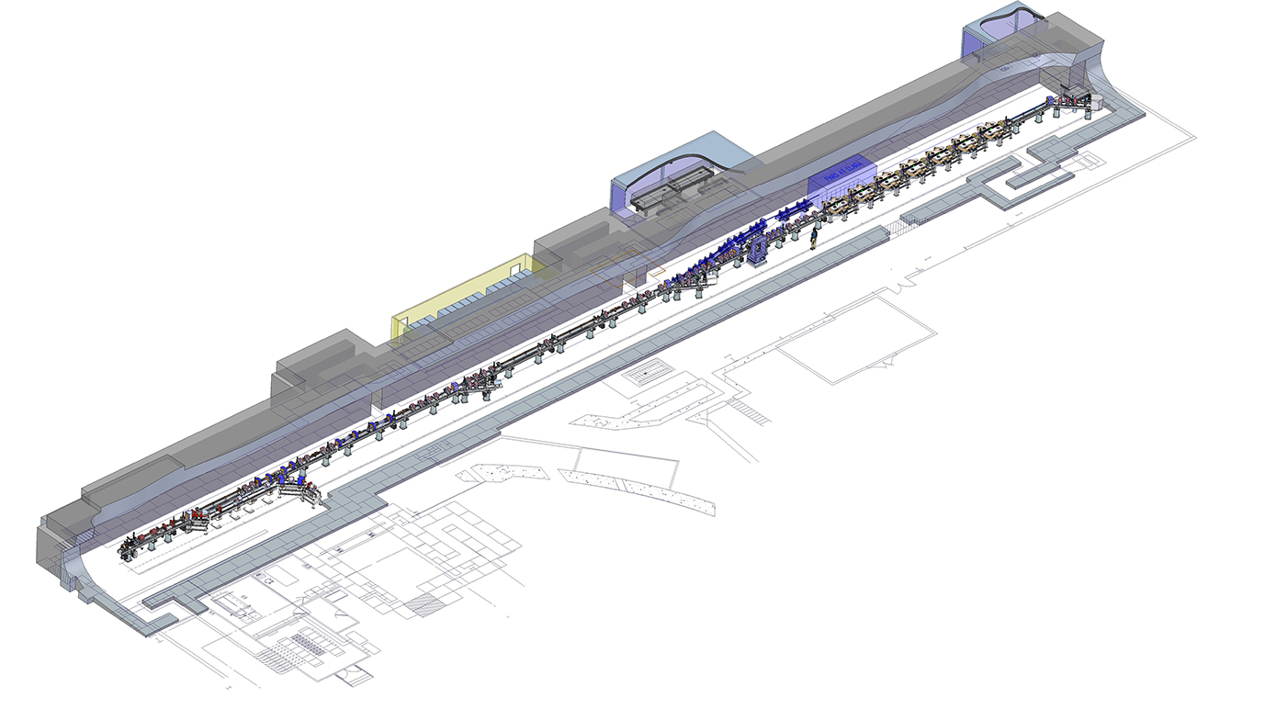

Figure 1: CLARA layout.

1.2.2. Presently at Daresbury the CLARA facility is being developed to provide 250 MeV electron beam. The facility is currently in Phase 1 and operates at 50 MeV in the ‘Electron Hall’ located at Daresbury Laboratory; a schematic for Phase 2, currently under construction, is shown in Figure 2.

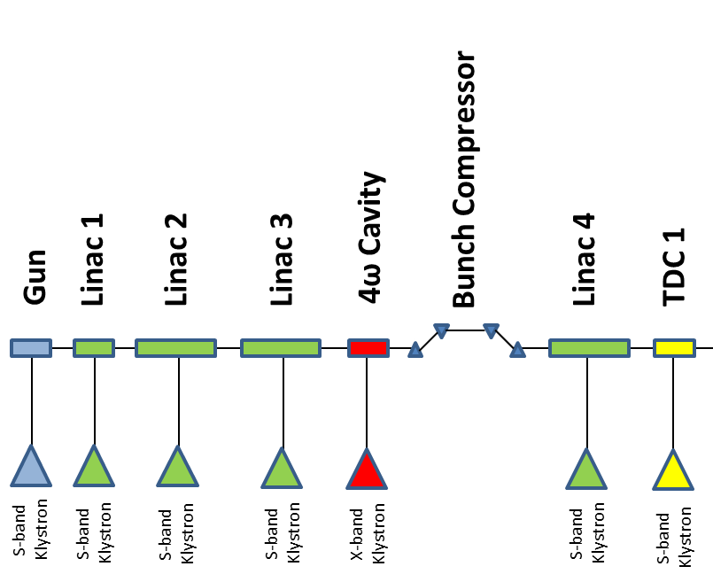

Figure 2: CLARA schematic.

1.3. Cavity Requirement
1.3.1. STFC requires a single (1-off) 9- cell, normal conducting RF transverse deflecting cavity (TDC), made to the drawings provided, to be manufactured and delivered to STFC Daresbury Laboratory (hereinafter referred to as STFC), Warrington. Detailed requirements are defined in this document

1.3.2. The parameters for the klystron driving the cavity are defined in the table below and are for information only.

Table 1: TDC klystron RF parameters (for information only)
Parameter | Value | Notes
Frequency | 2998.5 MHz
Nominal bandwidth of klystron | 5 MHz | At saturation (-1dB points)
Total peak output power | Up to 20 MW | Up to 12 MW at the input flange of the cavity
Average peak output power | Up to 3.6 kW
Pulse repetition rate range | 1 – 100 Hz
RF Pulse Width | Up to 3.0 µs
Amplitude stability | 0.0001
Phase Stability | 0.1°

1.4. Specification Abstract
1.4.1. This specification concerns the manufacture and delivery to Daresbury Laboratory, and documentation of 1 TDC. The cavity bid must comprise of:
• 1 cavity (with suitable blanking flanges installed
• 1 support structure for cavity
• Documentation to include, dimensional verification checks, RF measurements, RGA scans prior to dispatch.

2. General Conditions

2.1. Scope of Contract
2.1.1. The contract will cover the supply of materials, manufacture, vacuum brazing, inspection, assembly, RF testing, vacuum testing, packing and subsequent delivery of 1 TDC to STFC Daresbury Laboratory (hereinafter referred to as STFC), Warrington, 1 support structure for the TDC, and all the required documentation of the TDC.

2.1.2. The Contractor will be required to co-operate closely with STFC and its authorised representative at all stages of the contract. Technical issues will be resolved after adequate discussion.

2.1.3. The Contractor will be required to produce a full set of technical/manufacturing drawings based upon the functional specification drawing and CAD files provided. Drawings will be supplied to STFC upon completion of the project and will adhere to the STFC numbering system with drawing numbers issued upon successful tender. Drawings will be given in both .pdf and .dwf formats. 3D CAD is also required in Pro Engineer, Creo or neutral format (.stp or .iges). All CAD and drawings to be versioned as per STFC procedures.

2.1.4. The delivery to STFC of metrology reports of components, sub-assemblies and the final assemblies to an agreed manufacturing plan as outlined in section 2.4.

2.1.5. Any detailed assembly drawings and calculations, tooling, fixtures and manufactured components constructed or otherwise procured under the terms of the contract will become the property of STFC to dispose of as it sees fit.

2.1.6. The parameters of all detailed components and assemblies have been determined by STFC and are fully described in the accompanying drawings. The designs are the property of STFC and must not be disclosed to third parties without its express permission.

2.1.7. The manufacturer will be responsible for any departure from anticipated performance due to the failure to adhere to any part of this specification.

2.1.8. No change to the specified requirements is permitted without the written permission of STFC. However, if at any stage of the contract it is clear that advantage could be gained by such modification then the contractor is encouraged to bring it to the attention of STFC.

2.1.9. The contractor will be responsible for any departure from anticipated material requirements or performance due to the failure to adhere to any part of this specification where STFC has not approved deviation in writing beforehand.

2.2. Sub-Contracts
2.2.1. Full details of all sub-contracts must be available to STFC, and written permission shall be obtained from STFC before placement of such sub-contracts.

2.2.2. STFC will require written evidence of a formal contract between the manufacturer and any sub-contractor, together with the legal and contractual obligations that have been established. Information on delivery time scales will be essential.

2.2.3. STFC shall have the right of access to the premises of any such sub-contractor for inspection purposes, including witnessing of tests.

2.3. Price and Payment Schedule
2.3.1. Payment terms defined in clause 5 of the Terms and Conditions located in the RFx attachments. STFC observes the Confederation of British Industries’ Code of Practice regarding prompt payment and, in accordance with the Government direction, is committed to paying its suppliers within five days of the receipt of a valid invoice.

2.3.2. The price for major items is to be clearly defined within the bid.

2.3.3. STFC urge tenderers to indicate acceptance of STFC payment terms. However, STFC are prepared to consider alternative payment terms, which should be clearly proposed in the tender documents for possible negotiation in the event of a successful bid.

2.3.4. The payment schedule should also be clearly defined within the bid. Stage payments are expected.

2.4. Timescales and Delivery
2.4.1. Timescales for the project are very important. It is envisaged that the contract will be placed before end of September 2019 and the bidder should provide the best indication of delivery, installation and commissioning based on this date. It should be noted that a preferred delivery date for the cavity would be March 2020.

2.4.2. A draft manufacturing programme is required with the tender bid and a detailed programme including all necessary acceptance tests shall be issued by the contractor within one week of contract placement and must be approved by STFC. This programme must contain sufficient detail to enable progress of the contract to be monitored accurately.

2.4.3. Written progress reports must be submitted to STFC at intervals of one month during the contract by e-mail addressed to Louise Cowie (Louise.Cowie@stfc.ac.uk)

2.4.4. No change may be made to the agreed programme without the written approval of UK SBS. UK SBS must be contacted immediately of any circumstances which might prevent the contract delivery date from being met.

3. Drawings and Specification

3.1. Mechanical Specification
3.1.1. Manufacture of the components will be in accordance with relevant specifications supplied by STFC in addition to this document, these include;
- Knife Edge Vacuum Flange Details to drawing 48/037 Issue M.
- ASTEC-VAC-QCD-spc-002, General Specification for the Design, Construction and Handling of Ultra High Vacuum Vessels, Components and Assemblies for ASTeC Vacuum Projects.
- ASTEC-VAC-QCD-spc-0003, Procedures for the cleaning of Vacuum Items.
- ASTEC- VAC-QCD-spc-0004, Leak Testing of Vacuum Vessels and Assemblies for ASTeC
- ASTEC- VAC-QCD-spc-0005, Acceptance Tests for Vacuum Vessels, Components and Assemblies for ASTeC

3.1.2. The Contractor may propose alternative methods of construction. If any such modifications are agreed between the Contractor and STFC the relevant drawings will be modified by STFC and the agreement incorporated into the contract.

3.1.3. Except as agreed under 3.1.2, no departure from the drawings may be made without the express permission in writing of STFC.

3.1.4. Certain critical dimensions have been scaled from the TDC expected operating temperature (40°C) to the anticipated machining and measurement temperature of 20°C, and are marked as such on the attached drawing 256-14830. Exact machining temperature should be discussed with STFC upon successful order.

3.2 Mechanical Drawings

The mechanical drawing numbers are given in Table 2. Drawings are available as pdf and dxf formats.
Table 2: Mechanical drawings
Drawing number and issue | Description
256-14830 sht 1 iss B | RF Cavity Functional Specification Drawing –Sheet 1
256-14830 sht 2 iss B | RF Cavity Functional Specification Drawing –Sheet 2
256-14830 sht 3 iss B | RF Cavity Functional Specification Drawing –Sheet 3
256-15129 sht 1 iss A | CLARA Phase 2 WR284 DESY Flange
256-14900 sht 1 iss A | TDC and support structure assembly
256-14896 sht 1 iss A | TDC baseplate
256-14894 sht 1 iss A | TDC support stand vee and cone
256-14897 sht 1 iss A | TDC support stand flat
256-10293 sht 1 iss A | Mount-flat
256-10291 sht 1 iss A | Mount-cone
256-10292 sht 1 iss A | Mount-vee
256-10116 sht 1 iss A | Kinematic Adjuster
256-10118 sht 1 iss A | M24 Fine pitch notch nut
256-10289 sht 1 iss A | Clamp washer OD 34 x 9 hole x 4 thk
256-13947 sht 1 iss A | Kinematic adjuster
277-10310 sht 1 iss A | Threaded bush

Full set of 3D parts available in CREO, .STEP or .IGES formats

3.3. RF specification
3.3.1. The TDC must meet the RF parameters defined in Table 3.

Parameter | Design Value | Acceptance range
Frequency of operating mode (π mode) | 2998.5 MHz | 2.9985 ±0.25 MHz
Operational temperature | 40°C | 40 ± 5°C
Q₀ of operating mode | 16000 | > 13500
Q_{Ext} of operating mode | 16000 | Q0 ± 500
Field flatness of operating mode | 100% | > 85%
Coupling factor β of operating mode | 1 | 1 ± 0.04
Input | WR284 – DESY TYPE | For information
Accelerating Voltage | 10 MV | For information
Peak RF input power | Up to 12 MW | For information
Frequency of 7π/9 mode | 3.0061 | 1 MHz
Frequency of 5π/9 mode | 3.0282 | 1 MHz
Frequency of 3π/9 mode | 3.0591 | 1 MHz
Frequency of π/9 mode | 3.0821 | 1 MHz

4. Materials of Construction

4.1. General
4.1.1. Knife edge flange and outer cavity jacket material shall be austenitic stainless steel grade EN 1.4429 (316LN). Blanking flange material shall be to austenitic stainless steel grade EN 1.4301 (304).

4.1.2. Cavity body material is to be pure electrical/vacuum OFHC copper to specification BS EN 13601/BS EN 13604-CW008A-HO65.

4.1.3. All knife edge flange fasteners shall be Stainless Steel to BS.970 Pt 1 Grade 316S31 Class 70 to ISO 3506 (A4).

4.1.4. All material shall be as specified on the individual component detail drawings. Any request by the manufacturer to use alternative materials must be submitted in writing and must receive written approval by STFC.

4.1.5. All materials unless otherwise stated are to be supplied by the Contractor.

4.1.6. The Contractor shall supply all vacuum vessel blanking flanges, gaskets and fasteners as required.

4.1.7. Delivery of materials or components to be supplied by STFC on contract loan will be according to an agreed schedule determined on acceptance of the manufacturing schedule. The Contractor is required to inspect the materials or components on delivery and agree in writing within 7 days of receipt of the material that it is suitable for the purpose of the contract.
4.1.8. For any material not supplied by Daresbury Laboratory, material certificates are required. These should state the material specification, ladle analysis, room temperature mechanical properties and finishing process used.

4.1.9. Following cleaning of each vessel assembly and components as detailed in 5.6, the final assembly should be assembled using only silver plated copper gaskets.

4.1.10. Springs for the mounting system will be purchased and provided to the Contractor by STFC.

5. Construction

5.1. General
5.1.1. All manufacturing techniques shall be in accordance with specification ASTEC-VAC-QCD-spc-0002. Particular attention is drawn to Sections 4 (Conditions and Handling) and 7 (Machining and Fabrication) of that specification.

5.1.2. Vacuum brazing is envisaged for the cavity components, however, alternative joining methods can be proposed by the Contractor subject to approval by STFC. Diffusion bonding would be desirable and will be scored more highly in the tender exercise. However, this will be balanced against cost as per the weightings outlined in the ‘Invitation to Quote’. Any alternative methods will need to be discussed in detail after awarding the order to ensure final performance.

5.1.3. Should a manufacturer have a capability to perform diffusion bonding, they are encouraged to submit both a brazed option bid and a diffusion bonded bid.

5.1.4. The frequency of the cavities must remain the same by ± 0.25 MHz after joining. Field flatness must be better than 90%. Q must be greater than 13500.

5.2. Welding
5.2.1. All welding shall be to BS 7475 part 2, and must be executed by the TIG process unless specified otherwise.

5.2.2. All parts to be welded must be degreased as described in Section 7 of ASTEC-VAC-QCD-spc-0002 prior to welding.

5.2.3. To prevent undue oxidation of the vacuum surfaces all welds are to be backed by an inert gas purge.
5.2.4. Vacuum sealing welds made externally must have full penetration leaving a smooth surface on the vacuum side.

5.2.5. Under no circumstances must dye penetrant be used to check weld integrity.

5.2.6. Since the welding procedure is of great importance in determining the vacuum performance of the vessel, STFC reserves the right at any time during the production period to call upon the Contractor to demonstrate that the agreed procedures are being carried out.

5.3. Brazing
5.3.1. All vacuum brazing shall be to BS 1723 Pt 2 Section 5.

5.3.2. All vacuum brazing to be finished flush and shall be free from any defects such as blow holes, cavities and any sign of inclusion.

5.3.3. The Contractor shall specify filler material and procedure for any vacuum brazing with the tender. The written agreement of STFC will be given prior to brazing.

5.3.4. Should Nickel Plating be required to ensure an adequate braze, the nickel plating should be blister tested in vacuum to 900C for good adhesion. There must be no peeling or blistering of the nickel plated surfaces.

5.3.5. If at any stage of manufacture a weld or braze is shown to be defective, no rectification shall be done without the prior written approval of STFC.

5.3.6. The brazing process must have some amount of Hydrogen present, (4%) Hydrogen and 96% Argon is acceptable. 100% Hydrogen is preferred.

5.3.7. After brazing, the cavity must be stored in dry Nitrogen in a sealed container.

5.4. Vacuum Cleanliness
5.4.1. For the vacuum components to be completely compatible with the ultra-high vacuum environment of the RF cavity a high degree of cleanliness will be necessary at all stages of production to guarantee an acceptably low outgassing rate and weld integrity.

5.4.2. All mechanical cold working operations must exclude the use of heavy organic lubricants since these can be retained to some extent in the surface after the process.

5.4.3. The plate material is to be cleaned before any cutting or forming operation commences. It will be sufficient to swab with acetone, isopropyl alcohol or similar solvent. If a guillotine or press is to be used the blades should be cleaned. Care must be taken that any particulates are removed from the surface of the metal sheet before such operations to ensure that they are not pressed into the surface during cutting or forming.

5.4.4. When the plate material or any other component forming part of or within the vacuum envelope has been cut, formed and finally machined, the vacuum surface must never be in contact with oily or greasy objects (including bare hands leaving finger prints) unless a thorough cleaning operation is scheduled to follow immediately after.

5.5. Stress Relieving
5.5.1. Stress relieving of Individual OFHC components must be carried out after machining of component parts. Components are to be baked at 150°C (±10°C) and shall remain at temperature for 1/2 hour.

5.6. Cleaning
5.6.1. All components and assemblies shall be cleaned in accordance with specification ASTEC-VAC-QCD-spc-0003. The manufacturer shall supply details to STFC of the exact cleaning processes to be used. Certificate Vac/Certconf/001 shall be used for this purpose.

5.7. Degreasing
5.7.1. For the purposes of this specification, the term “degreasing” shall be taken to mean “carry out stages 6.1, 6.2.2 and 6.2.3 (if 6.2.2 is applied) of the specification ASTEC-VAC-QCD-spc-0003, followed by swabbing or washing with a solvent such as isopropyl alcohol, a thorough wash in water and drying in clean, dry, warm air”.

5.8. Preparation to achieve high Q0 and gradient
5.8.1. Please refer to Appendix 2 for example surface preparation method of the cavity inner surfaces. This or a similar method is envisaged, however, alternative preparation methods can be proposed by the contractor subject to approval by STFC.

6. Inspection and Testing

6.1. General
6.1.1. The STFC or its authorised representative shall have reasonable access to the contractor’s premises and the premises of any sub-contractors for the purposes of inspection and the witnessing of tests.

6.1.2. All tests must be undertaken with equipment and procedures approved by STFC.

6.1.3. All tests shall be properly recorded on test certificates and results submitted to STFC.

6.2. Tests at Contractors Premises before brazing
6.2.1. With the components suitably supported in a temperature stabilised environment (Stability +/- 1°C/hr), check all relevant dimensions, ensuring temperature is recorded with each measurement. Critical dimensions are those shown on all 3 sheets of the RF Cavity Functional Specification Drawings 256-14830. Measured values for these critical dimensions should be submitted to STFC prior to any brazing. If any of the specified dimensions are not achieved, no rectification is to be made without the prior approval of STFC. Tolerances are shown on the attached drawings. Note that Coordinate Measuring Machine (CMM) probe force should be low enough to avoid surface damage, and probe should not be dragged across cavity surface.

6.2.2. With the components suitably supported in a temperature stabilised environment (Stability +/- 1°C/hr), the cavity should be clamped together and RF measurements described in Appendix 1, Section 1 should be performed. Once scaled for measurement conditions, the frequency of the operating mode is expected to be within 1 MHz of the design frequency, and the 4 other modes should be within 2 MHz of their design frequencies, as defined in Section 3.3 Table 3. The polarisation measurement should show a factor of 10 higher electric field off-axis in the vertical direction than in the horizontal. If these criteria are not met, more RF measurements may be required.

6.2.3. Check that vacuum sealing faces are flat and free from distortion. Clamping rings of rotatable flanges should be free to rotate and should not rock on the inner part. New correctly sized copper gaskets should fit the flanges without interference.

6.2.4. Brazing should not go ahead until STFC has approved the results of these tests.

6.3. Tests at Contractors Premises after brazing
6.3.1. Check that vacuum sealing faces are flat and free from distortion. Clamping rings of rotatable flanges should be free to rotate and should not rock on the inner part. New correctly sized copper gaskets should fit the flanges without interference.

6.3.2. Following cleaning of the vessel assembly as detailed in 5.6 above, leak test to ASTEC-VAC-QCD-spc-0004 using only silver plated copper gaskets. It is essential to use metal seals between the leak detector system and the vessel to eliminate helium permeability associated with elastomer seals. The proposed system should be in accord with those specified in section 5.4.2 or 5.4.3 of ASTEC-VAC-QCD-spc-0004 and must be agreed in advance between the manufacturer and STFC. Method 3 as described in Section 5.4.4 may not be used in this case. The measured leak rate is to be < 1.10-9 mbar litre sec-1.

6.3.3. The frequency, Q0, QExt, and field flatness of the cavity should be measured as described in Appendix 1, Section 3. The measurements must be within tolerance as described in Section 3.3 Table 3.

6.3.4. The Contractor will be responsible for the supply of all vacuum test equipment and the connections to the leak detector, plus appropriate calibration and certification documentation

6.3.5. Vacuum component assemblies or individual vessels are to be uniformly vacuum baked (see 6.3.8) at a specified rate (see 6.3.9). The system is to be pumped either with an ion-pump or clean turbo-molecular pumping set, as noted in section 5 of specification ASTEC-VAC-QCD-spc-0004.

6.3.6. Bake-out temperature is 250°C for 24 hours. There is also the possibility of a required 650°C bake, which will be discussed upon successful placement of the order.

6.3.7. The bake-out temperature rise is to be no greater than 30°C per hour in systems with a temperature controlled enclosure. For systems with poor temperature control such as heater tapes, a rate of no greater than 10°C per hour is required.

6.3.8. Cool to 50°C at a rate no greater than 30°C per hour in a temperature controlled enclosure system, otherwise at a rate of 10°C per hour. Thereafter cool naturally to ambient.

6.3.9. Carry out leak test to ASTEC-VAC-QCD-spc-0004.

6.3.10. Carry out vacuum acceptance tests as specification ASTEC-VAC-QCD-spc-005 section 9.

6.3.11. To be acceptable, the measured leak rate shall be less than 1.10-9 mbar l sec-1; the assessed outgassing rate shall be less than 1.10-11 mbar 1 sec-1cm-2; the cleanliness limits shall be those listed for UHV in Appendix 2 of the above specification.

6.4. Tests at Contractors Premises by STFC Staff
6.4.1. Before acceptance the cavities will be required to satisfy the following tests.

6.4.2. Leak test to ASTEC-VAC-QCD-spc-0004.

6.4.3. Cleanliness tests to section 9 of ASTEC-VAC-QCD-spc-0005

6.4.4. Prior to shipping cavity RF test results must be approved by STFC.

6.5. DL Site acceptance tests
6.5.1. RF and vacuum acceptance tests will be carried out at STFC Daresbury to establish that the equipment meets the specification and that no damage or changes have occurred during transport. These tests will be performed within 1-2 months of arrival. Any equipment shown to be non-compliant may be shipped back to the Contractor for remedial action or rejected outright.

7. Warranty and Quality Assurance

7.1. General
7.1.1. The terms of the warranty, which the manufacturer proposes to apply should be stated in the tender. The manufacturer must guarantee the equipment against failure due to either faulty components or manufacture. The minimum expected warranty will be 24 months from the delivery of the equipment. Please confirm in your bid, but note that a longer warranty would be advantageous.

7.1.2. Any other warranty statements that apply as part of the tender should be clearly defined within the tender documentation.

7.1.3. The Contractor shall maintain and apply a quality assurance program compliant with ISO-9001 or equivalent for the design, manufacture and testing of all systems and equipment provided by them. CE or equivalent marking of equipment should be applied wherever required.
7.1.4. QC documentation required:
- A Quality Assurance plan
- List of key inspection points
- Non conformity reports
- Change requests

7.1.5. Change control:

7.1.5.1. In the event of a change to the agreed design of any component being required for any reason, STFC must be notified in writing immediately, with documentation describing the change and reasons for the change. STFC will respond in 5 days. Only if STFC agrees to the change request may the change be implemented.

7.1.5.2. Any deviation or modification to the design, leading to better performance, particularly with respect to peak power handling is welcome, but must undergo an approval process by STFC. Within this process, the changes must be disclosed in written documentation with any supporting evidence. Only after approval by STFC will the contractor be allowed to implement changes.

7.1.6. Non-Conformity Reports

7.1.6.1. In the event of a failure to meet specifications (RF, dimensional tolerance etc.) during inspection, a written Non-conformity report must be prepared immediately, in which a correction / mitigation procedure can be proposed by the contractor, to which STFC will respond within 5 working days. Only if STFC agrees to this proposal may the corrective action be performed and the component may be processed further. By accepting a proposed corrective action or mitigation process, STFC assumes no responsibility for the correctness of the component.

7.1.7. Site visits
7.1.7.1. STFC reserve the right to conduct site visits at pre-arranged stages in production. The schedule for these site visits is to be defined during the kick off meeting.

8. Protection and Transport

8.1. General
8.1.1. Following the final vacuum test at the contractor's premises, all blanking flanges must remain on the vessel. The vessel is to be let up from vacuum with dry nitrogen (dew point < -70°C) and the port used for connection to the leak detector and/or pumps is to be blanked off with a stainless steel flange and gasket.

8.1.2. Components and assemblies must be protected during storage and carriage in such a way as to prevent movement/damage due to any shock or vibration during transit. All components and assemblies are to be transported in such a way as to allow adequate access of handling equipment. Details of packing and required handling equipment are to be approved by STFC before delivery. All packaging will be retained by STFC unless agreed otherwise.

Appendix 1: RF measurement procedures

1. Measurement conditions
All RF measurements to be performed under temperature stable conditions.
For measurements in air take note of:
• air temperature
• cavity bulk temperature
• relative humidity
• air pressure
at the time of each measurement.
For measurements under vacuum take note of:
• cavity bulk temperature
• vacuum pressure

at the time of each measurement.

2. Clamped measurement
The cavity should be securely clamped together, including the input coupler and compensating dummy coupler, and beam pipes. Apparatus for clamping is to be provided by the contractor.

Measure S11 of the cavity using a calibrated vector network analyser, connected to the cavity input port via a coaxial line and a coax-to-waveguide adaptor. A coax to waveguide adaptor can be provided by STFC if required.

The operating mode is the first mode in the pass-band. The frequency of the operating mode should be within 1 MHz of the design frequency. There should be 4 other modes in the passband, with frequencies within 2 MHz of their design frequencies. The design frequencies can be found in Section 3.3 Table 3.

Check the polarisation of the operating mode. Using a probe down one of the beam pipes, make a measurement of the electric field in the end cell in two locations- one off axis in the horizontal plane and one in the vertical plane. The electric field should be 1 order of magnitude larger in the vertical off axis measurement. Repeat for the second beam pipe. See Figure 1 for measurement locations.

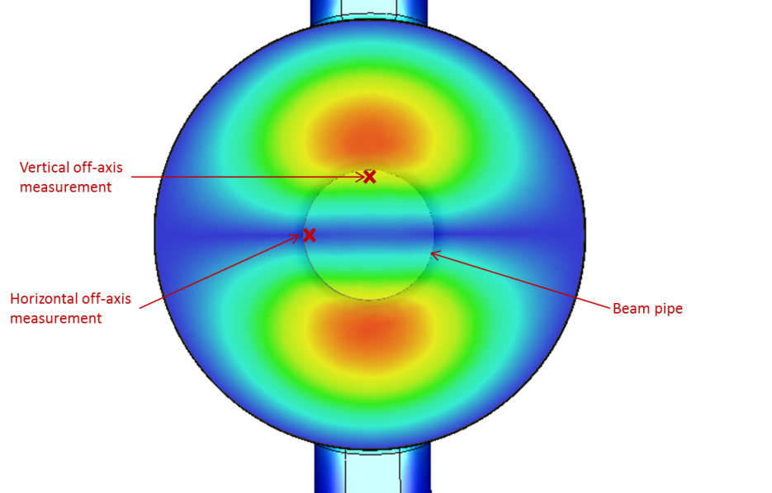

Figure A1: Measurement locations for polarisation check, superposed on electric field profile.

If either of these measurements do not meet the test criteria more measurements may be required.

3. Brazed measurement

3.1 In vacuum measurements
The cavity should be suitably supported. Measurements must be performed under vacuum, with pressure less than 1x 10-3 mBar. The cavity should be heated to the operating temperature (40°C) using the water cooling channels.

Measure S11 of the cavity using a calibrated vector network analyser, connected to the cavity input port via a coaxial line and a coax-to-waveguide adaptor. A coax to waveguide adaptor can be provided by STFC if required.

The operating mode is the first mode in the pass-band. The frequency of the operating mode should be within 0.25 MHz of the design frequency. There should be 4 other modes in the passband, with frequencies within 2 MHz of their design frequencies. Design frequencies can be found in Section 3.3 Table 3.

Determine from the Smith chart if the cavity is over or under-coupled. Then calculate the coupling factor β from the maximum and minimum values of the linear magnitude of the S11 reflection coefficient $Γ_{ max}$ and${ Γ}_{ min}$:
$$\left\{\begin{aligned}\frac{{Γ_{ max}-Γ}_{ min}}{{Γ_{ max}+Γ}_{min}}, \text{if under-coupled} \\ \frac{{Γ_{ max}+Γ}_{ min}}{{Γ_{ max}-Γ}_{min}}, \text{if over-coupled}\end{aligned}\right.$$

Q_{L} can be determined from the frequencies at the 3dB bandwidth of the operating mode, f₁ and f₂. Then $Q_{L}=\frac{f_{0}}{f_{1}-f_{2}}$. Q₀ and Q_{E} can then be determined from $Q_{0}=\left(1+β\right)Q_{L}$ and $Q_{E}=\frac{Q_{0}}{β}$.
The acceptance ranges for the coupling and Q values can be found in Section 3.3 Table 3.

3.2. Field flatness measurement
The field flatness measurement can be performed in air.

The field should be perturbed by a spherical metal bead along the longitudinal cavity axis and the phase change of S11 measured. The bead must be small enough that the phase variation caused by the bead is linear with frequency.

The H-field in the centre of each cell is proportional to the square of the maximum deviation in phase in the direction corresponding to an increase in frequency.

The field flatness is the ratio of the lowest H-field cell to the highest. It must be higher than 85%.

3.3. Polarisation check
The polarisation check can be performed in air.

The field should be perturbed by a spherical dielectric bead longitudinally along the cavity, 1 cm off axis vertically and the phase change of S11 measured. The bead must be small enough that the phase variation caused by the bead is linear with frequency.

The same measurement should then be performed off-axis horizontally. The phase variation seen in the vertically off axis case should be at least an order of magnitude higher than the horizontally off axis case.

Appendix 2: Example surface preparation method
- Vapor degrease in 1,1,1 trichloroethane or equivalent degreaser for 5 minutes.

- Alkaline soak clean in Enbond Q527 for 5 minutes at 180ºF.

- Cold tap water rinse for 2 minutes.

- Immense in 50% hydrochloric acid at room temperature for 1 minutes.

- Cold tap water rinse for 1 minute.

- Immerse in acid etch solution for a short period

For a single diamond point machined component this time is less than 5 seconds depending on the surface finish required.

For a component manufactured by regular machining techniques this time is typically less than 30 seconds and never more than 60

Recipe for bulk mix
Phosphoric Acid, 75% 21 gallons
Nitric Acid, 42º Baume 7 gallons
Acetic Acid, Glacial 2 gallons
Hydrochloric Acid 12.6 fluid ounces
Temperature Room

- Cold tap water rinse for minimum of 2 minutes until the film on part disappears

- Ultrasonic in DI Water for 1 minute.

- Ultrasonic in new, clean alcohol for 1 minute.

- Final Rinse to be done in new, clean alcohol.

- Hold in clean alcohol in stainless steel containers.

- Dry in a clean room using filtered N2.

Once components have been cleaned they can only be handled with gloves. Clean components should be stored in air tight containers back filled with dry filtered Nitrogen.

Section 5 – Evaluation model

The evaluation model below shall be used for this ITQ, which will be determined to two decimal places.

Where a question is ‘for information only’ it will not be scored.

The evaluation team may comprise staff from UK SBS and the Contracting Authority and any specific external stakeholders the Contracting Authority deems required. After evaluation the scores will be finalised by performing a calculation to identify (at question level) the mean average of all evaluators (Example – a question is scored by three evaluators and judged as scoring 5, 5 and 6. These scores will be added together and divided by the number of evaluators to produce the final score of 5.33 (5+5+6 =16÷3 = 5.33)

Pass / fail criteria

Questionnaire | Q No. | Question subject
Commercial | SEL1.2 | Employment breaches/ Equality
Commercial | FOI1.1 | Freedom of Information Exemptions
Commercial | AW1.1 | Form of Bid
Commercial | AW1.3 | Certificate of Bona Fide Bid
Commercial | AW3.1 | Validation check
Commercial | SEL3.11 | Compliance to Section 54 of the Modern Slavery Act
Commercial | AW4.1 | Contract Terms Part 1
Commercial | AW4.2 | Contract Terms Part 2
Quality | AW6.1 | Compliance to the Specification
- | - | Invitation to Quote – received on time within e-sourcing tool

Scoring criteria

Evaluation Justification Statement

In consideration of this particular requirement the Contracting Authority has decided to evaluate Potential Providers by adopting the weightings/scoring mechanism detailed within this ITQ. The Contracting Authority considers these weightings to be in line with existing best practice for a requirement of this type.

Questionnaire | Q No. | Question subject | Maximum Marks
Price | AW5.2 | Price | 25%
Quality | PROJ1.1 | Performance criteria | 15%
Quality | PROJ1.2 | Delivery | 15%
Quality | PROJ1.3 | Delivery Schedule | 10%
Quality | PROJ1.4 | Tolerance and Internal Finish Requirements | 10%
Quality | PROJ1.5 | Quality Control | 10%
Quality | PROJ1.6 | Diffusion Bonding | 10%
Quality | PROJ 1.7 | Warranty | 5%

Evaluation of criteria

Non-Price elements

Each question will be judged on a score from 0 to 100, which shall be subjected to a multiplier to reflect the percentage of the evaluation criteria allocated to that question.

Where an evaluation criterion is worth 20% then the 0-100 score achieved will be multiplied by 20%.
Example if a Bidder scores 60 from the available 100 points this will equate to 12% by using the following calculation:
Score = {weighting percentage} x {bidder's score} = 20% x 60 = 12

The same logic will be applied to groups of questions which equate to a single evaluation criterion.

The 0-100 score shall be based on (unless otherwise stated within the question):

0 | The Question is not answered, or the response is completely unacceptable.
10 | Extremely poor response – they have completely missed the point of the question.
20 | Very poor response and not wholly acceptable. Requires major revision to the response to make it acceptable. Only partially answers the requirement, with major deficiencies and little relevant detail proposed.
40 | Poor response only partially satisfying the selection question requirements with deficiencies apparent. Some useful evidence provided but response falls well short of expectations. Low probability of being a capable supplier.
60 | Response is acceptable but remains basic and could have been expanded upon. Response is sufficient but does not inspire.
80 | Good response which describes their capabilities in detail which provides high levels of assurance consistent with a quality provider. The response includes a full description of techniques and measurements currently employed.
100 | Response is exceptional and clearly demonstrates they are capable of meeting the requirement. No significant weaknesses noted. The response is compelling in its description of techniques and measurements currently employed, providing full assurance consistent with a quality provider.

All questions will be scored based on the above mechanism. Please be aware that the final score returned may be different as there may be multiple evaluators and their individual scores will be averaged (mean) to determine your final score.

Example
Evaluator 1 scored your bid as 60
Evaluator 2 scored your bid as 60
Evaluator 3 scored your bid as 40
Evaluator 4 scored your bid as 40
Your final score will (60+60+40+40) ÷ 4 = 50

Price elements will be judged on the following criteria.
The lowest price for a response which meets the pass criteria shall score 100.
All other bids shall be scored on a pro rata basis in relation to the lowest price. The score is then subject to a multiplier to reflect the percentage value of the price criterion.

For example - Bid 1 £100,000 scores 100.
Bid 2 £120,000 differential of £20,000 or 20% remove 20% from price scores 80
Bid 3 £150,000 differential £50,000 remove 50% from price scores 50.
Bid 4 £175,000 differential £75,000 remove 75% from price scores 25.
Bid 5 £200,000 differential £100,000 remove 100% from price scores 0.
Bid 6 £300,000 differential £200,000 remove 100% from price scores 0.
Where the scoring criterion is worth 50% then the 0-100 score achieved will be multiplied by 50.

In the example if a supplier scores 80 from the available 100 points this will equate to 40% by using the following calculation: Score/Total Points multiplied by 50 (80/100 x 50 = 40)

The lowest score possible is 0 even if the price submitted is more than 100% greater than the lowest price.

Section 6 – Evaluation questionnaire

Bidders should note that the evaluation questionnaire is located within the e-sourcing questionnaire.

Guidance on completion of the questionnaire is available at http://www.uksbs.co.uk/services/procure/Pages/supplier.aspx

PLEASE NOTE THE QUESTIONS ARE NOT NUMBERED SEQUENTIALLY
Section 7 – General Information

What makes a good bid – some simple do’s

DO:

7.1 Do comply with Procurement document instructions. Failure to do so may lead to disqualification.

7.2 Do provide the Bid on time, and in the required format. Remember that the date/time given for a response is the last date that it can be accepted; we are legally bound to disqualify late submissions. Responses received after the date indicated in the ITQ shall not be considered by the Contracting Authority, unless the Bidder can justify that the reason for the delay, is solely attributable to the Contracting Authority

7.3 Do ensure you have read all the training materials to utilise e-sourcing tool prior to responding to this Bid. If you send your Bid by email or post it will be rejected.

7.4 Do use Microsoft Word, PowerPoint Excel 97-03 or compatible formats, or PDF unless agreed in writing by the Buyer. If you use another file format without our written permission, we may reject your Bid.

7.5 Do ensure you utilise the Emptoris messaging system to raise any clarifications to our ITQ. You should note that we will release the answer to the question to all Bidders and where we suspect the question contains confidential information we may modify the content of the question to protect the anonymity of the Bidder or their proposed solution

7.6 Do answer the question, it is not enough simply to cross-reference to a ‘policy’, web page or another part of your Bid, the evaluation team have limited time to assess bids and if they can’t find the answer, they can’t score it.

7.7 Do consider who the Contracting Authority is and what they want – a generic answer does not necessarily meet every Contracting Authority’s needs.

7.8 Do reference your documents correctly, specifically where supporting documentation is requested e.g. referencing the question/s they apply to.

7.9 Do provide clear, concise and ideally generic contact details; telephone numbers, e-mails and fax details.

7.10 Do complete all questions in the questionnaire or we may reject your Bid.

7.11 Do ensure that the Response and any documents accompanying it are in the English
Language, the Contracting Authority reserve the right to disqualify any full or part
responses that are not in English.

7.12 Do check and recheck your Bid before dispatch.

What makes a good bid – some simple do not’s

DO NOT

7.13 Do not cut and paste from a previous document and forget to change the previous details such as the previous buyer’s name.

7.14 Do not attach ‘glossy’ brochures that have not been requested, they will not be read unless we have asked for them. Only send what has been requested and only send supplementary information if we have offered the opportunity so to do.

7.15 Do not share the Procurement documents, they are confidential and should not be shared with anyone without the Buyers written permission.

7.16 Do not seek to influence the procurement process by requesting meetings or contacting UK SBS or the Contracting Authority to discuss your Bid. If your Bid requires clarification the Buyer will contact you. All information secured outside of formal Buyer communications shall have no Legal standing or worth and should not be relied upon.

7.17 Do not contact any UK SBS staff or the Contracting Authority staff without the Buyers written permission or we may reject your Bid.

7.18 Do not collude to fix or adjust the price or withdraw your Bid with another Party as we will reject your Bid.

7.19 Do not offer UK SBS or the Contracting Authority staff any inducement or we will reject your Bid.

7.20 Do not seek changes to the Bid after responses have been submitted and the deadline for Bids to be submitted has passed.

7.21 Do not cross reference answers to external websites or other parts of your Bid, the cross references and website links will not be considered.

7.22 Do not exceed word counts, the additional words will not be considered.

7.23 Do not make your Bid conditional on acceptance of your own Terms of Contract, as your Bid will be rejected.

7.24 Do not unless explicitly requested by the Contracting Authority either in the procurement documents or via a formal clarification from the Contracting Authority send your response by any way other than via e-sourcing tool. Responses received by any other method than requested will not be considered for the opportunity.

Some additional guidance notes

7.25 All enquiries with respect to access to the e-sourcing tool and problems with functionality within the tool must be submitted to Crown Commercial Service (previously Government Procurement Service), Telephone 0345 010 3503.

7.26 Bidders will be specifically advised where attachments are permissible to support a question response within the e-sourcing tool. Where they are not permissible any attachments submitted will not be considered as part of the evaluation process.
7.27 Question numbering is not sequential and all questions which require submission are included in the Section 6 Evaluation Questionnaire.

7.28 Any Contract offered may not guarantee any volume of work or any exclusivity of supply.

7.29 We do not guarantee to award any Contract as a result of this procurement

7.30 All documents issued or received in relation to this procurement shall be the property of the Contracting Authority. / UKSBS.

7.31 We can amend any part of the procurement documents at any time prior to the latest date / time Bids shall be submitted through Emptoris.

7.32 If you are a Consortium you must provide details of the Consortiums structure.

7.33 Bidders will be expected to comply with the Freedom of Information Act 2000 or your Bid will be rejected.

7.34 Bidders should note the Government’s transparency agenda requires your Bid and any Contract entered into to be published on a designated, publicly searchable web site. By submitting a response to this ITQ Bidders are agreeing that their Bid and Contract may be made public

7.35 Your bid will be valid for 60 days or your Bid will be rejected.

7.36 Bidders may only amend the contract terms during the clarification period only, only if you can demonstrate there is a legal or statutory reason why you cannot accept them. If you request changes to the Contract terms without such grounds and the Contracting Authority fail to accept your legal or statutory reason is reasonably justified, we may reject your Bid.

7.37 We will let you know the outcome of your Bid evaluation and where requested will provide a written debrief of the relative strengths and weaknesses of your Bid.

7.38 If you fail mandatory pass / fail criteria we will reject your Bid.

7.39 Bidders are required to use IE8, IE9, Chrome or Firefox in order to access the functionality of the Emptoris e-sourcing tool.

7.40 Bidders should note that if they are successful with their proposal the Contracting Authority reserves the right to ask additional compliancy checks prior to the award of any Contract. In the event of a Bidder failing to meet one of the compliancy checks the Contracting Authority may decline to proceed with the award of the Contract to the successful Bidder.

7.41 All timescales are set using a 24-hour clock and are based on British Summer Time or Greenwich Mean Time, depending on which applies at the point when Date and Time Bids shall be submitted through Emptoris.

7.42 All Central Government Departments and their Executive Agencies and Non-Departmental Public Bodies are subject to control and reporting within Government. In particular, they report to the Cabinet Office and HM Treasury for all expenditure. Further, the Cabinet Office has a cross-Government role delivering overall Government policy on public procurement - including ensuring value for money and related aspects of good procurement practice.

For these purposes, the Contracting Authority may disclose within Government any of the Bidders documentation/information (including any that the Bidder considers to be confidential and/or commercially sensitive such as specific bid information) submitted by the Bidder to the Contracting Authority during this Procurement. The information will not be disclosed outside Government. Bidders taking part in this ITQ consent to these terms as part of the competition process.

7.43 The Government introduced its new Government Security Classifications (GSC) classification scheme on the 2nd April 2014 to replace the current Government Protective Marking System (GPMS). A key aspect of this is the reduction in the number of security classifications used. All Bidders are encouraged to make themselves aware of the changes and identify any potential impacts in their Bid, as the protective marking and applicable protection of any material passed to, or generated by, you during the procurement process or pursuant to any Contract awarded to you as a result of this tender process will be subject to the new GSC. The link below to the Gov.uk website provides information on the new GSC:

https://www.gov.uk/government/publications/government-security-classifications

The Contracting Authority reserves the right to amend any security related term or condition of the draft contract accompanying this ITQ to reflect any changes introduced by the GSC. In particular where this ITQ is accompanied by any instructions on safeguarding classified information (e.g. a Security Aspects Letter) as a result of any changes stemming from the new GSC, whether in respect of the applicable protective marking scheme, specific protective markings given, the aspects to which any protective marking applies or otherwise. This may relate to the instructions on safeguarding classified information (e.g. a Security Aspects Letter) as they apply to the procurement as they apply to the procurement process and/or any contracts awarded to you as a result of the procurement process.

USEFUL INFORMATION LINKS
- Emptoris Training Guide
- Emptoris e-sourcing tool
- Contracts Finder
- Equalities Act introduction
- Bribery Act introduction
- Freedom of information Act

