Station Approach, Winchester

Winchester City Council Design Brief
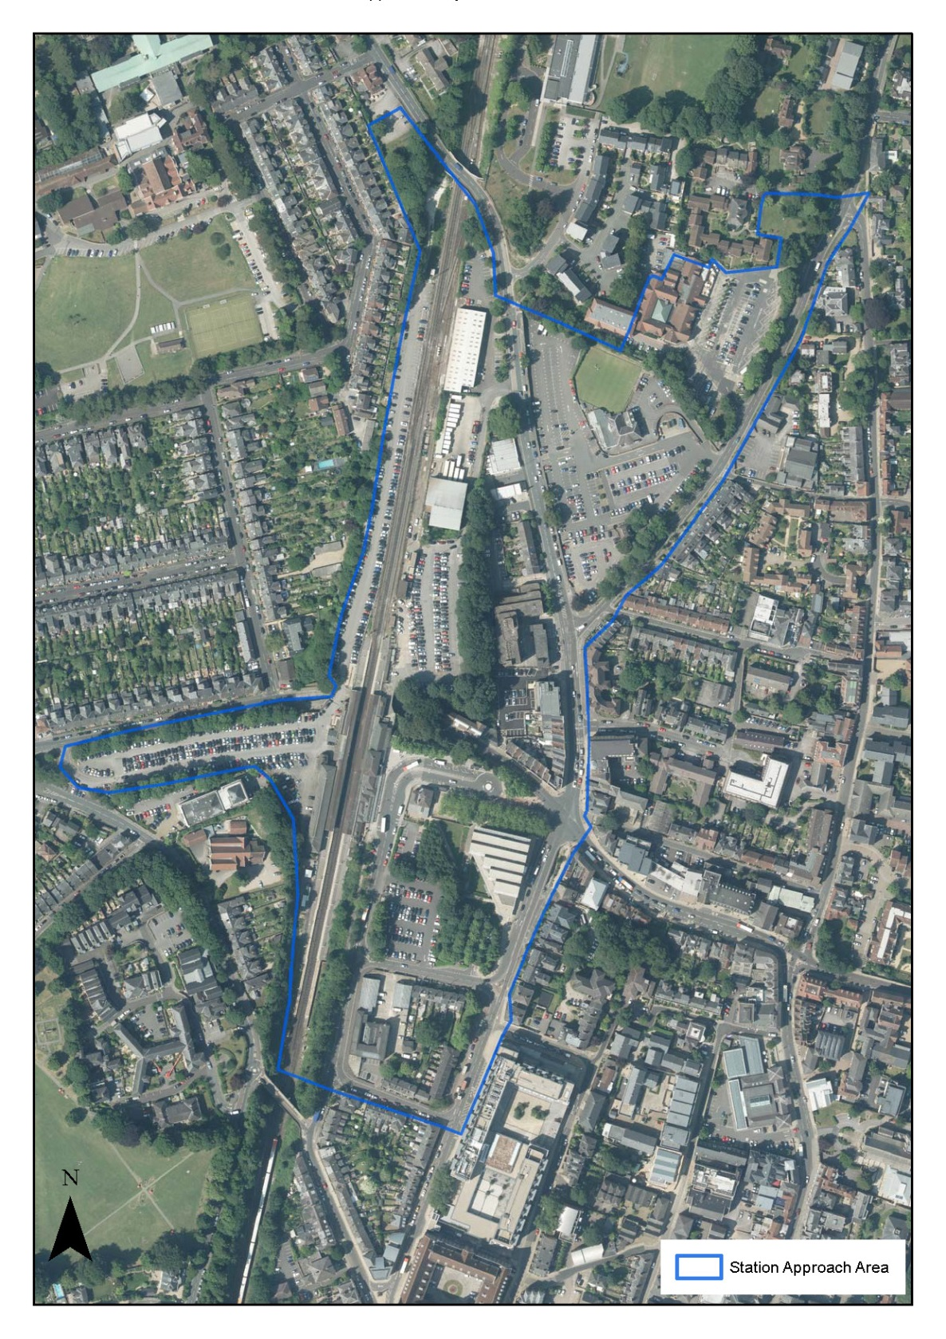

CONTENTS

Executive Summary 1
Project Introduction 2
Requirements of the Development Brief and Submissions 5
Provisional Development Requirements 7
Characteristics of the Area and the Council’s Objectives 9
Station Approach – Development Aim 10
Issues and Context 11
Consultation / Engagement 12
Public Realm 14
Car Parking 15
Principles for Determining a Successful Development Outcome 15

SUPPLEMENTARY DOCUMENTS:
- Archaeology Written Scheme of Investigation 2016 Cotswold Archaeology
- Station Approach Transport and Accessibility Background Report 2015 Winchester City Council
- Winchester Station Quarter - parking access review report 2015 Urban Flow
- Winchester Station Quarter - summary parking report 2015 Urban Flow
- Arboricultural Implication Assessment 2015 Harrison Arboriculture
- Cultural Heritage Assessment 2015 Elaine Milton Heritage & Planning
- Ecological Appraisal 2015 EPR
- Topographical drawings 2015 Encompass Surveys
- Preliminary Geo-Environmental and Geotechnical Assessment 2013 Tweedie Evans Consulting

SUPPLEMENTARY DOCUMENTS TO BE SUPPLIED BY WINCHESTER CITY COUNCIL:
- Interim Transport Assessment
- Land Ownership/Highway Land Plans
- Statutory Undertakers Plans and Assessments of Capacity

BACKGROUND DOCUMENTS:
- The Vision for Winchester Town 2012-2017
- Tibbalds – Winchester Station Approach Development Assessment September 2014
NB - both of the documents above can be found at: www.winchester.gov.uk/planning/major-sites/station-approach
- RIBA Concept Design: http://www.ribaplanofwork.com/about/Concept.aspx
- Winchester District Economic Strategy, 2010 – 2020: http://www.winchester.gov.uk/planning-policy/evidence-base/ economy/economic-strategy-2010-2020
- District Cycling Strategy: http://www.winchester.gov.uk/roads-highways/cycling-and-cycle-routes/winchester-district-cycling-strategy/
- Walking Strategy for Winchester: http://www.winchester.gov.uk/roads-highways/walking-winchester
- Winchester Railway Station Travel Plan: http://documents.hants.gov.uk/railway-station-travel-plans/ WinchesterStationTravelPlan-Final.pdf
- Local Plan Part 1: http://www.winchester.gov.uk/planning- policy/local-plan-part-1/adoption and emerging Local Plan Part 2: http://www.winchester.gov.uk/planning-policy/local-plan-part-2/
- Winchester Town Access Plan: http://www3.hants.gov.uk/tap-winchester-full-document.pdf
- Winchester District Car Parking Strategy 2014-18: http://www.winchester.gov.uk/parking/winchester-district- car-parking-strategy
- Culture, Innovation and the Winchester Economy 2014-2019: http://www.winchester.gov.uk/assets/files/19513/Cultural-Strategy-2014.pdf
- Hampshire County Council - proposed Winchester District Energy Scheme: contact environmentfutures@hants.gov.uk
- High Quality Places – Supplementary Planning Document: http://www.winchester.gov.uk/planning-policy/supplementary- planning-documents--spds-/high-quality-places-spd/
- Results of stakeholder consultation: http://www.winchester.gov.uk/planning/major-sites/station-approach/help-shape-future-station-approach/
- Route Map for a Low Carbon Economy http://www.winchester.gov.uk/assets/files/20340/CAB2586.pdf http://www.winchester.gov.uk/assets/files/20348/CAB2586-BackgroundDoc1.pdf
http://www.winchester.gov.uk/assets/files/20349/CAB2586-BackgroundDoc2.pdf
http://www.winchester.gov.uk/assets/files/20350/CAB2586-BackgroundDoc3.pdf
- Working Towards a Low Carbon District, CAB2682: http://www.winchester.gov.uk/assets/files/23239/CAB2682.pdf

This is an opportunity to add to Winchester’s impressive architectural history with proposals that are ‘of their time’, whilst reflecting the character and heritage of the city.

Executive Summary
Winchester is an ancient city, with a street plan dating back to the times of King Alfred. Its medieval heritage can be seen in the Cathedral, Winchester College and the Hospital of St Cross. Development during the Georgian and Victorian periods further contributed to create the special character that Winchester has today. This is an opportunity to add to Winchester’s impressive architectural history with proposals that are ‘of their time’, whilst reflecting the character and heritage of the city.
There is considerable potential to improve the area’s role as a gateway to the cathedral city and the South Downs National Park beyond for visitors, residents, commuters and students. The Council owns two sites within the Station Approach area, namely the site known as the Carfax site and the site known as the Cattlemarket site.
The Council intends to directly commission a design team to work with the Council as client and with other stakeholders in the city to formulate designs for mixed use developments on these sites together with a public realm strategy which can be implemented as development proposals come forward to demonstrate how improvements to the public realm can improve accessibility and the liveability of this part of the city.
On completion, a successful project will have produced:
- development proposals for sites in the Council’s ownership to provide a commercially viable mixed use development of office space and necessary parking provision, with supporting residential and small scale retail uses
- public realm proposals which will improve the permeability and accessibility through and to the area for pedestrians and cyclists and the links with the city centre and recognising the importance of the area around the Station as a gateway to the city.
- imaginative and welcoming proposals to improve the public realm with space to dwell and enjoy;
- an improved relationship between modes of transport and their impact on the local environment (a Background Report on Transport and accessibility will be provided to the successful Applicant);
- contributed to the target of maintaining growth whilst working towards a lower carbon Winchester District.

Project Introduction
Development of these sites is seen as both an objective in itself and as a catalyst for other improvements to public and private interests in the area.
The area currently has a variety of uses, some of which have obvious potential for improvement or development whilst others may be retained. There are a variety of ownerships; the Council proposes to engage with other owners who may wish to improve their property holdings through encouragement and enabling rather than through any other form of intervention.
The aim of this project is to realise the area’s potential, both in relation to the city’s economy and its role as a gateway. If it is successful the development should have a positive impact on the economy and environment of the city as a whole. It should provide new and improved public realm with better walking and cycling links for people who live and work in the area, or who move through it. It is an important location specifically identified in the Council’s ‘Vision for Winchester’ document.
A successful outcome of the regeneration of the area will achieve the creation of commercially successful developments; create a distinctive local character area respecting the best of the neighbouring areas, and improve the connectivity between the emerging suburb of Barton Farm, the historic area of Hyde, the station and the city centre.
The Carfax and Cattlemarket sites are two parcels of land within the area which are both owned by the Council and in excellent, sustainable locations. They offer the potential for creating innovative and attractive designs and public realm improvements and much needed commercial and housing development, with associated car parking and financial returns. Development of these sites is seen as both an objective in itself and as a catalyst for other improvements to public and private interests in the area.
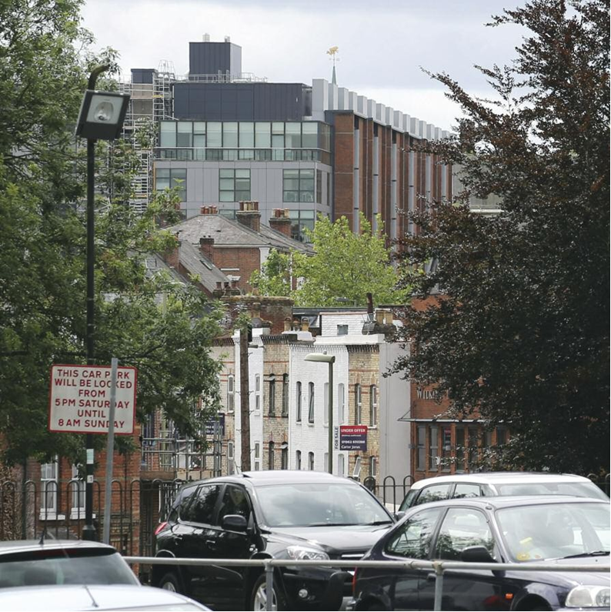
The Council wishes to bring forward proposals to redevelop the sites in its ownership. To ensure that this is done to best effect, and to provide a framework within which other, independent, development proposals can be assessed, the Council proposes to create a plan to enhance and develop the public realm and transport links throughout the area. This will need to reflect the many different groups of people who pass through the area to access educational, commercial, retail and tourist attractions when this and other development takes place.

Plan of Station Approach area
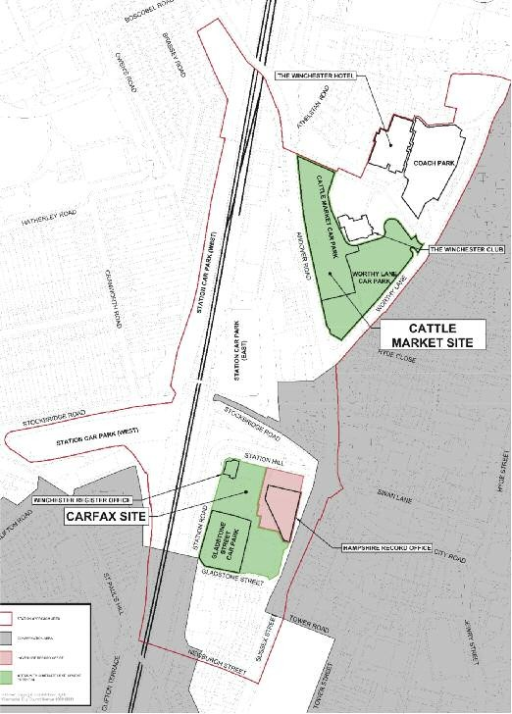
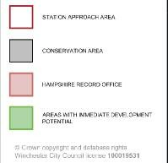
CATTLE MARKET SITE
CARFAX SITE
The Council is seeking to commission a design team to develop proposals which demonstrate how the requirements of the Brief can be achieved firstly by demonstrating the most appropriate disposition of uses across the Carfax and Cattlemarket sites, and secondly by producing a more detailed design proposal at RIBA stage 2 ‘Concept Design’ for the Carfax Site.
In parallel, a strategy for improvements to the public realm and connectivity in the area will be developed which sets a framework of sufficient detail to set out both the requirements with which future planning applications in the area must conform and contribute, and those works which should be undertaken as a public works to facilitate development.
If the Council decides to proceed with the Carfax scheme the design team will be commissioned to undertake the design to planning application stage.
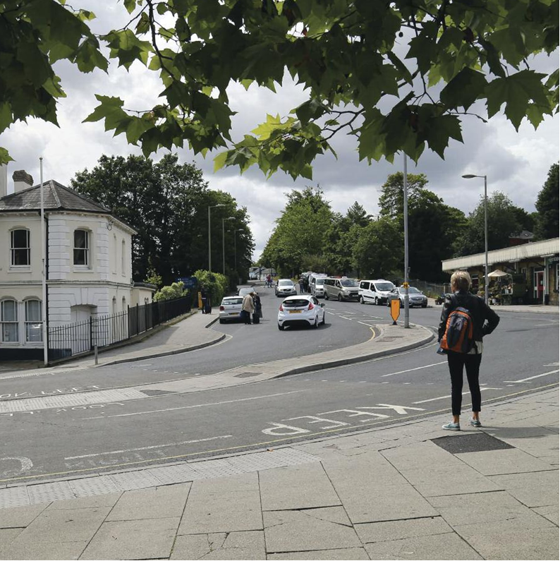

If planning consent is secured and the proposals remain deliverable it is expected that the design team will either be novated to the contractor or developer or retained by the Council as ‘design guardian’ depending on the chosen route of procurement for construction.
Detailed design proposals and development of the Cattlemarket will not be considered as part of this brief.

Requirements of the Development Brief and Submissions
The Council wishes to work with a design team to develop innovative and creative design solutions which will ‘structure’ the area as a whole, and demonstrate how the development requirements can be accommodated on the two sites in its ownership.
The design team (Architect’s team who will manage the project) will be responsible for procuring all design services required (apart from those listed below for the Authority to appoint). The Authority anticipates that the Project Team will include the following:
Lead Designer
Principal Designer;
Architectural design;
Landscape design;
Civil and Structural Engineer
M&E Engineer
BIM Co-ordinator;
BIM Information Manager;
Master planning including strategic sustainable development advice;
Urban Designer
BREEAM Consultant
Planning consultancy including townscape heritage and visual statement and relevant sustainability statement.
The following will be appointed by the Authority:-
Quantity surveyors, cost consultants and transport planners.
Through the public realm strategy the Council wishes to produce a template for decisions regarding infrastructure and third party development proposals to ensure a coherent and successful revitalisation of the area.
The Council wishes to obtain innovative and creative design solutions which will create a structure for the area as a whole.
The design work to be commissioned will therefore consist of:
- An analysis of the area and proposals for the disposition of the provisional development requirements (which are set out on Page 6) and such other uses as may be considered as appropriate and feasible between the Cattlemarket and Carfax sites shown in green on Page 3 in accordance with the principles set out in the Brief. Whilst being clear about the purpose of development in the area on which the design team must focus the Council is prepared to be flexible in its specific requirements and sees this process as a dialogue to seek the optimal relationship between elements.
- A public realm strategy considering issues such as walking and cycling routes, access to public transport, public spaces (including any green spaces and community gardens or public art), landscaping (hard and soft), street furniture and signage which demonstrates how the requirements that are set out in the Brief and background documents can be accomplished within, and if appropriate, beyond (depending upon avialble funding) the Station Approach area as shown on the plan on Page 3. This should be derived from and influence the proposals contained in item 1. It should be assumed that the upper limit of total expenditure on the public realm (i.e. implementation of the strategy) will be in the order of £5 million. This figure represents the ‘scale’ of the public realm strategy the Council wishes to develop, not the finance currently available. The design team will develop the public realm ideas and proposals into a completed strategic document which will establish an informal ‘design code’ for the public realm in the area.
- A proposal for the development of the proposed uses on the Carfax site at a level of detail consistent with RIBA Stage 2 ‘Concept Design’. If the Council agrees to proceed the design team will be commissioned to develop the design to planning stage.

1.15 It is envisaged that the Development will be taken forward in phases with the Council exercising the right at its sole discretion at the end of each Phase as to whether or not it wishes to instruct the successful Design Team in respect of the next phase:
• Phase 1: Disposition of uses across the Carfax and Cattlemarket sites, a strategy for improvements to the public realm, and a proposal for ‘Concept Design’ for the Carfax site (RIBA Stages 0 -2);
• Phase 2: Following agreement from the Council to proceed, the design team will be commissioned to develop the design to planning stage (RIBA Stage 3);
• Phase 3: Technical Design (RIBA Stage 4)
• Phase 4: Construction (RIBA Stage 5) - option to novate or retain depending on chosen route for procurement
• Phase 5: Handover and Close Out (RIBA Stage 6)
• Phase 6: In Use (RIBA Stage 7)
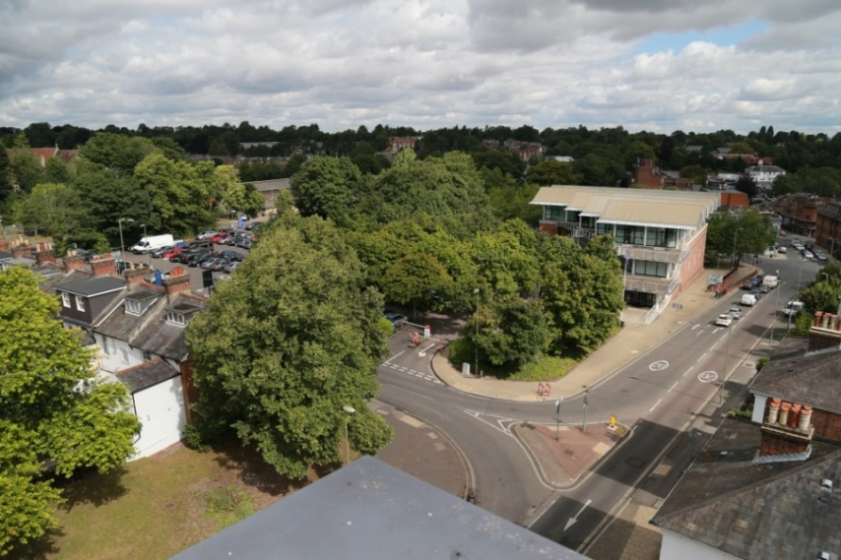

Provisional Development Requirements

13,000 sqm

Between
5,300sqm and 8,180sqm
465 sqm
13,000 sqm

Office floor space
Small scale retail
floor space
(including restaurant/ café uses)
(with associated
parking)
Residential
floor space

Across the two sites owned by the Council the provisional development requirements which the Council believes could be accommodated between the two sites and which should be tested by the design team are:
- approximately 13,000 sq m (140,000 sq ft) office floor space divided into two or three buildings with facilities and floorplates suitable for flexible use or subdivision either for a single or multiple occupiers with self contained car parking requirements incorporated into the design.
- provision of between 5,300 sq m (57,000 sq ft) and 8,180 sq m (88,000 sq ft) of residential floor space with associated parking in accordance with Council’s Local Plan and Affordable Housing policies;
- approximately 465 sq m (5,000 sq ft) small scale retail floor space including restaurant/café uses the purpose of which is to provide convenience shopping and services to office workers, local residents and commuters.

Development proposals for the Carfax and Cattlemarket sites should be contained within the Council’s land ownership. They must also be capable of delivery without creating any ransom situations.
In addition to the above requirements, the Council’s parking strategy seeks to maintain broadly the same level of public car parking provision across the area (ie 400 public spaces) and ensure that the parking is ‘purposeful’, in that, it is located so that it can best serve different users including meeting the needs of businesses, residents and shoppers. The strategy also seeks to ensure that parking makes efficient use of space and that it is provided to a high standard. Proposals should therefore seek to maintain approximately the current levels of public parking distributed across the two sites and if appropriate to take into account recent changes in parking supply in the area, including at the Railway Station, whilst exploring how this can best be located to minimise traffic impacts. The Council will work with the design team to guide and inform this process and to provide specific input in relation to the emerging City Transport Strategy.
The Council has commissioned an interim transport assessment and is retaining the services of the transport consultant throughout this process to inform the transport and parking inputs. A back ground report on Transport and accessibility has also been produced. An Air Quality Management Area has been designated within the City Centre including the Station Approach Area so air quality impacts will be an important consideration, specifically in relation to the main traffic junctions and adjoining streets.
Appropriate private car parking for the new commercial and residential usages of the development will also be required. The precise quantum will depend upon the extent and type of the accommodation to be provided on the two sites and the extent to which it can be demonstrated how the sustainable location could produce lettable space with reduced on site car parking.

The Council will be flexible in its requirements if that will help to achieve the best possible design solution.
The City Council acknowledges that as the Design Team’s work progresses it may become apparent that some flexibility is required in order to achieve the objectives set out in the Brief. The City Council as client will be flexible and guided by the appointed architectural practice on the most suitable approach where there are good reasons and justifications.

...create a high quality and welcoming arrival ‘gateway’ point.

Characteristics of the Area and the Council’s Objectives
An important outcome from a successful project is that both public realm quality and accessibility are improved.
The area at the southern end of the Andover Road and approaching the railway station has considerable potential which is, at present, largely unfulfilled. A small number of commercial premises exist along the railway corridor none of which are of any great design merit or significance. The route down Andover Road and Stockbridge Road into Winchester offers no sense of ‘arrival’. The new suburb of Barton Farm, further north along Andover Road, will create additional transport movements of all types, and further highlight the unresolved traffic problems in the Station Approach area. The area is used by many students from the college, local schools and Universities and any design should seek to respond to their needs.
The junction of Worthy Lane and Andover Road and some nearby streets are very busy at peak times as is the main cross-roads a little further on, known as the Carfax junction which is very important to movement through the area. This may be further impacted by the major residential developmnet area known as Barton Meadows to the north of the city centre as it progresses and as new bus services come on line. These present obstacles to pedestrian movements in particular but also for cyclists and to some degree, buses and commercial traffic arising from the busy intersection of cross town routes.
The area in front of the station is in good condition and has benefited from investment, but routes to the city centre are not as well defined as they should be and the area is largely used by taxis and buses thus providing an important interchange facility. The Carfax site immediately opposite has a mixture of uses which it is now proposed to redevelop in a way consistent with providing a characterful and welcoming arrival area and departure.
An important outcome from a successful project is that both public realm quality and accessibility are improved. The development and implementation of such works will rely upon partnership working with Hampshire County Council (HCC), train and bus operating companies and other key stakeholder groups including additional third party land or frontage owners who have been or may need to be involved. Initial discussions have taken place with a number of these organisations to confirm that they support the objectives and are keen to remain involved as it progresses. HCC, in their role as highway authority, are a particularly significant stakeholder. The Council is therefore seeking to develop proposals which are ‘in principle’ realistic and deliverable, but recognises that these may require agreements not yet in place.
A £5m bid is being made to the Enterprise M3 Local Enterprise Partnership for local growth funding to enable public realm, walking and cycling improvements to be made to the area around the development and Winchester Railway Station, linking into the city centre and beyond.
The Council places a strong emphasis on functional, high quality design in appropriate materials which should be distinctive and obviously ‘of its time’ but which should respect and be complementary to the adjacent townscape and adjoining uses/ buildings including the Railway Station itself. As a mixed use neighbourhood of commerce, housing, parking and a small amount of retail space development, the area has sufficient scale to have its own ‘internal’ public realm and design character but the transition to and from adjacent areas should be fluid and not abrupt. Sustainable building and layout based on good business principles should be at the heart of the design, construction and future operation. The Council has produced a High Quality Places Supplementary Planning Document to which reference should be made.

The Council places a strong emphasis on functional, high quality design in appropriate materials which should be distinctive and ‘of its time’ but which respects and take cues from the adjacent townscape.

Station Approach – Development Aim
...demonstrate a high standard of architectural, highway and landscape design, in harmony with the existing character of Winchester.
Through the development the Council seeks to:
- ensure the area around the station enhances the economic vitality of the city, offering modern, purpose built offices to improve employment opportunities;
- ensure that this development will contribute to achieving the Council’s objectives to increase high value employment prospects in the city, to build a low carbon economy (which includes an overall aspiration to cut emmssions by 40% across the District by 2020) and to promote the town’s walking and cycling strategies. The Council will seek to achieve BREEAM outstanding within the constraints of scheme viability.
- create a commercial office hub;
- create a high quality and welcoming arrival ‘gateway’ point and improve ‘wayfinding’ and legibility so that people find their way to the city centre and other key destinations, particularly by means other than the private car;
- enhance the public realm, public transport facilities and retail offer in the area to create attractive and vibrant public spaces responding to people and their needs whilst also building on and adding to the existing commercial and cultural life in the city;
- improve the aesthetic and landscape quality of the area, including the retention of important trees and create new planting areas, where space and practical considerations allow;
- demonstrate a high standard of architectural, highway and landscape design, in harmony with the existing character of Winchester, and use quality materials and detailing (noting future maintenance liabilities for publically owned spaces and land);
- safeguard and enhance important views (where it is appropriate to do so) and the character of the area;
- repair the urban fabric and create a cohesive high quality townscape, and public realm which is capable of being further enhanced as other developments within the area are brought forward;
- improve linkages to the station and through the sites that are consistent with the surrounding area and existing schemes and emerging proposals;
- provide car parking which meets both public and private needs (whilst considering recent changes to the Railway Station car parking) through the efficient use of space and is of a high quality design from a user perspective (the office car parking should be made available for public use at weekends where possible);
- strengthen the existing retail offer in addition to the local centre around Andover Road/Stockbridge Road;
- create mixed use buildings with active frontages by providing a variety of active uses along key routes;
- provide a mix of houses and flats (giving consideration to the Council’s policy on affordable housing);
- improve pedestrian, cycling and traffic flows along streets and at junctions, critically bearing in mind that improvements should avoid displacing vehicular traffic - especially elsewhere in the city - unless suitably mitigated;
- have consideration of the findings of recent research that show that traffic reduction and maximising pedestrian and cycling facilities increase considerably the commercial potential of an area. (http://activelivingresearch.org/sites/default/files/MakingThe CaseReport.pdf and a reference to the Pedestrian Pound at http://www.livingstreets.org.uk/sites/default/files/content/library/Reports/Pedestrian Pound_fullreport_web.pdf).
Winchester has a shortfall in modern, desirable commercial premises resulting in some businesses not being able to establish themselves or expand in the city. The development will support desired transport outcomes by improving access to markets and employment, improving public transport access and locating housing and commercial premises in a highly sustainable location.

…strengthen the existing retail offer... provide a mix of houses and flats.

Issues and Context
...improve pedestrian, cycling and traffic flows where possible.
Opportunities presented by this area have emerged from discussions between the Council and local stakeholders, and have been given momentum by the grant of planning permission for the Barton Farm development of 2000 dwellings with a local centre immediately to the north. Local Plan Policies set out in the adopted Local Plan Part 1 and in the emerging Local Plan Part 2 seek to ensure that there are a range of sites and premises available for businesses and commercial enterprises to set up and expand to meet their full potential and that adequate infrastructure is available. The Station Approach area has specific development plan policies with which this brief is consistent.
As part of its response to Barton Farm, Hampshire County Council (the highway authority) has commissioned three corridor studies to identify measures which could be undertaken using financial contributions from the developer for off site improvements. The developer will also be funding new bus services serving the site, linking to the Rail Station/ City Centre. The County Council has also developed a Winchester Railway Station Travel Plan in partnership with the train operating company and Network Rail, which needs to be taken into account in any proposals.
There is therefore a strong strategy and policy framework to guide this work including the Local Plan, the Council’s ‘Vision for Winchester’ document, the Council’s Economic Strategy, the Winchester Town Access Plan, a District Cycling Strategy and a Winchester Walking Strategy and the Station Travel Plan.
The Council adopted a Car Parking Strategy in 2014 which sets out a detailed policy framework against which to test development proposals.
There is a designated Air Quality Management Area within central Winchester which contains thresholds for certain pollutants. This contains an action plan and work is planned on a vehicle profiling survey/ exercise which will help inform further actions that might be required.

Consultation / Engagement
Workshops have taken place with stakeholders and residents looking at both sites and the public realm of the area, and which have identified a number of issues and potential opportunities which are set out in a separate report.
Substantial local consultation has also taken place in conjunction with the production of this brief and the emerging Local Plan Part 2.
Through February and March 2015 the Council undertook extensive consultation including a series of workshops with residents, local business and other stakeholders. A very good level of response was received including 650 individual comments through the online survey as well as 115 residents and 48 stakeholders who attended workshops.
During this consultation a wide variety of people and groups provided their thoughts on the Station Approach area and what possibilities there might be to improve it and support the local economy. The consultation was intended to help generate key principles at this early stage which will inform how any development will be taken forward. There is concern from local residents in particular regarding the form and operation of any development, and its impact on local traffic and travel patterns.
An important element of the design teams’ work will be to reflect upon the comments and ideas of local residents and other stakeholders and to demonstrate how the proposals brought forward have engaged with these. As there are a variety of views on the sites, some strongly contested, it is not expected that any proposals will resolve all differences or find favour with all, but the Council does wish to engage meaningfully with differing views.
The successful bidder will need to undertake extensive, iterative and high quality engagement with residents and stakeholders during the design process. This will be over and above the statutory consultation process as part of the planning application and use existing fora such as the Station Approach Panel and the Winchester Town Forum, as well as inclusive techniques to engage a wider audience in refining the design.
As part of the tender, bidders must produce an Engagement and Communication Strategy, setting how they propose to engage interested parties in the design process, up to the submission of a planning application. This will need to be comprehensive, representative of our communities and inclusive. Innovative methods of engagement will be encouraged to ensure all those interested in the site and its future development have an opportunity to contribute.
The reports of work done to date is available at: http://www.winchester.gov.uk/planning/major-sites/station-approach/help-shape-future-station-approach/ .

Public Realm
...create a public realm which is capable of being further enhanced as other developments are brought forward.
Securing a high quality public realm across the Station Approach area is an important objective and has two primary aims. Firstly, the Council wishes to ensure that the quality of the public realm makes a positive statement about the city itself on arrival via the station, and by all transport modes via the Andover Road/new development area. This project represents an opportunity to set a new standard. Secondly, provide improved walking and cycling routes within the public realm to key destinations such as the University and Hospital and town centre, improve the links with new development to the north, and ensure that there is strong connectivity to the town centre, improving convenience and encouraging non-car journeys.
Specific issues that the Council wishes to see addressed include:
- the relationship of development on the Carfax site to the station forecourt so as to create a generous area of public realm to act as a legible and welcoming arrival, circulation and departure space;
- improving the interchange facilities between train, bus and taxi services with well- graded and well-signed pedestrian routes between the two, ensuring safe pedestrian links and ensuring the most direct and practical routing of bus services;
- improved cycling and pedestrian movement within and through the station and surrounding area, and improving pedestrian and cycle accessibility and way-finding into the centre of Winchester by all available routes;
- we will require packages of transport and public realm interventions to be identified, with concept designs and initial costings which can be implemented in agreed phases and in line with funding when it becomes available.

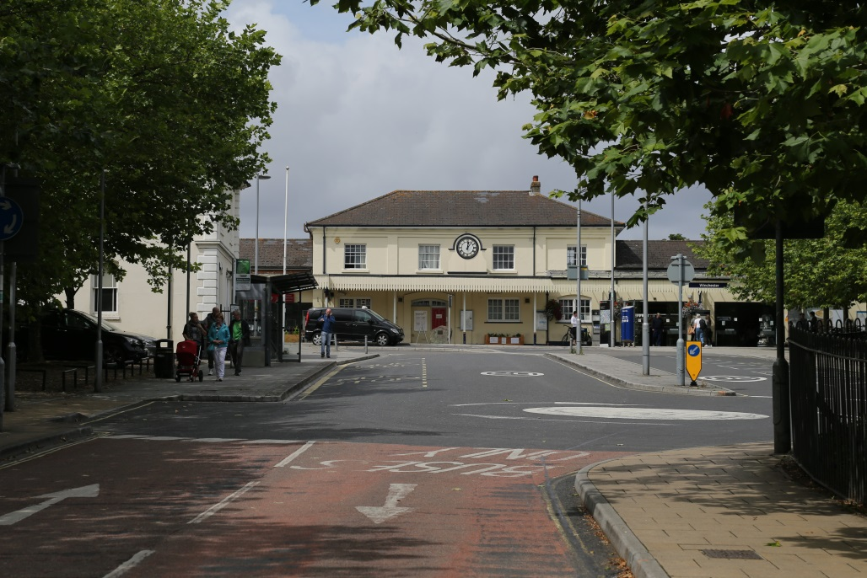

Car Parking
...improve linkages to the station and provide car parking.

The Council’s Parking Strategy sets out the framework for the area in terms of public parking provision and focuses on ensuring that parking spaces are provided in appropriate locations so as to manage traffic and retain the required provision to support Winchester’s economy. The Council has commissioned an interim Transport Assessment which can be developed to test design concepts and associated parking provision as they emerge. This can then be considered by the Council’s Advisory Panel and the Designers in terms of agreeing a sensible balance of uses and parking provision which can be accommodated on the sites.
Taking account of the total requirements indicated in the section of this brief entitled ‘Requirements of the Development Brief and Submissions’, the design proposals should examine both the quantum and the distribution of public and private parking between the two sites. It is recognised that design considerations may also have a significant role in determining the precise location and configuration of car parking provided.
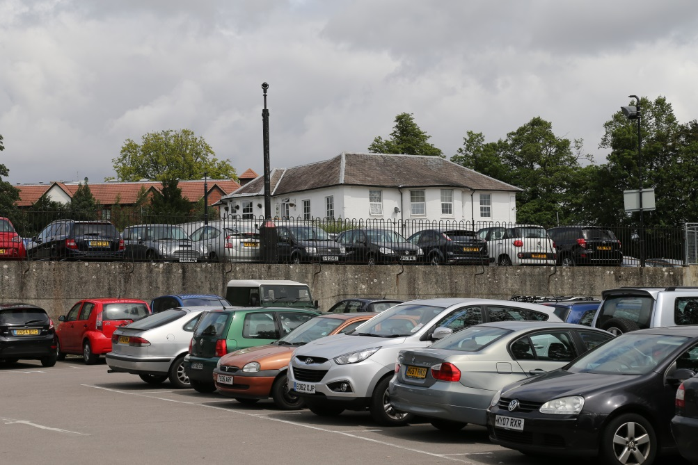

Principles for Determining a Successful Development Outcome
The Council will expect the following requirements to be met.

Generally
- produce a commercially viable scheme as defined by the Council in the procurement documentation;
- deliver accommodation in line with current and predicted future market requirements and in accordance with the Council’s adopted Local Plan;
- set a new standard for the quality of design and public realm where it is currently poor, whilst relating well with the existing conservation areas;
- place an emphasis on individual building design being part of the character of the whole area rather than creating landmarks or statements in their own right;
- deliver buildings and facilities that are sustainable, contributing to targets for carbon reduction and renewable energy, recognising the impact that car parking and transport can have on these objectives;
- proportionately scale new buildings using existing topography and the cues from existing buildings where these are helpful;
- adopt principles that minimise road and rail noise impacts upon residential receptors in accordance with chapter 7 of BS 8233:2014 including matters such as location, orientation, materials etc.;
- produce development which is permeable so that walking and cycling are prioritised along legible, well lit, attractive and lively routes;
- ensure that the street frontages of new developments enhance the pedestrian environment in particular but also that for cycling where possible;
- ensure that frontages are active wherever possible, avoiding stretches of blank façade;
- contribute as a whole to a lower carbon and sustainable Winchester;
- meet the requirements of typical commercial occupiers;
- deliver buildings attractive for long term institutional investment.

Carfax Site
- ensure careful massing to respect the two and three storey domestic dwellings which are opposite the site on Gladstone Street;
- have regard to the existing Hampshire Records Office and the Station building and assess the impact of development within the wider context including residential properties and views;
- retain a pedestrian route through the site linking the station forecourt and Sussex Street, and improve its quality and accessibility including Station Road and links beyond to the Upper High Street;
- create a focal point and attractive frontage immediately opposite the station to orientate arrivals;
- consider the relative merits of retaining or removing the former Register Office building on the north west corner of the site as part of an overall scheme.
- Consider how best to use the slope of the site which falls in two directions. Full topographical information will be provided. Archaeological information and infrastructure capacity work undertaken will also be provided.

Cattlemarket Site
- create a frontage onto Andover Road that is set back from the existing edge of pavement to provide a generous footpath with tree lined verge;
- make use of the Worthy Lane / Andover Road junction to create a focal point whilst considering the functioning of this junction and whether it could be improved in respect to pedestrian/ cyclist and vehicular movement and its interaction with the Carfax junction;
- adopt careful massing to respect the two storey domestic dwellings which are opposite the site on Worthy Lane and part of the Hyde conservation area.
- consider how best to use the existing fall/ slope across the site to best effect and consider any impacts of important views.

Public Realm
- Provide a comprehensive framework for the public realm which will enable the Council to ensure that individual development proposals are properly integrated into a programme of improvements in movement, access and the provision of attractive public space (of all types);
- Set out a vision for the quality of public realm which is itself a spur to investment and the redevelopment of individual sites;
- Identify specific improvements to the existing network of highways and informal routes could be improved (within the financial parameters defined in the Brief) to as to reduce the impact of necessary vehicle movement on the area and improve connectivity for pedestrians and cyclists;
- Include proposals for distinctive and eye-catching public space or shared space in areas of existing public control or within the specific development proposals for Cattlemarket or Carfax sites.
- Retain existing mature trees where possible and incorporate new planting and soft landscape features into the proposals so as to reflect the importance of ‘green features’ on the other edges of the city centre.
- Consider the inclusion of other elements which the Council has not specified but which could be desirable additions to the public realm, such as integrated public art, cultural or community facilities or ad hoc commercial opportunities which can add character and interest.

Summary of Tender Process and Selection Criteria
Potential Suppliers are required to complete a Standard Selection Questionnaire (SQ). The SQ involves 3 parts, information about the Potential Supplier, self-declarations regarding exclusion grounds and selection questions. Responses to the SQ will be used to create a shortlist for invitation to tender.
The tender process consists of a written submission and an interview, comprising a presentation and a question and answer session.
During the presentation, Potential Suppliers are required to demonstrate capability to deliver the key requirements from the written submissions. In particular, the Council will be looking to understand the team’s skills, capabilities and motivations to work with the Council and wider stakeholders.
The question and answer session will be used to probe Potential Applicants in regard to the proposal put forward and obtain clarification on any points which may arise from the written submissions and/or the presentations.
Tenders will be scored by an Evaluation Board (the Board), who will be assisted by an Advisory Panel. The Potential Supplier with the highest score will be awarded the contract.
The estimated programme for the project is set out below which will include engagement at each stage.

RIBA Stage | Task and estimated time required | Gateway | Estimated Start
RIBA Stage 2 | RIBA Stage 2 – Concept Designs  - 4 months  -6 weeks for economic and financial appraisals |  | Aug 17
 | Approval of RIBA Stage 2 and Agreement to proceed to RIBA Stage 3 | Cabinet approval | Feb 18
RIBA Stage 3 | RIBA Stage 3 - Development of Design to planning application  - 6 months
 | Approval of RIBA Stage 3 and Agreement to proceed to RIBA Stage 4 | Cabinet approval | Aug 18
 | Grant of Planning Permission | Planning Committee | Nov 18
RIBA Stage 4 | RIBA Stage 4 – Technical Design  3-5 months depending on route  1 month - for economic and financial appraisals
 | Approval of RIBA Stage 4 and Agreement to proceed to RIBA Stage 5 | Cabinet  approval | Feb 19
 | 2 month tender period
RIBA Stage 5 | Construction Start  -1.5 to 2 years |  | Apr 19
 | Tenant Leases - Building agreement and leases signed |  | Apr 18 to Jan 19
© Winchester City Council 2017

