**Framework Schedule 6 (Order Form Template and Call-Off Schedules)**

**Order Form**

CALL-OFF REFERENCE: **709840451**

THE BUYER: **Defence Infrastructure Organisation (DIO)**

BUYER ADDRESS St George’s House, DIO Head Office, DMS Whittington, Lichfield, Staffordshire, WS14 9PY

THE SUPPLIER: **REDACTED**

SUPPLIER ADDRESS: **REDACTED**

REGISTRATION NUMBER:1323955

DUNS NUMBER: **213239189**

SID4GOV ID:

APPLICABLE FRAMEWORK CONTRACT

This Order Form is for the provision of the Call-Off Deliverables and dated 20/12/23

It’s issued under the Framework Contract with the reference number RM6119 for the provision of Furniture & Associated Services.

CALL-OFF LOT(S):

**Lot 1**

CALL-OFF INCORPORATED TERMS

The following documents are incorporated into this Call-Off Contract. Where numbers are missing we are not using those schedules. If the documents conflict, the following order of precedence applies:

1. This Order Form including the Call-Off Special Terms and Call-Off Special Schedules.
2. Joint Schedule 1(Definitions and Interpretation) **RM6119**
3. The following Schedules in equal order of precedence:

* Joint Schedules for RM6119
  + Joint Schedule 2 (Variation Form)
  + Joint Schedule 3 (Insurance Requirements)
  + Joint Schedule 4 (Commercially Sensitive Information)
  + Joint Schedule 6 (Key Subcontractors)
  + Joint Schedule 7 (Financial Difficulties)
  + Joint Schedule 8 (Guarantee)
  + Joint Schedule 9 (Minimum Standards of Reliability)
  + Joint Schedule 10 (Rectification Plan)
  + Joint Schedule 11 (Processing Data)
  + Joint Schedule 12 (Supply Chain Visibility)
* Call-Off Schedules for **709840451**
  + Call-Off Schedule 1 (Transparency Reports)
  + Call-Off Schedule 2 (Staff Transfer)
  + Call-Off Schedule 3 (Continuous Improvement)
  + Call-Off Schedule 5 (Pricing Details)
  + Call-Off Schedule 11 (Installation Works)
  + Call-Off Schedule 15 (Call-Off Contract Management)
  + Call-Off Schedule 17 (MOD Terms)
  + Call-Off Schedule 20 (Call-Off Specification)

1. CCS Core Terms (version 3.0.7)
2. Joint Schedule 5 (Corporate Social Responsibility) RM6119
3. Call-Off Schedule 4 (Call-Off Tender) as long as any parts of the Call-Off Tender that offer a better commercial position for the Buyer (as decided by the Buyer) take precedence over the documents above.

No other Supplier terms are part of the Call-Off Contract. That includes any terms written on the back of, added to this Order Form, or presented at the time of delivery.

CALL-OFF SPECIAL TERMS

The following Special Terms are incorporated into this Call-Off Contract:

None

CALL-OFF START DATE: **22/12/2023**

CALL-OFF EXPIRY DATE: **31/03/2025**

CALL-OFF INITIAL PERIOD: **1 year, 3 months**

CALL-OFF CONTRACT VALUE: **£300,000.00 Ex VAT (Limit of Liability)**

CALL-OFF DELIVERABLES:

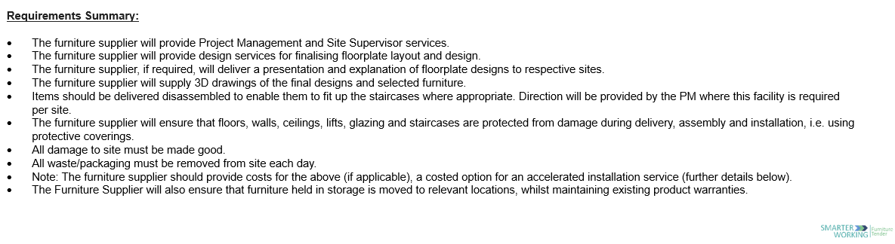

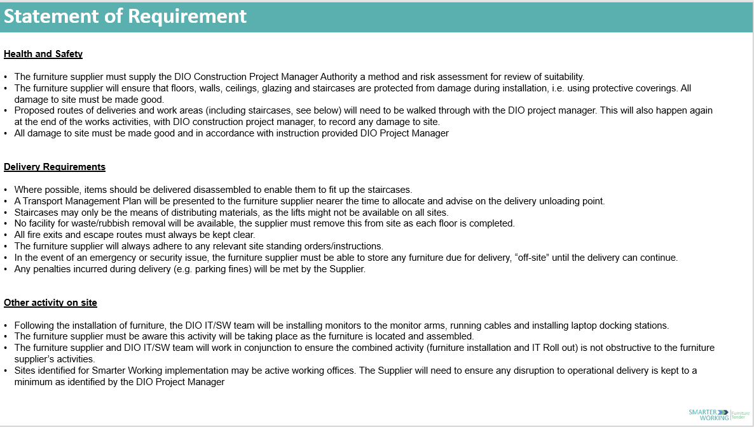

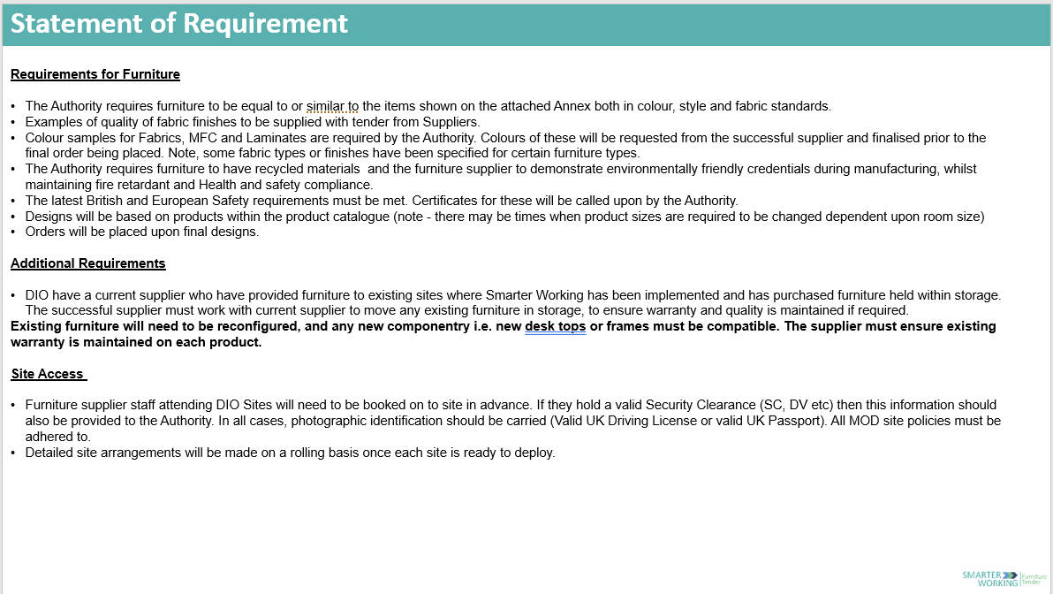

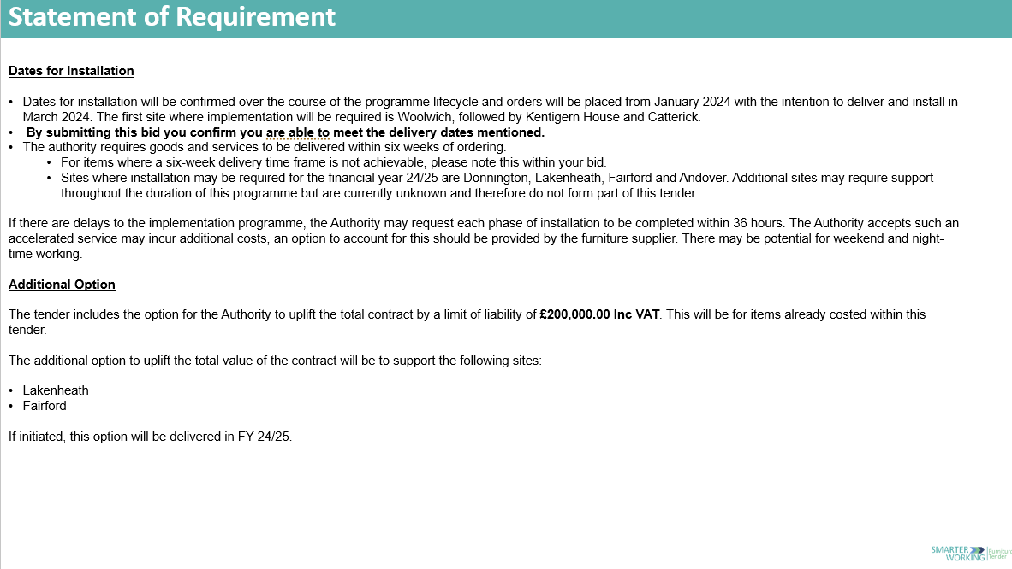

MAXIMUM LIABILITY

The limitation of liability for this Call-Off Contract is stated in Clause 11.2 of the Core Terms.

The Estimated Year 1 Charges used to calculate liability in the first Contract Year is£179,200 ex VAT.

CALL-OFF CHARGES

A further breakdown of costs is contained within;

**REDACTED**

**REDACTED**

REIMBURSABLE EXPENSES

None

PAYMENT METHOD

Payment will be made using MOD CP&F via Exostar

BUYER’S INVOICE ADDRESS:

**REDACTED**

**REDACTED**

**REDACTED**

Defence Infrastructure Organisation  
St George’s House  
Defence Infrastructure Organisation Head Office  
DMS Whittington  
Lichfield  
Staffordshire  
WS14 9PY

BUYER’S AUTHORISED REPRESENTATIVE

**REDACTED**

**REDACTED**

**REDACTED**

Kentigern House, 65 Brown Street, G2 8EX

BUYER’S ENVIRONMENTAL POLICY

Available online at: https://www.gov.uk/government/publications/jsp-418-mod-corporate-environmental-protection-manual

BUYER’S SECURITY POLICY

Available online at: https://www.gov.uk/government/publications/security-policy-framework

SUPPLIER’S AUTHORISED REPRESENTATIVE

**REDACTED**

**REDACTED**

**REDACTED**

**REDACTED**

SUPPLIER’S CONTRACT MANAGER

**REDACTED**

**REDACTED**

**REDACTED**

**REDACTED**

PROGRESS REPORT FREQUENCY

Not required

PROGRESS MEETING FREQUENCY

Quarterly on the first Working Day of each quarter, or if deemed necessary, within 10 working days of the authorities request.

KEY STAFF

N/A

KEY SUBCONTRACTOR(S)

Not applicable

COMMERCIALLY SENSITIVE INFORMATION

|  |  |  |  |
| --- | --- | --- | --- |
| Information considered confidential (include page/paragraph number) | Section of FOIA under which exemption is sought | Reason for exemption | Dates between which exemption is sought |
| All tender response | Commercial Interests | We believe the content of our response to be confidential – in that a competitor obtaining this information would have a level of knowledge of our business and our tender responses that would prejudice future procurement processes. | 20/11/2023 – 20/11/2033 |
| All pricing information | Commercial Interests | We believe the content of our response to be confidential – in that a competitor obtaining this information would have a level of knowledge of our pricing structure that would prejudice future procurement processes. | 20/11/2023 – 20/11/2033 |

SERVICE CREDITS

Not applicable

ADDITIONAL INSURANCES

Not applicable

GUARANTEE

Not applicable

SOCIAL VALUE COMMITMENT

Not applicable

|  |  |  |  |
| --- | --- | --- | --- |
| **For and on behalf of the Supplier:** | | **For and on behalf of the Buyer:** | |
| Signature: | **REDACTED** | Signature: | **REDACTED** |
| Name: | **REDACTED** | Name: | **REDACTED** |
| Role: | **REDACTED** | Role: | **REDACTED** |
| Date: | 21/12/2023 | Date: | 21/12/2023 |