

**Welcome to your Supplier Portal.**

Below is a step by step guide on Registering as a Prospective Supplier to the University of Derby

Once you have registed you will be able to view any live Request for Quotations or Tendering opportunities that are open. You will be able to respond to any questionnaires or messages we publish on the portal.

For open Tenders over £25k these will be advertised on Contracts Finder.

<https://www.gov.uk/contracts-finder>

Note: This does not mean you have become an Approved Supplier to the University. When the University wishes to place an order with you, we will contact you through the portal to request you provide your Bank details on the portal to enable us to raise Purchase Orders and make payments to you.

You can use the portal to:

* Update your details on-line
* View current quotations and tenders
* Send messages to the Procurement Team via the Portal using Social Messenger.

Suppliers should note our Oracle Cloud system contains some American terminology but we trust this user guide will provide assistance to you when completing your registration.

If you do require assistance, please email [Supplierqueries@derby.ac.uk](mailto:Supplierqueries@derby.ac.uk)

Simply click on each of the TABS below, or use the NEXT and BACK buttons to go to each of the TABS

The fields marked with a * are mandatory fields.

1. **Company Details**

Enter your Company name

Tax Organisation Type – There are several choices on the drop down box, select Corporation as highlighted below (if you are a Partnership, please select Partnership). If none of the choices from the drop down box are applicable, then please default to Corporation.

D.U.N.S number – If you have a D.U.N.S number then please enter this. If you do not have a D.U.N.S number, then please enter your Company number. This must be a nine digit number so please use Zeros in front to fill. For example if you Company Number is

03079282

Add an extra 0

003079282

If you are VAT registered, select the Tax Country from the drop down list. You can use the search to search for United Kingdom. Enter VAT registration number in the Tax Registration Number box. Please ensure you put the Country code in your VAT number e.g.

**GB12345678**

You can use the Attachments tab to upload any supporting information we may ask you to submit e.g. Insurance Certificates.

Enter your Contact Details

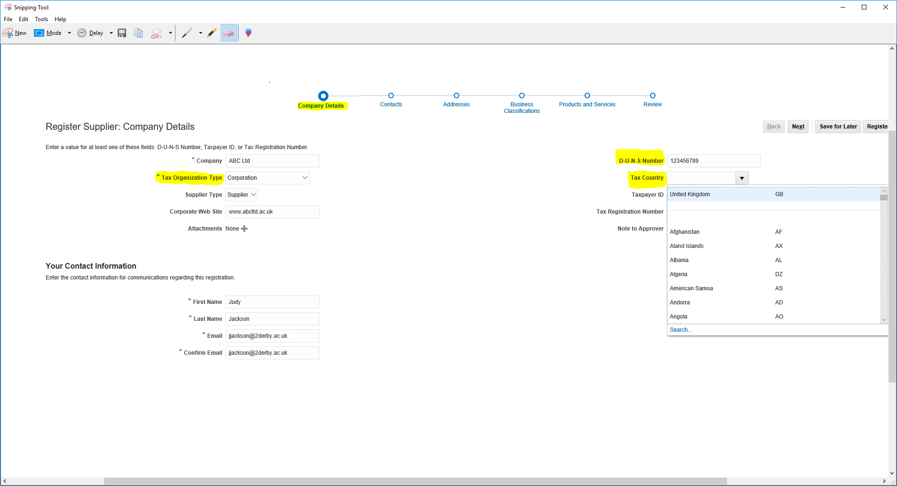

1. **Contact Details**

Click on the next Tab to go to the Contact details. You will note your contact details entered on the first Tab have been carried over to the Contact Tab.

To add additional Contacts click on the + Sign to Create a new Contact or the X sign to delete a Contact

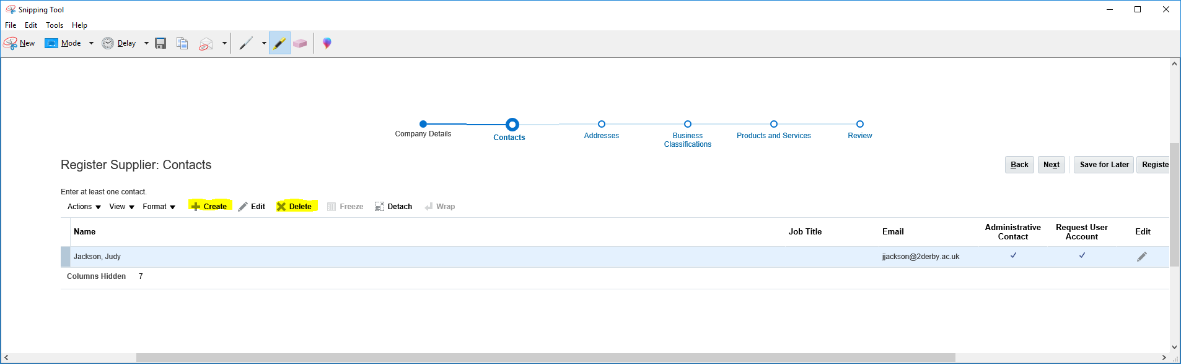

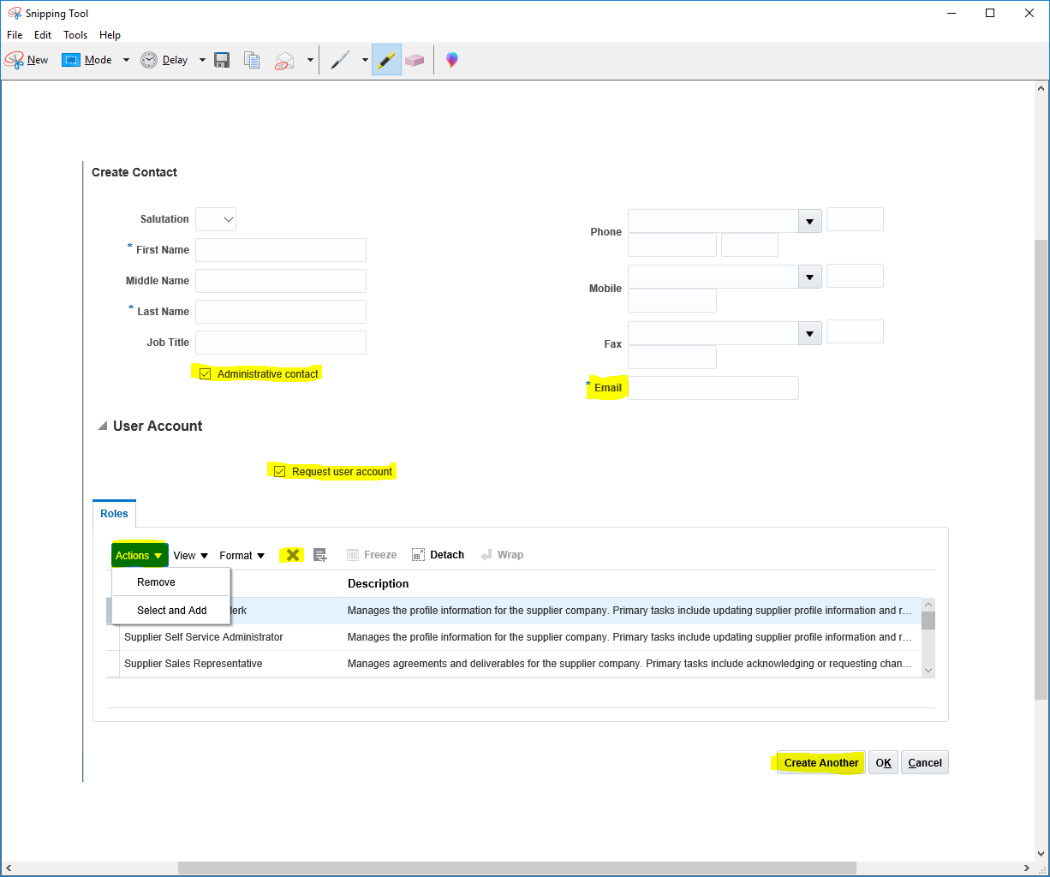

If you would like your contact to have a User Account, then ensure the Administrative and Request User Account boxes are ticked. Complete the contact details for each additional Contact you wish to create. By creating a User Account will mean your additional Contacts can access the data you have created in your Portal.

A list of roles will appear on the screen and if you click on Select and Add, you can select as many roles as you wish for a particular Contact, or you can remove the roles by clicking on the X . Each role has a description. Click on Create another to create an additional Account.

1. **Addresses**

Click on the Address Tab to create Addresses for your company. You can add as many addresses as you wish. Click on the + sign to Create

*The Address Name - you will note is mandatory. Please enter the city name in this field

For example if your address is in the city of Derby, enter **Derby** in this field.

IF you want to create another address which is based in the City of Manchester, then enter Manchester in this field.

You must always tick the Remit to box to enable Remittances to be sent electronically. You can also tick the Ordering and RFQ or Bidding boxes to enable Purchase Orders and Quotations to be sent to the Address created.

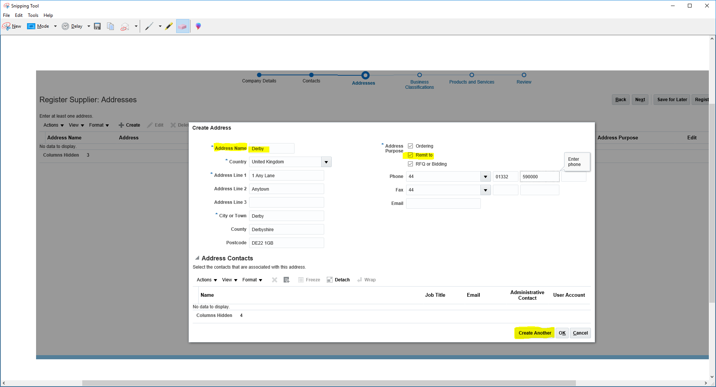

**Save for Later.** Although it only takes a few minutes to complete your registration, you may Save your record and complete the Registration later.

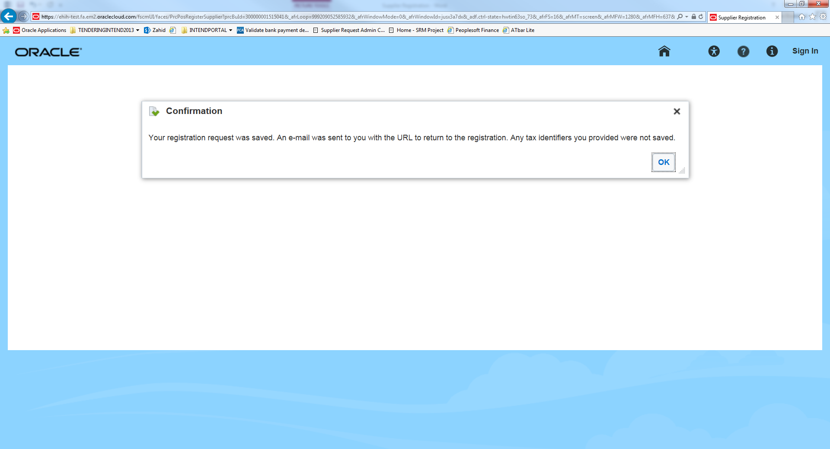

Suppliers will receive a notification email below.

Click on the Complete the Supplier Registration Request Link to complete the Registration.

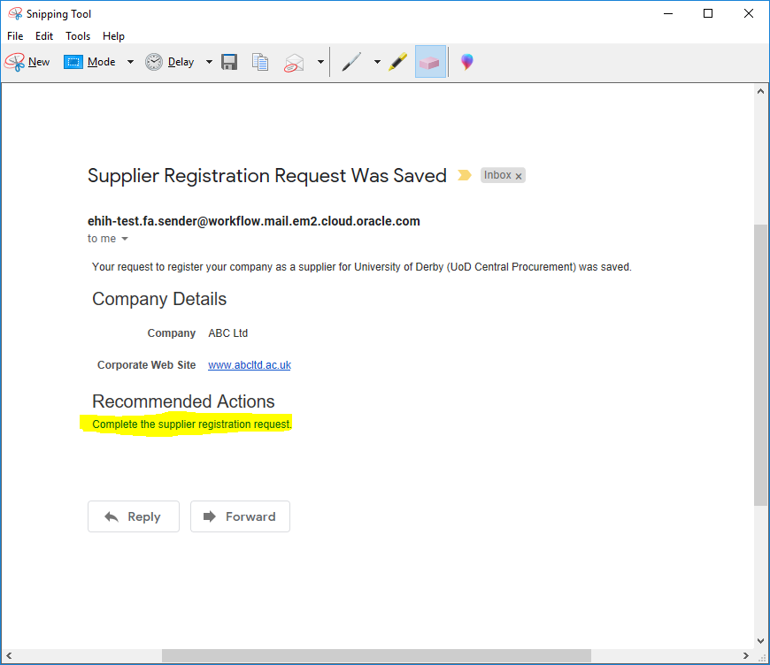

1. **Business Classification**

Click on the Business Classification to classify your Business based on choosing one of the Options below from the drop down box.

Click on the + sign to add your classification.

If none of the Classifications apply to your Business, then tick the

None of the classifications are applicable box

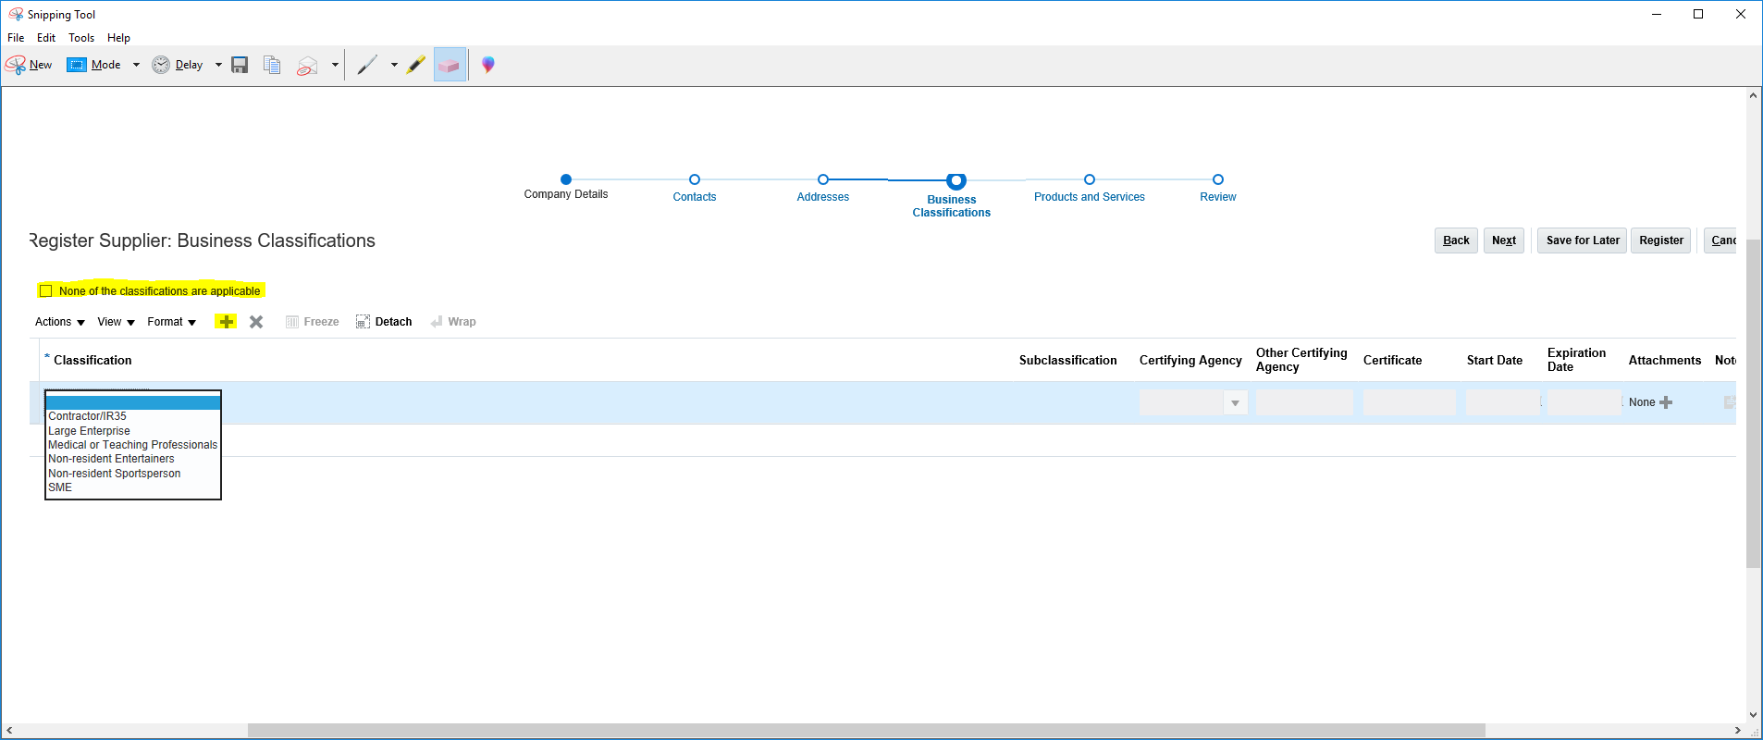

1. **Products & Services.**

Suppliers can select and add as many products and services as they choose to add to their profile. This will assist the Procurement team when sourcing Suppliers for Quotations and Tenders.

Click on the Select and Add button. A list of categories will be displayed. Tick as many categories as you can provide goods and services for.

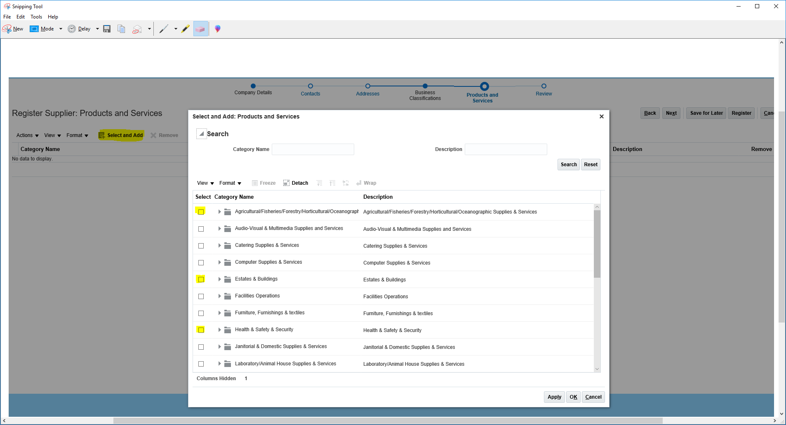

Press Apply and OK and the list of Categories will appear in your Company Profile.

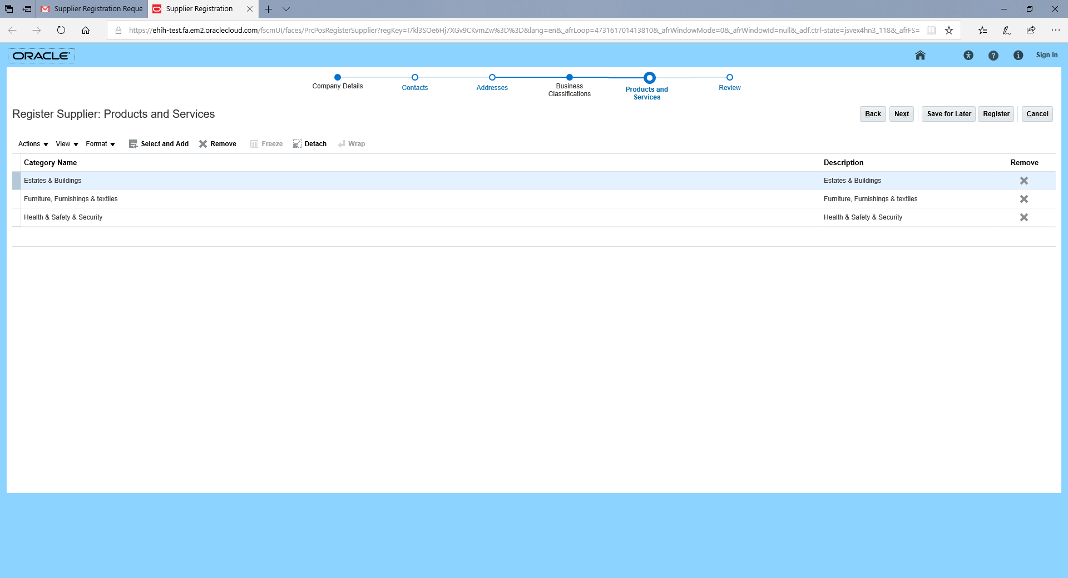

1. **Questionnaire**

Click on the Questionnaire Tab to complete the Equality in Higher Education Questionnaire.

**Suppliers will not be able to complete their registration unless the Questionnaire is completed.**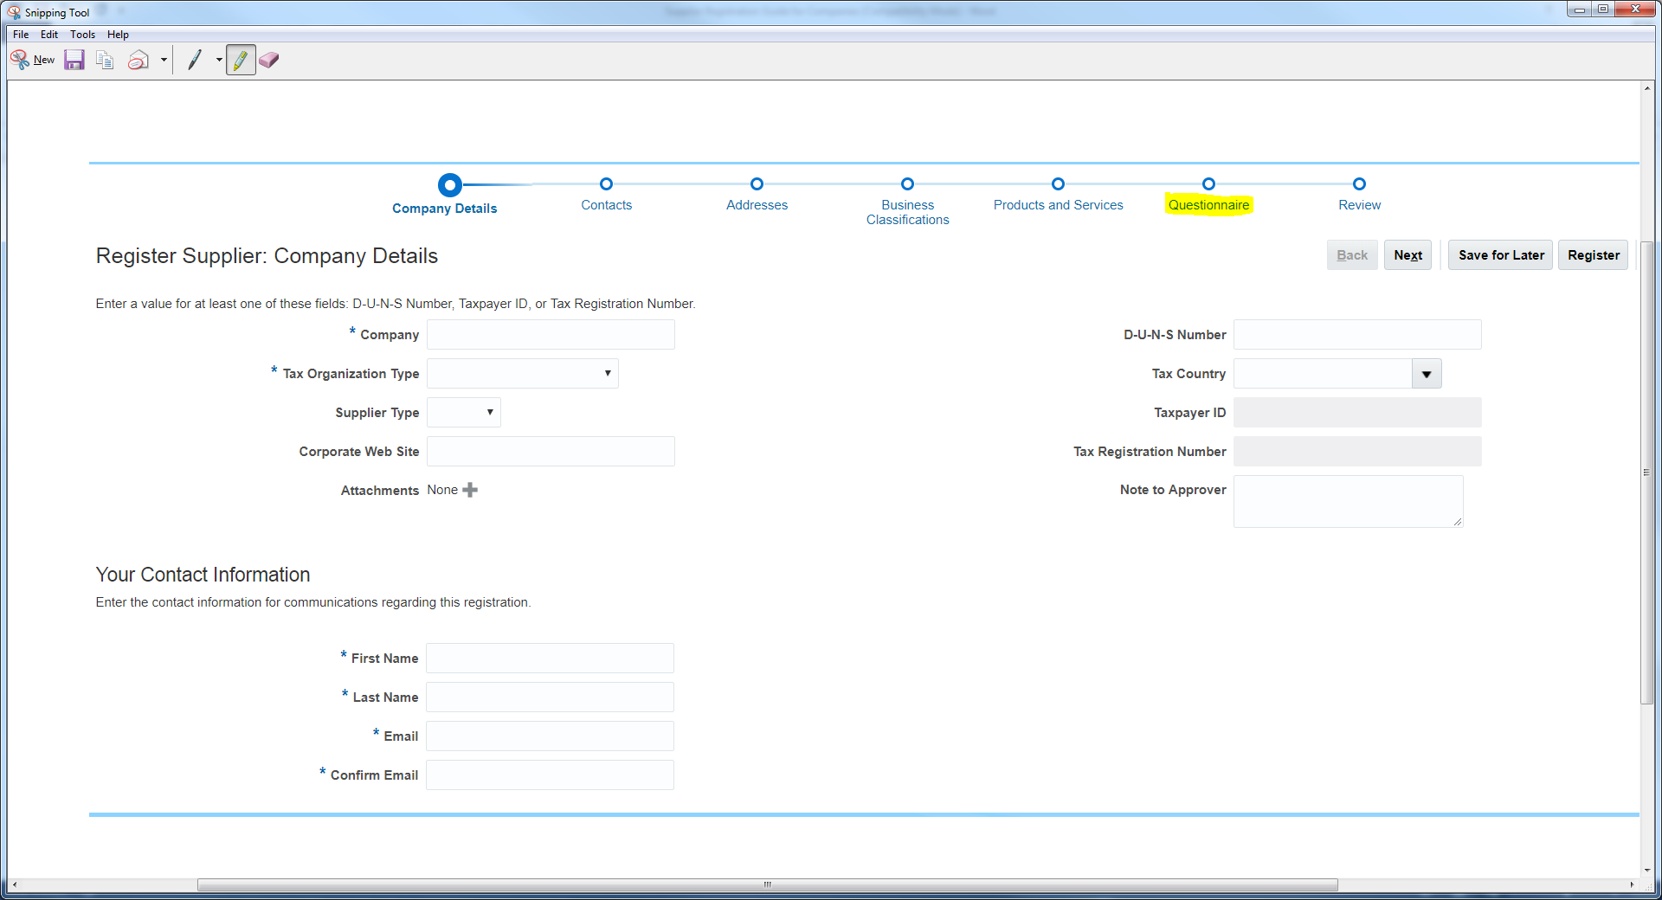

Please complete all the Sections of the Questionnaire by clicking on the drop-down box.

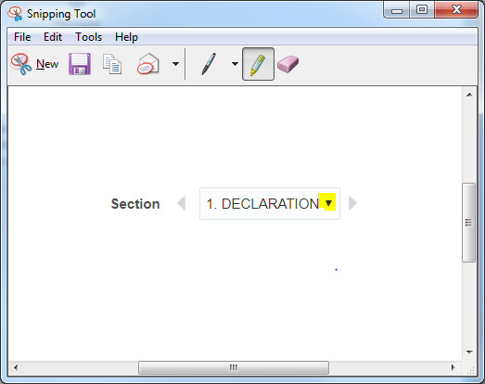

1. **Review**

Finally, Suppliers can review their details before submitting their Registration. Click on the Back or any of the Headings to review and edit their details.

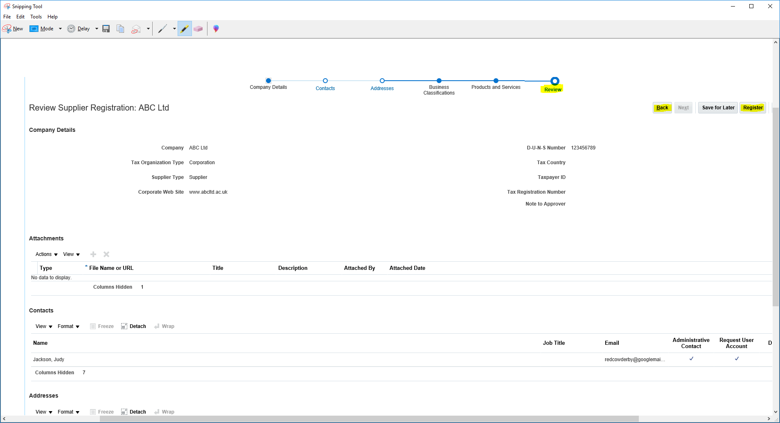

Click on the Register Tab to complete your registration. You will receive the following message.

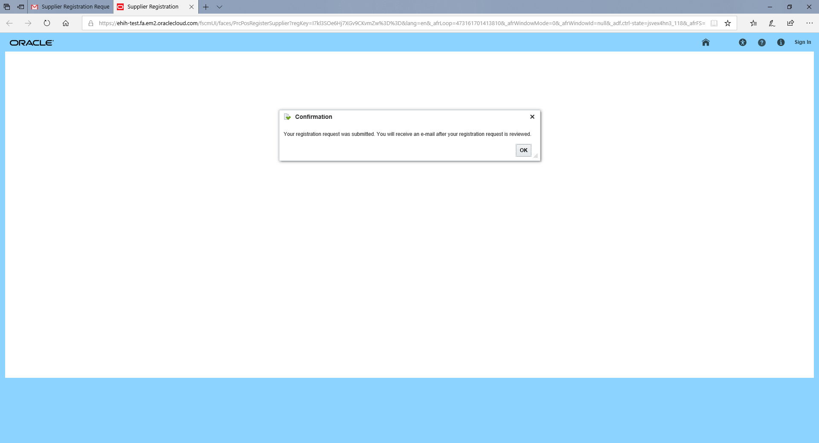

Your email notification will be:

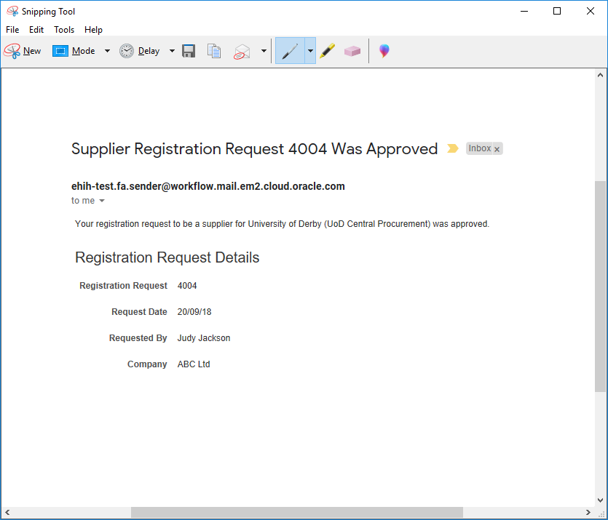

Suppliers will receive a separate email advising them of their log in details so that they can log back into the portal at any time.

Please note, this means you can only view current Quotations and Tenders at this stage.

If the University wishes to do business with you, you will receive a notification via the portal or a member of the Procurement team may contact you to request you log back into the portal to provide your bank details.

We are unable to request bank details at this stage of the registration due to the GDPR Regulations.

Queries: Please email your screens including screen shots where possible to [Supplierqueries@derby.ac.uk](mailto:Supplierqueries@derby.ac.uk)

Making changes to your Profile and using the Social Messenger Tool

Log into your portal using the URL address

<https://ehih.fa.em2.oraclecloud.com/homePage/faces/FuseWelcome>

If you have forgotten your Password, simply click on Forgot Password and you will receive instructions via email on how to reset your password.

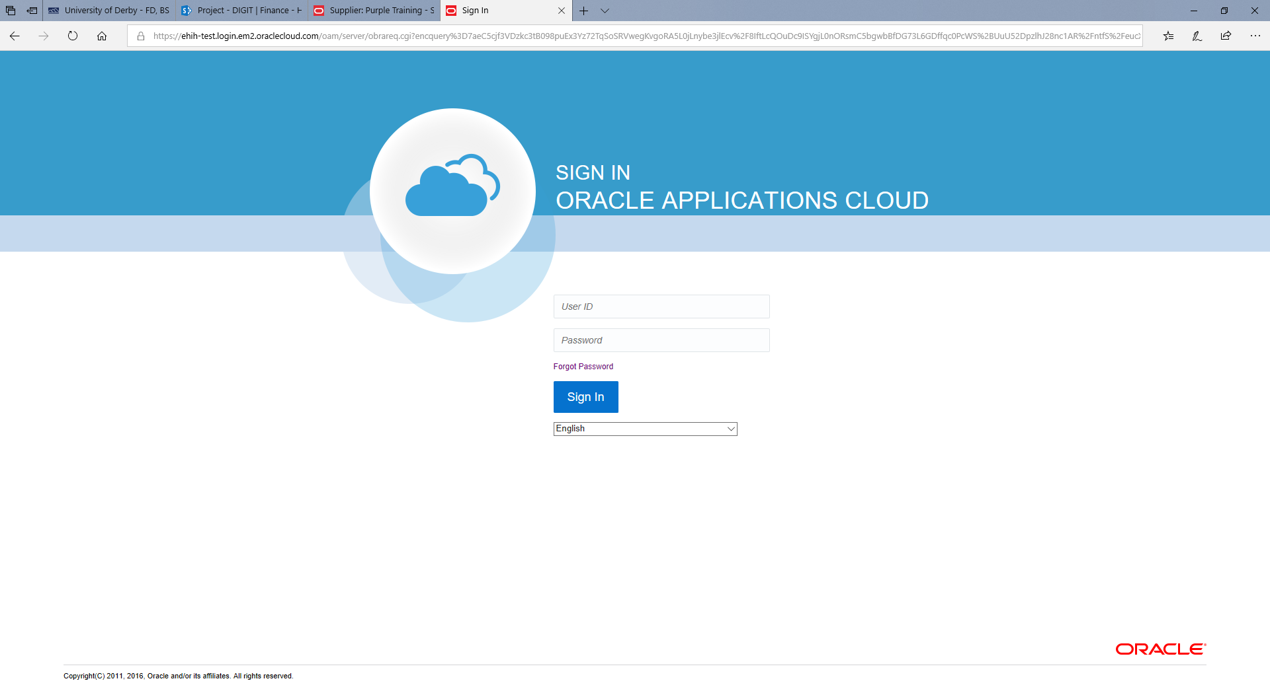

Your Opening Page will look like this.

Click on View Profile to see your current registration details.

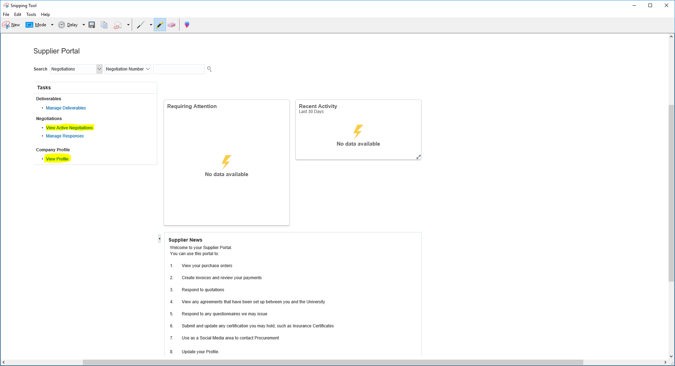

At this Stage of the Registration (i.e. because you are not yet an Approved Supplier to the University), you can only update your Profile and View current Quotations/Tenders and update your Profile.

View Active Negotiations to view current Quotations/Tenders

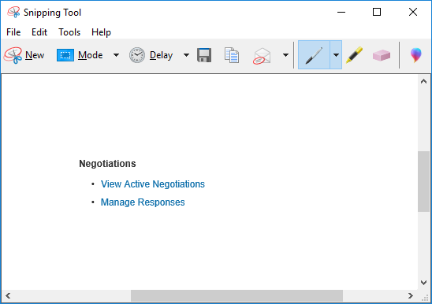

**Notifications & Messages**

Any Notifications or Messages that require your attention will be displayed in the Notifications Bell Icon

[Image result for picture of a bell](https://www.monash.edu/medicine/ccs/education/current-students/no-bell)

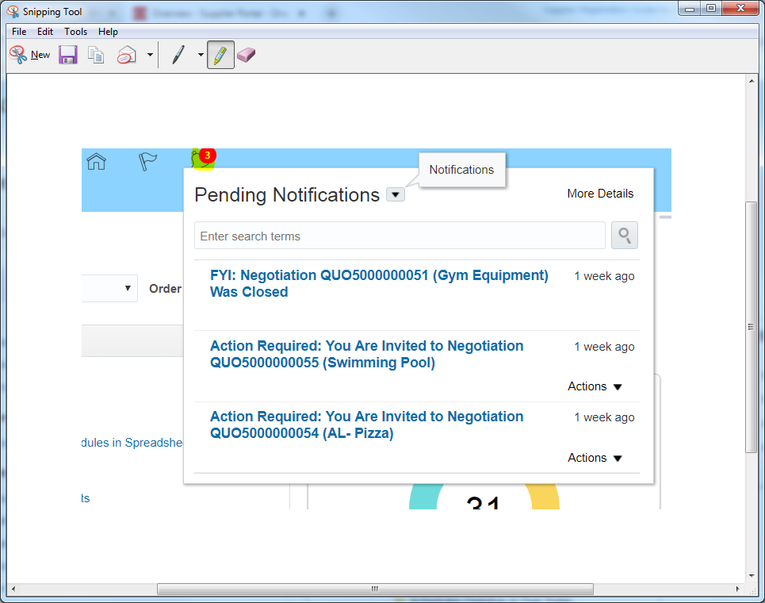

Click on the Message

You can also reply to the Message.



Any message you create will be retained in your Portal.

View and Update your Profile to view and update your details.

To make changes, simply use the + sign to add a new Address, Contract or Bank Account



Any updates you make to your record may be verified by a member of the Procurement Team who may contact you by telephone to verify the changes you have made.

If you do require assistance or have any queries, please email [supplierqueries@derby.ac.uk](mailto:supplierqueries@derby.ac.uk) with details of your query including a screen shot if possible.

We hope you find our self-service Portal useful and we look forward to doing business with you.

Procurement Team.





