Moss Side Farm
Peatland
Restoration
Works Foresters
Cadishead Island

Specification

1.1 Site Background information
Foresters field was formerly agricultural and is now being reconnected to Cadishead Moss.
A drainage diversion has separated this field into two sections, the west section next to Cadishead Moss is referred to as Cadishead Island and most of this contract is on that section.
There are a number of land drainage pipes within the area resulting in the drawdown of the perched water table within the peat.
Other previous land usage has left the wider peat mass fragmented, meaning controlling the hydrology, presents significant problems. It is hoped that the remedial works outlined in this document will help address these issues.

1.2 Contractor Experience
Contractors are invited to tender for this work, which will require not only skill and experience of this type of work but particularly on boggy, difficult to navigate peat soils. Successful Contractors must demonstrate knowledge of and have regard for the sensitive nature of wetland hydrology and ecology. It is not expected that this work will be sub-contracted out and must therefore be undertaken by the successful Contractor.

1.3 Nature of work
The work will include the following:
- The installation of 692m of deep trench bunding on Cadishead Island
- The installation of 278m of deep trench bunding on Foresters Field
- Installation of water control pipes x 6
- Installation of 30m of mammal pass under track with 500mm pipe
- Peat inversion 0.6 ha

2.0 Contact Information
Project Manager
Chris Evans 07979 873504 christopher.evans@naturalengland.org.uk

3.0 Access
The site can be reached via access points off Astley Road (west off Liverpool Rd B5320 in Irlam). This road is in a dilapidated state but is wide enough and stable enough to allow access for large machinery. Each field can be accessed directly from this road.
Access to the site beyond the road is only on foot and by vehicles that are specially adapted to driving on peatland i.e. low ground pressure vehicles.
The centre of the site can be found at SJ 70096 95303.
A google maps pin for the car park area and gateway to field https://maps.app.goo.gl/QdwEV2fJzZ78ifvP8

4.0 Project Management
- Day-to-day management and supervision of all machines and operatives will be the responsibility of the Contractor.
- The Contractor will be required to liaise weekly with Natural England (NE) during the project and provide progress reports when required.

5.0 General Principles

5.1 Prevention of enrichment/pollution of the sites
It is vital to the management of the site that there is no nutrient enrichment or spillage of chemicals, of any kind, onto the site. The Contractor shall meet high environmental standards by providing (and using) spill kits for all equipment and using bio-fuels and bio-lubricants in all machines where possible.

5.2 Method of works
Due to the difficulty of transporting any weight around on the peat surface, the work will need to be planned such that access and/or movement of material is done solely on foot or by low ground pressure plant/vehicles.

5.3 Peat/mineral interface
The Contractor must be careful to avoid disturbing the peat/sand or peat/clay interface at all costs. Therefore, great care needs to be taken when excavating/scraping/moving any peat whilst creating the bunds. The client will need to be informed immediately of any occasion where the underlying mineral surface is accidentally exposed. At the north end of the area the peat depths are much shallower and bunding works are expected to encounter the underlaying clay. In areas with limited peat availability clay can be used to form the bunds.

6.0 Works to be carried out

6.1 Creation of deep trench bunds

6.1.1 Background
Bunding techniques for peatland restoration have developed over time and these works reflect current best practice for lowland raised bog restoration. Deep trench bunds will benefit the site by blocking the subsurface water movement.

6.1.2 Bunding required.
692m of bunding within the Cadishead moss / forester reconnection area to form sub-surface peat walls.
278m of extra bunding to form sub-surface peat walls within the forester is required to block internal drainage pipes discovered in phase 1 works.
This will be achieved by digging to a depth of approx. 2m, turning over the peat and compacting this in place. This compaction is essential for sealing any pipes, cracks or voids in the peat and stopping water leaking.
The surface bunds’ main purpose is to slow the movement of surface water and provide some above ground water storage, which will further counter the effects of drier months.
The top bund must be made with wet putty peat and in line with the trench bunding underneath. It should be no more than 0.5m high and 1m wide at the base. It is then covered with loose vegetation, stripped from the surface when excavating the deep trench bund line.
To achieve the correct method of installation, this technique allows for a number of preliminary inspection digs to determine the required depth of the trench. Once determined, the installation must dig below the water loss depth and ensure good peat is compacted in the trench to seal against water loss. The bunds need to be constructed to at least 0.5m in height and 1m in width on level ground. However, ground levels within the field vary, so in higher areas the top level of the bund can be graded to ground level so that the bund is only a visible above ground in low lying areas.
The extra peat needed for building the bunds will be won by digging a series of shallow scrapes no deeper than 0.5m. Extra borrow pit locations will be discussed on site with NE staff through arrangement with the project manager.
No peat is to be won from within 2 metres of any bund feature or bund construction site. This is to ensure that the newly constructed bunds are not subjected to extra pressure from water pooling.

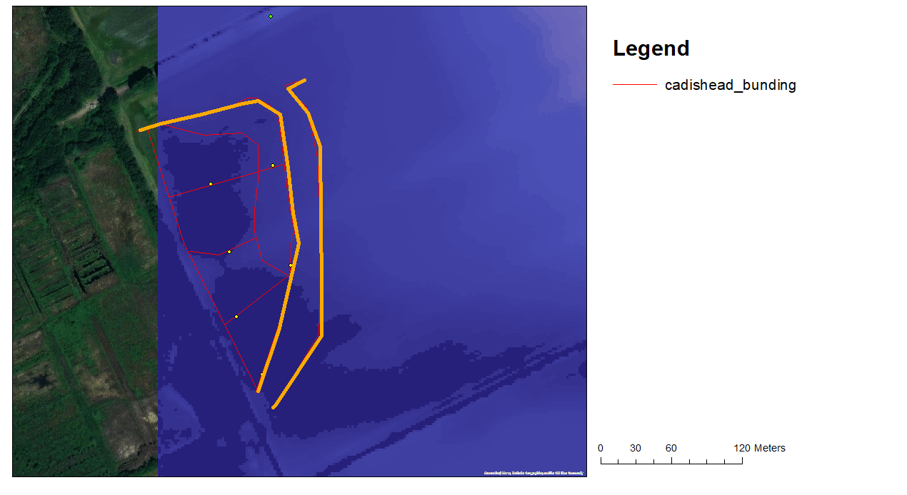
existing bund

Peat inversion

Mammal pass

Water control

Figure 1 Re-wetting plan Cadishead Island.
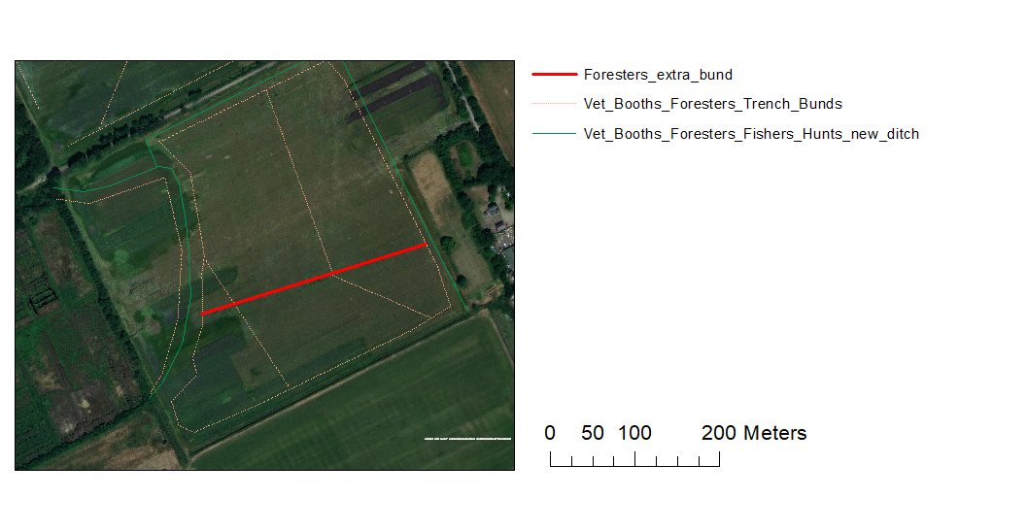
Figure 2 Re-wetting plan Foresters, red line shows new bund needed to block internal drainage pipes

6.2 Installation of Water Control Pipes and culverts

6.2.1 Background
The creation of a bunding network will result in water pooling in the ‘borrow pits’ where peat is won to build those bunds. Pooled water exerts higher hydraulic pressures on surrounding peat. Without any means of re-distributing this water and lowering that pressure, the bunds may suffer leakage, erosion caused by over-topping, wave action or a combination - compromising their structural integrity and ultimately resulting in their failure.

6.2.2 Control pipes required
Installation of 150mm diameter overflow pipes will be employed to maintain a degree of control of the site’s hydrology. Pipes will be fitted with an adjustable right angle ‘elbow’ piece, which can be adjusted dependent on the expected levels of rainfall. Pipes will be made of durable plastic and installed at appropriate locations that will be decided on site between land managers and contractors to ensure the most effective positioning.
A further 30m of 500mm pipe will be installed under the main access track to connect the local ditch network to the new ditch to allow water vole movement / recolonisation across the ditch network within our reserve.

6.3 Soil burying and surface microtopographic forming.

6.3.1 Background
The presence of a soil layer on top of the peat is a significant obstacle to the restoration of lowland raised bog peat converted to farmland in the 1800s. This “night soil” and modified peat layer is restricted to the depth of historical ploughing, so tends to be between 50-60cm deep on chat moss but can be shallower in areas of pastureland (10-30cm). To restore an area of this type of farmed peatland directly back to bog, all the nutrients and lime within the night soil need to be removed to expose acidic nutrient poor peat to provide the correct conditions for sphagnum and cotton grass to grow.

6.3.2 Soil burying and surface microtopographic forming.
Inversion of the top 1.5 m of peat and night soil, to bury night soil below a layer of wet, nutrient poor & acid peat. The wet peat at the surface will then be compacted to form microtopographic pools across the surface in two areas covering 0.6ha in total. The peat invention will be done by excavator working in retreat, with the peat mass excavated, and then inverted into a trench, then the back of the bucket used to compress the peat and sculpt the pools on the surface, the process will then be repeated to fill the newly cut trench (see fig 3). This will be done over the entirety of the 2 areas highlighted in fig1. The areas will then be enclosed by a deep trench bund to cut any drainage pipes flowing in or out of the area (note this is included as part of the overall bunding total). The result will be a mosaic of wet peat and bog pools ready for the establishment of bog habitat.
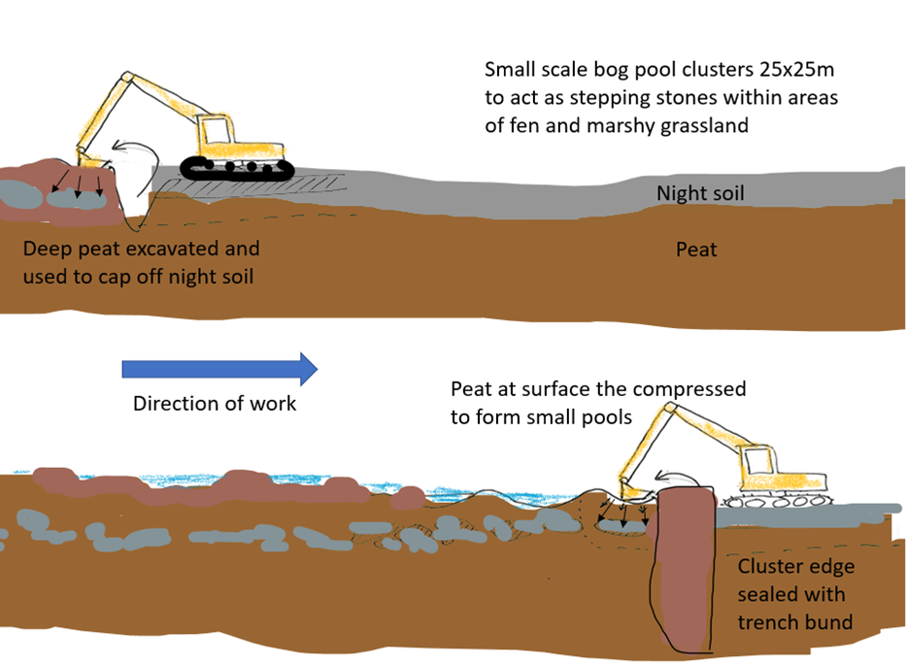
Fig 3. Envisioned working method Night soil burying and surface microtopographic forming

7.0 General work requirements
- All operatives will hold current, relevant certification for all machinery and the contractor will have appropriate public liability insurance cover. All certification, public liability insurance documents and a Health and Safety policy statement must be presented with the tender documents.
- All operators will be experienced of working on wet peatland sites undertaking restoration work of a similar kind.
- The contractor shall provide all equipment, all fuel and maintain all equipment required for the completion of the project, including all appropriate PPE.
- The contractor will be responsible for all first-aid within the contract work force, and a practising first-aider with current certification will be present at all times. The contractor will provide appropriate first aid equipment. Lone working will not take place under any circumstances. Welfare facilities can be provided at the close by Moss Side Farm if required.

7.1 Health and Safety
- A high-pressure gas pipeline runs through and adjacent to two fields.
- A permissive footpath runs to the north and west of the site. We can restrict public access when required for these works.
- The successful contractor will be expected to provide appropriate Risk Assessments and Method Statements.
- A Construction Phase Plan will be required with reference to welfare provided to operatives.
- Toilet facilities including warm water and a rest area can be made available at Moss Side Farm.
- Storage of plant can be provided at Moss Side Farm or parked in the field.

8. Water Voles
Water voles have been recorded in the area historically. Operatives need to be mindful of the potential of voles in or close to drains. NE will undertake a survey before works begin and discuss mitigation measures with the contractor if required.

9. Timescale
The work is expected to be completed by end-January 2024.

APPENDIX 1

PRELIMINARIES / GENERAL CONDITIONS
The successful contractor will:
Produce written risk assessments and method statements on all areas of operations.
Allow for production of Construction Phase Plan prior to the start of the works.
Maintain security, safety and protection of the site and works in accordance with HSE guidance and this specification.

Quantities
ITEM | DESCRIPTION | QTY | UNIT OF WORK
1.1 | The installation of deep trench bunding | 692 | metres
1.2 | Installation of mammal pass under track with 500mm pipe | 30 | metres
1.3 | Installation of water control pipes | 6 | each
1.4 | Peat inversion | 0.6 | ha

B

