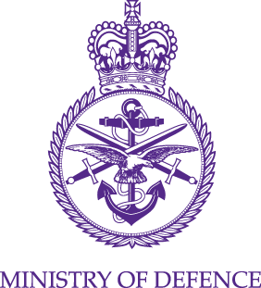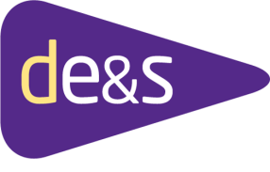

STATEMENT OF TECHNICAL REQUIREMENTS
(SoTR)
Provision and In-Service Support of Inflatable Craft for Navy Command Head Quarters (NCHQ)
Lot 1

Statement of Technical Requirements – Project Overview
- Vision Statement
- Background
- Key System Requirements
- Operational Context
- Through Life Support
- Overview of Logistic/In-Service Support Requirement
- Guide to the Statement of Technical Requirements
Vision Statement for Lots 1 & 2
“One Solution for all Capabilities”
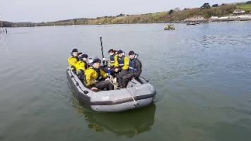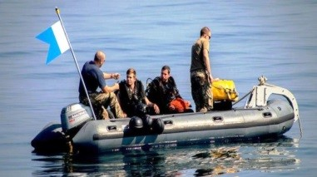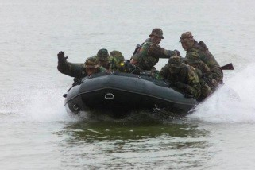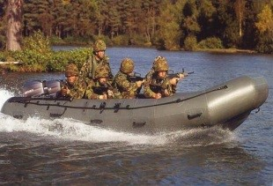

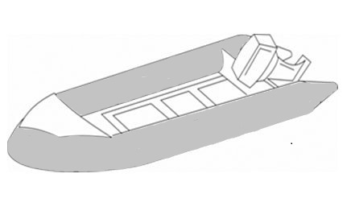
?

- Background

  - The Authority has a requirement to update its current fleet of inflatable craft being used by RFA, Navy, Army and Special Forces with a single solution. The current fleet of inflatable craft have previously been commercial off the shelf (COTS), with unique modifications made to satisfy requirements and fulfil capability.

  - The Authority is not seeking to replace the current in-service Outboard Motor (OBM) engines (Mariner 30HP twin engines and Mariner 50HP single engine).

  - The current classes of boats have been in-service for over twenty years, depending on class, and have exceeded their Out of Service Date (OSD) and are becoming increasingly more expensive to maintain as a result of obsolescent equipment.

  - The craft to be replaced include:

    - The General Purpose Workboat (GP) operated by Land, Navy, Dive Groups and Royal Fleet Auxiliary units.

    - The Explosive Ordinance Disposal (EOD) and Mine Clearance Measure (MCM) operated by RN Dive Units and Mine Counter Measure Vessels (MCMV).

    - The Inshore Raiding Craft (IRC) operated by Navy (Royal Marines (RM), Dive/MCMV and Special Forces).

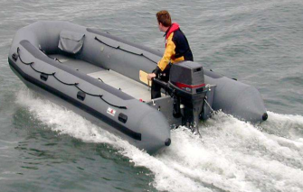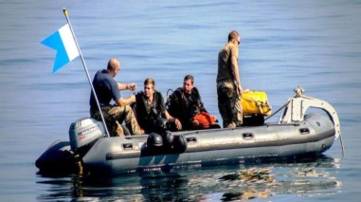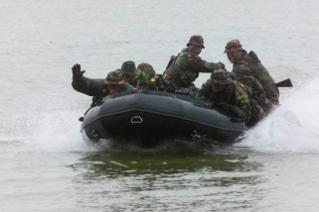
Current General Purpose Current EOD (Showing the current Current IRC
in-service Fairlead over the bow)

  - The Authority is envisaging one solution to replace all of the current in-service variants of inflatable craft with modifications for each capability (i.e. different deck choices/ colour choice/ method of inflation etc.) for Lot 1 and Lot 2. However, due to contract constraints, each lot will be marked separately.

  - The Authority requires a flexible, supportable and cost effective fleet of inflatable craft for the delivery of these specialised support roles. The Inflatable Craft project offers the opportunity to consider these requirements concurrently and deliver a capability that maximises commonality of equipment, which is expected to deliver a significantly lower support effort, maximise cost effectiveness and to rationalise the number of boat classes.

  - The Inflatable Craft project aims to introduce a new boat class of COTS design, with differing modifications between the IRC, GP and the EOD. It is anticipated that this will reduce the training requirement as personnel are trained on one class of boat and it will reduce the logistic support requirement as the equipment being supported is common across the whole class. To achieve flexibility in the delivery of the specialist operational roles, the deck and internal arrangements of the Inflatable Craft are to be configurable to meet the requirements of the operational role being undertaken. All Inflatable Craft shall be fully compliant with the Maritime and Coastguard Agency (MCA) Workboat Code of Practice for Category C Operations.

  - Each Inflatable Craft will be expected to be in service with the Ministry of Defence for a minimum of 7 years. However due to the nature of how these craft are operated, replenishment of stock to maintain The Authority’s Capability Allowance List will be needed to replace Craft that are deemed Beyond Economical Repair (BER).

  - Navy Command Head Quarters (NCHQ) is funding Lot 1 of the project and also represents the user communities. The Craft will be used in various operations and tasks including mine clearance, transport of equipment and personnel, training, dive support, autonomous insertion and extraction from over the horizon and discreet powered surveillance and reconnaissance in the riverine and littoral environments

  - The project’s aim is to introduce a fleet of 100x GP Craft, 55x EOD Craft and 130x IRC over a maximum four year period, as well as the replenishment of stock to maintain The Authority’s Capability Allowance List will be needed to replace Craft that are deemed BER.

  - Basic training in the operation and maintenance of the delivered craft will be required for the user community.

  - Further design changes may be carried out during the life of the craft through separate post design services (PDS) tasks.

- Key User Requirements

  - The following Key User Requirements (KUR) have been identified by the User to be critical to the Inflatable Craft project being able to deliver its Operational Capability. The term “Supporting Equipment” is referencing the OBMs, fuel bags and any other ancillary equipment such as paddles and inflatable bladders.

ID | Description
KUR 1 SoTR ID GP4.1 | The Craft and supporting equipment shall be capable of being delivered to a predetermined location via nominated Strategic Naval assets including but not limited to Mine Counter Measures Vessels (MCMV), Type 23 Frigates, Type 26 Frigates, Type 45 Destroyers, Landing Platform Dock (LPD), Landing Platform Helicopter (LPH), Queen Elizabeth Class (QEC) Aircraft Carrier, River Class Offshore Patrol Vessel (RCOPV), Royal Fleet Auxiliary (RFA) and Special Detachment (SD) Vessels.
KUR 2 SoTR ID GP1.14 | The Craft shall be sufficiently robust to ensure it can undertake the specified tasks. (Designed and built to be sufficiently robust to withstand wear and tear associated with use in areas of high likelihood of river obstacles, stony outcrops and reefs.)
KUR 3 SoTR ID RC2.4 | The IRC shall be capable of being Inflated during a Mission in under 2 minutes. (Not General Purpose or EOD)
KUR 4 SoTR ID RC2.1 | The IRC shall be capable of being collapsed to allow it to be used / cached / transported (Including keel).  (Controlled inflation / deflation of all areas from easily accessible valves. Control valve to provide positive indication of setting acquired. Each inflatable compartment should be able to be isolated independently from each other using in-service 10 Ltr air bottles. Once inflated there should be no loss of pressure).
KUR 5 SoTR ID GP3.8 & RC4.1 | The Craft shall be capable of delivering crew members complete with full operational load to locations identified within the Concept of Employment. (For Divers, crew of 6 plus all operational equipment. For RM, 2 Crew (Coxon plus 1) plus either 4 passengers with full field kit (Webbing, Rifle and enhanced bergen) or 6 passengers with light order kit (webbing rifle and day sack)).
KUR 6 SoTR ID GP3.8 | The Craft shall be capable of carrying heavy loads at planing speeds in accordance with ISO6185.
KUR 7 SoTR ID RC4.9 | The Raiding Craft shall have ability to conduct a patrol at varying speeds a steady state (medium) speed and extract from contact by acceleration to a high speed using in-service Mariner 50HP single engine. (Objective top speed of 30kts in 2mtr Wave height and up to Force 6 winds).  (Not GP or EOD)
KUR 8 SoTR ID GP3.7 | The Craft shall be able to safely transport passengers using anti-skid flooring, grab straps/hand hold in appropriate positions on the collar/tube.

  - The User has core needs that are required to be met by all variants of the Inflatable Craft. These are in 4 key areas;

    - Safe – The craft is safe to use at point of use: To comply with authority safety requirements as laid down in DSA02; the document can be read on the Naval Ship Assurance Support Service (NSASS) website. The standards used for any new equipment must be equivalent to those required by statute. The craft shall be designed, built and certified as fully compliant with the Maritime & Coastguard Agency Workboat Code of Practice for operation in Category C inshore coastal waters (up to 2 Nm from a Safe Haven) and compliant with Passenger Ship Rules.

    - Reliable – The Inflatable craft shall be designed and built to minimise the meantime between failures of components and equipment.

    - Available – The Inflatable craft shall be designed, built and maintained to maximise the time that the craft is available in order to deliver the required operational capability.

    - Supportable – The Inflatable craft shall be designed and built such that it can be effectively, efficiently and affordably supported by the User and Industry throughout its design life through the replenishment of spares.

- Operational Context

  - The Inflatable craft will be operating in a wide variety of environments. Inflatable craft that are embarked on Royal Navy and Royal Fleet Auxiliary Ships will be operating globally from the Arctic/Antarctic regions to the Equatorial and Tropics. The Craft has to equally be capable of operating in the temperate climate of the United Kingdom and Northern Europe.

  - The Craft will be operating in a wide variety of waters from Estuarial through the Littoral out to inshore coastal waters up to wind force 6 and significant wave heights up to and including 2 metres may be experienced.

General Purpose Craft

The Large General Purpose variant of the Inflatable craft will be operating from Royal Navy (RN) and Royal Fleet Auxiliary (RFA) ships for the transfer of equipment and stores from ship-to-ship and ship-to-shore in support of operations and disaster relief. Items to be transferred could include palletised stores.

Explosive Ordinance Disposal and Mine Counter Measure Craft:

Operating from UK Naval Bases (Helensburgh, Portsmouth and Plymouth), and also Sandown Class Mine Hunter ships operating around the globe.

Inshore Raiding Craft

The Inshore Raiding Craft variant is currently used by the Army, Royal Marines and MOD A Block (MAB) as a combat boat used in various roles such as reconnaissance, diving, patrol and assault, as well as other operations. The EOD/MCM teams also use the boat as a light weight alternative to the current GP Workboat for training purposes.

  - The craft will be operated from platforms that will include, but not limited to:

- Forward Operating Base (FOB) & Fleet Maintenance Base (FMB);
- Queen Elizabeth Class (QEC);
- Type 23;
- Type 26;
- Type 45;
- Type 31;
- LPD & LPH;
- RFA/SD vessels;
- Smaller Patrol Boat Platforms

  - The craft will also be delivered from land assets including in-service prime movers and 4wd vehicles. There is also a requirement to air deliver the craft via the Multi-Mission Parachute (MMP) system but this will not be proven until after the craft have been delivered to meet initial operating capability.

- Through Life Support Management

  - The proposed craft will have simple Low Level maintenance carried out by the user such as replacement of valves and small puncture repairs (usually tears up to 7cm), with no specialist tools required. Codified replacement parts and spares will be managed and ordered though the maritime inventory system CRISP.

  - The Contractor shall manage the provision of spares throughout the life of the contract. Details of support will be documented in the Through Life Management Plan (TLMP) submitted as part of a simple Integrated Project Management Plan (IPMP).

  - This is a 5 year contract which includes in-service support with 2 optional 1 year extension to the contract.

  - The in-service support for the craft and associated ancillaries will consist of the following:

    - Low Level Maintenance undertaken by the user, making use of spares provided through the inventory management system. Specialist tools are not to be required to repair equipment.

    - High Level Maintenance tasks are undertaken at the Contractor’s premises and involve Unplanned Reactive Repairs involving surveying all craft returned to stores as Repairable Stock and submitting quotes to The Authority on a case by case situation.

    - Initial Spares Provision – The successful bidder shall provide an initial provision of spares which will be codified during the initial phase of the contract. The initial provision of spares is to support the craft for 12 months after the delivery for the user.

    - Through Life Spares – The successful Contractor shall provide a complete list of spares for the duration of the contract. There will be replenishment of spares once they fall below a level determined by the Contractor.

    - Post Design Services – The successful Contractor will be required to undertake PDS tasks within the life of the contract. Labour costs will need to be provided by the tenderer as part of the application.

    - Configuration Control – The successful bidder shall manage the configuration of equipment manufactured into the craft and spares provision. This will require obsolescence management through equipment update and upgrade throughout the life of the contract.

    - Operational Documentation Management – The successful bidder shall be responsible for the periodic update of the documentation associated with the proposed equipment, such as the craft Book of Reference (BR), Operating Handbooks and support information such as the Command Safety Executive Summary (CSES).

    - Safety Documentation Management – The successful bidder shall be responsible for the creation and periodic update of the Safety and Environmental Case Report and initial Hazard Identification upon delivery of the first Craft.

  - For the detailed requirement for the logistic / in-service support requirement for the craft, please see the SoTR and integrated project management plan (IPMP) support documentation.

- Overview of Logistic/In-Service Support Requirement

  - The Logistic/In-service Support for all Inflatable Craft shall be provided by the successful Contractor for a period from acceptance of the first Inflatable Craft until two years after the acceptance of the final Inflatable Craft, as separately tasked under the Contract by the Authority.

  - The logistic/In-Service support for the Inflatable Craft will be broken down into two strands:

    - Low Level Maintenance (carried out by the User) – For Inflatable Craft that are embarked on ships and units, the Low Level Maintenance (LLM) is undertaken by the Users with spares provided by the successful Contractor via Naval Stores.

    - Unplanned Reactive Repairs – The successful Contractor shall undertake all unplanned reactive survey and repair (High Level Maintenance) of craft returned to stores as repairable stock at their own premises.

- Guide to the Statement of Technical Requirement – Schedule 2 to the Terms and Conditions

  - The SoTR contains the Authority’s requirements for design and manufacture of the proposed solution and in-service support requirements for maintaining the equipment availability, documentation and training requirements.

  - Schedule 2 is set out in a number of Sections in a tabular format:-

    - Requirements applicable to the Raiding Craft variant which are a combination of statute, good practice and user specific requirements;

    - Requirements applicable to the Large General Purpose variant which are a combination of statute, good practice and user specific requirements;

    - Specific Operational Role Requirements applicable to the Large Explosive Ordnance Disposal;

    - Safety, Information and Documentation Requirement;

    - Training Requirement;

    - Logistic and In-Service Support Requirement

  - The detailed requirements for the craft are set out in the Statement of Technical Requirements (SoTR).

  - The SoTR has various headings. The description of which is given below

  - SoTR Section: Sub-sections as detailed above.

    - SOR ID number: Defines the numerical number for the individual Requirement;

    - Title: Brief Description of the Requirement;

    - Requirement: Defines the individual system Requirement or constraint.

    - Performance Parameters:

      - Threshold / Minimum: Defines the essential level of performance required.

      - Objective / Maximum: Defines a level of performance that is unnecessary to exceed.

  - Performance Measurement: The Authority’s proposed method(s) of demonstration, post Contract award, that the Requirement is satisfied or complied with.

  - Priority: Identifies the importance of the requirement. There are 4 (four) relative priorities identified below;

    - M (Mandatory): A Requirement, generally a User constraint, designated as such for legal or safety reasons and which may not be traded. Mandatory requirements represent legal obligations and must be met.

    - K (Key): A requirement which should drive design and / or cost and which may require innovation or technology update (with the associated risk) to achieve the aim. A key requirement may not be traded without re-endorsement by the approving authorities.

    - Priority 1: A high priority requirement that may drive design and / or cost and which may tolerate acceptable levels of risk to achieve the aim. Priority 1 requirements are essential, but subject to technical capability and affordability.

    - Priority 2: A medium priority requirement that may drive design and / or cost. Priority 2 requirements are not essential but should be met if possible.

  - Supplementary Information: Additional information or comments to amplify the requirement where necessary.

  - Confirmation of Compliance Column: Confirmation that the Tenderers proposed solution is compliant with the individual requirement.

  - Statement of Compliance: Detailed description of how the Tenderers proposed solution meets the individual Requirement with references but is not limited to the Technical Specification and Drawings etc as supporting evidence.

