Profiled metal sheet roof with curved edge cladding detail.
Environment Agency Seaford Depot, Marine Parade, Seaford, BN25 2QR

This is a section of a commissioned consultancy report

Roof Description

The existing roof is pitched with corrugated profiled sheet covering with curved sheets feeding directly to wall cladding. The roof has GRP roof lights to both pitches of the roof. The roof has a ridge apex capping sheet with matching verge edge trim details. The roof has no visible rainwater gutters and appears to allow water runoff from the ridge apex down over the wall cladding onto the surface. The surface water is collected by linear drainage which surrounds the structure.

Observations:

Overall, the roof is in poor condition. The roofing sheets have lichen growth evident to all areas. There are several sheets that have the beginnings of surface corrosion, with cut edge noted to the area of the sheets which adjoin to the curved cladding. The curved edge cladding also shows signs of heavy corrosion will leaking noted internally due to this. The fixing caps are beginning to rust in isolated areas across the entire roof.

The GRP roof lights are also in fair condition. The roof lights show signs of UV degradation and soiling. A decision to re-use existing or replace should be considered upon further inspection.

Roof leaks were evident in various locations internally with staining to the underside of the roof and to the floor.
We have also enclosed a schedule of photographs identifying the principal defects noted during our inspection.

We require:
– replacement of the affected areas of existing roof covering. The advantage of this option allows the roof to be recovered without removing it in its entirety. As severe corrosion affects the edge of the cladding and the curved cladding to which they adjoin consideration into only replacing these areas could be beneficial and cost effective as the internal leaks are only noted below these areas.

.

The existing purlins supporting the roof structure internally appeared in fair condition with isolated purlins suffering from the beginnings of surface corrosion and require cleaning off and rust proof paint applied.

Photographic Schedule

Photo  No | Photograph Description | Photograph
 | General Condition Photographs
1. | General aerial view of profiled metal sheet roof. | 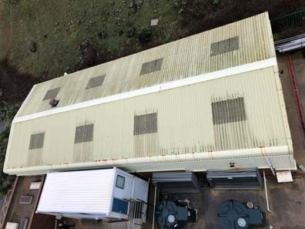
2. | Severe cut edge corrosion noted to north facing roof pitch. | 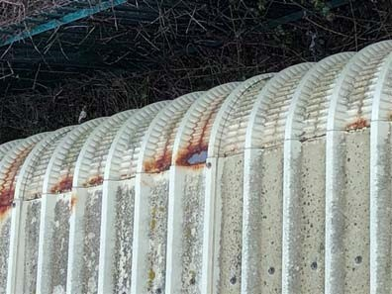
3. | Severe cut edge corrosion noted to north facing roof pitch. | 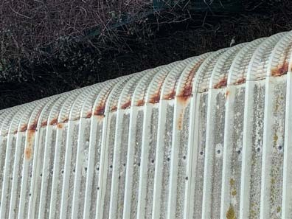
Photo  No | Photograph Description | Photograph
4. | Severe cut edge corrosion noted to north facing roof pitch. | 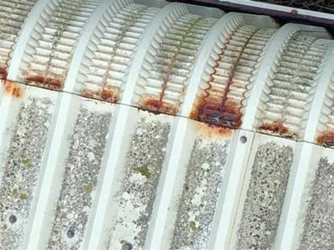
5. | Severe cut edge corrosion noted to north facing roof pitch. | 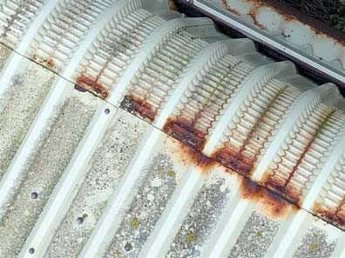
6. | Typical example of surface corrosion noted to isolated areas of profiled metal roof sheets. | 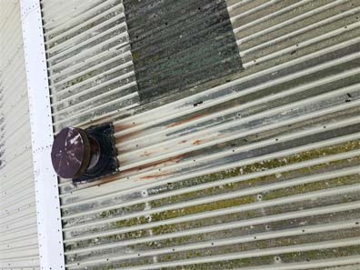

Photo  No | Photograph Description | Photograph
7. | Severe cut edge corrosion noted to south facing roof pitch. | 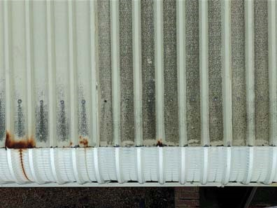
8. | Severe cut edge corrosion noted to south facing roof pitch. | 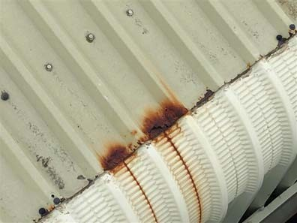
9. | Severe cut edge corrosion noted to south facing roof pitch. | 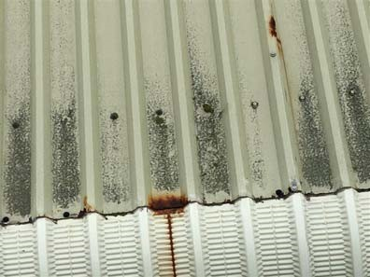
Photo  No | Photograph Description | Photograph
10. | Internal view of temporary patch repairs to north facing leaking cladding. | 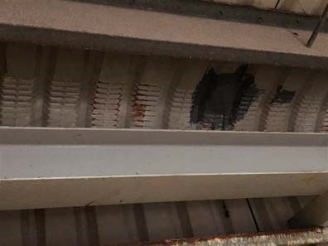
11. | Internal view of temporary patch repairs to north facing leaking cladding. | 