E-mail: procurementgroup@os.uk
Date: 17th December 2018

Dear Sir/Madam
REQUEST FOR INFORMATION (RFI) – ROAD ROUTING DATA
Ordnance Survey Ltd is a company registered in England and Wales (company registration number 09121572) whose registered address is at Explorer House, Adanac Drive, SOUTHAMPTON, SO16 0AS, UK (OS). OS is a limited company in which the entire share capital is owned by the Department for Business, Energy & Industrial Strategy (BEIS).
OS is the national mapping agency of Britain and is responsible for the surveying, production, maintenance, and marketing of a wide range of geographic information, relied on by government, business, and individuals. Further information can be found on our website: http://www.os.uk
This RFI sets out OS’ requirements for the provision of road routing features data and seeks to discover from potential suppliers what the market characteristics are, how requirements may be fulfilled and other specific information as specified in Appendix B. In order to respond to this RFI, please complete the response sections at Appendix B and return a copy, alongside any relevant documentation you wish to include, to procurementgroup@os.uk by no later than 17:00 on 11th January 2019.
Background
OS collects and maintains geographic information which underpins the production of some of the most detailed and frequently updated mapping in the world. In order to collect change to update and maintain our databases and products, intelligence on new or amended features is essential. OS is looking at further improving intelligence sources for road routing features. Intelligence referring to these features is essential for the update and maintenance of OS products.
Please do not hesitate to contact me if you have any questions concerning this project; thank you in advance for your support with this project.
Yours faithfully
Alex Bassett, Supplier Relationship Manager
For and on behalf of Ordnance Survey Limited

APPENDIX A DRAFT SPECIFICATION

Scope and Specification
Reliable intelligence is loaded in to OS databases to be edited by a variety of methods, including, ground surveying and desk-based editing. The data is edited and validated using a GIS (Geographic Information System) solution.
OS currently has a commitment to update all known change to specific features within 6 months. Some sites such as new major roads are dealt with differently and have to be delivered when they are opened. Intelligence is received from various sources to make a mosaic of information that can then be loaded in to a work management database in a geospatial format.
Jobs are then made available to appropriate work areas such as Remote Sensing (capture of data from aerial imagery) or Ground Surveying (capturing features and data on the ground).
Once the data is edited and validated it is then added back in to the main database where it can then be created in to one of OS’ many products
OS are looking for a supplier to deliver intelligence regarding routing restrictions to roads. Preferably across all of Great Britain. The intelligence should include new and amended restrictions. OS believes that this will lead to operational efficiencies and enhance the currency and quality of OS products.
OS specification includes the list below.
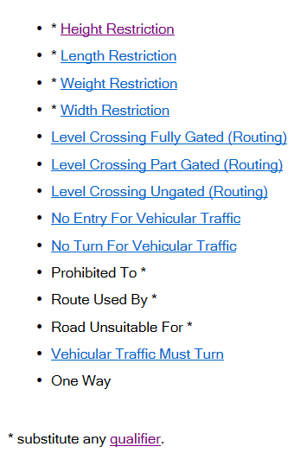
The data can be supplied in a non-spatial format. OS must be able to extract a location from the data supplied. Supply in non-spatial format should be supplied by MS Excel
Or
The data is supplied in a geographic format so that it can be loaded in to the work management database. Supply in geographic format via Shapefile or gdb
As a minimum the data supplied should contain the following;
Description of restriction | Street name | Postcode and/or x and y co-ordinates of restriction | Any other relevant connecting roads affected | Local Authority responsibility | Status Type (Proposed or Actioned) | Date of Capture or change

To qualify for further consideration, a participant’s proposal must:
Respond to all other requirements within the eventual tender, including the submission of ‘sample’ data in accordance with Annexe A Supply of Sample Data. The sample supplied will be validated by comparing the information with existing features within our data and ground visits to the restriction information supplied to validate the accuracy of the restriction description, location and any other additional information provided such as photographs.

APPENDIX B REQUEST FOR INFORMATION
There are a number of factors concerning our requirements, which require a better understanding of marketplace capability, before a tender can be published.

- We require provision of GB-wide coverage for road routing features data. However, it is recognised that potential suppliers may not cover the entirety of the required scope (e.g. England and Wales only, or Scotland only). Please provide details of your capability to provide GB-wide coverage, or alternatively any information regarding potential joint bids or sub-contracting arrangement that you would consider?
Response:

- We’re currently proposing to tender for a multi-year contract, upon which an all-inclusive fixed annual charge would apply. Please provide confirmation that this pricing structure would be feasible, or should it not be deemed feasible, please provide reasonings and details of alternative pricing model/s that you would propose.
Response:

- OS’ usage of the data road routing features data is for both commercial and non-commercial purposes, therefore:

- all intellectual property furnished or made available to the Supplier belong to OS absolutely; or
- Prepared by or for the supplier or its Personnel in the course of or in connection with the Contract are hereby assigned to and shall vest in OS absolutely (and the Supplier agrees to execute and do all such documents, acts and things as required by OS to enable such rights to vest in OS).

Please provide details of what arrangements you have in place to appropriate the provision of data to us.
Response:

