Uppingham Town Council
Tender Document – Tod’s Piece Play Area
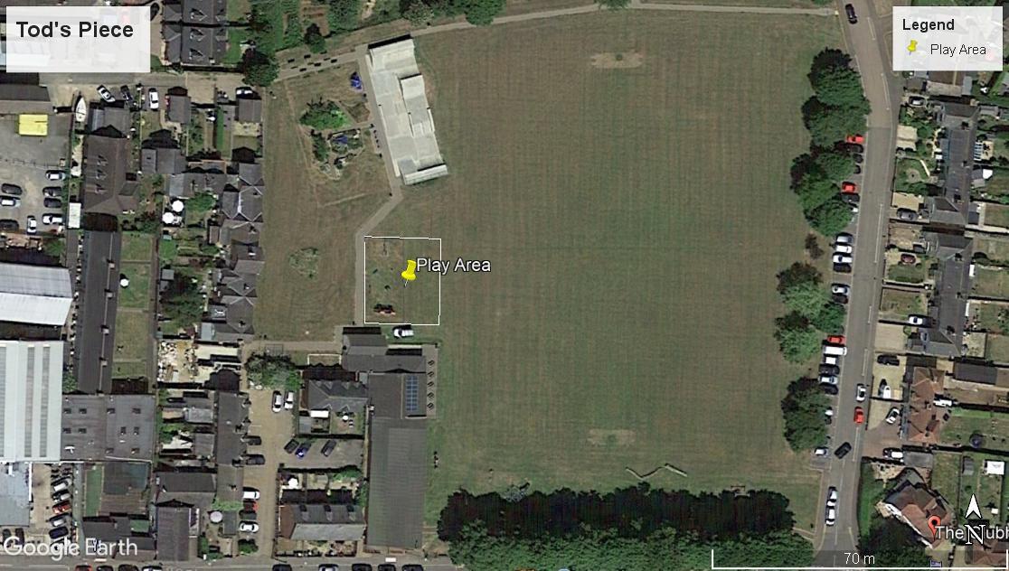
Provision to design and build a play area at Tod’s Piece
- General Requirements
Uppingham Town Council is seeking a suitably qualified company to design and build a play area to replace the existing facility at Tod’s Piece, which is detailed within this document. The budget is £65,000.00 (ex VAT).
The location of the site is North Street East, Uppingham, LE15 9QJ. There will be an opportunity for a site meeting with the named consultant, or suppliers can visit at their own convenience.
Following the formal review of submissions, and a public consultation of the preferred design which may result in some revisions, the aim is to place an order by mid-April 2019.
- Prices
All pricing should be exclusive of VAT and valid for 90 days from the due date of the response.
Prices will be fixed and firm for the duration of the contract.

- Non-Consideration of a Tender Response
The council has the right to refuse any or all submissions without tenderers being able to claim any compensation. All costs associated with the tender process and response is the responsibility of the suppliers that have been invited to participate.
The council may refuse a tender response if there has been any attempt to vary or alter the details within the document, or is not able to provide all the information required by the council to make a full evaluation.
Any offence or inappropriate actions by the supplier, including an offence under the Prevention of Corruption Act or the supplier directly canvasses any member of the council concerning the tender other than “appropriate” contact made to the individuals named within this document for the purposes of clarifying the requirements or raising any questions pertaining to the tender.
- Contract Conditions
The successful contractor will enter into a contract by way of a Purchase Order and Agreement (signed by both parties) with Uppingham Town Council with agreed terms and conditions.
The work is for the design, supply and installation of play equipment, surfacing, fencing and associated works which must all comply to current European Safety Standards mainly BS EN 1176 and BS EN 1177.
The successful contractor must provide evidence of Public Liability Insurance of no less than £5 Million and Employers Liability Insurance to the council within the tender response.
Confirmation of work hours, storage of materials, access to site, location of skips and a final Programme of Works and RAMS will need to be finalised and provided to the named consultant before work begins, most likely at the “Pre-Start” meeting, along with a Construction Phase Plan.
During installation, the contractors needs to keep public and maintenance access points clear of equipment and provide suitable HERAS fencing and safety notices around the construction site.
On completion of the project, any area that has been damaged during the installation such as the turf, surrounding pathways, existing play equipment and fencing (other than those being disposed of) must be returned to the original condition at the contractor’s expense. Reinstatement of the grassed area immediately around the play area must be new turf and topsoil.
- Overview of Project
Uppingham Town Council has set aside a budget of £65,000.00 to redevelop the play area at Tod’s Piece. The current fenced area will be extended to a proposed area of 17m x 20m as shown on the Google Map above (White outline). The area is for younger children (0-7 years of age) as there is a separate junior/teenage space outside of the fenced area.
The junior/teenage area will be subject to an addendum within this tender for additional play equipment and surfacing to compliment what is already installed. (no scoring of the addendum will apply as this will be used for budgeting and concepts only).
Materials
The council is open to a combination of materials, so both wood and/or steel material can be used, however maintenance still being a consideration will be scored accordingly. Any wooden posts will require steel feet where possible, and colours should be more muted than bright.
Removals
All existing play equipment within the current fenced area, along with the fence and gates will be removed and disposed off site in a suitable waste disposal facility. All spoil is to be removed off site.
Fencing
A new 1.0-metre-high bow top steel fence will be required around the perimeter (17x20m) with two self-closing pedestrian gates (colours to be determined if a palette of standard colours can be included in the proposal).
Furniture
The design needs to incorporate new benches with back rests and a new Picnic Table. A new bin and play sign will also be required (specifications to be advised).

Play Equipment
Overall the design and choice of play equipment will be up to the supplier, however the items and suggestions which should be included are:
- Toddler Seat Swings (2 seats)
- Multi Play Unit (suitable for up to 7 years of age)
- Climbing and/or Balance equipment
- Basket Swing
- Spinning item – dish roundabout or spinner
- Individual Play Panels
- Space for free play
Surfacing
Bonded (Jungle) Mulch to be used with a contrasting colour for a pathway between gates (colour palette to be provided). However, where wear is likely, under items such as the swings and spinning items, please use wetpour. The surfacing will cover the entire footprint within the fence and should have an organic look and feel rather than straight lines and corners, to make it fun and softer for the children, with a consideration for maintenance.
Both types of surfacing must be laid over a suitable MOT stone base, with confirmation of thickness and type of base, and type of edging (if applicable).
Post Installation Inspection
Please allow for a RPII inspection following the completion of the project, and any noted defects or medium to high risk reports need to be attended to and resolved before the open date noted on the table below.
- Addendum
The council is looking for a quotation and design for added play equipment and surfacing for the Junior and Teenage area of Tod’s Piece. No scoring will occur (and no set budget) other than to understand the costs and possibilities to add play value for older children, other than what is already in situ. This may result in a separate tender, or as a revision to the winning supplier for the main contract. Some ideas include:
- New Multi-Unit
- Dynamic/Rotating item
- Any other ideas that may suit the area and age group
- New surfacing to match what is being used in the 0-7 play area which and new surfacing under some of the existing play items where suitable

- Time Table for Project
Action: | Date:
Tender Site Meeting – date and time to be confirmed – or suppliers can visit at their own convenience | Week commencing 25th February
Final date for any clarification or questions on tender | 8th March
Tender Response Due (submissions after this time and date will not be considered) | 15th March – 13:00 pm
Final Design and Revisions (based on consultation of preferred design) | Early April
Award Date (Purchase Order) | Mid-April
Expected Start Date | Mid-June
Expected Completion Date including snagging and inspection report | Late July

8. Scoring Table
The table below will be used to score all the submissions in order to short list the responses to a preferred supplier.
Item | Detail | Score
Overall Design | Meeting the brief, design layout, aesthetics of equipment and surfacing, varied challenge and suitability for different ages of stated age range | 50%
Quality of Materials | Materials used, expected longevity, steel feet used, fixings and other considerations | 20%
Warranties | What is covered in the warranty, length of warranty for each type of material. Please refer to Warranty Table for consistency | 10%
Presentation | Quotation information, quality of the visuals, general information included and format of response | 10%
Discretionary | May include (but not limited to): Negative - credit report, evidence of operational or quality issues. Positive – additional inclusions or extras not requested however seen as a benefit | 10%

- Warranty Table (please complete in this format)
Material | Warranty in Years | Exclusions or Conditions of Warranty (Concise Point Form)
Wooden Posts, Panels and Platforms
Steel Posts and Components
HPL or HDPE panels
Bearings, Chains and Moving Parts
Surfacing and associated works

- Scoring Calculation

8-10 | Superior | Exceptional demonstration of the relevant ability, understanding, experience, skills, resources & quality measures required to meet the projects aims or requirement. Response highly relevant with comparable contract value.
6-8 | Good | A comprehensive response submitted in terms of detail and relevance and clearly meets most of the project aims or requirement with no negative indications or inconsistencies.
4-6 | Adequate | Reasonable achievement of the requirements specified in the tender offer & presentation for that criterion. Some errors, risks, weaknesses or omissions, which can be corrected/overcome with minimum effort.
2-4 | Below Expectations | Minimal achievement of the requirements specified in the tender offer & presentation for that criterion. Several errors, risks, weaknesses or omissions, which are possible, but difficult to correct/overcome and make acceptable.
0-2 | Poor to deficient | Limited response provided, or a response that is inadequate, substantially irrelevant, inaccurate or misleading

- Reference Sites
Please provide two suitable references that ideally are of similar value and requirements for this project. Please use the format below for each reference and no longer than 3 years since installation:
Name of Council/Client
Contact Name
Contact Telephone
Contact Email
Location of Installation
Value of Project
Description of Project
Date of Installation

- Format for Response
Please provide a hard copy to the council as follows:
- 1 x A1 with a single view for any 3D visuals (or closest size possible)
- 1 x A1 of a scaled CAD drawing (or closest size possible)
- 1 x A4 hard copy of any supporting material, such as the quotation
- DO NOT show any children or adults within the visuals.
- 1 x Signed copy of the form below
Additionally, send an email ONLY to Michael Carter by the due date – electronic responses are not to be sent to the council.
The items should be clearly marked “Tender Response – to be opened only by nominated council staff”
Parish Council Address for delivery:
Uppingham Town Council
49 High Street East
Uppingham
OAKHAM
LE15 9PY
Attention: Neil Wedge –Clerk to the Council

Dear Councillors and Clerk to the Council,
Tod’s Piece – Play Area Development
We have examined the site and the proposed works and hereby tender to execute and complete the works required and described in the specification incorporating all preliminaries and materials and workmanship requirements and the requirements of health and safety.

Such works to be subject to the conditions of the contract and to the entire satisfaction of the Employer and to be completed for the under mentioned sums.

£………………………….

£………………………………………………………………………………… (in words).

We understand that you are not bound to accept the lowest or any tender or quotation that you may receive and that tenders received after the time given for receipt will be disregarded.

We agree that this tender will remain open for consideration for 90 calendar days after the dated fixed for receipt of this tender.

Company…………………………………….………………………………

Address………………………………………………………………………

………………………………………………..………………………………

………………………………………………..………………………………

Signature………………………………………………. Date…………………………….

Position of Signatory………………………………………………………………………

Contact telephone number of signatory…………………………………………………

- Contact for Tender
Uppingham Town Council is using an independent consultant for all aspects of the Pre-Sales process (and Project Management) who will be the primary contact for this tender and installation.
Any questions relating to the tender and organising the time for a site visit should be directed to:
Michael Carter
Sports and Play Consulting Limited
07421 463099
michael@sportsandplayconsulting.co.uk

