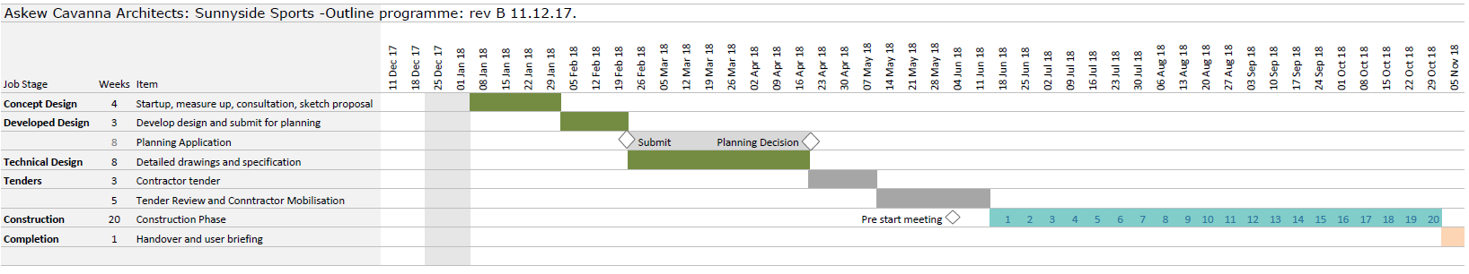**Appendix 2: Sunnyside Project Timeline**