Service Specification
Bromley IRIS Service 01/02/24 to 31/01/27

Service | Bromley IRIS Service (Identification & Referral to Improve Safety)
Commissioner Lead | South East London Integrated Care Board (Bromley)– Head of Safeguarding and Designated Nurse Safeguarding Adults (Bromley)
Provider Lead | To be determined.
Period | 01/02/24 to 31/01/27

- Scope
The Crime and Disorder Act 1998 places a statutory requirement on local authorities to monitor the level of Domestic Abuse (DA) in their communities and establish partnerships in order to reduce the problem as well as work together with other agencies to highlight the issue and coordinate a response.
The Domestic Abuse Act 2021 Statutory Guidance indicates that:
- Domestic Abuse is a high harm, high volume crime that remains largely hidden. The Crime Survey for England and Wales (CSEW)4 for the year ending March 2020 estimated that 2.3 million adults aged 16 to 74 had experienced domestic abuse in the previous year. 5 Childhood Local Data on Risks and Needs estimated that, between 2019 and 2020, approximately 1 in 15 children under the age of 17 live in households where a parent is a victim of domestic abuse.
- Findings from the Pathfinder Project highlighted that health professionals feel better able to enquire about domestic abuse if their Integrated Care System and primary care networks supported the placement of Independent Domestic Violence Advisors (IDVAs) or other accredited domestic abuse peer advocacy programme. These specialised trauma-informed services might then be best placed to follow up with any disclosures of abuse; a greater understanding of local referral pathways; specialist recovery and peer advocacy services to which they can refer or signpost victims, survivors or perpetrators dependent upon their unique situation.
- Health services should be encouraged and supported to set up robust partnerships with local domestic abuse specialist services and build referral pathways that are clear and easily accessible, to ensure staff feel confident to respond to victims.
- Health professionals can refer to the Pathfinder toolkit as good practice, taking an integrated healthcare response to domestic abuse, and a systematic approach to transforming the health sector’s response to domestic abuse. The toolkit combines all elements of evidence-based good practice, this includes: [amongst others]:
  - partnership working across health and specialist services, and specialist interventions such as the IRIS programme in general practices.
- The Inter-Collegiate and Agency Domestic Violence Abuse (INCADVA) forum is a policy forum which brings together the expertise and knowledge of national health and social care bodies, medical royal colleges and the domestic abuse sector. INCADVA have recommended a list of actions to highlight the vital role of the healthcare system in responding to domestic abuse, including:
  - Implementing the IRIS (Identification and Referral to Improve Safety) Programme. IRIS is an evidence-based intervention to improve the general practice response to domestic abuse through training, support to practice teams and having a DA specialist embedded in practices. It is nationally recognised as best practice and has informed NICE guidance.
  - Bromley IRIS service
Summary
This Service Specification relates to the delivery of Domestic Abuse (DA) training and support for all GP practices and Primary Care Network (PCN) staff in Bromley in accordance with the IRIS (Identification and Referral to Improve Safety) model of DA Training delivery to Primary Care, for the 3 years from 01/02/2024 to 31/01/2027.
The previous Bromley IRIS service was in place from April 2018 to March 2023, delivering education and training to Bromley GP practices on identification and appropriate referral of victims of Domestic abuse (DA). A procurement exercise to secure a Bromley IRIS Service delivery provider to run consecutively from the end of the previous contract at 31/3/23 was unsuccessful.
The new service provider will inherit a good legacy of approximately 41 of the 43 Bromley GP practices being IRIS accredited at 31/3/23.
Background

Health settings are trusted environments; they are places we can reach those subject to DA from every background and walk of life, including those who may not feel confident seeking help from other professionals. Awareness of, and the expected response to, DA should be embedded in the policy and practices of all health settings.
The IRIS programme is an evidence-based, effective and cost-effective intervention to improve the general practice response to domestic abuse and is nationally recognised. It has been cited as best practice in general practice for responding to domestic violence and abuse by the Department of Health and Social Care (2010, 2011, 2017), and has also informed the NICE guidance and standards on domestic violence and abuse. IRIS has been evaluated in a randomised controlled trial which found it to be a very successful programme for addressing domestic abuse in general practice. IRISi’s most recent national report (data to 31–3–19) has highlighted that the IRIS programmes across England and Wales have consistently brought about substantial increased referrals into specialist services as well as improved the safety and quality of life for patients
This specification is in line with the NICE public health guidance on domestic violence and abuse (PH50) which recommends offering specialist advice, advocacy and support in settings where people may be identified or may disclose that domestic violence and abuse is occurring https://www.nice.org.uk/guidance/ph50.
SELICB Bromley additionally, and separately, commissions a GP IRIS Clinical Lead to support local GP practices by promoting IRIS services and to attend appropriate steering groups, and professional DA forums, including the Bromley MARAC meetings. The GP Clinical Lead also provides ongoing support to nominated practices in conjunction with the Bromley IRIS service, and thus provide an important link between the Bromley IRIS service and Bromley GP practices.
The IRIS model
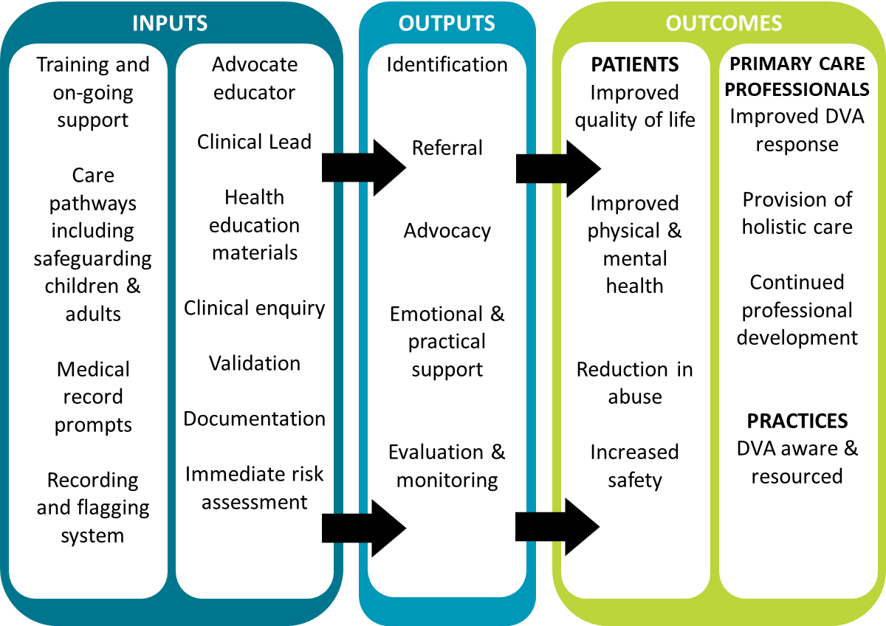
2. Outcomes
2.1 NHS Outcomes Framework Domains & Indicators

Domain 1 | Preventing people from dying prematurely | Yes
Domain 2 | Enhancing quality of life for people with long-term conditions | Yes
Domain 3 | Helping people to recover from episodes of ill-health or following injury | Yes
Domain 4 | Ensuring people have a positive experience of care | Yes
Domain 5 | Treating and caring for people in safe environment and protecting them from avoidable harm | Yes

2.2 Local defined outcomes
- Reduce the recurrence of Domestic Abuse.
- Patients value services that take a proactive role in identifying, responding to and preventing Domestic Abuse.
- Provide access to advocacy which benefits victims and survivors of DA with survivors showing improvement in abuse, mental health and quality of life.
- Improvements in patients’ physical and mental health and quality of life.
- Increase knowledge of Domestic Abuse issues and of help available to those affected by abuse among General Practice staff.
- Improve the confidence of Primary Care Network staff to ask questions about possible Domestic Abuse in a safe and empathetic way, make appropriate referrals and thereby improve patient care.
- Increase the number of patients referred from General Practices to DA support services
- Improve data collection and analysis of the number of disclosures and referrals.
- Improve the safety of patients by reducing repeat victimisation.
- Maintenance of IRIS trained accredited GP Practices and PCN staff, including provision of booster training and training resulting from Learning and Statutory Reviews.
- Provision of training to GP Practices and PCN staff.
- Patient record entries are made appropriately and safely, in line with current entry coding guidance and having due regard to their evidential value and potential perpetrator access.
3. Scope
3.1 Acceptance and exclusion criteria and thresholds:
- Bromley IRIS is accessible to all GP practices in Bromley
- All adult patients of participating surgeries will be eligible for the service
- Children do not directly access this service – their needs come under Children’s Services.
The IRIS model is evidence based for female patients aged 16 or above, but referral pathways are provided to all IRIS practices for male patients, male staff members and perpetrators of DVA with appropriate specialist organisations that can support them (unless the partner agency specialises in and has trained the AE in supporting male victim/survivors).
3.2 Aims and objectives of service
The Bromley IRIS Project aims to:
- Improve awareness of DA amongst clinicians and all their PCN staff at GP practices within Bromley.
- Increase the likelihood of staff identifying a possible patient DA issue and having the confidence to react appropriately, whether or not a direct disclosure is made to staff..
- improve support and referral options to patients who may be subject to domestic abuse, including advocacy support if required.
- encourage patients to take greater control of their life situation, including making disclosure and seeking help earlier than would otherwise be the case.
- provide appropriate information and resource materials to GP staff and patients.

3.3 Service description/care pathway
The Bromley IRIS service will provide Bromley GP practices with:
- No cost, customised health-focused DVA training, delivered either face to face in Practice settings or remotely, in accordance with Practice preference, by an IDVA-AE in conjunction with a SELICB clinical lead, in accordance with the IRIS model, in order that:
  - Primary Care Network teams are upskilled and benefit from the specialist IDVAE to whom their patients are referred.
  - Health professionals are encouraged to routinely ask patients about whether they feel safe, their experience of DA and appropriately respond, record, safety check and refer.
  - Patients receive appropriate advocacy, support and appropriate onward referral as required.
  - Practices receive IRIS accreditation, following deliver of Clinical training and booster sessions, in accordance with the IRIS model.
- Direct care pathways for patients to access specialist local DA services:
  - Following GP Practice referral to the IRIS service, determination will be, case by case and dictated by risk, as to whether the service can provide Advocacy to the patient, or whether onward referral to the Bromley general offer DA service commissioned by London Borough of Bromley (current provider -Bromley and Croydon Womens Aid (BCWA)), should be made.
  - If Bromley IRIS service provides DA Advocacy services to the referred patient, choice must be offered to the patient in respect of the means of the support i.e., face to face, telephone or remotely via Teams/Zoom etc, subject to appropriate Risk Assessment.
  - The Bromley IRIS service will conduct a Domestic Abuse, Stalking and Honour based violence (DASH) risk assessment and make referrals in accordance with Local Policy and referral routes e.g. to Childrens or Adults Safeguarding, Multi Agency Risk Assessment Conference (MARAC) etc, if appropriate and proportionate. Patient’s consent will always be sought but referral without consent will be made if risk and/or Public Interest dictates.
- Feedback to Practices following referral.
- The provision of training and support to Bromley GP Practices in relation to the dissemination of learning, to improve practice, from learning and statutory reviews e.g. Child Safeguarding Practice Reviews (CSPR), Safeguarding Adults Reviews (SARs) and Domestic Homicide Reviews.
3.3.2 Description of IDVAE service input into IRIS Project
For the period of this specification (1/2/24 to 31/1/27), the IRIS service provider will comply with the staffing provisions as indicated by the IRIS model i.e. 1 WTE IDVAE per 200K of population.
The Bromley Demography JSNA Chapter Update 2021 indicates that he latest (2021) estimates of the resident population of Bromley is 330,379, thus a requirement of 1.65 WTE IDVAEs for the Bromley IRIS service is noted as a minimum requirement. Bidders may model between 1.65 and 2.0 WTE IDVAEs – refer also to the Financial Model Template document.
This service specification includes the provision by the Provider of appropriate supervision and management of the Service.
The Service Provider should have local standard operating procedures and processes in place, to ensure that the service delivered is appropriate to support the required outcomes, and to resource such provisions appropriately.
The Service provider is encouraged to Initiate, develop and maintain professional relationships with other Bromley DA service providers and established DA Forums and Networks to foster multi -agency working and shared learning.

4 Applicable Service Standards
4.1 Applicable national standards (e.g. NICE)
- Domestic violence and abuse; how health services, social care and the organisations they work with can respond effectively. Issued: Overview | Domestic violence and abuse: multi-agency working | Guidance | NICE
- Safeguarding children, young people and adults at risk in the NHS Safeguarding accountability and assurance framework V.s July 2022: B0818_Safeguarding-children-young-people-and-adults-at-risk-in-the-NHS-Safeguarding-accountability-and-assuran.pdf (england.nhs.uk)
4.2 Applicable standards set out in Guidance and/or issued by a competent body (e.g. Royal Colleges):
- Domestic Abuse Act 2021 Statutory Guidance : Domestic Abuse Statutory Guidance (publishing.service.gov.uk)

- Royal College of General Practitioners: Good practice safeguarding in general practice (rcgp.org.uk)

- RCN Guidance Domestic Violence – Guidance to support those affected by domestic abuse| Royal College of Nursing (rcn.org.uk)

- Royal College of Psychiatry – Domestic Violence and Abuse 2015 Domestic violence and abuse - the impact on children and adolescents | Royal College of Psychiatrists (rcpsych.ac.uk)

4.3 Applicable local standards
- Bromley - An Intergenerational Domestic Violence and Abuse Strategy 2021—2024: ‘Making Domestic Abuse Everyone’s Business’.
- Bromley Community Safety Partnership Strategy 2020-2023
- Responding to domestic abuse: Guidance for general practices 2014
5. Applicable quality requirements and CQUIN goals
  - Key Performance Indicators
- The Service will maintain the rate of 90% of Bromley GP Practices IRIS accredited and either completed up to date booster sessions, or booked to do so in the following quarter.
- Accredited practices have at least 75% of Practice clinical staff fully IRIS trained i.e., having received both Clinical 1 and Clinical 2 training, and booster training as appropriate.
- The Service will respond to 95% or referrals from GP Practices within 24 hours.
- The Service will make attempt to contact 85% of referred victims within 36 hours of referral if appropriate to do so (taking account of risk and patient request).
- The Servive will feedback 90% of referral outcomes and/or updates to the referring Practice within 14 days of the receipt of the referral.
- The Service will in 95% of cases make a MARAC referral within 48 hrs of the completion of a DASH risk assessment scoring high risk, or where professional judgement dictates.
- The Service will maintain a register of accredited practices indicating training provided and planned booster sessions; register to be updated monthly and made available to the Commissioner and GP Clinical Leads.
- The Service will maintain a register of the details of Primary care/PCN staff, including staff type, who have attended training.
- The Service will deliver a minimum of two half-day DA IRIS education sessions per annum to the Bromley Health economy (e.g. to GP Academic Half days, in the safeguarding Awareness week or to the Bromley DA Health Forum).
- The service will attend quarterly IRIS steering group meetings with the ICB Commissioner and present quarterly and annual reports as follows:

- The service will provide quarterly reports to SELICB (Bromley), to include:

- Performance against KPIs.
- Number of GP practices trained, broken down by level of training and accreditation, including number of booster sessions delivered.
- Cumulative number of staff trained by staff groups.
- Planned training to GP practices in next quarter.
- Numbers of Clinical 1, Clinical 2 and booster sessions delivered.
- Number of referrals received into the service, including by Practice and abuse type.
- Breakdown of support and referral types provided to victims.
- Number of Childrens and Adults safeguarding referrals.
- Number of MARAC referrals.
- Victim demographic data.
- Narrative of good practice, trends, issues, opportunities for improvement, case studies etc, as appropriate.
- Feedback from training attendees.
- Exception reporting as appropriate.

- The service will produce an annual report to include:

- An annual overview of data contained in quarterly reports,
- Key achievements.
- Key ambitions for forthcoming year.
- Narratives and exception reports.
- Contract exit strategy (at contract end).
6. Location of Provider Premises
The Provider’s Premises are located at:
Not applicable. Both components of the Project will be offered at the premises of participating GP practices, or remotely, as required.

Domestic Abuse Statutory Guidance (publishing.service.gov.uk)
Domestic Abuse as defined by the Domestic Abuse Act 2021
Nicole Jacobs Designate Domestic Abuse Commissioner for England and Wales. Foreword to Pathfinder toolkit June 2020
Demography JSNA Chapter Update 2021 (bromley.gov.uk)
dvastrategy_final_september_2021.pdf (bromleysafeguardingadults.org)
bromley_community_safety_partnership_strategy_2020-23.pdf (bromleysafeguardingadults.org)
SafeLives' GP guidance.pdf

