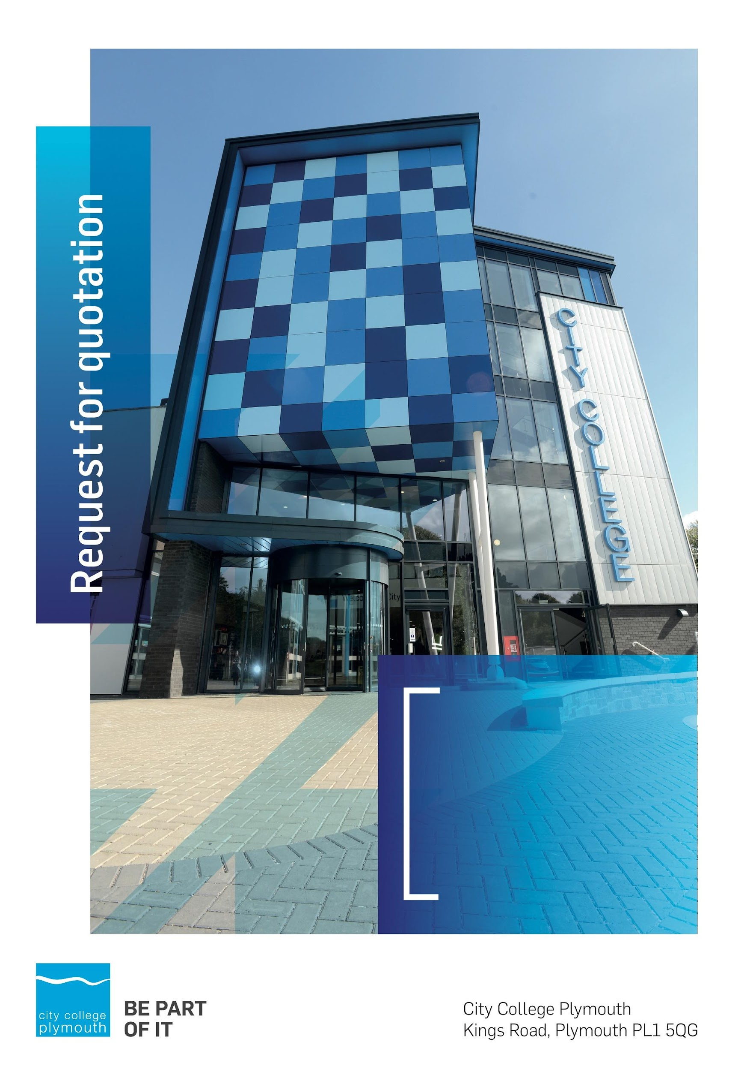

**Request for Quotation**

**RFQ190**

**Waste Disposal 2022**

**Issued 01/04/2022**

# Table of Contents

Table of Contents……………………………………………………………………………2

Table of Contents **2**

Confidentiality Statement **3**

Open Procedure **3**

Submission Details **4**

Submission Deadlines 4

Submission Delivery Address 4

Submission Questions and Clarifications 4

Electronic Submissions 4

Introduction and Executive Summary **5**

Business Overview & Background **6**

Our Guiding principle 6

Our Vision 7

Our Core values 7

Our Culture 7

The Way Forward - our Priorities 7

DETAILED Requirement **7**

Timescales 12

Written Submission 12

Pricing **14**

Terms and Conditions **14**

Validity **14**

Selection Criteria **14**

Award Price 15

Written submission 15

Assessment of Quotations **16**

Freedom of Information Act 2000 **16**

general data protection Regulation (GDPR) 2018 **16**

Agreement Conditions Acceptance and Declaration **16**

Supporting Documentation **16**

# Confidentiality Statement

This document, and any attachments thereto, regardless of form or medium, is intended only for use by the addressee(s) and may contain legally privileged and/or confidential, copyrighted, trademarked, patented or otherwise restricted information viewable by the intended recipient only. If you are not the intended recipient of this document (or the person responsible for delivering this document to the intended recipient), you are hereby notified that any dissemination, distribution, printing or copying of this document, and any attachment thereto, is strictly prohibited and violation of this condition may infringe upon copyright, trademark, patent, or other laws protecting proprietary and, or, intellectual property. In no event shall this document be delivered to anyone other than the intended recipient or original sender and violation may be considered a breach of law fully punishable by various domestic and international courts. If you have received this document in error, please respond to the originator of this message or email him/her at the address below and permanently delete and/or shred the original and any copies and any electronic form this document, and any attachments thereto and do not disseminate further.

Thank you for your consideration, City College Plymouth.

Where no notice is given, all information contained herein is Copyright 2019 City College Plymouth.

# Open Procedure

The College fully adheres to the requirements of the Public Contracts Regulations 2015, including for opportunities which are under threshold amounts.

Any Contractor who directly or indirectly canvasses any Member or Officer of the Institution, or advisor concerning the award of the contract for the provision of the services, or who directly or indirectly obtains or attempts to obtain information from any such member or Officer concerning any Tender or proposed Tender for the service will be disqualified from having his/her Tender considered.

# Submission Details

## Submission Deadlines

All submissions for responding to this Request for Quote must be submitted via email as stated below, no later than:

**Friday 13th May 2022**

**12:00 Noon**

Any submissions received after this date will not be considered.

## Submission Delivery Address

All submissions should be submitted electronically as below

## Submission Questions and Clarifications

You may contact the following person if you have any questions or require clarification on any topics covered in this Request for Quotation: Friday 6th May 2022.

**Adam Baker**

Procurement Officer

Phone: 01752 305313

Email: tenders@cityplym.ac.uk

All correspondence during the Tender should be channelled via the Procurement Officer using the above details only. Bidders found to have gained an unfair advantage shall be disqualified from the current opportunity and future opportunities with the College for a minimum of four (4) years.

## Electronic Submissions

Electronic submissions in response to this Request for Quotation will be accepted as long as they meet the following criteria:

Sent via email to: [tenders@cityplym.ac.uk](mailto:tenders@cityplym.ac.uk)

Document standards:

* Text must be in Microsoft Word format;
* Price tables must be in Microsoft Excel format (using pricing schedule in Appendix A);
* Supportive evidence may additionally be submitted in PDF format;
* Images, Designs, and other supporting evidence may be in either JPEG or PDF format
* Completed Appendix C Suitability Assessment & Selection Questionnaire (Including Mandatory & Discretionary Exclusions) Parts 1, 2 and 3. - *Please note this suitability assessment will not be viewed unless you are the winning tenderer. Failure at this stage may prevent the contract from being awarded.*
* Signed Agreement Acceptance and Declaration.

*Please note that the College is able to accept submissions sent in a compressed or “.zip” file format, so long as the files contained meet the standards described above.*

**WARRANTY**:

By submitting your tender bid, you are warrantying to the College that you have not breached our canvassing or soliciting clause.

If any successful tenderer awarded a contract is found to have provided an inaccurate warranty, then the College reserves the right to terminate the awarded contract with immediate effect and re-tender the contract from which the successful tenderer will be excluded from re-bidding and shall be disqualified from any future opportunities for a period of four years.

# Introduction and Executive Summary

Following the natural conclusion of the existing contract which was put in place 31 July 2019, City College Plymouth is seeking to contract with a single supplier for the provision of a comprehensive waste-stream disposal service across its four campus site Plymouth sites:

* Kings Road
* Piquet Barracks.
* Pinpoint
* Oceansgate

The purpose of this request is to establish an Three (3) Year contract with the option to extend for an additional one (1) + one (1) years, with an opt-out clause at 12 and 24 months with one month’s prior written notice.

The anticipated value of the supply contract will exceed £25,000. Therefore, as per the Public contracts Regulations 2015 the opportunity will be advertised on the government portal ‘Contracts Finder’.

# Business Overview & Background

City College Plymouth has a learning environment and organisational culture that impacts positively on the health, wellbeing and sustainability of our community and enables all of our students and staff to achieve their full potential.

City College Plymouth is one of the largest providers of innovative, technical and professional, education in the South West with a national reputation for promoting enterprise, employability and science, technology, engineering and mathematics (STEM). The College plays a central role in the educational, cultural and economic life of the region and works with strategic partners to facilitate growth, raise aspirations and foster wealth creation.

The College was awarded the Teaching Excellence Framework (TEF) Gold award for its university-level provision and its most recent Ofsted inspection confirmed that the College continues to be ‘Good’ with many outstanding features. The College was rated first in the South West and second nationally for student satisfaction in the latest FE Choices student satisfaction survey.

City College Plymouth is also one of the first Institutes of technology in the UK Working in collaboration with education providers and employers across the South West to improve the training in science, technology, engineering and maths in order to address skills gaps within these industries and support regional growth.

City College supports the region’s employers with their award-winning Apprenticeship provision, as well as providing a range of courses and bespoke training programmes which enable employees to upskill or retrain to better support their business’ requirements.

The College operates on two main sites within the city, serving 12,500 students and employing over 650 staff. The College operates year round, with opening times from 0800-2100 on some days.

## **Our Guiding principle**

City College Plymouth has a learning environment and organisational culture that impacts positively on the health, wellbeing and sustainability of our community and enables all of our students and staff to achieve their full potential.

## **Our Vision**

To be the learning destination of choice

## **Our Core values**

Respect, ownership, integrity for all

## **Our Culture**

Nurturing a passion for teaching and learning

Enriching our community through knowledge, experience and skills

Enabling every student to be the best that they can be

## **The Way Forward - our Priorities**

• Staff - our most important investment

• Students - our purpose

• Community - making a difference

• Achievement - reputation for success

• Wellbeing - infusing health into every day

# DETAILED Requirement

The estimated total contract value is approximately £110,000.

City College Plymouth would like to use the new waste contract as an opportunity to fully review how it disposes of it’s waste and work in partnership with the new supplier to ensure a more efficient service.

As part of this review we would like to seek **innovative solutions** from potential contractors as part of the tender process on resiteing of skips particularly at the Kings Road campus and providing alternative types of containment to fulfil the demand.

**It is therefore critical that potential suppliers visit the site to determine any operational constraints.**

**To arrange a site visit please email** [**djennings@cityplym.ac.uk**](mailto:djennings@cityplym.ac.uk) **to arrange an appointment.**

We are taking an alternative approach to procuring this contract which we hope will allow suppliers to offer innovation.

In **Appendix A** We have provided our estimated annual tonnages and waste composition data. Following a site visit we encourage suppliers to use this data to develop a new waste and resources solution for the Kings Road Campus.

The data provided in Appendix A **should not** be considered a commitment to purchase, services will only be ordered on an arranged basis, however the successful supplier will benefit exclusively from the College’s annual spend for these wastes.

City College Plymouth reserves the right to omit any item listed in **Appendix A**. The contractor should make due allowance in their pricing so that if any such item or items are omitted the prices for the remaining items shall stand for the period of the contract.

Bidders are invited to indicate any waste types which may incur an additional charge due to contamination. Each final disposal site address is also requested. The College will look to reduce the waste-miles of all waste disposals and as such local disposal will be an advantage.

**Reuse, Recycling and Landfill Diversion Targets**

Suppliers should consider how the Waste Hierarchy should be applied to any proposals, including how we can prioritise waste reduction and reuse.

The College is committed to working towards sustainability and currently recycles approximately 65% of it’s waste.

Following the bi-annual waste audit (See Appendix A) it is estimated that the College could potentially recycle a further 50% of General waste and reduce the overall amount of waste produced.

The College Recycling Target is therefore 85%.

The College Landfill Diversion Target is 100%.

The College currently re-uses some of its redundant furniture, but recognises there is significant room for improving reuse.

Bidders are invited to detail how they would assist the college in meeting or exceeding these targets.

The college would also want to work with the incoming contractor on the creation of Recycling hubs throughout the college to gradually phase out the need for bins in all offices and classrooms. It is hoped that this would reduce the overall amount of waste, reduce contamination and streamline the process. We therefore require suitable external litter and internal bins alongside signage and communication to help facilitate this.

We would also seek to achieve the following through the new contract;

* The provision of an L2 waste operative apprentice or equivalent who will be trained ‘off the job’ at City College Plymouth. This role will be seconded to College to work on Waste and Resources projects on campus.
* Support with designing a ‘Reuse Hub’ which will be used to repair/refurbish furniture, electrical appliances, bikes etc. Revenue from the sale of items will be reinvested in the Hub, training and education . Partnerships with local CICs.
* A commitment to ‘Zero to Landfill’ and processing of waste as close as possible to Plymouth City College
* A commitment to reach 75% recycling performance after one contract year. and 85% in year two.
* Maximising the segregation of food waste for Anaerobic Digestion working in partnership with both the College and catering contractor

**Contract Performance Standards**

The follow standards are required to successfully deliver this contract

|  |  |
| --- | --- |
| **Performance Criteria** | **Performance Standard** |
| Maintain Health & Safety and Waste Compliance | Maintain for the duration of the contract |
| Provide an Account Manager | Maintain for the duration of the contract |
| Resolving scheduled collection issues | Resolve the issue within 2 working days. |
| Resolving other contract issues | Resolve the issue within 7 working days. |
| Scheduled and ad-hoc collections | To be completed between 0600 - 0800 or 1000 - 1600 |
| On demand services | To be carried out by the end of the next working day if notified by midday the day before. |
| Clean and serviceable containers | To maintain clean and serviable containers for the duration of the contact. Repairs or replacements to be made within 7 working days of report. |
| The provision of apprentices | Provide a Level 2 apprentice in each contract year. Seconded to City College Plymouth to support the contract on campus. |

Failure to maintain the standards could result in PCC terminating the contract and recovering additional costs, incurred by PCC to secure interim services, from the supplier.

**City College Plymouth Sites**

A site visit is essential and can be booked by contacting Dominic Jennings, Premises Manager on 01752 305740. Slots are available w/c 4th April :-

City College Plymouth operates on four different sites, detailed below;

**Kings Road: Main Campus**

Kings Road

Devonport

PL1 5QG

**Pinpoint**:

11 Union St,

Plymouth

PL1 2SR

**Oceansgate:**

Units 6-12 Vivd Approach

Plymouth

Devon

PL 4RW

**Picquet Barracks**

Cumberland Road

Plymouth

PL1 4HX

The current services include:

**Kings Road**

* 35 yard roro x 1 – general waste – on demand
* 35 yard roro x 1 – card – on demand
* 240 litre wheelie bin x 6 – food waste - fortnightly
* 1100 litre wheelie bin x 3 – mixed recycling & plastic - weekly
* 14 yard skip x 1 – mixed recycling & plastic - weekly
* 8 yard closed skip x 2 – wood – on demand
* 6 yard open skip x 1 – brick & rubble on demand
* 14 yard closed skip x 1 – wood – on demand
* 1100 litre wheelie bin x 2 – general waste - weekly
* 1100 litre wheelie bin x 1 – card - fortnightly
* 8 yard closed skip x 1 – plasterboard – on demand
* 360 litre wheelie bin x 2 – mixed glass – wee
* Bags – as needed – animal waste collection from dog bin already installed by the College – monthly
* 240 litre bin x 1 – general waste – weekly

**Pinpoint -**

* 1100 ltr Wheelie Bin (General Waste) - weekly
* 1100 ltr Wheelie Bin (Mixed Recycling & Plastic) weekly

**Ocenasgate**

* 1100 ltr Wheelie Bin (General Waste) - weekly
* 1100 ltr Wheelie Bin (Mixed Recycling & Plastic) - weekly

**Picquet Barracks**

* 1100 ltr Wheelie Bin (Mixed Recycling & Plastic) - Weekly collection
* 1100 ltr Wheelie Bin (Card) - Fortnightly collection
* 1100 ltr Wheelie Bin (General Waste) - Weekly collection
* 2 x 8 yard closed skips (GW & Wood) - On demand

In appendix A we have provided the current tonnage across the different waste streams.

## Timescales

|  |  |
| --- | --- |
| **Action** | **Date** |
| Tender Issued | 01/04/2022 |
| Site Visits | To be arranged |
| Deadline for Queries | 06/05/2022 |
| Tender Response Date | 13/05/2022 |
| Evaluation of tenders | 16th May 2022 |
| Award Date | 31/06/2022 |
| Implementation Date | 01/07/2022 |
| New Contract Commencement | 01/08/2022 |

## Written Submission

You should submit a written document which details your company offer with particular interest to the following areas. Your contract prices will include the cost of all services detailed in the method statement. This document will be scored as per the evaluation table on page 15.

|  |  |
| --- | --- |
| **Method Statements** | **Requirements** |
| Provision of external litter & internal bins and educational support | * Waste awareness and educational support provided under the contract to meet Reuse, Recycling and Landfill Diversion targets. * Provision of external litter & internal bins designs to improve recycling segregation and maximise recycling * How existing bins could be repurposed. |
| Service Delivery | * How the contract will be transitioned & mobilised * The suppliers contact team - inc Account Manager * Details of key facilities & depots used to provide the contract * Collection schedules and approach to ad-hoc services * How collection containers will be maintained and kept clean * How a Waste Operative Apprentice will be provided * Additional non-contract support services * Payment arrangements, preferably consolidated monthly invoicing * Recycling rebates and price tracking |
| Compliance, monitoring and reporting | * How Health & Safety and Waste Compliance is maintained for the duration of the contract * How the contract performance will be monitored against the Contract Performance Standards by the supplier. * Issues and complaints resolution process * Reporting systems that provide:   + Accurate tonnage data for all services   + All waste transactions inc Duty of Care information   + Recycling, Recovery and disposal destinations   + Overall contract     - reuse performance     - recycling performance     - landfill diversion performance   + GHG Eq reporting   + Excel exports   + Tracking performance against Waste Recycling Targets |
| Contract Performance Standards | * Confirmation that the Supplier can meet the standards. * Any commentary on the standards |
| CCP Terms and Conditions | * Confirmation that the Supplier accepts the Terms and Conditions * Any commentary on the T&Cs |

# Pricing

Bidders should provide their pricing for each of the lines in Appendix A, including their proposed solution for the disposal of the different waste streams.

Prices should be firm and valid for at least the initial contract period (12 months) and then subject to an annual increase based on the average RPI from ONS data. Any increase is to be notified and agreed before being implemented.

# Terms and Conditions

The College’s normal business terms are 30 days from the date of invoice. Payment will become due subject to the above upon the College’s full acceptance of the goods/services.

This Request for Quotation and any resulting purchase order will be subject to the College’s General Terms and Conditions of Purchase of Goods/Services – see Appendix B.

# Validity

Bidder’s offers should be open and valid for acceptance for a period of no less than ninety [90] days from the date of submission.

# Selection Criteria

The successful supplier will have provided the Most Economically Advantageous Tender (MEAT) to the college. It should be noted that the bidder with the lowest submitted prices will not necessarily be down-selected. All bidders will be notified via email of the results of the outcome no later than 90 days from the date of submission. The date of contract award will be provided within that email.

The marking criteria follows:

|  |  |
| --- | --- |
| Category | Weight |
| Price | 50% |
| Provision of internal bins and educational support | 20% |
| Service Delivery | 10% |
| Compliance, monitoring and reporting | 10% |
| Contract management | 10% |

Please see table below for more details on the scoring method.

## Award Price

Lowest quote price divided by quote price multiplied by 100

## Written submission

|  |  |  |
| --- | --- | --- |
| **Assessment** | **Score** | **Interpretation** |
| **Excellent** | 4 | *Comprehensive response supported by examples*  *Description fully supported by details that demonstrate the applicant’s ability to provide the required services.* |
| **Good** | 3 | *Broad response supported by relevant examples.*  *Description well supported by details that demonstrate the applicant’s ability to provide the required services.* |
| **Satisfactory** | 2 | *Reasonable response supported by some evidence.*  *Description adequately supported by details that demonstrate the applicant’s ability to provide the required services.* |
| **Poor** | 1 | *Limited response not well supported by evidence.*  *Description inadequately supported by details that demonstrate the applicant’s ability to provide the required services.* |
| **Unacceptable** | 0 | *No response or insufficient information provided.* |

# Assessment of Quotations

Bidders must ensure that their quotation fully addresses all information requested within this RFQ document. Bidders must ensure that any quotation fully meets the specification required. The College reserves the right to discount any quotation which does not fully meet the specification.

The College reserves the right to seek clarification with bidders upon receipt of quotations.

# Freedom of Information Act 2000

Under the Freedom of Information Act 2000 the College cannot guarantee that information provided by bidders during the course of this RFQ procedure or any resulting contract will be held a confidential. The College will not routinely release information to interested parties unless required to do so in order to meet our statutory obligations.

# general data protection Regulation (GDPR) 2018

All bidders must comply with the General Data Protection Regulation (GDPR) 2018 in respect of using and processing personal information. Bidders must have in place technical and organisational safeguards to protect personal data from unauthorised use, disclosure or loss.

The College reserves the right to request a copy of your privacy statement if you are the successful bidder.

# Agreement Conditions Acceptance and Declaration

Bidders are required to sign and return the attached Agreement Conditions Acceptance and Declaration. Appendix D

# Supporting Documentation

Appendix A: Pricing Schedule

Appendix B: City College Plymouth Standard Terms & Conditions

Appendix C: Suitability Assessment & Selection Questionnaire

Appendix D: Agreement Conditions Acceptance and Declaration