ProContract Supplier Registration

- Navigate to this page from https://procontract.due-north.com/register

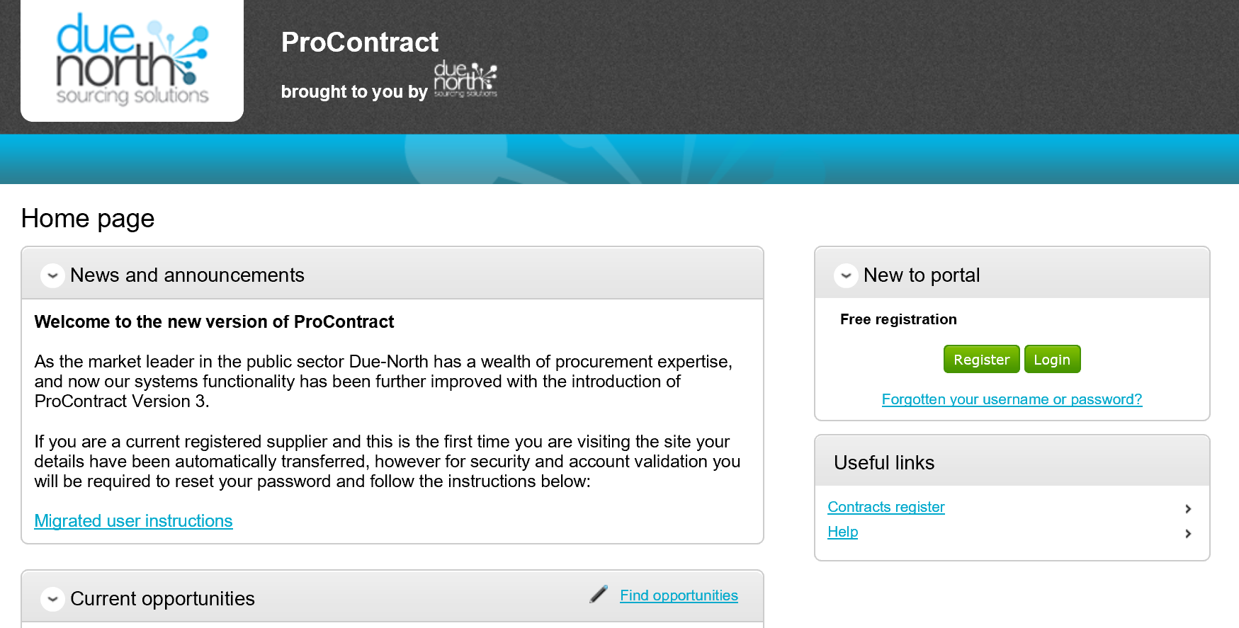

- Click on “Register”
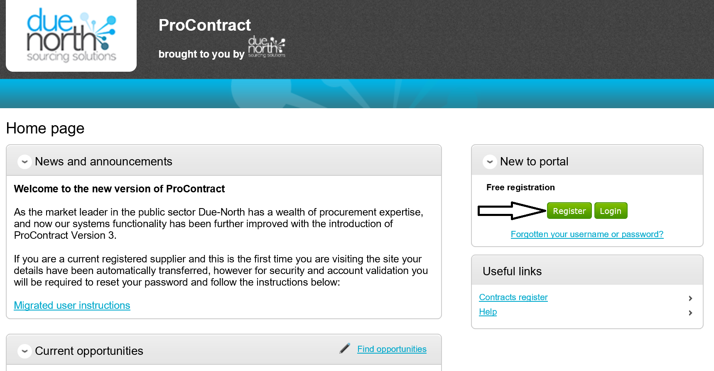

- Complete Registration form (1. Requirements – 5. Confirmation)
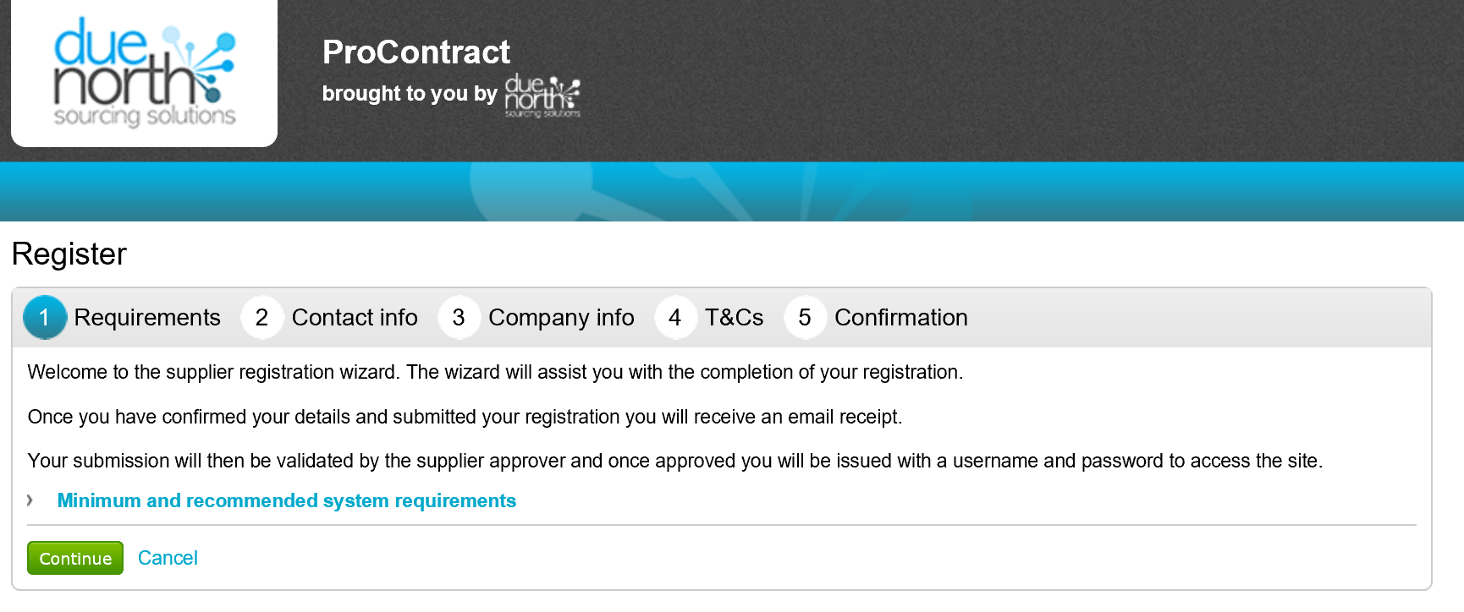
- Conclude Registration form and click on “Submit Registration).
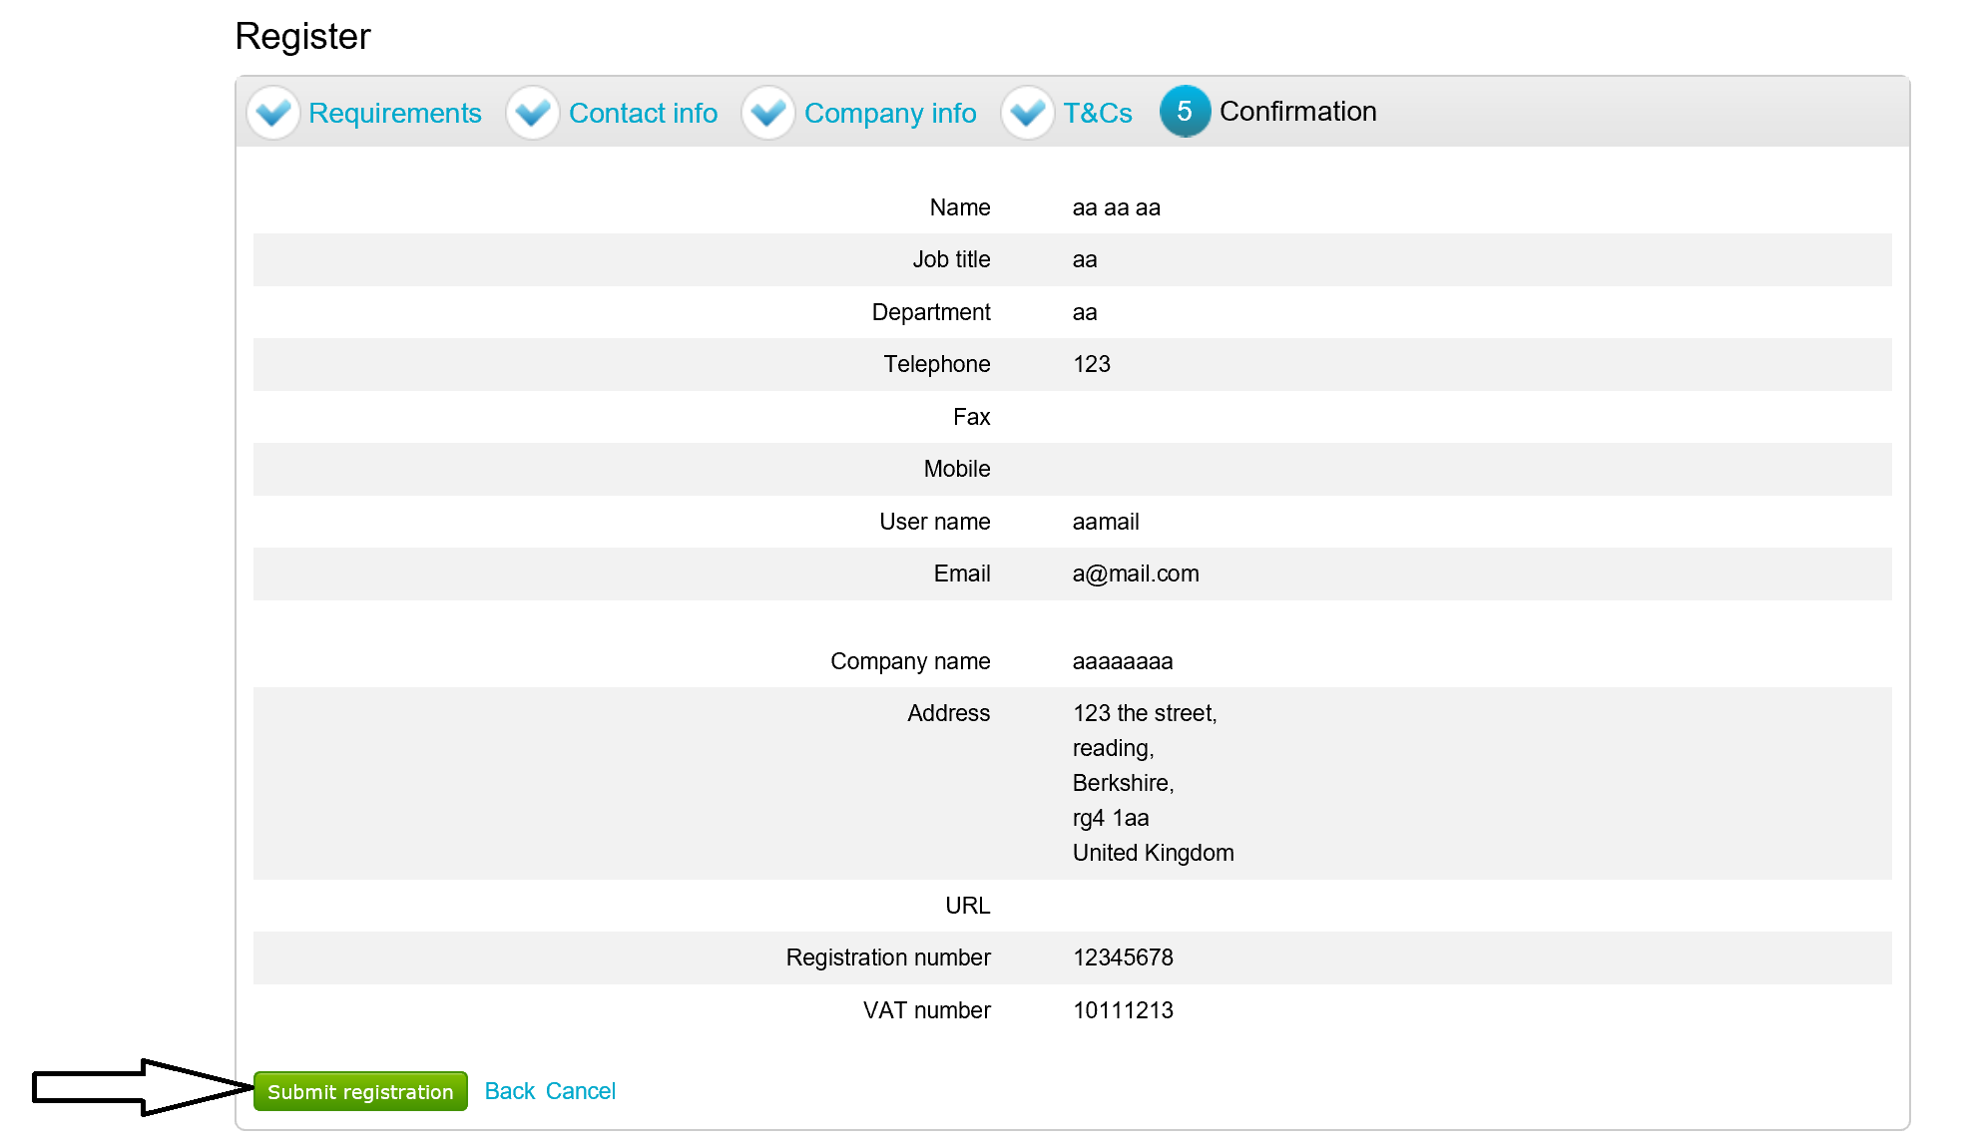

- You will receive an email confirmation upon completion. Once validated, you will receive a user name and password enabling access to the portal and view/access to procurement opportunities. In the event that you experience difficulties in completing the registration process, and/or your application is declined, please contact the supplier helpdesk on 01670 597136 (email: support@due-north.com)

