Memorandum of Information:

Adult Substance Misuse Services

Appendix 4 – ‘Substance Misuse in Medway’ -Consultant’s Report Executive Summary 2017

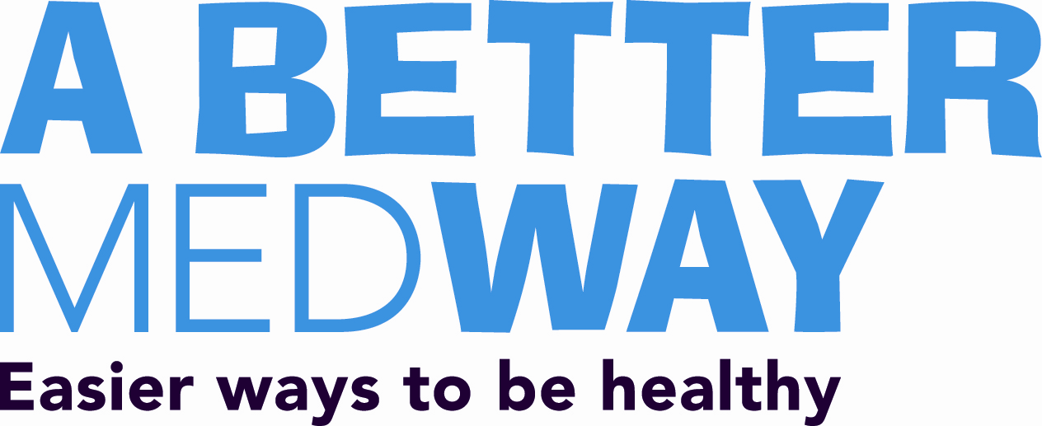
Double-click on the icon below to open the executive summary:

