**STRATTON ST MARGARET PARISH COUNCIL**

Please contact callam.greenwood@strattonstmargaret.gov.uk to arrange a site visit or ask any questions

**New dog agility equipment at enclosed dog park at Stephens Road**

**Location:**

Stephens Road Play Park

Stephens Road

Swindon

SN34DN

**Budget:** Up to but not exceeding £25,000 (excl VAT)

**Closing date:** 05/10/2024

**Usage:**

Dog park

Dog agility equipment

Shelter

**Site size:**

70m

(230.00 ft)

**Obstructions:**

Fence on west side of park separating play park from dog park

Fully enclosed existing fence in good condition

Area is sloped from north to south

Large tree to south of dog park area. No trees/ foliage to be removed for equipment.

Metal equipment preferred

Creation of a dog agility and training course open to the public. Sheltered area for dog walkers.

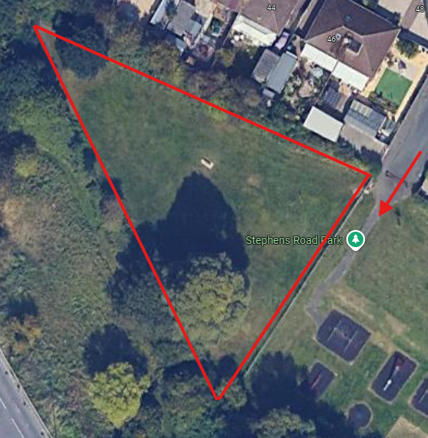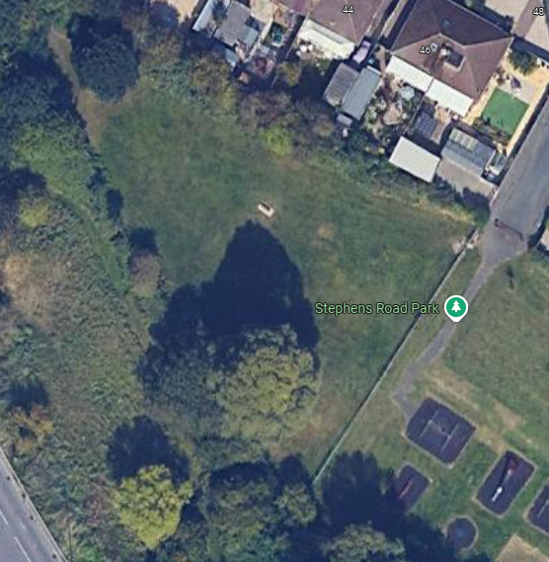

View of Stephens Road dog park

Access gate to Stephens road

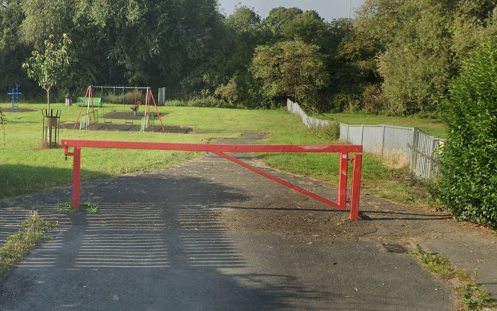

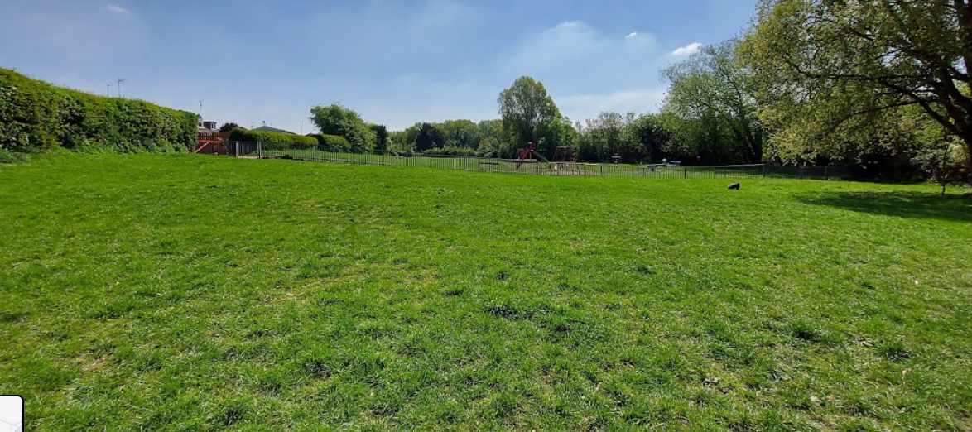

Area of development looking towards play park

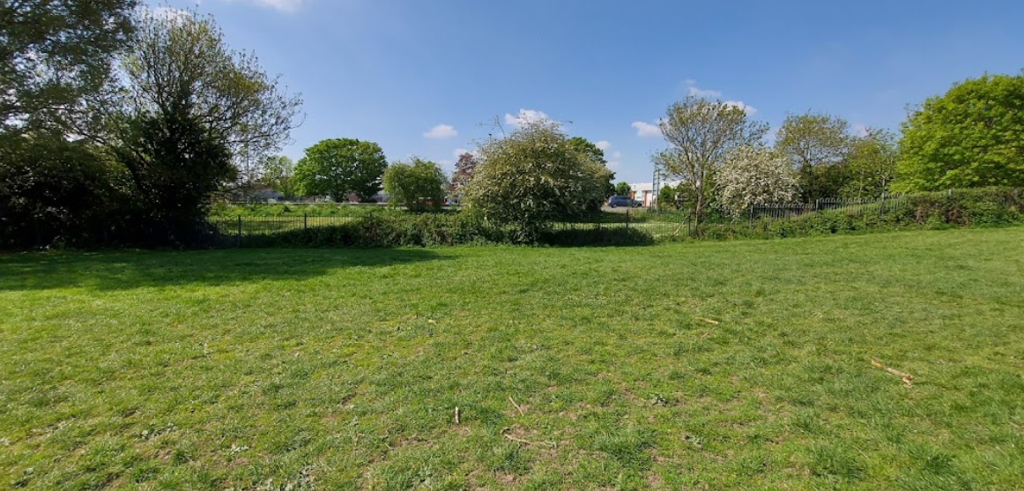

Area of development looking away from play park

**Existing equipment:**

* Wooden bench