**National Army Museum Ticketing Project**

Brief for the implementation, hosting and support of a new Ticketing and Event Booking System or Service for the National Army Museum

October 2016

**Contents**

1 Introduction 3

2 The National Army Museum 3

2.1 The New Museum 3

2.2 Building for the Future 4

3 A Profile of Our Visitors 5

3.1 The Museum’s Audience Segments 5

3.2 Growing Visitor Numbers 7

4 Technical Requirement 7

5 Scope of Works 8

6 Tender Process 9

6.1 Tender Response Requirements 9

6.1.1 Introduction 9

6.1.2 Understanding of the Requirement 9

6.1.3 Tendered Solution 9

6.1.4 Implementation Approach and Plan 9

6.1.5 Applicants Project Team, Qualifications and Experience 10

6.1.6 Pricing, Terms and Conditions of Offer 10

6.1.7 Formal Tender Documentation 10

6.2 Tender Submission 11

6.3 Tendering Costs 11

6.4 Contract Evaluation and Award Criteria 11

6.4.1 Selection Criteria 11

6.4.2 Evaluation and Award Criteria 12

6.5 Tender programme 14

6.6 Enquiries 14

7 APPENDIX A: DETAILED AUDIENCE INFORMATION 15

7.1 Growing Digital Engagement and Audiences 15

7.2 Growing Membership 16

7.3 Growing Commercial Audiences 17

8 APPENDIX B: DETAILED REQUIREMENTS 20

9 APPENDIX C: DETAILED PRICING 21

10 APPENDIX D: FORM OF TENDER 22

11 APPENDIX E: CERTIFICATE OF BONA-FIDE TENDER 23

12 APPENDIX F: SUPPLIER STATEMENT 24

# Introduction

In spring 2017, a new National Army Museum will open in London after a three-year closure. The Museum’s vision is bold - to use its rich historical and contemporary collections to foster people’s awareness, understanding and knowledge of the British Army, its soldiers and its legacy. By facilitating this exploration, the Museum will encourage debate about an institution that is little understood yet is intrinsically part of our democratic society and enables us to live with the freedoms we enjoy every day.

This ***Building for the Future*** project will transform the Visitor experience and will include the procurement of a range of new systems to support and enhance the commercial development of the Museum. A key component of the new Systems will be Ticketing; for access to Galleries, Exhibitions, Events, Spaces and Resources.

This new Ticketing System will be accessible both in the venue and from a new website, the latter being a vital part of the Museum’s vision to create a modern and digitally relevant 21st-century museum.

We are looking for a company with a proven understanding of Ticketing in the cultural, heritage and commercial sectors and who share our bold vision. You will need to demonstrate an ability to adapt the kinds of tickets offered in order to respond to the evolving impact that the new Museum will have on the Visitor experience.

This document provides a detailed description of the Ticketing project. The Museum is looking to work closely with a company to deliver a flexible and high-performance Ticketing solution. The new system will need to be seamlessly integrated into the Museums new website, along-side the other new Visitor systems and into the Museum’s Salesforce and Netsuite based back-office processes.

If you are interested in tendering for the project, this document provides the following information:

* Background on the National Army Museum and Building for the Future
* A Profile of Our Visitors
* The Technical Requirement
* The Scope of Works
* The Tender process.

We would welcome your proposal to work with us.

# The National Army Museum

## The New Museum

In spring 2017, a new National Museum Army will open in London after a three-year closure. The New Museum will be comprised of the following facilities:

* 5 Galleries; Soldier, Army, Battle, Society, Discovery
* 500m2 of exhibition space that can be divided into up to four temporary galleries
* a new 3 room Learning Centre
* a new early years learning centre – Play Base
* a new research centre and archive – Templar Studies
* a new café
* a new Shop
* a new Boardroom.

## Building for the Future

This new Museum is being created through the auspices of the **Building for the Future (BftF)** project. Set to cost £23.75million, the project has been funded by a Heritage Lottery Fund grant of £11.5m, with the remainder covered by fundraising carried out by the Museum.

The project is realising the wholesale transformation of the Museum’s offer onsite, offsite and online, across seven main work streams.

**1. A new brand and marque**

During 2014-2015 the Museum worked to create a new brand model to help direct and inform the development of the new Museum. It has influenced every aspect of the new Museum, from permanent displays, to interior design to signage to the extent that the new building physically embodies the new brand; helping to transform the Museum from a dark and traditional place to a modern, bright, and relevant Museum fit for the 21st century.

**2. A wholly new visitor experience.**

A major restructure of the building has created: five new thematic galleries – Soldier, Army, Battle, Society Discovery; a new 500m2 temporary exhibition gallery; a new three-room learning centre; a new early years learning facility (Play Base); a new research centre and archive; new café; a new shop and a new boardroom. All are being realised within a building designed to create a more welcoming and engaging physical experience and supported by a fresh approach to public programming (see below).

**3. New programmes for learning and outreach.**

The closure of the Museum has provided unprecedented opportunities to pilot new approaches to delivering our learning purpose and to test how the Museum can extend its reach whilst also providing the depth and breadth of offer required of a national museum. On opening, the Museum will offer relevant, thought provoking and challenging opportunities to engage with the Collection and our stories through community engagement and curation, new learning services aimed at early years, schools, families, adults and lifelong learners, and new a public programme that seeks to encourage active participation and debate in a wide range of topics from military history to present day conflicts and world geopolitics. It is a place that will spark conversations.

**4. New working models of service delivery and public engagement.**

The project has enabled the Museum to review its structure, the ways it fulfils its purpose, the services it offers and its enabling and supporting systems and processes. As the project moves into delivery phase, new teams, processes, services and training are being put in place to deliver an audience-focused, commercially sustainable and more goal-driven organisation. This is being facilitated by new working models with a focus on process and cross-departmental and cross-divisional collaboration.

**5. A sharper focus on generating income.**

The new visitor experience whilst creating a more welcoming and engaging physical experience has also sought to ensure a focus on facilities and activities to drive earned income. In order to achieve, this commercial spaces and the overall offer within the Museum have been designed to be visible, enticing and reflect the growing expectation of Museum audiences.

**6. Better conservation of and access to the Collection.**

The project has enabled the conservation of thousands of objects for the new displays. In addition, it has enabled a significant programme of digitisation that will provide easier and greater access to the Museum’s national archives online, that through an accompanying cataloguing and external partnerships, will provide a modern, flexible and customer-centred online enquiry services. This is aimed at meeting the needs of a broad range of researchers from the school pupil to the family historian to the expert academic.

**7.** **Going digital.**

Digital transformation underpins much of the new Museum’s work. Whilst attention is necessarily focused on what needs to be done to deliver the modern services expected of a 21st century museum, the creation of the Museum’s new website is seen as the first step in a medium- to long-term digital journey that will see a wholesale review, modernisation and streamlining of the Museum’s systems as digital becomes central not only to realising efficiencies but to delivering a world-class national museum service, locally, nationally and internationally. Digital is central to the Museum achieving a greater sphere of influence and impact and in developing brand awareness.

# A Profile of Our Visitors

## The Museum’s Audience Segments

As part of **BftF**, the Museum has undertaken extensive audience research, working with market research company Morris Hargreaves McIntyre. This work identified seven market segments for the Museum before its closure in 2014, as described in Figure 1. The Museum has used these segments to guide the development of the exhibitions and services within the project and to target and monitor audience development work to date within the delivery of the **Building for the Future** Activity Plan.

On opening, the Museum will continue to engage with each of the segments identified in Figure 1, but there will be a particular focus on the following audience segments that have been identified as having the strongest potential for growth in visitor numbers:

* Learning Families
* Kids' First Families
* Empathisers
* Self-Developers

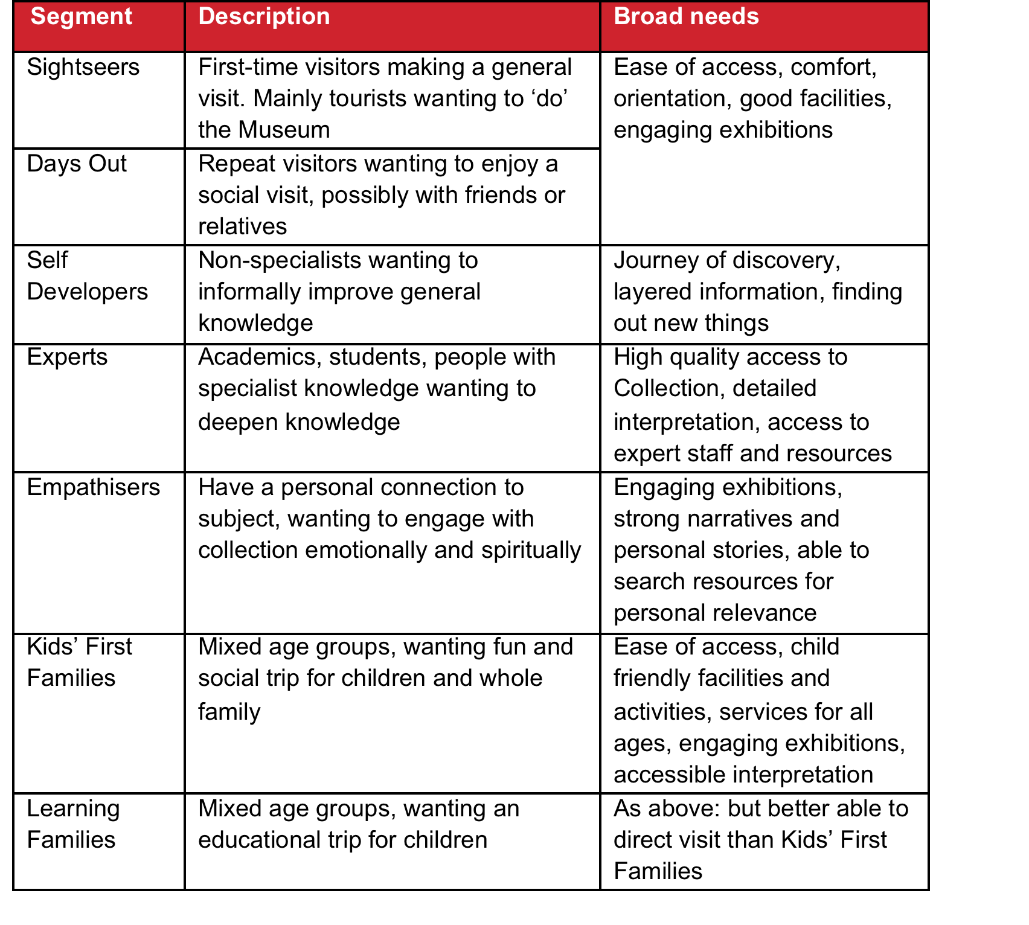

Figure 1 National Army Museum - Visitor Segmentation

Of these, Learning Families and Kids' First Families will be further prioritised. Whilst the **BftF** project also expects to attract a greater number of curiosity-driven first time visits amongst Sightseers – either from the UK or overseas – these are not seen as a high priority in the short-term.

An important strategy in achieving this growth is to grow participation to reflect the population diversity of modern Britain particularly certain demographic groups who are under-represented in the Museum’s pre-closure audiences:

* Women
* Non-specialists
* Local residents from such culturally and socially diverse boroughs as Southwark, Wandsworth, Hammersmith and Fulham and Lambeth.

In addition, the Museum will continue to build relationships and deepening engagement with:

* Schools – particularly from local socially and culturally diverse boroughs in London
* Students and academics – in military history, social history and politics
* Members of the armed services – active and retired

And as the Museum seeks greater participation and breadth in its audiences, it is looking to improve participation across Black, Asian and Minority Ethnic (BAME) groups, disability groups, young people, older people and N-Sec 5-8, continuing the work achieved through the Activity Plan.

## Growing Visitor Numbers

NAM’s projected visitor numbers, post re-opening are presented in Figure 2.

* 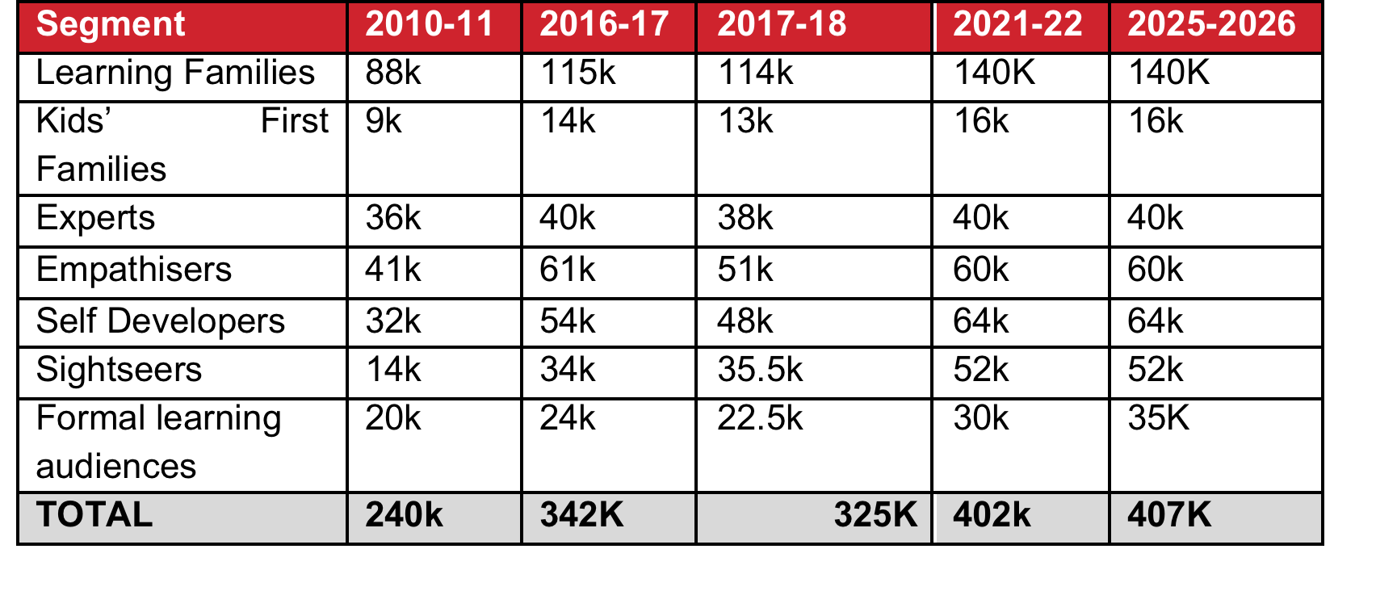

Figure 2 Current and Projected Attendance Figures

NAM will achieve this growth through three areas of audience development:

1. **Building existing audiences**. Welcoming back existing audiences and increasing the number of participants from those audience groups.
2. **Developing new audiences.** Reaching audience groups who have not previously engaged with NAM and encouraging them to do so through provision of new offers and better facilities and services, but also through repositioning the organisation in line with those audiences.
3. **Engaging diversity.** Encouraging a greater breadth of participant in NAM’s audiences, encouraging participants from more diverse ethnic, social and cultural backgrounds

Further background information describing Visitors and Audiences can be found in Appendix A.

# Technical Requirement

The Museum has a requirement for a Ticketing System, which should be able to support the sale and/or distribution of the following types of Tickets:

* General Admission (Time, Venue and Capacity limited)
* Gallery Admission
* Gallery Admission (Time, Venue and Capacity Limited)
* Event Admission
* Event Admission (Time, Venue and Capacity Limited)
* Group / Education Activity Booking (Time, Venue and Capacity Limited)
* Tour Booking (Time, Venue and Capacity Limited)

The Ticketing System should meet the following high-level requirements:

* Either a hosted service or an on premises solution
* A Ticketing System that can be integrated with the new NAM website in a visually coherent way and accessible from multiple pages
* Provision of a User Interface for both the customer and staff
* Support for Free Admission to Galleries and Exhibitions
* Support for Charged Admission to Exhibitions, Events, Spaces/Resources
* Ability to limit ticket sales by date, capacity and time slot
* Ability to Price by band (e.g. Adult, Child, Concession)
* Support for In-Venue Sales (including interface with payment gateway) via a Point of Sale
* Support for Online sales (including interface with payment gateway) via integration with the Museum’s website
* Financial reporting, including both:
  + System generated reports describing sales activity
  + Access via an API for integration with NetSuite
* Customer activity reporting through access to an API for integration with SalesForce
* Provision of Advance and Priority Booking Functionality
* Support for storing defined customers as Members and applying defined Membership Discounts to those Members (Members are registered and maintained as Members in a separate NAM system)
* Support for sales of a limited set of physical products, such as Guidebooks
* Support for Bundled Pricing, e.g. multiple Tickets for different events
* The System should be Promotion Ready (discount codes, vouchers, multi-buys)
* Support for printing of In-Venue Tickets via the Point of Sale
* Support for Online E/Ticketing, including downloadable and printable tickets, or display on a Mobile device
* Hierarchical Access Control
* Provision of modern Point of Sale Hardware for In-Venue sales

These high-level requirements are for guidance as to the scope of the required solution. The applicant should study and respond to the Detailed Requirements as provided in Appendix B.

# Scope of Works

Interested applicants should include the following works in their tender:

* Configuration of the proposed solution to meet all requirements
* Documentation for available API’s
* Details of provision of a Test System for integration and testing
* Training details for NAM Staff
* Documentation, either hardcopy or online
* Licensing or subscription costs of the solution for 3 years (On-Premises or Hosted or Cloud)
* Hosting costs of the solution for 3 years (if hosted)
* Support (Ongoing Help-desk and Technical Trouble-shooting) and upgrades for 3 years

NAM would like the applicant to outline an initial delivery schedule assuming following milestones for the project:

* Nov 21st 2016 – Contract kick-off
* Dec 23rd 2016 – Set-up complete
* Jan 13th 2017 – In-venue hardware installed
* Jan 27th 2017 – Testing complete ready to go-live.

A detailed delivery schedule will be agreed during contract negotiations.

# Tender Process

Interested applicants should follow the instructions below when preparing their tender.

## Tender Response Requirements

Tenders should comprise the following sections and content:

* Introduction
* Understanding of the Requirement
* Tendered Solution
* Implementation Approach and Plan
* Applicants Project Team, Qualifications and Experience
* Pricing, Terms and Conditions of Offer
* Formal Tender Documentation

### Introduction

In this section the applicant should introduce the company and provide high-level benefits of their tender.

### Understanding of the Requirement

In this section the applicant should provide a detailed analysis of the requirements, clearly demonstrating that they understand the relative importance of the key requirements and what NAM are trying to achieve.

### Tendered Solution

In this section, the applicant should provide a detailed description of their tendered solution and the benefits it will bring to NAM. This section should include submission of a detailed response to the Detailed Requirements in Appendix B, identifying the following:

* Whether the tendered solution is compliant to each requirement
* How the tendered solution meets each requirement?
* Whether the requirement is met Out of the Box, by Configuration or will require Extension to the Core System

### Implementation Approach and Plan

In this section, the applicant should demonstrate:

* A clear methodology statement for the development and delivery of the Works detailed in Section 5
* An outline work plan identifying key sign-off points informed by this brief
* Confirmation of team members, including sub-contractors if relevant
* What support and interaction will be required from NAM staff?

### Applicants Project Team, Qualifications and Experience

In this section, the application should provide the following information:

* Details of three relevant projects that demonstrate qualifications and experience. For each project, include a description of the project, you, your company’s and/or sub-contractors’ role, client, budget and project dates.
* Two References from recent contracts that are relevant to this project. References should include the name and contact details of the clients’ representatives who could be approached for references. References will be taken up before confirmation of appointment.
* Copies of up-to-date insurance - NAM requires Public Liability with a minimum of £10 million, Employers Liability with a minimum £10 million and Professional Indemnity Insurance to the value of £2 million.
* Copies of the company’s published accounts for the last three years.

### Pricing, Terms and Conditions of Offer

Pricing for the applicant’s tender should be submitted as follows:

* The applicant should complete the spreadsheet in Appendix C in order to submit and explain their price.
* The Price is to be a fixed sum for the provision of all Works as outlined in the Scope of Works.
* The Price should be for either a Hosted or On Premises solution according to Supplier preference. If the latter, required infrastructure should be stated. Pricing should be for three years of operation.
* The Price is to include all expenses. This will include travel costs, accommodation, disbursements, reports and all other expenses and costs required in the provision of the Works.
* The fee should **exclude** VAT at the prevailing rate.
* Any other terms or conditions that the applicant wishes to apply to any resulting contract should be documented in this section, including payment terms, clauses for termination, data protection etc.

### Formal Tender Documentation

Applicants should complete the following formal documentation and submit it with their tender:

* The completed Form of Tender (Appendix A)
* The completed Certificate of Bona-Fide Tender (Appendix B)
* The completed Supplier Statement (Appendix C)
* All forms (Appendix A, B and C) should be signed by the Applicant or, in the case of a Company by the Secretary or other authorised person
* Any other information that is required to clarify the proposal.

## Tender Submission

An electronic copy of your tender may also be returned no later than 12:00hrs on November 4th 2016 via email: [jfoster@nam.ac.uk](mailto:jfoster@nam.ac.uk) with the subject header – “<CompanyName>-NAM Ticketing Tender Proposal”. Proposals received before 9.00hrs on November 4th will not be accepted.

The proposal should package should also contain:

* The completed Form of Tender (Appendix A)
* The completed Certificate of Bona-Fide Tender (Appendix B)
* The completed Supplier Statement (Appendix C)
* Any other information that is required to clarify the tender.

Tenders are to remain open for acceptance for a period of 60 days.

## Tendering Costs

NAM will not be responsible for or pay for any costs or expenses that are incurred by any applicant in preparing and submitting their tender.

## Contract Evaluation and Award Criteria

The tender board may consist of the following NAM representatives:

* Assistant Director (Commercial & Visitor Experience)
* IT Service Manager
* The Visitor Systems Contractor (independent contractor engaged to facilitate procurement)

The tender board will evaluation the submitted tenders according to the following process:

* Initial review of all tenders against the Selection Criteria in Section 6.5.1 to identify tenders that qualify for detailed evaluation
* Qualified tenders will then be formally evaluated against the Evaluation and Award Criteria in Section 6.5.2. Two tenders will be short-listed for interview/demonstration
* The winner will be selected after refining the scores against the Evaluation and Award Criteria after the demonstration

### Selection Criteria

With regards to this tender, all bidding firms must confirm that they meet the criteria in Figure 3.

|  |  |  |
| --- | --- | --- |
| **Item** | **Criteria** | **Max Score** |
| 1 | Understanding of the Requirement | 5 |
| 2 | Experience; review of the three Submitted Case Studies | 5 |
| 3 | Financial Security; review of Insurance and Accounts | 5 |
| 4 | Demonstrable API allowing Customer and Financial Information from Ticket sales to be easily extracted on a regular basis | 5 |
| 5 | Meet at least 80% of the Essential Technical Requirements | 5 |

Figure 3 Selection Criteria

The case studies must be of no more than 2 sides of A4 each.

For any potential provider that scores less than the **minimum pass mark of 3** for each question in the selection criteria, the BFI reserves the right to not consider that potential provider further.

### Evaluation and Award Criteria

An evaluation team will consider all tenders that have passed the Selection Criteria above, with a view to shortlisting 2 Potential Providers for the presentation / interview stage. The weighted evaluation criterion for selection to presentation / interview is described in Figure 4

|  |  |
| --- | --- |
| **Criteria** | **Weight %** |
| Quality of Response to Technical Requirements | 50 |
| Implementation Approach and Plan | 10 |
| Qualifications, Project Team and Experience | 10 |
| Price and Value for Money | 30 |

Figure 4 Award Criteria

#### Quality of Response to Technical Requirements Evaluation

The Quality of Response to Technical Requirements Section will be evaluated using the criteria in Figure 5.

|  |  |
| --- | --- |
| **Score** | **Interpretation** |
| 4 | **Satisfies the requirement with additional benefits.**  Demonstration by the Potential Provider of the relevant ability, understanding, experience, skills and resource & quality measures required to provide the services. Response identifies factors that will offer additional added value with evidence to support the response. |
| 3 | **Satisfies the requirement.**  Demonstration by the Potential Provider of the relevant ability, understanding, experience, skills and resource & quality measures required to provide the services. |
| 2 | **Satisfies the requirement with some reservations.**  Demonstration by the Potential Provider of the relevant ability, understanding, experience, skills and resource & quality measures required to provide the services, with some reservations. |
| 1 | **Does not meet the requirement and / or insufficient information provided.**  Does not comply and / or insufficient information provided by the Potential Provider of the relevant ability, understanding, experience, skills and resource & quality measures required to provide the services. |

Figure 5 Criteria for Assessing Quality of Response

#### Implementation Approach and Plan

The Implementation Approach and Plan will be accessed by applying a more subjective score out of 10 and by focussing on:

* Whether the proposed schedule meets the required timelines
* Approach to and Quality of the Training
* Impact on NAM staff
* The quality of the documentation
* The quality of the ongoing support

#### Qualifications, Project Team and Experience

The Qualifications, Project Team and Experience will be accessed by focussing on:

* Quality of the Case Studies
* Qualifications and Experience of the Project Team

#### Price and Value for Money

The Price and Value for Money section will be evaluated using the following formula:

* Price’ will be score as follows: (Lowest Bid / Potential Providers Bid) x 30%
* Value for Money’ will be scored using the 1 to 4 schema above.

Following the presentation / interview stage the evaluation team will identify a preferred Potential Provider with a view to reaching a contractual agreement subject to clarification of any outstanding matters.

Please note that the only valid form of notification will come from an Authorised Officer of NAM, via formal email correspondence. You must not, under any circumstances, accept the award of the contract via any other method.

All Potential Providers will be contacted on the same day to advise if their bid has been successful or not.

NAM will award the contract to the tenderer whose tender has been determined as substantially fulfilling the conditions and which demonstrates the most economically advantageous tender overall.

Although post tender clarification of issues is often necessary, NAM does not normally enter post tender negotiations except in exceptional circumstances and therefore the price submitted at the initial stage should be your keenest. For clarity, the prices you submit should be shown exclusive VAT where applicable.

## Tender programme

The key dates in relation to this tender exercise are detailed below.

|  |  |
| --- | --- |
| * **Activity** | **Date** |
| * Brief issued | 19th October 2016 |
| * Tender submission deadline | 12:00hrs November 4th 2016 |
| * Notification shortlisted candidates | 11th November 2016 |
| * Demonstrations and Interviews | w/c 14th November 2016 |
| * Appointment of chosen company | 18th November 2016 |
| * Initial project start up meeting – agreement of timings going forward | w/c 21st November 2016 |

The above programme is indicative of NAM’s timescales. However, the project sits within the **BftF** Master Programme and may be subject to alteration.

The forward programme will be developed in discussion with the appointed company.

## Enquiries

Any enquiries arising must be submitted in writing via email to:

Nic Snape, Visitor Systems Contractor

Email: nic.snape@talisman-innovations.com

Enquiries will be answered within three working days.

# APPENDIX A: DETAILED AUDIENCE INFORMATION

## Growing Digital Engagement and Audiences

The Museum took the opportunity of the closure of the physical Museum to refocus its attention on digital engagement, creating a new Digital Engagement Strategy (2014) that helped shape and sharpen the Museum’s web, social media and digital work during 2014-15 and 2015-16 when delivering its Heritage Lottery Fund Activity Plan. During this period the Museum ran a series of digital marketing campaigns, both paid and organic, to maintain brand awareness. Some of this activity was intended to drive traffic to the website; some was intended to help develop our social media communities. Campaign highlights include the following:

* **Waterloo bicentenary (organic):** An organic social media campaign (Feb-Oct 2015) called #WaterlooWednesday resulted in 10,688 comments likes and shares, and 114,601 impressions across social media platforms.
* **Waterloo bicentenary (paid):** A paid digital marketing campaign (Apr-Aug 2015), including social media and digital media buying, resulted in 46,524 visits to the NAM website, and 3.4m impressions across social media platforms.
* **WW1 Empire & Commonwealth:** NAM created a set of videos to raise awareness of the Empire & Commonwealth contribution to the First World War. A paid digital marketing campaign (Nov 2015) resulted in 291,891 video views and 1.2m impressions across social media platforms.

|  |  |  |  |
| --- | --- | --- | --- |
|  | **PRE-CLOSURE** | **BUILDING FOR THE FUTURE** | |
|  | **2013-14** | **2014-15** | **2015-16** |
| Website (visits) | 778,953 | 880,188 | 930,794 |
| *% increase* |  | *13%* | *6%* |
| Facebook (reach) | 61,707 | 508,084 | 2,941,488 |
| *% increase* |  | *723%* | *479%* |
| Twitter (impressions) | 78,866* | 577,600 | 3,100,400 |
| *% increase* |  | *632%* | *437%* |
| YouTube (views) | 144,026 | 215,234 | 766,839 |
| *% increase* |  | *49%* | *256%* |
| * Reporting on Twitter impressions only began in October 2013. | | |  |

Figure 6 Web and social media engagement 2014-16

## Growing Membership

An integral part of our audience development and growth strategy is to deepen people’s engagement with the Museum. We call this our ‘Ladder of Engagement’. Visualised in Figure 5 this shows how we will plan our communications and engagement activities to enable people to move through increasing levels of engagement with the Museum. Clearly not everyone will want to become part of the NAMily.



Figure 7 Ladder of Engagement – user relationship structure for the National Army Museum

## Growing Commercial Audiences

Commercial income is budgeted to be in the region of £2M in the first year of opening. Of this, £1.5M is to be generated as a result of footfall to the Museum. These income targets have been shaped around the visitor targets found at Figure. 3 The remaining £0.5M is to be generated through utilising the web to either book activity, secure venue hires or purchase a product online.

Figure 8 Geographic location of visitors to the Museum’s website (UK v Rest of World); Source: Google Analytics

The UK drives the most traffic, but there has been year-on-year growth in US and Australian audiences.

Figure 9 Geographic location of visitors to the NAM website (London v Rest of UK); Source: Google Analytics

England drives the most traffic, but there has been increasing diversity year-on-year. Equally, London drives the most traffic, but there has been increasing diversity year-on-year.

Figure 10 Sources of visitors to the NAM website (Organic v Referral v Direct v Other); Source: Google Analytics

Figure 11 Devices used to access the NAM website (Desktop v Tablet v Mobile phone); Source: Google Analytics

Data shows that there is a year-on-year trend away from desktop use towards tablet and mobile phone use. This highlights the importance of factoring in responsive design to the redevelopment of the website.

Figure 12 Visitor motivations for accessing the NAM website

*Source: Qualaroo online survey - Spring 2014, immediately prior to closure (Sample size 3,505)*

Figure 13 Top five most visited content areas on the NAM website (Online Collection v Research v Exhibitions v Microsites v Online Inventory)

*Source: Google Analytics*

# APPENDIX B: DETAILED REQUIREMENTS

The Detailed Technical Requirements are presented in the separate spreadsheet, entitled 20161024_NAM-Ticketing_Requirements.

Please complete all fields identified in Yellow in the Spreadsheet and submit with your Tender as a separate file, by adding the Tender Reference to the end of the file name, as defined in the formal Form of Tender Appendix D.

# APPENDIX C: DETAILED PRICING

The format for the submission of the Detailed Pricing is presented in the separate spreadsheet, entitled NAM-Ticketing_Pricing_20161018.

The pricing spreadsheet includes information about likely number of Tickets purchased and/or revenue generated as a guide to pricing.

Please complete all fields identified Yellow in the Spreadsheet and submit with your Tender as a separate file, by adding the Tender Reference to the end of the file name, as defined in the formal Form of Tender Appendix D.

# APPENDIX D: FORM OF TENDER

Tender for: National Army Museum Ticketing Project

To: The Council and Director of the National Army Museum

Sirs,

I/We the undersigned, having examined the enclosed tender documents and Appendices, do hereby offer to execute and complete in accordance with the said documents the works described therein:

For the sum as listed in the attached document:

Tender Reference:

I/We hereby affirm our agreement to enter into a contract with the Council of the National Army Museum for the due performance of the Works in the form described by the above said documents.

I/We have completed the Certificate of Bona-Fide Tender included in this document.

I/We understand that the Trustees are not bound to accept the lowest or any tender which may be received nor or responsible for any cost incurred in the preparation of any tender.

I/We declare that this offer is to remain open for acceptance for a period of 60 days from the date fixed for the receipt of tenders.

Signed: ____________________________________________________

In the capacity of

Duly authorised to sign the tender on behalf of:

Date:

# APPENDIX E: CERTIFICATE OF BONA-FIDE TENDER

Tender for: National Army Museum Ticketing Project

I/We certify that this is a bona-fide tender and that I/we have not fixed or adjusted the amount thereof by or under in accordance with any agreement or arrangement with any other person.

I/We also certify that I/We have not done and I/We undertake that I/we will not do at any time any of the following acts:

1. Communicate to a person other than the person calling for these tenders the amount or approximate amount of the proposed tender except where the disclosure, in confidence, of such amount(s) was necessary to obtain insurance premium quotations required for the preparation of the tender.
2. Enter into any agreement or arrangement with any other person that he shall refrain from tendering or as to the amount of any tender to be submitted;
3. Offer or pay or give or agree to pay or give any sum of money or valuable consideration directly or indirectly to any person for doing or having done or causing or have caused to be done in relation to any other tender or proposed tender for the said work any act or thing of the sort described above.

In this certificate the word “person” includes any person and any body, association, corporate or un-incorporated; and “any agreement” includes such transaction, formal or informal, and whether legally binding or not.

Signed: ____________________________________________________

In the capacity of

Duly authorised to sign the tender on behalf of:

Date:

# APPENDIX F: SUPPLIER STATEMENT

We certify that the information supplied is accurate to the best of our knowledge and that we accept the conditions and undertakings requested in the assessment. We understand that false information could result in our exclusion from the Tender process or the Approved Suppliers List at any time, even after initial inclusion. We also understand that it is a criminal offence to give or offer any gift or consideration whatsoever as an inducement or reward to any servant of a public body and that any such action will empower such body to cancel any contract currently in force and will result in exclusion from the Tender and / or the Approved Suppliers List.

Signed by: _____________________________________________________

Name: (in BLOCK LETTERS) ______________________________________

Title: _________________________________________________________

Date: _________________________________________________________

for and on behalf of: _____________________________________________

This form should be signed by a Director, Partner or other authorised signatory of the organization and returned as part of the Tender Response