Appendix F - AV Presentation for Stage and Screen

This AV presentation will be where most of the big screen footage will be shown. This presentation should provide a ‘wow’ moment in the exhibition, showcasing not only film footage of big movie blockbusters and TV shows filmed locally, but also why the Liverpool City Region is used in so many diverse shows. This needs to be presented in a creative, fun and exciting way for e.g., audio, projection mapping, animation etc. It is the main presentation in this section and should provide visitors with an overview.

**Objective:**

The film is to showcase Merseyside as a key filming location for the international and UK film industry. Visitors will get a fun experience and will be able to understand the scale of filming in the city region. The film needs to ask and answer, Why Liverpool? It will also give visitors the chance to see ‘behind the scenes’ of some of their favourite movies and TV shows.

**Key message:**

To reflect the success, ambition and confidence of Liverpool as a key filming location.

**Technical information:**

The presentation will be located in the corner of the gallery, to the left side of the main gallery entrance. The film acts as an overview and backdrop to the ‘The city on screen’ section of the gallery. We are proposing that the presentation could be spread over two large walls (see visual “drawing of gallery view” which includes measurements). We are open to suggestions on how we technically show this film, whether it is presented by means of projection, screens or both. It could be presented on 2no. large screen or a series of screens. The surrounding area will be a mixture of large graphics, open display costume, film props and movie posters (see visual “drawing of gallery aerial view”). The overall footprint of this area where the film will be shown is 20sq metres. The area has been designed to have a light colour palette with most walls being white and the flooring a mid-grey tone; the lighting within this space will need to be maintained at a certain level, to meet the required access standards for display and conservation.

**Look and Feel:**

The video needs to capture the energy of a film set, exciting but not overwhelming, and to showcase the uniqueness of the Liverpool City Region and its locations, from grand architecture, parks and beaches, to urban and suburban areas. The film will be a potential montage of film and TV footage, still imagery of locations and sound bites reflecting the role of Liverpool Film Office in developing Liverpool as a key filming destination. The film potential/suggestion is to show the real locations of Liverpool used in the famous clips. Below are some visual reference examples of multiple windows/ projection mapping to give a look and feel of what NML looking to produce on the gallery:

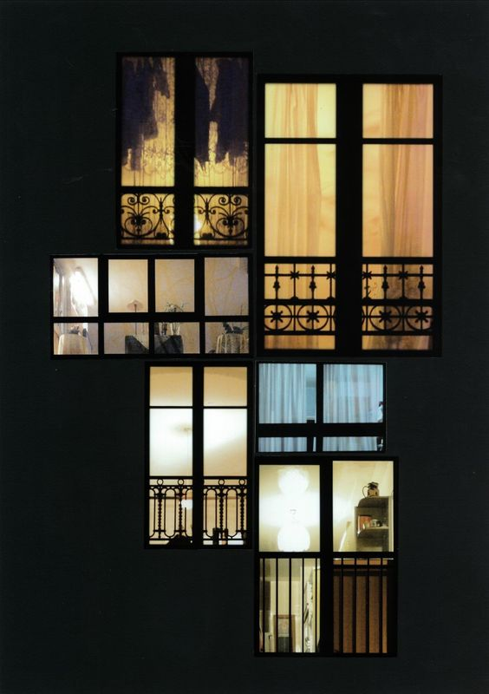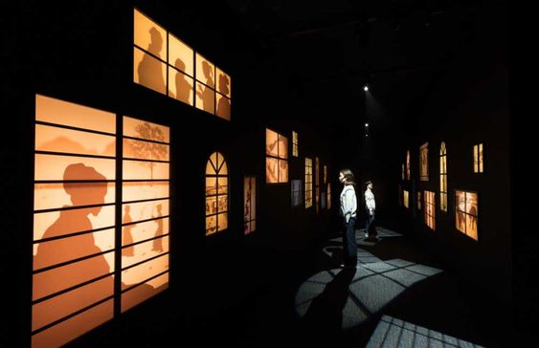

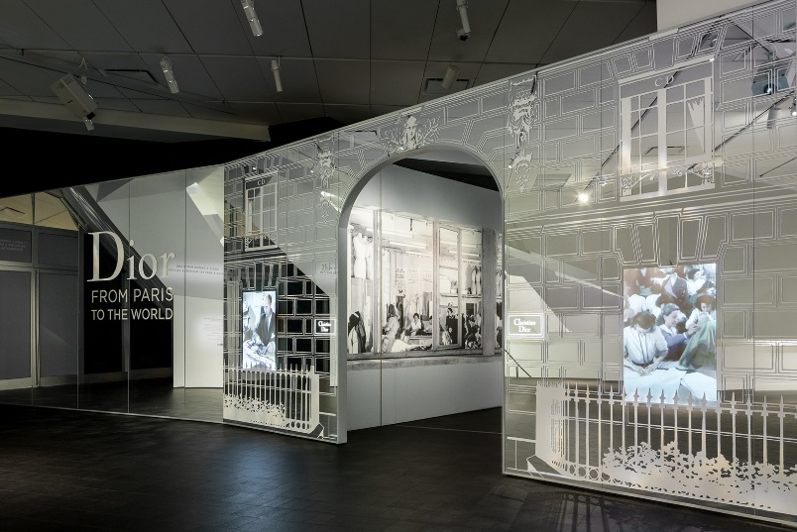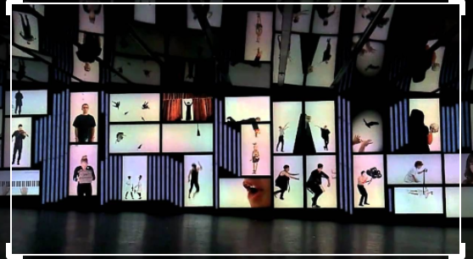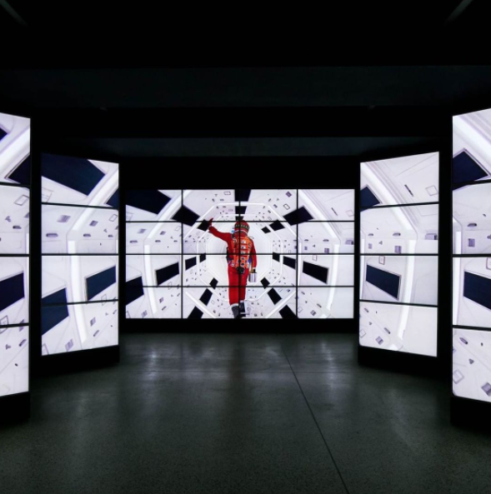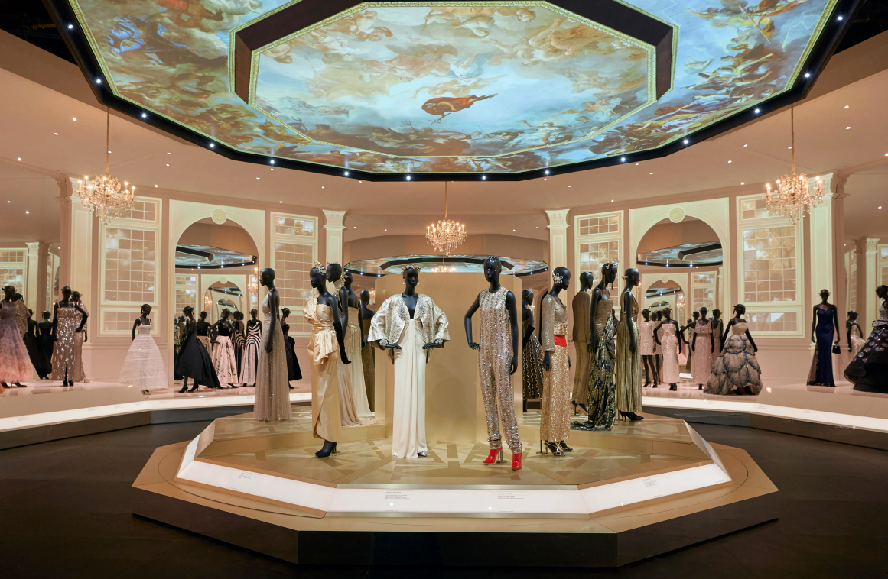

[**https://www.instagram.com/p/CGmbSMdAqBW/**](https://www.instagram.com/p/CGmbSMdAqBW/)

**Content to be included:**

We are looking at telling the wide story of film and TV in Liverpool, but we would like to prioritise the following films and big TV productions using relevant clips:

**Film**

(Range of locations and time periods)

Fantastic Beasts and Where to Find Them

Captain America: The First Avenger

51st State

Chariots of Fire

The Magnet

Film Stars Don’t Die in Liverpool

Letter to Brezhnev

**TV**

Shows set in and about Liverpool and shows using Liverpool as ‘elsewhere’

Peaky Blinders

Cilla

Tin Star Liverpool

Victoria

War of the Worlds

**‘Sound Bites’**

Liverpool Film Office and film and TV crew ‘sound bites’. This could be from directors, location managers, stunt people, crews, extras, wardrobe and production teams.

**Dwell time:** Approximately 3- 5minutes max. Contain a holding page which would be the ‘title of the section’ and would be shown between film looping. The film should run continuously on a loop.

**Audience:** Aimed at a general audience but needs to be accessible for visitors on the autism spectrum and dementia. The AV will also need to include subtitles.

**Copyright:** Footage and imagery is the responsibility of the AV Software provider, to research/source and purchase the copyright licenses/rights, under the guidance of the NML content team. NML requires all copyright license clearance to be at least ten year or a lifetime, nothing less. NML will require copies of the project files and media, so the AV presentation can be updated if and when necessary.

**Handover:** Once the final version of the software content has been signed off by the client team, the AV Software content producer will be required to deliver/handover final version of the AV files to the AV Hardware contractor.