British Deputy High Commission Lagos, Nigeria
Main Works
Contract Ref CPG-6500-2021

We invite you to register your interest for the British Deputy High Commission, Main Works via the Procurement Portal, e-Bravo/Jaggaer.

BACKGROUND INFORMATION

The British Deputy High Commission (BDHC) in Lagos is situated in its own small compound in the Victoria Island area of the city. The main building is in a poor state of repair and suffers from ongoing maintenance issues incurring significant costs. There is an over-provision of space within the BDHC compound and consequently, there is an opportunity for estate rationalisation, bringing other services and people connected to the BDHC into one place.

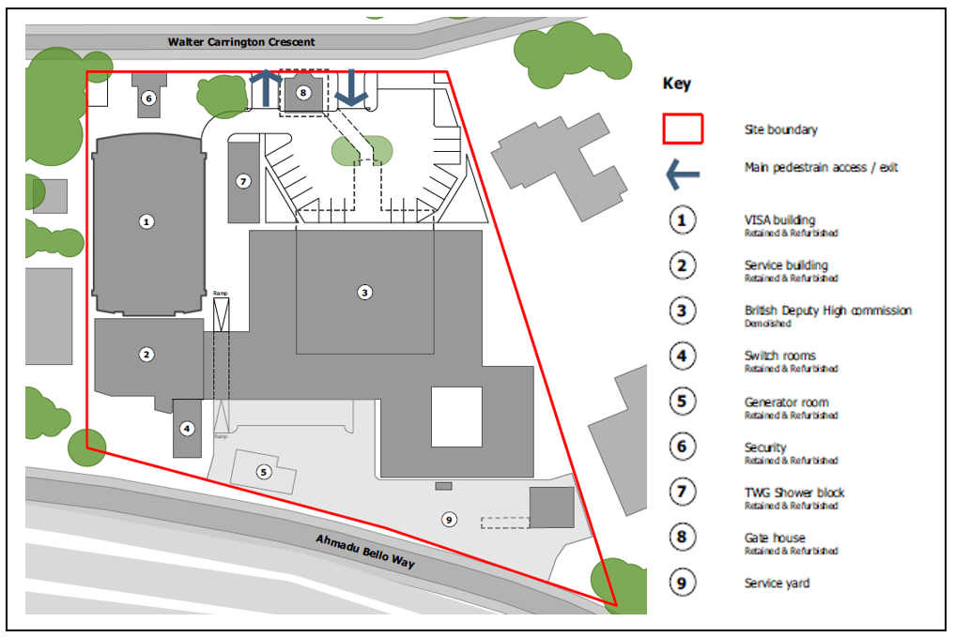
There are three main buildings on the site, the UKVI Building, which is to be refurbished, the Service Building, which houses plant feeding the rest of the compound, and the Chancery where staff are currently based. There are also a number of other, smaller buildings such as changing rooms. The plan below identifies the main items on site.

Submissions from subcontractors or suppliers for part of the works will not be considered. If the SQ is satisfactory then an invitation to tender (ITT) will be issued electronically via the dedicated FCDO web portal.

In order to be considered for this project and receive pre-qualification and/or tender information it is necessary that you register your company (including any relevant information requested) on the Foreign, Commonwealth & Development Office Procurement Portal, e-Bravo/Jaggaer. Failure to do this will mean your company may not receive a Tender; no tenders will be issued via open e-mail.

Project 6500, PQQ 1077: British Deputy High Commission Lagos, Nigeria
Main Works
How to Register Your Company/Express Interest in this Project:

1. Register your company on the eSourcing portal (this is only required once) - Browse to the eSourcing Portal: https://fcdo.bravosolution.co.uk and click the link to register. - Accept the terms and conditions and click "continue" - Enter your correct business and user details - Note the username you chose and click "Save" when complete - you will shortly receive an e-mail with your unique password (please keep this secure).

2. Login to the portal with the username/password - Click on the relevant Selection Questionnaire (SQ) - You can now access any attachments by clicking the "Settings and Buyer Attachments" in the "Actions" box;

Responding to the SQ - You can choose to "Reply" or "Reject" (please give a reason if rejecting) - You can now use the 'Messages' function to communicate with the buyer and seek clarification - Note the deadline for completion, - There may be a mixture of online & offline actions for you to perform (there is detailed online help available), You must then publish your reply using the publish button in the "Actions" box on the left-hand side of the page. If you require any further assistance please consult the the online help or contact the eTendering help desk.

Potential Providers should answer all questions as accurately and concisely as possible in the same order as the questions are presented. Where a question is not relevant to the Potential Provider’s
organisation, this should be indicated, with an explanation. Where attachments are requested to be submitted within the electronic SQ, these shall be submitted in a PDF format (Adobe or similar).
SQ or Bids not submitted via the FCDO’s eProcurement portal will not be considered.

SQ Return Date: 12:00hrs – Friday 18th June 2021 (BST) – Please note that any SQ’s submitted after the deadline has closed will be considered ‘late’ and may not be accepted for shortlisting.

