Guide for Construction Projects With a Project Value Over £100,000.

Version 3.1

Shared Prosperity Fund Construction Projects Guidance
- General.
1.1 A grant provide from a programme administered by Cornwall Council represents a significant investment of Public Funds. This guidance is for projects with a value in excess of £100,000. For this size of project, it is expected that applicants/recipients are supported by a professional such as an Architect or Quantity Surveyor. This guidance is primarily aimed at those professionals.

The Cornwall and Isles of Scilly Shared Prosperity Fund Good Growth Principles
- C1 Reduction in C02 emissions
- C2 Circularity - reduction in use of virgin raw materials. Recycle reuse principles
- G1 Nature recovery

1.2 Good Growth Fund recipients with projects involving built structures should embed these principles into the construction or renovation process. Environmental and resource saving enhancements should aim to be above the legal baseline, alongside associated appropriate mitigation measures. Evidence of which should be provided in the funding application. The following sections outline the topic areas which should be considered to ensure sustainable capital works.
1.3 All organisations proposing capital builds should consider their construction methods and materials, heat and power generation and storage options, transport connections and contribution to biodiversity net gain.

1.4 Applicants will be expected to consider environmental enhancements above the legal baseline, and associated mitigation measures appropriate to their scheme, and provide evidence to that effect within their funding application.

- Good Growth
2.1 Cornwall Council declared a Climate Emergency in 2019 and an Ecological Emergency in 2022. We need all of our communities to transition to become net zero without delay, which means reducing the UK’s net greenhouse gas emissions by at least 100% by 2050, compared to 1990 levels. In the UK, 49% of annual carbon emissions are attributable to buildings. We must intensify our efforts and eliminate virtually all emissions arising from heating, cooling and energy use in our buildings. It is imperative that the Cornwall and Isles Shared Prosperity Fund programme contributes to decarbonising the built environment through both improving existing buildings and ensuring that new capital works are fit for a net zero future. This can be achieved most efficiently by constructing buildings that conform to net zero standards, but this is not always possible and even making small changes that work towards environmental goals can be of significant value. Therefore, where Shared Prosperity Fund (SPF) funding is being used for the building or refurbishing of buildings, then the aim should be to strive to meet some of the Good Growth principles.

3. C1 Reduction in CO2 Equivalents emissions
3.1 This section will discuss the key steps that can be taken to reduce the whole life greenhouse gas emissions of built structures, both in terms of the initial construction or retrofit as well as the day-to-day operations.

3.2 When considering the carbon impact of development, it is important to consider not just the carbon emissions associated with energy use, but to also take a holistic view of the building’s entire lifetime carbon footprint, from construction to demolition:

Whole life carbon = Operational carbon + Embodied carbon

3.3 Whole life carbon analysis
3.3.1 Whole life carbon assessment (WLC, or Life Cycle Assessment) is the most comprehensive way to assess, measure and ultimately reduce a building’s entire lifetime carbon footprint. WLC encompasses operational carbon emissions (day-to-day resource use such as heating, cooking ext.) in addition to the embodied carbon emissions, which result from the materials used and the construction/dismantling process itself. Please see below for a full explanation of operational and embodied carbon.

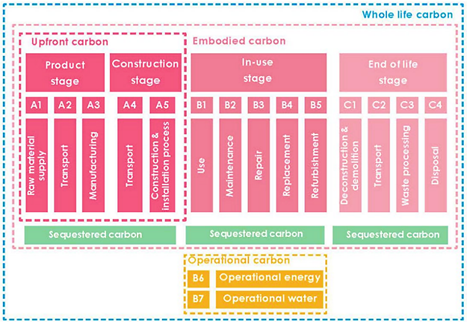
-Source: Low Energy Transformation Initiative, Whole Life Carbon One-pager

3.3.2 A key strength of using a WLC is that it enables a balance to be struck between the in-use or operational emissions against the embodied or fabric emissions. This is important because by prioritising embodied or operational carbon whilst neglecting the other, there may be unintended consequences where for example over-sophisticated systems save less carbon than they embody.

3.4 Operational carbon
Operational carbon describes the emissions associated with the operation and maintenance of a built asset including heating, hot water, cooling, ventilation, lighting systems, cooking, equipment, and lifts. A building that meets net zero operational carbon does not burn fossil fuels, is 100% powered by renewable energy, and achieves a very high level of energy performance. To achieve this the development will have maximised fabric performance and energy efficiency, as well as installing renewal heat and/or power technologies.

3.5 A Fabric First approach
3.5.1 The building ‘fabric’ is made up of the materials that make up walls, floors, roofs, windows and doors. A ‘fabric first’ approach to building design involves maximising the performance of the fabric itself, before considering such things as heating, energy or controls. Focusing on the building fabric is more sustainable than relying on energy saving products, or renewable technologies, as designing a building to use as little as possible at the outset is more efficient than retrospectively minimising resource use. This approach can optimise energy efficiency and reduce carbon emissions, thereby decreasing ongoing operational and maintenance costs.

3.5.2 In order to minimise resource use and greenhouse gas emissions, both operational and embodied carbon emissions must be minimised. The graphics below, reassembled from London Energy Transformation Initiative’s Climate Emergency Design Guide, an excellent resource, outlines a detailed picture of the indicative design measures which could be taken to minimise resource use.

Remember this is some of the design considerations your project’s architect and construction contractors may explore.
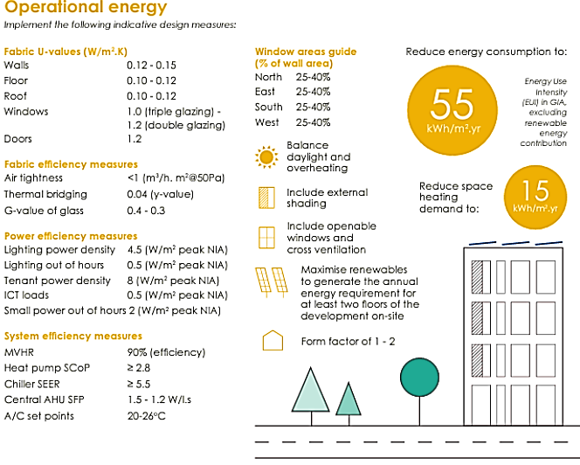

-Source: Graphics reassembled from London Energy Transformation Initiative: Climate Emergency Design Guide;

3.6 Embodied carbon
Embodied carbon is the total greenhouse gas (GHG) emissions generated to produce a building. This includes emissions caused by material sourcing, fabrication of components, transport, construction, maintenance, repair and replacement, demolition, dismantling and disposal. It is the energy that is embodied in the materials that are used. It excludes operational carbon emissions.

As initial construction is incredibly resource intensive, the retrofit or reuse of an existing building and thereby getting more use out of an existing structure and materials already on site is typically the lowest carbon option.

Remember this some of the design considerations your project’s architect and construction contractors may explore.
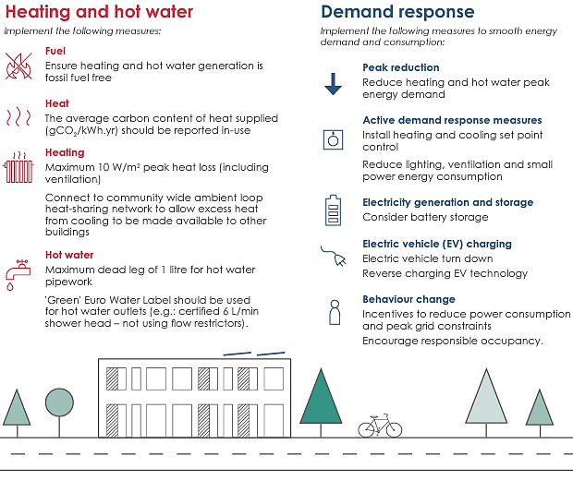
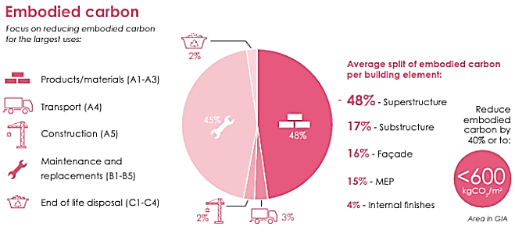
-Source: Graphics reassembled from London Energy Transformation Initiative: Climate Emergency Design Guide;

3.7 Net zero design principles
In addition to considerations of the above, the Royal Institute of British Architects has recommended the following principles for the design and retrofit of net zero and low carbon buildings Sustainable Outcomes Guide:

    - Passive First
Use form, fabric and landscape to optimise ambient lighting, heating, cooling and ventilation
- Location, orientation, massing, protection and shading
- Windows, daylighting, ventilation, solar and acoustic control
- Insulation, airtightness and thermal mass

    - Fine-tune, with gentle engineering
Use efficient and well-integrated mechanical and electrical systems and user-friendly controls
- Lighting systems, with effective;
- Ventilation systems, both natural and mechanical
- Heating, cooling heat storage and heat recovery systems
- Responsive system and room controls, with good user interfaces

    - Incorporate on-site renewables
Use low and zero carbon technologies to minimise energy purchases and carbon emissions. Consider:
- Building Integrated photovoltaic and solar hot water panels
- Ground, water and air source heat pumps and opportunities for heat recovery
- Heat and electricity storage, to improve load management and demands on mains supplies
- Local opportunities for wind and water power and for community systems

3.8 Key information sources
- Climate Emergency Development Plan Document
- UK Green Building Council: Resource use and the built environment, including circular economy principles and a wealth of other useful resources.
- RIBA: Sustainable Outcomes Guide
- RICS: Whole life carbon assessment for the built environment
- HM Cabinet Office: The Construction Playbook
- London Energy Transformation Initiative: Climate Emergency Design Guide;
- London Energy Transformation Initiative: Defining and Aligning: Whole Life Carbon & Embodied Carbon
- What is Net Zero: https://www.british-business-bank.co.uk/finance-hub/what-is-net-zero-an-introduction-for-small-businesses/
- SME Climate Hub Calculator: https://businessclimatehub.org/start-measuring/
- Carbon Trust: https://www.carbontrust.com/what-we-do/assurance-and-certification/route-to-net-zero-standard

3.9 Examples of certified approaches to sustainable buildings that recipients could consider using:
- Passivhaus standards are a fabric first building standard that exceed current national and local standards, certified by the Passivhaus Trust. Passivhaus adopts a whole-building approach with measured targets, focused on high-quality construction, certified through a quality assurance process. Standards exist for new build (Passivhaus) and retrofit (EnerPHit).
- CarbonLite standards, developed by the AECB are designed to deliver environmentally responsible building practices and the creation of sustainable low energy, low carbon buildings. They work with Passivhaus standards but also cover whole life carbon. CarbonLite have certified standards for New Build and Retrofit.
- BREEAM standards, developed by the BRE Trust offer sustainable building standards for new build and retrofit for many different types of development.

4. C2 Circularity - reduction in use of virgin raw materials. Recycle reuse principles
‘In our current economy, we take materials from the Earth, make products from them, and eventually throw them away as waste – the process is linear. In a circular economy, by contrast, we stop waste being produced in the first place.’

  - The circular economy is based on three principles, driven by design:

4.1.1 Eliminate waste and pollution: Currently, our economy takes raw materials from the Earth, we make products, and eventually we discard them as waste, the end point often being landfills or incinerators. This system cannot work in the long term because our planetary resources are finite. In terms of construction, we need to design how the materials can re-enter the economy at the end of their use.

4.1.2 Circulate products and materials (at their highest value): Building on the above principle, this means designing products so they can be useful at every stage of their life. Thereby products should be kept in use for as long as possible, and then if unavoidable, reused, repaired, remanufactured, and recycled or composted.

4.1.3 Regenerate nature: By moving to a circular economy, we minimise the amount of land and resources we need and maximise space for nature to thrive
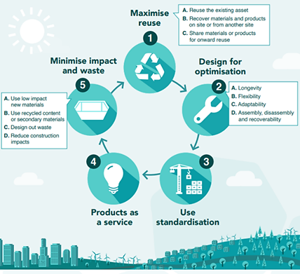
Source: UK Green Building Council, Circular Economy Metrics Paper

4.2 RIBA’s Built for the Environment report shows that 40% of global greenhouse gas emissions are attributable to buildings and construction, consuming about 50% of all raw materials worldwide in the process. In addition, over 50,000 buildings are demolished each year across the UK, many of which could have been repurposed. The circular economy offers ways to reduce these unsustainable figures, seeking to eliminating waste by reusing buildings and their material components wherever possible.

4.3 Key information sources
- UK Green Building Council circular economy guidance
- London Assembly: Circular Economy Statement Guidance
- Buildings As Material Banks: Materials Passports
- Architects Climate Action Network: Circular Series
- University of Sheffield: Regenerate - a circular economy engagement tool
- Further reading: What is the circular Economy: https://ellenmacarthurfoundation.org/topics/circular-economy-introduction/overview

5. G1 Nature recovery

5.1 Constructing or renovating a built structure will always have an impact directly or indirectly on the natural environment, but there are ways to enhance the surrounding area and support nature recovery. Many of these measures are easy and low cost but can make a tangible difference:
- Protect and create natural functioning habitats to generate biodiversity gain
- Provide wildlife corridors (green and blue) to allow wildlife movements
- Blurred boundary design to patchwork habitats
- Installing creature features e.g., bird or bat boxes, insect hotels or bee bricks
- Creating wildflower meadows
- Creating a wildlife pond
- Nature-friendly lighting
- Pollinator-friendly mowing regimes
- Appropriate tree planting
- Stopping the use of artificial pesticides and/or wider land-management improvements.

5.2 The best way to make a difference for nature locally is to understand what’s already in your local environment and what can be done to enhance the local ecosystem. The Cornwall and Isles of Scilly Local Nature Partnership has devised a step by step guide for exactly this purpose.

5.3 Ensure Site Remediation has been considered and addressed as required. Site remediation is the process of removing polluted or contaminated soil, sediment, surface water, or groundwater, hydrocarbon contamination, asbestos to reduce the impact on people or the environment. A polluted site can have a serious impact on human health, water supplies, eco-systems and even on building structures.
5.4 Your application might include surveys and management plan development for your enterprise premises using the Wildlife Trust guide

5.5 Useful Links:
- Cornwall and Isles of Scilly Local Nature Partnership: Nature recovery toolkit
- Carbon Neutral Cornwall 2030 Hive: Together We Can Toolkit
- UK Green Building Council: Biodiversity net gain factsheets
- Local Nature Recovery: more information on how the scheme will work
- The CIOS Nature Recovery Plan
- The CIOS Local Nature Partnership

6. Invitation To Tender (ITT) Considerations

6.1 Construction Contracts

It is recommended that for larger construction projects that use is made of the construction industries standard contracts such as:
- NEC4 Engineering and Construction Short Contract: https://www.neccontract.com/products/contracts?msclkid=7019a4d273551abaef25c726e4086e8f
- One of the The Joint Contracts Tribunal Limited’s Contracts: https://www.jctltd.co.uk/category/contract-families

6.2 Meeting your Good Growth Contractual Clauses.

There are specific clauses that must be met within your SPR Offer Letter which are based on the above and provided below to ensure you have fully considered your building project at Enclosure 1.

6.3. Social Value

6.3.1 The Public Service (Social Value) Act2012 requires all public authorities to consider how the services they commission will improve the SCOCIAL, ENVIRONMENTAL and ECONOMIC WELLBEING of communities. Putting this in a simpler form:

“If we spend on the delivery of services, can that investment be used to also deliver a wider benefit to the community?”

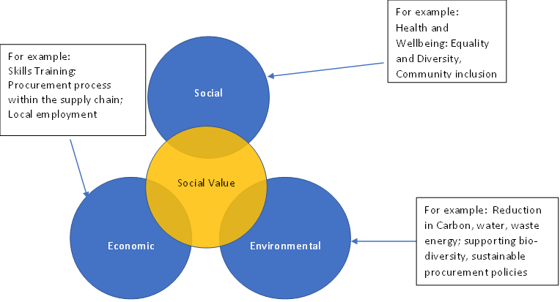

6.3.2 As an applicant receiving public funding through a grant, Social Value should be included in contracts above £100,000.00 (excluding VAT) and form a minimum of 10% of the evaluation of any ITT.

6.3.3 Why is social value important? Social Value ensures and promotes:

- It promotes “the power of procurement for good” – impact positively on the CIOS economy for example
- Cornwall Council is leading the way in CO2 Equivalents reduction and achieving its ambitions to be carbon neutral by 2030.
- Encouraging organisations to behave in a way that benefits society more broadly – promote reusable packaging, optimum transport to reduce carbon emissions for example
- It should encourage local employment, skills training and environmental improvements
- Encourage local businesses to invest and engage in their communities and improve their processes and policies.
6.3.4 Potential Social Value Questions that might be used in an ITT. Please note that you should only use a selection of these questions but at least 2 and in particular consider those which meet the Good Growth Principles; the larger the project then more questions and a possible increase on the 10% evaluation criteria. Note Social Value evaluation should not exceed 20% and this is normally only used on multi-million pound procurements.

Question | How the question might be assessed
Improved staff wellbeing and mental health | Equality, diversity and inclusion training provided for staff
Working with the Community | Support provided to help local community draw up their own Community Charter or Stakeholder Plan
Air pollution is reduced | Car miles driven using low or no emission staff vehicles included on project as a result of a green transport programme. See also Section 3.2
Safeguarding the natural environment | See Section 5 and Good Growth Principles
Safeguarding the natural environment | Donations or investments towards expert designed sustainable reforestation or afforestation initiatives
Safeguarding the natural environment | Volunteering with initiatives working on environmental conservation and sustainable ecosystem management - resources invested including time, funds and in-kind contributions
Safeguarding the natural environment | Plastic recycling rate on the contract (to e.g. reduce microplastics) See Section 3.2 and Good Growth Principles
Resource efficiency and circular economy solutions are promoted | Value of service provided by local partnerships that implement circular economy solutions. See Section 3.2 and Good Growth Principles
Resource efficiency and circular economy solutions are promoted | WATER: Percentage of buildings meeting good practice benchmark (e.g. REEB). See section 3.2
Social innovation to create local skills and employment | Innovative measures to promote local skills and employment to be delivered on the contract - these could be e.g. co-designed with stakeholders or communities, or aiming at delivering benefits while minimising carbon footprint from initiatives, etc.
Social innovation to support responsible business | Innovative measures to promote and support responsible business to be delivered on the contract - these could be e.g. co-designed with stakeholders or communities, or aiming at delivering benefits while minimising carbon footprint from initiatives, etc.
More local people in employment | No. of local direct employees (FTE) hired or retained (for retendered contracts) on contract for one year or the whole duration of the contract, whichever is shorter. What local subcontractors will be involved.
More opportunities for local  MSMEs and VCSEs | Total amount (£) spent through contract with local micro, small and medium enterprises (MSMEs)
Carbon emissions are reduced | Savings in CO2 Equivalents emissions on contract achieved through de-carbonisation (specify how these are to be achieved). See also Section 3.2 and Good Growth Principles

When assessing the responses to the Social Value Questions, any potential tenderer should make it clear how they are going to meet their commitment:
- What you will do
- When will you do it
- How will you do it
- Why will you do it
- How will you report on it
These should then form part of any contract that you enter into.
Enclosure 1
The following contract clauses will be included in the funding agreement if selected within the Initiation Form
Good Growth principles | What this means | Mechanism | Contract clauses  up to £50,000 | Contract clauses  £50,000 - £200,000 | Contract clause over £200,000
Reduction in CO2 emissions | Cornwall Council declared a climate and ecological emergency in 2019.  It is vital that all businesses, communities and the Council work together to find a way to reduce consumption and lower our carbon emissions to avert climate and ecological breakdown. For more information, please see Cornwall Council’s Climate Change Action Plan. | Environmental Sustainability Policy includes some of the following areas:  - The recipient organisation’s commitment to Net Zero by 2050 in the UK.  - Estimated carbon dioxide equivalent reductions as a result of the project.  - Increased take up of energy efficiency measures as a result of the project.  - Increased use of cycleways or foot paths as a result of the project.  - Increased amount of low or zero carbon energy infrastructure installed as a result of the project.  - Provision of other associated environmental growth infrastructure e.g., EV charging points or building performance monitoring equipment.  - Increased business sustainability as a result of the project.  - Number of trees planted as a result of the project.  - Travel planning to reduce the number of vehicle movements.  - Training / raising awareness amongst staff, participants or beneficiaries about how they can reduce their carbon footprint.  - Consider opportunities for mitigation of negative practices where possible to work towards delivering net zero.  - All organisations proposing capital builds should consider their construction methods and materials, heat and power generation and storage options, transport connections and contribution to biodiversity net gain.  - The environmental management measures that are in place and which will be in effect and utilised during the performance of the contract. These measures must combat climate change and/or contribute towards nature recovery and/or any other activities outcomes that constitute environmental growth.  - Carbon emissions reduced (KG/Tonnes);  - Renewable energy capacity installed (kWh);  - Mode shift towards active travel or public transport (No Miles Saved);  - Reduction in consumer energy demand/use through energy efficient purchasing (kWh);  - Households supported to take energy efficiency measures (No of Households);  - Participants attending carbon reduction training (No of Participants).  - Amount of green or blue space created or improved (m2). | Recipient to submit Environmental Sustainability Policy at the point of final claim  submission. | Recipient must produce an Environmental Sustainability Policy as part of the gateway criteria, at the time of submitting their application.  The Recipient will provide relevant information to Cornwall Council to monitor and evidence impact and performance in relation to this principle | If not already included in the Environmental Sustainability Policy, the Recipient must produce a Carbon Reduction Plan within 6 months of signing the funding agreement which details their organisational carbon footprint and confirms their commitment to achieving Net Zero by 2050. If necessary, the Recipient will resubmit their Environmental Sustainability Policy at the point of final claim submission which commits the organisation to reduce C02 emissions in the long term.  The Recipient will provide relevant information to Cornwall Council to monitor and evidence impact and performance in relation to this principle
Circularity - reduction in use of virgin raw materials. Recycle-reuse  principles | In our current economy, we take materials from the Earth, make products from them, and eventually throw them away as waste – the process is linear. In a circular economy by contrast, we stop or reduce the amount of waste being produced in the first place. Measures to move towards a more circular economy may include improving  recycling rates, sustainable production of natural resources (such  as timber and minerals), and tackling pollution and food waste. Striving towards a circular economy is important because we need to preserve our world’s finite resources for future generations. | ​​​​​A Circular Economy can be defined as one where materials are retained in use at their highest value for as long as possible and are then reused or recycled, leaving a minimum of residual waste.  A Circular Economy Statement could include the following areas:  - Reducing waste, consider zero landfill policies, onsite composters.  - Improved resource efficiency, utilising recycled / reuse principles, reduction in use of virgin raw materials.  - Reducing food waste.  - Training of staff.  - Explain how resource efficiency is communicated to your customers.  - What channels do you give them to improve their own resource efficiency e.g., compostable / recycled packaging.  Increased percentage of waste recycled (% increase in Waste Recycling);  - Reduction in waste production (KG/Tonnes);  - Products designed to be recyclable and/or reusable (No of Products);  A Circular Economy Statement would primarily be relevant to projects which have physical inputs. The Statement will set out the management measures that they have in place, including, the strategic approach, a bill of materials, recycling and waste reporting form. | Recipient to submit Environmental Sustainability Policy at the point of final claim  submission. | Recipient must produce an Environmental Sustainability Policy as part of the gateway criteria, at the time of submitting their application.  The Recipient will provide relevant information to Cornwall Council to monitor and evidence impact and performance in relation to this principle | If not already included in the Environmental Sustainability Policy, the Recipient must produce a Circular Economy Statement within 6 months of signing the funding agreement which details their organisations commitment to reducing waste and supporting the circular economy. If necessary, the Recipient will resubmit their Environmental Sustainability Policy at the point of final claim submission which commits the organisation to the reduction in use of virgin raw materials and principles of recycling.  The Recipient will provide relevant information to Cornwall Council to monitor and evidence impact and performance in relation to this principle
Nature recovery | In line with the rest of the UK, nature is in serious decline  in Cornwall. Over the last 30 years, nearly half of  terrestrial mammals and three-fifths of butterflies are  found in fewer places. Almost half of breeding birds  have declined. In order to avert ecological breakdown, we must go beyond decarbonising our economy and endeavour to conserve our natural environment.  Nature recovery is about improving natural capital. Natural capital is the elements of nature that have value to society, such as forests, fisheries, rivers, biodiversity, land and minerals.  Stocks of natural capital provide flows of services and assets over time and are incredibly beneficial for a society. Services and assets may include commodities with a market value (minerals, timber, freshwater) or non-market value (such as outdoor recreation, landscape amenity).  At its simplest, a natural capital approach is about thinking of nature as a set of assets which benefit people. The ability of natural assets to provide goods and services is dependent on their quality, quantity and location. | An online resource has been launched by the Department for Environment, Food and Rural Affairs (Defra) to help ensure better environmental decision-making by valuing our ‘natural capital’. For the first time, a comprehensive and integrated set of evidence and guidance about UK natural capital is now accessible from one place. It is intended to help policy makers, businesses, landowners and public sector organisations make better planning decisions in order to protect and to boost natural capital.  ‘Natural capital’ is the sum of our ecosystems, providing us with food, clean air and water, wildlife, energy, wood, recreation and protection from hazards. The natural capital approach will make it easier for public and private organisations to better assess and value the environment. This will help deliver benefits including long-term flood risk reduction, boosts to wildlife, improvements to water and air quality, and opportunities for biodiversity net gain.  A conservation covenant agreement may be suitable for some contracts and projects. A conservation covenant agreement is a private, voluntary agreement to conserve the natural or heritage features of the land. This can include buildings on the land. Conservation covenants can be used to secure the benefits delivered by biodiversity net gain and other measures for the long term.  In general, most projects will need to demonstrate nature recovery and net biodiversity gain as part of their Environmental Sustainability Policy, as stated in the gateway criteria and application form guidance. Within the Environmental Sustainability Policy, applicants will need to explain how their organisation can support nature recovery through their project. If the project involves development, they may wish to show how they have built with nature in mind by integrating nature, including through green infrastructure, sustainable drainage and wildlife friendly features, for example:  - Protecting and creating natural functioning habitats to generate biodiversity gain;  - Providing wildlife corridors (green and blue) to allow wildlife movements;  - Blurred boundary design to patchwork habitats.  If the project involves use of a building or land that is not being developed, recipient’s should consider how they could enhance it to be more nature-friendly through:  - Installing creature features e.g., bird or bat boxes, insect hotels or bee bricks;  - Creating wildflower meadows;  - Creating a wildlife pond;  - nature-friendly lighting;  - pollinator-friendly mowing regimes;  - Appropriate tree planting;  - stopping the use of artificial pesticides and/or wider land-management improvements. | The project must deliver a net biodiversity gain and provide evidence to demonstrate that this aim has been achieved. | The project must deliver a net biodiversity gain and provide evidence to demonstrate that this aim has been achieved.  The Recipient will provide relevant information to Cornwall Council to monitor and evidence impact and performance in relation to this principle | The project must deliver a net biodiversity gain and provide evidence to demonstrate that this aim has been achieved.  Additional clause if applicable; a Conservation covenants can be included to conserve either the:  - natural environment or the natural resources of the land (or the setting of land)  - land as a place of archaeological, architectural, artistic, cultural or historic interest (or the setting of land)  The Recipient will provide relevant information to Cornwall Council to monitor and evidence impact and performance in relation to this principle

