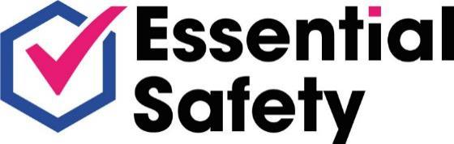


FIRE RISK ASSESSMENT REPORT

For: North Northamptonshire Council

At: Raven House Children’s Home
53/55 Rockingham Road
Corby
NN17 1AJ

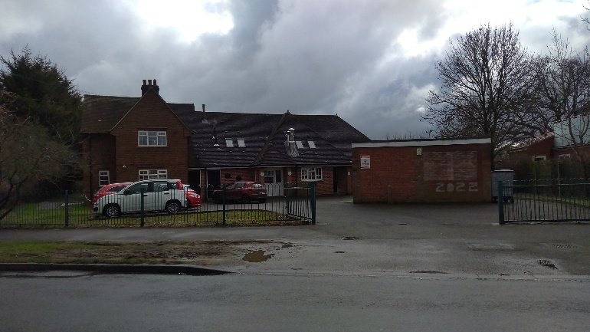

Report Date: 1st March 2023

By: Jonathan Roberts
Fire Safety Consultant
Essential Safety Ltd

 | Name | Date
Prepared By | Jonathan Roberts | 1st March 2023
Reviewed By | James Balding | 20th March 2023
Issued To | Lisa Phillips  Compliance & Maintenance Manager | 20th March 2023
PREFACE

At the request of Lisa Phillips, Compliance & Maintenance Manager for North Northamptonshire Council, (“The Client”) Jonathan Roberts of Essential Safety Ltd (“The Consultant”) carried out an assessment of the fire risks at Raven House Children’s Home, 53/55 Rockingham Road, Corby NN17 1AJ on the 1st of March 2023.

The Client’s brief was to carry out an assessment of the fire risks at the premises; to produce a written report; and to provide recommendations and an action plan to implement any identified fire safety risk improvement measures.

This report identifies, in the professional opinion of the consultant, breaches of the Regulatory Reform (Fire Safety) Order 2005 (RRFSO), and recommendations for fire safety improvement measures.

This fire risk assessment is based upon a non-invasive survey of the premises

The survey involves the inspection of building elements and fabric which are visible without the need to remove casings, cladding or other building components. The survey may involve inspection of accessible areas above suspended ceiling tiles and in loft spaces, where safe access is available, to check compartmentation walls or fire stopping of services etc.

The survey does not involve the removal or sampling of cladding, insulation or other building materials. The survey does not include access to lift shafts or other areas not normally accessed by day-to-day occupants of the premises.

The consultant carrying out this assessment has no powers under any statutory order to demand access or for the production of documents or information. Therefore, information provided by the client and their representatives during the course of the assessment is assumed to be accurate.

The information and recommendations provided by Essential Safety Ltd within reports are provided in good faith based upon the information and evidence available at the time and no guarantee can be provided that matters of non-compliance may not be discovered by inspectors with statutory powers during any subsequent inspections.

Essential Safety Ltd makes every effort to identify contraventions of statute and best practice as determined by approved codes of practice and British Standards. All advice is provided as the opinion of Essential Safety Ltd and is subject to interpretation in a court of law in the UK.

Essential Safety Ltd makes every effort to ensure that the information provided is accurate and up to date but no legal responsibility is accepted for any errors or omissions or misleading statements.

METHODOLOGY

The assessment was carried out using the following methods:
- Policy & document reviews
- Workplace Inspections
- Interviews with the Responsible Person

KEY TO FINDINGS AND RECOMMENDATIONS

Action Plan Priorities
Findings which are, in the professional opinion of the assessor, compliant with the requirements of Regulatory Reform (Fire Safety) Order 2005 (RRFSO) and associated guides.
Where there are potential health and safety risks or where failure to implement changes would be highly likely to attract legal implications. Immediate action is recommended to put changes into effect.
Where action is recommended within the 3 months to alleviate or make improvements that will have a considerable impact.
Where action is recommended within 12 – 24 months.
Where the recommendation involves excessive costs or should be implemented as part of a planned maintenance plan.

LEGAL REQUIREMENTS

Section 2 of the Health & Safety at Work etc. Act 1974 (HASWA) places a general responsibility upon employers for the health, safety & welfare of their employees, and then goes on to outline more detailed requirements upon the employer to provide:
- A safe place of work
- Safely maintained plant
- Safe systems of work
- Safe use, handling, storage & transport of articles & substances
- Information, instruction, training and supervision
- A written Policy (5 or more employees)

Section 3 of HASWA places a duty upon employers to persons not in their employment, but who might be affected by their activities.

The Management of Health & Safety at Work Regulations 1999 require employers to assess the risks to the health & safety of employees & non-employees, and implement the necessary safe practices and procedures to protect them. These Regulations also place a further responsibility upon employees to report any unsafe circumstances to their employer.

The Regulatory Reform (Fire Safety) Order 2005 (RRFSO) places responsibilities upon the “responsible person” in respect of fire safety. The “responsible person” is anyone who has a degree of control over premises or systems, including managing agents, employers, occupiers or anyone else who has who has some control over premises.

Under the RRFSO, the “responsible person” must:
- Carry out a fire-risk assessment, identifying any possible dangers and risks
- Consider who may be especially at risk
- Eliminate or reduce the risks from fire as far as is reasonably possible and provide general fire precautions to deal with any possible risk left
- Take other measures to ensure that there is protection if flammable or explosive materials are stored or used
- Create a plan to deal with any emergency and keep a record of the findings
- Review the plans and findings when necessary.

Question | Response | Details

Preliminaries
Occupier of Premises | North Northamptonshire Council.
Responsible Person | Nicola Ahern, the Manager
Position | The Manager was not available at the time of this assessment.  Gemma Johnston, the Assistant Manager and Chris Martin, the Senior Residential Worker were the senior persons responsible providing assistance on the day of this assessment.
Address of Property | Raven House Children’s Home  53/55 Rockingham Road  Corby  NN17 1AJ
Suggested date for Review | 1st March 2024

Previous Fire Risk Assessment
Date | 18th January 2022
Description | The previous Fire Risk Assessment was carried out by Essential Safety Limited

1 The Building
1.1 Number of floors | Two
1.2 Approximate floor area (m2) | The premises measure approximately 350m²
1.3 Brief details of building | The premises are a former domestic residence of brick construction with a pitched tiled roof.  The ground floor comprises of an entrance foyer, a kitchen, a dining room, a games room , a lounge, a disabled toilet, an office, store cupboards, a manger’s office, a laundry, a bathroom, two bedrooms and a flat.  The first floor comprises of a staff room, storerooms, a staff sleeping room, a medication room, two bathrooms and three bedrooms. From which there is a central stairwell to the foyer area and a protected fire stairwell at the rear of the property.  There is a separate garage at the front of the property which is approximately 40m² and is mainly used for storage.
Appendix 1

1.4 Inaccessible areas | Access to the following areas was not available at the time of this assessment:  - First floor cupboard FR008  - Ground floor cupboard FR029  - Administration store room in the garage  - Limited access was available to the loft space
Recommendations | 1.4 – It is recommended that further investigations are carried out to verify that any sources of ignition and fuel within the first floor cupboard FR008; ground floor cupboard FR029; administration store room in the garage and the loft space are adequately managed.
1.5 Is the premises a multi-occupied building? | No
1.6 If so, have significant findings been shared with the occupiers? | N/A
1.7 Are fire engineered solutions present? If so, have there been any significant changes? | N/A

2 The Occupants
2.1 Approximate number of occupants in the premises at any one time. | A maximum of 16 occupants are likely to be present at the premises at any one time.
2.2 Maximum number of staff or residents at any one time | A maximum of 8 members of staff are on duty at any one time during the day with 1 waking and 1 sleeping staff members present at night.  A maximum of 5 residents are likely to be present at the premises at any one time.
2.3 Maximum number of visitors / members of the public at any one time. | A maximum of 3 visitors are likely to be present at the premises at any one time.
2.4 Opening times and times of occupation | Staff occupy the premises between the hours on a 24 hour basis.

3 Occupants at special risk
3.1 Any sleeping occupants? | Yes | At the time of this assessment there were 3 residents and 1 sleeping members of staff at the premises.
3.2 Any persons with disabilities? | No | The management are aware of the need to produce a Personal Emergency Evacuation Plan (PEEP) should the need arise.
3.3 Any occupants in remote or high-risk areas? | No
3.4 Others (Including Lone Workers) | Yes | A Lone Working Policy is in place with the staff maintaining communication.

4 History of Fires
4.1 Any known history of previous fires or false alarms in the premises? | No

5 Fire Safety Legislation Applicable to Premises
5.1 Applicable Legislation | The Regulatory Reform (Fire Safety) Order 2005
5.2 Other Fire Safety Legislation

6 Procedures and Arrangements
6.1 Is there a general statement of policy in place? | Yes | The Fire Safety Policy is maintained in the Fire Log Book at the premises.
6.2 Is there a person nominated as responsible for fire safety? | Yes | Nicola Ahern, the Manager is the Responsible Person for the management of fire safety measures at the premises.
6.3 Is there a competent person(s) available to assist in implementation of fire safety legislation? | Yes | Chris Martin, the Senior Residential Worker is the competent person(s) who are available to assist in implementation of fire safety legislation at the premises.
6.4 Are there appropriate fire evacuation procedures in place? (Including what to do in the event of a fire, raising the alarm, safe evacuation of all persons, arrangements for summoning the fire & rescue services etc.) | Yes | The Council has developed detailed fire evacuation procedures.
Recommendation | 6.4 It is recommended that the Evacuation Procedure is developed to include specific instructions to members of staff on their actions in the event of a resident refusing to leave the building. This should include evaluating the risks and benefits of remaining for a limited period of time in order to either persuade the individual to leave or ensuring they are in a place of comparative safety if possible, balancing these against the likely risk to the member of staff in doing this.
6.5 Is the assembly point located in a suitable position and identified? | Yes | The assembly point is located at the front gates from where further egress is available.
6.6 Are there competent people nominated to assist with the evacuation? | Yes
6.7 Are there people nominated to liaise with the fire service in the event of a fire? | Yes | The Senior Staff member will liaise with the Fire Service in the event of a fire.
6.8 Are there routine in house inspections / audits of fire safety measures in the premises? | Yes | Monthly audits are conducted by the management and external audits are also conducted.

7 Training and Drills
7.1 Are all staff given fire safety instruction & training on employment induction? | Yes | New members of staff are provided with fire safety instruction during their induction.
7.2 Are all staff given periodic "refresher training" at suitable intervals? (dependent on staff competencies) | Yes | All staff complete fire awareness training on a rolling annual basis.

7.3 Are staff with special responsibilities (e.g. Fire Wardens) given additional training? | Yes | Two staff members are identified as Fire Marshals, however, the training records were not available at the time of this assessment to verify the dates of the training.
Recommendations | 7.3 It is recommended that a review of the Fire Marshals is undertaken to verify that there is coverage for all areas at all times of occupation.  It is further recommended that a sufficient number of staff should attend Fire Marshals’ training as soon as reasonably possible, including practical instruction in the safe selection and use of fire-fighting equipment, to ensure that there is coverage at all times, including coverage for holidays and absences.  It is recommended that Fire Marshals attend refresher training every 3 years.
7.4 Is the training up to date? | No | Please refer to Section 7.3.
7.5 Are fire drills carried out at appropriate intervals and recorded? | Yes | The records show that the last fire drill was conducted on the 20th of February 2023.

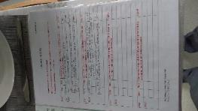
Appendix 2

8 Testing and Maintenance
8.1 Is there a system in place to report deficiencies/defects? | Yes | All deficiencies are reported to the management who will make arrangements for repairs and maintenance as required.
8.2 Is weekly testing of fire detection and/or alarm systems undertaken (in line with manufacturer’s recommendations and/or relevant standards)? | Yes | Various staff members test the fire alarm on a weekly basis.
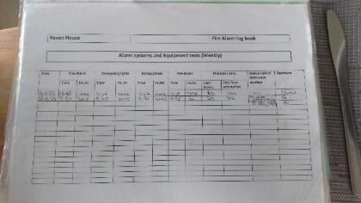
Appendix 3

8.3 Periodic servicing & maintenance of the fire alarm & detection system was last carried out on: | The fire alarm system was last serviced on the 19th of January 2023 by Newflame.
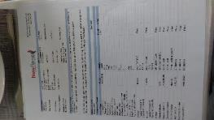
Appendix 4
8.4 Are the interlinked smoke and heat detectors present within their expiry date? | N/A
8.5 Is there a system in place to manage and reduce the likelihood for unwanted fire detection signals? | Yes | Keyed manual call points are provided to reduce the risk of false alarms.
8.6 Are monthly testing routines for emergency lighting undertaken? | Yes | The emergency lighting is tested by various staff members staff on a weekly basis.  Please refer to Appendix 3
8.7 Periodic servicing & maintenance of the emergency lighting was last carried out on: | Records were not available at the time of this assessment, it was unclear whether periodic servicing & maintenance of the emergency lighting is carried out at the premises within the last twelve months.
Recommendations | 8.7 All emergency lighting at the premises should be subjected to a full discharge test by a competent person annually in accordance with BS 5266 with the records maintained within the Fire Safety Log Book retained on the premises.  Units can be tested by simulated mains failure at the key switch where provided. The tests should be made during the daylight hours to allow sufficient time for the units to be fully re-charged before the hours of darkness. A fully discharged unit can take between 14-16 hours to re-charge.
8.8 Are monthly checks of fire extinguishing appliances undertaken? | Yes | Various staff members check the fire extinguishing appliances on a weekly basis.  Please refer to Appendix 3

8.9 Is annual servicing of fire extinguishing appliances undertaken? | Yes | The fire extinguishing appliances were last serviced by Newflame in December 2022.
Appendix 5

8.10 Is six-monthly inspections and annual testing of rising mains undertaken? | N/A
8.11 Is weekly testing of sprinkler installations undertaken (if present)? | N/A
8.12 Are routine checks of internal fire doors and final exit doors undertaken? | Yes | The fire doors and final exit door checks are conducted on a weekly basis.  Please refer to Appendix 3
8.13 Other relevant inspections or tests (e.g. smoke control systems): | N/A

9 Electrical and Gas Sources of Ignition
9.1 Are reasonable measures taken to prevent fires of electrical origin? | No | Please refer to Section 9.2
9.2 Are fixed installations periodically inspected and tested in accordance with guidance given in the Electricity at Work Regulations 1989? | Records not available
Appendix 6

Recommendations | 9.2 All fixed electrical installations at the premises should be tested, inspected and certified by a suitably competent person, in accordance with the Electricity at Work Regulations 1989 and as defined within guidance published by the Institute of Electrical Engineers (IEE). Should the report detail that the condition of the electrical installations are unsatisfactory remedial works should be completed by a competent person every five years.
9.3 Have all portable electrical appliances been adequately tested in accordance with guidance given in INDG 236 (Rev 2)? | Yes | The portable electrical appliances service labels indicate that they were last subjected to Portable Appliance Testing in February 2022.
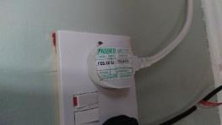
Appendix 7
9.4 Is there suitable policy regarding the use of personal electrical appliances? | Yes
9.5 Is there suitable limitation and control of trailing leads and adaptors? | No | A 4-gang extension was observed in the Staff Sleep Room with a kettle positioned on the bedside unit above.
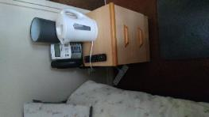
Appendix 8
Recommendations | 9.5 It is recommended that the 4-gang extension cable in the Staff Sleep Room is relocated away from liquids that may cause a fire following a spillage.
9.6 Are gas fired installations present within the building? | Yes | The premises are provided with two gas boilers in the boiler room, which provide heating to all areas of the premises.

9.7 Are gas fired installations periodically inspected and tested? | No | The gas boilers were last subjected to an inspection by Andrew Pipework Services Limited on the 7th of March 2022, however, it was verbally confirmed that the gas cooker/hob has not been subjected to an inspection.
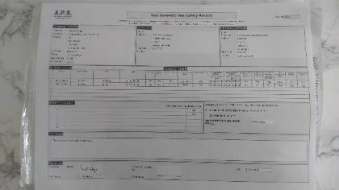
Appendix 9
Recommendations | 9.7 The gas cooker/hob at the premises have been serviced, maintained and subjected to annual safety checks by a GAS SAFE registered engineer in accordance with the Gas Safety (Installation and Use) Regulations 1998.
9.8 Are records of annual gas safety checks available? | No | Please refer to Section 9.7

10 Smoking
10.1 Are reasonable measures taken to prevent fires as a result of smoking? | Yes | Smoking is not permitted on the premises.
10.2 Is there a smoking policy in place? | Yes
10.3 Are there designated smoking areas? | N/A
10.4 Are designated smoking areas suitably managed? | N/A

11 Arson
11.1 Has the potential for arson been identified? | Yes | The premises is provided with an intruder alarm and CCTV.
11.2 Are there suitable measures in place to identify, reduce and where possible eliminate the threat of arson? | Yes
11.3 Is there suitable security in place? | Yes

12 Portable Heaters and Heating Installations
12.1 Are portable heaters used? | Yes | Portable heaters are used in communal areas occupied by staff during cold weather spells.
12.2 If portable heaters are used, is the use of more hazardous types (e.g. radiant bar or LPG appliances) avoided? | Yes
12.3 Are the heaters suitably managed to minimise the hazard of ignition of combustible materials? | Yes
12.4 Are fixed heating installations subject to regular maintenance? | No | Please refer to Section 9.7

13 Cooking
13.1 Does cooking take place on the premises? | Yes | The Chef conducts cooking at the premises.
13.2 Are filters / grills & ductwork cleaned regularly? | No | It was verbally confirmed that the kitchen filters are not cleaned on a regular basis.  It was unconfirmed whether extraction ductwork is cleaned on an annual basis by a competent person
Recommendations | 13.2 It is recommended that the extract filters are cleaned on a monthly basis to prevent build ups of grease and oil which will accelerate a fire, records should be kept for inspection by the authorities.
Recommendations | 13.2 It is recommended that the extract canopies and ductwork are deep cleaned and inspected annually to prevent build ups of grease and oil which will accelerate a fire, records should be kept for inspection by the authorities.
13.3 Are suitable extinguishing appliances available? | Yes | The staff kitchen is provided with a CO₂ extinguisher and a fire blanket.  Please refer to Section 23.1
13.4 Is the use of deep fat fryers suitably managed? | N/A
13.5 Are reasonable measures taken to prevent fires as a result of cooking? (including additional fire safety training where necessary) | No | However, the Chef is scheduled to attend Fire Marshal training on the 3rd of March 2023

14 Lightning Protection
14.1 Does the building have a lightning protection system? | No
14.2 If yes is the system subject to periodic checks / maintenance? | N/A

15 Other Significant Ignition / Fuel Sources That Should Be Considered
15.1 Ignition Sources (e.g. other work / manufacturing processes) | Sources of ignition at the premises include:  - Significant quantities of electrical equipment;  - Gas installations;  - Audio visual equipment;  - Lighting.
15.2 Fuel Sources (e.g. furniture, curtains, bedding etc.) | Sources of fuel at the premises include quantities of combustible materials such as paper, books, cardboard, and furniture.

15.3 Are all sources of fuel and ignition at the premises adequately controlled? | Yes
15.4 Has a suitable and sufficient risk assessment been carried out at the premises in accordance with the Dangerous Substances and Explosive Atmospheres Regulations (DSEAR) 2002? | N/A

16 Housekeeping
16.1 Are combustible materials managed adequately and separated from potential ignition sources? | No | The television in the staff sleep room is in close proximity to the curtains.
Appendix 10

Recommendations | 16.1 It is recommended that television in the Staff Sleep Room is relocated away from the curtains.
16.2 Is the avoidance of unnecessary accumulation of combustible materials or waste suitably managed? | No | Quantities of combustible materials were observed in the loft space and the garage at the time of this assessment.
Appendix 11 | Appendix 12 | Appendix 13

Recommendations | 16.2 To reduce the risks from arson and accidental ignition, it is recommended that the quantity of waste combustible materials are removed from the loft space and the garage and that the quantity of waste stored at the premises is reduced as far as possible.
16.3 Is all waste disposed of promptly? (Inc. office waste and manufacturing waste). | Yes
16.4 Are all external refuse containers stored away from the buildings? | No | The external refuse containers are stored behind the garage
16.5 Is there appropriate storage for any hazardous / inflammable materials? | No | Please refer to Section 19.1
16.6 Have all chemicals / substances subject to the COSHH regulations been identified and suitable records maintained? | Not known | It is unclear whether records of all chemicals / substances are maintained at the premises.
Recommendations | 16.6 It is recommended that a register of all hazardous substances which are stored or used at the premises is developed, that Safety Data Sheets are obtained and that COSHH Assessments are carried out by competent person.
16.7 Is the standard of housekeeping deemed adequate? | Yes | However, please refer to Section 16.2

17 Hazards Introduced by Outside Contractors and Building Works
17.1 Is there a policy in place for outside contractors with regard to fire safety requirements? | Yes
17.2 Is there a "hot work" permit system in place? | Yes
17.3 If in-house personnel undertake "hot-work", are they suitably trained and have they received adequate fire safety instruction? | N/A | No “hot work” is carried out by in-house personnel.
17.4 Are works undertaken by contractors overseen by a competent person? | Yes | Appointed staff oversee contractors’ works being managed at the premises.

18 Means of Escape from Fire
18.1 Is there an adequate provision of exits? | Yes | The premises are provided with numerous exits on the ground floor and two fire exits from the first floor via the amin stairs and the rear protected stairs.  It is considered that these exits provide adequate capacity for the anticipated occupation numbers within the premises.
18.2 Can all exits be easily and immediately openable, without the use of a key? | Yes
18.3 Do all fire exits (where possible) open in the direction of escape? | Yes | The main entrance of the original building and the Annex are inwards opening, the remaining exits open in the direction of travel.
18.4 Are there reasonable distances of travel to final exits? | Yes | The premises are provided with reasonable travel distances via protected corridors, protected stairs and final exits located throughout the premises.  It is considered that all relevant persons would be able to vacate the premises before conditions become untenable.

18.5 Are all escape routes suitably protected by fire resisting construction where necessary? | No | The loft hatch does not appear to provide 30 minutes fire protection.
Appendix 14

Recommendations | 18.5 It is recommended that the loft hatch is maintained or replaced to provide 30 minutes’ fire protection.
18.6 If there are inner rooms in the premises, are suitable fire safety measures incorporated? | Yes
18.7 Are all escape routes unobstructed? | No | The surrounding areas of several fire exit doors have potential trip hazards where there are uneven undulations.
Appendix 15 | Appendix 16

Recommendations | 18.7 It is recommended that the ground outside the fire exits is maintained to reduce the risk of trips and falls.
18.8 Is it considered that the building is provided with reasonable arrangements for means of escape for disabled occupants? (Adequate exits, designated refuges etc.) | Yes
18.9 Is it considered that the building is provided with suitable means of escape in case of fire? | Yes | Based upon the exit capacity, locations of exits, numbers of occupants it is considered that that all occupants will be able to vacate the premises safely before conditions become untenable.

19 Measures to Limit Fire Spread and Development
19.1 Is it considered that there is adequate compartmentation within the premises? | No | Breaches of fire compartmentation were observed in the boiler room and the Manager’s office during this assessment.  The loft hatch in the new Meds Room does not appear to provide 30 minutes fire protection  Flammable filler was observed in the understairs maintenance cupboard.
Appendix 17 | Appendix 18 | Appendix 19 | Appendix 20 | Appendix 21

Recommendations | 19.1 The breaches in the compartmentation of the boiler room and the Manager’s office should be fire-stopped with the appropriate fire-resisting materials by a competent contractor to provide a minimum of 30 minutes.
Recommendations | 19.1 It is recommended that the loft hatch in the new Meds Room is maintained or replaced to provide 30 minutes’ fire protection.
Recommendations | 19.1 It is strongly recommended that flammable filler or other flammable repair materials are not used at the premises and that any flammable items are stored away from the main building and garage.
19.2 Is the compartmentation maintained to a reasonable standard? | No | Please refer to Sections 18.5, 19.1 and 19.3

19.3 Are fire door units in good condition? (Including the frame and ironmongery) | No | The first floor door to the rear protected stairwell does not close fully onto its stops.  Excessive gapping around the top, sides and at the threshold of numerous fire doors were observed at the time of this assessment.  The glass vision panel in the first floor door to the rear protected stairwell is loose in its framework.  Damage was observed on several fire doors and the frame surround.  Several fire doors have hinges that do not bear the CE mark or equivalent.  Fire doors are not fully provided with intumescent strips or cold smoke seals.
Appendix 22 | Appendix 23 | Appendix 24 | Appendix 25 | Appendix 26
Appendix 27 | Appendix 28

Recommendations | 19.3 It is recommended that a fire door survey is carried out by a competent person, to ascertain the provision of fire doors in the fire breaks to include:  - the gapping around the doors;  - the threshold gapping;  - that all fire doors close fully into their stops;  - the condition of the doors and their frames;  - that appropriate ironmongery is provided;  - that the smoke seals and intumescent strips are provided and in good condition.  Remedial works identified in the door survey should be conducted by a competent person.
19.4 Do fire doors close fully onto their stops and are they free from obstructions? | No | Please refer to Section 19.3
19.5 Are smoke seals and intumescent strips in good order? | No | Please refer to Section 19.3
19.6 Is the likelihood of fire spread limited through suitable wall, floor and ceiling linings adequately controlled? | No | Please refer to Sections 18.5, 19.1 and 19.3

20 Escape Lighting
20.1 Is a reasonable standard of escape lighting provided when the premises are occupied in the hours of darkness or where there is limited natural daylight? | No | There does not appear to be any emergency lighting provided in the ground floor accessible WC.
Recommendations | 20.1 It is recommended that emergency lighting is provided in the ground floor accessible WC.

21 Fire Safety Signs and Notices
21.1 Is there adequate fire safety / means of escape signage and notices in line with current standards? | Yes

22 Means of Giving Warning in Case of Fire
22.1 Is there adequate means for giving warning of fire? | No | Based upon a visual inspection, the premises appear to be provided with a fire alarm system conforming to BS 5839: Part1: category L1  However, please refer to Section 22.3
22.2 Is there a manually operated electrical fire alarm system provided in accordance with guidance given in BS 5839 Part 1? | Yes

22.3 Is automatic fire detection provided in accordance with guidance given in BS 5839 Part 1? | Yes | A ceiling beam in the Old Meds Room is greater in depth than 10% of the full ceiling height, however there is only one automatic smoke detection unit provided.  The cable to the automatic smoke detection unit in the corridor loft space does not appear to be fire resistant and is white in colour.
Appendix 29

Recommendations | 22.3 It is recommended that an additional automatic fire detection, linked to the existing fire alarm system, should be installed within the inner area of the Old Meds Room in accordance with BS5839-1.
Recommendations | 22.3 Verification should be obtained that the cable to the automatic smoke detection unit in the corridor loft space is 30 minutes fire resistant.
22.4 Is the fire alarm system connected to a monitoring company? | No

23 Fire Extinguishing systems
23.1 Is there reasonable provision of portable fire extinguishers in accordance with guidance given in BS 5306? | Yes | The premises are provided with a number of fire extinguishers which are considered commensurate with the risks at the premises.  However, the fire extinguishers in the staff sleep room are located under the wall mounted television, on the far side of the room.  The boiler room is provided with a powder fire extinguisher which was observed to be on the floor during this assessment.  Two fire extinguishers in the garage were obstructed at the time of this assessment.
Appendix 30 | Appendix 31 | Appendix 32

Recommendations | 23.1 It is recommended that the fire extinguishers in the staff sleep room are relocated near to the door.
Recommendations | 23.1 It is recommended that the fire extinguisher in the boiler room should be mounted to the wall with the handles at a maximum height of 1m and that the appropriate signage is displayed.
Recommendations | 23.1 Fire fighting equipment must not be obstructed at any time. It is recommended that the obstructions to the foam fire extinguisher in the garage are removed and that staff are informed to keep fire extinguishers free from obstructions.
23.2 Are nominated persons trained to use extinguishers provided? | No | Please refer to Section 7.3
23.3 Are there fixed extinguisher systems in place? | No
23.4 Has sufficient information and instruction been given to staff regarding the use of fixed extinguishing systems? | N/A

24 Further Comments
Carbon monoxide detectors were observed on the ground floor corridor near to the office and on the first floor corridor, However, there were no fuel burning appliances observed in these areas. In addition, carbon monoxide detectors were not observed in the kitchen or in the boiler room at the time of this assessment.
Recommendation
24 It is recommended that a Carbon Monoxide alarm is provided in the kitchen and the Boiler Room. The siting of the alarms should be in accordance with the manufacturers instructions and as a guide carbon monoxide alarms should be positioned at head height, either on a wall or shelf, approximately 1 to 3 metres away from a potential source of carbon monoxide.
If it is likely that the carbon monoxide alarm within the Boiler Room will be inaudible or muffled in the occupied parts of the premises, it is recommended that Bluetooth Carbon Monoxide alarms are provided with the sister alarm being sited in the area of regular occupation nearest to the room which contains the fuel-burning appliance. Carbon monoxide may pass undetected through walls in to occupied areas of the premises.

Photographs
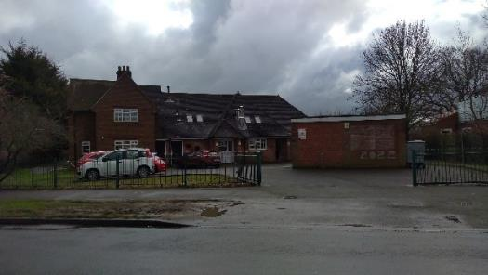  Appendix 1 | 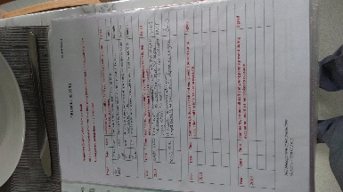  Appendix 2
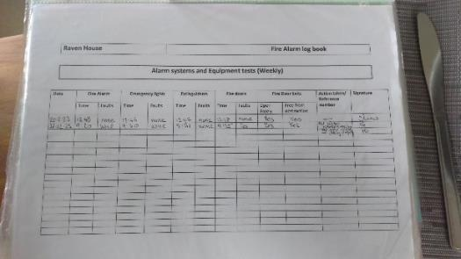  Appendix 3 | 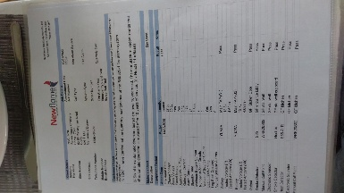  Appendix 4
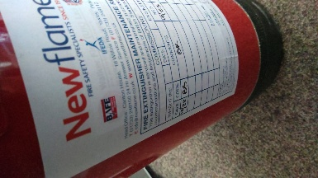  Appendix 5 | 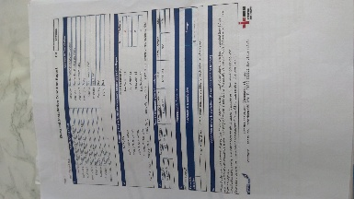  Appendix 6
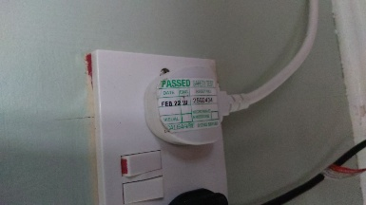  Appendix 7 | 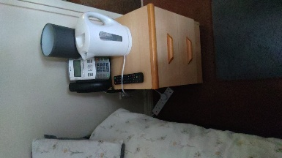  Appendix 8
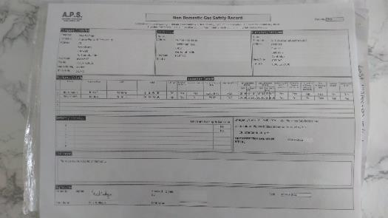  Appendix 9 | 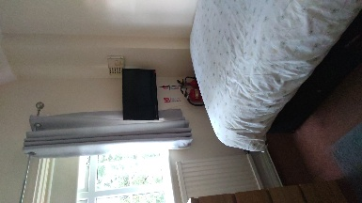  Appendix 10
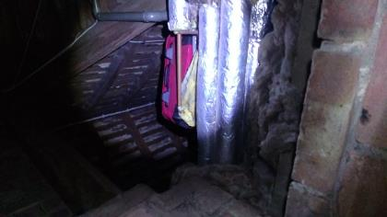  Appendix 11 | 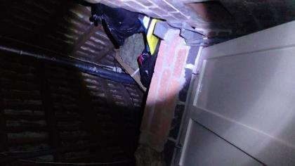  Appendix 12
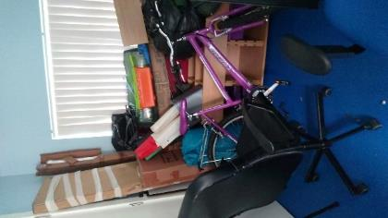  Appendix 13 | 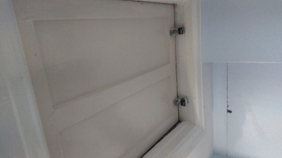  Appendix 14
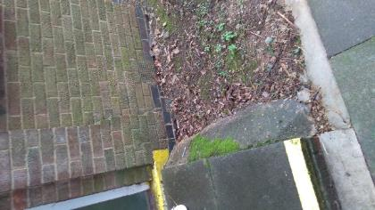  Appendix 15 | 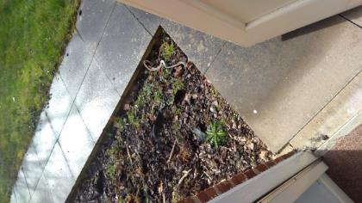  Appendix 16
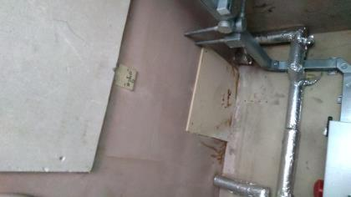  Appendix 17 | 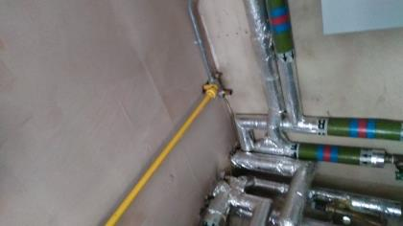  Appendix 18
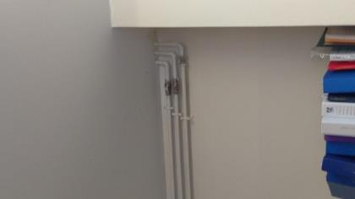  Appendix 19 | 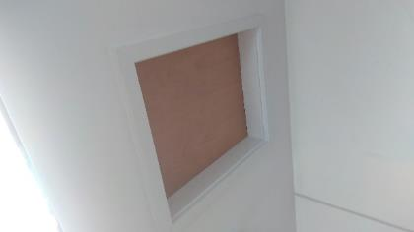  Appendix 20
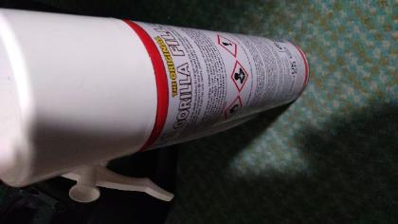  Appendix 21 | 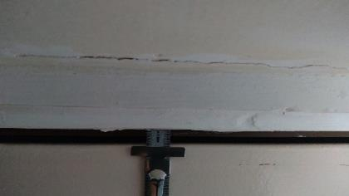  Appendix 22
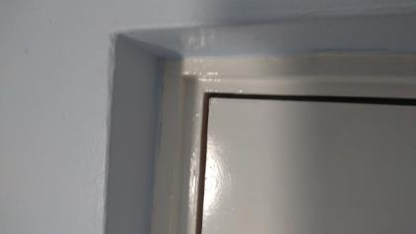  Appendix 23 | 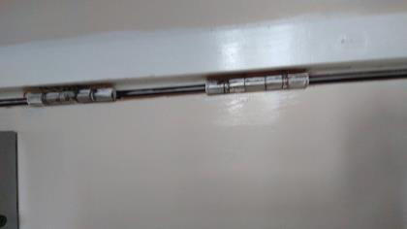  Appendix 24
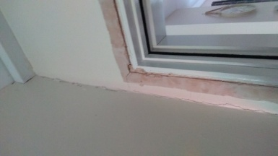  Appendix 25 | 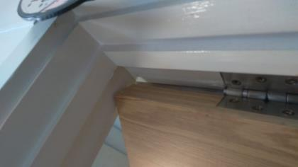  Appendix 26
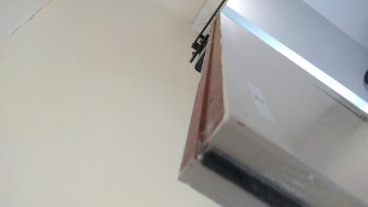  Appendix 27 | 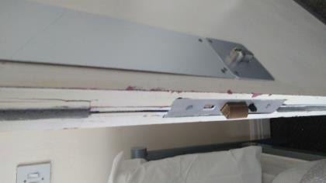  Appendix 28
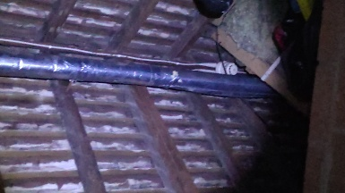  Appendix 29 | Appendix 30
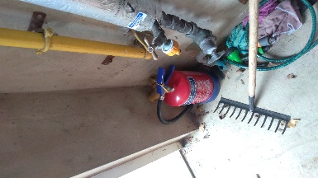  Appendix 31 | 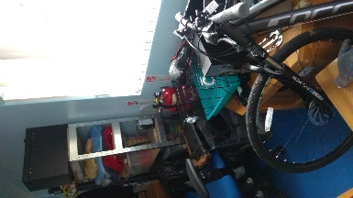  Appendix 32

FIRE RISK ASSESSMENT – RISK LEVEL
The following simple risk level estimator is based on a more general health and safety risk level estimator contained in BS 8800:

Taking into account the fire prevention measures observed at the time of this risk assessment, it is considered that the hazard from fire (probability of ignition) at this building is:

Medium

(Low, Medium or High)

Taking into account the nature of the building and the occupants, as well as the fire protection and procedural arrangements observed at the time of this risk assessment, it is considered that the consequences for life safety in the event of fire would be:

Moderate

(Slight Harm, Moderate Harm or Extreme Harm)

In this context, the definition of the above terms is as follows:

Slight Harm: Outbreak of fire is unlikely to result in serious injury or death of any
occupant (other than an occupant sleeping in a bedroom in which a fire occurs).

Moderate Harm: Outbreak of fire could result in injury of one or more occupants,
but it is unlikely to involve multiple fatalities.

Extreme Harm: Significant potential for serious injury or death of one or more
occupants.

Fire Hazard | Potential Consequences of Fire
 | Slight harm | Moderate harm | Extreme harm
Low | Trivial risk | Tolerable risk | Moderate risk
Medium | Tolerable risk | Moderate risk | Substantial risk
High | Moderate risk | Substantial risk | Intolerable risk
Accordingly, it is considered that the risk to life from fire at this building is:

Trivial |  | Tolerable |  | Moderate | X | Substantial |  | Intolerable

A suitable risk-based control plan should involve effort and urgency that is proportional to risk. The following risk-based control plan is based on one advocated by BS 8800 for general health and safety risks:

Risk Level | Action and Timescale
Trivial | No significant action is required and no detailed records need be kept
Tolerable | No major additional controls required. However, there may be a need for consideration of improvements that involve minor or limited cost.
Moderate | It is essential that efforts are made to reduce the risk. Risk reduction measures should be implemented within a defined time period.  Where moderate risk is associated with consequences that constitute extreme harm, further assessment may be required to establish more precisely the likelihood of harm as a basis for determining the priority for improved control measures.
Substantial | Considerable resources may have to be allocated to reduce the risk. If the building is unoccupied, it should not be occupied until the risk has been reduced. If the building is occupied, urgent action should be taken.
Intolerable | Building (or relevant area) should not be occupied until the risk is reduced.

Note that, although the purpose of this section is to place the fire risk in context, the above approach to fire risk assessment is subjective and for guidance only. All hazards and deficiencies identified in this report should be addressed by implementing all recommendations contained in the following section. The risk assessment should be reviewed periodically.

Action Plan Priorities
Priority A | Where there are potential health and safety risks or where failure to implement changes would be highly likely to attract legal implications. Immediate action is recommended to put changes into effect.
Priority B | Where action is recommended within the 3 months to alleviate or make improvements that will have a considerable impact.
Priority C | Where action is recommended within 12 – 24 months.
Priority D | Where the recommendation involves excessive costs or should be implemented as part of a planned maintenance plan.
FIRE RISK ASSESSMENT ACTION PLAN

Item  Reference | Recommendation | Completion Priority  (See above) | Date Completed
1.4 | It is recommended that further investigations are carried out to verify that any sources of ignition and fuel within the first floor cupboard FR008; ground floor cupboard FR029; administration store room in the garage and the loft space are adequately managed. | B
6.4 | It is recommended that the Evacuation Procedure is developed to include specific instructions to members of staff on their actions in the event of a resident refusing to leave the building. This should include evaluating the risks and benefits of remaining for a limited period of time in order to either persuade the individual to leave or ensuring they are in a place of comparative safety if possible, balancing these against the likely risk to the member of staff in doing this. | B
7.3 | It is recommended that a review of the Fire Marshals is undertaken to verify that there is coverage for all areas at all times of occupation. It is further recommended that a sufficient number of staff should attend Fire Marshals’ training as soon as reasonably possible, including practical instruction in the safe selection and use of fire-fighting equipment, to ensure that there is coverage at all times, including coverage for holidays and absences. It is recommended that Fire Marshals attend refresher training every 3 years. | B
8.7 | All emergency lighting at the premises should be subjected to a full discharge test by a competent person annually in accordance with BS 5266 with the records maintained within the Fire Safety Log Book retained on the premises. Units can be tested by simulated mains failure at the key switch where provided. The tests should be made during the daylight hours to allow sufficient time for the units to be fully re-charged before the hours of darkness. A fully discharged unit can take between 14-16 hours to re-charge. | A
9.2 | All fixed electrical installations at the premises should be tested, inspected and certified by a suitably competent person, in accordance with the Electricity at Work Regulations 1989 and as defined within guidance published by the Institute of Electrical Engineers (IEE). Should the report detail that the condition of the electrical installations are unsatisfactory remedial works should be completed by a competent person every five years. | A
9.5 | It is recommended that the 4-gang extension cable in the Staff Sleep Room is relocated away from liquids that may cause a fire following a spillage. | B

Item  Reference | Recommendation | Completion Priority  (See above) | Date Completed
9.7 | The gas cooker/hob at the premises have been serviced, maintained and subjected to annual safety checks by a GAS SAFE registered engineer in accordance with the Gas Safety (Installation and Use) Regulations 1998. | A
13.2 | It is recommended that the extract filters are cleaned on a monthly basis to prevent build ups of grease and oil which will accelerate a fire, records should be kept for inspection by the authorities. | B
13.2 | It is recommended that the extract canopies and ductwork are deep cleaned and inspected annually to prevent build ups of grease and oil which will accelerate a fire, records should be kept for inspection by the authorities. | B
16.1 | It is recommended that television in the Staff Sleep Room is relocated away from the curtains. | A
16.2 | To reduce the risks from arson and accidental ignition, it is recommended that the quantity of waste combustible materials are removed from the loft space and the garage and that the quantity of waste stored at the premises is reduced as far as possible. | B
16.6 | It is recommended that a register of all hazardous substances which are stored or used at the premises is developed, that Safety Data Sheets are obtained and that COSHH Assessments are carried out by competent person. | A
18.5 | It is recommended that the loft hatch is maintained or replaced to provide 30 minutes’ fire protection. | A
18.7 | It is recommended that the ground outside the fire exits is maintained to reduce the risk of trips and falls. | B
19.1 | The breaches in the compartmentation of the boiler room and the Manager’s office should be fire-stopped with the appropriate fire-resisting materials by a competent contractor to provide a minimum of 30 minutes. | A
19.1 | It is recommended that the loft hatch in the new Meds Room is maintained or replaced to provide 30 minutes’ fire protection. | A
19.1 | It is strongly recommended that flammable filler or other flammable repair materials are not used at the premises and that any flammable items are stored away from the main building and garage. | A

Item  Reference | Recommendation | Completion Priority  (See above) | Date Completed
19.3 | It is recommended that a fire door survey is carried out by a competent person, to ascertain the provision of fire doors in the fire breaks to include: the gapping around the doors; the threshold gapping; that all fire doors close fully into their stops; the condition of the doors and their frames; that appropriate ironmongery is provided; that the smoke seals and intumescent strips are provided and in good condition. Remedial works identified in the door survey should be conducted by a competent person. | A
201 | It is recommended that emergency lighting is provided in the ground floor accessible WC. | A
22.3 | It is recommended that an additional automatic fire detection, linked to the existing fire alarm system, should be installed within the inner area of the Old Meds Room in accordance with BS5839-1. | A
22.3 | Verification should be obtained that the cable to the automatic smoke detection unit in the corridor loft space is 30 minutes fire resistant. | A
23.1 | It is recommended that the fire extinguishers in the staff sleep room are relocated near to the door. | B
23.1 | It is recommended that the fire extinguisher in the boiler room should be mounted to the wall with the handles at a maximum height of 1m and that the appropriate signage is displayed. | B
23.1 | Fire fighting equipment must not be obstructed at any time. It is recommended that the obstructions to the foam fire extinguisher in the garage are removed and that staff are informed to keep fire extinguishers free from obstructions. | B
24 | It is recommended that a Carbon Monoxide alarm is provided in the kitchen and the Boiler Room The siting of the alarms should be in accordance with the manufacturers instructions and as a guide carbon monoxide alarms should be positioned at head height, either on a wall or shelf, approximately 1 to 3 metres away from a potential source of carbon monoxide. If it is likely that the carbon monoxide alarm within the Boiler Room will be inaudible or muffled in the occupied parts of the premises, it is recommended that Bluetooth Carbon Monoxide alarms are provided with the sister alarm being sited in the area of regular occupation nearest to the room which contains the fuel-burning appliance. Carbon monoxide may pass undetected through walls in to occupied areas of the premises. | B

