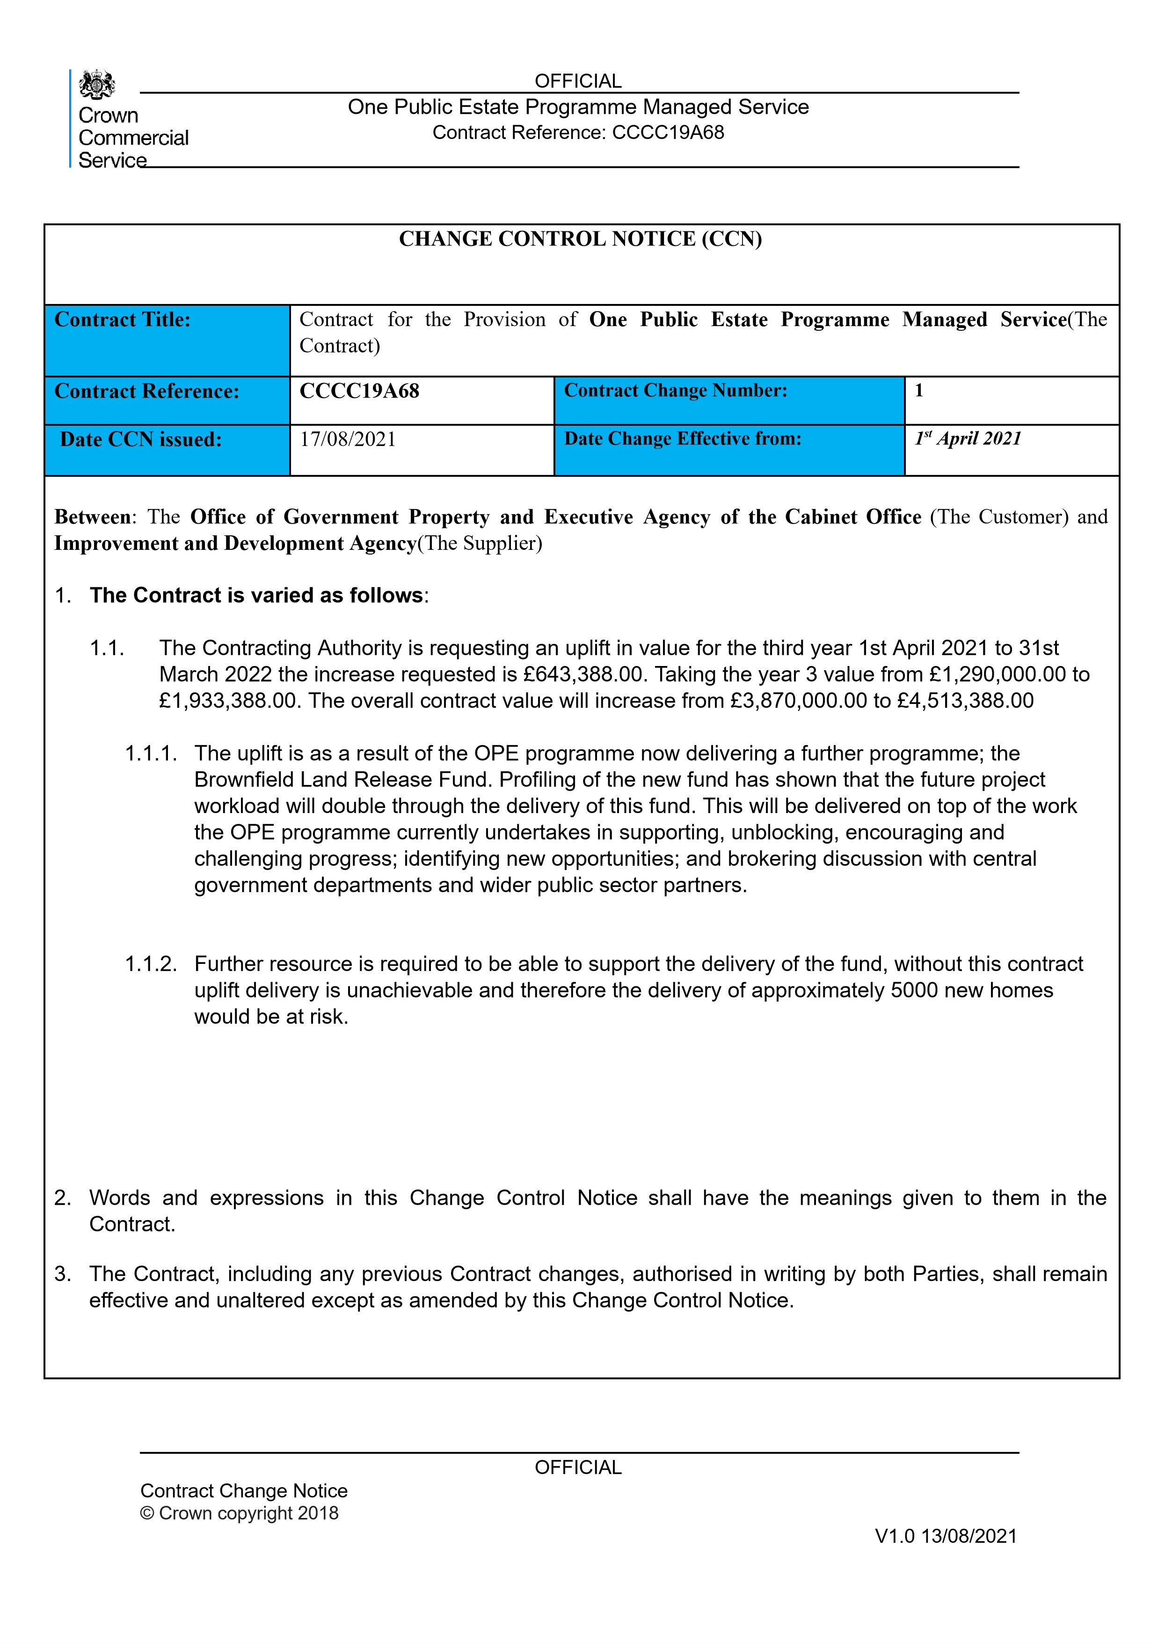





**REDACTED**

OFFICIAL

One

Public

Estate

Programme

Managed

Service

Contract

Reference:

CCCC19A68

OFFICIAL

Contract

Change

Notice

©

Crown

copyright

2018

V1.0

13/08/2021

Change

authorised

to

proceed

by:

representative):

(Customer’s

Signature

Date

Signature

Date

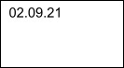

10

/

9/2021

**REDACTED**

Deputy Commercial

Director



**REDACTED**

**REDACTED**







**REDACTED**