Appendix 1 – Building elevations

    - Building 1
    - The building elevations for building 1 are produced below.
    - 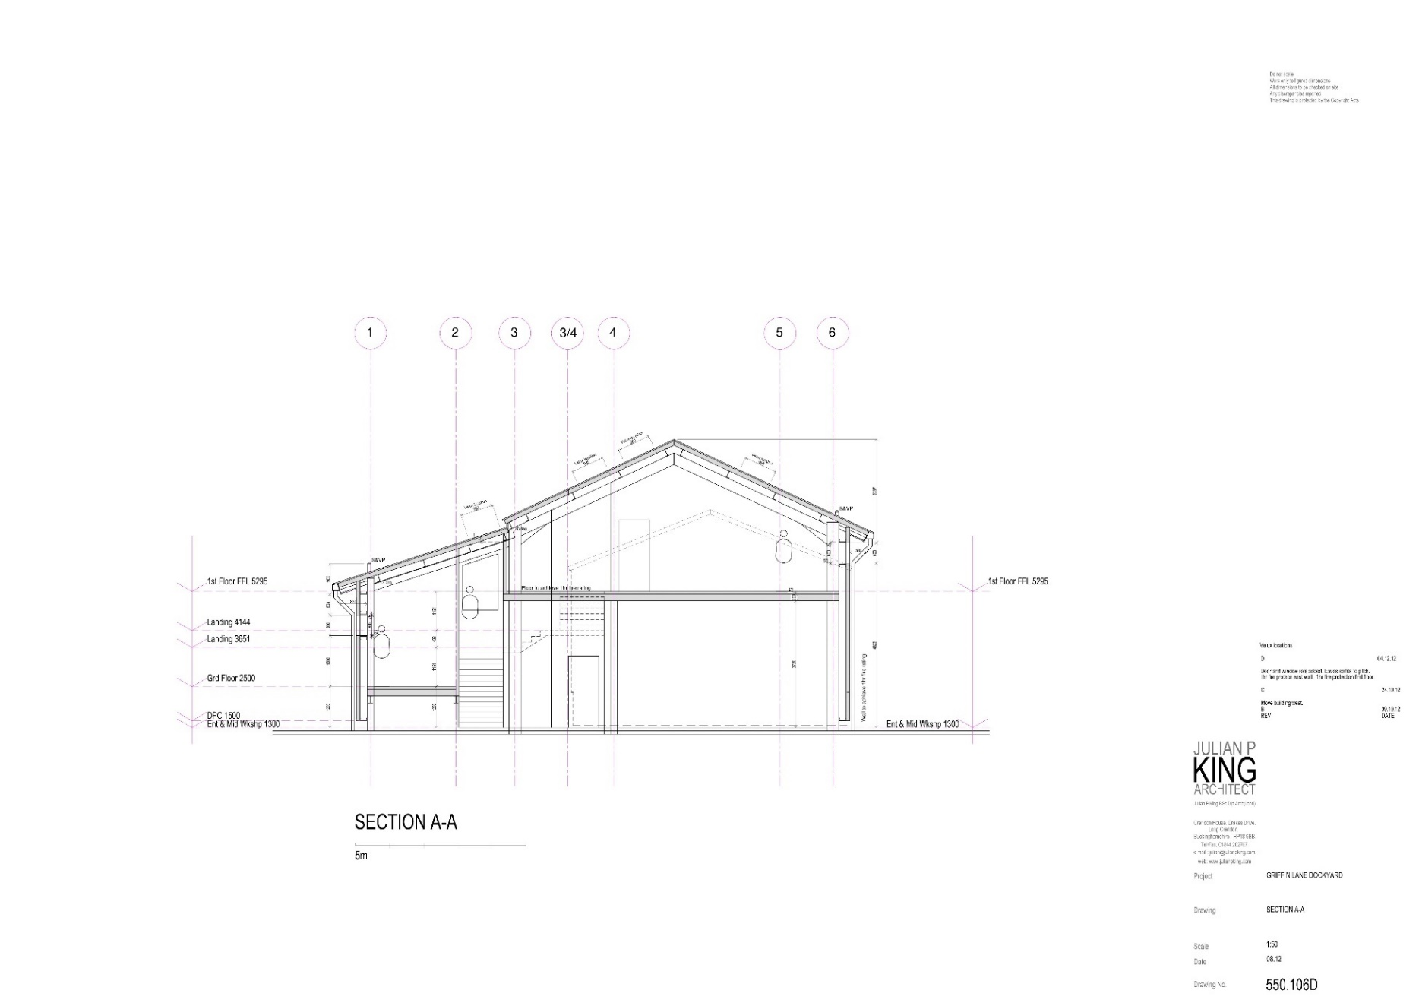
    - 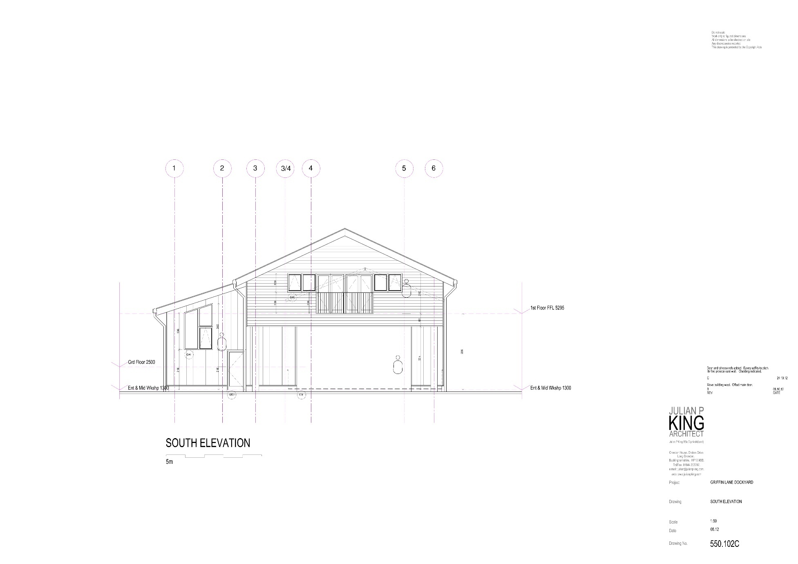
    - 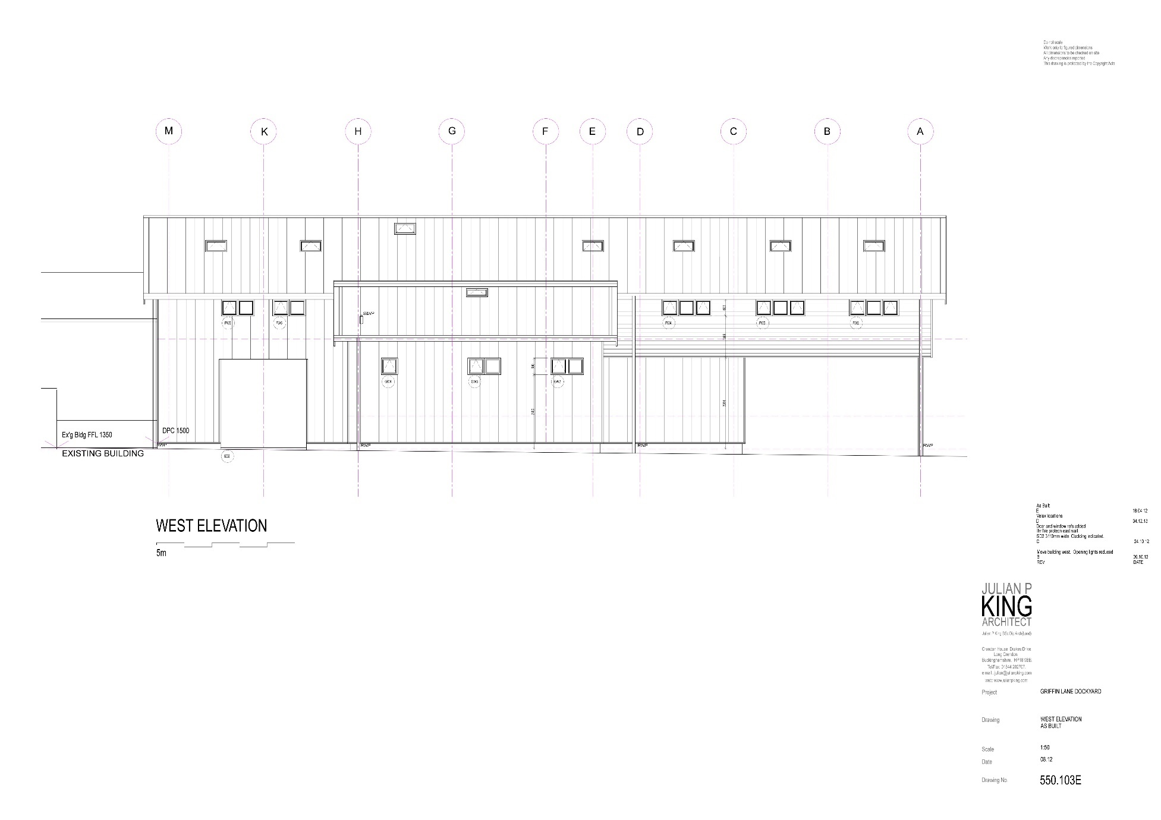
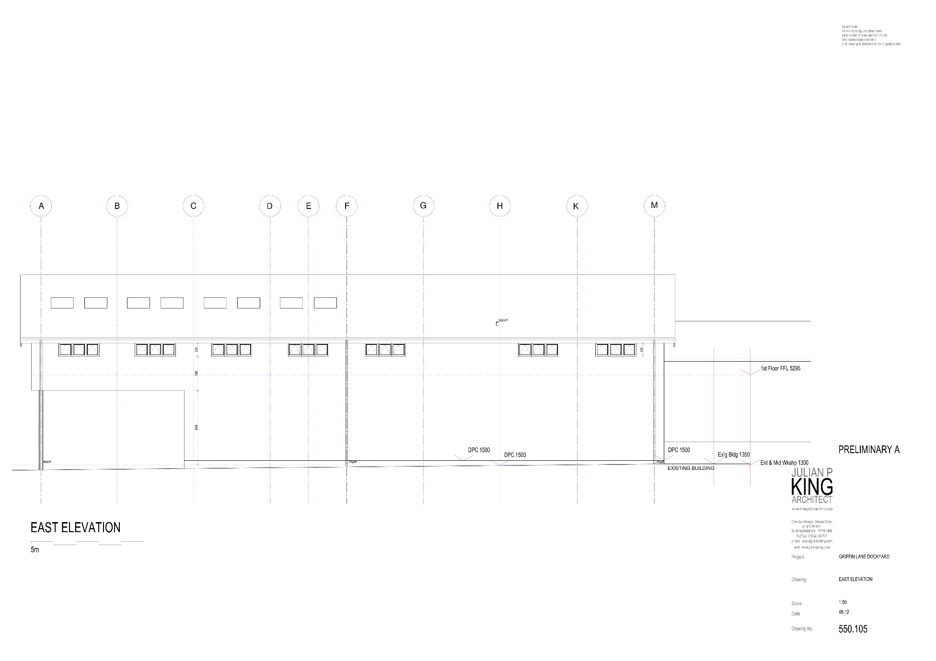
    - 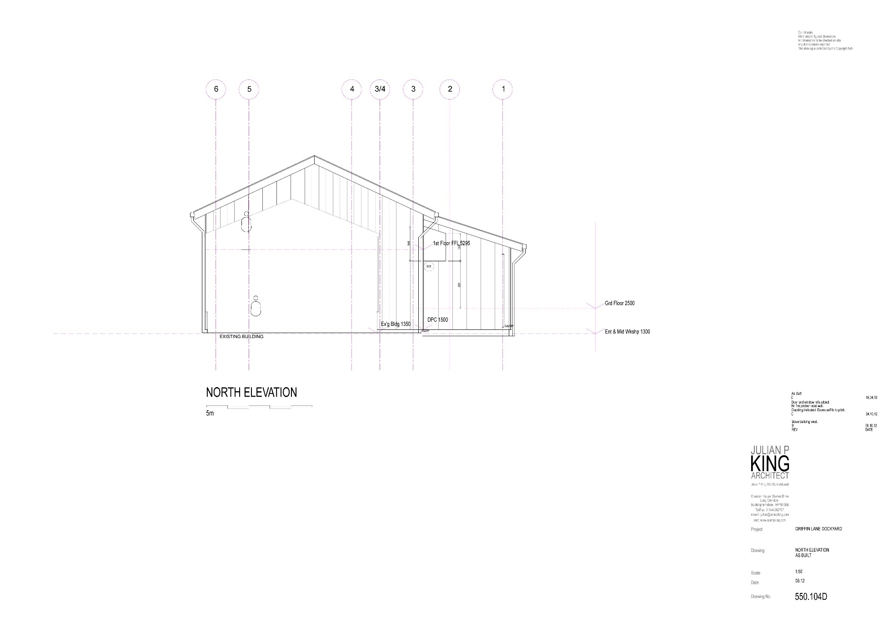

    - Building 2
    - Building 2 has the following approximate dimensions – Length 22m, Width 7.9m. Height from floor to eaves is 4.5m. Height from floor to the apex is 6.2m.
    - 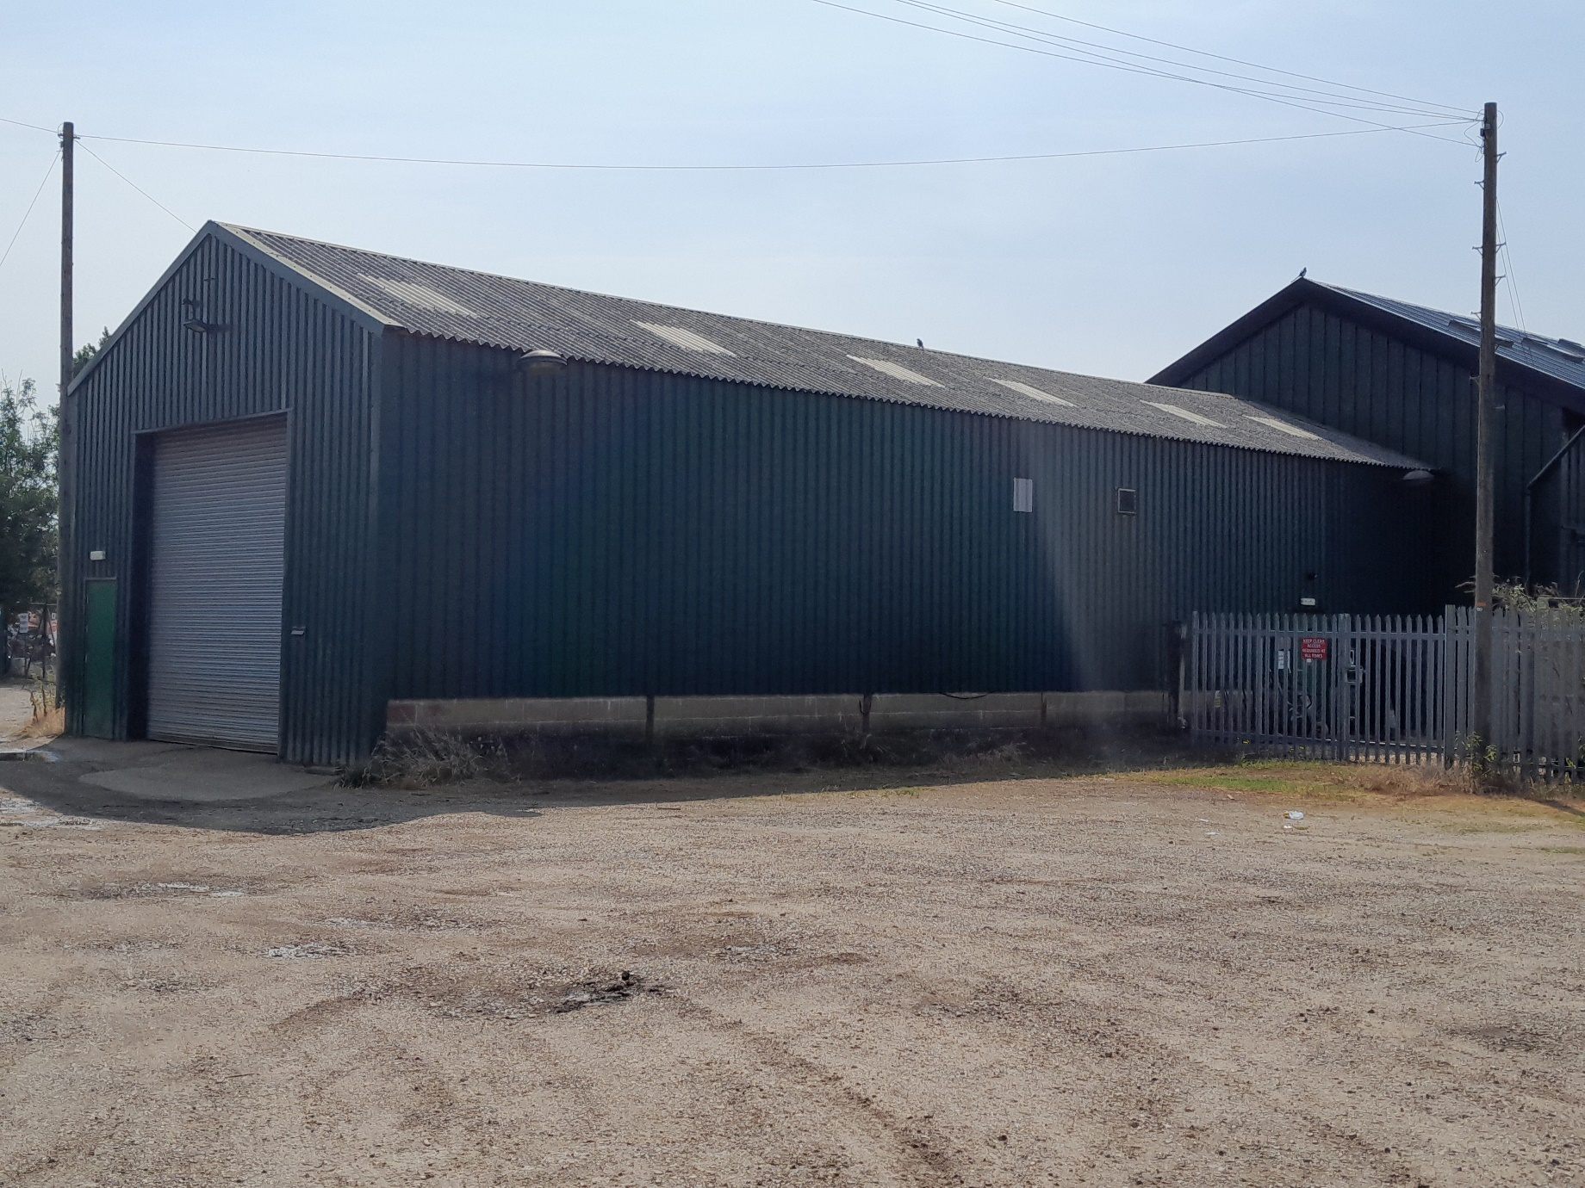
Exterior of west wall of Building 2
    - 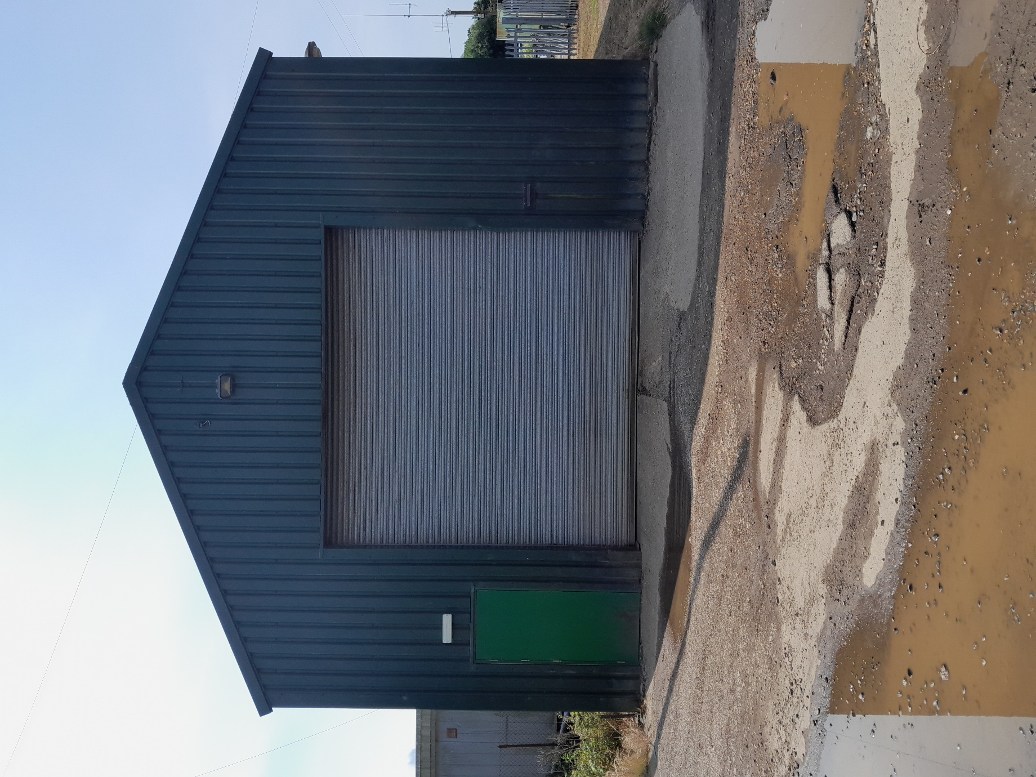
Exterior North Wall Building 2
    - 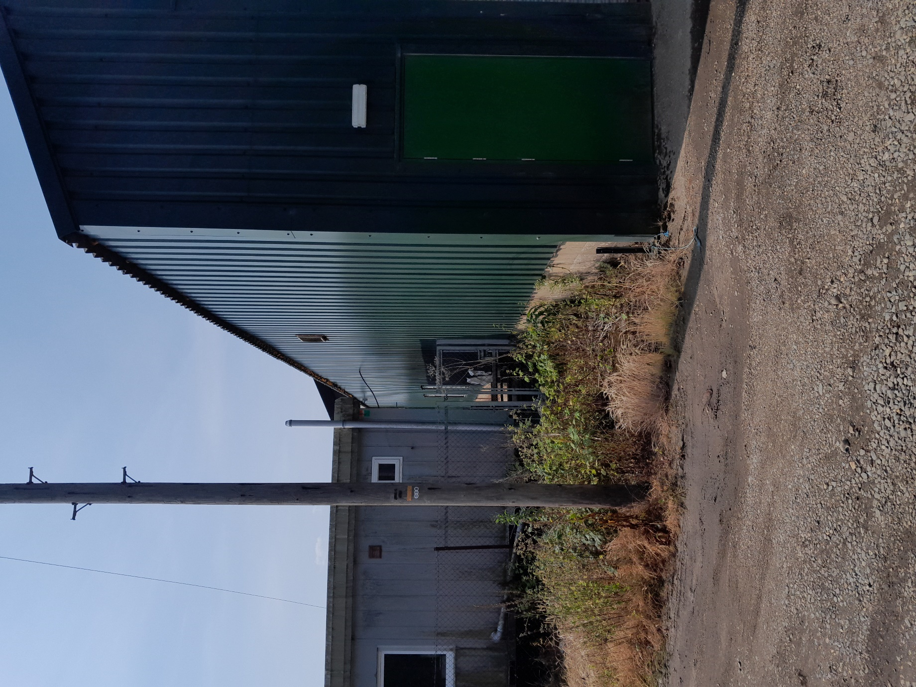
Exterior East Wall Building 2
    - 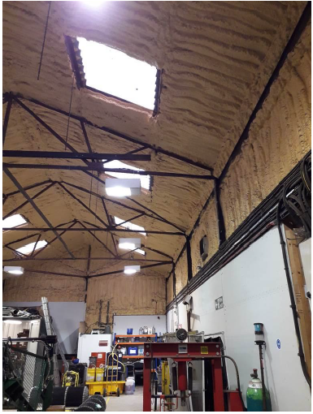
Interior of roof Building 2

