Specification
Background to the Environment Agency
Who is the Environment Agency?
We are an Executive Non-departmental Public Body responsible to the Secretary of State for Environment, Food and Rural Affairs. Our principal aims are to protect and improve the environment, and to promote sustainable development.
Further information on our responsibilities, Corporate Plan and how we are structured can be found on our website:
https://www.gov.uk/government/organisations/environment-agency/about

What do we spend our money on?
We are a major procurer of goods and services within the UK, spending circa £600M per annum, our major spend areas are:
Flood and Coastal Risk Management (design, construction, and maintenance)
ICT and Telecommunications
Vehicles and Plant
Environmental Consultancy and Monitoring
Temporary Staff and Contractors
Facilities Management, Energy and Utilities
Flood Management and Water Related Services

What do we need from our suppliers?
Suppliers are vital in supporting the delivery of our corporate plan. We aim to support the economy and society whilst delivering more environmental outcomes for every pound we spend. In many areas we are leading the way on environmental and technical developments. It is our role to ensure that suppliers clearly understand our corporate aims and objectives and know that we are committed to delivering the best value most sustainable solutions, taking into account the whole life cost of our procurement decisions. We promote diversity and equality and treat all of our suppliers fairly.

Our procurement strategy may be of interest to you as a potential supplier. It sets out our priorities and key commitments in a range of areas such as delivering our corporate plan, Government policy, supplier management and sustainable procurement:
https://www.gov.uk/government/organisations/environment-agency/about/procurement#procurement-strategy

Government changes and collaboration
Since 1 April 2013, the Environment Agency is no longer responsible for delivering the environmental priorities of Wales. This is now the remit of Natural Resources Wales (NRW). Further information can be found here:
http://naturalresources.wales/splash?orig=/
By bidding for this requirement, you may also be approached by other members of the Defra network, NRW or other government departments that are specifically named in the tender document.

Further information
For further information and to see our commitments to Diversity and Equality, please visit our website:
https://www.gov.uk/government/organisations/environment-agency/about/procurement
https://www.gov.uk/government/organisations/environment-agency/about/equality-and-diversity
Also, are you up to date on environmental legislation? See links below for further information:
Waste and Environmental Impact - https://www.gov.uk/browse/business/waste-environment
Environmental Regulations -
https://www.gov.uk/browse/business/waste-environment/environmental-regulations

Contract Ref:
Contract Title: Design and build of a toolkit and supporting content. Environment Agency; Integrated water management approaches.

Background to the specific work area relevant to this purchase
The Integrated Water Management Framework (IWMF) programme is hosted by the Environment Agency’s Oxford to Cambridge team on behalf of the wider Defra Group, working closely with stakeholders across the sector and geography. Embedded in strategic placemaking partnerships, this 3-year programme offers the opportunity to shape, test and trial developing mechanisms and policy approaches to help deliver a step-change in the way water, including flood risk, is managed. The programme works with the Oxford to Cambridge Pan Regional Partnership governance framework, geography, and stakeholders, however it is designed and managed in a way that will provide learning and approaches that are applicable more widely.

The IWMF programme will explore how to draw together current and ongoing water, flood, natural capital, and land use planning work, to create a fully interconnected water and flood risk approach to planning and decision making. The end goal is to enable a more proactive, holistic approach to decision making and solution planning for water management infrastructure – focusing on the needs of the natural environment and ultimately avoiding reactive water management solutions that focus primarily on damage limitation.

The programme has delivered its first phase which focuses on evidence, exploration of issues and dependencies, and engagement. This relied on collaborative steering and technical groups that have co-designed outputs and are invested in defining change collectively. It brings together work across water, flood, natural capital, and land use planning to create an integrated water and flood risk evidence base. In its current phase, the programme will support the identification of options at scale which deliver multiple benefits for the environment and people, allowing a more proactive and holistic approach to decision making and solution planning across all water management infrastructure.
This phase has multiple concurrent projects, each one looking to integrate part of the water planning and interventions processes. To effectively use the outputs of these projects and studies to influence future ways of working we need to coherently present the learning, case study examples and recommendations from these projects to an extensive and varied stakeholder group in a user centric way.

Requirement
The Oxford to Cambridge Integrated Water Management Framework (IWMF) end goal is to enable a more proactive, holistic approach to decision making and solution planning for water management infrastructure.
We need to communicate the programme’s outputs coherently and effectively and, in a user, centric way. We have identified the need to create an interactive or self-selection toolkit/framework that can easily, and based on user needs, communicate the learning and guidance from across the whole suite of projects.
The majority of this commission will be design and functionality focused, with the client team providing the content. We would however expect the supplier to provide guidance on the appropriate style of content that could work best with the proposed design elements. The Supplier shall take a lead in providing clear requests of what is needed from the client to enable the supplier to deliver a strong and compelling product.
This commission's aim is to develop a strong, recognisable identity for integrated water management. This is to support the embedding of the approach externally, and to help stakeholders to navigate the tools, guidance and products that surround it.

Target Audience
Our target audience is internal Environment Agency/Defra group staff, external regulators, policy makers, land use and water planners.
The framework should ensure that they can access integrated water management material easily and based on their selections in the toolkit to engage effectively with taking an integrated approach. The toolkit should also support users to interact knowledgeably and effectively with other organisations taking an integrated water management approach.

Benefits
1. Capability and confidence of users in taking an integrated water management approach is raised.
2. Clarity and efficiency of access to integrated water management tools, approaches, guidance, and learning is increased.
3. Ability to share integrated water management learning is increased.
4. The internal and external profile of the development and application of integrated water management is significantly increased. With a focus on the Environment Agency’s work around this.

Objectives
Deliver the above requirements in developing and delivering an engaging, user centric, consistent, simple, and visually pleasing way, to optimise understanding and buy-in.
● Ensure all stakeholders are able to review our project findings to gain a basic understanding of how integrated water management fits in to the environmental planning and delivery cycle through a toolkit. This will be achieved through an effective use of design, graphics, and diagrams
● Route different stakeholders to access our project summaries and findings and to focus in on the material that is most relevant for their role, yet still allow interested stakeholders to see the full picture of our work, how it links into the work of the wider water sector and our ambitions for the water environment.
● Ensure simple access to integrated water management information and guidance through design and delivery of a framework tool to link to current and future integrated water management material
● Ensure users recognise key decisions points in the integrated water management planning cycle where the most effective opportunities for taking an integrated approach are and provide links to material and guidance that will support them doing so.

Products/ Elements
We anticipate the work to create the toolkit to be developed in three parts:
The detail of the three elements or products and timings can be seen in the workflow diagram below

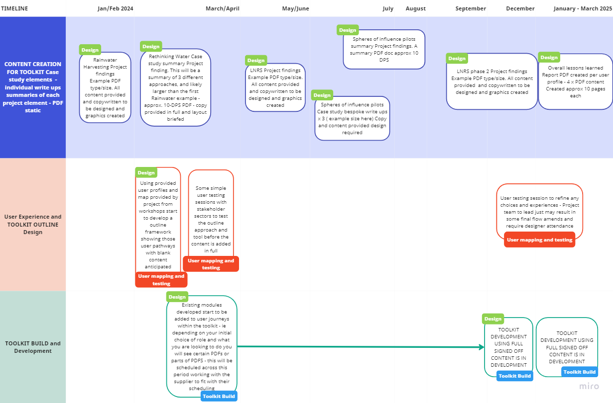

Element 1: Content creation
Development of case study summaries or the base content of the toolkit
We first need to create engaging summaries of the work we have. We have 4 pilot projects in progress, that will each require a summary case study to be developed. Within each of these there are a few case studies which may also warrant individual summaries.
The EA project team will provide all the base content, so the brief is around layout and presentation of that copy with supporting graphics and elements that help to communicate the key points and processes.
An example of the sort of size and detail is given here: Note the summary may need to link to pre-existing and pre hosted full reports through simple embedded links.
There is no hosting requirement within this brief nor any requirement to design full technical reports.
As the product timeline indicates we will have approx. 8-10 summary PDFs needing to be created. All will use the same colour palette and general approach, in order to create a 'package' feel. In terms of icons and graphics, there will be a requirement for individual "setting" of text and images for each PDF.

Element 2 – Toolkit/Framework Design
Develop a simple, visual, and interactive integrated water management toolkit/ framework to link the users with the relevant content and relevant context. A combination of static and interactive elements may help to bring the story to life.
The toolkit will provide a window to the learning and approaches that are applicable more widely than just the Oxford to Cambridge area. We hope that an integrated approach will focus on the needs of the natural environment, ultimately avoiding reactive water management solutions that focus primarily on damage limitation.
It should have an intuitive menu and journey for users. Bringing in messages, examples, stories and resources as appropriate. Functionality and design will allow spotlights on specific work programmes that direct users to alternative materials / web hosted content.
We would like this there to be stakeholder feedback loop built into the design process to refine the design.
We would like you to consider the use of 'user personas' (4-6 of them) to improve the look and feel for a range of different stakeholders and to direct people to relevant content. The Client would provide these personas if this option was deemed to be appropriate and taken forward.
The toolkit must adhere to all our branding and accessibility requirements. See link here.

Element 3 – Build of Toolkit
The final element is to build the toolkit.
The build would be based on the design for element 2 and the content developed through element 1. The client team will also signpost to external guidance and content to be signposted to in the toolkit ensuring wider work is considered.
You will need to plan the build using the most appropriate platform.
We would like you to undertake the build in stages to allow for review and sign off of functionality.

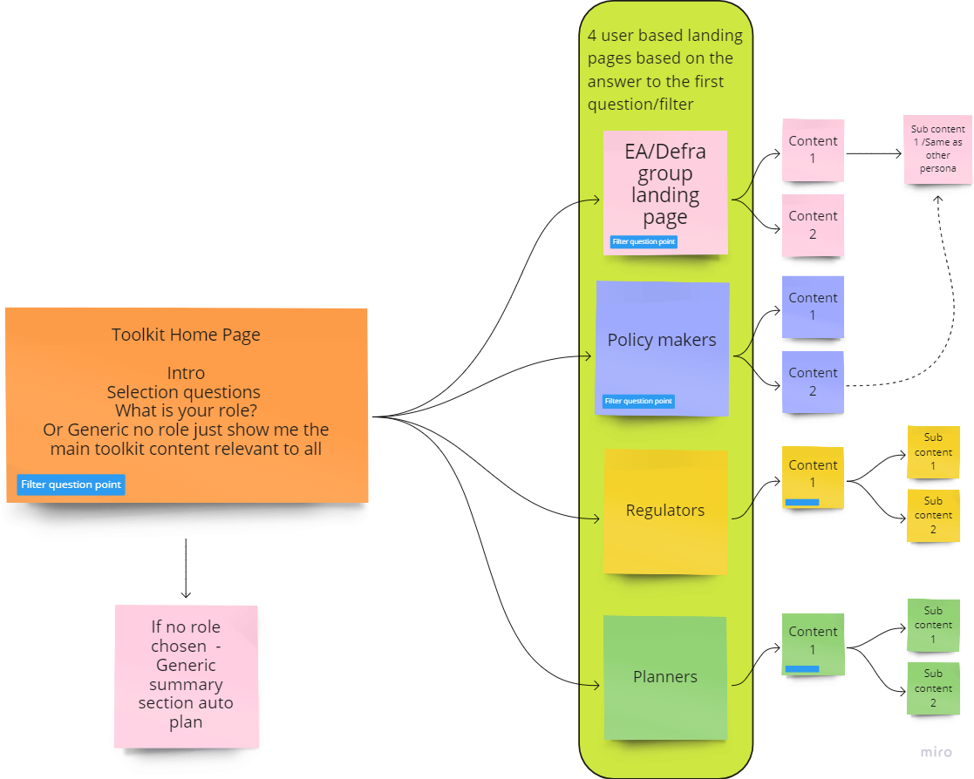

Usability
The end products must be accessible and interactive to the user’s needs.
All products may include signposts to tools hosted on websites external to the EA.
All products should be developed to enable EA to make updates to content and structure in the future and should include methods/guidance to enable this.
Additional information will be supplied following the award of contract.

Sustainability
The Environment Agency protects and improves the environment and is committed to reducing the sustainability impacts of its activities directly and through its supply chains. We expect the Contractor to share this commitment and adopt a sound, proactive sustainable approach in keeping with the 25 year environmental plan/our commitments compliant with all applicable legislation. This includes understanding and reducing direct and indirect sustainability impacts and realising opportunities, including but not restricted to; resilience to climate change, reducing greenhouse gas emissions, water use and quality, biosecurity, resource efficiency and waste, reducing the risk of pollution, biodiversity, modern slavery and equality, diversity & inclusion, negative community impacts.
As a delivery partner, the successful contractor is expected to pursue sustainability in their operations, thereby ensuring the Contracting Authority is not contracting with a supplier whose operational outputs run contrary to the Contracting Authority’s objectives. The successful contractor will need to approach the project with a focus on the entire life cycle of the project

Sustainability Considerations
We are committed to continually improving our sustainability performance. The Environment Agency has set itself tough objectives as a clear commitment and contribution to sustainable development throughout England. The Agency recognises that this can only be achieved through commitment from all sectors of society, and it is intent on raising awareness amongst industry and commerce.

Contractors must adopt a sound proactive environmental approach, designed to minimise harm to the environment.

Environmental criteria should be considered as part of your tender submission with credit given for innovation. Factors to be considered could include areas such as:
1. Paper use: All documents and reports prepared by consultants and contractors are produced wherever possible on recycled paper containing at least 100% post consumer waste and printed double sided.
2. Travel: use of public transport, reduce face to face meetings by using email and videoconferencing. Meetings to be held in locations to minimise travel and close to public transport links.
3. Packaging: should be kept to a minimum. Re-use and disposal issues must be considered.
4. Efficient Energy and Water Use.
5. Disposal of Waste: Whilst on site the contractor is responsible for the disposal of their own waste and can only use client facilities with express permission from the on site facilities officer.
6. Whilst on site, contractors should comply with the local environmental policy statement which will be made available to you in advance or on arrival.

Diversity and Equal Opportunities
We are committed to promoting equality and diversity in all we do and valuing the diversity of our workforce, customers, and communities. As a public body, we publish regular information about what our equality objectives are and how we’re meeting them.
https://www.gov.uk/government/organisations/environment-agency/about/equality-and-diversity

Health and Safety
Contractors will be responsible for making sure all required health and safety aspects including risk assessments are undertaken and required management measures are in place to protect worker exposure. This includes management of all partners, consortium members and subcontractors.

eMission2030 - our sustainability plan
We need to act urgently to tackle our own negative impact on the environment through the carbon produced by our use of raw materials, energy and transport and the impact on those working in the manufacturing processes of what we buy. Our new sustainability plan - eMission2030 – outlines our ambition for the future and use hard evidence to radically change our way of thinking to build sustainability into every decision we make.

We have adopted the United Nations Sustainable Development Goals (also known as The Global Goals) as a framework for eMission2030 – to tackle a broader range of social and economic development issues. But to achieve our commitments we'll need to do things with urgency, together and even more work in partnership with others. This will need to be delivered across the whole organisation to be successful.

We want you to feel empowered to take your own actions and try out innovative ideas to make both big and small changes and challenge unsustainable decisions and actions We'll be asking all parts of our organisation to create their own delivery plans which shows what they will do to achieve our commitments.

Outputs and Contract Management

● January 2024– Start up meeting between project officer/team and supplier.
● Monthly status check ins thereafter along with management of the provided Timeline and the milestones below
● Monthly Budget view of work done and budget remaining/spent

Key milestones are as per the provided timeline graphic:
● End of February 2024 – PDF 1 summary briefed and created
● End of April 24 – PDF 2,3,4 Summaries briefed and created
● End of May 24 - Outline initial user journey toolkit with "dummy" content created and tested with user reps
● User toolkit development starts - using existing content to start population
● End of June 24 -PDF 5 Summary briefed and created.
● End of August 24 PDF 6,7,8,9 Summary briefed and created.
● End of September PDF 10 Summary briefed and created.
● End of January 2025 - User toolkit final user testing and adjustments
● End of February 2025 - Toolkit finalised

This contract shall be project managed on behalf of the Environment Agency by Ceri Lewis, Oxford to Cambridge Programme Manager (ceri.lewis@environment-agency.gov.uk). With Daniel Curtis, Integrated Water Management Delivery Manager as the Project Executive (daniel.curtis@environment-agency.gov.uk).

Monthly project team meetings (virtual or face to face as appropriate) with additional check points should be used to ensure the project is keeping to time and scope. The regularity of these can be adjusted to reflect different periods of the project and needs. Regular conversations and emails between the project manager and contractor are expected throughout the project.

We will expect the supplier to invoice for work periodically (monthly or bi-monthly as appropriate). These invoices will be assessed and paid within a month, with the intention of this turn around being much shorter (1-2 weeks).
All invoices must quote the purchase order number in order to be processed. A file copy invoice must be provided to the contract manager, on request. The timescale for payment of invoices will be up to 30 days after we have received a valid invoice.

